**ABC Money Transfer Project Development Tasks**

**Steps to Run This Project:**

1. Clone the project.
2. Open the project in a code editor like Visual Studio.
3. Set up the database:
   * Open appsettings.json and follow the provided setup instructions.
4. After updating the appsettings.json file, open the **Package Manager Console**.
5. In the console, type Add-Migration to create the migration. If you encounter an error, delete the migration folder and its files from the project, then rerun Add-Migration.
6. In the console, you will be prompted to enter a name for the migration. Type any name and press Enter.
7. After successfully creating the migration, type Update-Database and press Enter. This will take some time.
8. Once completed, a message should display "Done." Your database and tables will be created. If you see any other error messages, don't hesitate to get in touch with me.

**UI Features Steps.**

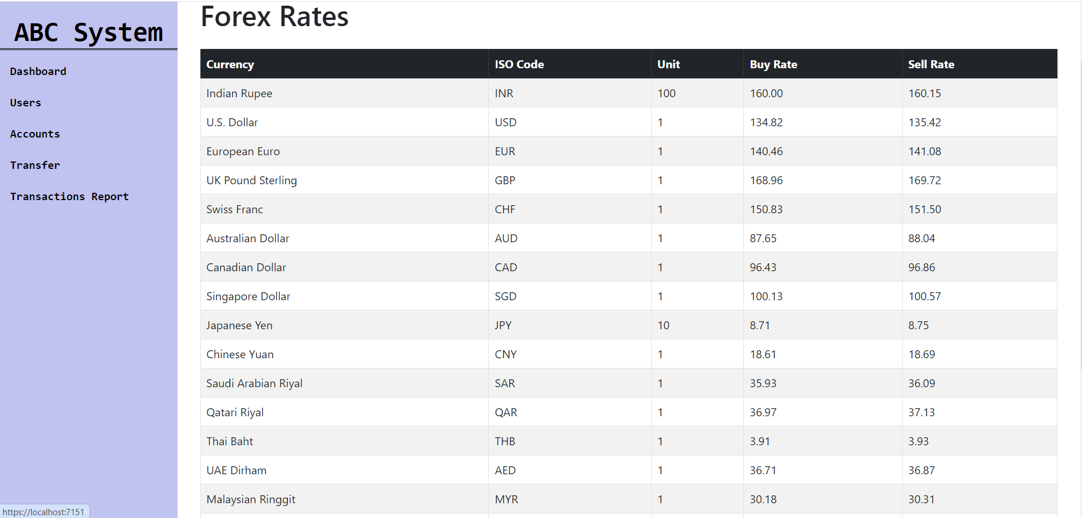

Fig: Dashboard

Step 1 Show a dashboard to fetch and display today's exchange rate for Nepal.

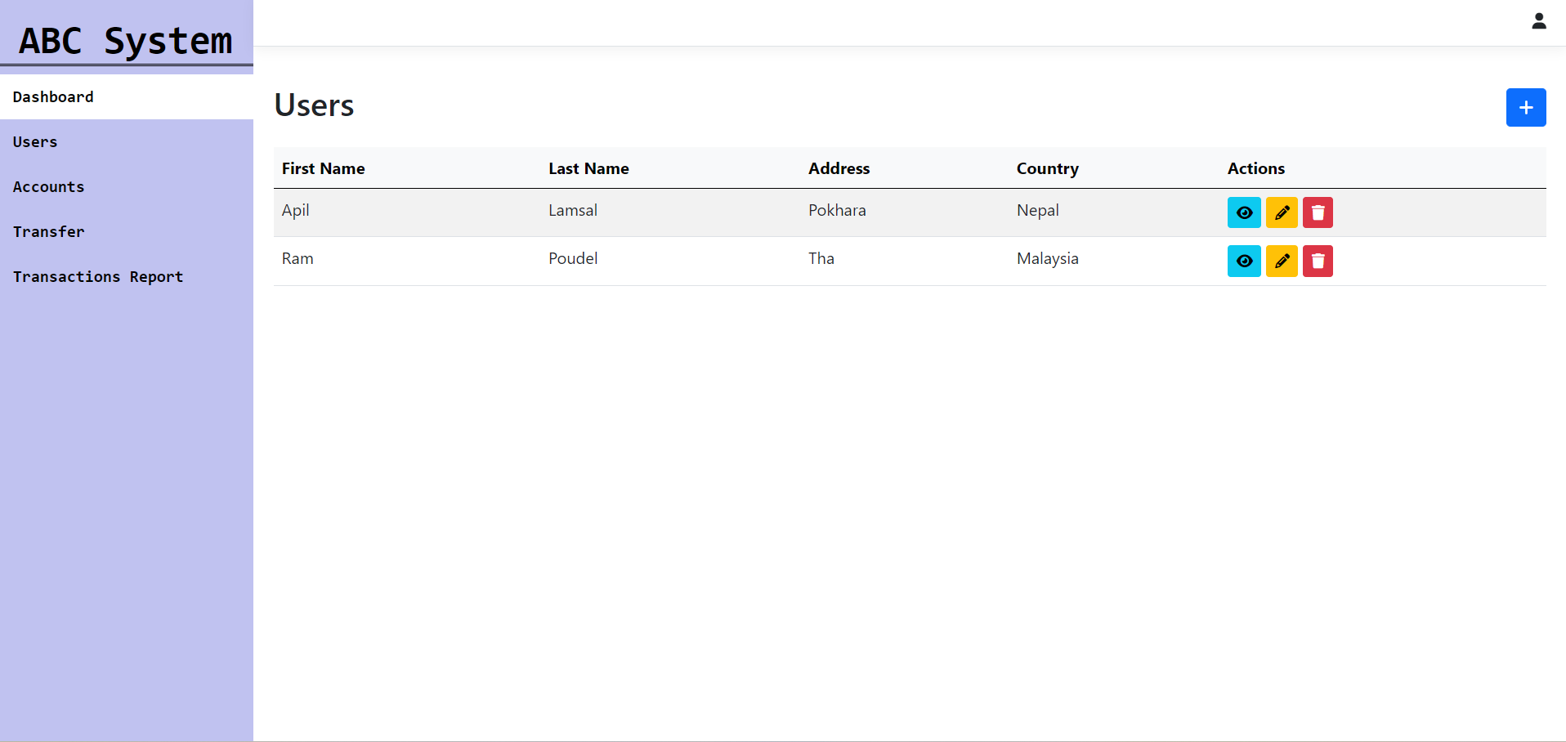

Fig: Users List

Step 2 involves implementing CRUD operations to manage users by allowing the creation, viewing, updating, and deletion of user records.

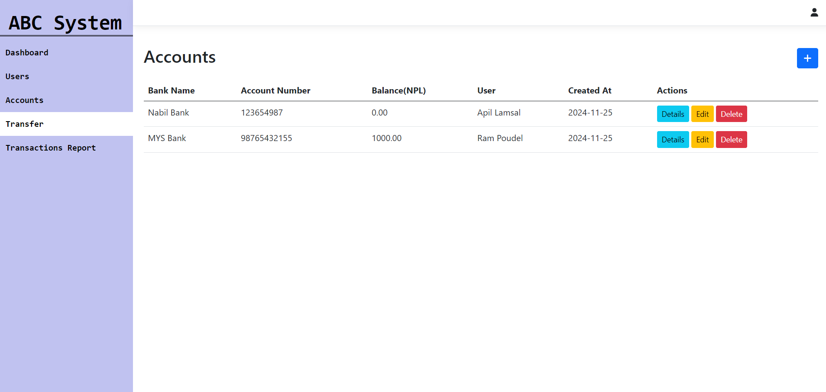

Fig: Accounts CRUD

Step 3 involves implementing CRUD operations to manage accounts, connecting them to users, and allowing the creation, viewing, updating, and deletion of account records.

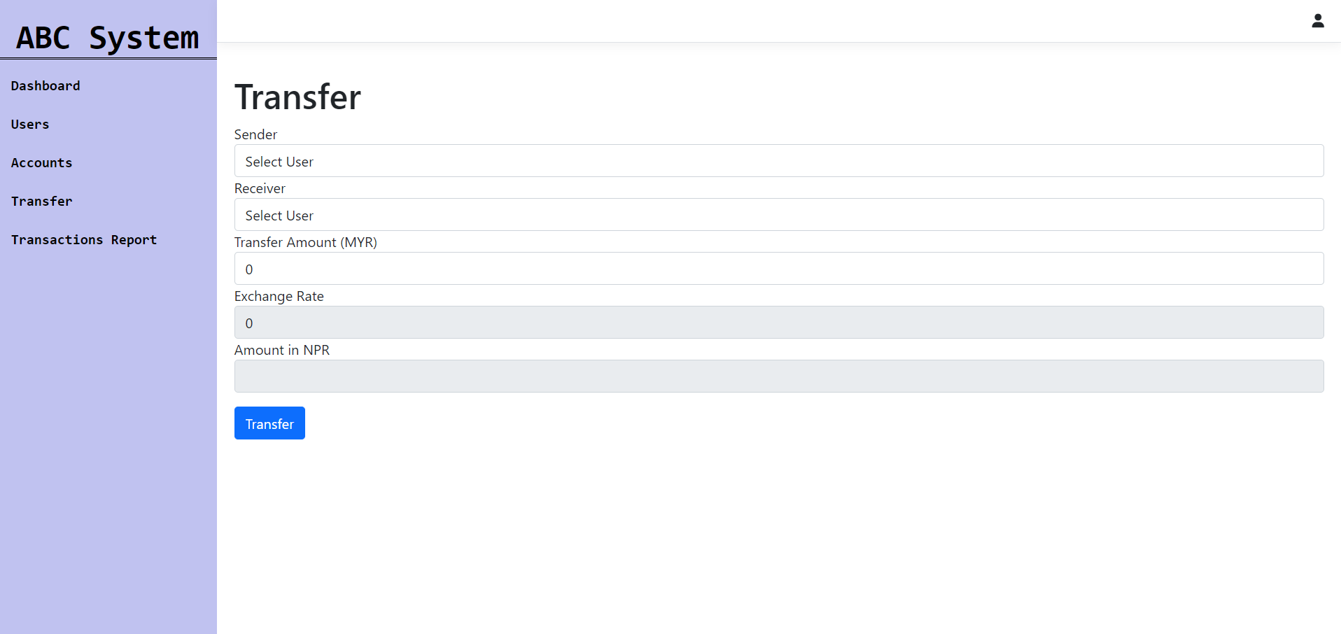

Fig: Transfer

Step 4 involves implementing the transfer process where a sender can transfer money to a receiver, both of whom are users. The system will display the sender's country exchange rate, calculate the converted amount in NPR (Nepalese Rupees), and, once the transfer is completed, store the transaction details in the transaction table.

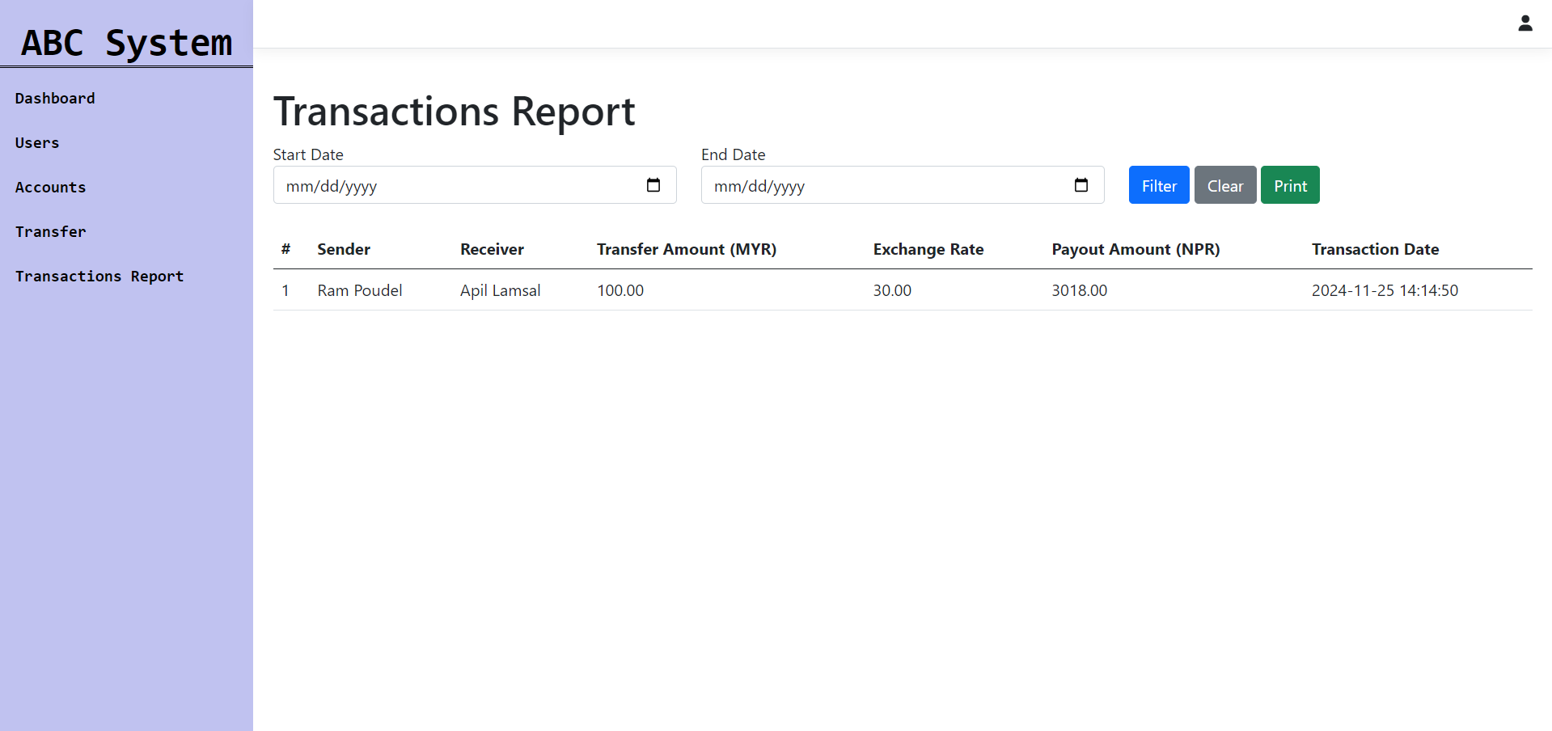

Fig: Table of Transactions History Report

Step 5 involves displaying a transfer history list with a filter feature that allows users to filter transactions by a date range (Start Date - End Date). Additionally, a print option should open a printable version of the displayed data in the table when clicked.