
School of Applied Sciences
Bachelor of Science in Computing

COMP404 – 411/412 IP Routing
Network Design and Simulation
Academic Year 2021/22

Name: Tommy Lam
Student ID: P-180-2206

Subnet / VLSM
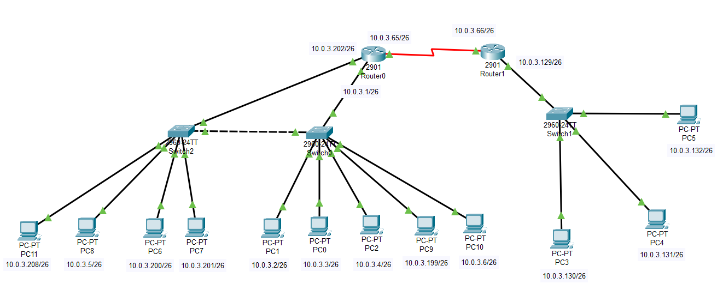
Figure 1: Network planning diagram

As shown in Figure 1, This network is composed of four subnets, PC6, PC7,PC9 and PC11 belong to the 10.0.3.192 network segment, PC0, PC1, PC2, PC8 and PC10 belong to the 10.0.3.0 network segment, AND PC3,PC4 and PC5 belong to the 10.0.3.128 network segment. Router0 and Router1 belong to network segment 10.0.3.64.

Static routing
Verification
- Click on one of the routing ICONS()
- Select the "CLI" ()
- Enter "en" on the console to enter privileged mode()
- Enter "show IP route" in privileged mode.()
- Then, You can see the configuration similar to those in Figure 2. The "S" in the figure is the static route
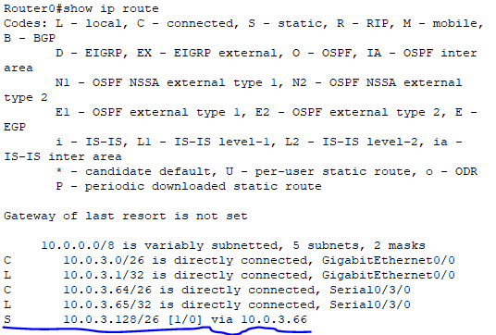
Figure 2: The routing configuration
- From the main page, click "PC10" and select "Command Prompt "on the "Desktop", enter "ping 10.0.3.131" in the Command window, and you will see something similar to figure 3.
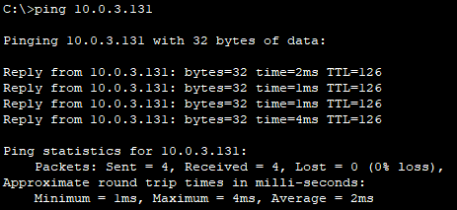
Figure 3: PC10 sends a request to PC4(10.0.3.131)
Since I set ACL on Router1 (only PC10 can access the right-side network[10.0.3.128] through Router1), PC11 cannot access the right-side network.

ACL
Verification
- Click on the Router1
- Click the "CLI"()
- Enter "en" on the console to enter privileged mode()
- In privileged mode, enter "show access list" to see results similar to figure 4.
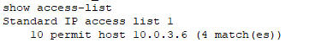
Figure 4: The configuration of access list
- In addition, you can use the "show run" command in privileged mode to view details.
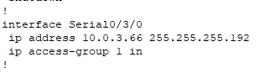
In this picture, you can see that Access List 1 has been applied to Serial 0/3/0

When you try to enter "Ping 10.0.3.132" on the console of PC11, you will get the result in Figure 5. But when you try to enter this command on the console of PC10, you can receive positive feedback.
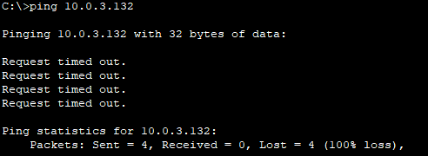
Figure 5: PC11 attempts to connect to PC5 (10.0.3.132)

VLAN / Trunk
Verification:
- Click on "Switch 0"
- Click the "CLI"()
- Enter "en" on the console to enter privileged mode()
- Enter "show vlan bri" on the command line to view VLAN settings. Refer to figure 6 for settings.
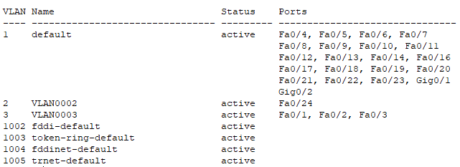
Figure 6: The configuration of VLAN
As you can see, I divided FA0/1-3 of the switch to VLAN0003 and F0/24 to VLAN0002. If you observe carefully, you can find that there is no FA0/15 in the figure because I set FA0/15 as the trunk interface. You can enter the "show interfaces f0/15 switchport" command in privileged mode, and then see the following results like Figure 7.

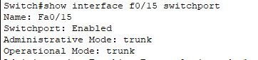
Figure 7: The configuration of interface FA0/15

In Figure 7, you can see that the FA0/15 interface has been set to trunk. You can use the same steps to view the VLAN configuration of switch 2. The trunk interface of switch 2 is also FA0/15.
PC6, PC7 and PC11 are connected to FA0/1, FA0/2 and FA0/3 of Switch2 respectively, and PC0,PC1, and PC2 are connected to FA0/1,FA0/2, and FA0/3 of Switch 0 respectively. PC8 does not belong to the same subnet as PC6 and PC7. PC8 is connected to FA0/24 on Switch 2. PC9 does not belong to the same subnet as PC0,PC1, and PC2. PC9 is connected to FA0/24 on Switch 0. Therefore, we get the following result.
 | VLAN 0002 | VLAN 0003
Switch 0 | FA0/24 | FA0/1, FA0/2, FA0/3
Switch 2 | FA0/1, FA0/2, FA0/3 | FA0/24

Now you can type ping 10.0.3.3 into the PC8 console and get positive results(Figure 8).
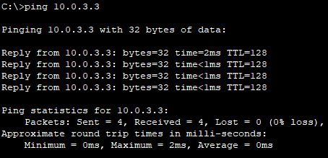
Figure 8: PC8 try to ping PC0 (10.0.3.3)

