Tilak Education Society's
S. K. College of Science & Commerce (Autonomous)
Department of Mass Media and Communication
KALEDIOSCOPE
2025-26
CLAIRVOYANT

SR.  NO: | DATE | EVENTS
1. | 17.12.2025 | CLAIRVOYANT ROUND 1 | 1. ADVENTURE JUNGLE  An interactive and creative quiz designed to test students’ media literacy, brand recall, and  listening skills. In this game, teams listen to a series of 15 advertisement audio clips and identify the corresponding brand or product.This activity focuses on advertising, media communication, and audience perception
 |  | CLAIRVOYANT ROUND 2 | 2.BILLBOARD MANIA.  A dynamic visual communication activity where teams design a billboard or poster on a surprise theme. This round tests students’ advertising creativity, brand storytelling, and visual design skills—core aspects of the BAMMC curriculum.  It encourages participants to blend marketing insight, aesthetic appeal, and media strategy to deliver a clear and impactful brand message.
GENERAL RULES:
●Registration fees is Rs. 20 per student.
• 3 members from each group
• There will be 2 rounds
Winner and runner-up are selected according to the maximum answers given.
• Judge’s decision would be final decision.

1.EVENT: | CLAIRVOYANT ROUND 1
2.EVENT NAME: | Adventure Jungle (Guess the Ad Through the Jungle)
3.LOCATION | Class room
4.NO. OF  VOLUNTEERS REQUIRED | 5: TOTAL
5.SCORE CARD | 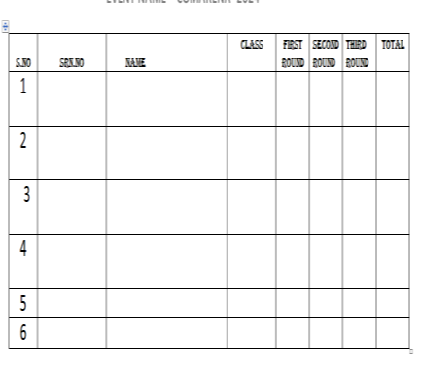
6.JUDGES : | NA
7.⁠STUDENT-IN- CHARGE | CR OF SY AND TY
8.TEACHER-IN- CHARGE | MRs DIVYA HARIHARAN,Ms SUMEDHA MAM
9.ENTRY FEE: | 20 PER HEAD
10. PRIZE : | FIRST PRIZE: Trophies & Certificates
 | SECOND PRIZE : Trophies & Certificates
11. RULES | 1.A total of 15 ad sounds will be played.  2.Each team must identify the brand/product and write the answers on the provided answer sheet.  3.Teams must submit their sheets within the given time limit after the last sound is played.  4.No use of mobile phones or external help is allowed.  5.The team with the maximum number of correct answers qualifies for the next round.  6.In case of a tie, a bonus ad sound will be played as a tiebreaker.

1 | EVENT: | CLAIRVOYANT ROUND 2
2 | EVENT NAME: | Billboard Mania
3 | LOCATIO N | CLASS ROOM
4 | NO. OF  VOLUNTE ERS  REQUIRE D | 5 in total
5 | SCORE CARD | 
6 | JUDGES : | NA
7 | STUDENT-IN-  CHARGE | SY AND TY CR’S
8 | TEACHER-IN-  CHARGE | MRs DIVYA HARIHARAN,Ms SUMEDHA MAM
9 | ENTRY FEE: | 20 PER HEAD
10 | PRIZE : | FIRST PRIZE: Trophies & Certificates
 |  | SECOND PRIZE : Trophies & Certificates
11 | RULES | 1.Only the winners from Round 1 will qualify to participate in this round.  2.The topic or theme for the billboard/poster will be given on the spot.  3.Each team must design a creative billboard/poster based on the given theme.  4.Materials required: chart paper, colors, sketch pens, and any other stationery items the team wishes to use.  5.Time limit:20 minutes.

6.The poster should clearly reflect the brand message and be visually appealing.
Judging criteria: creativity, relevance to theme, clarity of message, and presentation.

 | 1 | EVENT: |  | CLAIR | VOYANT
 | 2 | EVENT  NAME: |  | SNAP,S | HOOT,SLA | Y(REEL M | AKING)
 | 3 | LOCATION |  | CLASS | ROOM
 | 4 | ⁠NO. OF  VOLUNTEER S REQUIRED |  | 5
 | 5 | SCORE CARD
 |  |  |  | Sr no | Participant name | Creativity &  Originality (10) | Relevance to Theme  (10) | Overall  Presentation  (10) | Total  (30)
 | 6 | JUDGES : |  | NA
 | 7 | ⁠STUDENT-IN-CHARGE |  | CR’S
 | 8 | TEACHER-IN-CHARGE |  | Mrs DI | VYA HARI | HARAN,Ms | SUMEDHA | KALE
 | 9 | ENTRY FEE: |  | 50RS P | ER TEAM
 | 10 | PRIZE: |  | FIRST | PRIZE:2000
 |  |  |  | SECON | D PRIZE:10 | 00

 | 11 | RULES | 1)One entry per college.  2)The topic or theme will be given on the spot.  3)Teams must shoot and create a short reel within the college c premises.  4)Total time: 1 hour (including shooting, editing, and submissio 5)Teams should carry their own equipment, including mobile p apps, and data/transfer cables for submission.  6)The reel should be original, creative, and relevant to the give 7)Duration of the reel: 30–60 seconds.  8)Judging criteria: creativity, relevance to theme, clarity of mes quality, and overall impact. | ampus n).  hones, editing n theme.  sage, editing

