Mati FoodFinder (MFF)
Data Flow Diagram (DFD) Specification — Level 0 Context & Level 1 Subsystem Decomposition
Standard: Gane & Sarson / DeMarco & Yourdon (per docs/DFD_and_Example.pdf) | Target: Production Supabase / PostGIS | Status: Complete & Verified
――――――――――――――――――――――――――――――――――――――――――――――――――――――――――

1. Executive Summary & System Boundary
Mati FoodFinder (MFF) is an integrated, city-centric mobile and web discovery, food ordering, table reservation, in-store dining check-in, community engagement, and multi-role marketplace platform tailored specifically for the culinary ecosystem of Mati City, Davao Oriental, Philippines. The system interconnects four distinct human and operational user roles:
- Customer (Diner): Discovers local karenderias and restaurants, places orders with cash-on-delivery (COD) fulfillment, tracks real-time status with a secure 4-digit PIN, submits table reservations, checks in at tables via physical acrylic QR stands, and shares community food reviews.
- Merchant (Restaurant / Karenderia Staff): Manages store profiles, operating schedules, categorized food menus, real-time item availability toggles, incoming kitchen order tickets, table booking requests, and in-store diner analytics.
- Rider (Independent Courier): Goes on-shift to access the pool of available delivery jobs across Mati City, claims jobs atomically, picks up orders from merchants, navigates to barangay drop-off landmarks, verifies customer handoff via 4-digit PIN authentication, and settles COD collections.
- System Administrator: Oversees platform governance, audits merchant verification applications, moderates user accounts and community reports, and monitors platform-wide business telemetry (GMV, order counts, service health).

2. DFD Notation Standards & Governing Rules
As established in the reference specification (docs/DFD_and_Example.pdf), a Data Flow Diagram (DFD) provides a structured, graphical depiction of how data moves through a system and undergoes functional transformations, abstracting away underlying implementation minutiae to highlight user-centric business logic. MFF adheres strictly to the Gane & Sarson standard notation, supplemented by DeMarco & Yourdon principles:
DFD Element | Gane & Sarson Symbol | DeMarco & Yourdon | Functional Purpose in MFF
Process | Rounded rectangle with numbered header slot | Circle / Bubble | Transforms incoming data packets into outgoing flows (e.g., calculates delivery fee, validates PIN).
Data Flow | Directed arrow with noun label | Directed arrow with noun label | Depicts the unidirectional or bidirectional transport of structured data packets between nodes.
Data Store | Open-ended rectangle with left ID block (D1..D6) | Open parallel horizontal lines | Persistent relational database repositories holding data at rest (Supabase PostgreSQL tables).
External Entity | Square rectangle with shaded header / drop shadow | Plain rectangle | External sources or destinations of data outside the system boundary (Customer, Merchant, Rider, Admin).

NOTE: Governing DFD Engineering Rules (Reference: docs/DFD_and_Example.pdf)
1. Single-Process Boundary: The Context Diagram (Level 0) contains exactly one central process node (Process 0) representing the entire system boundary.
2. No Data Stores at Context Level: Data stores are strictly prohibited at Level 0 as they reside inside the system; they are first introduced during Level 1 decomposition.
3. Flow Continuity & Balancing: All inputs and outputs connected to external entities at Level 0 must be rigorously conserved and balanced across the decomposed processes in Level 1.
4. Universal Flow Labeling: Every directed arrow must bear an explicit, descriptive data payload label.
5. Transformation Principle: Incoming data to any process must be semantically distinct from its outgoing data, proving that computational or business transformations occurred.

3. Level 0 Context Data Flow Diagram
The Level 0 Context Diagram establishes the highest-level operational boundary of Mati FoodFinder. The complete system is abstracted into central Process 0: 'Mati FoodFinder (MFF) System'. All information exchanges between the system boundary and the four primary external entities (Customer, Merchant, Rider, and System Administrator) are formally mapped below:
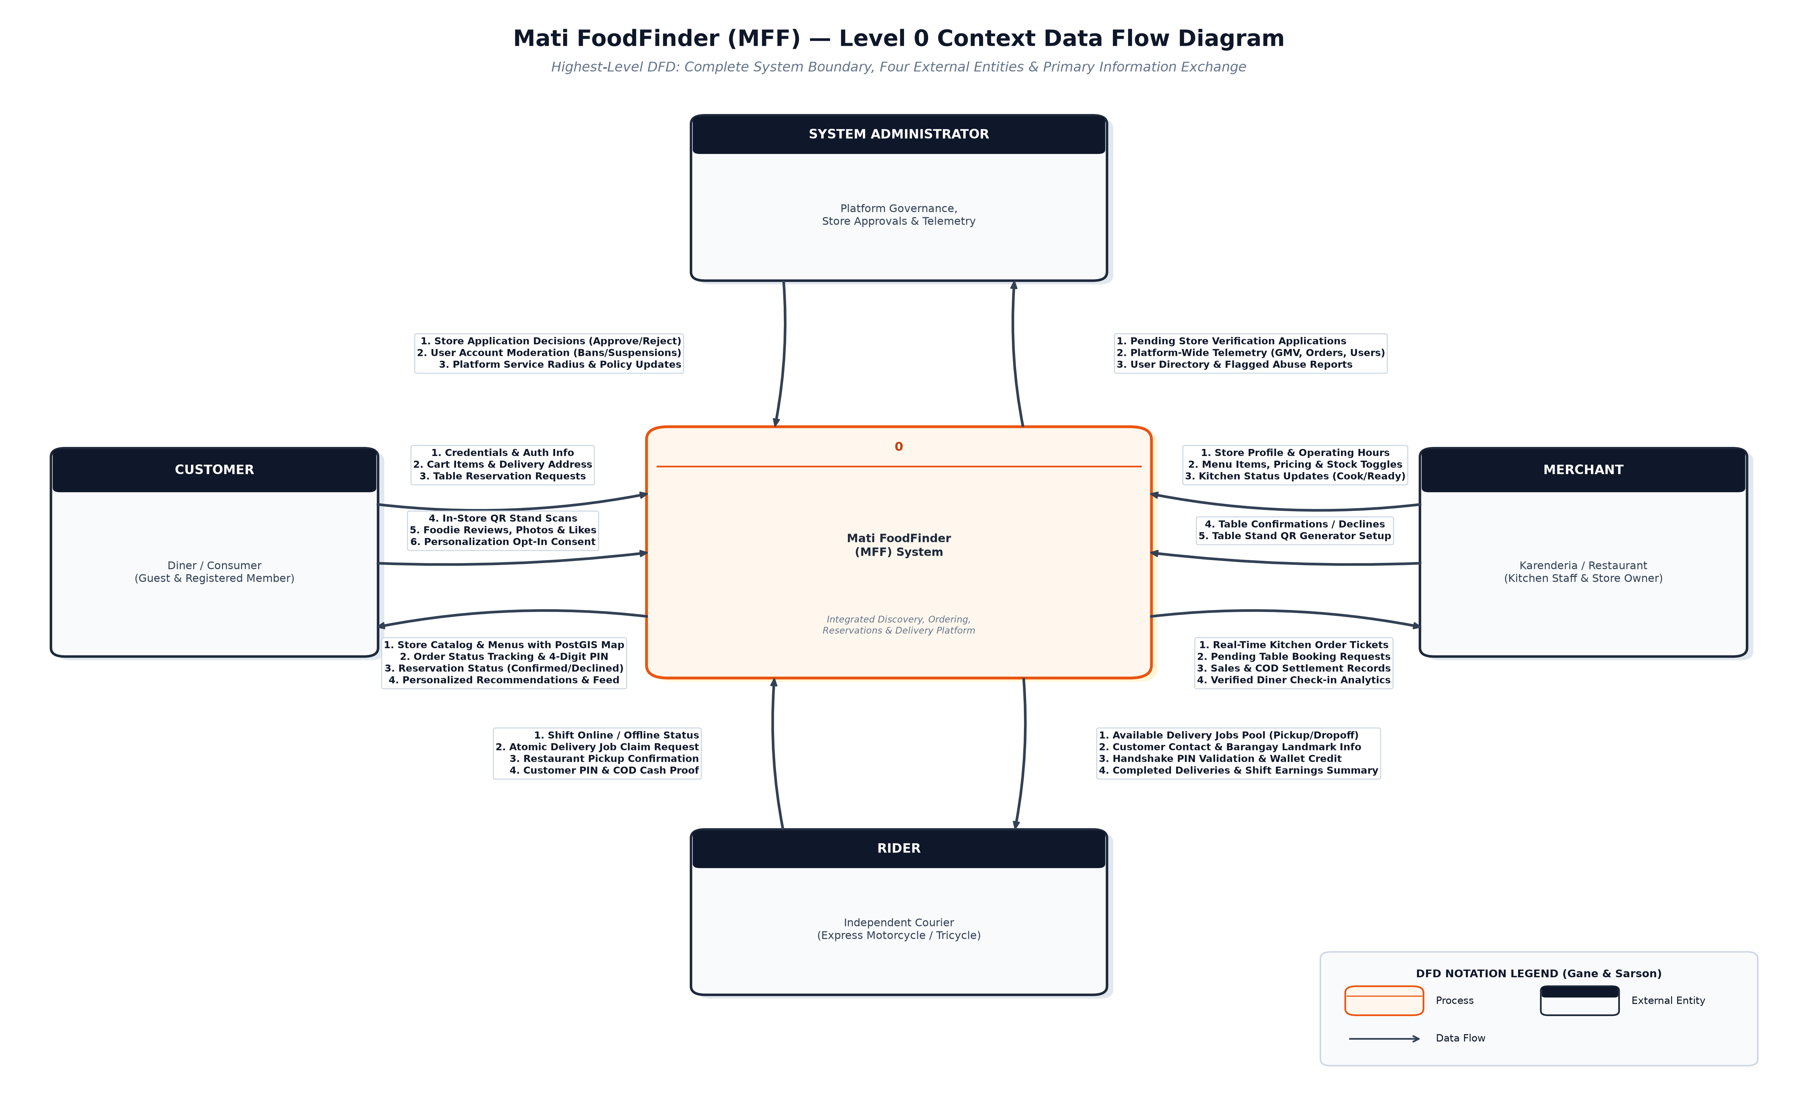
Figure 1: MFF Level 0 Context Data Flow Diagram (High-Resolution Vector Graphic)
Table 1: Level 0 Context Diagram — External Entity Data Flow Specifications
External Entity | Direction | Data Flow Name | Data Elements / Payload | System Purpose
Customer | Inbound | Auth & Order Submissions | Email/password, cart items, delivery coordinates, COD selection | Identity & Checkout
Customer | Inbound | Engagements & Check-ins | Acrylic QR stand scan, foodie photo, review stars, opt-in consent | Visits & Reviews
Customer | Outbound | Catalog, Status & Handshake | Restaurant catalog, PostGIS map, order ETA, 4-digit PIN, booking status | Tracking & Feed
Merchant | Inbound | Catalog & Schedule Setup | Store hours, menu items, prices, item stock toggles, table stand QR setup | Store Administration
Merchant | Inbound | Order & Table Decisions | Accept/prep/ready updates, table confirmation/decline choices | Kitchen Operations
Merchant | Outbound | Operational Feeds | Real-time kitchen tickets, pending reservations, sales totals, check-in stats | Order Fulfillment
Rider | Inbound | Shift & Courier Actions | Online/offline toggle, atomic job claim, restaurant pickup, PIN + COD proof | Delivery Execution
Rider | Outbound | Dispatch & Earnings | Available jobs pool, drop-off landmark, PIN validation, earnings summary | Courier Portal

4. Level 1 Subsystem Decomposition Data Flow Diagram
Level 1 decomposes central Process 0 into eight cohesive, single-responsibility subsystems. It also formally exposes the six authoritative data stores corresponding directly to the persistent PostgreSQL tables managed under Mati FoodFinder's backend infrastructure. Strict orthogonal data corridors are utilized to ensure that no flows collide with or traverse intermediate process boundaries:
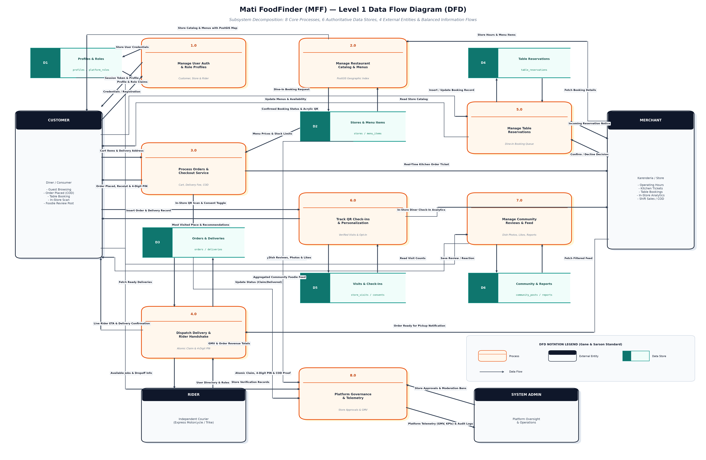
Figure 2: MFF Level 1 Subsystem Decomposition DFD (8 Core Processes, 6 Authoritative Data Stores)
Table 2: Level 1 Authoritative Data Stores Catalog (Supabase PostgreSQL)
Store ID | Data Store Name | Physical Tables | Primary Key & Indexes | Security (RLS)
D1 | Profiles & Roles | profiles, platform_roles, store_memberships | id (UUID), role_type, store_id | User-Owner & Admin RLS
D2 | Stores & Menu Items | stores, menu_items, operating_hours | id (UUID), store_id, PostGIS geo-point | Public Read, Merchant Edit
D3 | Orders & Deliveries | orders, order_items, deliveries, cod_settlements | id (UUID), order_id, rider_id, status | Participant Access Only
D4 | Table Reservations | table_reservations, store_stands | id (UUID), store_id, customer_id, booking_dt | Customer & Merchant RLS
D5 | Visits & Check-ins | store_visits, personalization_consents | id (UUID), customer_id, store_id, consent_bool | Consented Customer RLS
D6 | Community & Reports | community_posts, post_likes, post_reports | id (UUID), author_id, store_id, status | Public Read, Admin Moderated

5. Detailed Subsystem Process Specifications
Table 3: Level 1 Decomposed Process Specifications & State Transformations
ID | Process Name | Entities | Input Flows | Computational Transform | Data Stores | Output Flows
1.0 | Manage User Authentication & Role Profiles | Customer, Merchant, Rider, Admin | Registration credentials, sign-in OTP, role assignment requests | Validates credentials via Supabase Auth, decrypts JWT claims, resolves multi-role memberships, persists profile attributes to D1. | D1 (Profiles & Roles) | Authoritative session token, decrypted user profile, role claims
2.0 | Manage Restaurant Catalog & Menus | Merchant, Customer | Store business profile, operating schedules, categorized menu items, pricing, availability toggles | Enforces merchant authorization, verifies price positivity, indexes GPS coordinates into PostGIS geography(Point, 4326), writes to D2. | D2 (Stores & Menu Items) | Public restaurant feed, categorized menu catalog, spatial location pins on interactive Mati City map
3.0 | Process Orders & Checkout Service | Customer, Merchant | Active cart items, delivery coordinates, barangay landmark, delivery notes, payment method (COD) | Verifies item availability and live prices from D2, computes delivery fee, validates COD limits, creates order and delivery records in D3, generates random 4-digit PIN. | D2 (Stores & Menus - Read), D3 (Orders & Deliveries - Insert) | Order placed confirmation, customer receipt with 4-digit PIN, real-time kitchen order ticket to merchant
4.0 | Dispatch Delivery & Rider Handshake | Rider, Merchant, Customer | Shift online toggle, atomic claim request, pickup confirmation, customer 4-digit PIN entry, COD cash collection proof | Executes atomic rider assignment to prevent double-claiming, transitions order through out_for_delivery, validates 4-digit PIN server-side, completes delivery in D3. | D3 (Orders & Deliveries - Read/Update) | Available delivery pool to riders, live courier ETA to customer, handshake completion confirmation, COD cash record
5.0 | Manage Table Reservations | Customer, Merchant | Dine-in booking request (party size, target date/time, special requests), merchant confirmation or decline | Validates store operating hours from D2, registers booking request in D4 with pending state, dispatches alert to merchant, updates to confirmed/declined. | D4 (Table Reservations - Read/Write) | Incoming booking notification to merchant, confirmed booking status and acrylic stand instructions to customer
6.0 | Track QR Check-ins & Personalization | Customer, Merchant | In-store acrylic stand QR scan token, customer location GPS, opt-in consent toggle | Verifies QR stand token authenticity against registered store, checks explicit opt-in consent in D5, records verified visit, computes 'Most Visited' heuristic. | D5 (Visits & Check-ins - Read/Write) | Personalized discovery feed and recommendations to customer, aggregated in-store diner analytics to merchant
7.0 | Manage Community Reviews & Social Feed | Customer, System Admin | Dish review text, star rating, food photo upload, post reaction/like, abuse report submission | Validates user identity from D1, stores post in D6, tracks likes, filters abusive content, routes flagged posts to admin moderation queue. | D6 (Community & Reports - Read/Write) | Aggregated foodie community feed, post reaction counts, moderation notifications to admin
8.0 | Platform Governance & Telemetry | System Administrator | Store approval/rejection decision, user suspension/ban, platform service radius adjustment | Aggregates system-wide financial telemetry (GMV, order volume) from D3, store applications from D2, user directory from D1, audit logs from D6. | D1, D2, D3, D6 (Read/Update) | Live administrative telemetry dashboard, store verification status updates, audit compliance trail

6. DFD Balancing & Flow Continuity Verification
A foundational requirement of structured analysis (docs/DFD_and_Example.pdf) is DFD Balancing: every external input and output entering or leaving the system boundary at Level 0 must be rigorously conserved and mapped to one or more decomposed processes at Level 1 without omission or spurious addition. Table 4 provides the mathematical and architectural proof of flow continuity across MFF levels:
External Entity | Level 0 Context Flow | Direction | Decomposed Level 1 Flow | Target Process ID
Customer | Credentials & Auth Info | Inbound | Credentials / Registration | Process 1.0
Customer | Cart Items & Delivery Address | Inbound | Cart Items & Delivery Address | Process 3.0
Customer | Table Reservation Requests | Inbound | Dine-In Booking Request | Process 5.0
Customer | In-Store QR Scans & Consent | Inbound | In-Store Stand Scan & Consent | Process 6.0
Customer | Foodie Reviews & Photos | Inbound | Dish Reviews, Photos & Likes | Process 7.0
Customer | Catalog & PostGIS Map | Outbound | Store Catalog & Menus with Map | Process 2.0
Customer | Order Tracking & 4-Digit PIN | Outbound | Order Placed & PIN / Live Courier ETA | Processes 3.0 & 4.0
Customer | Personalized Recommendations | Outbound | Most Visited Place / Community Feed | Processes 6.0 & 7.0

7. Comprehensive Data Dictionary (Composite Payloads)
In accordance with standard CASE engineering practices, the Data Dictionary defines the internal composition, data types, validation constraints, and business rules of key composite data structures transmitted across MFF data flows:
7.1 Cart Checkout & Order Submission Payload
Flow: Customer -> Process 3.0
- customer_id: UUID (Foreign key to profiles.id)
- store_id: UUID (Foreign key to stores.id)
- items: Array of { menu_item_id: UUID, quantity: Integer (>=1), unit_price: Decimal, options: String[] }
- delivery_address: String (Specific street / barangay in Mati City)
- barangay_landmark: String (Optional visual navigation cue for courier)
- payment_method: Enum ('cod' | 'cash_on_delivery')
- delivery_fee: Decimal (Calculated based on distance rules)
- order_total: Decimal (Sum of item subtotals + delivery fee)
7.2 Courier Handshake & 4-Digit PIN Verification Payload
Flow: Rider -> Process 4.0
- order_id: UUID (Foreign key to orders.id)
- rider_id: UUID (Foreign key to profiles.id / riders)
- claim_token: UUID (Atomic lock token preventing double-assignment)
- submitted_pin: Char(4) (Encrypted string matched against orders.handshake_pin)
- cod_amount_collected: Decimal (Exact cash collected from recipient)
- proof_of_delivery_uri: String (Optional photographic evidence URL)
- handoff_timestamp: Timestamp with Timezone
7.3 Table Reservation Request Payload
Flow: Customer -> Process 5.0
- customer_id: UUID (Foreign key to profiles.id)
- store_id: UUID (Foreign key to stores.id)
- party_size: Integer (Between 1 and 20 guests)
- reservation_date: Date (YYYY-MM-DD)
- reservation_time_slot: Time (HH:MM within store operating hours)
- customer_contact_phone: String (Philippine mobile format e.g. +639...)
- special_requests: Text (Optional dietary / seating preferences)
- reservation_status: Enum ('pending', 'confirmed', 'declined', 'completed', 'no_show')
7.4 In-Store Acrylic QR Stand Scan Payload
Flow: Customer -> Process 6.0
- stand_qr_token: String (Cryptographic signature from acrylic stand table card)
- scanned_store_id: UUID (Decoded target merchant identifier)
- table_number: Integer / String (Optional physical table identifier)
- diner_gps_latitude: Float (Verification that device is within store perimeter)
- diner_gps_longitude: Float (Verification that device is within store perimeter)
- personalization_consent_opt_in: Boolean (Explicit customer privacy grant)
7.5 Merchant Verification & Onboarding Application
Flow: Merchant -> Process 8.0 (Admin Review)
- store_name: String (Registered business trade name)
- owner_profile_id: UUID (Foreign key to profiles.id)
- barangay: Enum / String (Official Mati City barangay e.g. Central, Dahican, Sainz, Matiao)
- business_permit_number: String (Official local government municipal permit)
- operating_schedule: JSONB ({ day_of_week: 0..6, open_time: '08:00', close_time: '21:00' })
- postgis_coordinates: Point(longitude, latitude)
- verification_status: Enum ('pending_review', 'verified', 'rejected', 'suspended')

― End of Data Flow Diagram (DFD) Specification Document ―

