UNIVERSITY OF ENERGY AND NATURAL RESOURCES, SUNYANI
DEPARTMENT OF INFORMATION TECHNOLOGY AND DECISION SCIENCES



TOPIC:
CRAFTHIVE: A MOBILE-BASED ARTISAN SERVICE MARKETPLACE

A PROJECT WORK SUBMITTED TO THE DEPARTMENT OF INFORMATION TECHNOLOGY AND DECISION SCIENCES IN PARTIAL FULFILMENT OF THE REQUIREMENTS FOR THE DEGREE OF BACHELOR OF SCIENCE IN INFORMATION TECHNOLOGY

KUMI FRANKLIN UEB3213722
YANKYERA VIDA UEB3201022
OWUSU AMIRIKA STEPHEN UEB3200422
AMANKONA MANASSEH KYERE UEB3201622
AKUNARH CLIFFORD EVANS UEB3211522

2026

DECLARATION
We, Kumi Franklin, Yankyera Vida, Owusu Amirika Stephen, Amankona Manasseh Kyere, and Akunarh Clifford Evans hereby declare that this very document is out of our own hard work and research and has no material published by others. Neither does it contain materials that has been accepted for the awards of any qualification of the universe, with the exception of where proper acknowledgment has been made.

SIGNATURES OF STUDENTS:
KUMI FRANKLIN (UEB3213722)
SIGNATURE: ................................................ DATE: ............................
YANKYERA VIDA (UEB3201022)
SIGNATURE: ................................................ DATE: ............................
OWUSU AMIRIKA STEPHEN (UEB3200422)
SIGNATURE: ................................................ DATE: ............................
AMANKONA MANASSEH KYERE (UEB3201622)
SIGNATURE: ................................................ DATE: ............................
AKUNARH CLIFFORD EVANS (UEB3211522)
SIGNATURE: ................................................ DATE: ............................

CERTIFIED BY:
DR. SAMUEL OFORI FRIMPONG
SIGNATURE: ................................................ DATE: ............................

HEAD OF DEPARTMENT:
DR. A. A. AMPONSAH
SIGNATURE: ................................................ DATE: ............................

DEDICATION
We dedicate this work to Almighty God for strength, guidance, and grace throughout our four years of study. We also reserved for our parents, guardians and family members because of their sacrifice, prayers, financial support and encouragement. Lastly, we dedicate this project to the hard-working men and women artisans of Ghana, whose hard work and service to our communities greatly improve them. We hope this project makes their work easier and improves their situation.

ACKNOWLEDGMENTS
We sincerely thank Almighty God for His life, health, strength, and guidance throughout our studies and the development of this project. We are grateful to our supervisor, Dr. Samuel Ofori Frimpong, for introducing the CraftHive idea, providing guidance, and supporting us throughout the project, as well as Mr. Nkrumah Jonathan for his valuable assistance in reviewing our technical work and documentation. We also appreciate the Head and staff of the Department of Information Technology and Decision Sciences at UENR for the knowledge and skills that made this project possible. Finally, we thank the artisans, students, coursemates, and friends who contributed their time, feedback, testing, and encouragement, all of which helped us successfully complete this work.

ABSTRACT
In Ghana, the vast majority of jobs are in the informal sector and highly skilled artisans are at the heart of it. But the digital revolution that transformed transport and food delivery has left the artisanal trades behind. A customer cannot know if the tradesperson is capable or reliable before hiring, and artisans never sign contracts, have irregular work schedules and no assurances of payment after the work is done. In the end, it's a market that is paralyzed by mistrust.
This report presents the design and implementation of a cross-platform mobile marketplace, CraftHive, that aims at formalising the contracting of informal skilled labour in Ghana. The mobile clients are built with React Native, the admin portal is built with Next.js, and the back-end is built with Supabase/PostgreSQL. There are two ways it does this with respect to trust. Before appearing to customers, each artisan has to send over a Ghana Card, any trade certificate carried and a picture of himself or herself, which will be checked by the administration. The payment is then placed in a buffer as a hold by serverless edge functions and is only paid out to the artisan when the customer confirms that the payments are accepted, and there is therefore no risk of the other party defaulting.
The system was built using Agile lifecycle and tested using unit testing, integration testing and informal testing by 10 to 15 course mates using their own systems. Core functions passed, message delivery remained within the 600 millisecond target and testing revealed several media and interface handling faults, which were addressed prior to the final build.
Keywords: mobile marketplace, artisan services, informal economy, escrow payment, Know Your Customer verification, React Native, Supabase, Ghana, mobile money.

TABLE OF CONTENTS
DECLARATION i
DEDICATION ii
ACKNOWLEDGMENTS iii
ABSTRACT iv
TABLE OF CONTENTS v
LIST OF FIGURES viii
LIST OF TABLES ix
LIST OF ABBREVIATIONS x
CHAPTER ONE 1
INTRODUCTION 1
1.1 Background of the Study 1
1.2 Problem Statement 3
1.2.1 Absence of Verifiable Identity 3
1.2.2 Financial Insecurity and Payment Disputes 3
1.2.3 Restricted Market Reach 4
1.2.4 No Accountability or Dispute Resolution 4
1.3 Objectives of the Study 4
1.3.1 General Objectives 4
1.3.2 Specific Objectives 5
1.4 Research Questions 5
1.5 Scope of the Study 6
1.6 Significance of the Study 6
1.6.1 For the Artisan 6
1.6.2 For the Customer 7
1.6.3 At the National Level 7
1.6.4 Academic Contribution 8
1.7 Limitations of the Study 8
1.8 Organisation of the Report 9
CHAPTER TWO 10
LITERATURE REVIEW 10
2.1 Introduction 10
2.2 The Informal Economy and Digital Platform Labour 10
2.3 Trust and Reputation in Two Sided Marketplaces 11
2.4 Escrow as a Mechanism for Financial Security 12
2.5 Mobile Money and the Ghanaian Payment Context 13
2.6 Accessibility and Digital Literacy 14
2.7 Theoretical Framework: Technology Acceptance and Diffusion 14
2.7.1 The Technology Acceptance Model 14
2.7.2 Diffusion of Innovations 15
2.8 Comparative Review of Existing Systems 15
2.8.1 Global Service Marketplaces 15
2.8.2 Local Classified Platforms 16
2.8.3 The Agency Model 16
2.9 Research Gap 17
CHAPTER THREE 19
METHODOLOGY 19
3.1 Introduction 19
3.2 Research Methodology: Agile Software Development 20
3.2.1 Selection and Justification 20
3.2.2 Sprint Structure and Execution 20
3.3 Requirements Analysis and Specification 21
3.3.1 Functional Requirements 21
3.3.2 Non-Functional Requirements 22
3.4 Feasibility Study 24
3.4.1 Technical Feasibility 24
3.4.2 Economic Feasibility 25
3.4.3 Operational Feasibility 25
3.4.4 Schedule Feasibility 25
3.5 System Architecture and Modelling 25
3.5.1 Use Case Diagram 26
3.5.2 Sequence Diagram for the Escrow Transaction 27
3.5.3 Activity Diagram for Identity Verification 28
3.5.4 Job State Machine 29
3.6 Database Design and Data Dictionaries 30
3.7 Human Computer Interaction and Interface Design 33
CHAPTER FOUR 34
IMPLEMENTATION AND RESULTS 34
4.1 Introduction 34
4.2 Development Environment 34
4.3 Implementation of Core Components 34
4.3.1 Frontend State Management 34
4.3.2 Backend Security Through Row-Level Security 35
4.3.3 The Escrow Logic Engine 36
4.3.4 Real-Time Communication 36
4.4 System Interfaces 37
4.5 Testing and Results 41
4.5.1 Unit and Integration Testing 41
4.5.2 User Testing 41
4.6 Discussion of Findings 43
CHAPTER FIVE 45
SUMMARY, CONCLUSION AND FUTURE WORK 45
5.1 Introduction 45
5.2 Summary of the Project 45
5.3 Achievement of Project Objectives 46
5.4 Conclusions 46
5.4.1 Verification Is the Feature That Moved People 46
5.4.2 Escrow Removes the Financial Standoff 46
5.4.3 The Stack Is Viable for a Small Team 47
5.4.4 Testing Quality Follows From How It Is Done 47
5.5 Limitations of the Study 47
5.6 Recommendations for Future Work 48
5.6.1 Direct Mobile Money API Integration 48
5.6.2 Automated Identity Verification 48
5.6.3 Structured Onboarding Through Trade Associations 48
5.6.4 Completing Localisation 48
5.6.5 Formal User Acceptance Testing 48
5.7 Reflections on the Development Process 49
5.8 Final Remarks 50
REFERENCES 51
APPENDICES 56
Appendix A: Project Directory Structure and Repository Links 56
A.1 Official Project Repository Access 56
A.2 Monorepo File Structure 56
Appendix B: Core System Execution Commands 57
B.1 Mobile Client Application (React Native / Expo) 57
B.2 Administrative Dashboard (Next.js 14) 57
B.3 Supabase Backend and Edge Functions 57
Appendix C: API Endpoint Reference 58
Appendix D: Glossary of Terms 59
Appendix E: Team Roles and Contributions 59

LIST OF FIGURES
Figure 3.1: The traditional process of hiring an artisan compared with the CraftHive process
Figure 3.2: The Agile sprint cycle adopted for the development of CraftHive
Figure 3.3: Three tier system architecture of the CraftHive platform
Figure 3.4: Use case diagram showing actor interactions with the CraftHive platform
Figure 3.5: Sequence diagram of the escrow payment transaction
Figure 3.6: Activity diagram of the artisan identity verification pipeline
Figure 3.7: State machine governing the lifecycle of a job and its escrowed funds
Figure 3.8: Entity relationship diagram of the CraftHive database
Figure 4.1: Login interface
Figure 4.2: Customer home and discovery dashboard
Figure 4.3: Real-time negotiation and messaging interface
Figure 4.4: Artisan dashboard
Figure 4.5: Booking detail and escrow payment interface
Figure 4.6: Administrative dashboard showing the identity verification queue

LIST OF TABLES
Table 3.1: Sprint structure and deliverables
Table 3.2: Functional requirements grouped by user role
Table 3.3: Non-functional requirements
Table 3.5: Data dictionary for the users table
Table 3.6: Data dictionary for the jobs table
Table 3.7: Data dictionary for the profiles table
Table 3.8: Data dictionary for the messages table
Table 3.9: Data dictionary for the reviews table
Table 3.10: Data dictionary for the wallets table
Table 2.1: Comparative summary of existing platforms
Table 4.1: Issues raised during user testing and the action taken
Table 5.1: Project objectives and their achievement
Table C.1: API endpoint reference

LIST OF ABBREVIATIONS
API | Application Programming Interface
FCM | Firebase Cloud Messaging
HCI | Human Computer Interaction
ILO | International Labour Organization
KYC | Know Your Customer
MoMo | Mobile Money
RBAC | Role-Based Access Control
REST | Representational State Transfer
RLS | Row-Level Security
SDLC | Software Development Life Cycle
TAM | Technology Acceptance Model
UAT | User Acceptance Testing
UENR | University of Energy and Natural Resources
UML | Unified Modeling Language
UUID | Universally Unique Identifier
WSS | WebSocket Secure

CHAPTER ONE

INTRODUCTION

1.1 Background of the Study
The way individuals purchase, learn about their surroundings, and find employment has been subtly altered over the past 20 years due to declining data prices and almost universal mobile ownership. Out of that shift came the gig economy: a layer of apps that stand between a worker and a customer and pair them up one task at a time. Several industries have been rebuilt around this model almost completely. Others have barely felt it. Ghana holds both patterns at once, and the contrast between them is the starting point for this project. Ghana shows great unevenness sharply. International and local platforms have completely digitized transport of various goods and now it is food’s turn. The movement of skilled manual labour has remained constant. Most homeowners, even after twenty years apart, will still locate a plumber in almost the exact same way. According to Heeks (2017), while worker occupations on digital platforms emerge rapidly in some cases in developing economies, others remain completely untouched. To appreciate the need for CraftHive, it is important to first understand how employment in Ghana is structured, as it is fundamentally different from the corporate economies of the industrialized world. The International Labour Organization reports that the informal economy is the dominant form of employment across much of Sub Saharan Africa rather than a marginal supplement to formal work (International Labour Organization, 2018). Bonnet, Vanek and Chen (2019) make the same argument in their work on the definitions and theory of the informal economy, observing that in many developing countries the informal sector is where the majority of economic life actually takes place. Ghana fits the pattern closely. Studies of the national labour market place informal employment at roughly eighty to eighty five percent of total employment (Bonnet, Vanek & Chen, 2019), a figure the Ghana Statistical Service (2019) corroborates in its most recent living standards survey. Within the industry, skilled manual craftspeople hold a unique role. Technical skills, such as that of a plumber or electrician or a mason, a carpenter or a painter, or an appliance technician were developed after years of apprenticeship. If they're not there to be part of the social fabric, society would not exist. But the structure in which they operate is structurally deficient – easily understood but difficult to fix. The work of hiring at Sunyani, Kumasi or Accra is a frustrating affair. A homeowner facing a burst pipe has no directory to consult. They ask a neighbour, walk to the nearest hardware shop, or drive to a junction where artisans are known to gather. The reliance on physical closeness leads to the creation of a market with large information asymmetries, which, according to Tadelis (2016), is the main problem facing any peer to peer market. Before the artisan steps at the door, the customer cannot assess the skill, check the reliability or verify the identity. Pricing also lacks a baseline, which means that a customer in a more affluent suburb may be quoted several times the going price merely because they have nothing to compare against. On the other hand, the scenario related to technology has completely altered. Thanks to economical Android handsets, mobile penetration has expanded significantly, while mobile data coverage has now extended to most urban areas and peri-urban areas. Mobile money is a more important development. The telecommunications network services have engaged millions of unbanked Ghanaians into digital finance through value storage and transfer from a basic handset (GSMA, 2022). According to Suri and Jack (2016), this kind of mobile infrastructure reduces transaction cost and connects previously fragmented markets, and Senyo and Osabutey (2020), in their study in Ghana, show that mobile money has emerged as a major enabler of financial inclusion. The obstacle preventing access to the internet is not hardware or payment infrastructure. Both elements are present and established. The main issue is trust with respect to hiring an artisan it is a harder trust problem than ordering a taxi. Letting a stranger into your home to do work which the customer is not able to assess in any way. These are tangible risks that people are concerned about – their goods may be stolen, damaged through incompetence or the visit may be a survey for a later burglary. Artisans also carry the mirror image of that risk. Not having written contracts exposes them to non payment. Almost all the trade people we spoke to know a common sequence. After many days, the job is finished, and only then the client makes a complaint, pushes the price down, or simply refuses the balance. The artisan suffers from the loss without a recourse. In a bid to secure themselves, artisans demand money for materials up front, which, in turn, arouses the client’s panic that the money will vanish before the hassle begins. When each party reasonably harms the other, they find themselves in a standoff from which neither party emerges better off. Due to the impasse, CraftHive was created. This does not serve the same purpose as a phone book. This is an intermediary which is active which holds identity records and also holds money, so that there is no need for either party to rely on the goodwill of a stranger. In Chapter Three, we contrast the traditional process and the process CraftHive puts in its place with the rest of the system design.

1.2 Problem Statement

1.2.1 Absence of Verifiable Identity
Initially, fear of violence and cost becomes an overhead. Customers are hesitant to allow unknown individuals into their homes, and the current setup essentially shifts the entire verification burden onto the customer who hasn’t means of verifying. Anyone can assert he is a master electrician. Due to the shielding of anonymity that fosters fraudulent behaviour and most employment hiring having a nucleus of personal contacts it caps the market well below its real scale. The result is not evenly distributed. Even if they have money, a customer with a big personal network finds an effective route to a trusted craftsman by asking around. A new house builder, or a client who has no tradespeople in his network, has no alternative and must choose either a tradesman from whom he knows nothing or no one at all, or he must refuse any job. The absence of a common and verifiable identity system increases friction in trading to the extent that it effectively extracts the least capable players from the market. This mirrors the classic adverse selection problem under information asymmetry, in which buyers unable to verify a seller's quality in advance cause the least reliable providers to dominate the market (Hawlitschek, Teubner, & Weinhardt, 2016).

1.2.2 Financial Insecurity and Payment Disputes
As the sector operates outside the ambit of contract law, both players face financial exposure. Upon completion, clients’ delayed or refusal in payment results in wage theft of the artisan. Customers may lose a deposit paid for materials. Neither side has access to a neutral intermediary. One of the recurrent constraints on small enterprise growth in Ghana is this lack of formal records which precisely describes the artisan without a record of payment. Both threats exacerbate each other, creating a more dangerous scenario than either one on its own. Due to one incident of being underpaid, one artisan responds by demanding a larger deposit on the next job. This increases the amount a customer stands to lose if that artisan is dishonest, which in turn leads to increased suspicion of any deposit request at all. Both parties are behaving rationally. The responses of both sides to the market forms an individual and sensible response to the lack of enforcement mechanism in the market. This results in a collective response that is worse for everybody who is still trying to transact. This pattern matches evidence from Ghana's own informal sector, where the absence of formal contract enforcement pushes entrepreneurs toward trust-based informal safeguards such as upfront deposits and mobile-money-mediated credit arrangements with suppliers and customers (Tetteh, Goedhuys, Konte, & Mohnen, 2025).

1.2.3 Restricted Market Reach
Professionals in the trade sector are limited to offline systems. A carpenter labouring in one suburb is invisible to a client a couple of kilometres distant. Repeat clients and word-of-mouth are essential for artisanal businesses. A website and social media are usually out of the budget of a craftsman. Moreover, they cannot gather a portfolio of their past work or a record of reviews that a stranger would take seriously. The invisible nature of the workers does self-reinforcement which restricts them to remain super poor. It is an easy limitation to overlook as there are no visible complaints. If a customer cannot get a good electrician, they simply go with what their neighbour recommends, never knowing there’s a better qualified electrician three streets over all along. The market failure in this case is quiet, not dramatic, which is precisely why it has not drawn the same attention as blatant fraud. However, its cumulative cost to artisan incomes is likely greater. This dependence on personal referral mirrors recent evidence from a growing African city that job seekers who rely on a narrow personal network, rather than open channels of information, remain excluded from opportunities that exist just beyond it (Abebe, Caria, Fafchamps, Falco, Franklin, & Quinn, 2021).

1.2.4 No Accountability or Dispute Resolution
When you get stuck in an engagement gone wrong, you merely cannot turn anywhere. No administrator is allowed to intervene, no profile is allowed to be marked and no refund is allowed to be compelled. The lack of long-term repercussions for subpar performance diminishes the motivation to uphold standards throughout the entire industry. what distinguishes a market with occasional bad actors from a market where bad behaviour is rational is lack of consequence. When it will become common knowledge, the artisan will lose out on future work, leading to a loss of reputation. In the offline model, word-of-mouth works so slowly and so poorly that the association between a bad job today and lost business months down the line is skimpy. By eliminating this connection, a lot of pressure for stable quality, which a working market would otherwise impose voluntarily, is removed. This is consistent with evidence that even where digital reputation systems exist, they often fail to discipline poor performance once power sits with one side of the transaction (Wood & Lehdonvirta, 2023), precisely the kind of mechanism this study finds too slow and unreliable in the offline artisan sector.

1.3 Objectives of the Study

1.3.1 General Objectives
The goal of this project is to create, develop, and assess a secure market place that connects clients with verified local artisans in Ghana. The system will utilize a programmable escrow mechanism that will eliminate the financial risk that currently prevents both artisans and clients from transacting.

1.3.2 Specific Objectives
The project had five specific objectives to achieve this aim:
1. To create a Know Your Customer verification pipeline. This requires every artisan to submit a government issued Ghana Card, any trade certification held and a live selfie photo for administrative review before access is granted.
2. To create an escrow payment gateway in which the customer's money is debited and kept in the state of a neutral platform before the work starts and is released for the artisan only once the customer confirms completion.
3. To create a mobile ecosystem with dual interfaces. One interface, optimized for customer discovery and booking, may be taken by the customer. The other interface, optimized for artisan portfolio management, job handling and earnings, may be taken by the artisan. The mobile application was designed using React Native.
4. To implement an in-app messaging functionality with low latency, which would support the exchange of text and image and audio notes, so as to have agreement on requirements in place before the start of job.
5. To create a web dashboard for administrators to verify identity documents, monitor platform activity, and adjudicate disputes based on a job's recorded history.

1.4 Research Questions
The guiding research questions of the project are:
- To what degree does mandatory identity verification, instead of a purely reputational rating system, alter customers' willingness to hire an artisan they have not met before?
- Does a programmatic escrow mechanism powered by serverless functions using a mobile money payment pathway remove the financial risk which currently deters artisans and customers from transacting digitally?
- To ensure that such a marketplace can be used by artisans and customers with varying levels of digital literacy and different device quality, and in light of constraints particular to an actual Ghanaian deployment context, what interface and infrastructure adjustments would be needed?

1.5 Scope of the Study
The scope was defined deliberately across three dimensions so the system could be completed and properly tested within an academic year.
Functional scope. The platform is for the informal skilled trades in plumbing, electrical, carpentry, masonry, painting and appliance repair. It handles the entire process of an engagement from registration to identity verification, search and filtering, negotiation by chat, funding of escrow, monitoring of job status, release of funds, and review that follows.
Technical scope. The mobile clients are created using Expo SDK and React Native from the same TypeScript codebase being compiled to both Android and iOS. The backend is built on Supabase and is powered by PostgreSQL, Supabase Storage, Supabase Storage for portfolio and identity documents, Supabase Realtime for messaging. Server side logic that must not be trusted to the client, principally the escrow routing, runs in Supabase Edge Functions on the Deno runtime. The administrative dashboard is a Next.js application, deployed and reachable online.
Geographical scope. Although the architecture imposes no geographical limit, the pilot deployment, testing, and interface decisions target urban and peri urban users in the Bono and Greater Accra Regions, with requirements gathering and informal testing concentrated in Sunyani. This study does not assume integration with a live national identity verification application programming interface, automated dispute resolution without human intervention, or deployment outside the pilot region.

1.6 Significance of the Study

1.6.1 For the Artisan
For craftspeople, the website provides a pathway from uncertain day labor towards something more akin to a verifiable career. The platform gathers a record of completed jobs, ratings, and earnings, which becomes a piece of evidence that previously did not exist. Transaction records on the platform can serve as a certificate for un-certified workers. Over time, such a record may assist in credit applications, which are currently disallowed, due to the lack of an employment record. Suri and Jack (2016) find that this kind of digital transaction history is exactly what is missing for unbanked workers, and that its absence is part of what keeps informal earners locked out of formal credit. This importance does not relate to features whose existence is merely speculative, as in the previous case. The earnings record referred to in Chapter Three exists today on every job completed. Moreover, it is the sort of record a microfinance lender could examine in principle before a formal collaboration with a lender is put in place. The artisan begins to realise the value from the first job he has completed and not on the delivery of some future integration.

1.6.2 For the Customer
The system lessens the burden and risk for clients in home upkeep. This is possible through collaboration with an entity that guarantees the reliability of the service provider used. In the above context, it substitutes the bet of employing an alien with a reservoir of employees whose identification has been examined and the cash is not at stake until the work is done, to the customer’s satisfaction. This lines up with Mou, Shin and Cohen's (2017) finding that institutional safeguards, not just accumulated ratings, are what let a customer trust a stranger enough to transact.
Each use increases the benefit. A customer who books once and has a good experience has a verified artisan they can return to directly for future work, while still benefitting from the platform’s protection on their first try with someone new. As usage continues, the platform diverges from being a once-off call-in-an-emergency directory and more like an ongoing relationship with a steady group of tradespeople. This is closer to the way hiring already works for those customers who happen to have a fair-sized personal network, extended to customers who do not.

1.6.3 At the National Level
In the larger context, the platform produces structured data around cash-in/cash-out activities, which is currently not visible to any public system. This gives us some insight into government objectives like financial inclusion and the progressive formalisation of the informal economy; a process that is strongly shaped by institutional pressures on SMEs in Ghana. Senyo and Osabutey (2020) identify exactly this kind of digital footprint as one of the antecedents through which FinTech innovations extend financial inclusion in practice. Through the strategic use of mobile technology, it can be utilized to enhance the informal sector instead of being a displacing force for the latter. The design choices described in this report are adapted from that principle. It’s worth stating plainly that formalisation in this sense is a by-product of solving the trust problem, not a separate goal that the platform pursues at the expense of the artisans it serves.
There is nothing about CraftHive that requires an artisan to register with any taxing authority or to take on obligations they did not have previously. The record becomes valuable to some national level objective only to the extent that it proved first to be valuable to the artisan and customer who created it and it becomes crucial for everyday lives extensiveness application.

1.6.4 Academic Contribution
This project documents a case study of creating an escrow backed two sided marketplace for a developing economy. The architecture of gig platforms is well-described for western markets, as Graham, Hjorth and Lehdonvirta (2017) document at length, but applying it here is a different problem: payment runs on mobile money rather than credit cards, and identity verification depends on a national card scheme rather than a credit bureau.
Research confirms this combination hasn’t been conducted. This document contains the various schemas, the access control rules, and the state logic needed to accomplish this.
The intended reader for that record is not merely an examiner. This has been written for any future student with the same problem. The Chapter Three's database schema and Chapter Four’s row-level security policies are all written with sufficient specificity for that purpose. Both chapters contain written records of defects and corrections. A different team working on a similar two sided marketplace in a similar market could use them as a starting point rather than starting entirely from first principles, which is really the most concrete form of contribution a student project of this kind can offer.

1.7 Limitations of the Study
It should be clearly pointed out that several limitations exist. Payments were verified in a sandbox instead of real commercial payments (real money processing requires having a registered business and merchant agreement). The application is dependent on the network and there is no offline mode; hence, it is limited to areas where coverage is available. An administrator conducts identity verification by visually comparing documents (rather than through an automated check against the national identity register), a integration identified in Chapter Five as the highest priority for future work. The interface has been presented with a language selector. However, the application is not covered by translation. Thus, it is not presented here as a delivered capability. Ultimately, the testing process lacked formality. Between ten and fifteen coursemates used the application on their own devices during and after development, and there was no logging of scripted tasks or times to completion. It sufficed to reveal errors related to interface and media management; it is not enough to back any assertion regarding usability within the wider population, the platform is intended for.

1.8 Organisation of the study
The remainder of this report is organised into four further chapters. Chapter Two reviews the literature on the informal economy, on trust and reputation in two sided marketplaces, on escrow mechanisms, and on the theory of technology acceptance, and it evaluates the existing platforms critically. Chapter Three sets out the methodology: requirements elicitation, the feasibility study, the Agile process followed, the system architecture, the database design, and the interface design principles applied. The results of the implementation of the system and the faults detected and corrected are presented in Chapter Four. In Chapter Five, the project is summarised, its conclusions are drawn and directions for further work are recommended.

CHAPTER TWO

LITERATURE REVIEW

2.1 Introduction
The design of CraftHive was not settled in a vacuum. Each significant decision, from the insistence on identity verification to the choice to hold funds in escrow, answers a problem that existing research has already described. This chapter investigates the research. This article discusses a variety of topics. Topics include the nature of the informal economy in the developing world. It also looks at the role of trust in two sided marketplaces. The article will take a look at escrow as a mechanism designed to reduce perceived risk. The estate considers the mobile money context in Ghana. It also considers accessibility related issues. Finally, the article looks at the theory that shaped interface design. The piece ends with critical assessment of existing platforms and with an account of the gap they leave. This literature review was selective against a specific test; it did not undertake an exhaustive survey. Inclusion of any study in this chapter was ensured to happen if it bore relevance to a decision the Coalition team actually had to make, rather than on gig platforms or digital marketplaces in the abstract. The standards adopted in this article are stricter than those which might be adopted in a standard literature review, and were chosen for just this reason. A review that accounted for everything written on platform economies without tying each source to a specific choice made in Chapter three, or four would appear more expansive on the page but would be less useful as an account of the particular way in which CraftHive is built. Readers looking for a general survey of gig economy scholarship should treat this chapter as a partial one; readers wanting to understand the reasoning behind CraftHive's specific architecture will find that connection made explicit at every stage.

2.2 The Informal Economy and Digital Platform Labour
According to the International Labour Organization (ILO, 2018) the informal economy is defined as the activities in the economy that are not or inadequately regulated by national legislation and policies. The importance of this definition is that it reflects the lack of the guarantees that formal work often provides, such as written contracts, enforceable conditions of work and access to social insurance. In many parts of the developing world, the informal sector is not a term that needs to be defined along the lines of "what's left over" after all the "formal" jobs are filled, but it is a primary way of livelihood in its own right (Bonnet, Vanek & Chen, 2019). In Ghana it accounts for the large majority of the labour force (Bonnet, Vanek & Chen, 2019), and Ghana Statistical Service data on living standards confirms how much household income depends on it. Labour in that sector is not the same as unskilled labour. These artisans have technical knowledge acquired through a period of apprenticeship. But like unskilled labour, their income remains volatile. This is because they do not belong to any corporate structure. Heeks (2017) commented that when digital platforms enter a sector, something paradoxical occurs. The mechanism which can both formalise and uplift a worker, by lowering the cost of finding customers, can also intensify competition and strip away protection just as much. Multiple studies have proven similar results through a variety of methodologies and approaches. In developing economies, gig work usually offers a fixed wage for autonomy which is paired with algorithmic control (Wood et al, 2019). In addition, Vallas and Schor (2020) view this tension as definitional to platform work instead of incidental to it. Furthermore, this tension worsens on account of a platform that connects workers to a distant instead of local demand (Graham et al, 2017). According to De Stefano (2015), the legal risk that lies at the heart of this issue is this: on-demand work does not afford you protections associated with formal employment unless, of course, the platform is designed to do so. These sources suggest a single governing variable, rather than many: whether or not the platform is a party to the transaction, or whether it is simply a listing service. CraftHive was built to be the latter, taking custody of the payment so the artisan's labour is protected by the system itself rather than by a client's goodwill, closer to the accountable end of what Sundararajan (2016) calls crowd-based capitalism than to its exploitative end.

2.3 Trust and Reputation in Two Sided Marketplaces
Two sided marketplaces help connect two groups with coordinating difficulties and trust as their currency. Tadelis (2016) describes two problems that every two sided marketplace will face and that can stall marketplace creation. Adverse selection is when the buyer cannot judge the quality of the seller before the deal‚ while moral hazard is the problem of the seller getting slack once the deal is completed because there is no one holding him to his promise. Another consequence of information asymmetry is moral hazard‚ which is also present in the Ghanaian artisan market. Marketplaces answer this with reputation systems. Hui et al. (2016) showed in empirical work on eBay's reputation and buyer protection mechanisms that digital reputation can substitute for the word of mouth reputation that operates within a village or neighbourhood, extending it to strangers. The mechanism has limits. Ratings can be manipulated, and Tadelis (2016) notes that reputation systems only work if participants are motivated to leave honest feedback in the first place, a public good problem that undermines the reliability of ratings even where manipulation is not deliberate. The star rating itself does not offer anything, at the moment a stranger walks through the front door of a customer. The level of trust required to let an artisan into one's home is far greater than for the online purchase of a physical good. According to Möhlmann (2015), consumer trust in electronic commerce is shaped more by perceptions of social presence and institutional assurance than by perceptions of interface quality. This body of work informed the decision of making ID verification compulsory rather than optional. CraftHive changes the basis of trust from accumulated rating to checked identity by requiring a Ghana Card, a trade certificate where one exists, and a live selfie that an administrator compares against the card. The platform keeps a record of the name and identity number of an artisan who steals or causes willful damage. The information serves as a deterrent, as it transforms an anonymous stranger into a responsible person for the customer.

2.4 Escrow as a Mechanism for Financial Security
Verification refers to identity. It does nothing with finance. To address wage theft by a customer and deposit theft by an artisan, which are financially problematic, the prevailing opinion is a financial response mechanism. Escrow is a long accepted arrangement whereby a neutral third party holds the funds and only makes them available when the parties have agreed on the conditions in which to release them. As mobile payment technology has matured, its digital equivalent has become viable. According to Hui et al. (2016), the presence of an escrow service is likely to be one of the most effective structural mechanisms to lower perceived risk between parties who do not know each other. The study of Ert, Fleischer and Magen (2016) shows empirically that credible trust building mechanism translates into willingness to pay because buyers who trust a seller's reputation will pay a higher price without having to repeat the interaction. Just like digital goods, escrow allows you to protect funds for a physical service. The backend in CraftHive uses this function. Customer funding the job before work starts demonstrates capacity to pay for the job. When the craftsman sees the dashboard showing that the money is “held”, he can start working and the money can’t be held at the end arbitrarily. The funds transfer automatically when the customer confirms. The negotiation that currently poisons so many jobs is removed from the relationship altogether and is handled by the system. Just to be clear: Escrow does not fix everything in itself and this affects the design of CraftHive. With escrow in place, a situation where a person refuses to pay after the work is done is prevented. Similarly, an artisan not disappearing with a deposit for materials before the work starts is also prevented. This doesn't automatically prove a genuine question over whether the work was completed to an acceptable standard. That second issue is a quality dispute not a payment dispute and the two are easy to confuse because they emerge at the same time in a job’s life-cycle CraftHive regards them as distinct: the escrow mechanism guarantees the funds’ existence and their release only on confirmation, while the disputed state and the administrator arbitration process as described in Chapter Four exist specifically to deal with the quality question that escrow by itself cannot address. The decision to construct both mechanisms instead of just escrow and assume it will be sufficient was made in direct response to hearing artisans and customers agree that the two kinds of disagreement feel the same from the inside of the dispute but need different remedies.

2.5 Mobile Money and the Ghanaian Payment Context
Every marketplace that wishes to hold or move money in Ghana needs to be built around mobile money rather than around cards. The GSMA states Sub Saharan African is the world’s mobile money centre, with account numbers and transaction values other regions cannot match (GSMA, 2022). According to Aron (2018), better risk sharing and reduced transaction costs were found to be consistently associated with mobile money by a wide evidence review. Moreover, he found this pattern to be consistent with figures on household income and expenditure by Ghana Statistical Service (2019). Ghana falls within that pattern. According to Osabutey and Jackson (2024), the rapid advancement of mobile wallet technology progressed from being just a curiosity to a routine one. Thus, users began to treat mobile wallets as ordinary places to just keep money instead of just sending it. The implications for platform design are actionable. Even if a customer does not have a bank card, they can fund the escrow account. An artisan who does not have a bank account will still be paid, and can withdraw at an agent in their neighbourhood. According to (2020), this is how exactly financial technology has fostered inclusion in Ghana by reaching non-users of the formal banking system. Previously Suri and Jack (2016) made the wider case, showing across a number of African economies that mobile infrastructure reduces the cost of transacting as well as connects markets which distance has separated. A platform that overlooked this and built on card payment would exclude most of the people it exists to serve, on both sides of the market.

2.6 Accessibility and Digital Literacy
The documentation on technology acceptance are often written on users that are already comfortable with the software. The community of artisans does not constitute a homogeneous group. Many experienced tradespeople left formal schooling early, and some read English with difficulty even where they speak it fluently. An interface that assumes otherwise will be abandoned regardless of how useful the underlying service is. Evidence from Ghana specifically supports this concern. The perceived ease of use was found to be a better predictor of the adoption of digital services in Ghana than perceived usefulness, which contradicts the expected order from the theory. Thus, there is an inverse correlation between the perceived difficulty of using services and the adoption rates among users who see a potential benefit in these services. Osabutey and Jackson (2024) provide similar arguments based on the West African region, where mobile services are adopted only when they are integrated into the existing behavioral patterns and infrastructural capabilities of each region. These findings informed three decisions made by CraftHive. Trade categories are carried by icon as well as by word. Texts are used to label the navigation controls instead of leaving them bare. Furthermore, any action that will move money will seek an explicit confirmation in clear language.

2.7 Theoretical Framework: Technology Acceptance and Diffusion

2.7.1 The Technology Acceptance Model
The adoption of a system relies less on its technical advantages and more on the perception its users have of it. The model, reviewed comprehensively by Marangunić and Granić (2015), focuses on two factors. Perceived usefulness is defined as the extent to which a person believes that the system will enhance his or her performance. The perceived ease of use is the extent to which users expect the target system to be effortless. Design targets were both given treatment. The escrow arrangement is helpful for both parties involved. On one side, a customer develops a customer base that is normally outside his geographic area, and that customer’s payment is protected pending assessment by the artisan of the work. Ease of use required more deliberate attention, given the digital literacy range described above, which is why the interface uses large touch targets, high contrast type, and familiar iconography rather than a feature rich but demanding design. The Unified Theory of Acceptance and Use of Technology, developed by Venkatesh, Thong and Xu (2016) as an extension of TAM, adds social influence and facilitating conditions as further predictors of adoption, both of which matter in a context where an artisan's decision to use the platform is shaped by whether their peers are already using it. A trade that has no visible presence on CraftHive gives a prospective artisan little reason to join ahead of the customers who would make joining worthwhile, which is the same cold start problem that affects any two sided market before it reaches a critical mass of both sides.

2.7.2 Diffusion of Innovations
Where TAM and UTAUT explain an individual's decision, Dearing and Cox's (2018) account of the diffusion of innovations framework explains how that decision spreads across a population of potential adopters over time. Rogers identifies five attributes of an innovation that determine how quickly it is taken up: relative advantage over the practice it replaces, compatibility with existing values and routines, complexity of use, trialability at low risk, and observability of results to others in the same social network. Mapped onto CraftHive, relative advantage is the escrow guarantee itself, a benefit an artisan can grasp without any technical explanation. It is more compatible to build payment around mobile money than ask artisans to live with an unfamiliar financial instrument. Interface simplifications already described directly addressed complexity. The current pilot's ability to trial is constrained as KYC is a requirement for registration and no benefit is visible at that stage, which is a point of friction worth exploring further. The recommendation in Chapter Five relies predominantly on the attribute of observability. This is because onboarding through a trade association provides each new artisan with a visible cohort of peers who have already started using the platform. This condition is precisely the one Rogers found to result in adoption accelerating rather than crawling.

2.8 Comparative Review of Existing Systems

2.8.1 Global Service Marketplaces
Mature platforms like TaskRabbit and Thumbtack feature strong interfaces, a tested rating system, and secure payments. They are not available in Ghana and are structurally unsuitable for it. The payment systems used to assume that most Ghanaian informal artisans had credit cards when they don’t. Their background check queries are also of Western criminal and credit databases, which have no equivalents in Ghana. Fiverr addresses an entirely different issue. Because it’s designed for remote delivery of digital work, it has no concept of a worker going to a job address.

2.8.2 Local Classified Platforms
Tonaton and Jiji are essentially big classified directories where artisans can post their ads and phone numbers. The architecture is unfit for services, not just limited. They are bulletin boards. There is no way to confirm that the advertiser is a genuine trader, that payment is mediated, that the job is tracked. Users are forced offline to negotiate and pay, which is exactly where the fraud occurs, so the trust barrier is unaffected.

2.8.3 The Agency Model
According to the report, a couple of local businesses have tried an agency model, where a small fleet of artisans working for them are sent out on an application. The model ensures quality control but incurs heavy overhead of salaries and logistics, which makes geographic expansion painfully slow and expensive. This also does not help the independent artisanal creator; he becomes an employee instead of being one’s own boss. Instead, CraftHive adopts the marketplace model, providing independent workers with the infrastructure to run their own operations without becoming platform employees.
The comparison across all four approaches is summarised in Table 2.1, in terms that are most relevant to this project: identity verification, escrow protection, mobile money, and worker independence.
Table 2.1: Comparative summary of existing platforms against the requirements of the Ghanaian artisan market
System / Approach | Strengths | Limitations
TaskRabbit / Thumbtack (global marketplaces) | Mature interfaces, tested rating systems, secure card payment | Unavailable in Ghana; assumes credit cards and Western background checks
Fiverr (remote gig marketplace) | Strong seller tools, established payment protection | Built for remote digital work only; no concept of physical, location based service
Tonaton / Jiji (local classifieds) | Large local reach; free to list; familiar to Ghanaian users | No identity verification, no escrow, no job tracking; users pushed to negotiate offline
Agency model startups | Good quality control through direct employment | High overhead; slow to scale; converts independent artisans into employees
CraftHive (this project, 2026) | Ghana Card verification; escrow held server side; mobile money native; artisans remain independent | Payments sandboxed rather than live; identity check performed manually, not against a national API

2.9 Research Gap
Research study indicates that there is a specific gap. The platform economy and reputation literature is comprehensive but predominantly centred on Western markets and card based payment. The global platforms that take verification and escrow seriously do not exist here and presume financial infrastructure that Ghanaian artisans don’t use. Local platforms that are matching the payment context are directories (and sites) which do not have verification, do not have escrow and are not accountable. What has not been built is a single system combining mobile money payment, location aware discovery of physical trades, verification against a national identity document, and programmatic escrow, designed for the Ghanaian market. CraftHive is an attempt to build and document exactly that.
Three narrower gaps sit inside that broader one and are worth naming individually, because each corresponds directly to a design decision made later in this report. First, the trust literature reviewed in section 2.3 is written almost entirely about digital goods and services, where the worst outcome of a failed transaction is a refund; it says comparatively little about markets where the transaction culminates in a stranger entering a private home, a risk category the KYC design in Chapter Three was built to address specifically rather than by analogy. Second, the escrow literature in section 2.4 demonstrates that escrow reduces perceived risk in general, but stops short of the practical question of how an escrow mechanism should be built on mobile money rather than card rails, which is precisely the implementation problem Chapter Four works through. Third, the platform labour literature in section 2.2 debates whether platforms uplift or exploit workers, largely in the abstract. It offers little guidance on which specific architectural choices tip a given platform toward one outcome or the other. This report treats that question as answerable in the specific case of CraftHive. The custody of payment and the identity verification pipeline are the concrete mechanisms doing the protective work, rather than the claim being left at the level of intention.

CHAPTER THREE

METHODOLOGY

3.1 Introduction
The major risk in the project was converting a paper argument into an actual application that stores people’s money, and we recognised that early on. Within a marketplace that involves payments, slacking off becomes exceedingly unwise. Having no methodology to write one of these would have left us with security issues, and scope creep weekly. We worked by first gathering requirements and running some feasibility checks before writing any real code. After that, we followed the Agile process of developing the code iteratively. We show various versions of that code here as the process unfolded. Next, we outline the system architecture and database design of the app. Finally, we describe the interface principles that have guided its design. Prior to outlining the method itself, it helps to see what it was aiming to change. In Figure 3.1, we compare the traditional process of hiring an artisan to the process CraftHive is replacing. All subsequent methodological decisions in this chapter, including the choice of Agile, what database fields to use, etc., are made to close the gap between those two columns.
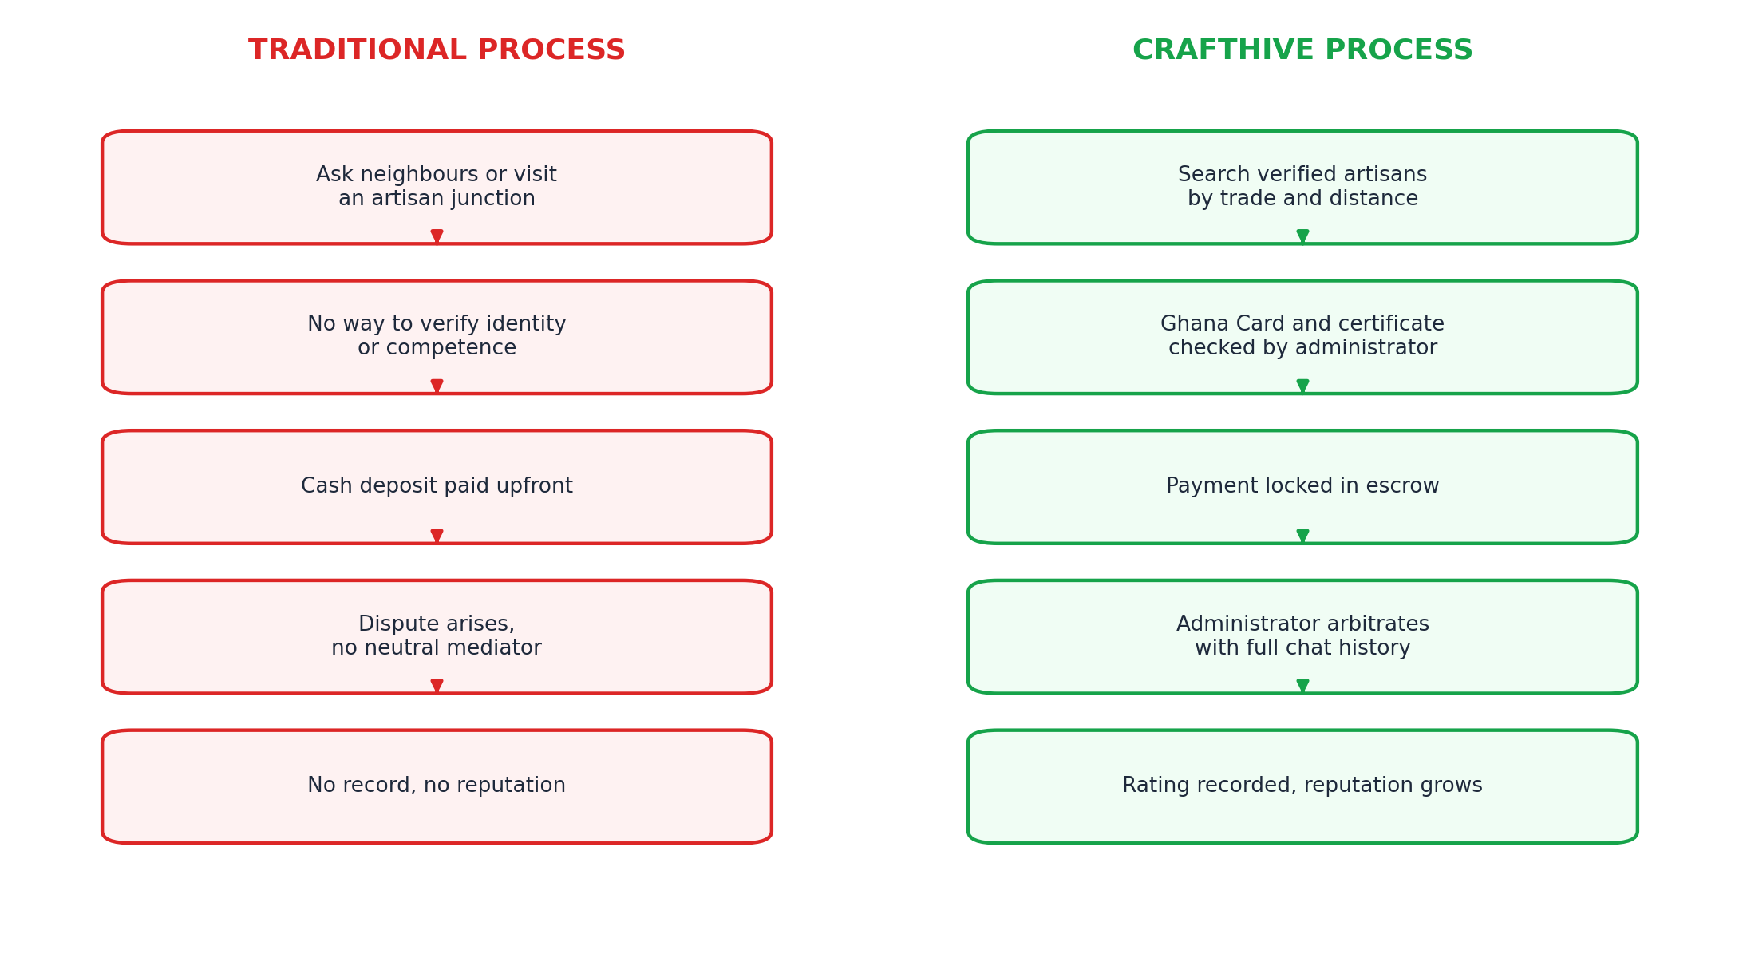
Figure 3.1: The traditional process of hiring an artisan compared with the CraftHive process

3.2 Research Methodology: Agile Software Development

3.2.1 Selection and Justification
The immense architectural complexity and ever-evolving nature of a two sided marketplace meant that a flexible, iterative approach was essential. A linear, Waterfall style plan was thought about and rejected. Waterfall believes that every requirement can be fixed before writing a line of code, and this did not hold here: many features, especially image and voice sharing in chat, only became requirements when something working existed for people to actually use. Midway through an event, something happened clarifying the consequence. The chat was working, just text, and we thought that was the end of it. As we observed someone explaining a broken tap by text, it became evident within about 10 seconds that text wouldn’t cut it. People were required to demonstrate the problem to the artisan. Incorporating photos necessitated integrating secure media storage and image compression into a module that we had already deemed finalized. With a painful change in a Waterfall plan, you reopen the specification and argue about whether it counts as scope. For us it was a card on the backlog. We decided to put that one first and schedule it for the next sprint. Most of the stuff that mattered came out in a similar way, when we saw something not quite working and fixed it, instead of a plan written in the first month.

3.2.2 Sprint Structure and Execution
The development ran over a span of ten two-week sprints. Each of these sprints produced a working increment. This is further shown in Table 3.1.
Table 3.1: Sprint structure and deliverables
Sprint | Focus | Deliverable
1 and 2 | Foundation | Development environment configured, PostgreSQL schema defined, authentication and role based routing working.
3 and 4 | Profiles and discovery | Artisan profile and portfolio creation, image upload to storage, customer search and filtering.
5 and 6 | Communication | Realtime chat over WebSockets with image and voice note support, push notification routing.
7 and 8 | Escrow engine | Job state machine, edge function for funding and release, wallet balances and commission calculation.
9 and 10 | Governance and polish | Administrative dashboard, verification queue, interface refinement, testing and bug fixing.

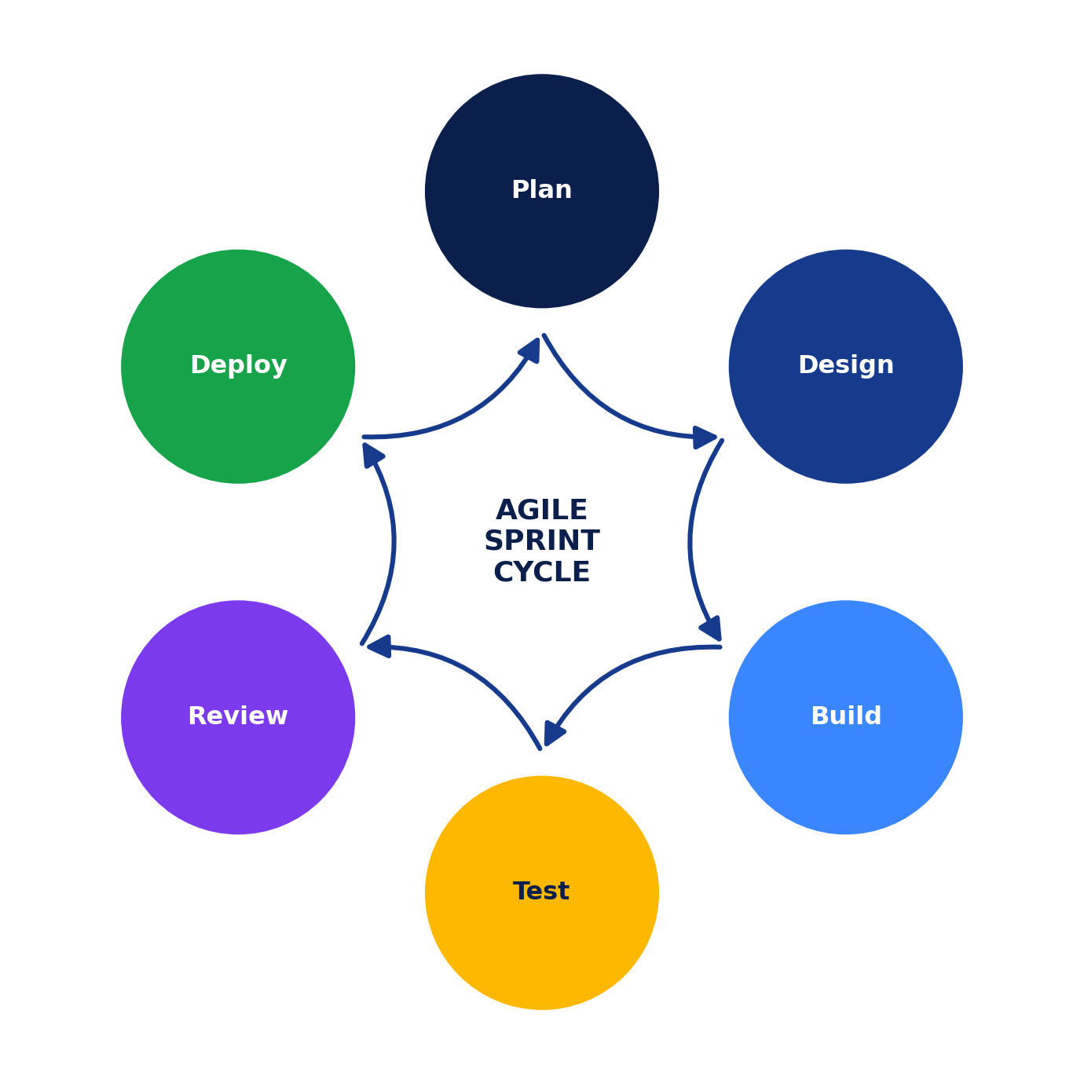
Figure 3.2: The Agile sprint cycle adopted for the development of CraftHive

3.3 Requirements Analysis and Specification
We understood the requirements with meaning. We selected them from two locations. The first was a series of informal conversations in Sunyani. The second was a structured review of the platforms discussed in Chapter Two, where every weakness we found in a competitor became something the new system had to answer.

3.3.1 Functional Requirements
Functional requirements describe what the system must do. Because CraftHive serves three roles, they are grouped by role and listed in Table 3.2.
Table 3.2: Functional requirements grouped by user role
ID | Role | Requirement | Priority
FR-01 | Customer | Register, authenticate, and recover a lost password through Supabase Auth. | High
FR-02 | Customer | Search verified artisans and filter by trade category, distance, and rating. | High
FR-03 | Customer | View an artisan profile including biography, portfolio images, and past reviews. | High
FR-04 | Customer | Exchange text, images, and voice notes with an artisan in real time before booking. | High
FR-05 | Customer | Request a job, receive a quote, and fund it into escrow. | High
FR-06 | Customer | Track the state of a job from request through to completion. | High
FR-07 | Customer | Confirm completion, releasing escrowed funds, and submit a rating. | High
FR-08 | Artisan | Upload Ghana Card, trade certificate, and live selfie for verification. | High
FR-09 | Artisan | Create and maintain a public profile and portfolio gallery. | High
FR-10 | Artisan | Receive push notification of a job request and accept or decline it. | High
FR-11 | Artisan | View earnings, funds held in escrow, and request withdrawal. | High
FR-12 | Administrator | Review pending verification submissions and approve or reject with a reason. | High
FR-13 | Administrator | Suspend or ban accounts that attract substantiated complaints. | Medium
FR-14 | Administrator | Arbitrate a disputed job using its message and state history. | Medium

3.3.2 Non-Functional Requirements
Non functional requirements constrain how well the system performs those functions, set out in Table 3.3.
Table 3.3: Non-functional requirements
ID | Category | Requirement
NFR-01 | Security | Passwords are stored only as bcrypt hashes. Row Level Security is turned on for every table.
NFR-02 | Security | All traffic is via HTTPS. Financial state transitions execute server side in edge functions and are never trusted to the client.
NFR-03 | Performance | Primary screens render within three seconds on a normal 3G or 4G connection. Chat messages arrive in under 600 milliseconds.
NFR-04 | Scalability | The schema is normalised to third normal form and indexed on the columns used for discovery, principally trade category and location.
NFR-05 | Usability | Touch targets are large, type is high contrast, and any action with financial consequence requires explicit confirmation.
NFR-06 | Availability | Backend services target 99.9 percent uptime, since an outage would block access to escrowed funds during active jobs.

3.4 Feasibility Study

3.4.1 Technical Feasibility
We needed three things the stack had to deliver: one codebase for both phones, live data for chat and status, and somewhere safe to keep identity documents. React Native on Expo gave us the first from a single TypeScript codebase, so we were not maintaining two native apps in parallel with five people. Supabase gave us the rest in one place, meaning Postgres, auth, storage, realtime, and serverless functions, without any of us having to stand up and secure a server. Both are very mature and well documented, as it turned out more important than it sounds, because when we got stuck, the answer was usually already written down somewhere. The project was justifiable in technical terms. An alternative to managed back-end services which was considered and rejected early on was spinning up and operating our own PostgreSQL server, our own authentication service, and our own object storage. The five of us had never run production infrastructure. A self-managed server comes with a failure mode where security becomes a weak point. A small team with no infrastructure experience is exactly the sort of team which will do that under duress. By choosing to go with a managed platform, the team saved a lot of time and cut a risk category that they couldn’t safely handle.

3.4.2 Economic Feasibility
Costs were negligible. The team used open-source libraries react-native, next.js and the Supabase client libraries, and the free service tiers of Supabase and Vercel were enough during development and testing. Aside from the internet data and the access to test handsets, I incurred no expenses. To achieve sustainability after the pilot is completed, a ten percent commission would be deducted from every escrow transaction that is successfully completed. This scales with usage and would also pay for hosting as the platform expands further.

3.4.3 Operational Feasibility
In essence, operational feasibility refers to whether anyone will use it. The reply on the artisan side was not subtle. All the people we engaged with put not getting paid as their biggest worry. Also, the thought that the money would already be in the system before they even picked up a tool got a reaction we did not have to stir out of them. The app itself was what's taking them time. Some were suspicious to use phone to run their work at all, and that is the real adoption risk, which is why we kept the interface as bland as we could. According to Osabutey and Jackson (2024), the adoption of digital services among resource-constrained West Africans typically only happens when the tools and habits people already have are utilized. This is why we designed the payment around mobile money.

3.4.4 Schedule Feasibility
Having just ten two-week sprints allows no leeway on a project of this nature, and so the schedule was seen from day one as a constraint on ambition rather than a target to hit regardless of cost. Next, the project team focused on the what of the system: what would they build? What were acceptable features that would not compete with key components within the sprinting period? For example, an in-app calendar as a way to schedule site visits was one item raised and dropped early. As soon as it became clear this win could compete for sprint time against the escrow engine or KYC pipeline, it was eliminated from the plan. Sticking firmly to that priority order, core financial and identity features first, convenience features only if time remained, is why the system reached a working end-to-end state within the ten sprints, rather than being left with several partially finished features and no single one fully working.

3.5 System Architecture and Modelling
CraftHive is designed according to a three-tier framework. The presentation tier comprises the two React Native mobile clients and the Next.js administrative portal. The logic tier holds the Row-Level Security policies that gate every database request, the realtime channels that carry messages, and the edge functions that execute financial operations away from the client. The data tier is the PostgreSQL database together with object storage for images and documents.
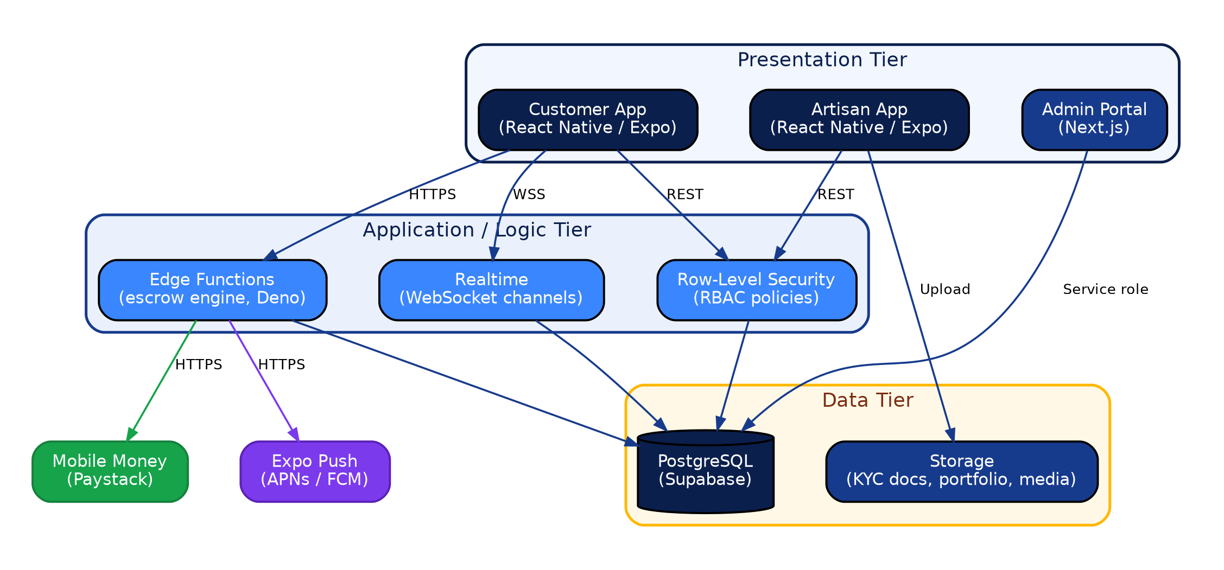
Figure 3.3: Three tier system architecture of the CraftHive platform
Separating the system into presentation, logic, and data tiers follows established practice in software architecture. Richardson (2018) describes this kind of layered separation as the foundation for reasoning about a system's quality attributes independently of one another, since a security fault in the logic tier can then be fixed without touching the presentation layer. Fowler (2018) makes the related point that keeping domain logic, in this case the escrow rules, out of the presentation layer is what allows that logic to be tested and trusted on its own terms.

3.5.1 Use Case Diagram
The use case diagram in Figure 3.4 maps the system from the perspective of its three actors and shows how role based access control partitions the platform. The customer initiates search, chat, escrow funding, confirmation, and rating. The artisan submits verification documents, manages portfolio, accepts or rejects contract and withdraws funds. The administrator checks the documents and settles disputes. An authenticated session is required to fund escrow, meaning a financial action cannot occur absent a verified identity token behind it.
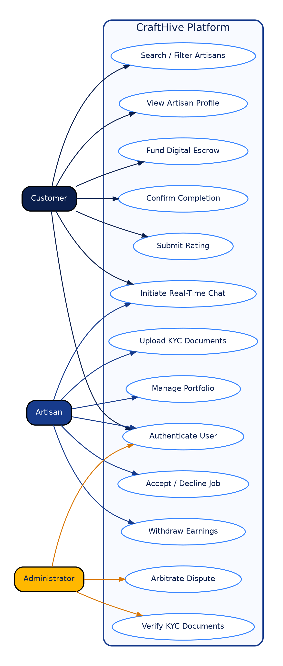
Figure 3.4: Use case diagram showing actor interactions with the CraftHive platform

3.5.2 Sequence Diagram for the Escrow Transaction
A use case diagram depicts user system interactions. Sequence diagram shows the order in which it happens, which is more important when money is at stake. A complete Escrow Transaction is traced in figure 3.5. The customer that wants a job gets it by simply submitting that through the application. The database records this job request in the Pending state. The craftsman takes it, moving it to accepted. When the customer funds the job, an edge function runs server-side. Debiting the customer wallet, this function flags the job as funded. Activity continues. Once the customer confirms it, the edge function computes platform commission, credit the balance to the artisan wallet, and marks job completed. All monetary moves operate within the edge function instead of on the handset.
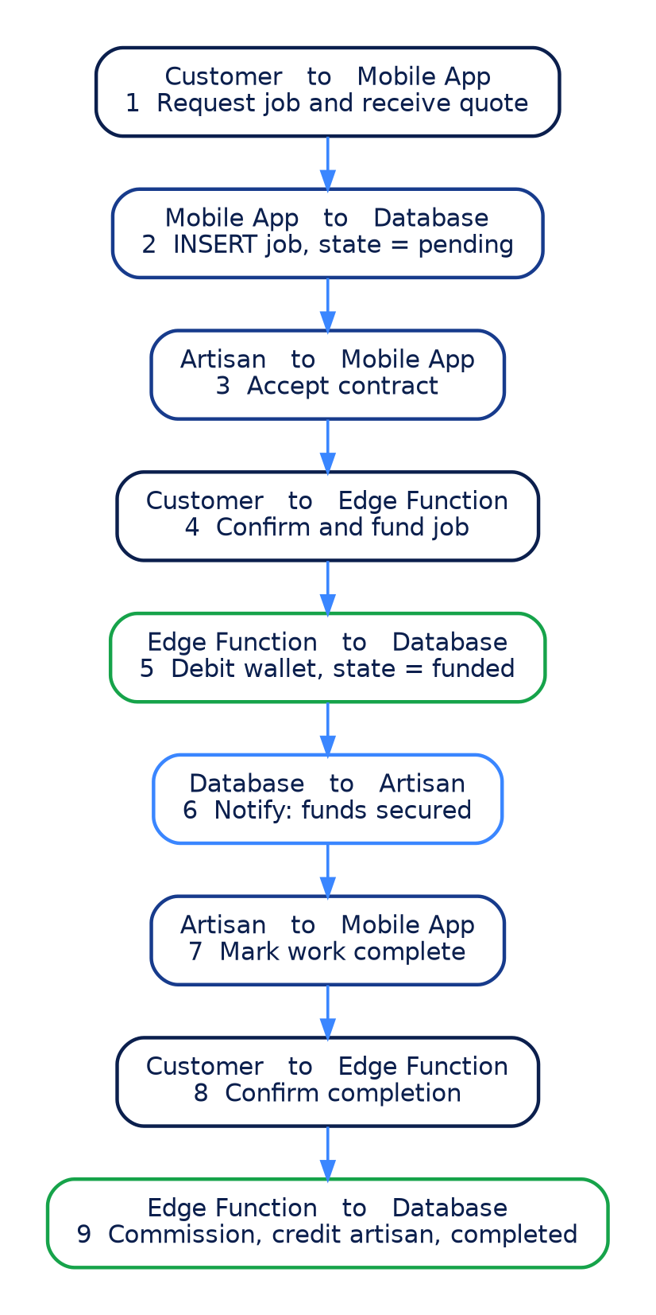
Figure 3.5: Sequence diagram of the escrow payment transaction

3.5.3 Activity Diagram for Identity Verification
The activity diagram in Figure 3.6 presents the verification pipeline. An artisan registers, completes the trade profile, and then uploads a Ghana Card, certificates in hand and live selfie. Pending accounts prevent a profile from appearing on customer search results altogether. An administrator verifies that selfie with the card picture and possibly either approves the account, making it visible, or rejects giving a reason.
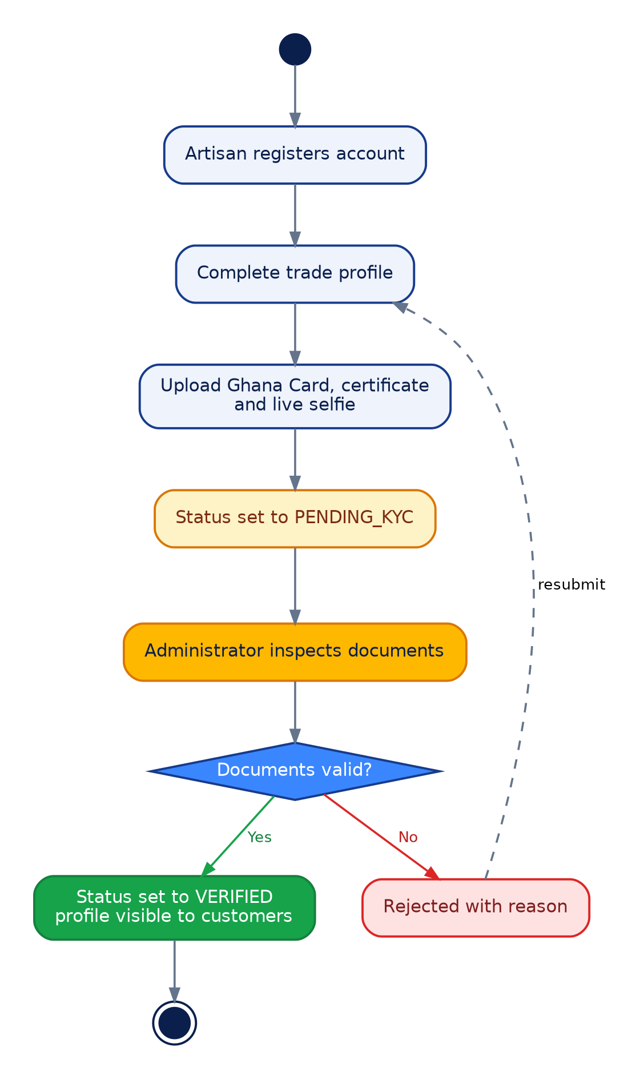
Figure 3.6: Activity diagram of the artisan identity verification pipeline

3.5.4 Job State Machine
Since the financial logic implies that a job occupies at any moment exactly one well defined state, the allowed states and the permitted transitions are explicitly modelled in Figure 3.7. Enforcing this as a database enumeration rather than as application logic means a defect in the mobile client cannot push a job into an undefined state, which is the fault most likely to strand somebody's money.
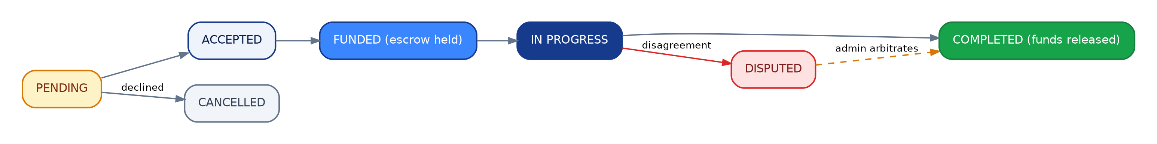
Figure 3.7: State machine governing the lifecycle of a job and its escrowed funds

3.6 Database Design and Data Dictionaries
The database is PostgreSQL, hosted through Supabase, and normalised to third normal form to remove redundancy and prevent the update anomalies that denormalised schemas invite. The entity relationship diagram appears as Figure 3.8.
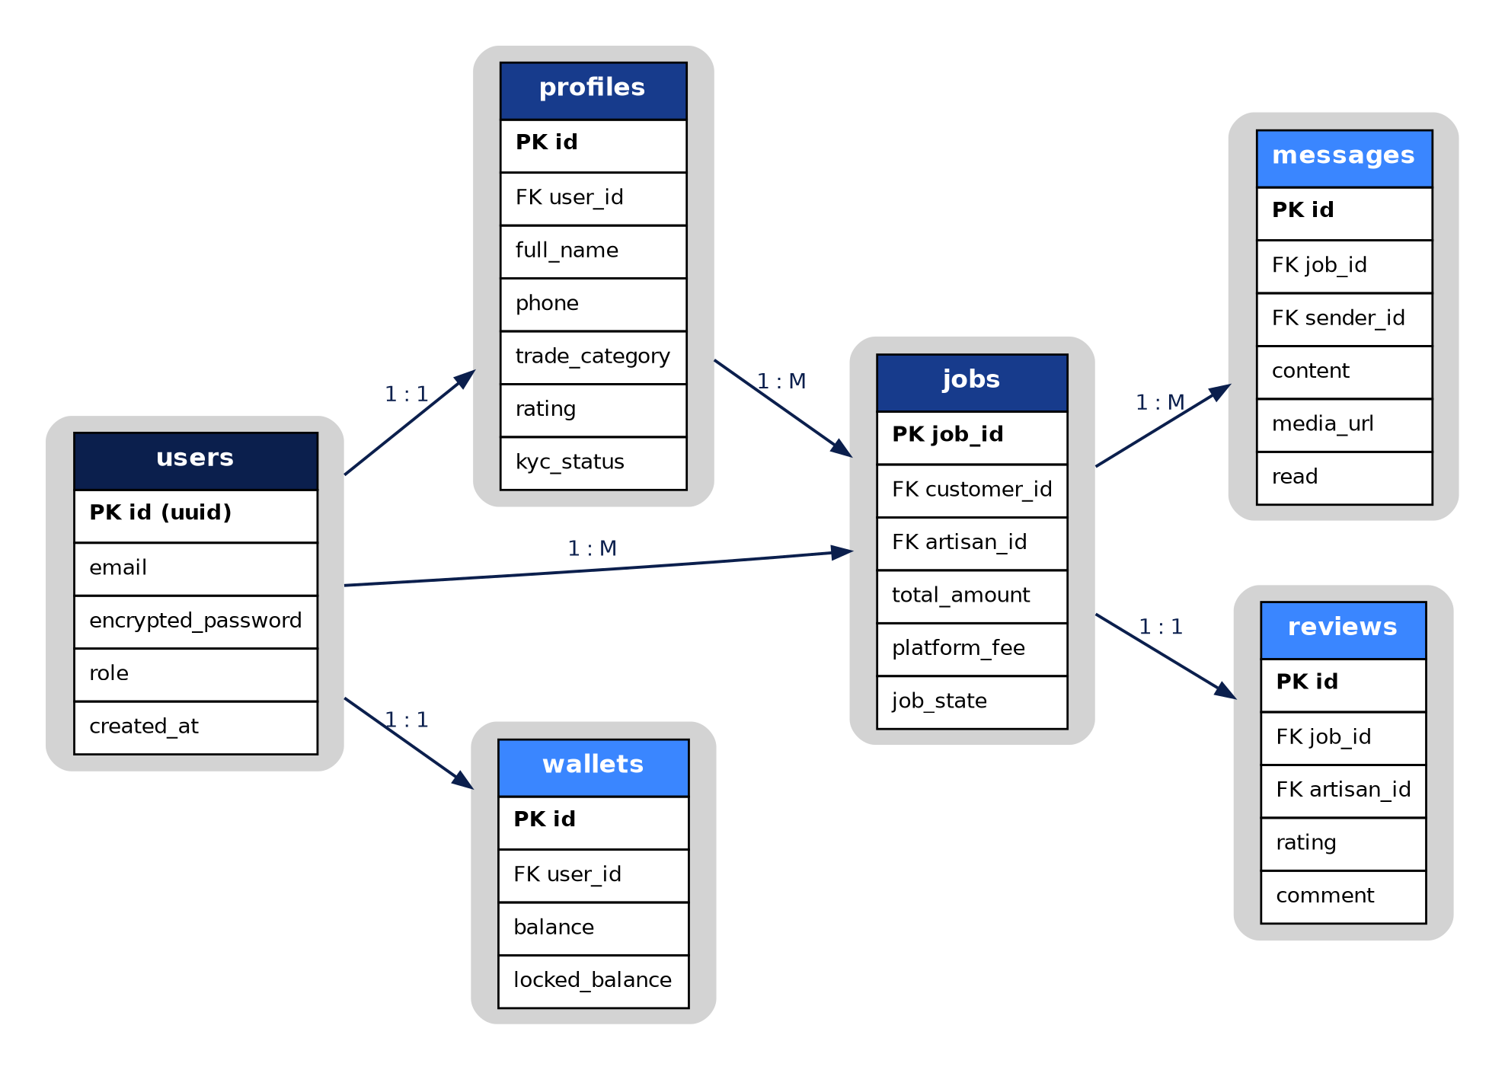
Figure 3.8: Entity relationship diagram of the CraftHive database
The jobs table is at the heart of the design and contains two foreign keys to the users table – one for the customer, and one for the artisan. If a customer is on one engagement and an artisan is on another, there is no need to duplicate their identity with this dual reference. Each message mentions the job that it is related to, which enables that message to be the only one associated with the job and ensures that some administrator will have a complete record to work through if a dispute arises.
Documentation of the structure of the three central tables is provided in Table 3.5, Table 3.6 and Table 3.7.

Table 3.5: Data dictionary for the users table
Column | Data type | Description | Constraint
id | uuid | Unique identifier issued by Supabase Auth. | Primary key
email | varchar | Login address for the account. | Unique, not null
encrypted_password | varchar | Password stored as a bcrypt hash. | Not null
role | enum | One of customer, artisan, or admin. | Not null, indexed
created_at | timestamptz | Account creation time. | Default now()

Table 3.6: Data dictionary for the jobs table, which holds the escrow state machine
Column | Data type | Description | Constraint
job_id | uuid | Unique identifier for the engagement. | Primary key
customer_id | uuid | The account that requested the work. | Foreign key to users
artisan_id | uuid | The account contracted to perform the work. | Foreign key to users
total_amount | numeric(10,2) | Agreed price in Ghana cedis. | Not null
platform_fee | numeric(10,2) | Commission deducted on completion. | Default 0
job_state | enum | pending, accepted, funded, completed, disputed, or cancelled. | Not null, indexed
created_at | timestamptz | Time the request was raised. | Default now()

Table 3.7: Data dictionary for the profiles table
Column | Data type | Description | Constraint
id | uuid | Profile identifier. | Primary key
user_id | uuid | Account the profile belongs to. | Foreign key to users
full_name | varchar | Display name shown to other users. | Not null
trade_category | varchar | Trade practised, for artisan accounts. | Nullable, indexed
rating | numeric(2,1) | Mean of all ratings received. | Default 0
kyc_status | enum | unverified, pending, verified, or rejected. | Default unverified
The structure in the ERD finishes off with three more tables: messages, reviews and wallets as stated in Table 3.8, Table 3.9 and Table 3.10.
Table 3.8: Data dictionary for the messages table
Column | Data type | Description | Constraint
id | uuid | Message identifier. | Primary key
job_id | uuid | Job the message belongs to. | Foreign key to jobs
sender_id | uuid | Account that sent the message. | Foreign key to users
content | text | Text body of the message. | Nullable
media_url | text | Storage path for an image or voice note attachment. | Nullable
read | boolean | Whether the recipient has opened the message. | Default false

Table 3.9: Data dictionary for the reviews table
Column | Data type | Description | Constraint
id | uuid | Review identifier. | Primary key
job_id | uuid | Job the review was submitted for. | Foreign key to jobs, unique
artisan_id | uuid | Artisan being rated. | Foreign key to users
rating | smallint | Star rating from one to five. | Not null, check 1-5
comment | text | Optional written feedback. | Nullable

Table 3.10: Data dictionary for the wallets table
Column | Data type | Description | Constraint
id | uuid | Wallet identifier. | Primary key
user_id | uuid | Account the wallet belongs to. | Foreign key to users, unique
balance | numeric(10,2) | Funds available for withdrawal. | Default 0
locked_balance | numeric(10,2) | Funds held in active escrow contracts. | Default 0
updated_at | timestamptz | Last time the balance changed. | Default now()

The difference between balance and locked_balance in the wallets table is by design and not because of a naming accident. A dashboard for an artisan should show two values: money they can actually take out, and money promised, which is still conditional based on a customer marking the work complete. Merging them into a single balance column either inflates what an artisan can truly use, or it needs to do a slower query against the jobs table every time the wallet screen is rendered. Organizing them accordingly on the wallet row itself makes the artisan’s financial position readable at a glance and keeps the escrow release function simple: it only ever needs to move a number from locked_balance to balance.

3.7 Human Computer Interaction and Interface Design
Design choice of the interface was aimed at its audience. There is severe variance in the digital literacy of older artisans, and an interface that assumes fluency with contemporary conventions will end up excluding exactly the users that the project exists to help. The heuristics utilized here are provided by Hermawati and Lawson (2016), specifically the visibility of system status as well as language from the user world, not the system world. According to Masoudi et al. (2019), a good interface makes the possible actions visible to the user. This prevents the user from wondering what they can do on a particular screen.
The layout was governed by two principles. The things that matter most are placed in the lower third of the screen, which is where the thumb is naturally rendered cording with Ljubic, Glavinic and Kukec's (2015) application of Fitts's law, which states that distance and size determine how quickly and reliably a control can be hit. Categories are carried through icon and text, which eases the reading burden for illiterate users.

CHAPTER FOUR

IMPLEMENTATION AND RESULTS

4.1 Introduction
The design for chapter three. What happened to us when we tried to build it. The choices that were actually important during the implementation, security handling at the database level, the escrow engine, the interfaces we delivered, and the testing we performed to convince ourselves the thing worked. The testing becomes essential since an app dealing with other people's money cannot be released on the basis of a doubtful assumption.

4.2 Development Environment
The mobile clients were developed using Expo SDK 54 and React Native. The admin dashboard was developed with Next.js, while the backend using Supabase – a PostgreSQL database as a service with serverless edge functions, storage, authentication, and real-time channels – packages the solution (PostgreSQL Global Development Group, 2024; Next JS, 2024; Supabase, 2024). With regards to payment processing, they are done via mobile money gateway and not card rails. Notifications which push are sent through a push service (Expo, 2024). The Deploy info for admin dashboard online vercel, and the mobile distribution is a package that installs on Android 8.0 and higher.

4.3 Implementation of Core Components

4.3.1 Frontend State Management
React Native made mobile clients, hooking functional components in everywhere. React Context providers surround the root and store global state, such as logged-in session detail, current role, and wallet balances. This approach is adopted to prevent the passing of state down through a series of components that aren’t interested in it, a pattern that gets out of hand quickly once an app reaches this scale. We used a reducer alongside the context in cases where a flow has multiple steps, the clearest of which being the sequence a customer moves through when funding a job. This means that we have each step explicitly managed, and the screen cannot fall out of sync with the backend’s actual state. A detail of an implementation led to a fault worth recording. In the beginning the developers tracked the approval status of an artisan within the local storage of the mobile device. The application functioned in a way that caused the hardware to retain outdated data. As a result the interface displayed an incorrect screen to the artisan after an administrator granted them access. The team implemented a solution to designate the database column on the server as the primary reference point for all information. To prevent data from becoming inconsistent, the software now fetches the current status every time the user navigates between screens.

4.3.2 Backend Security Through Row-Level Security
Because the mobile clients query the database directly, security could not be left to the application layer. Row-Level Security does this by checking a row-based policy in the database before returning or changing any rows. Such a stance follows the advice of the OWASP Foundation (2023), who has ranked broken access control as the most pervasive and severe category of vulnerability in today's applications in its Top Ten.
The policy governing the jobs table restricts access to the two parties involved:
CREATE POLICY "Restrict job access to participants"
ON public.jobs FOR SELECT TO authenticated
USING (auth.uid() = customer_id OR auth.uid() = artisan_id);
Authenticated users querying the jobs table will only see rows where their id is either the customer or the artisan. If you attempt to read the table wholesale, you get an empty set, not an error. This is because, from the database 's point of view, there are no matching rows. The same pattern is repeated with small variations across every table that carries personal or financial data. Messages are restricted to the two participants in the job the message belongs to, which is a slightly more involved policy because it has to join out to the jobs table to establish who those participants are:
CREATE POLICY "Restrict message access to job participants"
ON public.messages FOR SELECT TO authenticated
USING (EXISTS (SELECT 1 FROM public.jobs
WHERE jobs.job_id = messages.job_id
AND (jobs.customer_id = auth.uid() OR jobs.artisan_id = auth.uid())));
Wallets are locked down more tightly still, since a balance is the one figure in the whole schema a user should never be able to see for anyone but themselves:
CREATE POLICY "Restrict wallet access to the owner"
ON public.wallets FOR SELECT TO authenticated
USING (auth.uid() = user_id);
Writing these policies one table at a time, rather than relying on a single blanket rule, took longer during Sprint 1 and 2 than the team expected. It eventually turned out profitable. The access control for database is not provided through the screens. Due to this structure, any functionality which a developer adds during a later development cycle is endowed with this protection. A programming bug in the app, irrespective of which buttons the user interface allows the user to press, cannot enhance the data that the user sees.

4.3.3 The Escrow Logic Engine
Escrow logic is the one part of the system which no one would reasonably trust to a mobile device. When the handset abruptly loses connectivity mid-transaction, a modified client can simply lie and deny the job was done. Thus the release mechanism operates in a Supabase Edge Function on the Deno runtime. When the customer confirms completed, the function executes four operations. To prevent paying the artisan multiple times, it verifies that the job is in the funded status at the time of the call, rejecting otherwise. The amount in escrow is read to calculate platform commission i.e. 10% and artisan net share. The debit, credit and change of state are performed in a single database transaction by the system. Since the transaction is atomic, any error will have the system revert entirely. There is no way the system can take away currency from one account holder unless that currency appears in the second account holder.

4.3.4 Real-Time Communication
The chat system uses Supabase Realtime to send message text, pictures, and voice recordings. Ideally, every conversation is related to one job. The history of the negotiations has been related to the legal contract between the parties with this organisations. It is worth noting an error that has occurred often in this case. The messaging schema stores metadata for images and voice notes in JSONB payload columns. However, Postgres change notifications do not carry JSONB payload columns. By subscribing naively, messages arrive without attachments and rendered as an empty text. Injecting a signal, as opposed to an inserted value, would be the fix. Whenever an insert event is received, we would re-fetch the complete message record.

4.4 System Interfaces
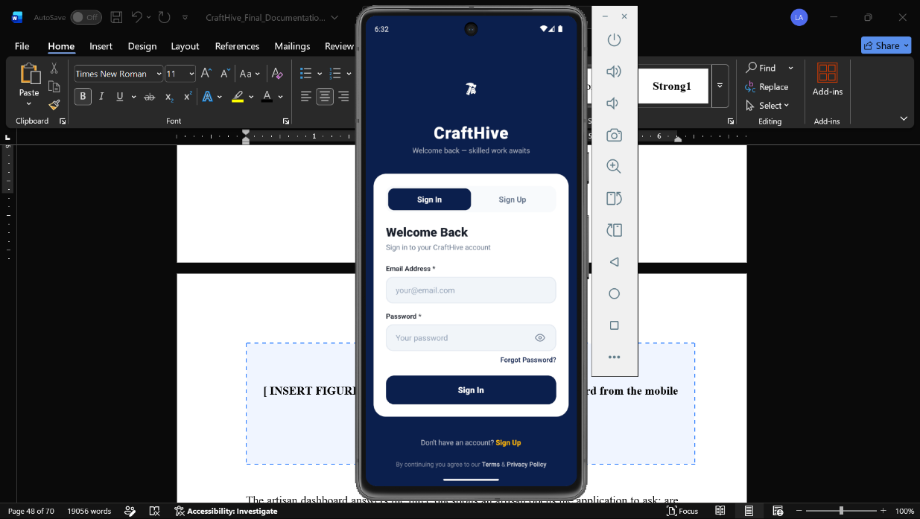
Principal screens delivered are shown figure 4.1, Figure 4.2, Figure 4.3, Figure 4.4, Figure 4.5, and Figure 4.6.

Figure 4.1: Login interface
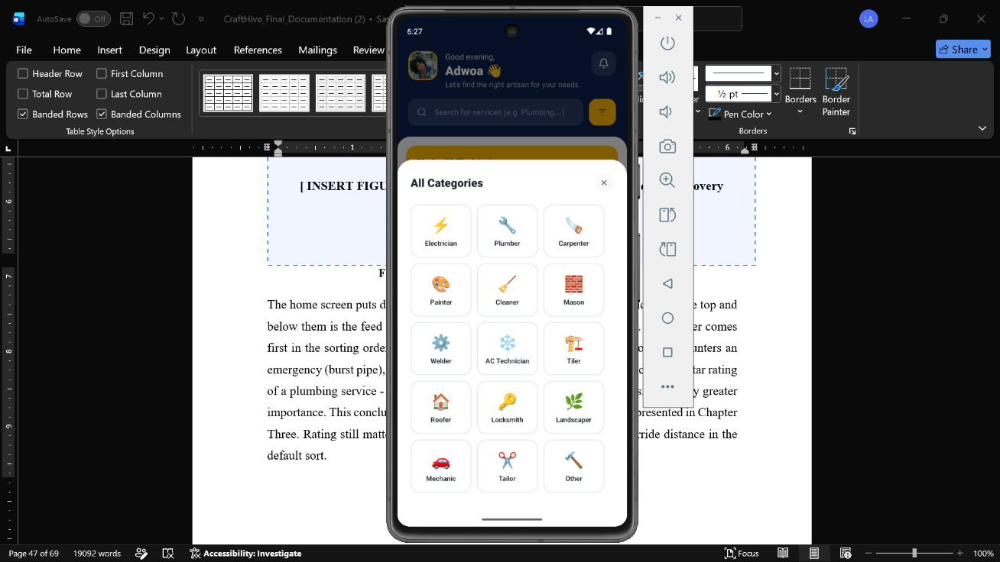
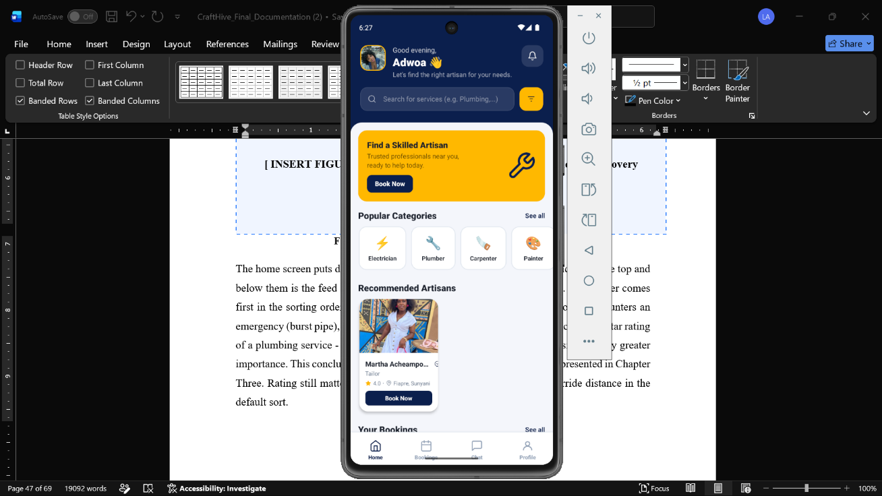
Any one of three roles can fill in a single login form. The destination is determined by the role associated with the record against the account. The screen carries nothing beyond the credentials, the recovery link, and the registration link. Keeping one form rather than three separate entry points was a deliberate simplification. A returning user does not have to remember which door they came through last time, and it removes an entire category of support question, someone who registered as a customer trying and failing to log in through an artisan-only screen, before it can arise.

Figure 4.2: Customer home and discovery dashboard
The home screen puts discovery first. Trade categories are represented as icons on the top and below them is the feed of nearby artisans arranged by distance and rating. The former comes first in the sorting order, which is explained by the fact that when a customer encounters an emergency (burst pipe), they are unlikely to worry about the minor differences in the star rating of a plumbing service - instead, the proximity to the point of failure is of significantly greater importance. This conclusion was reached on the basis of the conversations presented in Chapter Three. Rating still matters and is shown prominently, but it does not override distance in the default sort.

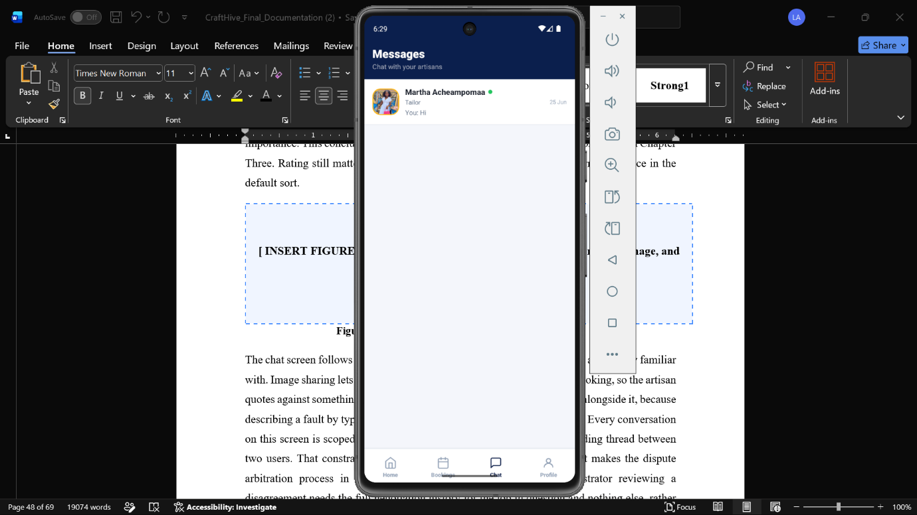
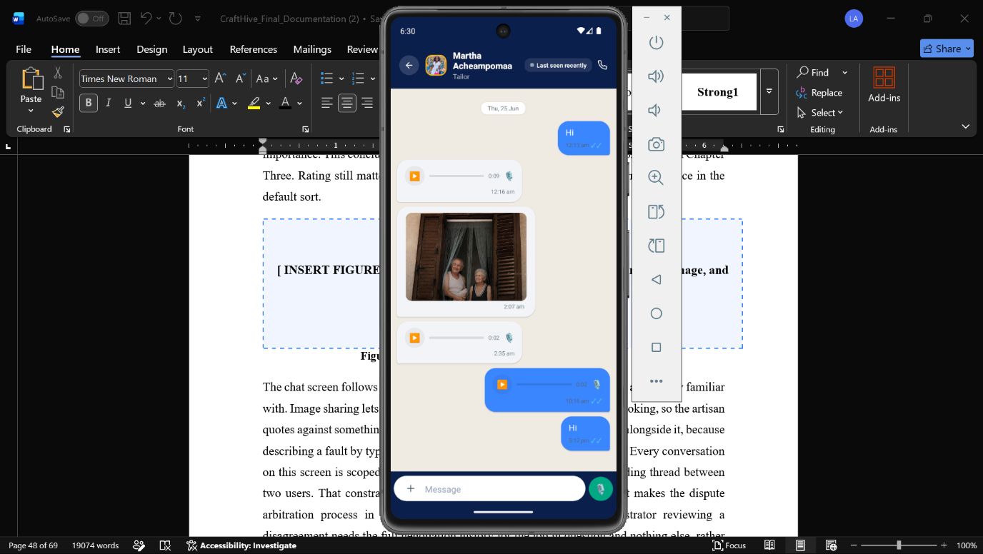

Figure 4.3: Real-time negotiation and messaging interface
The chat screen follows the conventions of the messaging apps phone users are already familiar with. Image sharing lets a customer photograph the broken fitting before booking, so the artisan quotes against something they have actually seen. Voice notes were added alongside it, because describing a fault by typing is slow and several artisans preferred to speak. Every conversation on this screen is scoped to a single job rather than existing as a free-standing thread between two users. This limitation was not an accident of the schema, it is precisely what makes the dispute arbitration process in section 4.3.3 possible to begin with. After all, an administrator assessing a dispute needs the complete negotiation history for the job in question, and nothing else. In other words, they do not need to sift through a general conversation for the relevant part.

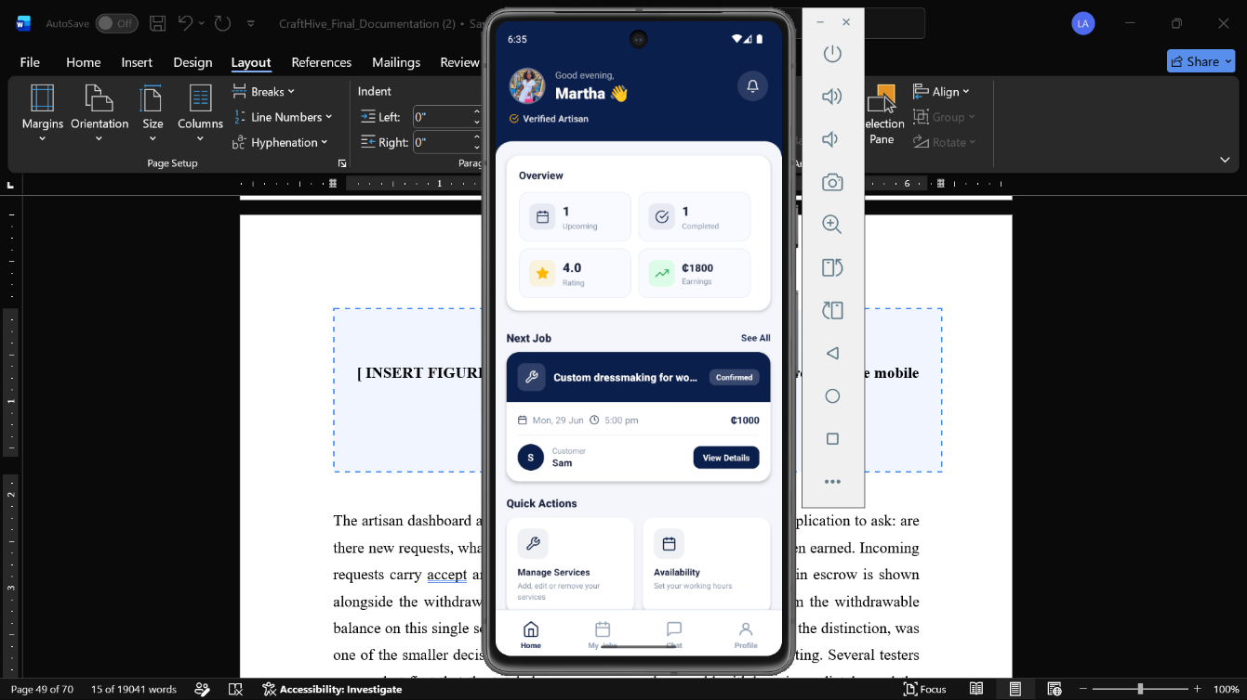
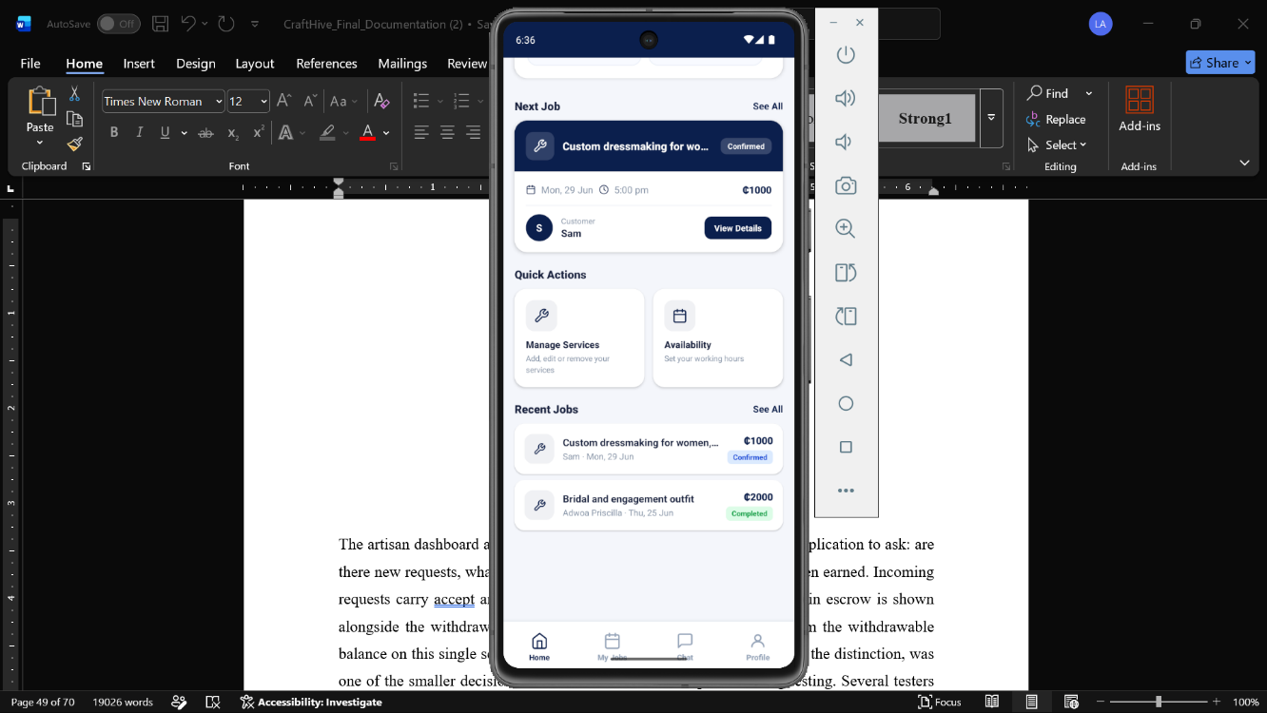

Figure 4.4: Artisan dashboard
The artisan dashboard addresses the three questions that an artisan opens the application to ask: are there new requests and what is happening with current jobs and what has been earned. Whenever a request is received, it automatically comes with a built-in accept or decline action. When your escrow holds funds, the balance will show in addition to the withdrawable amount. One of the little decisions to matter more than expected in testing was separating the escrow balance from the withdrawable balance within one screen, rather than making it necessary to see the difference on the second screen. At first, a few testers thought that the total shown was money they could withdraw right away. The visual split, as described in the data dictionary for the wallets table in Chapter Three, was added to remedy this misreading before it could cause disappointment over a job that just hadn’t been confirmed complete yet.

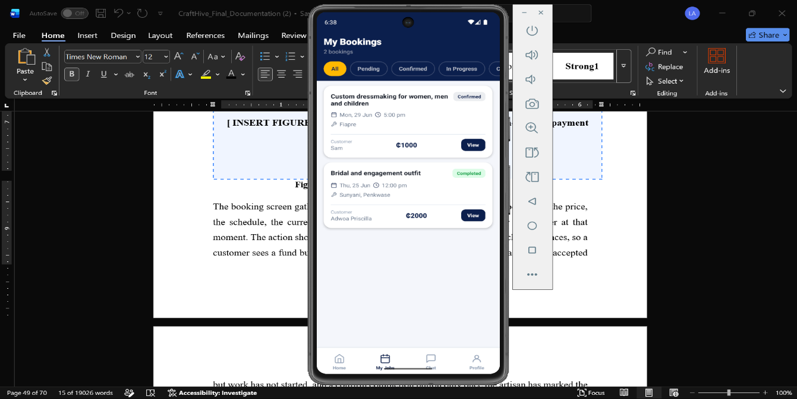
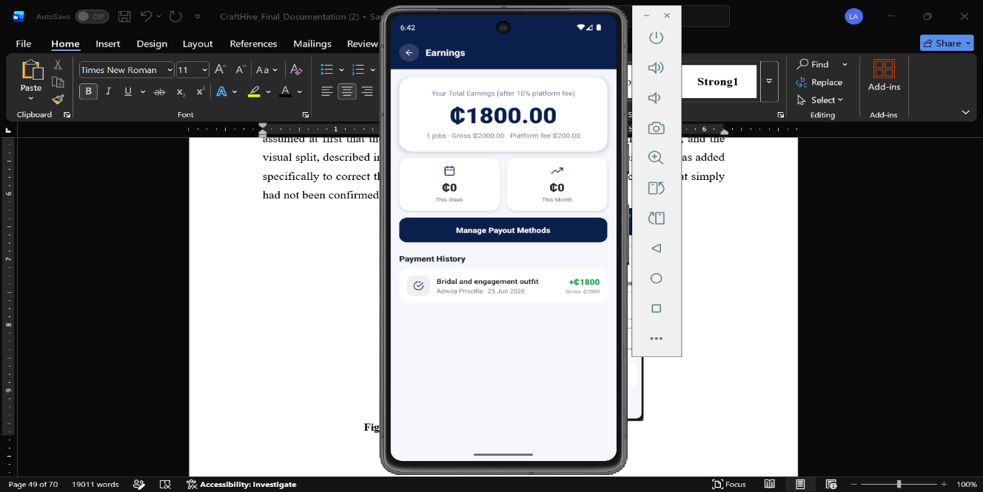
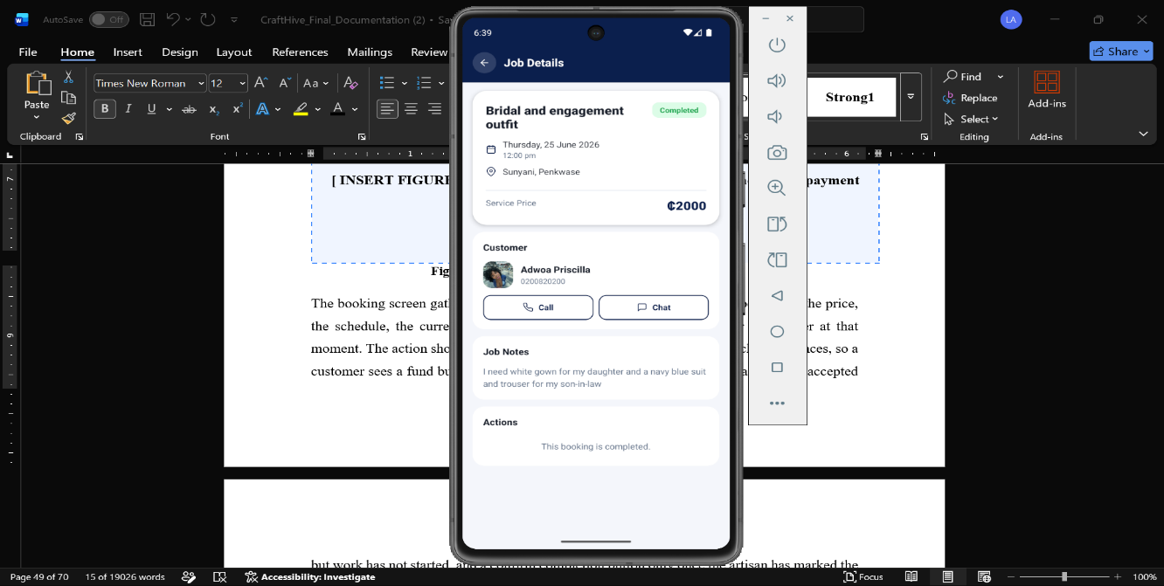

Figure 4.5: Booking detail and escrow payment interface
The booking screen presents all the details which are gathered in one view, i.e., the agreed scope, the price, the schedule, the current state, whichever action (s)he can take at that moment. The action depicted here changes automatically, via the job state machine, so the customer sees a fund button before payment, then a waiting message once the artisan accepted and work has not started, then a confirm completion button only once the artisan marks the job done. Presenting exactly one correct action at a time, rather than a menu of options most of which do not currently apply, was intended to make it difficult for either party to attempt an action the current state does not actually support.
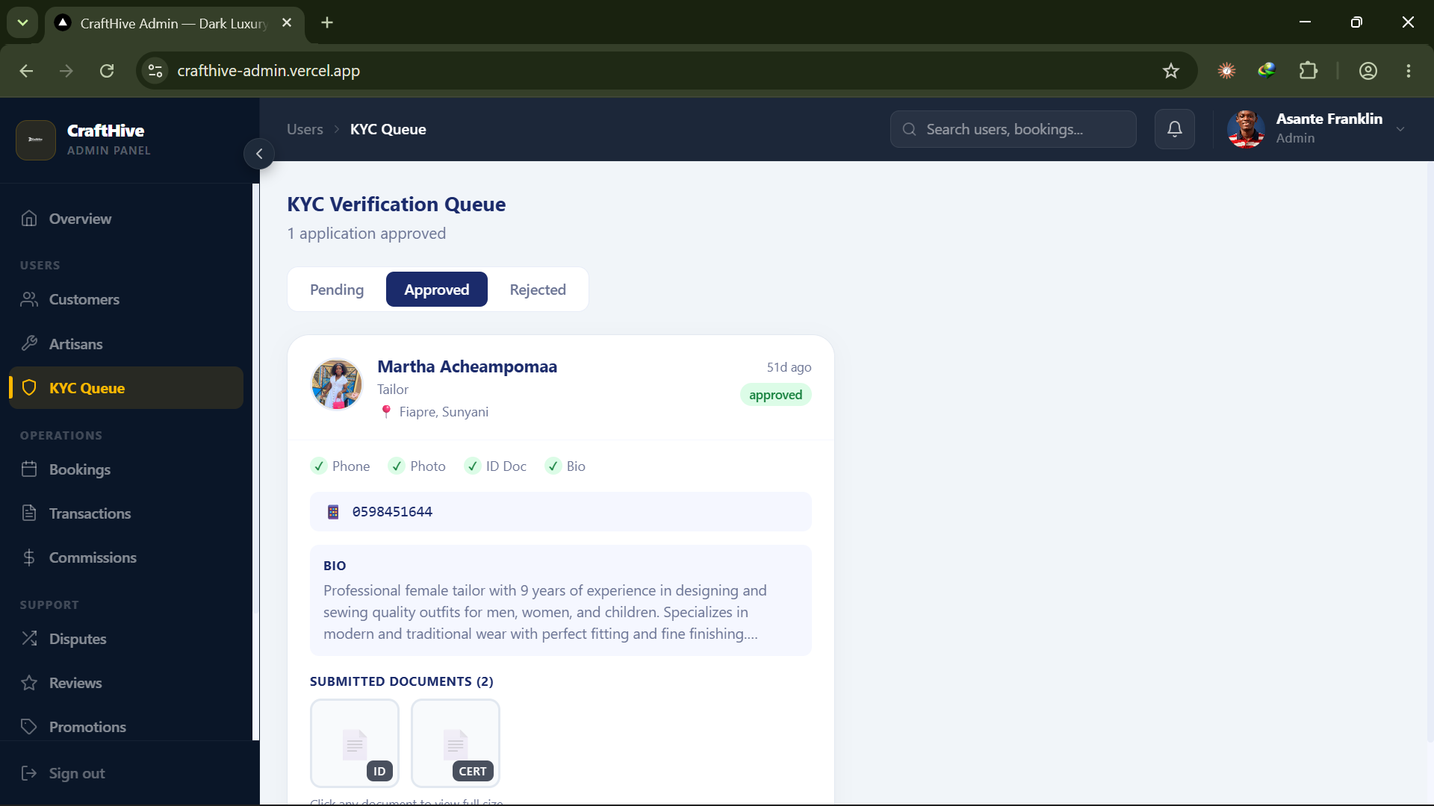
Figure 4.6: Administrative dashboard showing the identity verification queue
The administrative dashboard presents pending verification submissions with the uploaded card, certificate, and selfie side by side so comparison is immediate. Approval or rejection updates the account status, and rejection requires a reason that is returned to the artisan. Requiring a reason on rejection, rather than allowing a bare decline, was added after early testing of the admin flow made clear how little an artisan could do with a rejection that offered no explanation. A rejected applicant who cannot tell whether their photograph was blurry, their card had expired, or their trade certificate was missing has no way to correct the submission, and would likely give up on the platform rather than try again blind.

4.5 Testing and Results
We conducted tests using four different layers, starting with small pieces of isolated logic and culminating in real users utilizing the application. As the escrow engine is a stateful distributed system, it also needs verification at various layers, as described by Kleppmann (2017) and Richardson (2018) for such systems.

4.5.1 Unit and Integration Testing
The focus of unit tests was the commission calculator due to its direct impact on fund allocation error. Large amounts and ones with fractional pesewas were run through the function, so both share of the artisan and the platform fee always add up to the given amount. An integration test that focuses on the boundary between the mobile clients and Supabase – in particular message latency, escrow funding, and that Row-Level Security correctly hides jobs and profiles not belonging to the querying user. Both levels were successful. The amount of testing that was done on the commission calculator was never disproportionate which was by design. The function is small and compact; it is a few arithmetic lines, but it is the only piece of logic in the whole code base where a rounding error would not fail visibly, but would fail silently. Anyone looking at a screen that displays incorrectly can tell it is incorrect. A commission split that is off by a pesewa on every transaction will be invisible until someone reconciles the books, which already has happened many times over. In this project, we spent about as much testing effort on this function as we did on any other function. The reason previous function, although small, received this much attention is that the consequence of a silent failure would be expensive.

4.5.2 User Testing
Formal user acceptance testing with a recruited sample was outside what this project could arrange. What happened instead was continuous informal testing. Between ten and fifteen coursemates and friends used the application while it was being built and again once it was working end to end. They installed it on their own handsets, which gave a spread of Android versions and screen sizes that the team could not otherwise have covered, along with two iPhones. No scripted task list was used and no completion times were recorded, so this section reports what testing found rather than measured performance. That is a real limitation and it is stated as one. The issues raised, and the action taken on each, are recorded in Table 4.1.
Table 4.1: Issues raised during user testing and the action taken
Issue reported by testers | Diagnosis | Action taken
Application lagged badly, then crashed on two older Android handsets, when a photograph was sent in chat. | Full resolution camera images were being uploaded without resizing, exhausting memory on lower specification devices. | Client side compression added before upload. Crashes stopped and uploads became faster on slow connections.
Testers could not find the earnings screen. | Navigation icons carried no text labels. | Text labels added beneath every icon in the primary navigation.
Content overlapped the coloured header on smaller screens. | Negative margins had been used to pull content up under the header, which behaved inconsistently across screen sizes. | Each affected screen restructured around a single scrolling container with a rounded content area below the header.
Voice notes recorded but would not play back on iPhone. | The audio library the module was built against had been deprecated and no longer managed the iOS audio session. | Chat audio migrated to the replacement library, with the session mode set explicitly before each playback.
Images and voice notes sometimes arrived in chat as empty messages. | Database change notifications do not carry JSONB payload columns, so attachments were missing from the event. | Client re-fetches the full message record on each insert event rather than trusting the notification payload.
Booking screen still offered a payment button after payment had gone through. | The button was rendered from stale local state rather than the stored payment status. | Payment state read from the backend record, and the button replaced with a confirmation once funds are held.

The one that taught us the most valuable lesson was not listed in this table because it was not discovered by testers’ actions but rather by our own experience. When a Row-Level Security policy prevents an attempt to update, it does not always return an error, which means that your application will be under the impression that everything went smoothly when it actually did not. In some cases, you might receive an “empty” response with a success code that will allow your program to continue believing that the write operation was successful when there was no change at the database level. This outcome is rather unpleasant in any system where the write operation’s result is returned to the user confirming some action, such as a money transfer in a banking system. We spent the better part of two days being misled by the response codes before realizing what the problem was due to the client’s requests getting denied without any error indication. The first step to resolving the issue was to perform a separate read operation immediately after every write to confirm the changes at the database level rather than relying on the response codes. The second was to review the policies to ensure that they did not deny any operations that were not intended to be restricted.

4.6 Discussion of Findings
Two patterns run through the defects recorded in this chapter, and both are worth naming because they shaped how the team approached the rest of the build after they were found. The first pattern is that the faults which mattered most were invisible from the interface. A crash is loud. It stops testing dead and someone reports it within minutes. The Row-Level Security flaw that stealthily blocked writes while reporting success to the client caused neither a crash nor any visible anomaly, allowing it to linger in the codebase far longer than any of the other six defects in Table 4.1. The practical lesson, which has since influenced the team’s feature specification, was that a success response from the backend was always to be treated as a claim to be evaluated, not an assertion to be trusted – causing every write to a financial or reputation-related model to be immediately cross-verified by a reading back. The second weakness runs through all the issues in how the assumptions were made about the devices, not the code, that the code was targeting. The image compression problem assumed that all phones had roughly equivalent memory, the layout overlap assumed that all screens had sufficient height to conceal a negative margin, and the audio session error assumed that the underlying libraries would behave consistently across all devices and OS versions. In each case, the implementation correctly performed the operations it was instructed to, but the instructions themselves were written under incorrect assumptions about the target environment. This highlights yet another flaw in the team’s preparation in that all the issues would have been avoided had they been testing on the diverse set of devices that the course fellows actually used – ten to fifteen different mobile phones per person, on average. This represents the single best datapoint in favor of the ad-hoc testing methodology, as it demonstrates the superiority of actual usage over the clean environment of a simulation. The third weakness is substantially less easy to admit, but it is no less true: that each of these flaws could have been avoided had the original code been written by a more experienced team that knew to plan for such pitfalls at design time. In short, there is no silver bullet for software design, and all teams – including the author’s – make mistakes that can be categorized as either logical or systemic depending on context and perspective. But by the same token, none of these issues would have existed if the team members had possessed the experience they gained over the course of the project at the beginning of their work. None of the five of us had built a payments-adjacent mobile application before this project. The value of the testing process was not that it eliminated inexperience; it was that it converted inexperience into specific, documented lessons faster than working in isolation would have, and it did so before those lessons became the kind of failure a customer or artisan would have encountered rather than a coursemate testing on a Tuesday evening. The difference between users who learn at their friend’s expense versus the expense of a real user is the practical argument for developing a testing habit, even where a formal acceptance test is an unrealistic goal.

CHAPTER FIVE

SUMMARY, CONCLUSION AND FUTURE WORK

5.1 Introduction
This chapter provides a summary of the project, draws conclusions from the design and testing work described in Chapters Three and Four, evaluates how far the stated objectives were met, acknowledges the limitations of the system, and sets out recommendations for future work.

5.2 Summary of the Project
This project designed, built, and evaluated CraftHive, a cross platform mobile marketplace intended to formalise the contracting of informal skilled labour in Ghana. The informal trades carry a large part of Ghana's employment, and they have been left out of the digital shift that reshaped transport and food delivery. What keeps them out is not mainly technical. It is the absence of trust between two people who have no way to check each other, and the absence of anyone neutral to hold the money while the work gets done.
The system was built with React Native for the mobile clients, Next.js for the administrative dashboard, and Supabase for the backend, following an Agile process of ten two-week sprints. The requirements were generated from a limited number of informal interviews with artisans and student entrepreneurs in Sunyani as well as a systematic examination of current platforms. To solve the trust issue, two mechanisms are put in place. The first is a Know-Your-Customer pipeline that keeps an artisan invisible until an administrator has reviewed their Ghana Card, certificate, and selfie. The second is an escrow gateway. This later mechanism holds a customer’s payment until they confirm that the work has been completed.
The testing was done from unit tests, integration tests, and continuously informally used for the course work by 10 to 15 coursemates on their own devices. The assessment revealed six specific problems related to the interface and media handling. Although all six of them were successfully corrected; there was also a serious silent failure discovered within the security layer. That failure has since influenced how every write operation touching money is now written and checked by the team.

5.3 Achievement of Project Objectives
Table 5.1 serves as a link between Chapter 1’s objectives and what was ultimately delivered.
Table 5.1: Project objectives and their achievement
Objective | Achievement
Build a Know Your Customer verification pipeline. | Delivered. Ghana Card, certificate, and selfie upload with administrator review before profile visibility.
Develop an escrow payment gateway. | Delivered. Funds locked and released by an atomic edge function, with a ten percent commission calculated on release.
Design a dual interface mobile ecosystem in React Native. | Delivered. Separate customer and artisan interfaces from a single Expo codebase.
Implement low latency in app messaging with text, image, and voice. | Delivered. Realtime chat scoped to each job, with a documented fix for a payload delivery fault.
Construct an administrative web dashboard. | Delivered. A Next.js dashboard for verification review and dispute arbitration, deployed and reachable online.

5.4 Conclusions

5.4.1 Verification Is the Feature That Moved People
Testers responded most strongly to verification, which supports Mou, Shin and Cohen (2017)’s and Hui et al. (2016)’s emphasis on institution based trust in online marketplaces. Unlike rating systems that rely on arbitrary numbers which may or may not be credible, verification of identity offers the opportunity to see something more reliable than the number alone.

5.4.2 Escrow Removes the Financial Standoff
Safe keeping of the funds in a neutral state mitigated both fears; the artisan knew the funds were secured before commencement, while the customer knew the money would not move until the work was completed. This structural effect Hui et al. (2016) describe, reproduced here in a mobile money context rather than a card based one, is consistent with mobile money’s role in Ghanaian financial inclusion more broadly (Suri & Jack, 2016; Aron, 2018).

5.4.3 The Stack Is Viable for a Small Team
By using a managed backend along with React Native, five students were able to create and deploy a marketplace that handles payments, without provisioning a single server. That matters for similar work in the region: the infrastructure cost that would once have made a project like this impossible has largely disappeared.

5.4.4 Testing Quality Follows From How It Is Done
The informal testing revealed some defects and a major silent failure detected and exploited by the team’s own uses of the system were more informative than any number processes studies would have produced officially. Genuine users on actual devices, even without a script, reveal only the flaws of concern.
While it does not argue against formal testing in principle, section 5.6.5 suggest exactly that as future work. The two approaches respond to different questions, it says. Once a target has been set, a reader can tell how usable the system is, relative to that target, through a formal evaluation that measures completion times. The informal approach that is actually used here was more appropriate for answering the previous question, which was what we needed answering first. Not how fast can a user complete a task but does the system survive contact with a real device and a real person at all. As the hope was for the first version to be built by a small team and within a fixed academic time, the second question was the one worth answering before the first.

5.5 Limitations of the Study
The limitations mentioned in the first chapter are repeated here because they have a direct bearing on the way the conclusions should be read. The payment was verified in a sandbox and not through live commercial transactions. Rather than checking against the national identity register, identity verification relies on a manual check from an administrator. The language selection feature in the interface is not yet fully functional and full localisation remains future work. The testing was informal as it drew on ten to fifteen coursemates in one setting. This was enough to reveal interface and media handling faults but was insufficient to support any claim about usability across the wider audience the platform is intended for.

5.6 Recommendations for Future Work

5.6.1 Direct Mobile Money API Integration
The greatest value enhancement is allowing direct interface connection with the interfaces run by the telecommunication networks so that a customer can fund escrow straight from their mobile wallet and an artisan can withdraw straight back to theirs. That will automate the process eliminating the need for manual steps that exist at both ends.
This integrated solution does not only signify convenience. At every point in the manual process, there is a chance for the customer to have second thoughts and/or get distracted or simply leave the flow altogether and for now, the sandboxed flow- while it is thoughtful- has more steps than a wallet-to-wallet transfer would. When there are fewer steps, the chances of conversion increases. Hence, reducing steps in the payment flow are, without question, going to be more valuable to conversion than any other change the team could make to the interface.

5.6.2 Automated Identity Verification
There can be an automated process to confirm the live comparison against the national identity register instead of just manual card and selfie check. This will increase the verification strength and remove the manual administrative logjam that gets created as the platform scales.

5.6.3 Structured Onboarding Through Trade Associations
The deployment should start with established artisan associations rather than waiting for organic signups, as a two sided marketplace cannot attract consumers without artisans and artisans without consumers. A single well-facilitated onboarding session could rapidly and reliably populate the supply side of an association.

5.6.4 Completing Localisation
It is already present in the interface. Adding text to speech for the major Ghanaian languages will expand the platform to artisans who have limited reading comprehension in English, thereby completing translation coverage.

5.6.5 Formal User Acceptance Testing
A systematic evaluation with a recruited sample across a wider age and literacy range, with timed scripted task measures, would provide the type of usability evidence that informal testing by coursemates cannot.

5.7 Reflections on the Development Process
In addition to the problems and design decisions discussed in the previous section, the project has taught us a lot. The below lessons are related to the work process. Therefore, they are provided below.
To begin with, it was the problems and issues that were not apparent to start. As soon as someone encountered an issue, they reported it, whether it was a crash or a UI layout issue. The Row-Level Security fault that silently blocked payment-related writes survived far longer, precisely because the interface gave no sign anything was wrong. That asymmetry changed how the team approaches new code even now: a feature that appears to work on first use is treated as unverified rather than confirmed, until its actual database effect has been checked directly rather than inferred from the screen.
The second is that requirements gathered from a small number of real conversations outperformed requirements the team might have guessed at from general knowledge of the sector. Five conversations in Sunyani is not a large sample by any formal standard, and this report has been careful not to claim otherwise. But those conversations surfaced the deposit-fraud dynamic described in section 1.2.2 with a clarity that secondary reading alone would not have supplied, because it came from people describing something that had actually happened to them rather than from a general description of the problem. The lesson generalises beyond this project: a handful of real accounts of a problem is worth more to a design process than a much larger volume of assumption.
The third is that building for constrained devices and patchy connectivity is not a peripheral concern to be handled once the core features work. It shaped the core features themselves. The decision to compress images before upload, the decision to keep every screen legible without relying on animation or heavy graphics, and the decision to make every financially significant action explicit rather than clever, all trace back to the fact that the people this platform is for are using ordinary phones on ordinary Ghanaian mobile networks, not flagship devices on fast fibre connections. One of the decisions the team would back most strongly if pressed on their decision-making for the project is designing for that reality from the start, instead of as an extra.

5.8 Final Remarks
CraftHive is a working system that has been built on a real problem and it is not a demonstration which has been built to appear finished. The verification pipeline, the escrow engine, and the messaging system behave as expected. The defects that testing uncovered came about because people actually used the application rather than the fact a checklist was completed. The restrictions noted here are genuine and the recommendations point to the specific things that would need to change for the platform to operate at scale beyond a pilot. In a nutshell, the evidence shows that a small student team can build a financially functioning, identity verified marketplace for the informal sector excluded from the digital economy so far, within those limits.

REFERENCES
Abebe, G., Caria, A. S., Fafchamps, M., Falco, P., Franklin, S., & Quinn, S. (2021). Anonymity or distance? Job search and labour market exclusion in a growing African city. The Review of Economic Studies, 88(3), 1279-1310. https://doi.org/10.1093/restud/rdaa057

Aron, J. (2018). Mobile money and the economy: A review of the evidence. The World Bank Research Observer, 33(2), 135-188. https://doi.org/10.1093/wbro/lky001

Bonnet, F., Vanek, J., & Chen, M. (2019). Women and men in the informal economy: A statistical brief. WIEGO and International Labour Organization. https://www.wiego.org/wp-content/uploads/2019/09/Women-and-Men-in-the-Informal-Economy-A-Statistical-Brief-for-web.pdf

Dearing, J. W., & Cox, J. G. (2018). Diffusion of innovations theory, principles, and practice. Health Affairs, 37(2), 183-190. https://doi.org/10.1377/hlthaff.2017.1104

De Stefano, V. (2015). The rise of the just-in-time workforce: On-demand work, crowdwork, and labor protection in the gig economy. Comparative Labor Law and Policy Journal, 37(3), 471-504.

Ert, E., Fleischer, A., & Magen, N. (2016). Trust and reputation in the sharing economy: The role of personal photos in Airbnb. Tourism Management, 55, 62-73. https://doi.org/10.1016/j.tourman.2016.01.013

Fowler, M. (2018). Patterns of enterprise application architecture. Addison-Wesley Professional.

Ghana Statistical Service. (2019). Ghana living standards survey round 7 (GLSS 7): Main report. Ghana Statistical Service.

Graham, M., Hjorth, I., & Lehdonvirta, V. (2017). Digital labour and development: Impacts of global digital labour platforms and the gig economy on worker livelihoods. Transfer: European Review of Labour and Research, 23(2), 135-162. https://doi.org/10.1177/1024258916687250

GSMA. (2022). The mobile economy Sub-Saharan Africa 2022. Global System for Mobile Communications Association. https://www.gsma.com/mobileeconomy/sub-saharan-africa/

Hawlitschek, F., Teubner, T., & Weinhardt, C. (2016). Trust in the sharing economy. Die Unternehmung, 70(1), 26-44. https://doi.org/10.5771/0042-059X-2016-1-26

Heeks, R. (2017). Decent work and the digital gig economy: A developing country perspective on employment impacts and standards in online outsourcing, crowdwork, etc. (Development Informatics Working Paper No. 71). University of Manchester. https://doi.org/10.2139/ssrn.3431033

Hermawati, S., & Lawson, G. (2016). Establishing usability heuristics for heuristics evaluation in a specific domain: Is there a consensus? Applied Ergonomics, 56, 34-51. https://doi.org/10.1016/j.apergo.2015.11.016

Hui, X., Saeedi, M., Shen, Z., & Sundaresan, N. (2016). Reputation and regulations: Evidence from eBay. Management Science, 62(12), 3604-3616. https://doi.org/10.1287/mnsc.2015.2323

International Labour Organization. (2018). Women and men in the informal economy: A statistical picture (3rd ed.). International Labour Office.

Kleppmann, M. (2017). Designing data-intensive applications: The big ideas behind reliable, scalable, and maintainable systems. O'Reilly Media.

Ljubic, S., Glavinic, V., & Kukec, M. (2015). Finger-based pointing performance on mobile touchscreen devices: Fitts' law fits. In M. Antona & C. Stephanidis (Eds.), Universal Access in Human-Computer Interaction. Access to Today's Technologies (pp. 318-329). Springer. https://doi.org/10.1007/978-3-319-20678-3_31

Marangunić, N., & Granić, A. (2015). Technology acceptance model: A literature review from 1986 to 2013. Universal Access in the Information Society, 14(1), 81-95. https://doi.org/10.1007/s10209-014-0348-1

Masoudi, N., Fadel, G. M., Pagano, C. C., & Elena, M. V. (2019). A review of affordances and affordance-based design to address usability. Proceedings of the Design Society: International Conference on Engineering Design, 1(1), 1353-1362. https://doi.org/10.1017/dsi.2019.141

Möhlmann, M. (2015). Collaborative consumption: Determinants of satisfaction and the likelihood of using a sharing economy option again. Journal of Consumer Behaviour, 14(3), 193-207. https://doi.org/10.1002/cb.1512

Mou, J., Shin, D.-H., & Cohen, J. (2017). Understanding trust and perceived usefulness in the consumer acceptance of an e-service: A longitudinal investigation. Behaviour & Information Technology, 36(2), 125-139. https://doi.org/10.1080/0144929X.2016.1203024

Osabutey, E. L. C., & Jackson, T. (2024). Mobile money and financial inclusion in Africa: Emerging themes, challenges and policy implications. Technological Forecasting and Social Change, 202, Article 123339. https://doi.org/10.1016/j.techfore.2024.123339

Richardson, C. (2018). Microservices patterns: With examples in Java. Manning Publications.

Senyo, P. K., & Osabutey, E. L. C. (2020). Unearthing antecedents to financial inclusion through FinTech innovations. Technovation, 98, Article 102155. https://doi.org/10.1016/j.technovation.2020.102155

Sundararajan, A. (2016). The sharing economy: The end of employment and the rise of crowd-based capitalism. MIT Press.

Suri, T., & Jack, W. (2016). The long-run poverty and gender impacts of mobile money. Science, 354(6317), 1288-1292. https://doi.org/10.1126/science.aah5309

Tadelis, S. (2016). Reputation and feedback systems in online platform markets. Annual Review of Economics, 8, 321-340. https://doi.org/10.1146/annurev-economics-080315-015325

Tetteh, G. K., Goedhuys, M., Konte, M., & Mohnen, P. (2025). Mobile money use and entrepreneurs' access to trade credit in the informal sector. Review of Development Economics, 29(4), 2311-2331. https://doi.org/10.1111/rode.13223

Vallas, S., & Schor, J. B. (2020). What do platforms do? Understanding the gig economy. Theory and Society, 49(5), 857-882. https://doi.org/10.1007/s11186-020-09408-w

Venkatesh, V., Thong, J. Y. L., & Xu, X. (2016). Unified theory of acceptance and use of technology: A synthesis and the road ahead. Journal of the Association for Information Systems, 17(5), 328-376. https://doi.org/10.17705/1jais.00428

Wood, A. J., Graham, M., Lehdonvirta, V., & Hjorth, I. (2019). Good gig, bad gig: Autonomy and algorithmic control in the global gig economy. Work, Employment and Society, 33(1), 56-75. https://doi.org/10.1177/0950017018785616

Wood, A. J., & Lehdonvirta, V. (2023). Platforms disrupting reputation: Precarity and recognition struggles in the remote gig economy. Sociology, 57(5), 999-1016. https://doi.org/10.1177/00380385221126804

Expo. (2024). Expo documentation: Router, push notifications and build services. Retrieved from https://docs.expo.dev/

Next JS. (2024). Next.js documentation. Vercel. Retrieved from https://nextjs.org/docs

OWASP Foundation. (2023). OWASP top ten: The ten most critical web application security risks. Retrieved from https://owasp.org/www-project-top-ten/

PostgreSQL Global Development Group. (2024). PostgreSQL 16 documentation. Retrieved from https://www.postgresql.org/docs/

React Native. (2024). React Native documentation. Meta Open Source. Retrieved from https://reactnative.dev/docs/getting-started

Supabase. (2024). Supabase documentation: Auth, realtime, storage, edge functions and row level security. Retrieved from https://supabase.com/docs https://supabase.com/docs

APPENDICES

Appendix A: Project Directory Structure and Repository Links

A.1 Official Project Repository Access
The full source code and cloud backend of CraftHive can be accessed at the links below.
GitHub Repository: https://github.com/Lan-kvng1/CraftHive
Supabase Cloud Endpoint: https://nbjretwmzpyclsgmqaqe.supabase.co

A.2 Monorepo File Structure
The tree below corresponds to the actual organisation of the CraftHive codebase. This is the case because it spans the Expo Router mobile client, the Next.js admin dashboard, and the Supabase back end configuration.
crafthive/
|-- crafthive-mobile/ # Cross-platform React Native app(Expo SDK 50)
| |-- app/ # Expo Router file-based routing
| | |-- (auth)/ # login.tsx, register.tsx
| | |-- (customer)/ # home.tsx, search.tsx, chat.tsx
| | |-- (artisan)/ # dashboard.tsx, jobs.tsx, wallet.tsx
| | `-- _layout.tsx # Root navigation container and context providers
| |-- components/ # Reusable UI components (NativeWind / Tailwind)
| | |-- PrimaryButton.tsx # Accessible touch-target button
| | |-- ArtisanCard.tsx # Verified artisan feed item
| | `-- EscrowStatusBadge.tsx # Visual state machine indicator
| |-- context/ # React Context global state management
| | |-- AuthContext.tsx # Supabase Auth listener and JWT handler
| | `-- WalletContext.tsx # Live wallet and escrow ledger context
| |-- lib/
| | `-- supabase.ts # Supabase client initialisation
| |-- package.json # Mobile Node.js dependencies
| `-- app.json # Expo configuration (permissions, assets)
|
|-- crafthive-admin/ # Next.js 14 SSR web governance dashboard
| |-- src/
| | |-- app/ # Next.js App Router structure
| | | |-- admin/ # Protected admin portal pages
| | | | |-- kyc/ # Ghana Card and selfie vetting interface
| | | | |-- disputes/ # Escrow arbitration and chat audit interface
| | | | `-- users/ # Global user account governance grid
| | | `-- page.tsx # Admin login page
| | `-- components/ # Tailwind CSS web UI components
| `-- package.json # Web admin dependencies
|
`-- supabase/ # Supabase backend configuration and database
|-- functions/ # Deno serverless edge functions
| `-- escrow-release/ # Atomic escrow release handler (index.ts)
|-- migrations/ # PostgreSQL database migration scripts
| `-- 20260601_init_schema.sql # Tables, indexes, enums, and RLS policies
`-- config.toml # Local Supabase emulator configuration

Appendix B: Core System Execution Commands
The commands below document the exact operations required to initialise, serve, test, and build each component of the CraftHive system.

B.1 Mobile Client Application (React Native / Expo)
cd crafthive-mobile
npm install
npx expo start --clear
npx expo run:android
npx expo run:ios
eas build --platform android --profile preview

B.2 Administrative Dashboard (Next.js 14)
cd crafthive-admin
npm install
npm run dev
npm run build
vercel --prod

B.3 Supabase Backend and Edge Functions
supabase start
supabase db push
supabase functions serve escrow-release --no-verify-jwt
supabase functions deploy escrow-release

Appendix C: API Endpoint Reference
The endpoints used by the application are presented in Table C.1. The REST endpoints are created by the Supabase from the PostgreSQL schema. All queries go through the Row-Level Security layer, so the access levels are controlled by the database not the client.
Table C.1: API endpoint reference
Method | Endpoint | Description | Access
POST | /auth/v1/signup | Register a new account | Public
POST | /auth/v1/token | Authenticate and receive a session token | Public
GET | /rest/v1/profiles | Retrieve a user profile | Authenticated
PATCH | /rest/v1/profiles | Update own profile | Owner
GET | /rest/v1/profiles?kyc_status=eq.verified | List verified artisans | Customer
POST | /rest/v1/jobs | Create a job request | Customer
PATCH | /rest/v1/jobs?job_id=eq.{id} | Accept, decline, or update a job | Participant
POST | /rest/v1/messages | Send a chat message | Participant
POST | /rest/v1/reviews | Submit a rating and review | Customer
GET | /rest/v1/wallets?user_id=eq.{id} | Retrieve wallet and escrow balances | Owner
POST | /storage/v1/object/{bucket} | Upload a document, photograph, or voice note | Authenticated
WS | realtime:job_{id} | Live messages and status changes | Participant
POST | /functions/v1/fund-escrow | Debit the customer wallet and lock funds | Customer
POST | /functions/v1/release-escrow | Deduct commission and credit the artisan | Customer

Appendix D: Team Roles and Contributions
CraftHive was built by a group of five, and work was divided by area of the system rather than by chapter of this report, since the two do not correspond cleanly. The table below records where primary responsibility sat for each part of the system, acknowledging that every member reviewed and contributed to areas beyond their own, as is normal in a project of this size run on a fixed timeline.
Area of the system | Primary responsibility
Mobile client architecture and navigation | Kumi Franklin
Database schema, Row-Level Security policies, and edge functions | Yankyera Vida
Escrow logic, wallet handling, and payment integration | Owusu Amirika Stephen
Real-time chat, notifications, and media handling | Amankona Manasseh Kyere
Administrative dashboard and KYC review interface | Akunarh Clifford Evans

Requirements gathering, testing, and the writing of this report were carried out jointly, with each member contributing to the chapters most closely related to the area of the system they had built.

