3. How to create a regular GitHub Education account?

Step 1: Everybody click to go to <https://education.github.com> .

Step 2: Select “Github Student Developer Pack “(If you are a teacher, choose “Github Teacher Toolbox”).

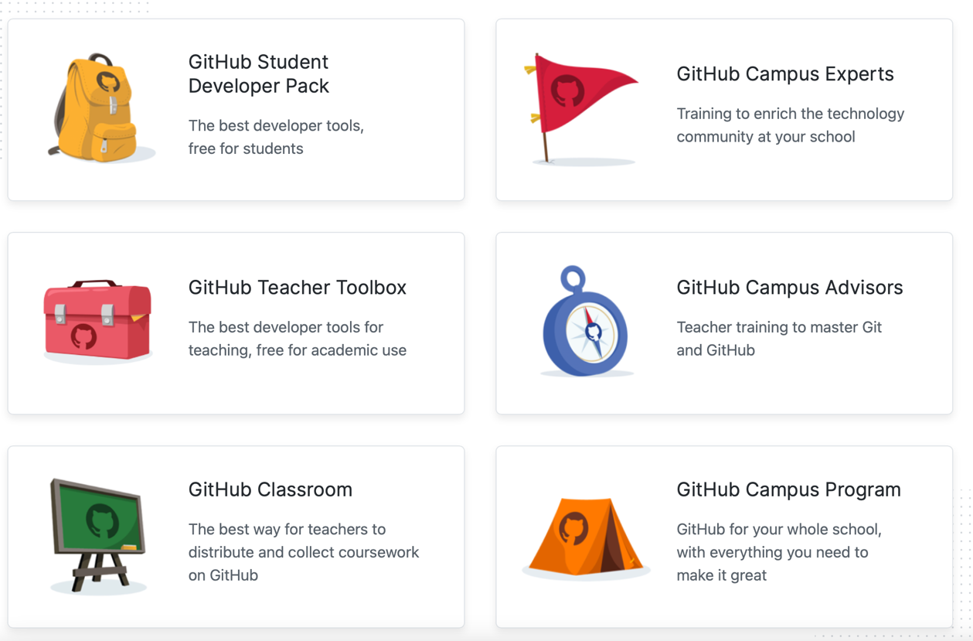

Step 3: Select “Sign in”.

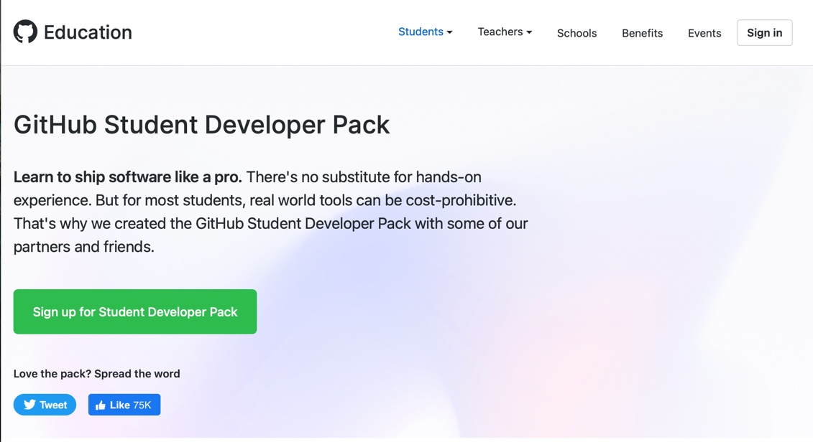

Step 4: Click in “Creat an account”

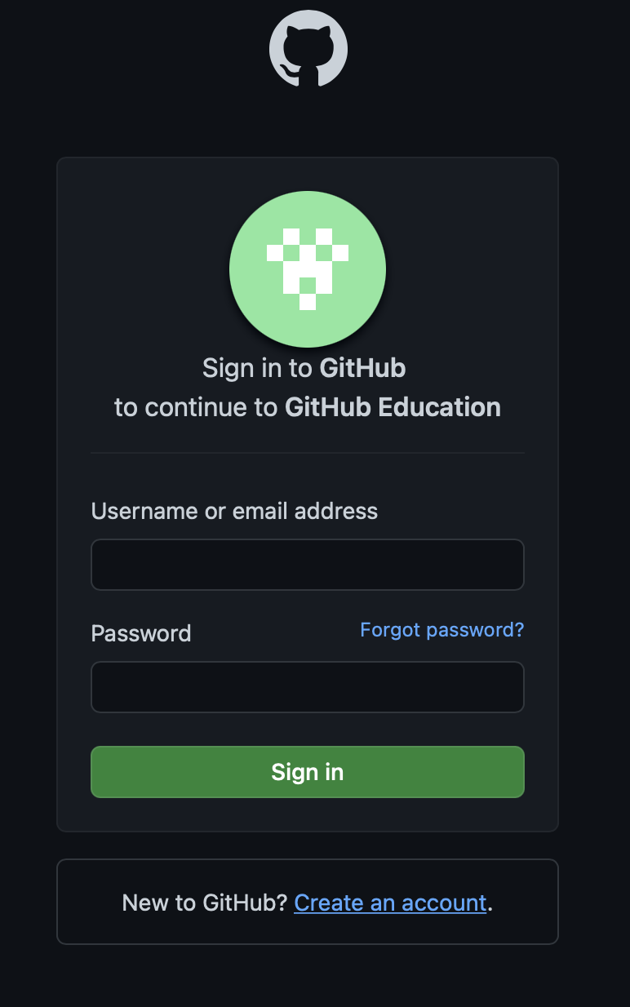

Step 5: Fill in the full information about email, password, login name, solve 1 simple question. Next click “Continue”.

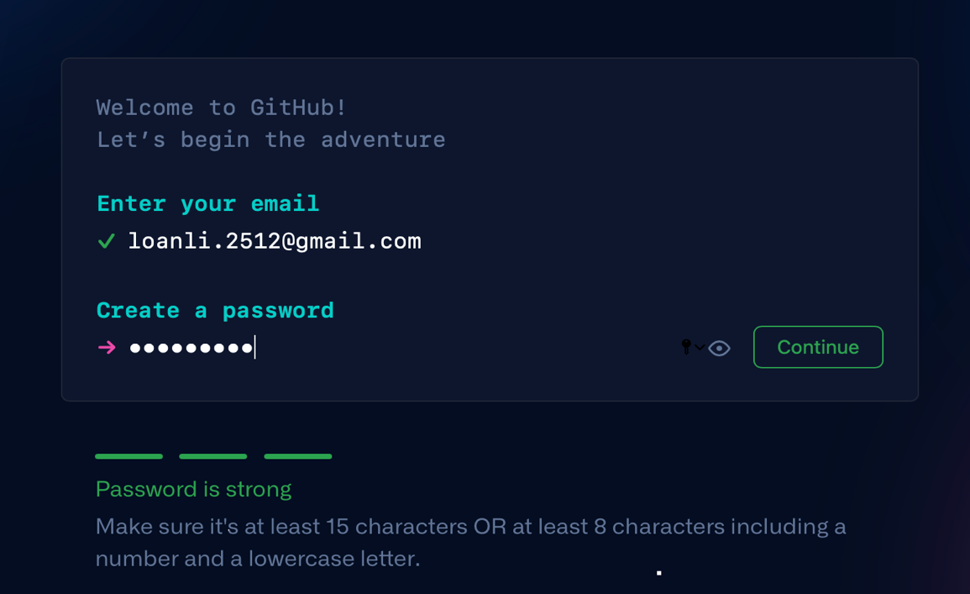

Note: For those of you who want to create an account with the school's email, use that email and prepare to add a photo of yourself.

Step 6: You need to enter the activation code sent to the email to be able to successfully create and the website will appear as below.

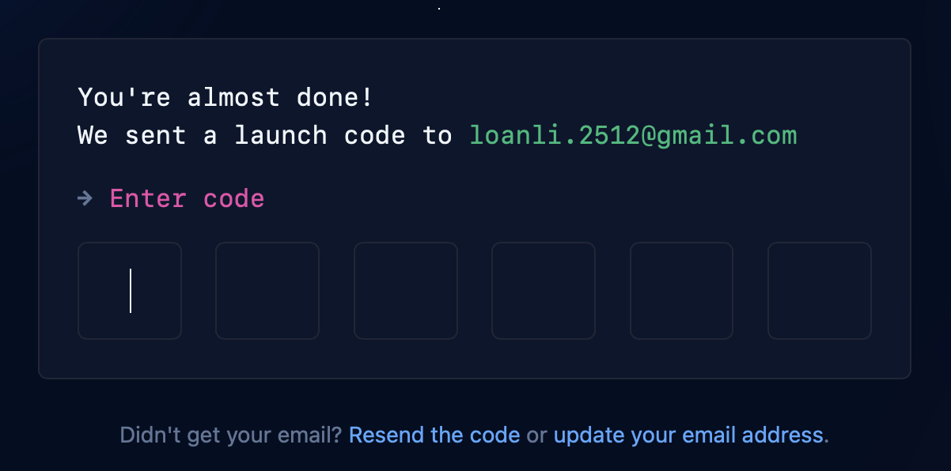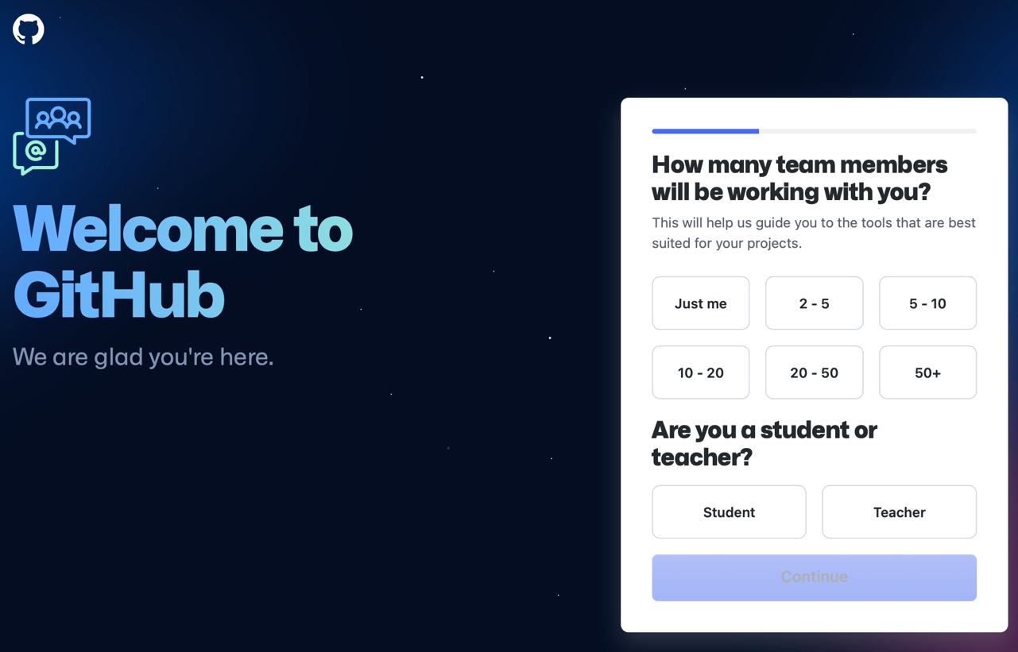

Step 7: Finally, you just need to select the items that correspond to you and select "Apply for your GitHub student benifit" as shown below .

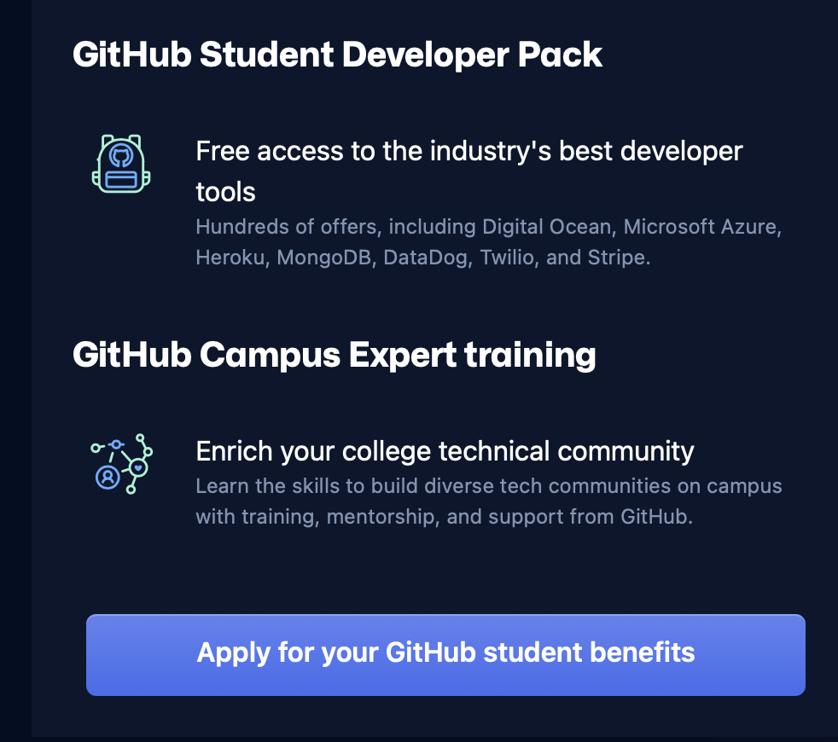

After you have successfully created a new account according to your needs, please reload the website and log in for the first time. Logging in completly, you can use the benefits of the Github Education program.