2.3 GitHub education for Instructor

First, Github education helps teachers manage, communicate, and notify students in a convenient way. (through the use of mail .edu.vn to know the exact information of students)

Besides it allows to use industry leading tools in the classroom of the instructor, for free.

( GitHub teacher toolbox)

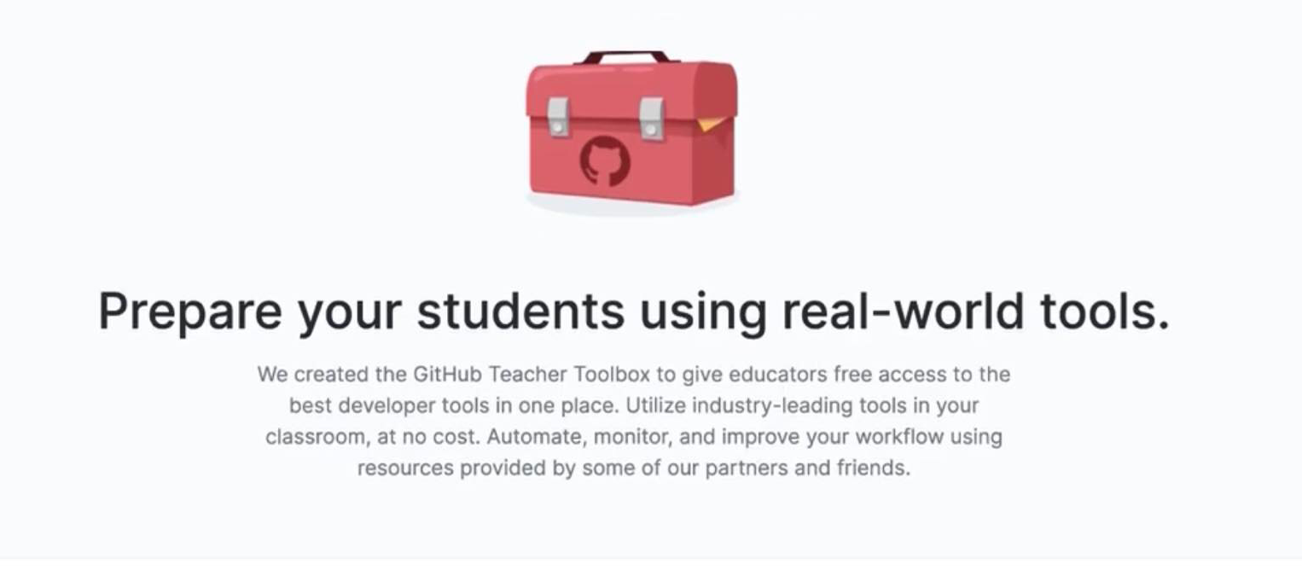

(GitHub Teacher Toolbox Best developer tools for teaching, free for learning purposes)

Automate, monitor, and improve faculty workflow using resources provided by several Github partners and friends . Streamline faculty assignments. Bootstrap assignments in snap. Scale for large courses with ease.(by GitHub Classroom)

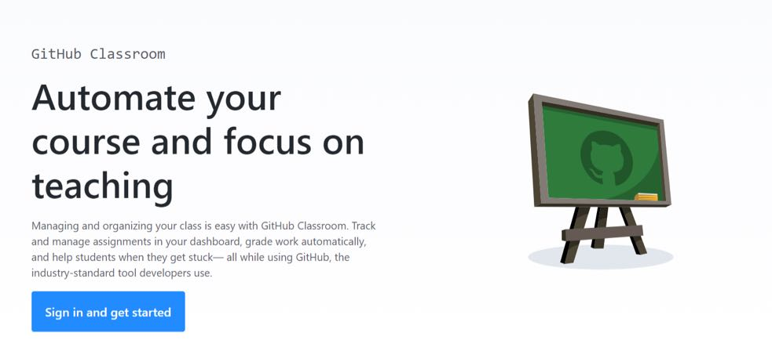

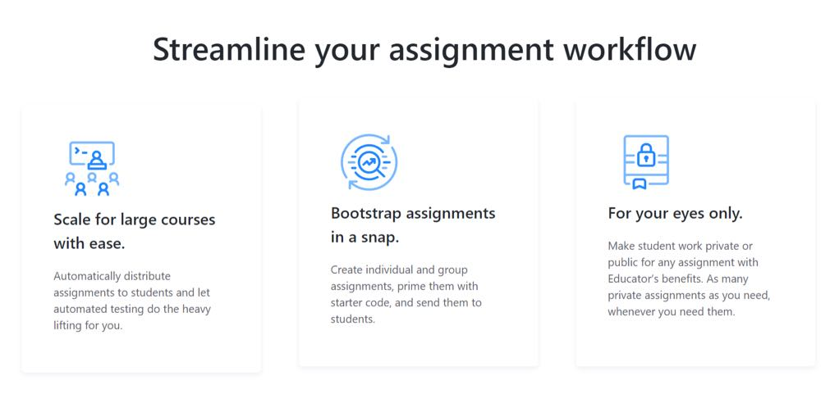

One way to build skills and knowledge for teachers (GitHub Campus Advisors Train teachers to master Git and GitHub)

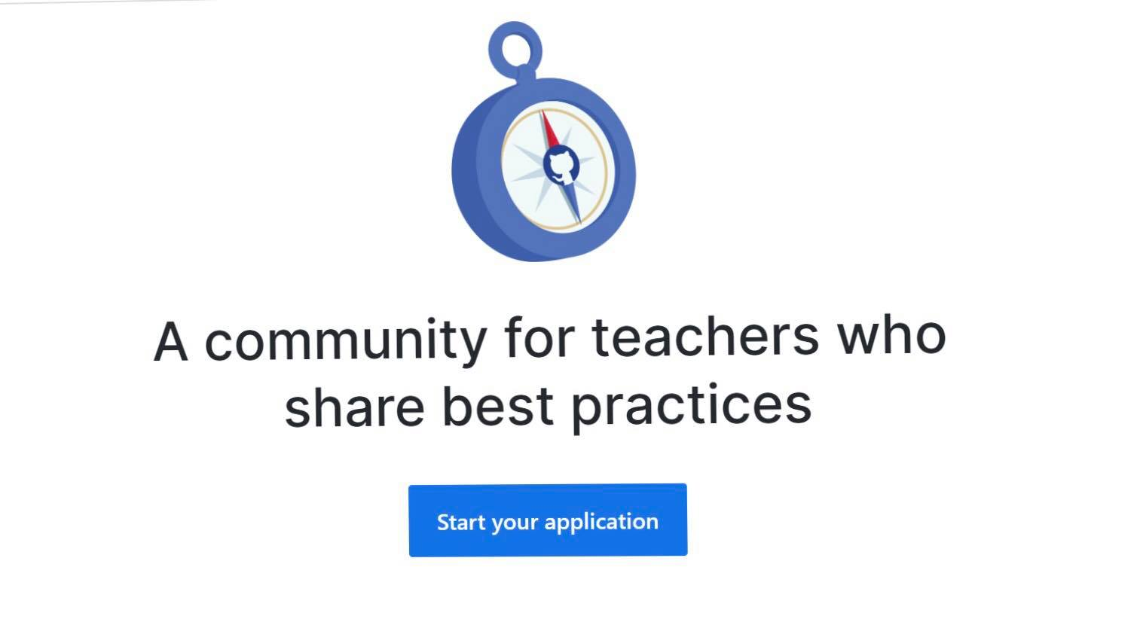

Finally, all instructors can exchange and learn additionally from other instructors around the world through the GitHub Education Community (Where veteran teachers share tips, tricks, and scripts)

