Report

COMPX341 Assignment 4

Lan Niu

* Link:

GitHub: <https://github.com/Lan1u/COMPX341-Assignment4>

* Black-box Test:

1.Testing IsPrime method

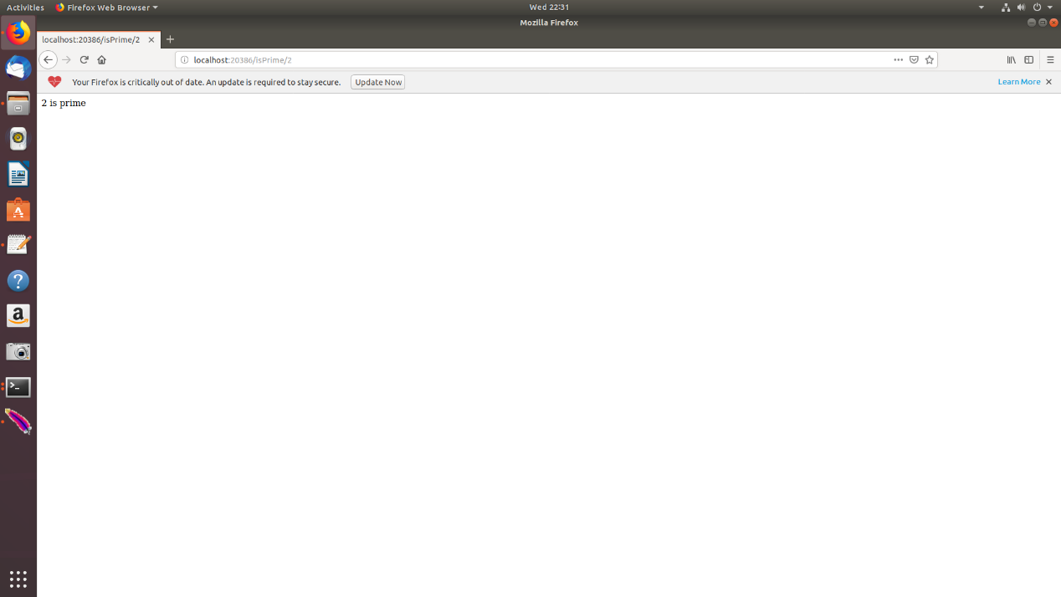

Use the correct path, port, method name and number to access the website. The page should show if the number is prime.

2.Testing primeStored method

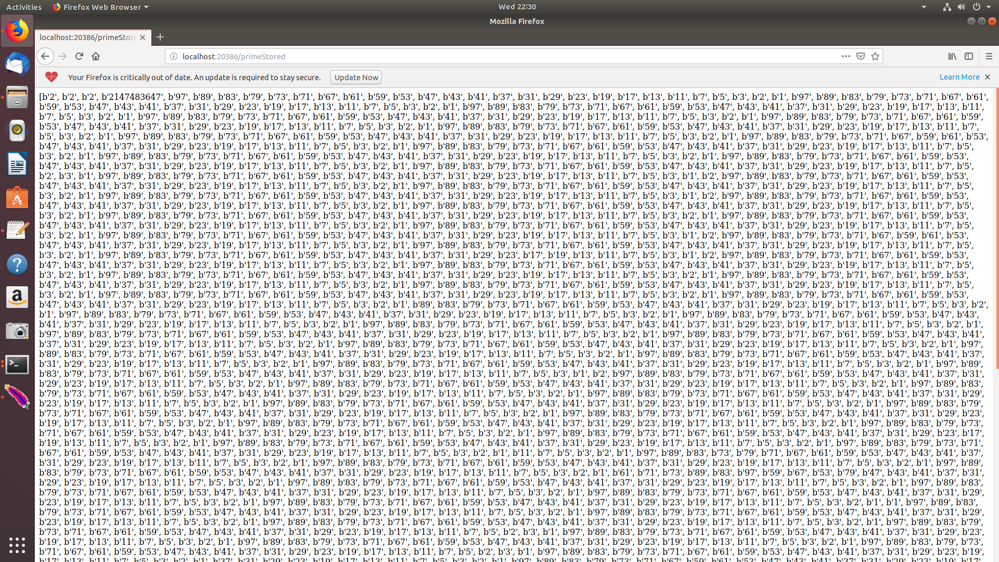

Use the correct path, port, method name to access the website. The page should show all prime numbers stored.

3. Testing if the wrong port can be connected

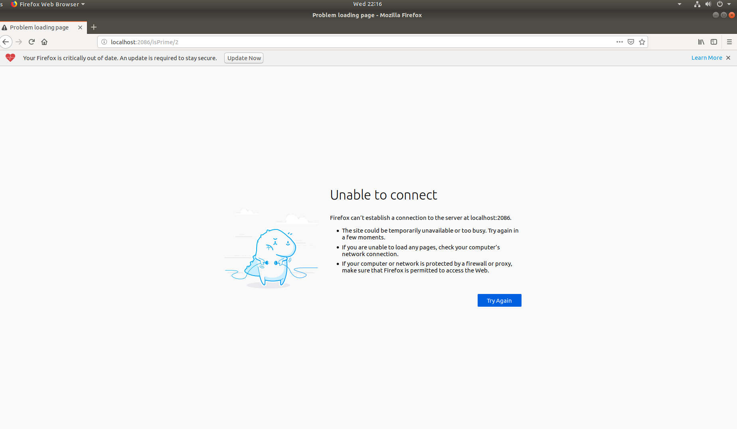

It cannot be connected.

4. Testing if the wrong method name can be connected

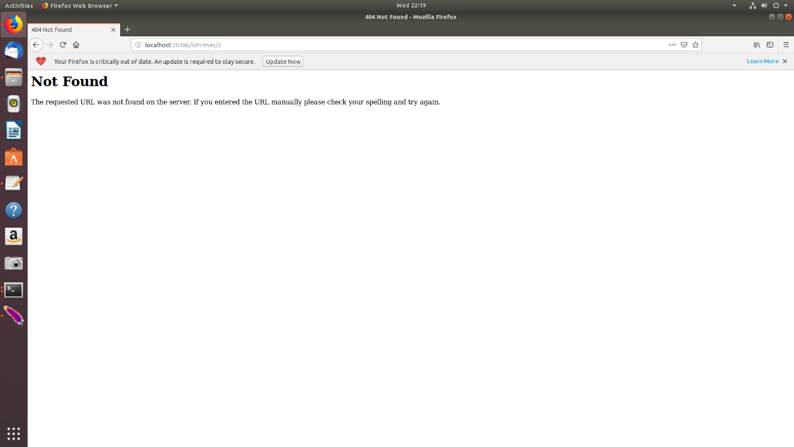

It cannot be connected

5. Testing if the wrong umber can be connected

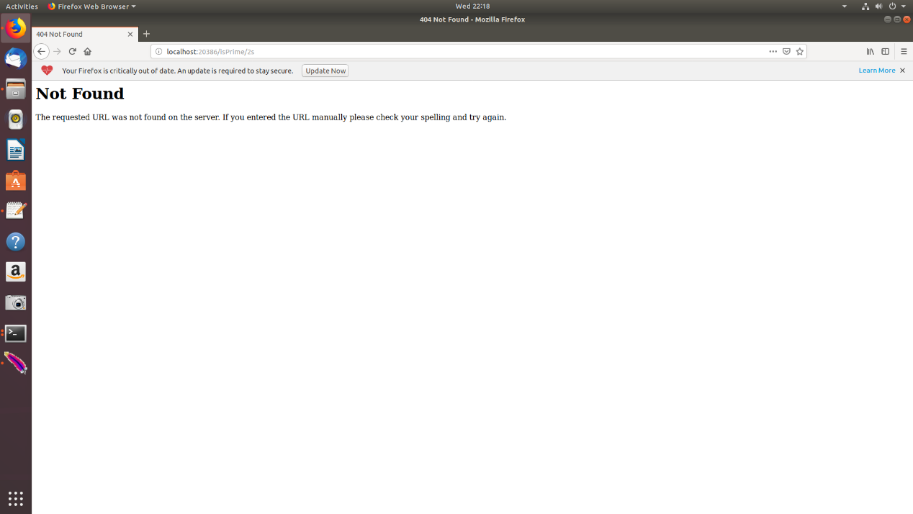

We enter a non-numeric string like ‘s2’, then it returns Not Found.

* White-box Test:

1. Testing When entering negative numbers 1 and 0

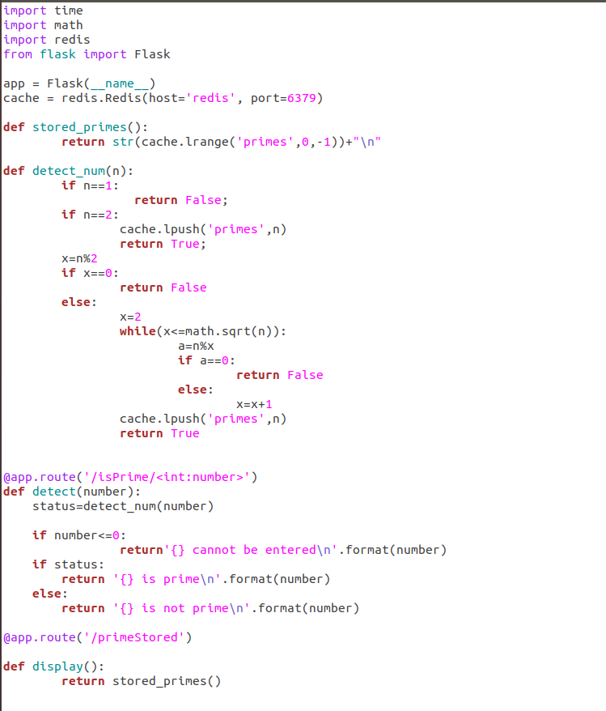

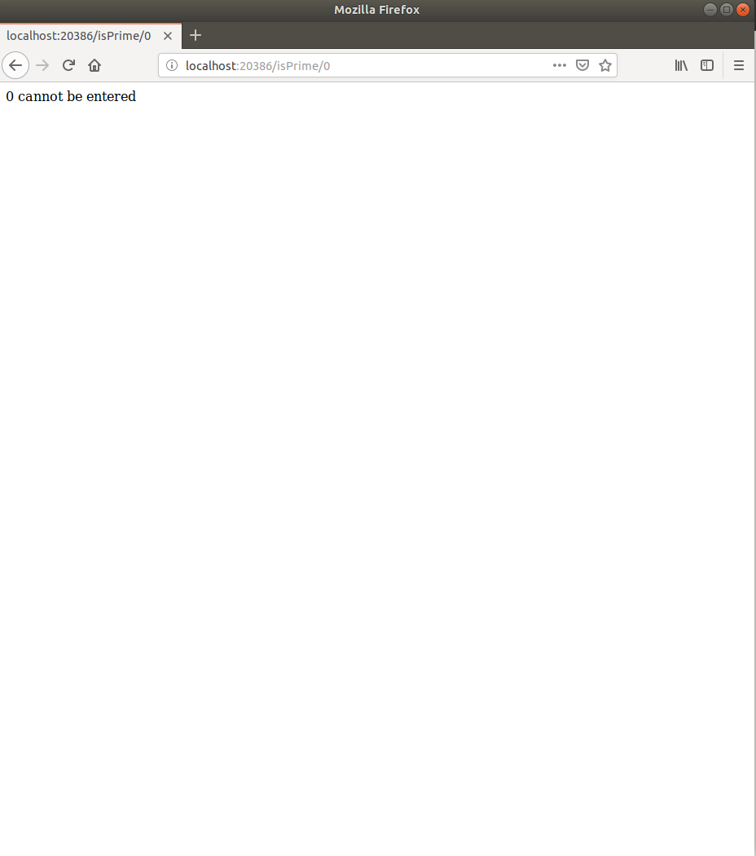

* stress-test results:

Number: 2147483647 Thread: 50

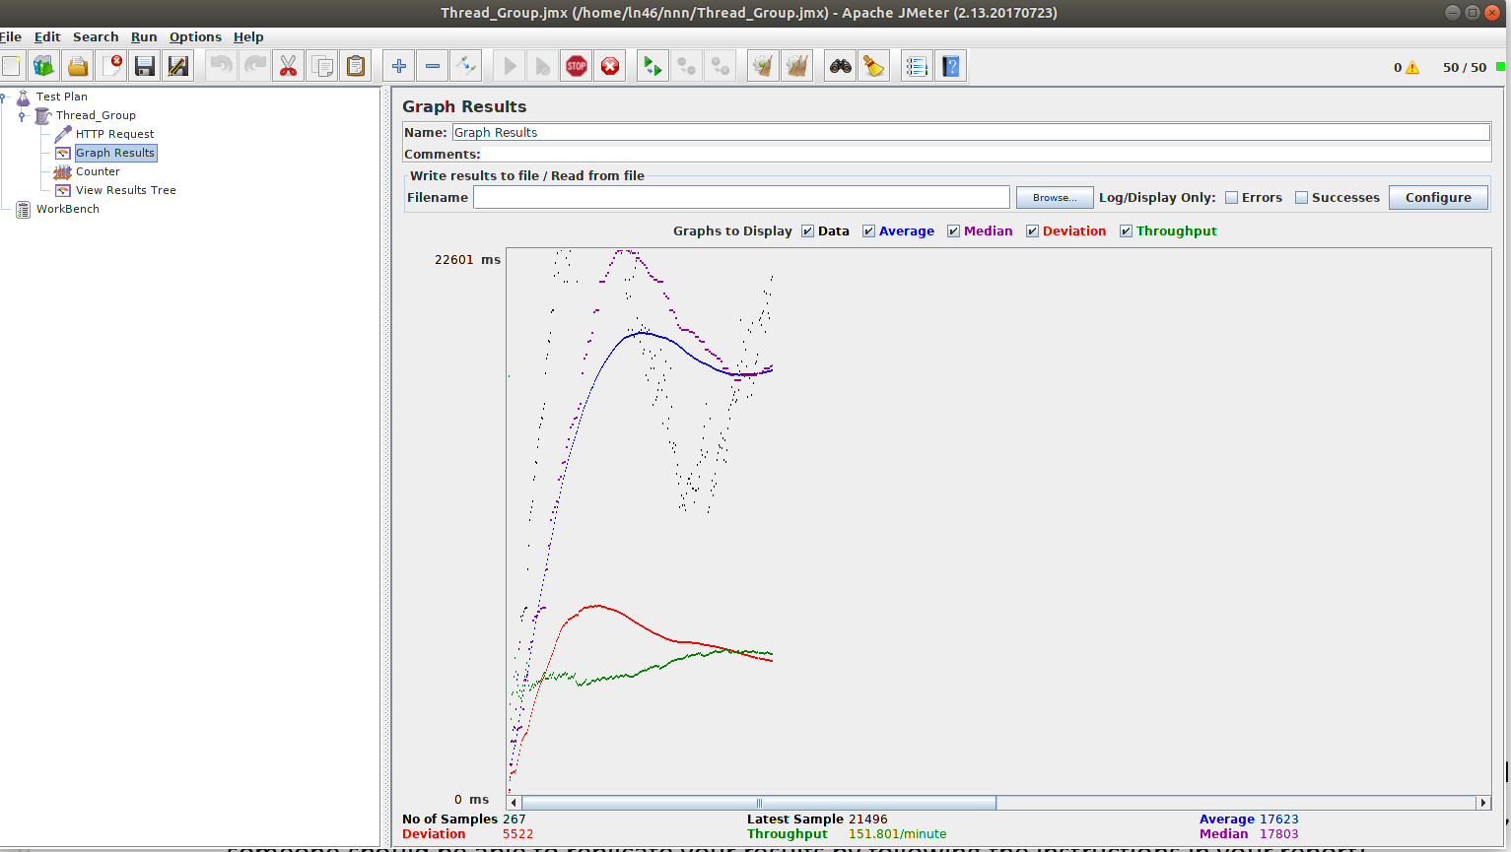

Number: 1to 100

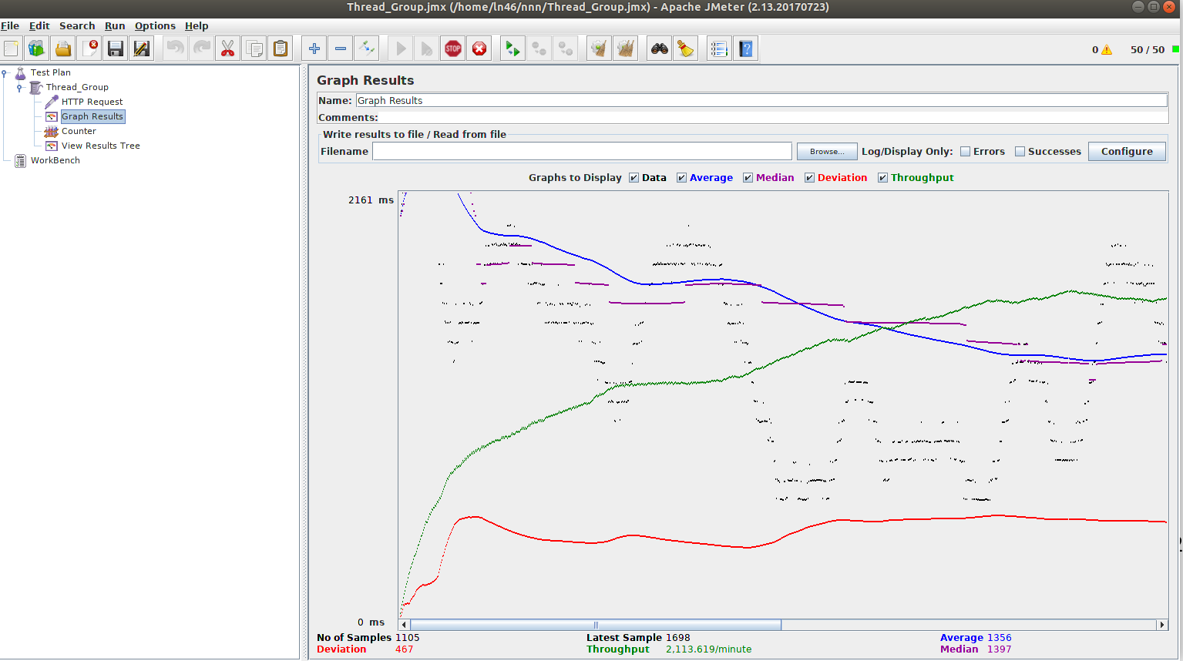

Thread 50 duration 60:

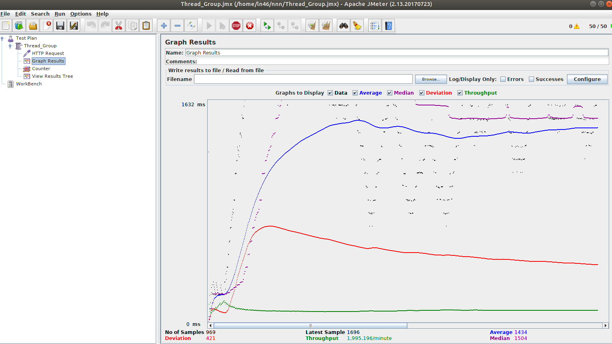

Cpu=0.5

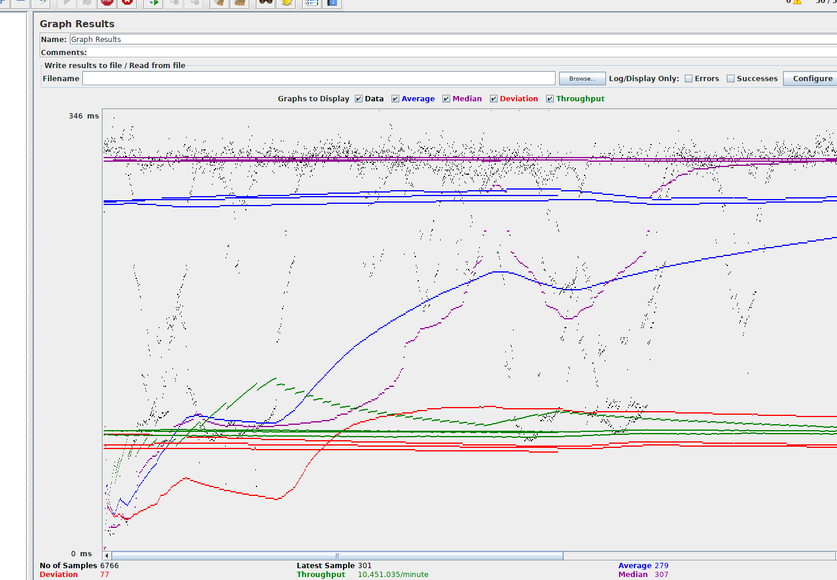

Cpu=1

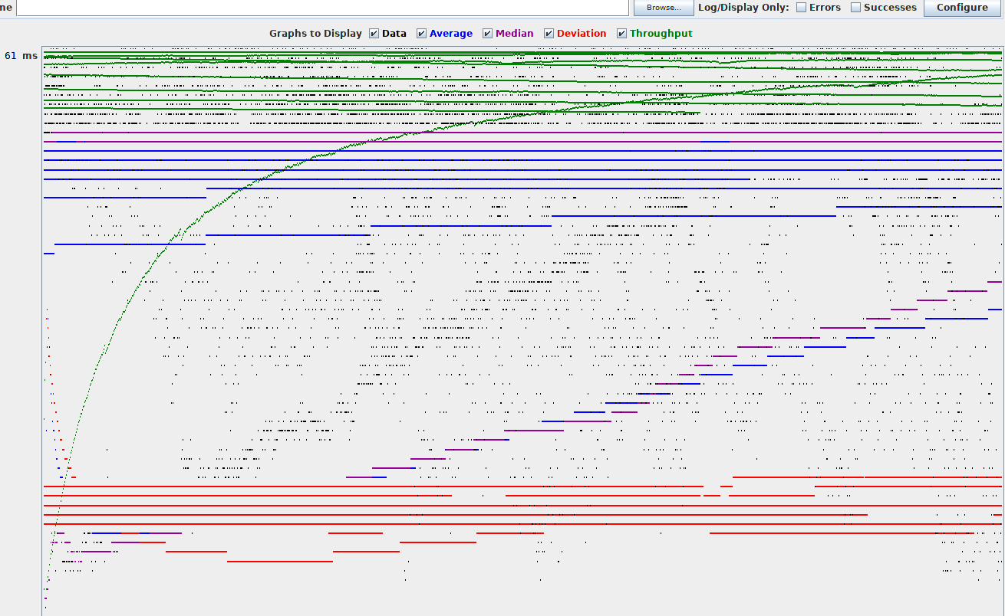

Cpu=4

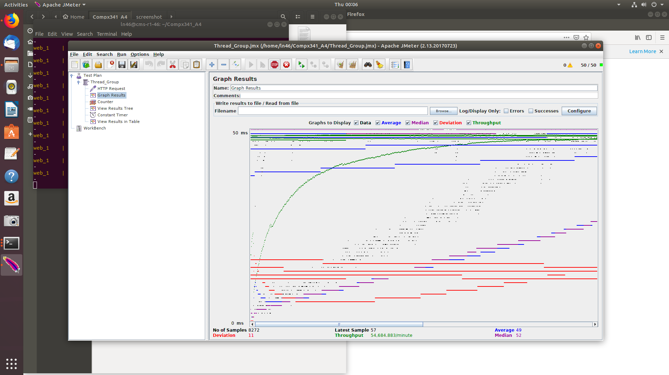

Timer delays=100

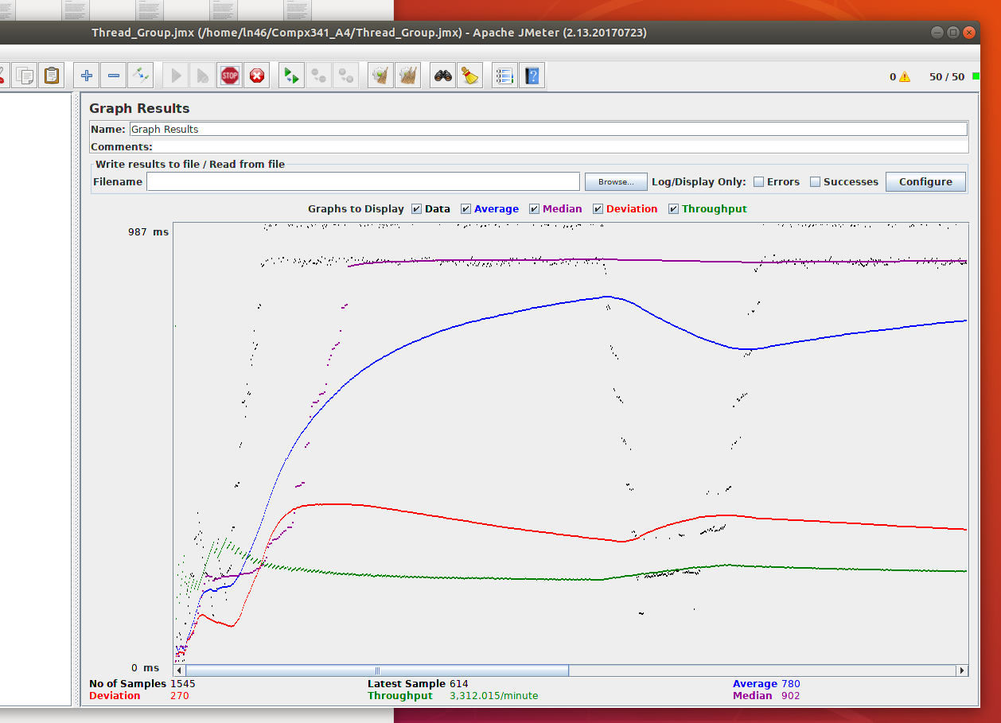

Timer delays =1000

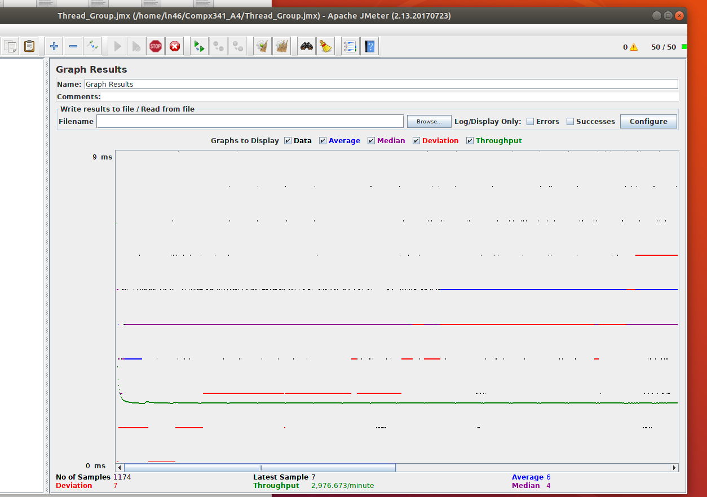

Timer delays =10000

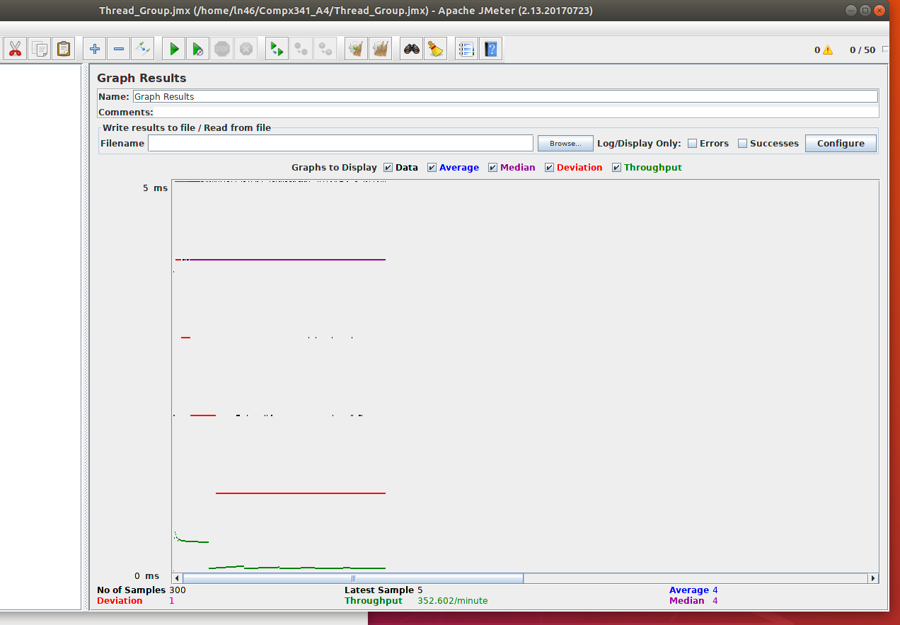

Using console to start Jmeter

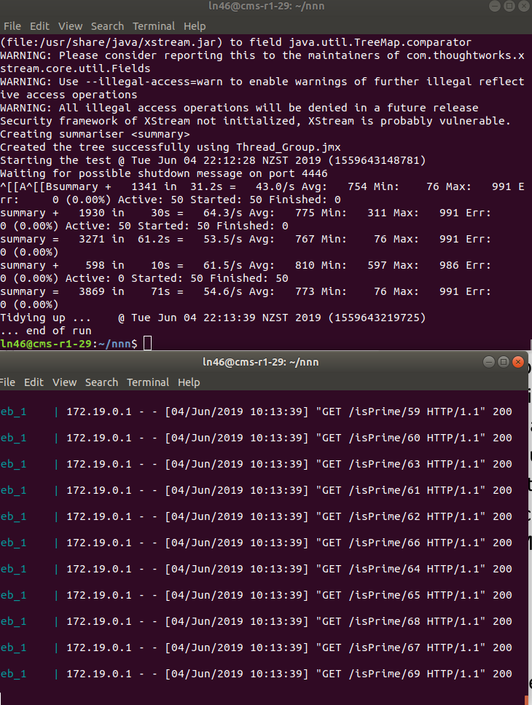

* Result

1. High CPU limits will create high throughput, response-time will be reduced.
2. Up timer delays will reduce throughput and response-time will be increased. Everything will be stable.
3. According to queue theory, the average and median values should rise because the number of requests in the queue increases. When the number of visits is stable, all data is stable.
4. According to Markov chains, the system will stabilize to a certain probability. We can notice that after a period, all data is a straight line, almost no fluctuation.