**MASENO UNIVERSITY**

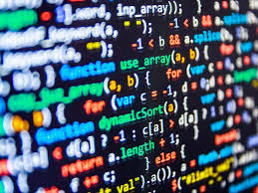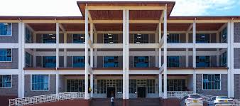

***SCHOOL OF COMPUTING AND INFORMATICTS***

To all the student pursuing computing course are all welcomed to attend a end of year party that will be held at the graduation square on 12th December. You are reminded to come accompanied with your laptops, the shall be a lot of fun and many activities shall be held.



