**Computing Studies and Information Systems**

**CSIS 3860 001 SUMMER 2024**

**DATA VISUALIZATION**

**SCREENSHOT IMAGES**

Submitted to Prof. Rupa Manabala

Submitted by Lan Dinh

Student ID 300383107

1. **Excel insert worksheet**

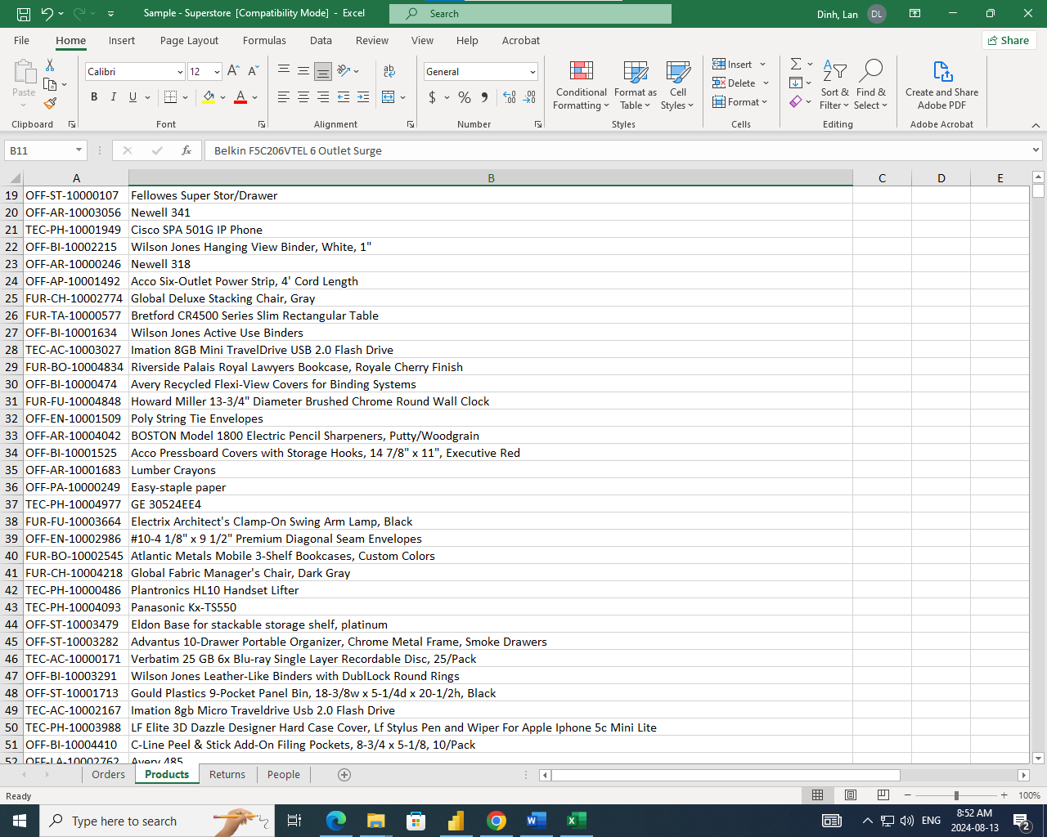

Figure 1. People worksheet

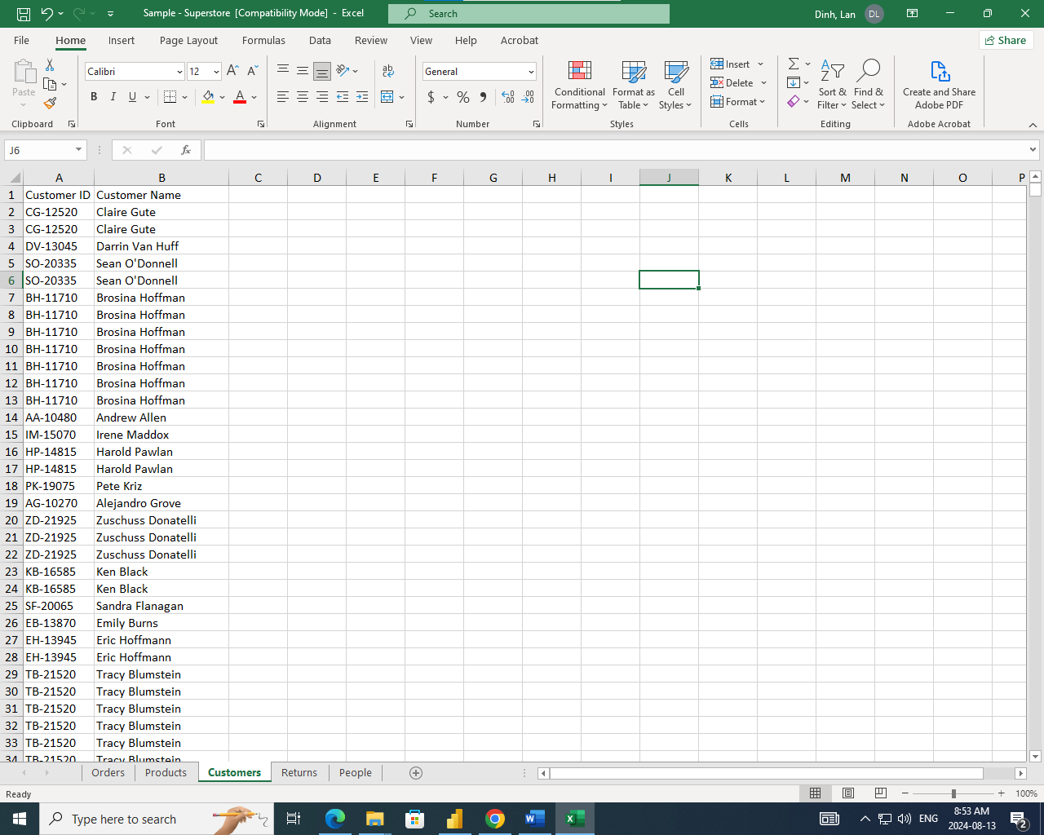

Figure 2. Customers worksheet

1. **Added Tables**

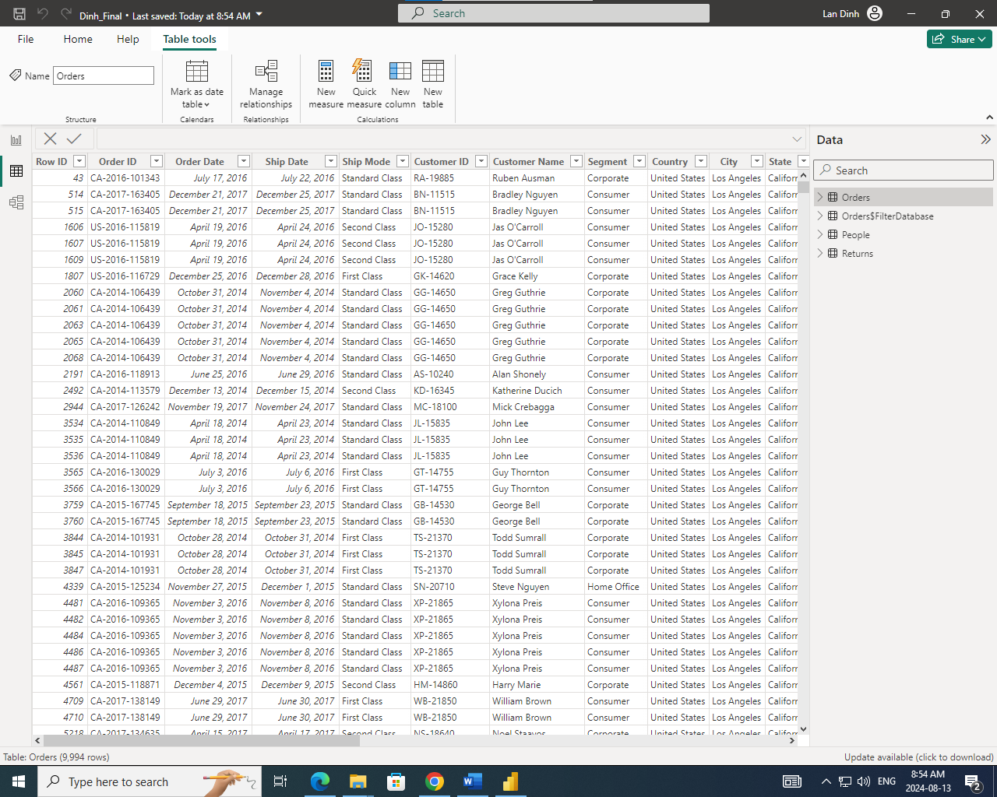

Figure 3. Old Table View

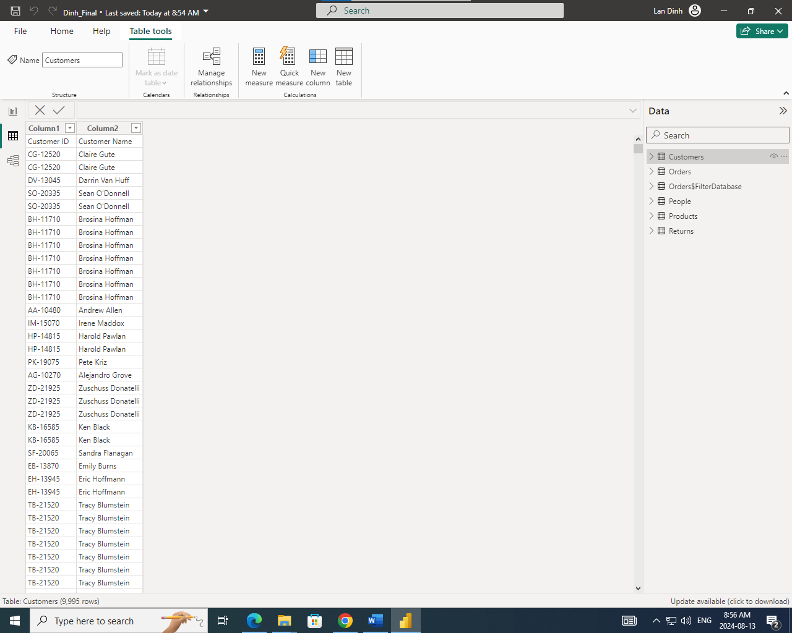

Figure 4. New Table View

1. Applied Steps

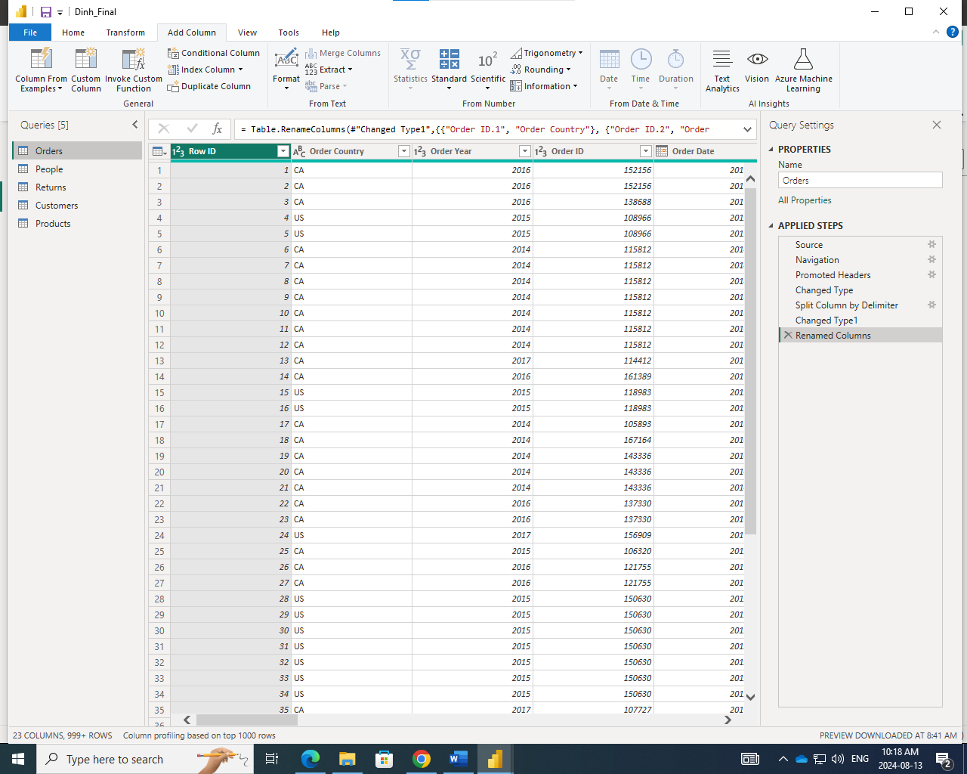

Figure 5. Applied Steps - Orders Query

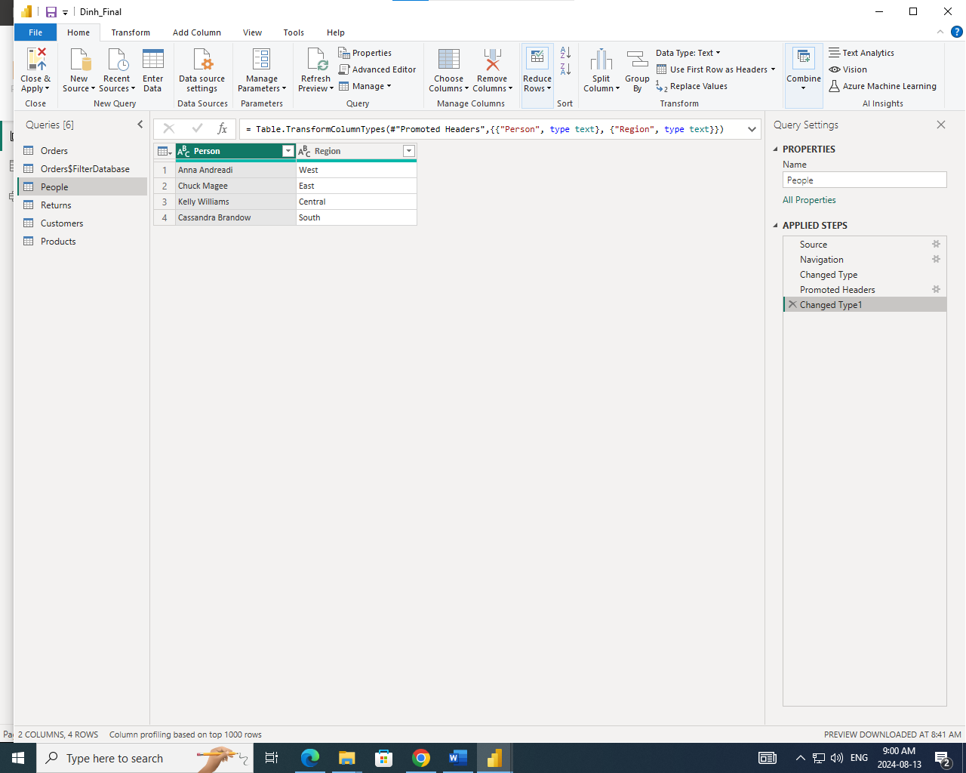

Figure 6. Applied Steps - People Query

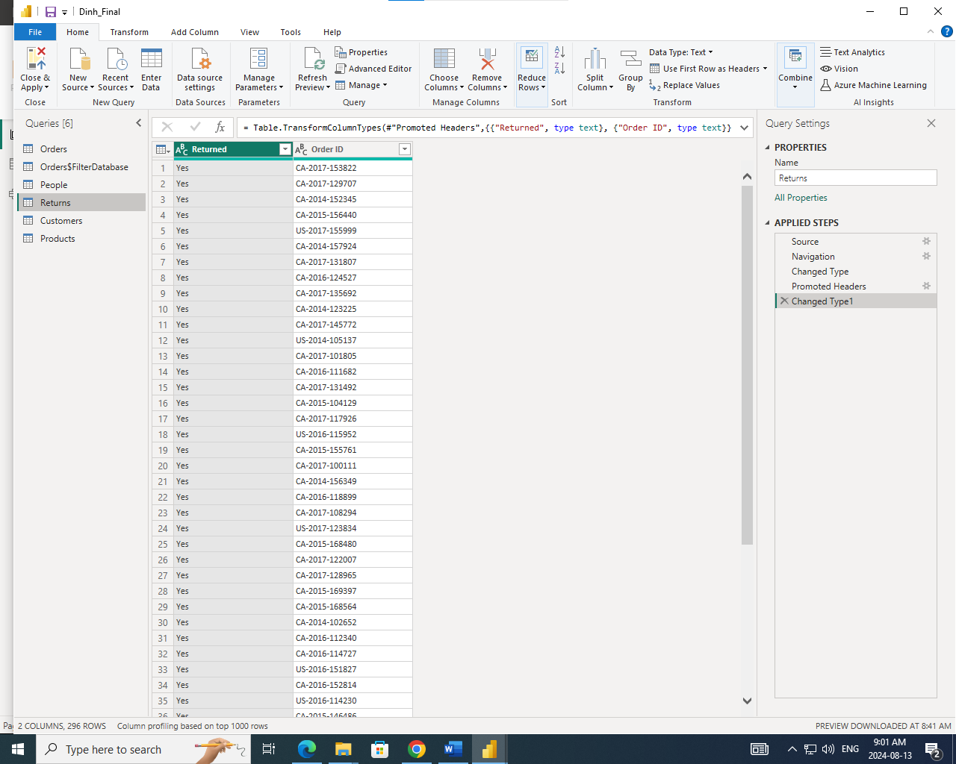

Figure 7. Applied Steps - Returns Query

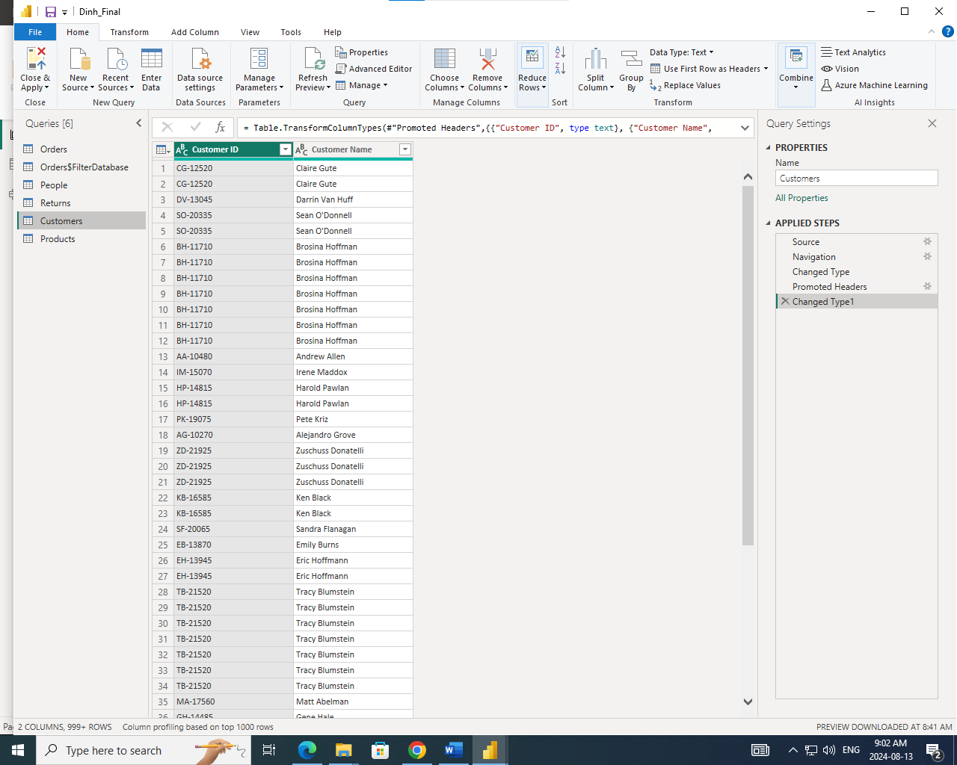

Figure 8. Applied Steps - Customers Query

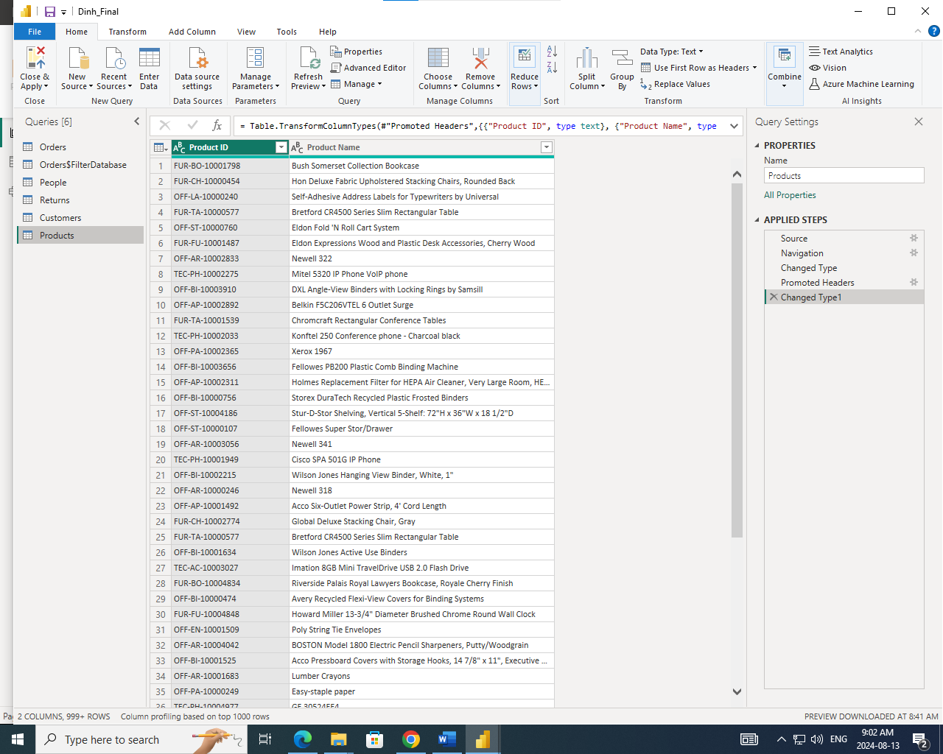

Figure 9. Applied Steps - Products Query

1. **Data Model**

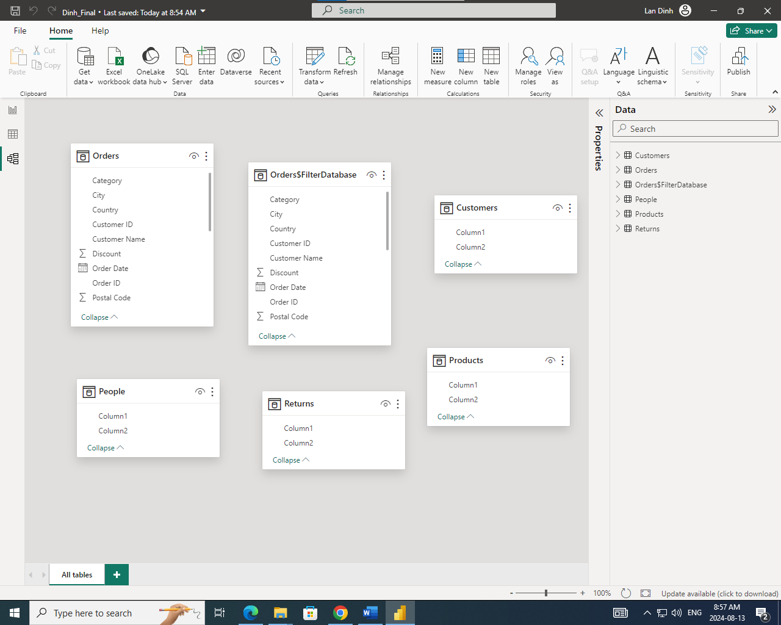

Figure 10. Default Data Model

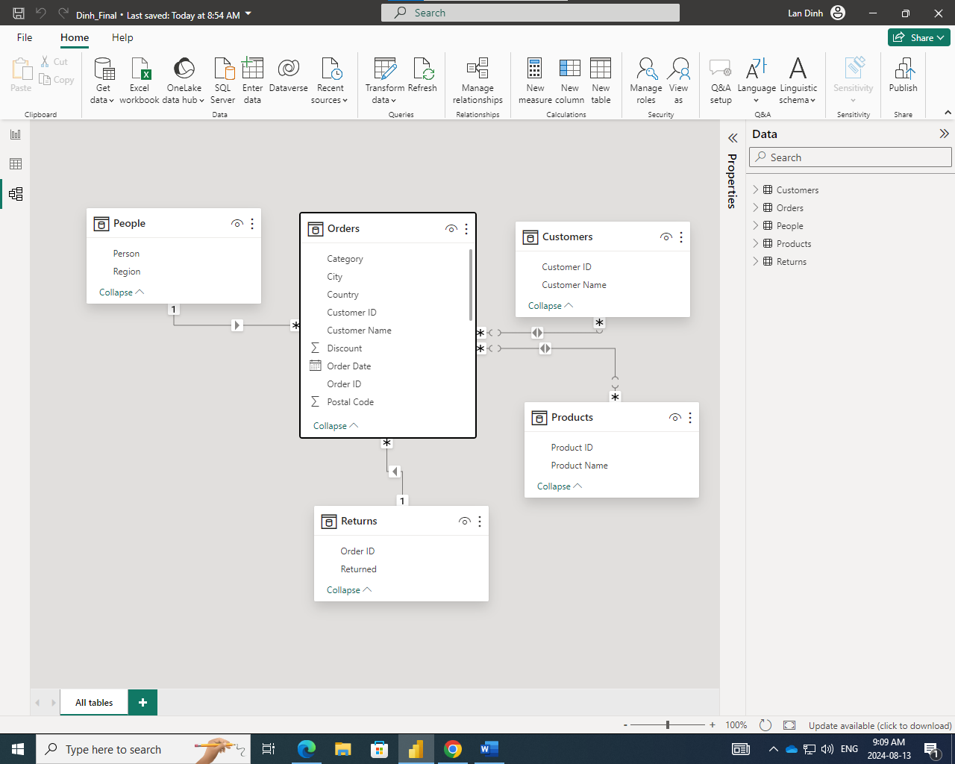

Figure 11. Relationship Model

1. **Calculated column**

