Recommend System

Repo: [GitHub](https://github.com/LanLi2017/cs410text_mining)

1. An overview of the function of the code (i.e., what it does and what it can be used for).

This whole project is based on python 3.6 version. We use the most popular and stable framework: MVC, model-view-controller to achieve the whole data interaction which is from back-end to front-end. And the whole project is including three parts:

The first is Django part , used to construct the website which will output the customers’ information, like the users’ nickname, email and the interested tags. The customized data will be stored in the “data.csv” file.

The second part is the text-mining part, crawler && KNN classification

The third part is the feedback part, this step is used to verify the accuracy and robustness in our second step. Here we use Email function to recommend the events which may interest the users, in accordance with tags in the “data.csv” file at the first step.

1. Documentation of how the software is implemented with sufficient detail so that others can have a basic understanding of your code for future extension or any further improvement.
   1. Sign in interface

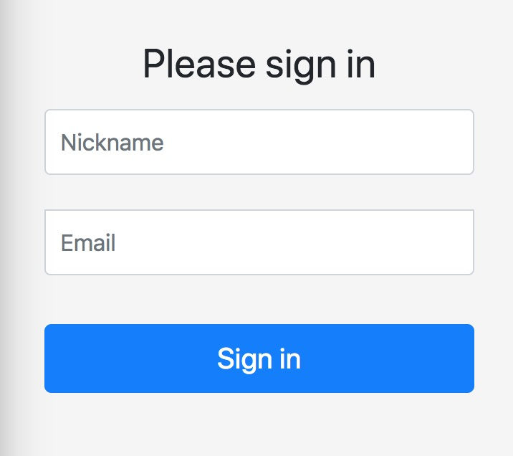

Users can set their own nickname, and input their email for receiving the recommending events later.

2. click and redirect to choose tags which users are interested in.

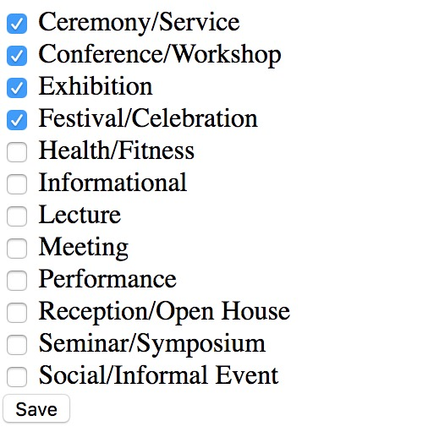

Here we set twelve types events for users choosing: Ceremony/Service, Conference/Workshop, Exhibition, Festival/Celebration, Health/Fitness, Informational, Lecture, Meeting, Performance, Reception/Open House, Seminar/Symposium, and Social/Informal Event.

3. send recommending events to users according to the tags selected.

1. Documentation of the usage of the software including either documentation of usages of APIs or detailed instructions on how to install and run a software, whichever is applicable.
   1. Get the latest official version of the Django:1

Option 1:

$ pip install Django==2.0.5

Option 2:

$ git clone https://github.com/django/django.git

* 1. BeautifulSoup libraray install

3. smtp sending email

1. Brief description of contribution of each team member in case of a multi-person team.
   1. Xiaokai Cui
   2. Jiajun Chen
   3. Lan Li

Using the Django to construct the register interface and subscriber interface, and store users’ information into sqlite database. Then output the data file for later use.

[1] <https://www.djangoproject.com/download/>