

Side-Channel Information Leakage Through Client Probe Requests to Hidden Access Points

Lan Ngai B00159127

Kai Guy B00159763

Alex Anthony Dela Cruz B00149504

May 2026

School of Informatics and Cybersecurity, Faculty of Computing, Digital & Data,
Technological University Dublin

Supervised by:
Gregory South

Submitted to Technological University Dublin in partial fulfilment of the requirements for the degree of
Bachelor of Science in Computing in Digital Forensics & Cyber Security

Declaration
I hereby certify that this material, which I now submit for assessment on the programme of study leading to the award of Degree of Science in Computing in Digital Forensics & Cyber Security in the Technological University Dublin, is entirely my own work except where otherwise stated, and has not been submitted for assessment for an academic purpose at this or any other academic institution other than in partial fulfilment of the requirements of that stated above.

Signed:________________________ Dated: ____/_____/_____

Signed:________________________ Dated: ____/_____/_____

Signed:________________________ Dated: ____/_____/_____

Abstract
GUIDE TO STUDENTS: An abstract is a brief overview of the project. Ideally it should fit onto a single page.
This project tackled the problem of creating a computer-based tool to model and manipulate music. The problem to be solved was how to create a computer tool that is easy to use but that also allows for non-trivial musical actions to be made on the computer. In this report a description is presented of the specification and analysis of the problem, the review of relevant research conducted, and the life cycle of the system that was developed to solve the problem.
Key features of the developed system, called “Pitch Circles”, including its basis in a respected music theory, its development in an object-oriented programming language – Java 2, and the evaluation of the system from an HCI (Human Computer Interaction) perspective, in additional to more traditional functional testing.
The result is a simple, but powerful tool for basic musical tasks, that is easy to learn while elegantly modelling the symmetric and asymmetric features of the Western Diatonic music system. With the Pitch Circles tool novices users can identify the relationship between triadic chords and different regions (scales), and use simple rules for movement around the tonal circles to derive and apply fundamental musical principles including the chromatic and diatonic circles of fifths.

Acknowledgements
We would like to acknowledge the help and support from our supervisor Gregory (Greg) South who gave us great guidance all semester long while empathising with our personal struggles along the way which caused some issues while completing this project.
We would also like to thank our year tutor, Peter Alexander who advised us and answered many questions before we started on this group thesis.

Table of Contents
Declaration 2
Abstract 3
Acknowledgements 4
Table of Contents 5
List of Tables 8
Table of Figures 9
List of Equations 10
List of Abbreviations 11
Chapter 1: Introduction 12
1.1 Project Overview 12
1.2 Research Questions 12
1.3 Objectives 12
1.4 Structure of the Report 13
Chapter 2: Literature Review 14
2.1 Overview of SSID Technology & Capabilities 14
2.2 Understanding Wi-Fi 14
2.3 General Data Protection Regulation (GDPR) Legislation 17
2.4 User Privacy Concerns 17
2.5 Password Leaks in Probe Requests 19
2.6 Log Distance Path Loss Model 19
Chapter 3: Methodology 22
3.1 Overview of Methodology 22
3.2 Stage 1: Review of existing work 22
3.3 Stage 2: Requirements specification 23
3.4 Stage 3: Supporting Experimentation 24
3.5 Stage 4: Analysis Capture 24
3.6 Stage 5: Trilateration Phase (POC) 26
3.7 Stage 6: Evaluation of results 28
Chapter 4: System Requirements & Specification 29
4.1 System Requirements & Specifications 29
4.2 Why Linux & Not Windows 30
Chapter 5: System Design 31
5.1 Architectural Overview 31
5.2 Purpose of the Module 31
5.3 Log-distance Path Loss Model 32
Chapter 6: Supporting Tests 33
6.1 Supporting Tests Overview 33
6.2 Initial Testing 33
6.3 Testing Androids’ Behaviour 38
6.4 Evaluating Supporting Evidence Gathered 41
Chapter 7: Implementation of Prototype 42
7.1 Proof of Concept Testing 42
7.2 Prototype Overview 43
7.3 Key Findings from Testing Prototype 44
Chapter 8: Testing & Evaluation 48
8.1 Testing Overview 48
8.2 Triangulation 48
8.3 User Profiling 57
8.4 Mistaken Password Field 61
8.5 Evaluation of Results 62
Chapter 9: Key Learnings Derived 63
9.1 Monitor Mode 63
9.2 Sequence Numbers 63
9.3 General Data Protection Regulation Legislation 63
9.4 Human Error 63
9.5 Threat landscape 63
Chapter 10: Conclusions & Further Work 64
10.1 Conclusions 64
10.2 Further Work 64
List of References 65
Appendix A: Project Planning 68
i) Initial Gantt Chart 68
ii) Corresponding Notes to the Initial Gantt Chart 68
iii) Unexpected Circumstances 69
iv) Timeline of Events 69
v) Format Planning 69
Appendix B: Legal Compliance, Ethics & Interest 70
i) Legal Compliance & Ethics 70
ii) Declaration of No Conflict of Interest 70
Appendix C: Program listings 71
i) The GitHub Repository Link 71
ii) Summary of included program listings 71
iii) “collecting_antenna_strength.py” 72
iv) “basic_packet_sniffer.py” 73
v) “basic_pyshark.py” 75
vi) Referencing for “prototype_pyshark.py” & “final_pyshark.py” 77
vii) “prototype_pyshark.py” 78
viii) “final_pyshark.py” 79
Appendix D: Hardware & Software Used 80
i) Hardware Used 80
ii) Software Used 81
iii) Wireshark Filter Used 81
iv) Expenditure 81
Appendix E: Statement of Contribution 82
i) Lan Ngai 82
ii) Alex Anthony Dela Cruz 82
iii) Kai Guy 82

List of Tables
Table 2.1 – An example of address field values in the probe request frames. 19
Table 2.2 – Path loss exponent values (Khaled & Ajib, 2022). 22
Table 6.1 - Meaning of each type/subtype in the Wireshark filter as frame types. 40
Table 7.1 – Path loss exponent values (Khaled & Ajib, 2022). 45
Table 7.2 – Path loss exponent values (Khaled & Ajib, 2022). 48
Table 9.1 - Corresponding Gantt chart notes. 71
Table 9.2 - Hardware resources used in this project. 83

Table of Figures
Figure 2.1 – The discovery stage. 17
Figure 2.2 – The authentication stage. 18
Figure 2.3 – The association Stage 18
Figure 2.4 – A threat actor profiling an individual based on listening for probe requests and analysing the SSIDs found. 20
Figure 5.1 - High-level design diagram. 33
Figure 5.2 - Low-level design diagram. 34
Figure 6.1 - Initial Testing: Wireless client connects to the hidden access point while being monitored. 35
Figure 6.2 - Initial Testing: Hidden AP being turned off while being monitored. 36
Figure 6.3 - The SSID of the hidden AP can be seen in the probe responses. 36
Figure 6.4 - The destination can expose the type of device the probe request was meant for. 37
Figure 6.5 - The antenna signal can be seen in the Radiotap header. 37
Figure 6.6 - Initial Testing: overall picture of the pcap file in Wireshark. 38
Figure 6.7 - Close up of the deauthentication packets shown in the Wireshark capture file. 38
Figure 6.8 - The deauthentication packets shown in the Wireshark capture file. 39
Figure 6.9 - Wireshark filter used to view only relevant subtypes of the management frames. 39
Figure 6.10 - The Wireshark filter used to hone in on specific packets. 40
Figure 6.11 - Wireshark capture of the behaviour of the Samsung A16. 41
Figure 6.12 - Wireshark capture of the behaviour of the Samsung A16 continued. 41
Figure 6.13 - Wireshark capture of the behaviour of the Samsung A5. 42
Figure 6.14 – Image of a probe request from the Samsung A5 showing the source MAC address. 42
Figure 7.1 - Various possible names for the SSID attribute we tried. 44
Figure 7.2 - Timeline up until "prototype_pyshark.py". 46
Figure 7.3 - Picture of the output of “debug.py” called “debug.txt” with the SSID attribute highlighted. 47
Figure 7.4 – Method used to calculate from RSSI to distance. 48
Figure 8.1 - SSID exposed through probe requests, "starducks_staff_blanchsc". 59
Figure 8.2 - SSID exposed through probe requests, "blanch_sc". 60
Figure 8.3 - SSID exposed through probe requests, "blanch_library". 60
Figure 8.4 - SSID exposed through probe requests, "eduroam_test". 61
Figure 8.5 - SSID exposed through probe requests “alan_home”. 61
Figure 8.6 - SSID exposed through probe requests, “friend_phone”. 62
Figure 8.7 - Example of if a password was mistakenly entered into the SSID field. 63
Figure 10.1 - Timeline of the creation of the Python scripts. 73
Figure 10.2 – “collecting_antenna_strength.py”. 75
Figure 10.3 - "basic_packet_sniffer.py". 76
Figure 10.4 - "basic_pyshark.py". 77
Figure 10.5 - "basic_pyshark.py" with a focus on the event loop portion. 78
Figure 10.6 - "basic_pyshark.py" with the event loop part highlighted. 78
Figure 10.7 - Image of the reference list in both “prototype_pyshark.py” and “final_pyshark.py”. 79
Figure 10.8 81

List of Equations
Equation 2.1 - Standard equation model for log distance path loss. 19
Equation 2.2 - Our derived equation to approximate distance from RSSI. 20
Equation 7.1 - Our derived equation to approximate distance from RSSI. 45

List of Abbreviations

AP
Access Point, 35
BSSID
Basic Service Set Identifier, 16
EU
European Union, 43
GDPR
General Data Protection Regulation, 43
MAC
Media Access Control, 41
RSS
Relative Signal Strength, 37
RSSI
Relative Signal Strength Index, 21
SSID
Service Set Identifier, 14

Introduction

Project Overview
xxxxxxxxxxxxxxxxxxxxxxx

Research Questions
This section outlines key questions asked while research for this report was conducted. These questions are centred around privacy concerns regarding set service identifiers (SSIDs) being in plaintext format as it’s relatively easy to attain.
- Should Set Service Identifiers (SSIDs) be treated as sensitive information since under General Data Protection Regulation (GDPR) it is deemed as personal data?
- When does publicly broadcasted data reveal sensitive information in context?
- Do the current existing mechanisms remain effective in protecting user data and privacy in the context of SSIDs?
- What security risks does this pose to the average individual?
- What differences are there between different client devices such as Android devices and Apple devices if there is a difference?
- Would we be able to fingerprint device types (whether that be Android, Apple, Windows etc.) through IEEE headers?

By asking these questions we created a storyboard of events. It highlights a potential misuse of publicly available information. For example: How do Wi-Fi modems and mobile device remember each other? What if there was an eavesdropper in the middle? How much indirect information is revealed through the public broadcast of SSIDs from probe requests and beacon frames?

Objectives
The main objectives of this project and subsequent report are as follows:
- To determine the effectiveness of legislation and compliance in place currently regarding SSIDs being deemed as personal data under GDPR.
- To determine whether mechanisms currently in place are sufficiently protected users’ personal data being SSIDs such as enabling an access point (AP) as hidden through disabling broadcast SSID.
- To explore possible privacy issues which the average individual may face when SSIDs are not secured.
- To put the possible privacy issues into the perspective of the average individual in real life.

Structure of the Report
This report is outlined as such, it will explore past published papers and their findings relevant to the authors’ research questions regarding this project. This will be followed by the methodology adopted by the authors of this report and the system specifications used for the purpose of this project along with its justification for the system design choice. This report will also include the implementation of a prototype and proof of concept tests done in support of the objectives to this project. Findings from the al testing will be explored in full to address our research questions and objectives.

Literature Review

Overview of SSID Technology & Capabilities
Service set identifier or more well known as “SSIDs” are unique names set to identify Wi-Fi networks (Paulsen & Toth, 2016) while basic service set identifier (BSSID) refers to the unique MAC address of that specific piece of hardware transmitting the radio waves (Frankel, et al., 2007). SSIDs are often overlooked when it comes to security. Most guidelines and recommendations focus on the security architecture and technologies used (Souppaya & Scarfone, 2012).
Current mechanisms in place to secure SSIDs follow the idea of hiding them completely through the no broadcast option when configuring the wireless access point (AP) however the SSIDs thought to be hidden can still be uncovered through clients’ Wi-Fi probe requests. Localisation is also possible through the leverage of triangulation and deriving distance through the standard log distance path loss model. We review a report which focuses on fine tuning the accuracy of the path loss exponent depending on seasonal conditions and antenna height and elevation. This is particularly interesting as this method of localisation does not require a radio map, making it quite accessible.
Another consideration which may be often forgotten is the human error aspect as in section 2.5 of this report we review a study were the researchers discovered that an unexpected amount of passwords of APs were exposed due to user error. It seemed that users had mistakenly filled the SSID field with the password of the AP.

Understanding Wi-Fi
Wi-Fi runs on the IEEE 802.11 protocol (Gridelli, 2024). Clients search through all available frequencies for SSIDs to join. Wireless access points send out beacons frames so that they can be discovered by clients. These beacon frames contain essential information such as the SSID, the BSSID, beacon interval, timestamp for network synchronization, and capability information (Gupta & Rohil, 2012).
An authentication request probe is then sent when the client finds a SSID matching its configuration. The authentication request and response frames remain unencrypted however the 4-way handshake following that is encrypted (Gridelli, 2024).
During the discovery stage a probe request is sent out by the wireless client to a broadcast address or to a specific SSID. The access point may then send out a probe response. After that the client would then send out an acknowledgement frame. This is then succeeded by the open authentication stage.
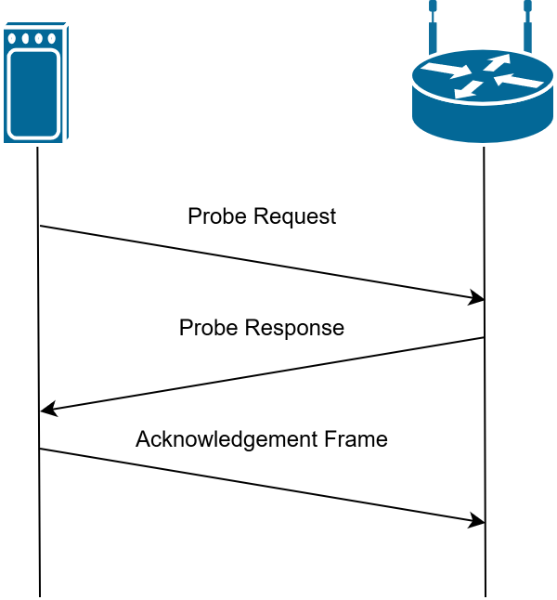
Figure 2.1 – The discovery stage.
During the open authentication stage, the wireless client sends an authentication request, the access point then replies with an authentication response. This stage is a legacy formality and is present in modern protocols (i.e. WPA2, WPA3) before the association stage. During the association stage the client sends an association request. The access point would then send an association response with an association ID (AID). After this the security handshake would take place.
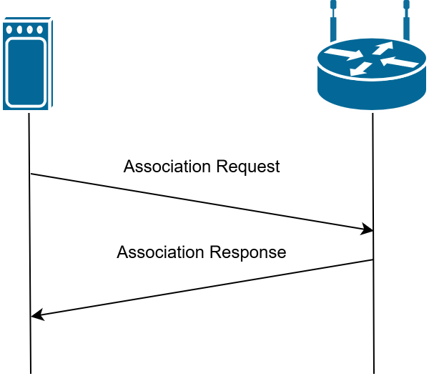
Figure 2.2 – The authentication stage.
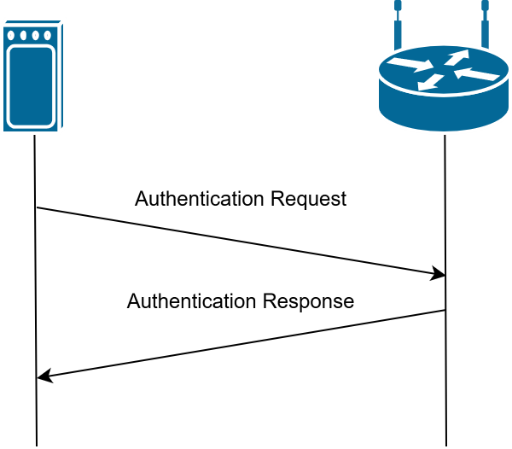
Figure 2.3 – The association Stage

With WPA2 Personal (WPA2-PSK), WPA3 Personal (WPA3-PSK) a 4-way handshake derives the encryption keys. For this report we only need to focus on the probe requests.
Probe request frames contain address fields containing information such as the destination address, source address, and BSSID which are set with values seen below.

Address Field | Value
Destination Address | ff:ff:ff:ff:ff:ff
Source Address | This would be the MAC address of the wireless client.
BSSID | ff:ff:ff:ff:ff:ff
Table 2.1 – An example of address field values in the probe request frames.

General Data Protection Regulation (GDPR) Legislation
The piece of legislation which enforces and defines users’ personal data in European Union member states is the General Data Protection Regulation (GDPR). GDPR has been adopted for ten years (as of this report). Under Article 4 GDPR defines personal data with “online identifiers” being deemed as personal data (General Data Protection Regulation Article 4, 2016). GDPR deems unique identifiers such as Media Access Control (MAC) addresses and Service Set Identifiers (SSIDs) as personal data. MAC addresses allow for the identification of individual devices as they are unique to said devices. SSIDs are unique identifiers given to access points (APs). This is supported by Recital 30 GDPR.
This is crucial to keep in mind when in regards to this project as what is deemed as personal data can be found in side channel leakage without much difficulty. Although this legal act detours bad actors from spreading personal data publicly it doesn’t prevent attackers from gaining access to these types of personal data.

User Privacy Concerns
Wi-Fi is in most homes and daily lives of many. We are constantly surrounded by this technology whether that be in our homes, offices and or place of education.
Since probe requests are unencrypted the service set identifier (SSID) of the access points (APs) which the wireless client has visited beforehand can be collected and examined. Many APs have contextual names. For example, the SSID of a university may contain the university’s name or a coffee shop’s SSID may contain the name of the coffee shop. This can allow for life pattern analysis of an individual (Sun, et al., 2017). For example, a user’s workplace could be deduced even if the individual’s workplace access point is hidden. Although the access point itself is not broadcasting itself the wireless client would be exposing the ‘hidden’ SSID through probe requests from the wireless client. A combination of contextual SSIDs could give a bad actor an idea of the individual’s place of work or education and frequented establishments such as coffee shops (Kim, et al., 2014).

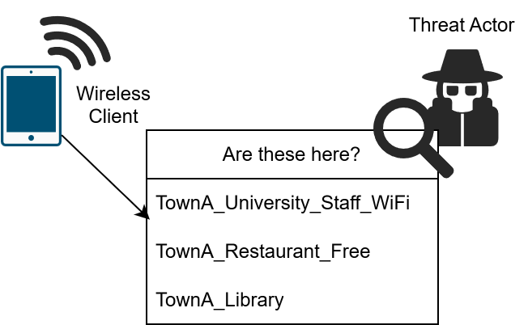
Figure 2.4 – A threat actor profiling an individual based on listening for probe requests and analysing the SSIDs found.

Another concern would be passive localisation tracking. In a study done by (Sun, et al., 2017) it is shown that the location of a wireless client can be tracked with errors “lower than 2 meters and 3.5 meters” (Sun, et al., 2017), indoor and outdoor using received signal strength indication (RSSI). RSSI can be found in the Radiotap header measured in decibel-milliwatts (dBm). By using a non-fingerprint-based method the need for a radio map is eliminated as this localization method relies on the geometry of triangles. This shows that an individual’s general location can be monitored through their devices. It would make lifestyle pattern analysis possible using a non-intrusive method and without additional software. For example, a bad actor could gain insight into when their target is home.

Password Leaks in Probe Requests
In a study done in 2022, researchers found that 11.8% of transmitted probe requests collected by them contained “numeric strings with 16 digits or more” (McDougall, et al., 2022) in the SSID fields. The study was done in Germany with a data set containing 252 242 probe requests collected by the researchers themselves. It was concluded that those are likely default initial passwords of popular home routers in Germany. This was supported by the numeric strings following character combinations such as “PW:”, “WPA:” or “(WPA/WPA2:)” in a variety of cases (McDougall, et al., 2022).
In some cases, the same researchers found that the same string would have slight changes such as spaces, dots or commas added between some of the characters but essentially containing the same digits such (e.g. 1234567812345678 and 1234 5678 1234 5678) (McDougall, et al., 2022). From this pattern analysed the researchers assumed that it was most likely users logging in multiple times using varying spellings of the same credentials.

Log Distance Path Loss Model
The log distance path loss model is a mathematical model which shows a relationship between relative signal strength index (RSSI) and distance. This is essential to one of our research questions which involves the possibility of approximately triangulate the location of a wireless client through the perceived antenna strength shown in probe requests sent by clients.

Environment Type | Exponent Range (condition)
Free Space | 2
Urban area cellular radio | 2.7 – 3.5
Shadowed urban cellular radio | 3 - 5
Inside a building (line of sight) | 1.6 – 1.8
Obstructed in building | 4 – 6
Obstructed in factory | 2 - 3
Table 2.2 – Path loss exponent values (Khaled & Ajib, 2022).

From the standard log distance path loss equation model we can derive an equation to calculate the distance from the perceived RSSI or antenna strength by rearranging the original standard equation which can be found below in Equation 2.1.

$$PL(d) = PL(d₀) + 10n log₁₀(d/d₀)$$
Equation 2.1 - Standard equation model for log distance path loss.

- $PL(d)$ is the predicted path loss measured in decibels (dB) at $d$ which is distance in metres.
- $PL(d_{0})$ is the reference path loss (also measured in dB), this is measured at $d_{0}$ , a close known distance.
- $n$ is the path loss exponent which is unitless and accounts for the environment. (See Table 6.1 for reference).
- $d$ is the distance between the transmitter and the receiver. This is measured in metres.
- $d_{0}$ is the reference distance.

Equation 2.2 is the equation derived from the standard log distance path loss equation model (Equation 2.1).

$$d={10}^{(\frac{(PL\left(d_{0}\right)-PL(d))}{10n})}$$
Equation 2.2 - Our derived equation to approximate distance from RSSI.

The study which we reviewed looked at the effects of the height of the antenna and seasonal effects across different models and propose ways to tune and extend the standard textbook model (Khaled & Ajib, 2022). The researchers found that taking into account antenna height and elevation made the results more accurate. They also discovered that seasonal affects such as rain, snow, and foliage are important and by taking into account can lead to better outcomes in especially the winter months. The focus on the winter months because it was found that weather conditions in winter months affected the accuracy of the textbook model for log distance path loss. One of the findings was that the path loss exponent was higher in winter conditions compared to summer conditions. This essentially meant that there was more path loss in winter than in summer.
Fortunately our experiments with running our Python script took place during warmer more summer like weather so we didn’t have to take into account for winter conditions. If our experimental period took place in more winter conditions we may have had to adjusted our path loss exponent to account for the weather conditions.

Methodology

Overview of Methodology
During the period where we conducted our research, we decided that progressing with an Agile framework would be most appropriate for our project and team. This is because of the lightweighted nature of Agile frameworks however also putting a focus on flexibility and continuous improvement. We felt that flexibility was a priority as one of the authors had an internship at the time while two other authors on this project both had the usual university schedule. We found that working with an agile practice allowed for us to organise our time in a productive manner while being able to guarantee continuous progression.
We wanted to keep an open mind so that we accounted for issues along the way. Before every meeting we had goals in mind and responsibilities to be carried out as individuals, then at the meetings themselves we would discuss our concerns and where we were at in this group project. At the end of each meeting we would each know what tasks we were each assigned and expected to complete by the following meeting. Alongside our regular team meetings, we also had regular meetings with our supervisor for feedback.
During our overall project period we faced many individual personal challenges this led to changes to our methodology and work completed compared to our initial plans (details can be found within Appendix A on page 26).

Stage 1: Review of existing work
Our initial stage was reviewing existing work when it came to this project. We wanted to review what were the possibilities we must work within so that we can define our scope further on. From this stage we gathered ideas and formed research questions based on previous works. This is reflected within our literature review section in this report. We originally had the idea of doing field research in a densely populated area such as Dublin’s inner city to gather a more grounded idea of the current wireless technological landscape however due to privacy concerns we decided to stick to a sandboxed environment where all data collected and hardware used would be owned by ourselves (the authors of this report).
After reviewing existing works related to our topic of privacy concerns around Service Set Identifiers (SSIDs) we narrowed down on what our first tests were going to be consisting of. This included hardware and software resources we would need.

Stage 2: Requirements specification
The following software tools were used throughout the project to support packet capture, processing, and analysis:
- Wireshark – Used as the primary packet analysis tool for capturing and inspecting IEEE 802.11 wireless frames, including probe request traffic
- Kali Linux – Used as the main operating environment for wireless network analysis, providing support for monitor mode operation and integration with packet capture tools.
- Rust – Used to develop a custom script for processing captured probe request data and extracting signal strength (RSSI) values for proximity estimation.

The experimental setup consisted of the following hardware components:
- 2020 MacBook Pro (Intel-based) – Used as the host system and primary monitoring device for wireless packet capture.
- 2 × Alfa AWUS036ACS AC600 USB Wi-Fi Adapters – Used to support wireless monitoring and improve compatibility with monitor mode operations.
- TP-Link Router – Configured as the controlled access point for generating and managing wireless network traffic during testing.

The following client devices were used to generate probe request traffic and simulate real-world wireless behaviour:
- 2 × iPhones (iOS 26+) – Used to generate iOS-based probe request traffic during normal Wi-Fi scanning behaviour.
- 1 × MacBook – Used as an additional Apple-based device for probe request generation and comparison testing.
- 2 × Android devices
  - Samsung Galaxy A5
  - Samsung Galaxy A16

Stage 3: Supporting Experimentation
This stage highlights our experiments conducted in support of the topic of this thesis (Side-Channel Information Leakage Through Client Probe Requests to Hidden Access Points). This includes setting up the equipment and software for capture.
During this phase we conducted experiments to compare and contrast the behaviours of different devices (such as iPhones compared to Samsung Android phones) and antenna signal in relation to the physical distance to which the emitting device is from the receiver.

Stage 4: Analysis Capture
The Capture Analysis phase will focus on designing a controlled and reliable environment in which probe request frames can be captured and analysed effectively. The main aim at this stage will be to ensure that wireless traffic, specifically probe requests, can be consistently detected, recorded, and examined under stable conditions. Establishing this foundation will be important before progressing to deeper analysis, as it will help ensure that the data collected is both accurate and reliable. Careful consideration will be given to the configuration of the environment so that the results are valid and can be clearly linked to the behaviour being studied.

To achieve this, a small-scale testbed will be created to simulate a typical wireless network scenario while still maintaining control over key variables. This approach will allow the investigation to reflect realistic device behaviour in a structured and manageable setting. By reducing external interference and limiting variability, the setup will make it easier to attribute captured data directly to the devices involved in the experiment. This controlled environment will also support repeatability, allowing the same conditions to be recreated if further testing or validation is required.

The hardware and virtual environment used in this setup consists of a TP-Link wireless router configured as the access point, a 2020 Intel-based MacBook Pro acting as the host system, a Kali Linux virtual machine running on the MacBook, and a simulated client device representing a typical wireless user. The access point provides a stable and controlled wireless environment, while the client device generates probe requests through normal behaviour such as scanning for available Wi-Fi networks. The Kali Linux virtual machine is used as a dedicated environment for network analysis tools, separating traffic inspection from general host system activity. Within this setup, Wireshark is used as the main tool for capturing and analysing wireless packet data. It runs inside the Kali Linux environment and is responsible for inspecting IEEE 802.11 frames in detail, particularly probe request traffic and associated metadata.

The MacBook Pro and Kali Linux virtual machine are configured to capture wireless traffic operating under the IEEE 802.11 protocol. This configuration enables the capture of raw wireless frames without requiring association with the access point. Once traffic is captured, Wireshark is used to filter and inspect probe request frames in real time and from saved capture files (PCAP format). Filters such as wireless management frame types are applied to isolate probe requests and extract relevant fields including source MAC addresses and the Access Point it is trying/successfully connect to. This allows the dataset to be prepared for later analysis without interference from unrelated traffic.

The captured data is also exported as PCAP files for further processing in the analysis phase. This ensures repeatability, as the same dataset can be re-examined or validated if needed. Overall, this setup allows comprehensive observation of probe request behaviour, including broadcast frames that are typically not visible during normal network usage. During analysis, patterns of probe requests will be compared across devices (iOS and Android), using both Wireshark’s filtering capabilities and external processing scripts to identify differences in behaviour.

Stage 5: Trilateration Phase (POC)
This phase focuses on the development of a system to capture and interpret wireless probe request activity. The aim is to extract four key parameters: 1) Received signal strength (RSSI), 2) Estimated distance derived from that signal, 3) number of probe requests observed, 4) and the MAC addresses detected. These measurements form a structured dataset that can later be used to infer the presence and relative position of nearby devices.

RSSI acts as the primary measurement in this approach. It reflects how strong a signal is at the receiver and serves as the basis for distance estimation. While RSSI is not a direct measure of distance, it provides a useful approximation when interpreted through a signal propagation model. This makes it suitable for environments where direct positioning methods are not available.

Distance estimation is the most critical component of this phase. Using RSSI values, an approximate distance between the transmitting device and the receiver can be calculated. These estimates are affected by environmental factors such as obstacles, interference, and signal reflection. However, by collecting repeated measurements, the system can reduce the impact of these fluctuations and produce more consistent results. Can do on FLAT TERRAIN as well

Probe request count is also considered as part of the dataset. This metric reflects how often a device is actively searching for networks within the area. A higher number of probe requests can indicate sustained device presence, while lower counts may suggest transient or passing devices. Including this information helps provide context to the signal measurements.

MAC addresses are recorded during the capture process, but they are not treated as reliable identifiers. Many modern devices use MAC address randomisation, which limits their usefulness for direct tracking. Instead, MAC observations are used alongside RSSI and probe count to support the identification of distinct devices in a more indirect manner.

By combining these measurements, the system builds a more complete representation of the wireless environment. Instead of relying on a single parameter, it uses multiple indicators to improve reliability. This approach helps reduce the effect of noise and uncertainty in the data, which is particularly important in real-world conditions.

The data generated in this phase is then used for trilateration. Distance estimates collected from multiple observation points can be combined to approximate the location of a device. By comparing these distances, it becomes possible to determine where a device is likely to be positioned. This phase therefore provides the measurement foundation required for spatial localisation using trilateration techniques.

Stage 6: Evaluation of results
The team will gather all the evidence collected during testing to build a clear and practical proof of concept. This will show the security risks linked to broadcasted SSIDs and probe requests, explaining in simple terms how this information can be captured, analysed, and potentially misused. It will also bring together the original hypothesis with the results from testing and documentation, making the overall findings easy to follow, consistent, and understandable.
The final report will present this work as a straightforward, real-world scenario. It will explore how these risks could expose possible gaps in GDPR, as well as highlight concerns around unwanted surveillance, social engineering, and targeted campaigns. Each piece of evidence will support the others, gradually building a clearer and more complete picture of how these vulnerabilities could be used in practice.
Overall, the proof of concept will act like a step-by-step storyboard, showing how the data is collected, what insights can be drawn from it, and why it matters. By linking technical findings to realistic situations, the project aims to make the risks easier to understand while clearly demonstrating their potential real-world impact and importance.

System Requirements & Specification

System Requirements & Specifications
For this project, we conducted our research on a vast range of different hardware but ultimately worked primarily worked on a 2020 MacBook with a virtual Kali Linux machine and a live bootable USB drive of Fedora 43 both collecting data through Alfa Wi-Fi adapters (awus036acs) which allow for monitor mode. Our program used Python 3.12 and PyShark which is a Python wrapper for Tshark which is Wireshark’s command-line interface (CLI). The choice to use Python version 3.12 rather than version 3.14 was because we found that version 3.12 had broader compatibility especially because we had looked to older existing code for answers to troubleshooting with PyShark. It wasn’t difficult to use version 3.12 rather than 3.14 due to the “alternatives” command in Fedora.
We took a look at other options prior to choosing PyShark such as Scapy however we found PyShark to be intuitive to us as we were already familiar with Wireshark and subsequently Tshark as well. Our script by the name of “basic_packet_sniffer.py” shows our initial attempts at working with Scapy.
We had to buy another Apple USB C adapter because the Xiaomi adapter which one of the authors had did not work with the Wi-Fi adapter. We noticed that if we had the Xiaomi adapter plugged into the laptop and then the Apple adapter into the Xiaomi adapter with the Wi-Fi adapter plugged into the Apple adapter then it would also work. (We will explore this further under section 9.2).
The Client devices used for testing were a mix of different iPhones and Samsung Android phones. The three iPhones involved were running iOS 26.2.1, iOS 26.4 developer and iOS 26.4.2. One of the Samsung phones was running Android 16 with the kernel version being 6.12.23 while the older Samsung phone was running Android 8 with a kernel version of 3.18.14. These wireless clients were what we had on hand as purchasing more devices would be too costly.

Switching From Windows to Linux
Windows is notoriously limited when it comes to wireless monitor mode support. Windows is restricted when it comes to low-level packet captures. According to on Wireshark’s own Wikipedia web site, they go through the capture setup and on different systems. It mentions that Windows is has limited support for adapters and drivers (Wireshark, 2020). In comparison, the section on the Linux setup seems more straightforward so we decided to take this approach.
Another issue we ran into with our Windows environments were unstable due to new the updates being rolled out at the time (Batt, 2026). Since Linux is open-source it wasn’t a difficult change to make as it came at no extra cost. We installed Fedora 43 on a USB drive to make a live USB bootable for convenience. Linux is also better optimized for our research as there are less background processes and less permissions issues.
Another issue we found with Windows was when we tried to install Python packages and libraries. On Windows we ran into a few warnings but didn’t mean that the dependencies installed were completely broken. However after making the switch to Linux we found that the scripts ran faster and installing the libraries needed was simpler with no warnings.

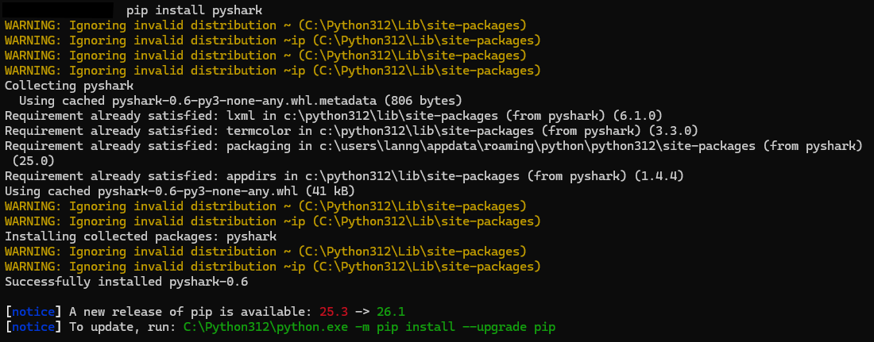
Figure 4.1 - Installing PyShark on our Windows machine.

System Design

Architectural Overview
The architecture of our system consists of a Python script which relies on a Tshark wrapper to then output the desired findings to the command-line interface. The output is formulated from data gathered from the wireless client through the Wi-Fi adapter connected to the laptop running the script. Figure 5.1 shows a high-level diagram of our system.

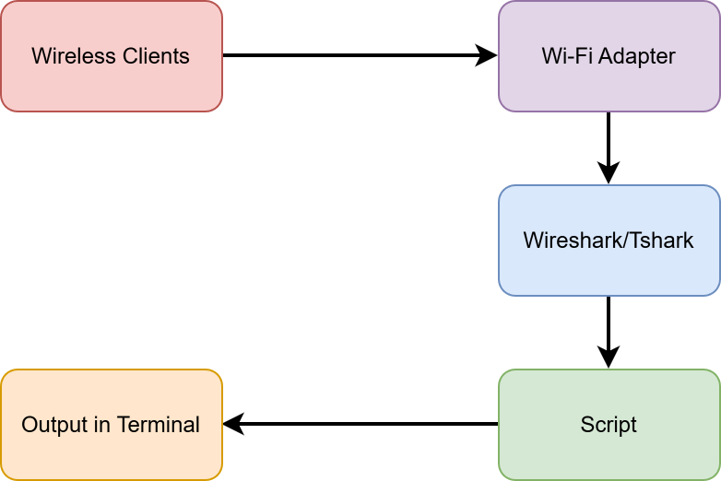
Figure 5.1 - High-level design diagram.

Purpose of the Module
The module named “prototype_pyshark.py” is our main and only module. Its purpose is to allow the user to enter a wireless interface and collect packet data from the inputted interface. Then it would display relevant pieces of information. This includes but are not limited to the subtype of the packet, media access control (MAC) address, destination basic set service identifier, antenna signal, estimated distance and set service identifier (SSID). This is to show
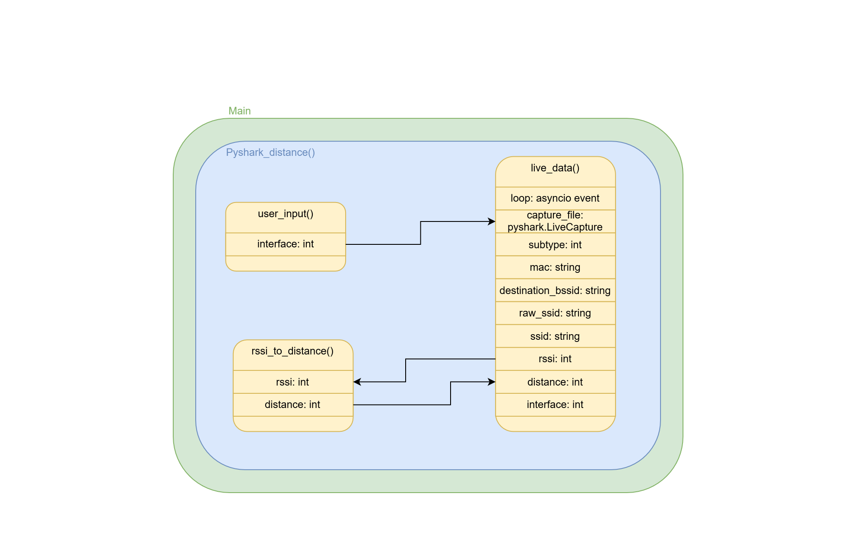
Figure 5.2 - Low-level design diagram.

Log-distance Path Loss Model
The log-distance path loss model is what we used to get the approximate distance of a wireless client to the Wi-Fi adapter through the antenna signal data.
https://cal3.calculator.city/calculate-distance-using-rssi-value/

Supporting Tests

Supporting Tests Overview
This section of this paper highlights tests conducted prior to fully committing to developing a script. This was done so that we could substantiate our research questions and topic.

Initial Testing
During this stage we wanted to simply see what type of information can be gained from side channel leakage. We had a setup consisting of two wireless client devices (two iPhones running iOS 26), a wireless access point (AP) with broadcasting disabled, and a 2020 MacBook Pro (Intel Core i5) in monitor mode (Figure 7.1). For our experiments monitoring devices being in monitor mode was crucial as it allows for optimized monitoring of wireless network channels 802.11b/g/x (Cisco, n.d.).
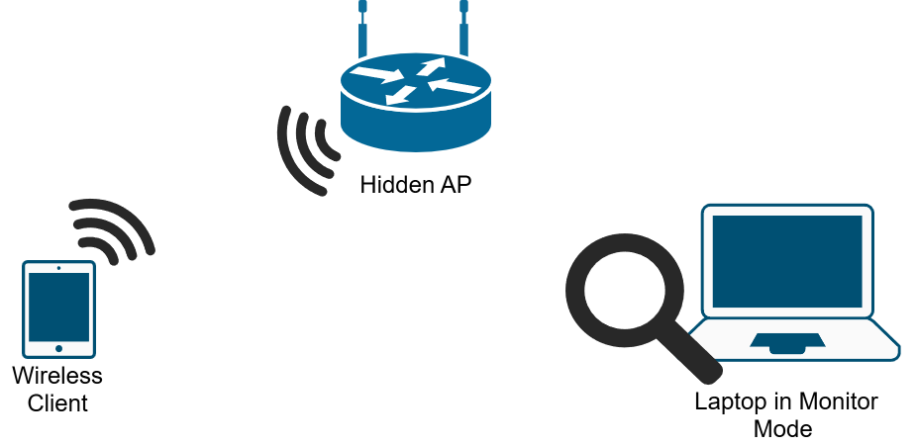
Figure 6.1 - Initial Testing: Wireless client connects to the hidden access point while being monitored.

In this initial test we wanted to see if we could view specifically probe requests as that could reveal the service set identifier (SSID) of the hidden wireless AP. While actively sniffing for probe request packets we found that the wireless client does expose the SSID of the hidden AP in its probe requests. The wireless client would also continue send out probe requests consistently even when the AP was turned off (Figure 7.2).

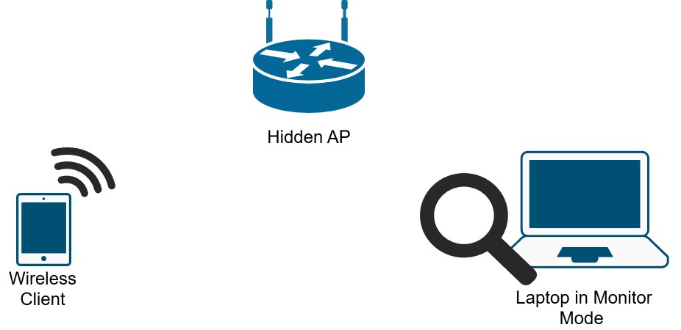
Figure 6.2 - Initial Testing: Hidden AP being turned off while being monitored.

From this initial test we found that there are side channel leakages in regards to SSIDs of hidden APs being essentially broadcasted by the wireless hidden AP through its probe responses. While testing the iOS devices we also noticed that iPhones do not send out very frequent probe requests when the screen is off, however when the screen is on (even when locked), the iPhones send out a high volume of probe requests.
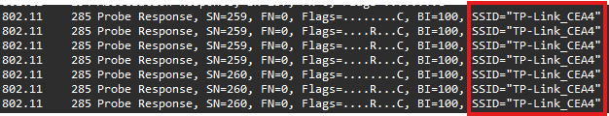
Figure 6.3 - The SSID of the hidden AP can be seen in the probe responses.
From Figure 7.3 we can see that although our AP is set to not broadcast its SSID (essentially making it a hidden AP) the true SSID is still visible in its probe responses consistently. This defeats the purpose of disabling SSID broadcast entirely. In Figure 7.4 we can see that bits of information regarding the device type can be seen in the destination field in our Wireshark capture file.
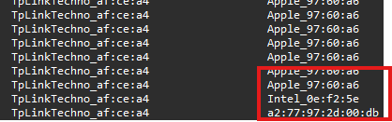
Figure 6.4 - The destination can expose the type of device the probe request was meant for.
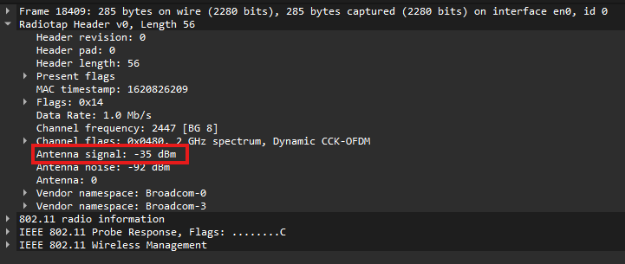
Figure 6.5 - The antenna signal can be seen in the Radiotap header.
In Figure 7.5 we can see that the antenna signal can be seen in the Radiotap header. This could make user localisation possible. The idea would be that we would record the relative signal strength (RSS) at a known distance such as one meter then we could calculate the distance the device is from our monitoring antenna with some calculations. With three antennas we could calculate the general localisation of the wireless client. This would show the dire consequences of such side channel leakage.
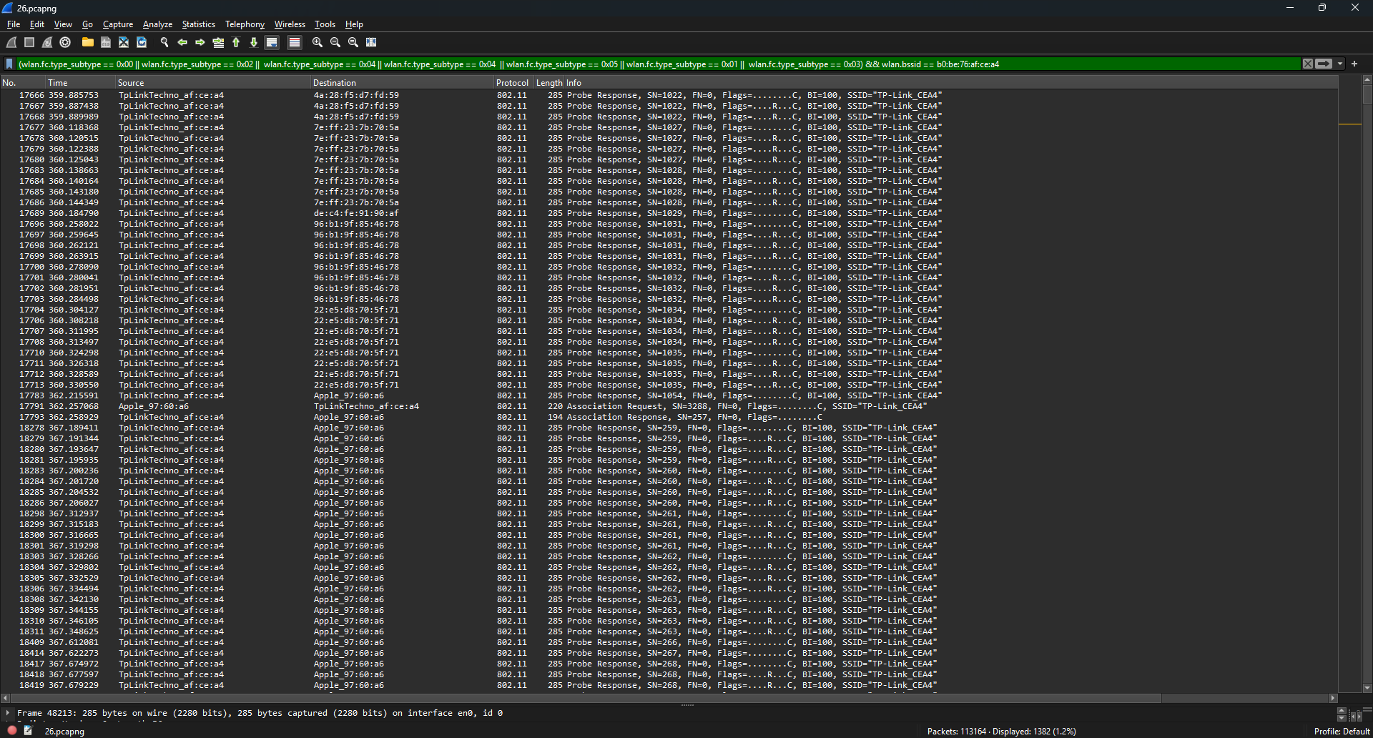
Figure 6.6 - Initial Testing: overall picture of the pcap file in Wireshark.

Another finding from this was that by using a Wi-Fi deauthorisation device we could force the wireless client off the network of the hidden AP and synthetically get the client to send out probe requests. An attacker could use this method to force side channel leakage and learn of hidden APs’ SSIDs.
In the images below (Figure 7.7 and 7.8) we can see when the deauthorization packets were sent and used to forcefully deauthorize all devices connected to our hidden AP.
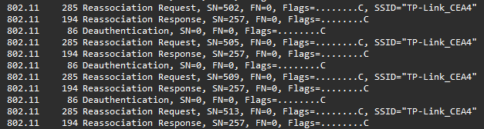
Figure 6.7 - Close up of the deauthentication packets shown in the Wireshark capture file.

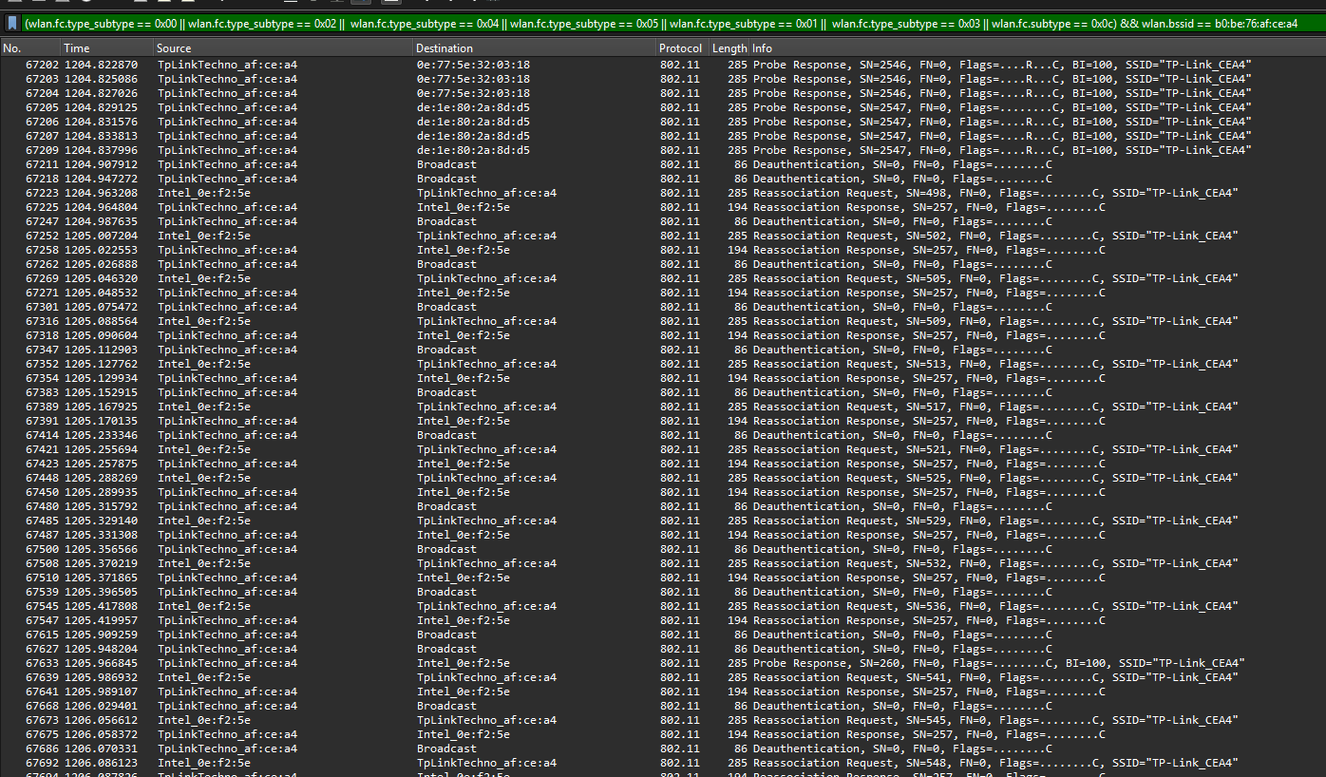
Figure 6.8 - The deauthentication packets shown in the Wireshark capture file.

Following initial testing we had developed another research question which was if Android and devices other than iOS devices behave differently regarding probe requests.
Below in Figure 7.9 shows the Wireshark filter we used to narrow down the relevant packets in the capture files. Table 7.1 shows the associated subtypes which the filters refer to. Using the “wlan.bssid” attribute allows us to narrow it down to packets which match the BSSID of our hidden AP.
Figure 6.9 - Wireshark filter used to view only relevant subtypes of the management frames.

Type/Subtype in Hexadecimal Code | Frame Type
0x00 | Association Request
0x01 | Association Response
0x02 | Reassociation Request
0x03 | Reassociation Response
0x04 | Probe Request
0x05 | Probe Response
Table 6.1 - Meaning of each type/subtype in the Wireshark filter as frame types.

Testing Androids’ Behaviour
For this experiment we had two Samsung phones both running Android. The Samsung A16 is running Android 16 while the Samsung A5 is running Android 8. For reference the A16 came out in the latter half of 2024 while the A5 came out late 2014. The set up for this experiment remains the same as the initial experiment however the wireless client being testing will be two Android phones rather than iPhones.
Figure 6.10 shows the Wireshark filter which we used to focus on specific packets. Table 6.1 explains what each of the subtypes mean. Overall the filter essentially filters for association requests, association responses, reassociation requests, reassociation responses, probe requests, or probe responses and the packets must have a SSID of “TP-Link_D5C0” (which is the SSID of the hidden access point).
Figure 6.10 - The Wireshark filter used to hone in on specific packets.

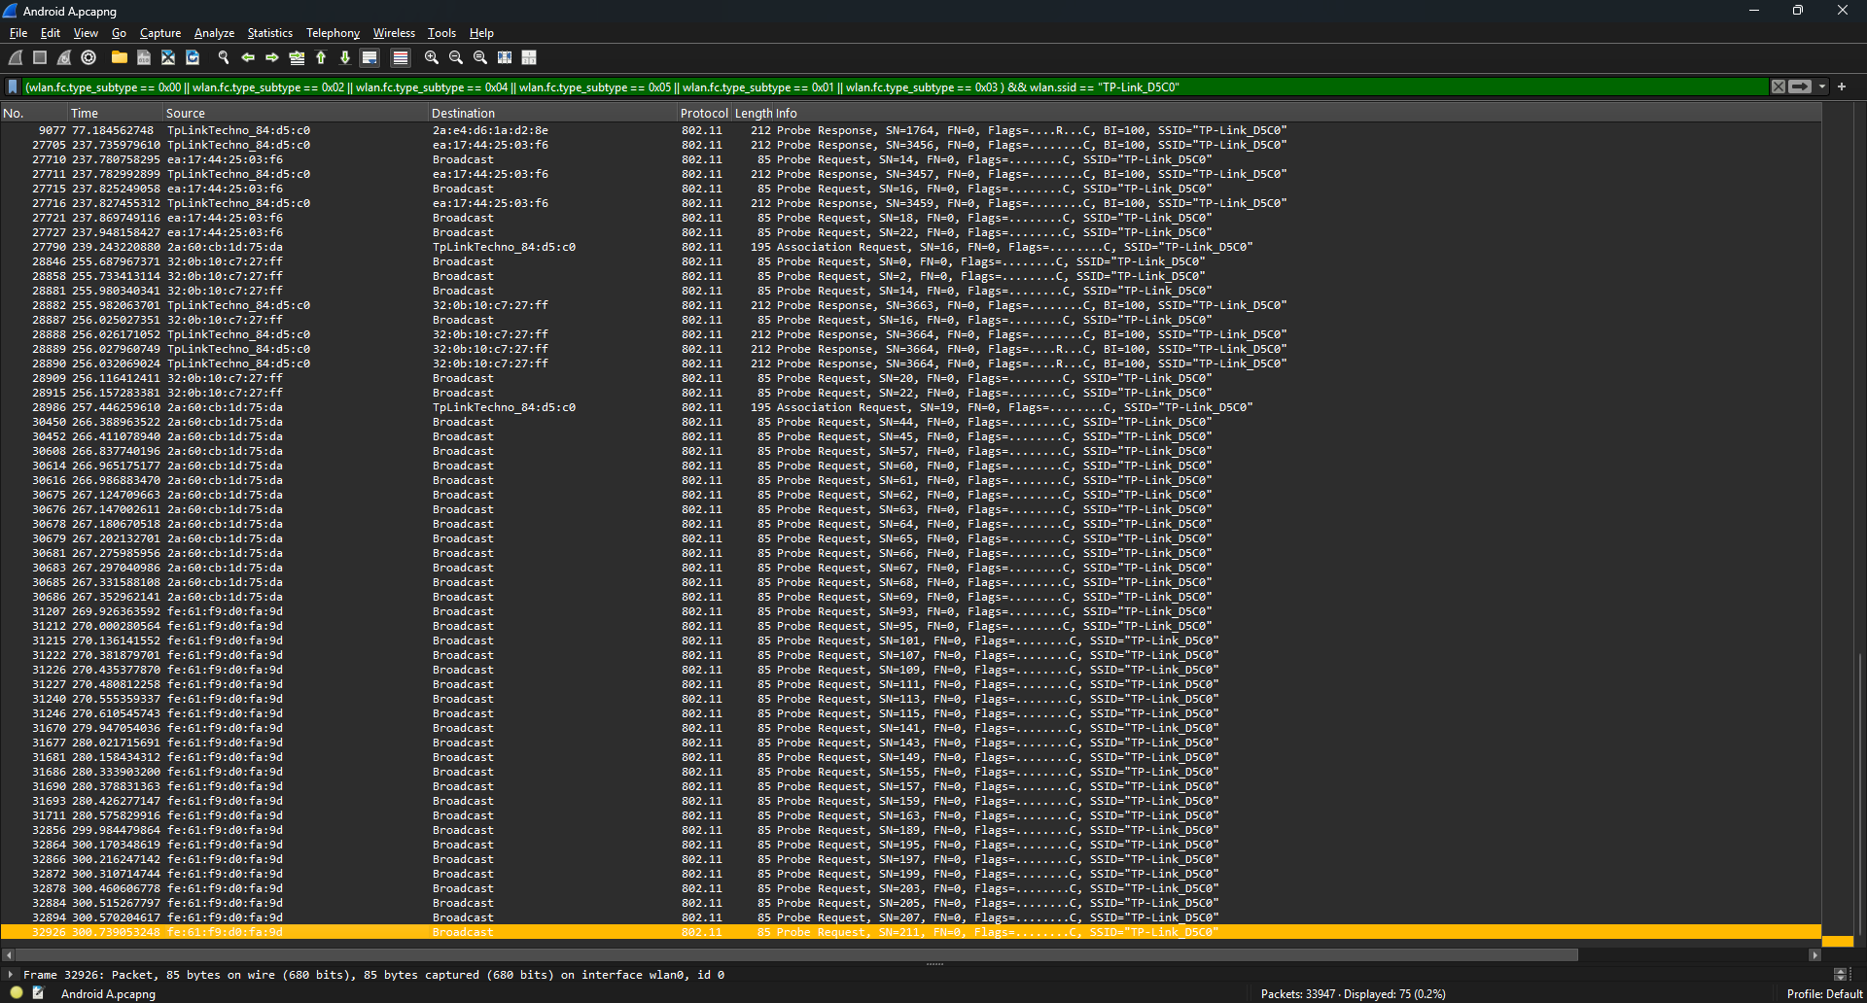
Figure 6.11 - Wireshark capture of the behaviour of the Samsung A16.

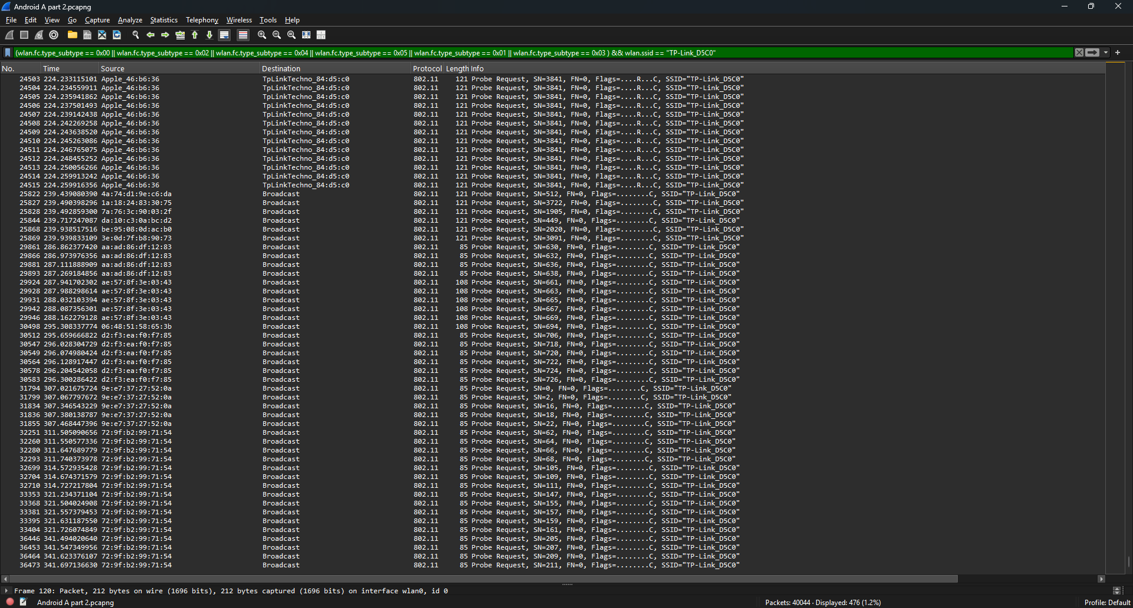
Figure 6.12 - Wireshark capture of the behaviour of the Samsung A16 continued.

From our tests we observed that the Android phones performed completely differently to the iPhones. The Androids seemed to only start probing while the AP was turned on. In contrast the iPhones would send out probe requests even when the AP was turned off.
However there was noticeable difference between the Samsung A16 and A5. The A16 used Media Access Control (MAC) address randomisation while the A5 appeared to replace the first 24 bits of the MAC address of the device. After a bit of research we found that this was a feature of Wireshark where it resolves the first 24 bits of the MAC address to be of the name of the vendor using vendor (OUI) lookup as our device was using a MAC address block which is registered to Samsung Electronics.
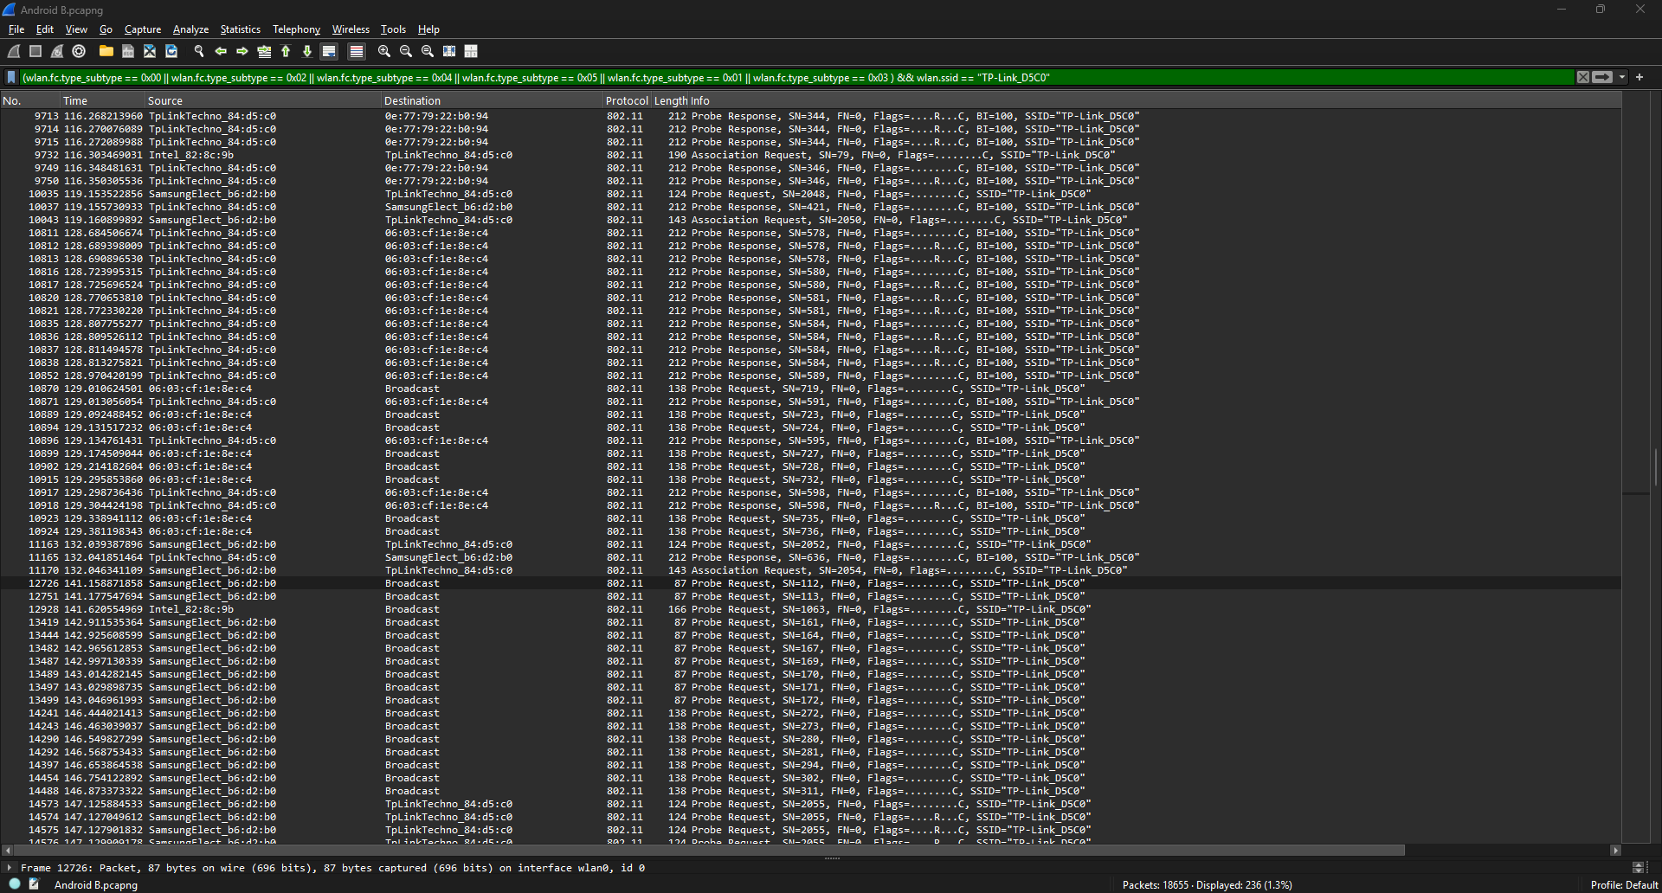
Figure 6.13 - Wireshark capture of the behaviour of the Samsung A5.

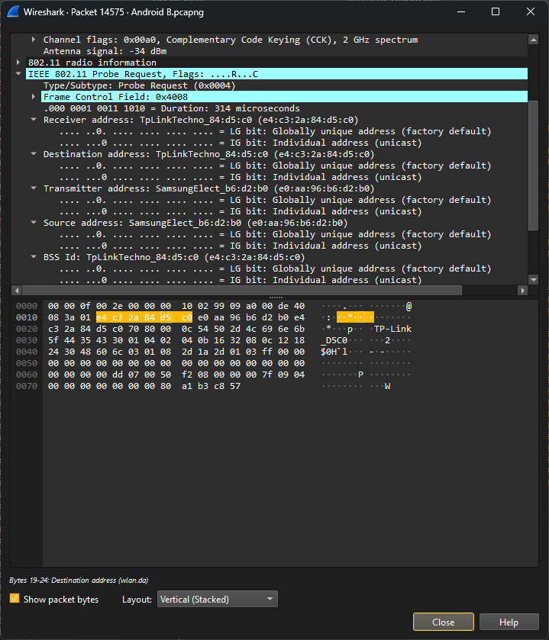
Figure 6.14 – Image of a probe request from the Samsung A5 showing the source MAC address.

Looking further into the probe request in Figure 6.14 we can see that the full true MAC address can be seen. We used maclookup.app to search for our prefix and found that our prefix was registered as a part of a block of approximately 16 million addresses.

Evaluating Supporting Evidence Gathered
From our supporting evidence gathered we noted that the behaviour between iPhones and Samsung Android phones are quite different. Modern iPhones and Samsung phones both cycle through MAC addresses. However one key difference is that Samsung phones don’t continue to send out probe requests when the hidden AP is turned off while iPhones send excessive numbers of probe requests even when the hidden AP is turned off and the iPhone screens are on although locked.
An interesting observation made was that although there was a ten year release date difference between the Samsung A16 and A5 the only difference which we could see was that the older A5 did not have MAC randomisation. This is likely due to lack of legislation and security recommendations at the time of release. According to the European Union (EU)’s General Data Protection Regulation (GDPR) MAC addresses were only formally recognised as personal data in 2018.
From our analysis we learned that Wireshark resolves the MAC address to the vendor of the registered first 24 bits. This can be seen in Figure 6.4 as well. This was something we nearly overlooked until we did the analysis on the behaviour of Android phones. These tests that we ran show supporting evidence of side channel information leakage in the probe requests.

Implementation of Prototype

Proof of Concept Testing
Our proof of concept test is named “basic_pyshark.py” this was a very basic initial scaffold script before our prototype. We used this to test PyShark usage to then compare to our experience with using Scapy. Through this test we found that using PyShark feels more intuitive for us as we were already familiar with Wireshark and Tshark.
At this point we noted that we were able to retrieve certain attributes such as the MAC address, BSSID and signal similarly to Wireshark. However we couldn’t resolve the SSID at this point so that was our next goal with this script and that’s what would make it our official prototype to this project. That would the biggest change from “basic_pyshark.py” to “prototype_pyshark.py” which are both visible on our GitHub. Below in Figure 7.1 is an image of the variations of attribute names we tried to get the SSIDs from the packets.
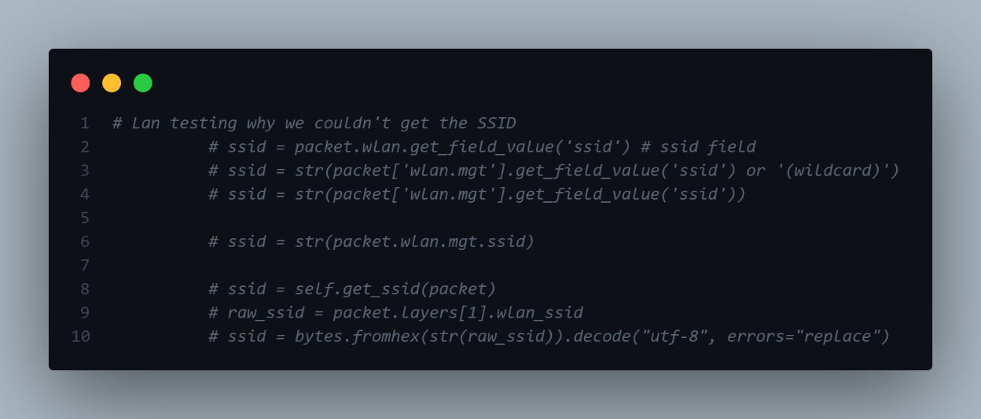
Figure 7.1 - Various possible names for the SSID attribute we tried.

Prototype Overview
The prototype script for this project is named “prototype_pyshark.py”. This script was capable of resolving SSIDs from their hexadecimal format and calculate the estimated distance from using the antenna strength or relative signal strength index (RSSI). From our initial tests we concluded that the approximate distance of the wireless client device being targeted had surprisingly accurate results. The initial test was performed with a known distance (which was 1 metre from the Wi-Fi adapter) and generally on the same plane or elevation. We used the floor as guidance for this. It showed that the client was one to two metres away from the Wi-Fi adapter. Originally I had set the “condition” variable as 3.0 as I was indoors. However I changed it to 2.0 and that made it a lot more accurate. The ideas for the maths behind estimating distance from RSSI and the condition multiplier value was taken from (Khaled & Ajib, 2022).

Environment Type | Exponent Range (condition)
Free Space | 2
Urban area cellular radio | 2.7 – 3.5
Shadowed urban cellular radio | 3 - 5
Inside a building (line of sight) | 1.6 – 1.8
Obstructed in building | 4 – 6
Obstructed in factory | 2 - 3
Table 7.1 – Path loss exponent values (Khaled & Ajib, 2022).

Key Findings from Testing Prototype
While troubleshooting we had our doubts as there are many factors to the findings. We were worried that the SSID field was just left empty or that we were not targeting the correct attribute name. After try many different attribute name we discovered that we could just try to dump out all available attributes in the wireless local area network (WLAN) layer so at first we just assumed that it was just called “ssid”. After that didn’t work we tried “Ssid” and “SSID”. Since that didn’t yield any results we found a way to dump our all of the attributes available and grep for “ssid”. To our luck this worked and we found that the attribute is “wlan_ssid”. We found the name of the SSID attribute by looking at the output from “debug_all()”.
The script named “debug.py” contains two methods “debug_wlan()” outputs the available WLAN attributes while “debug_all()” outputs all available attributes. Below in Figure 7.2 is the output from “debug.py” of the attributes (click here for the debug output file). From this we found that the SSID attribute should be under the “wlan.mgt” layer and realised that our issue lays in us targeting the wrong layer since we tried “wlan_mgt” rather than “wlan.mgt”. Another fault was that we tried to get an attribute by the name of “ssid” and “Ssid” rather than “wlan_ssid”. At this point we gained some troubleshooting experience.

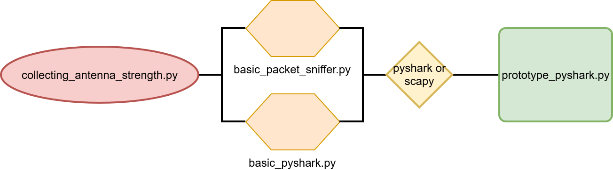
Figure 7.2 - Timeline up until "prototype_pyshark.py".

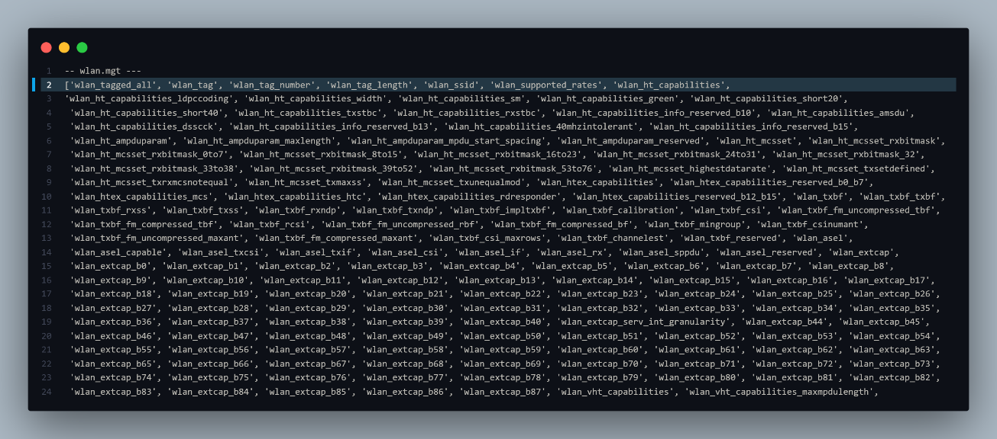
Figure 7.3 - Picture of the output of “debug.py” called “debug.txt” with the SSID attribute highlighted.

After we overcame this hurdle we came across another issue with the format of SSIDs which has a colon between each hexadecimal byte (e.g. 00:1A:2B:3C:4D:5E). We stripped the colons away and got the bytes from hexadecimal format. Before we attempted to parse the SSIDs we checked with an online from hexadecimal to UTF-8 converter to see that the SSID data was valid and able to be displayed correctly. From this point we could decode the SSID byte data into readable UTF-8 characters. The “errors=’replace’” part means that when a bad byte cannot be resolved as a UTF-8 will be replace with a placeholder such as a simple ? or � instead of throwing up an error. “strip()” removes any invisible white spaces such as tabs and spaces.

Although the distance values gathered are approximate distances our implementation shows that this method of localisation is still accurate enough with an error range between 0.5 m to 1.5 m. Even with errors in inaccuracy a user’s location can be approximated to a building or room. Our equation was derived from the standard log distance path loss equation model as mentioned previously, in our literature review section.
In Figure 7.3 we show our implementation of the equation (Equation 7.1) derived to find the distance between the transmitter (wireless client) and the receiver (Wi-Fi adapter) in Python. When we conducted our first test, it was conducted indoors with many obstacles and using the recommended path loss exponent (as seen in Table 7.2) we were able to get some relatively accurate results. During that initial test we found a reading of -90 dBm from the iPhone 15 Pro Max in an indoors environment with many obstacles at 1 m from the receiver. This (-90 dBm) was our “calibration” variable which represented $PL(d_{0})$. At the time we choose the value of 2 for our path loss exponent (represented by $n$) which we called “condition”. RSSI was just the antenna strength received in dBm.
$$d={10}^{(\frac{(PL\left(d_{0}\right)-PL(d))}{10n})}$$
Equation 7.1 - Our derived equation to approximate distance from RSSI.

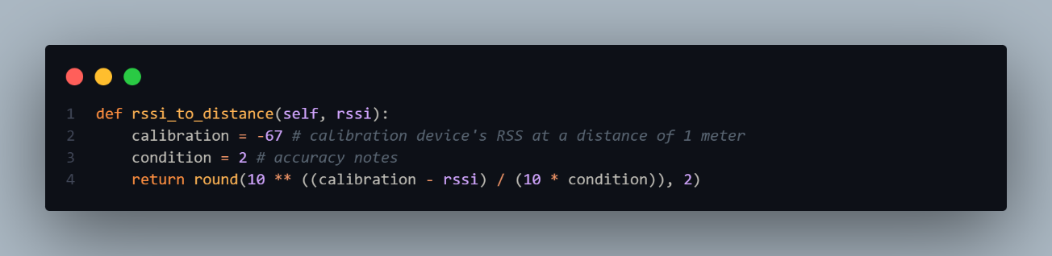
Figure 7.4 – Method used to calculate from RSSI to distance.

Environment Type | Exponent Range (condition)
Free Space | 2
Urban area cellular radio | 2.7 – 3.5
Shadowed urban cellular radio | 3 - 5
Inside a building | 1.6 – 1.8
Obstructed in building | 4 – 6
Obstructed in factory | 2 - 3
Table 7.2 – Path loss exponent values (Khaled & Ajib, 2022).

Through our prototype Python script we show that the distance to a receiver from a wireless client can be approximated through widely available probe requests without detection from the wireless client. This process can occur unknowingly from the perspective of the owner or user of the wireless client device. This is particularly concerning because it shows that this data can be collected with relative ease. With the aid of three total receivers the user localisation through triangulation would be possible with a radio map. Although the location is not exact but instead an approximate location it would still be enough to narrow down to at least what building the device is in and even what room.

Testing & Evaluation

Testing Overview
The following tests in this section of the report focus on larger tests ran with scripts which have calculated factors such as calculating an approximate distance from antenna signal perceived, along with our conclusions and security concerns explained.

Triangulation
During this phase a script was made to measure the distance of a device’s probe request to the monitor. The test included the use of the formerly “basic_pyshark.py” now “final_pyshark.py”, to capture probe requests that are sent by the device. This is done by sending out connection requests to an access point, in this case, we are monitoring devices trying to connect to our AP with the SSID: “TP-Link_D5C0” only. Once the collection of this data has been made, we performed triangulation through basic mathematical triangulation.
For testing purposes one monitor was used to capture the probe requests at 3 different points. These points were approximately 1.3 meters apart, in which the mobile device was placed within. During testing we noticed that although we were in ideal conditions, we still had some variance in the measured distances. As this always going to be the case for scans as volatile as signals, we have allowed room for error in the realms of 0.3 meters to 0.8 meters.
For the purpose of data collection as ensuring a stable judgement for distance collected, judgement calls based on the distance collected at each point. Point B was used to test the accuracy of the script. The distance between the monitor and the mobile device was marked down as 0.57m. Although this measure did not showcase in the output of point B, the output featured a distance of 0.56m. This measurement was the most featured measure in the output, hence this was taken as the distance between the monitor and the mobile device.
Point A had the most consistent measurement throughout its whole output with variance arising due to external factors, such are objects in the way of signal. However these variances remained minimal, and the measure that came at a consistent distance was 1.26m.
Finally at point C, it was discovered that a distance 0.4 meters showed up 10 times. An average of all the numbers was taken into account which amounted to approximately 0.43 meters.
Output at Point B
sudo python prototype_pyshark.py
Please enter the name of the interface: wlp0s20f0u1u1
2026-05-03 16:46:14,382 - LiveCapture - DEBUG - Creating Dumpcap subprocess with parameters: /usr/sbin/dumpcap -q -i wlp0s20f0u1u1 -w -
2026-05-03 16:46:14,383 - LiveCapture - DEBUG - Dumpcap subprocess (pid 5887) created
2026-05-03 16:46:14,489 - LiveCapture - DEBUG - Creating TShark subprocess with parameters: /usr/sbin/tshark -l -n -T pdml -Y (wlan.fc.type_subtype == 0x00|| wlan.fc.type_subtype == 0x01|| wlan.fc.type_subtype == 0x02|| wlan.fc.type_subtype == 0x03 || wlan.fc.type_subtype == 0x04 || wlan.fc.type_subtype == 0x05 || wlan.fc.type_subtype == 0x08)&& (wlan.ssid == "TP-Link_D5C0") -i -
2026-05-03 16:46:14,489 - LiveCapture - DEBUG - Executable: /usr/sbin/tshark
2026-05-03 16:46:14,490 - LiveCapture - DEBUG - Capturing on 'wlp0s20f0u1u1'
2026-05-03 16:46:14,490 - LiveCapture - DEBUG - File: -
2026-05-03 16:46:14,490 - LiveCapture - DEBUG - TShark subprocess (pid 5911) created
2026-05-03 16:46:14,514 - LiveCapture - DEBUG - Running as user "root" and group "root". This could be dangerous.
2026-05-03 16:46:14,597 - LiveCapture - DEBUG - Capturing on 'Standard input'
SubType: '4' | MAC: '32:ea:43:9a:19:e5' | SSID: 'TP-Link_D5C0'| Dest BSSID : 'ff:ff:ff:ff:ff:ff' | Signal: '-76' dBm | Distance: '2.82' m
SubType: '4' | MAC: '32:ea:43:9a:19:e5' | SSID: 'TP-Link_D5C0'| Dest BSSID : 'ff:ff:ff:ff:ff:ff' | Signal: '-68' dBm | Distance: '1.12' m
SubType: '4' | MAC: '22:43:d1:82:22:24' | SSID: 'TP-Link_D5C0'| Dest BSSID : 'ff:ff:ff:ff:ff:ff' | Signal: '-66' dBm | Distance: '0.89' m
SubType: '4' | MAC: '22:43:d1:82:22:24' | SSID: 'TP-Link_D5C0'| Dest BSSID : 'ff:ff:ff:ff:ff:ff' | Signal: '-66' dBm | Distance: '0.89' m
SubType: '4' | MAC: '1e:61:e6:dc:0b:a5' | SSID: 'TP-Link_D5C0'| Dest BSSID : 'ff:ff:ff:ff:ff:ff' | Signal: '-62' dBm | Distance: '0.56' m
SubType: '4' | MAC: '1e:61:e6:dc:0b:a5' | SSID: 'TP-Link_D5C0'| Dest BSSID : 'ff:ff:ff:ff:ff:ff' | Signal: '-58' dBm | Distance: '0.35' m
SubType: '4' | MAC: '92:f8:fd:a8:7a:90' | SSID: 'TP-Link_D5C0'| Dest BSSID : 'ff:ff:ff:ff:ff:ff' | Signal: '-60' dBm | Distance: '0.45' m
SubType: '4' | MAC: '92:f8:fd:a8:7a:90' | SSID: 'TP-Link_D5C0'| Dest BSSID : 'ff:ff:ff:ff:ff:ff' | Signal: '-60' dBm | Distance: '0.45' m
SubType: '4' | MAC: '6a:ec:69:34:78:e8' | SSID: 'TP-Link_D5C0'| Dest BSSID : 'ff:ff:ff:ff:ff:ff' | Signal: '-62' dBm | Distance: '0.56' m
SubType: '4' | MAC: '6a:ec:69:34:78:e8' | SSID: 'TP-Link_D5C0'| Dest BSSID : 'ff:ff:ff:ff:ff:ff' | Signal: '-62' dBm | Distance: '0.56' m
SubType: '4' | MAC: 'fa:7d:0f:96:3c:15' | SSID: 'TP-Link_D5C0'| Dest BSSID : 'ff:ff:ff:ff:ff:ff' | Signal: '-62' dBm | Distance: '0.56' m
SubType: '4' | MAC: 'fa:7d:0f:96:3c:15' | SSID: 'TP-Link_D5C0'| Dest BSSID : 'ff:ff:ff:ff:ff:ff' | Signal: '-60' dBm | Distance: '0.45' m
SubType: '4' | MAC: 'ee:27:fe:30:fa:58' | SSID: 'TP-Link_D5C0'| Dest BSSID : 'ff:ff:ff:ff:ff:ff' | Signal: '-60' dBm | Distance: '0.45' m
SubType: '4' | MAC: 'ee:27:fe:30:fa:58' | SSID: 'TP-Link_D5C0'| Dest BSSID : 'ff:ff:ff:ff:ff:ff' | Signal: '-58' dBm | Distance: '0.35' m
SubType: '4' | MAC: 'de:54:f6:37:e6:0c' | SSID: 'TP-Link_D5C0'| Dest BSSID : 'ff:ff:ff:ff:ff:ff' | Signal: '-60' dBm | Distance: '0.45' m
SubType: '4' | MAC: 'de:54:f6:37:e6:0c' | SSID: 'TP-Link_D5C0'| Dest BSSID : 'ff:ff:ff:ff:ff:ff' | Signal: '-62' dBm | Distance: '0.56' m
SubType: '4' | MAC: 'b6:76:4e:6e:9d:7d' | SSID: 'TP-Link_D5C0'| Dest BSSID : 'ff:ff:ff:ff:ff:ff' | Signal: '-64' dBm | Distance: '0.71' m
SubType: '4' | MAC: 'b6:76:4e:6e:9d:7d' | SSID: 'TP-Link_D5C0'| Dest BSSID : 'ff:ff:ff:ff:ff:ff' | Signal: '-64' dBm | Distance: '0.71' m
SubType: '4' | MAC: 'f6:1f:4a:ef:53:d5' | SSID: 'TP-Link_D5C0'| Dest BSSID : 'ff:ff:ff:ff:ff:ff' | Signal: '-56' dBm | Distance: '0.28' m
SubType: '4' | MAC: '12:0a:14:ff:96:1d' | SSID: 'TP-Link_D5C0'| Dest BSSID : 'ff:ff:ff:ff:ff:ff' | Signal: '-56' dBm | Distance: '0.28' m
SubType: '4' | MAC: '12:0a:14:ff:96:1d' | SSID: 'TP-Link_D5C0'| Dest BSSID : 'ff:ff:ff:ff:ff:ff' | Signal: '-56' dBm | Distance: '0.28' m
SubType: '4' | MAC: 'a6:bc:e0:41:7a:b0' | SSID: 'TP-Link_D5C0'| Dest BSSID : 'ff:ff:ff:ff:ff:ff' | Signal: '-62' dBm | Distance: '0.56' m
SubType: '4' | MAC: 'a6:bc:e0:41:7a:b0' | SSID: 'TP-Link_D5C0'| Dest BSSID : 'ff:ff:ff:ff:ff:ff' | Signal: '-62' dBm | Distance: '0.56' m

Output at Point A
sudo python prototype_pyshark.py
Please enter the name of the interface: wlp0s20f0u1u1
2026-05-03 16:21:04,387 - LiveCapture - DEBUG - Creating Dumpcap subprocess with parameters: /usr/sbin/dumpcap -q -i wlp0s20f0u1u1 -w -
2026-05-03 16:21:04,388 - LiveCapture - DEBUG - Dumpcap subprocess (pid 14038) created
2026-05-03 16:21:04,507 - LiveCapture - DEBUG - Creating TShark subprocess with parameters: /usr/sbin/tshark -l -n -T pdml -Y (wlan.fc.type_subtype == 0x00|| wlan.fc.type_subtype == 0x01|| wlan.fc.type_subtype == 0x02|| wlan.fc.type_subtype == 0x03 || wlan.fc.type_subtype == 0x04 || wlan.fc.type_subtype == 0x05 || wlan.fc.type_subtype == 0x08)&& (wlan.ssid == "TP-Link_D5C0") -i -
2026-05-03 16:21:04,507 - LiveCapture - DEBUG - Executable: /usr/sbin/tshark
2026-05-03 16:21:04,508 - LiveCapture - DEBUG - Capturing on 'wlp0s20f0u1u1'
2026-05-03 16:21:04,508 - LiveCapture - DEBUG - File: -
2026-05-03 16:21:04,508 - LiveCapture - DEBUG - TShark subprocess (pid 14062) created
2026-05-03 16:21:04,538 - LiveCapture - DEBUG - Running as user "root" and group "root". This could be dangerous.
2026-05-03 16:21:04,620 - LiveCapture - DEBUG - Capturing on 'Standard input'
SubType: '4' | MAC: '62:c7:40:42:46:85' | SSID: 'TP-Link_D5C0'| Dest BSSID : 'ff:ff:ff:ff:ff:ff' | Signal: '-82' dBm | Distance: '1.26' m
SubType: '4' | MAC: '62:c7:40:42:46:85' | SSID: 'TP-Link_D5C0'| Dest BSSID : 'ff:ff:ff:ff:ff:ff' | Signal: '-82' dBm | Distance: '1.26' m
SubType: '4' | MAC: '62:c7:40:42:46:85' | SSID: 'TP-Link_D5C0'| Dest BSSID : 'ff:ff:ff:ff:ff:ff' | Signal: '-80' dBm | Distance: '1.0' m
SubType: '4' | MAC: '62:c7:40:42:46:85' | SSID: 'TP-Link_D5C0'| Dest BSSID : 'ff:ff:ff:ff:ff:ff' | Signal: '-80' dBm | Distance: '1.0' m
SubType: '4' | MAC: '62:c7:40:42:46:85' | SSID: 'TP-Link_D5C0'| Dest BSSID : 'ff:ff:ff:ff:ff:ff' | Signal: '-82' dBm | Distance: '1.26' m
SubType: '4' | MAC: '62:c7:40:42:46:85' | SSID: 'TP-Link_D5C0'| Dest BSSID : 'ff:ff:ff:ff:ff:ff' | Signal: '-82' dBm | Distance: '1.26' m
SubType: '4' | MAC: '62:c7:40:42:46:85' | SSID: 'TP-Link_D5C0'| Dest BSSID : 'ff:ff:ff:ff:ff:ff' | Signal: '-82' dBm | Distance: '1.26' m
SubType: '4' | MAC: '62:c7:40:42:46:85' | SSID: 'TP-Link_D5C0'| Dest BSSID : 'ff:ff:ff:ff:ff:ff' | Signal: '-82' dBm | Distance: '1.26' m
SubType: '4' | MAC: '62:c7:40:42:46:85' | SSID: 'TP-Link_D5C0'| Dest BSSID : 'ff:ff:ff:ff:ff:ff' | Signal: '-82' dBm | Distance: '1.26' m
SubType: '4' | MAC: '62:c7:40:42:46:85' | SSID: 'TP-Link_D5C0'| Dest BSSID : 'ff:ff:ff:ff:ff:ff' | Signal: '-82' dBm | Distance: '1.26' m
SubType: '4' | MAC: '62:c7:40:42:46:85' | SSID: 'TP-Link_D5C0'| Dest BSSID : 'ff:ff:ff:ff:ff:ff' | Signal: '-82' dBm | Distance: '1.26' m
SubType: '4' | MAC: '62:c7:40:42:46:85' | SSID: 'TP-Link_D5C0'| Dest BSSID : 'ff:ff:ff:ff:ff:ff' | Signal: '-82' dBm | Distance: '1.26' m
SubType: '4' | MAC: '62:c7:40:42:46:85' | SSID: 'TP-Link_D5C0'| Dest BSSID : 'ff:ff:ff:ff:ff:ff' | Signal: '-82' dBm | Distance: '1.26' m
SubType: '4' | MAC: '62:c7:40:42:46:85' | SSID: 'TP-Link_D5C0'| Dest BSSID : 'ff:ff:ff:ff:ff:ff' | Signal: '-82' dBm | Distance: '1.26' m
SubType: '4' | MAC: '62:c7:40:42:46:85' | SSID: 'TP-Link_D5C0'| Dest BSSID : 'ff:ff:ff:ff:ff:ff' | Signal: '-82' dBm | Distance: '1.26' m
SubType: '4' | MAC: '62:c7:40:42:46:85' | SSID: 'TP-Link_D5C0'| Dest BSSID : 'ff:ff:ff:ff:ff:ff' | Signal: '-82' dBm | Distance: '1.26' m
SubType: '4' | MAC: '62:c7:40:42:46:85' | SSID: 'TP-Link_D5C0'| Dest BSSID : 'ff:ff:ff:ff:ff:ff' | Signal: '-80' dBm | Distance: '1.0' m
SubType: '4' | MAC: '62:c7:40:42:46:85' | SSID: 'TP-Link_D5C0'| Dest BSSID : 'ff:ff:ff:ff:ff:ff' | Signal: '-82' dBm | Distance: '1.26' m
SubType: '4' | MAC: '62:c7:40:42:46:85' | SSID: 'TP-Link_D5C0'| Dest BSSID : 'ff:ff:ff:ff:ff:ff' | Signal: '-78' dBm | Distance: '0.79' m
SubType: '4' | MAC: '62:c7:40:42:46:85' | SSID: 'TP-Link_D5C0'| Dest BSSID : 'ff:ff:ff:ff:ff:ff' | Signal: '-78' dBm | Distance: '0.79' m
SubType: '4' | MAC: '62:c7:40:42:46:85' | SSID: 'TP-Link_D5C0'| Dest BSSID : 'ff:ff:ff:ff:ff:ff' | Signal: '-78' dBm | Distance: '0.79' m
SubType: '4' | MAC: '62:c7:40:42:46:85' | SSID: 'TP-Link_D5C0'| Dest BSSID : 'ff:ff:ff:ff:ff:ff' | Signal: '-78' dBm | Distance: '0.79' m
SubType: '4' | MAC: '62:c7:40:42:46:85' | SSID: 'TP-Link_D5C0'| Dest BSSID : 'ff:ff:ff:ff:ff:ff' | Signal: '-82' dBm | Distance: '1.26' m
SubType: '4' | MAC: '62:c7:40:42:46:85' | SSID: 'TP-Link_D5C0'| Dest BSSID : 'ff:ff:ff:ff:ff:ff' | Signal: '-80' dBm | Distance: '1.0' m
SubType: '4' | MAC: '62:c7:40:42:46:85' | SSID: 'TP-Link_D5C0'| Dest BSSID : 'ff:ff:ff:ff:ff:ff' | Signal: '-84' dBm | Distance: '1.58' m
SubType: '4' | MAC: '62:c7:40:42:46:85' | SSID: 'TP-Link_D5C0'| Dest BSSID : 'ff:ff:ff:ff:ff:ff' | Signal: '-82' dBm | Distance: '1.26' m
SubType: '4' | MAC: '62:c7:40:42:46:85' | SSID: 'TP-Link_D5C0'| Dest BSSID : 'ff:ff:ff:ff:ff:ff' | Signal: '-82' dBm | Distance: '1.26' m
SubType: '4' | MAC: '62:c7:40:42:46:85' | SSID: 'TP-Link_D5C0'| Dest BSSID : 'ff:ff:ff:ff:ff:ff' | Signal: '-82' dBm | Distance: '1.26' m
SubType: '4' | MAC: '62:c7:40:42:46:85' | SSID: 'TP-Link_D5C0'| Dest BSSID : 'ff:ff:ff:ff:ff:ff' | Signal: '-82' dBm | Distance: '1.26' m
SubType: '4' | MAC: '62:c7:40:42:46:85' | SSID: 'TP-Link_D5C0'| Dest BSSID : 'ff:ff:ff:ff:ff:ff' | Signal: '-82' dBm | Distance: '1.26' m
SubType: '4' | MAC: '62:c7:40:42:46:85' | SSID: 'TP-Link_D5C0'| Dest BSSID : 'ff:ff:ff:ff:ff:ff' | Signal: '-82' dBm | Distance: '1.26' m
SubType: '4' | MAC: '62:c7:40:42:46:85' | SSID: 'TP-Link_D5C0'| Dest BSSID : 'ff:ff:ff:ff:ff:ff' | Signal: '-82' dBm | Distance: '1.26' m

Snippet Output at Point C
lan@fedora:~/Programs/side_channel_leakage$ sudo python prototype_pyshark.py
Please enter the name of the interface: wlp0s20f0u1u1
2026-05-03 16:18:19,813 - LiveCapture - DEBUG - Creating Dumpcap subprocess with parameters: /usr/sbin/dumpcap -q -i wlp0s20f0u1u1 -w -
2026-05-03 16:18:19,813 - LiveCapture - DEBUG - Dumpcap subprocess (pid 13724) created
2026-05-03 16:18:19,917 - LiveCapture - DEBUG - Creating TShark subprocess with parameters: /usr/sbin/tshark -l -n -T pdml -Y (wlan.fc.type_subtype == 0x00|| wlan.fc.type_subtype == 0x01|| wlan.fc.type_subtype == 0x02|| wlan.fc.type_subtype == 0x03 || wlan.fc.type_subtype == 0x04 || wlan.fc.type_subtype == 0x05 || wlan.fc.type_subtype == 0x08)&& (wlan.ssid == "TP-Link_D5C0") -i -
2026-05-03 16:18:19,917 - LiveCapture - DEBUG - Executable: /usr/sbin/tshark
2026-05-03 16:18:19,918 - LiveCapture - DEBUG - Capturing on 'wlp0s20f0u1u1'
2026-05-03 16:18:19,918 - LiveCapture - DEBUG - File: -
2026-05-03 16:18:19,918 - LiveCapture - DEBUG - TShark subprocess (pid 13748) created
2026-05-03 16:18:19,948 - LiveCapture - DEBUG - Running as user "root" and group "root". This could be dangerous.
2026-05-03 16:18:20,031 - LiveCapture - DEBUG - Capturing on 'Standard input'
SubType: '4' | MAC: '62:c7:40:42:46:85' | SSID: 'TP-Link_D5C0'| Dest BSSID : 'ff:ff:ff:ff:ff:ff' | Signal: '-76' dBm | Distance: '0.63' m
SubType: '4' | MAC: '62:c7:40:42:46:85' | SSID: 'TP-Link_D5C0'| Dest BSSID : 'ff:ff:ff:ff:ff:ff' | Signal: '-74' dBm | Distance: '0.5' m
SubType: '4' | MAC: '62:c7:40:42:46:85' | SSID: 'TP-Link_D5C0'| Dest BSSID : 'ff:ff:ff:ff:ff:ff' | Signal: '-68' dBm | Distance: '0.25' m
SubType: '4' | MAC: '62:c7:40:42:46:85' | SSID: 'TP-Link_D5C0'| Dest BSSID : 'ff:ff:ff:ff:ff:ff' | Signal: '-68' dBm | Distance: '0.25' m
SubType: '4' | MAC: '62:c7:40:42:46:85' | SSID: 'TP-Link_D5C0'| Dest BSSID : 'ff:ff:ff:ff:ff:ff' | Signal: '-70' dBm | Distance: '0.32' m
SubType: '4' | MAC: '62:c7:40:42:46:85' | SSID: 'TP-Link_D5C0'| Dest BSSID : 'ff:ff:ff:ff:ff:ff' | Signal: '-72' dBm | Distance: '0.4' m
SubType: '4' | MAC: '62:c7:40:42:46:85' | SSID: 'TP-Link_D5C0'| Dest BSSID : 'ff:ff:ff:ff:ff:ff' | Signal: '-76' dBm | Distance: '0.63' m
SubType: '4' | MAC: '62:c7:40:42:46:85' | SSID: 'TP-Link_D5C0'| Dest BSSID : 'ff:ff:ff:ff:ff:ff' | Signal: '-74' dBm | Distance: '0.5' m
SubType: '4' | MAC: '62:c7:40:42:46:85' | SSID: 'TP-Link_D5C0'| Dest BSSID : 'ff:ff:ff:ff:ff:ff' | Signal: '-70' dBm | Distance: '0.32' m
SubType: '4' | MAC: '62:c7:40:42:46:85' | SSID: 'TP-Link_D5C0'| Dest BSSID : 'ff:ff:ff:ff:ff:ff' | Signal: '-76' dBm | Distance: '0.63' m
SubType: '4' | MAC: '62:c7:40:42:46:85' | SSID: 'TP-Link_D5C0'| Dest BSSID : 'ff:ff:ff:ff:ff:ff' | Signal: '-72' dBm | Distance: '0.4' m
SubType: '4' | MAC: '62:c7:40:42:46:85' | SSID: 'TP-Link_D5C0'| Dest BSSID : 'ff:ff:ff:ff:ff:ff' | Signal: '-72' dBm | Distance: '0.4' m
SubType: '4' | MAC: '62:c7:40:42:46:85' | SSID: 'TP-Link_D5C0'| Dest BSSID : 'ff:ff:ff:ff:ff:ff' | Signal: '-72' dBm | Distance: '0.4' m
SubType: '4' | MAC: '62:c7:40:42:46:85' | SSID: 'TP-Link_D5C0'| Dest BSSID : 'ff:ff:ff:ff:ff:ff' | Signal: '-72' dBm | Distance: '0.4' m
SubType: '4' | MAC: '62:c7:40:42:46:85' | SSID: 'TP-Link_D5C0'| Dest BSSID : 'ff:ff:ff:ff:ff:ff' | Signal: '-76' dBm | Distance: '0.63' m
SubType: '4' | MAC: '62:c7:40:42:46:85' | SSID: 'TP-Link_D5C0'| Dest BSSID : 'ff:ff:ff:ff:ff:ff' | Signal: '-76' dBm | Distance: '0.63' m
SubType: '4' | MAC: '62:c7:40:42:46:85' | SSID: 'TP-Link_D5C0'| Dest BSSID : 'ff:ff:ff:ff:ff:ff' | Signal: '-74' dBm | Distance: '0.5' m
SubType: '4' | MAC: '62:c7:40:42:46:85' | SSID: 'TP-Link_D5C0'| Dest BSSID : 'ff:ff:ff:ff:ff:ff' | Signal: '-72' dBm | Distance: '0.4' m
SubType: '4' | MAC: '62:c7:40:42:46:85' | SSID: 'TP-Link_D5C0'| Dest BSSID : 'ff:ff:ff:ff:ff:ff' | Signal: '-70' dBm | Distance: '0.32' m
SubType: '4' | MAC: '62:c7:40:42:46:85' | SSID: 'TP-Link_D5C0'| Dest BSSID : 'ff:ff:ff:ff:ff:ff' | Signal: '-72' dBm | Distance: '0.4' m
SubType: '4' | MAC: '62:c7:40:42:46:85' | SSID: 'TP-Link_D5C0'| Dest BSSID : 'ff:ff:ff:ff:ff:ff' | Signal: '-72' dBm | Distance: '0.4' m
SubType: '4' | MAC: '62:c7:40:42:46:85' | SSID: 'TP-Link_D5C0'| Dest BSSID : 'ff:ff:ff:ff:ff:ff' | Signal: '-70' dBm | Distance: '0.32' m
SubType: '4' | MAC: '62:c7:40:42:46:85' | SSID: 'TP-Link_D5C0'| Dest BSSID : 'ff:ff:ff:ff:ff:ff' | Signal: '-76' dBm | Distance: '0.63' m
SubType: '4' | MAC: '62:c7:40:42:46:85' | SSID: 'TP-Link_D5C0'| Dest BSSID : 'ff:ff:ff:ff:ff:ff' | Signal: '-76' dBm | Distance: '0.63' m
SubType: '4' | MAC: '62:c7:40:42:46:85' | SSID: 'TP-Link_D5C0'| Dest BSSID : 'ff:ff:ff:ff:ff:ff' | Signal: '-74' dBm | Distance: '0.5' m
SubType: '4' | MAC: '62:c7:40:42:46:85' | SSID: 'TP-Link_D5C0'| Dest BSSID : 'ff:ff:ff:ff:ff:ff' | Signal: '-74' dBm | Distance: '0.5' m
SubType: '4' | MAC: '62:c7:40:42:46:85' | SSID: 'TP-Link_D5C0'| Dest BSSID : 'ff:ff:ff:ff:ff:ff' | Signal: '-68' dBm | Distance: '0.25' m
SubType: '4' | MAC: '62:c7:40:42:46:85' | SSID: 'TP-Link_D5C0'| Dest BSSID : 'ff:ff:ff:ff:ff:ff' | Signal: '-70' dBm | Distance: '0.32' m
SubType: '4' | MAC: '62:c7:40:42:46:85' | SSID: 'TP-Link_D5C0'| Dest BSSID : 'ff:ff:ff:ff:ff:ff' | Signal: '-72' dBm | Distance: '0.4' m
SubType: '4' | MAC: '62:c7:40:42:46:85' | SSID: 'TP-Link_D5C0'| Dest BSSID : 'ff:ff:ff:ff:ff:ff' | Signal: '-72' dBm | Distance: '0.4' m
SubType: '4' | MAC: '62:c7:40:42:46:85' | SSID: 'TP-Link_D5C0'| Dest BSSID : 'ff:ff:ff:ff:ff:ff' | Signal: '-74' dBm | Distance: '0.5' m
SubType: '4' | MAC: '62:c7:40:42:46:85' | SSID: 'TP-Link_D5C0'| Dest BSSID : 'ff:ff:ff:ff:ff:ff' | Signal: '-76' dBm | Distance: '0.63' m

Once the data has been collected, we can plot the points into a graph as shown below
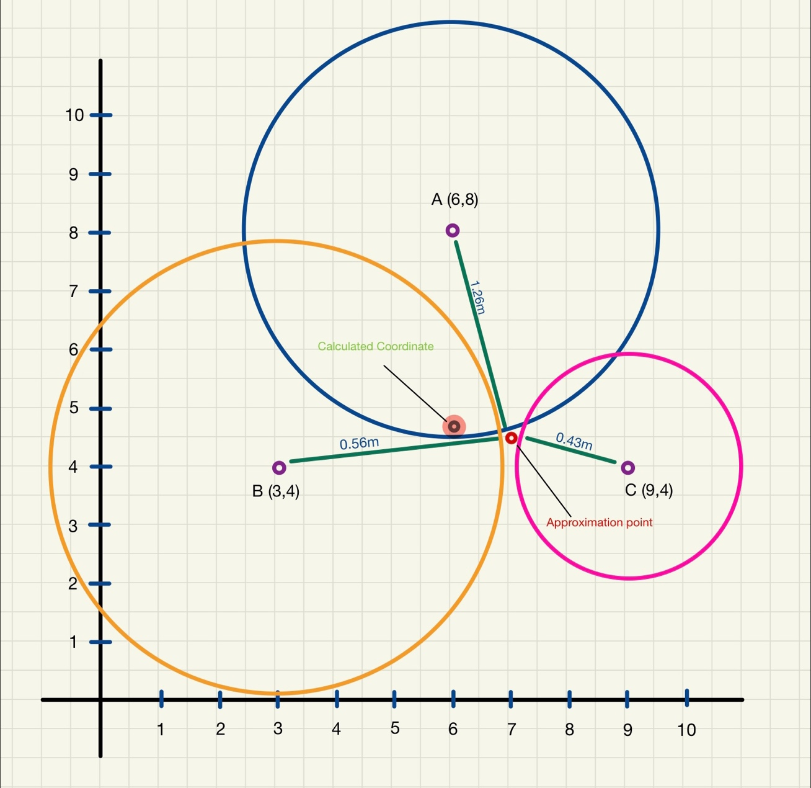

The approximation point indicates where the assumed placement of the mobile device during the time of testing was. This allows us to approximate the coordinate before calculations are made. This serves as guidelines when calculating, allowing the Approximation point and the Calculated Coordinate to have 0.3m - 0.8m for room for error.
https://www.101computing.net/cell-phone-trilateration-algorithm/#:~:text=Cell%20Phone%20Trilateration%20AlgorithmEdit,20
TBD Later. I need sleep

User Profiling
This section highlights the sensitive nature of set service identifiers (SSIDs). SSIDs are unique identifiers and deemed as personal data under the General Data Protection Regulation (GDPR) however in practice it’s not treated as such. The text entered in the SSID fields are completely exposed. The following Figures 8.1 to 8.6 depict how simply it is to view the SSID field in the probe request frames.
SSIDs often carry significant names which may be linked to a location, role and or organisation. This means that from the SSID alone a bad actor may gain some information on the individual or individuals which carry the wireless client devices from which the probe request stems from. This can be made even more significant with accompanying further reconnaissance.
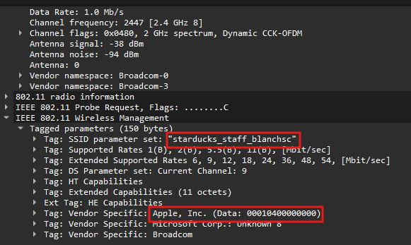
Figure 8.1 - SSID exposed through probe requests, "starducks_staff_blanchsc".
For example, if we consider that the packets depicted in Figures 8.1 to 8.6 came from one single wireless client we would know that the wireless client itself is an Apple product. The owner of the device may work at “Starducks” in the Blanchardstown area with a possibility of “sc” standing in for shopping centre.
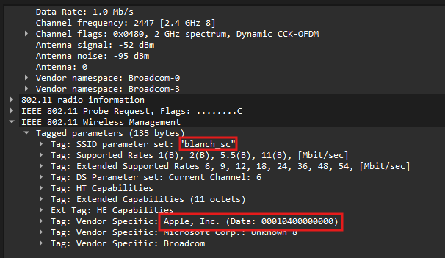
Figure 8.2 - SSID exposed through probe requests, "blanch_sc".
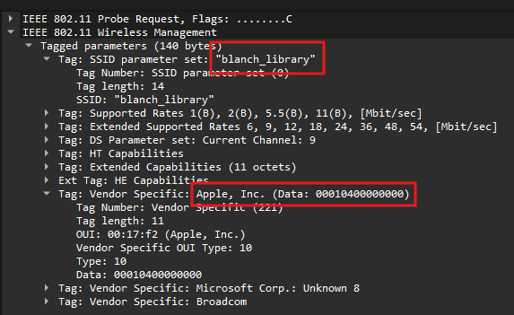
Figure 8.3 - SSID exposed through probe requests, "blanch_library".
Alongside the other SSIDs such as “blanch_sc” and “blanch_library” we could assume that the owner may live somewhere in the Blanchardstown area. This can support that the “eduroam_test” network they could be trying to connect to could be TU Dublin Blanchardstown. It doesn’t give the threat actor all the answers but with further reconnaissance the threat actor could prove or disprove this theory. The SSIDs may give them a point to start from.
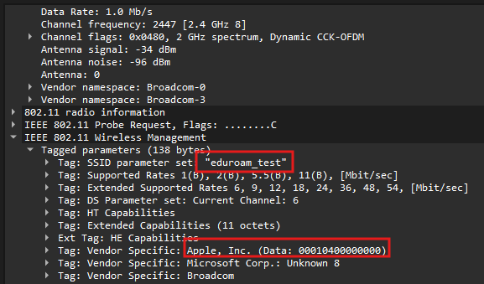
Figure 8.4 - SSID exposed through probe requests, "eduroam_test".
Another tendency that people have is naming their SSIDs depending on the location of the network. Taking into account the scenario described above and the packets depicted below in Figure 8.5 and 8.6 a threat actor may note that the person which this wireless Apple client belongs to might be named Alan or know someone that may be named Alan instead.
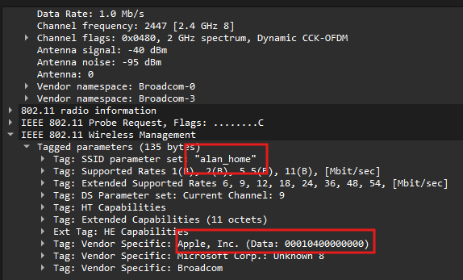
Figure 8.5 - SSID exposed through probe requests “alan_home”.

The following Figure 8.6 shows that in the case that the wireless client connected to a “friend’s” hotspot before it can also be found in probe request frames. Often people have the tendency to put their own names in the SSID of their hotspots or name the devices with their own names included for example “Jane’s iPhone”. These details can aid in uncovering one’s social circle or reinforce findings from open source investigations.
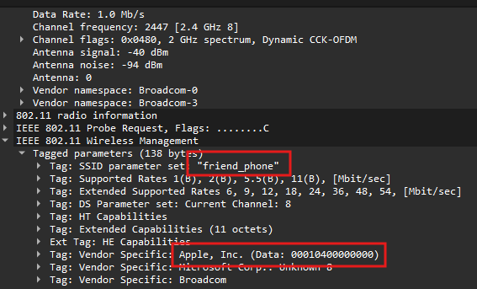
Figure 8.6 - SSID exposed through probe requests, “friend_phone”.

Mistaken Password Field
Figure 8.7 shows how since SSID fields can be viewed as they are shown in plaintext we can see that if an individual mistakenly enters their password in the SSID field unknowingly a bad actor may be able to use that to gain access to the person’s network. In the study reviewed in chapter 2 section 2.5 we learned that this occurs more commonly than expected through the data in which that study gathered. Some seemingly tried to enter the passwords with different variations multiple times.
The vulnerable such as elderly individuals who may not understand modern technology may be especially susceptible to this.
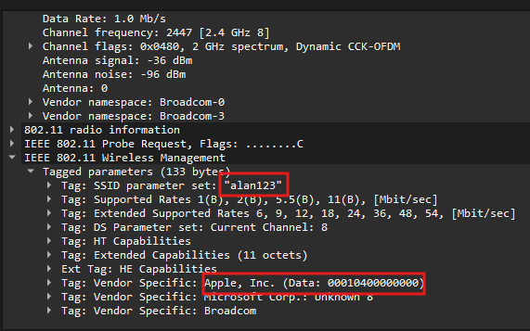
Figure 8.7 - Example of if a password was mistakenly entered into the SSID field.

Evaluation of Results

Key Learnings Derived

Monitor Mode

Sequence Numbers
While performing some tests we noticed an interesting pattern in terms of the sequence numbers. The sequence numbers showed gaps in them with the difference being around over a thousand. For example we would see a difference up to hundreds of packets between some packets. After doing some research we concluded that it might be due to us turning on and off our access point (AP) and so some packets were lost.
Another observation made was that it would be a smaller sequence number than the packet above it. This may be due to packets getting lost and then the sequence number resets. It could also be due to us deauthorizing the network.

General Data Protection Regulation Legislation
Prior to this project we did not know that GDPR applied to online and digital identifiers such as media access control address (MAC addresses) and set service identifiers (SSID). In hindsight it makes sense since both are unique identifiers. Although there is legislation protecting certain actions and activities it would be the main deterrent. The type of activity in which its attempting to prevent may deter bad actors from releasing personal information about an individual.

Human Error

Threat landscape

Conclusions & Further Work

Conclusions
dfjdfkljldfjglk fdjg ld fglk dfg lkd fjg ldkfglkdfgld jfg dfjg dlfkjg dlfjg ldfg df glkdjf glkd jfglkjdf jg dflkjgldfkg lkdfjglkdfj glkfjdglkdfjgfdg. fdjg ld fglk dfg lkd fjg ldkfglkdfgld jfg dfjg fdjg ld fglk dfg lkd fjg ldkfglkdfgld jfg dfjg.

Further Work

List of References
Anon., n.d. MAC Look Up. [Online]
Available at: https://maclookup.app/macaddress/a0b4a5/mac-address-details
[Accessed 05 05 2026].
Calculator City, 2026. Calculate Distance Using Rssi Value. [Online]
Available at: https://cal3.calculator.city/calculate-distance-using-rssi-value/
[Accessed 01 05 2026].
Cisco, n.d. Monitor Mode. [Online]
Available at: https://www.cisco.com/c/en/us/td/docs/wireless/controller/9800/config-guide/b_wl_16_10_cg/monitor-mode.pdf
[Accessed 25 04 2026].
Dionicio, R., 2018. netbeez. [Online]
Available at: https://netbeez.net/blog/station-authentication-association/
[Accessed 07 April 2026].
Dionicio, R., 2018. netbeez. [Online]
Available at: https://netbeez.net/blog/secure-network-4-way-handshake/
[Accessed 09 April 2026].
Ergen, M., 2002. IEEE 802.11 Tutorial, California: University of California Berkeley.
European Commission, n.d. European Commision. [Online]
Available at: https://commission.europa.eu/law/law-topic/data-protection/data-protection-explained_en
[Accessed 25 04 2026].
European Parliament, C. o. t. E. U., 2016. gdpr-info. s.l.:s.n.
Frankel, S., Eydt, B., Owens, L. & Scarfone, K., 2007. Establishing Wireless Robust Security Networks: A Guide to IEEE 802.11i , s.l.: National Institute of Standards and Technology .
Gridelli, S., 2024. netbeez. [Online]
Available at: https://netbeez.net/blog/how-wifi-connection-works/
[Accessed 07 April 2026].
Gupta, V. & Rohil, M. K., 2012. Information Embedding in IEEE 802.11 Beacon Frame, Pilani: Birla Institute of Technology and Science.
Khaled, Z. E. & Ajib, W., 2022. Log Distance Path Loss Model: Application and Improvement for Sub 5 GHz Rural Fixed Wireless Networks, Chicoutimi; Montreal: IEEE Access.
Kim, Y. S., Tian, Y., Nguyen, L. T. & Tague, P., 2014. LAPWiN: Location-Aided Probing for Protecting User Privacy in Wi-Fi Networks, s.l.: Carnegie Mellon University.
McDougall, J. A. et al., 2022. Probing for Passwords – Privacy Implications of SSIDs in Probe Requests, Hamburg: University of Hamburg.
Nayanajith, R., 2014. mrncciew. [Online]
Available at: https://mrncciew.com/2014/10/27/cwap-802-11-probe-requestresponse/
[Accessed 09 April 2026].
Nayanajith, R., 2014. mrncciew. [Online]
Available at: https://mrncciew.com/2014/08/19/cwsp-legacy-802-11-securiry/
[Accessed 08 April 2026].
Paulsen, C. & Toth, P., 2016. NISTIR 7621 Revision 1 Small Business Information Security: The Fundamentals, s.l.: National Institute of Standards and Technology .
Scheuner, J. et al., 2016. Probr – A Generic and Passive WiFi Tracking System, Zurich: Communication Systems Group CSG, Department of Informatics IfI, University of Zurich.
Souppaya, M. & Scarfone, K., 2012. NIST Special Publication 800-153 Guidelines for Securing Wireless Local Area Networks (WLANs): Recommendations of the National Institute of Standards and Technology, Gaithersburg: National Institute of Standards and Technology.
Sun, L., Chen, S., Zheng, Z. & Xu, L., 2017. Mobile Device Passive Localization Based on IEEE 802.11 Probe Request Frames, s.l.: Hindawi.
Yinan, G., Shuguo, Z. & Dawei, X., 2012. Overview of Wi-Fi Technology , Xuzhou: School of Information and Electrical Engineering.
Yu, W. X., 2017. wifi-ap-scanner. s.l.:s.n.

- Project Planning
- Initial Gantt Chart
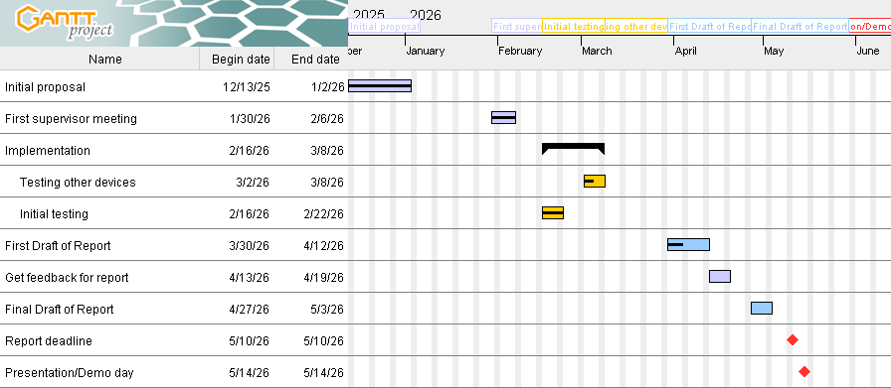
- Corresponding Notes to the Initial Gantt Chart
Name | Notes
Initial testing | In person meeting to do some initial testing around our second option which involves getting monitor mode to work and then recording the behaviour of a wireless client when connecting to a hidden access point.
Testing other devices | Testing involving different operating systems such as iPhone compared to Android to see if they behave different when looking at the probe requests sent such as intervals etc.
First Draft of Report | - Lan will work on the literature review part and formatting of the report as well as concluding the meeting minutes.  - Alex and Kai will replicate the testing with Android devices (we lost the pcap files).  - Kai will work on the program documentation.  - Alex will work on the implementation document
Get feedback for report | Get feedback for first draft & make relative changes.
Report deadline | Due at 11:59pm on Brightspace
Presentation/Demo Day | - In rooms A010, A011 & A012  - Between 10am & 3pm  - Greg & another academic 12mins + 5mins for questions  - Demo for full time or Demo + presentation
Table 9.1 - Corresponding Gantt chart notes.
- Unexpected Circumstances
A member of the team suffered from an unexpected death in the family and subsequent family relation issues with existing mental health issues this caused some delays to our project schedule as to make time for recovery.
- Timeline of Events

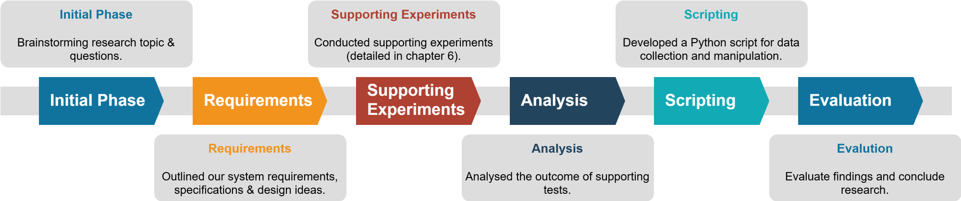
Figure 10.1 - Timeline overview.

- Initial Phase:
  - Weeks 2 (02/02/2026 to 08/02/2026)
- Requirements:
  - Week 3 (09/02/2026 to 15/02/2026)
- Supporting Experiments:
  - Weeks 4 & 5 (16/02/2026 to 01/03/2026)
- Analysis:
  - Weeks 6 to 8 (02/03/2026 to 22/03/2026)
- Scripting:
  - Weeks 9 to 12 (23/03/2026 to 03/05/2026)
- Evaluation:
  - Week 13 (04/05/2026 to 10/05/2026)
- Format Planning
- Legal Compliance, Ethics & Interest
- Legal Compliance & Ethics
All testing was done on and with hardware belonging to the authors responsible for this work. The authors declare that permission was given for said hardware resources to be used in this work.
Data of those other than the authors were not collected and used in this work.
The authors are not liable for any subsequent usage by other individuals from the contents and findings from this report. Research for this project was conducted in and for a purely educational setting.
- Declaration of No Conflict of Interest
The authors declare that they have no relevant or material financial interests related to this work.

- Program listings
- The GitHub Repository Link
https://github.com/LanNgai/side_channel_leakage
- Summary of included program listings
- “collecting_antenna_strength.py” – Created from parts of another developer’s source code to help understand Python receiving signals. (Yu, 2017)
- “basic_packet_sniffer.py” – Used to test the Scapy Python module.
- “basic_pyshark.py” – Used to test the PyShark Python module.
- “prototype_pyshark.py” – Our prototype Python script using PyShark to gather packets and calculate distance from the relative signal strength indicators.
- “final_pyshark.py” – Our final script which puts the action of parsing the set service identifiers (SSIDs) in a separate method within the class.

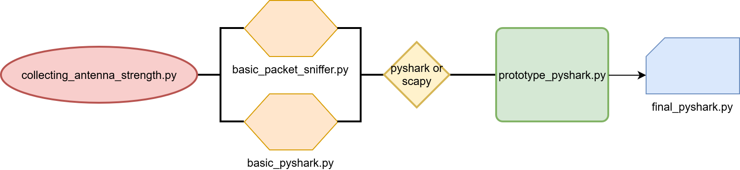

Figure 10.2 - Timeline of the creation of the Python scripts.

- “collecting_antenna_strength.py”
The following is a python script which we wrote to experiment with an existing work on a Wi-Fi AP Scanner. This gave us some experience with Python and made it more comfortable to work with. This script was modified from the wifi-ap-scanner which is referenced at the top of our script (Yu, 2017).
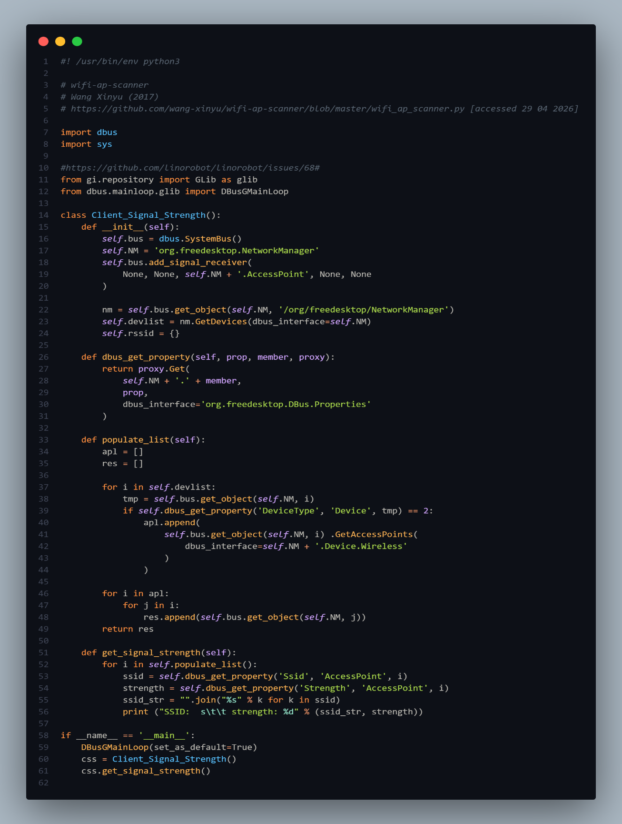
Figure 10.3 – “collecting_antenna_strength.py”.
- “basic_packet_sniffer.py”
The following is a picture of our “basic_packet_sniffer.py”. This was our script when we were experimenting with the Scapy Python module. The sources which we consulted are included at the top of the script itself. It’s a very basic packet capture Python script. The method “packet_callback()” just prints the summary of the packets collected. The packets are filtered for only Transmission Control Protocol (TCP) packets, limited to 10 packets per capture, using our “packet_callback()” method.
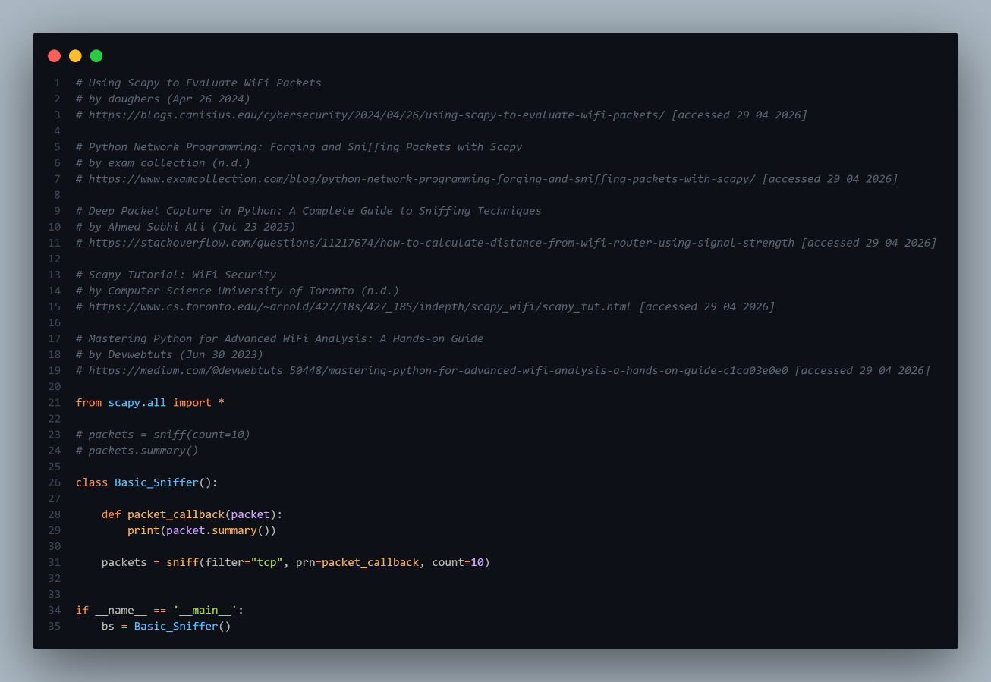
Figure 10.4 - "basic_packet_sniffer.py".

- “basic_pyshark.py”
The following image shows the “basic_pyshark.py”. This is our experimental Python script working with the PyShark wrapper. The resource which the script was influenced from is referenced at the top of our script.
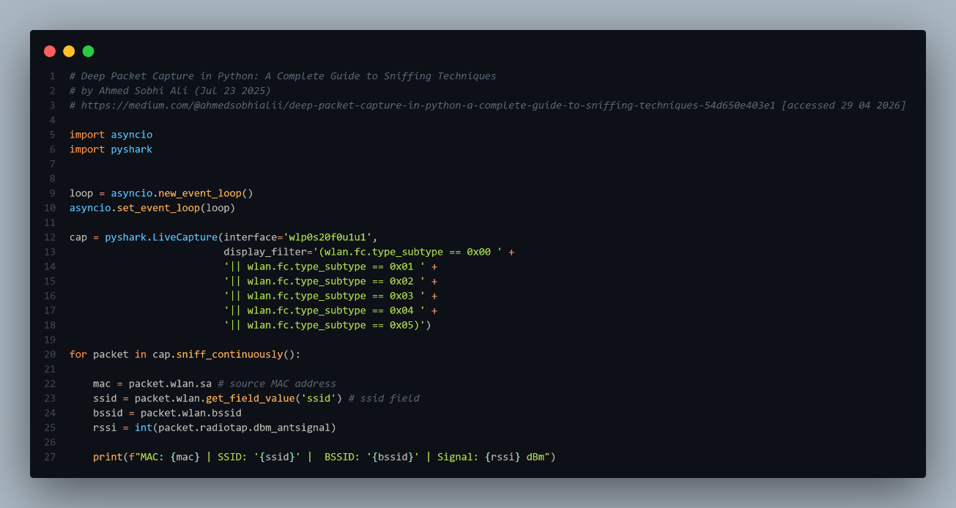
Figure 10.5 - "basic_pyshark.py".

We had some issues with event loops so we added a part (highlighted in Figure 10.2.4) which creates an event loop and sets that created loop so that we have more control. This migrated into our “prototype_pyshark.py” and “final_pyshark.py” scripts as well.

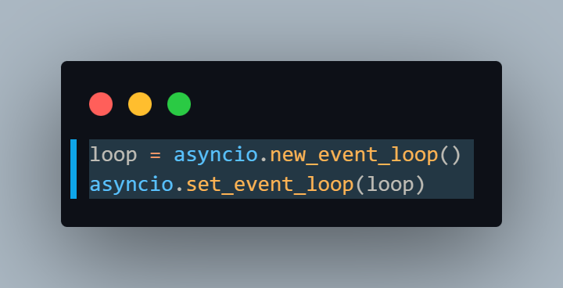
Figure 10.6 - "basic_pyshark.py" with a focus on the event loop portion.
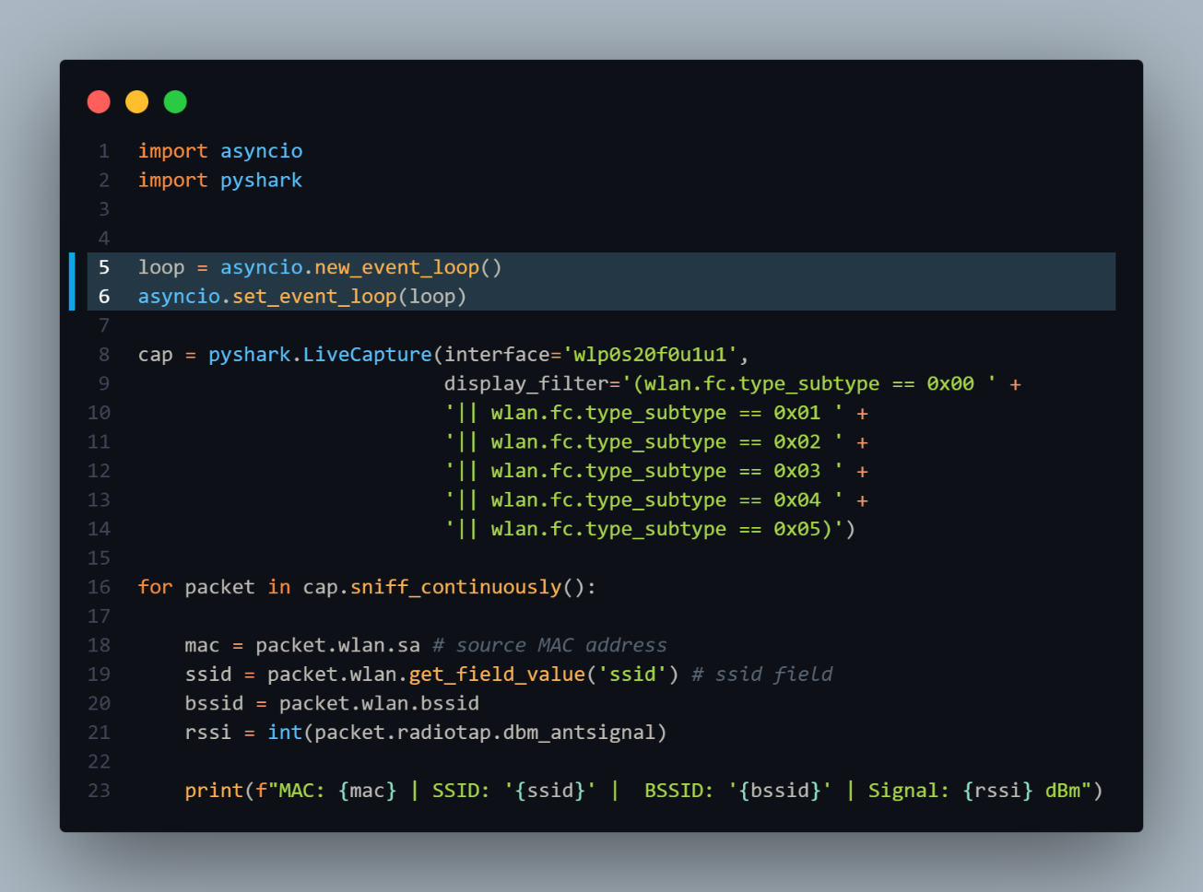
Figure 10.7 - "basic_pyshark.py" with the event loop part highlighted.

- Referencing for “prototype_pyshark.py” & “final_pyshark.py”
The following image shows our references in the Python scripts, “prototype_pyshark.py” and “final_pyshark.py”. The following list of references can be found at the top of both scripts.

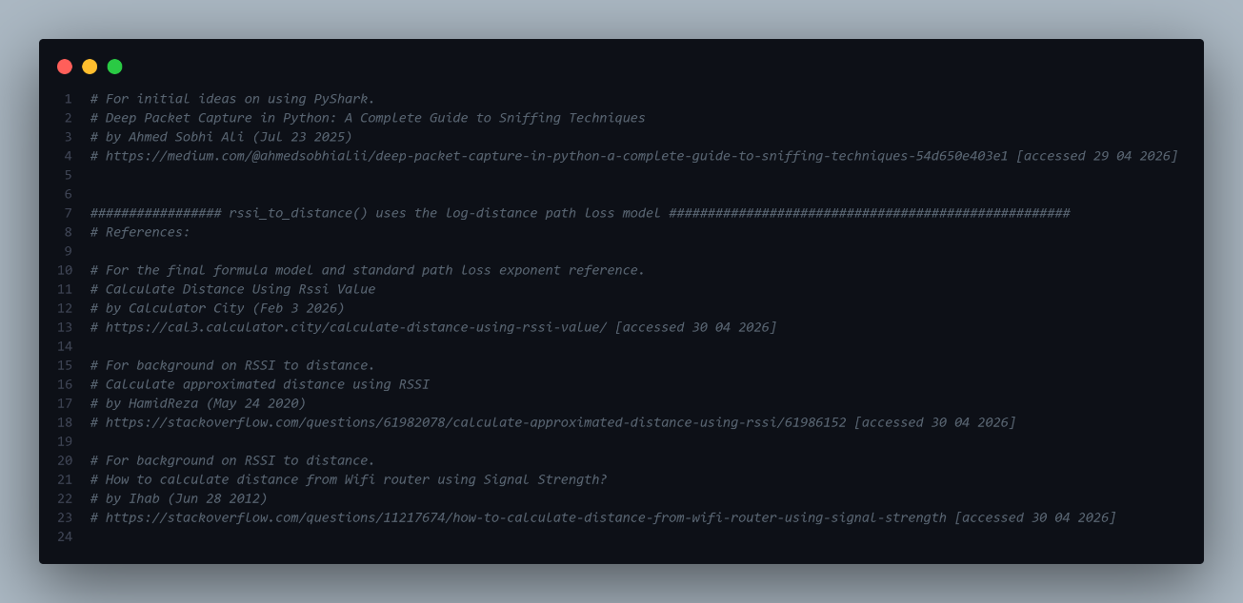
Figure 10.8 - Image of the reference list in both “prototype_pyshark.py” and “final_pyshark.py”.

- “prototype_pyshark.py”
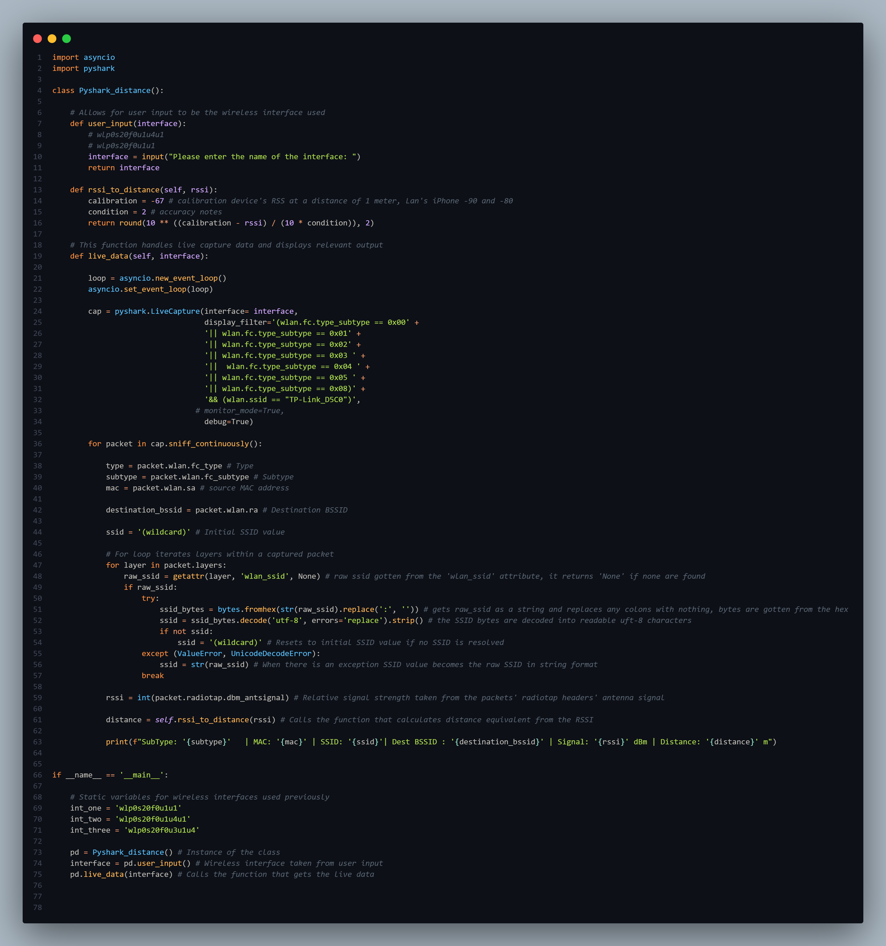

- “final_pyshark.py”
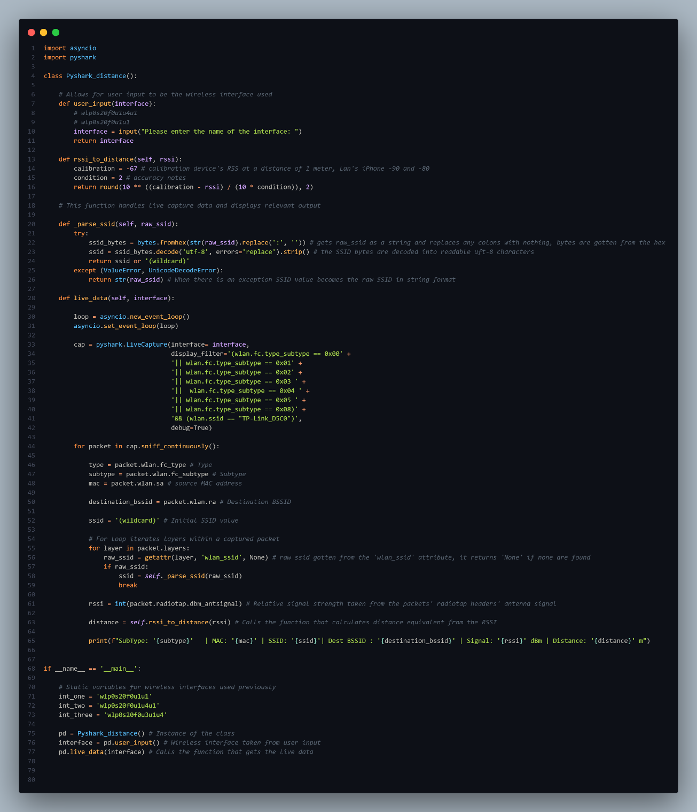
Figure 10.9

- Hardware & Software Used
- Hardware Used
Resource Role | Resource Name | Version
Deauthentication device | DSTIKE Deauther Watch X | N/A
Wireless Client | iPhone 17 Pro | iOS 26.2.1
Wireless Client | iPhone 15 Pro Max | iOS 26.4.2
Wireless Client | iPhone 13 | iOS 26.4 developer beta
Wireless Client | Samsung A16 | Android 16  Kernel 6.12.23
Wireless Client | Samsung A5 | Android 8  Kernel 3.18.14
Wireless Hidden AP () | TP-Link TL-Wr940n Wireless router | 450mbps
Wireless Hidden AP () | TP-Link TL-Wr940n Wireless router | 450mbps
Device For Monitoring | MacBook Pro | 2020 Intel Core i5
Wi-Fi USB Adapter | Alfa Network Alfa USB Adapter | awus036acs
Wi-Fi USB Adapter | Alfa Network Alfa USB Adapter | awus036acs
Wi-Fi USB Adapter | Generic | 802.11n
Table 9.2 - Hardware resources used in this project.
- Software Used
Resource Role | Resource Name | Version
Project Planning | GanttProject | 3.3.3322
Network Traffic Packet Analyser | Wireshark | 4.6.5
Diagramming Application | Draw.io | 29.7.9

- Wireshark Filter Used
(wlan.fc.type_subtype == 0x00 || wlan.fc.type_subtype == 0x02 || wlan.fc.type_subtype == 0x04 || wlan.fc.type_subtype == 0x05 || wlan.fc.type_subtype == 0x01 || wlan.fc.type_subtype == 0x03) && wlan.bssid == e4:c3:2a:84:d5:c0
- Expenditure

- Statement of Contribution
- Lan Ngai
- Python Scripts
- Formatting
- Chapter 1: Introduction
- Chapter 2: Literature Review
- Chapter 3: Methodology
- Chapter 4: System Requirements & Specifications
- Chapter 5: System Design
- Chapter 6: Supporting Tests
- Chapter 7: Implementation of Prototype
- Chapter 9: Key Learnings Derived
- Appendix A: Project Planning
- Appendix B: Legal Compliance, Ethics & Interest
- Appendix C: Program Listing
- Appendix D: Hardware & Software Used
- Alex Anthony Dela Cruz
- Kai Guy

