CPSC 1160: Week 11 Homework – Doubly Linked Lists
Due: As indicated by submission link
Total Marks: 10
Instructions – PLEASE READ
- This work is to be done individually.
- You should submit only one version via D2L. Check instructions from TA regarding what to submit (zip/just code). Code files must always be included.
- Keep a copy of everything you submit in some online storage that is accessible by you only.
Copying another student’s work or submitting anything that is not your own work will result in a zero for all parties involved. Academic alert may follow!

EXERCISES
In this assignment you will be writing a program that may be used by a store (or an online shopping site) that sells various categories of products (such as Amazon selling TVs under the category Electronics, Alibaba selling Frying pans under the category Cookware etc) to maintain their inventory.
The following image shows what a Store object may look like (on the inside).
Imagine the object shown below is for a Store object whose name is Amazon.
This store currently has two categories of products, namely Books and Electronics (the two categories are stored inside a doubly-linked list, each category is a node inside a doubly-linked list, hence the arrows, downward arrow means null).
Also, under the Books category the store currently has three products:
1.Book1, Price: 10, Quantity: 5
2.Book2, Price: 20, Quantity: 3
3.Book3, Price: 5, Quantity: 100
And under the Electronics category the store currently has two products:
1. Laptop, Price: 500, Quantity: 10
2. TV, Price: 300, Quantity: 5
All products inside each category is stored in a doubly-linked list (each product is a node inside a doubly-linked list, hence the arrows, downward arrow means null). The Electronics category has its products in its own doubly-linked list and Books category has its products in its own doubly-linked list.

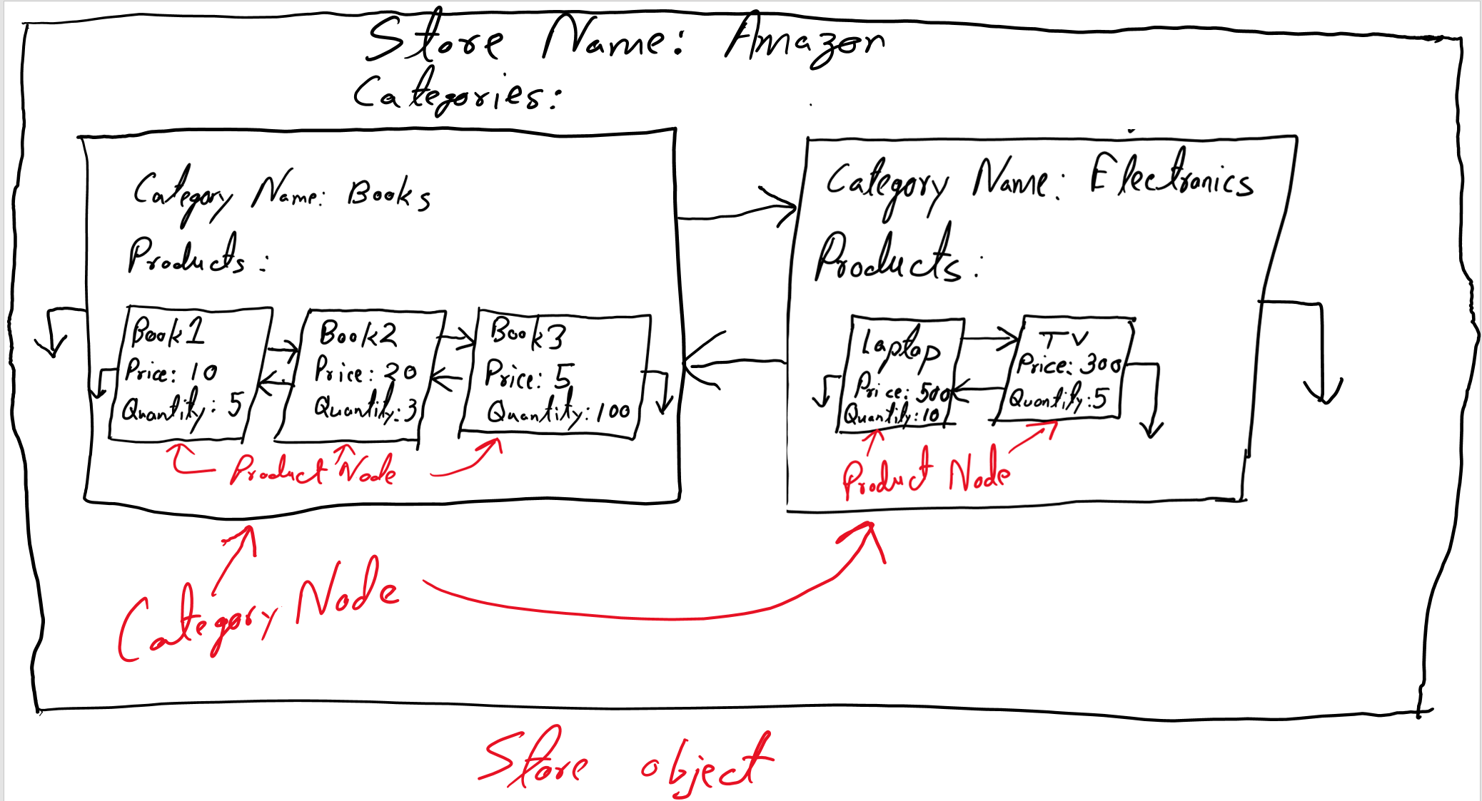

Complete the following tasks (following order will be wise, beware of shallow copy).

- A class named ProductNode has already been written for you.
  - You CANNOT add/remove/change any data members
  - You may add/remove/change methods to this class, but it is not necessary (in my solution, I did not add any code to this file).

- A class named CategoryNode has been written PARTIALLY
  - You CANNOT add/remove/change any data members
  - Look for the comment “//COMPLETE THE CODE” and write your code for that method.
    - Read method comments to know what needs to be done
  - You may add/remove/change methods to this class.

- If you have completed the CategoryNode class then you should test it before moving onto Store class (see below). Store class will need a working CategoryNode class
  - To do this test Open StoreDriver.cpp
  - Go to main function, read the comments
  - Run TEST1 only (and not TEST2, that is for the Store class)
  - For this test I have added expected output in comments.

- A class named Store has been written PARTIALLY
  - You CANNOT add/remove/change any data members
  - Look for the comment “//COMPLETE THE CODE” and write your code for that method.
    - Read method comments to know what needs to be done
  - You may add/remove/change methods to this class.

- Test Store class by running TEST2
  - To do this test open StoreDriver.cpp
  - Go to main function, read the comments
  - Run TEST2 only (and not TEST1 that is for the CategoryNode class above)
  - Analyze outputs for errors
  - For this test NO expected output was added

LoadStoreFromFile function is just their to load data from a file for faster testing, Sample file (store1.txt) has been provided. This is for testing purposes. LoadStoreFromFile will not work unless Store class has been completed correctly OR if data format inside store1.txt is altered (you can alter data but not formatting if you want to create your own test cases).

