

**Faculty of Engineering & Technology Electrical & Computer Engineering Department**

**Linux Laboratory -ENCS3130**

**Python project**

**Prepared by:**

Batool Hammouda 1202874

Lana Batnij 1200308

**Instructor:**

Dr.Mohammad jubran

**Date:**

8-9-2023

* The main menu:

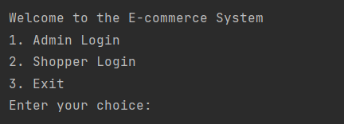

* Admin menu:

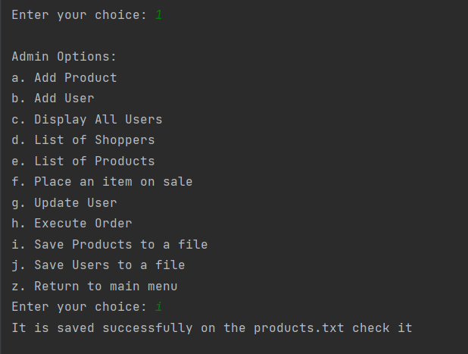

* Add new products:

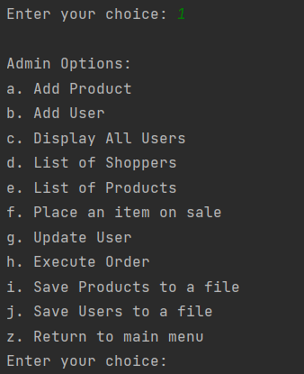

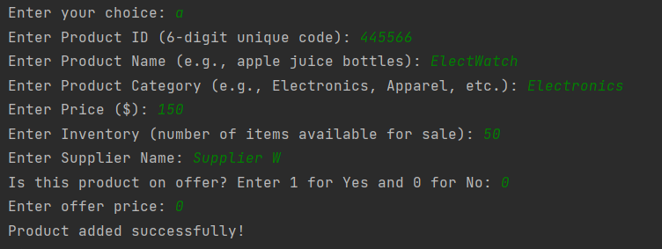

Result in file:

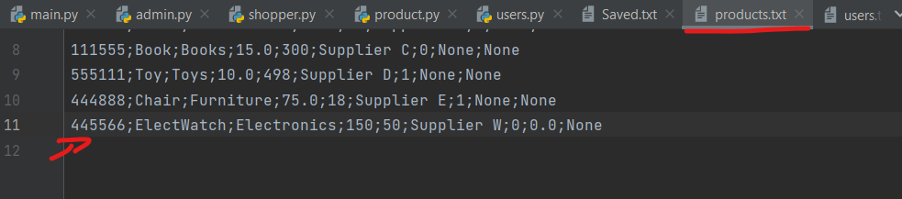

* Add user (only by the admin):

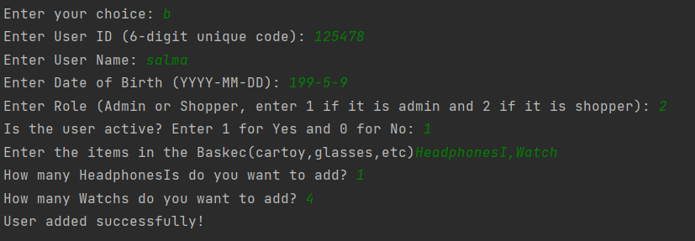

In the file :

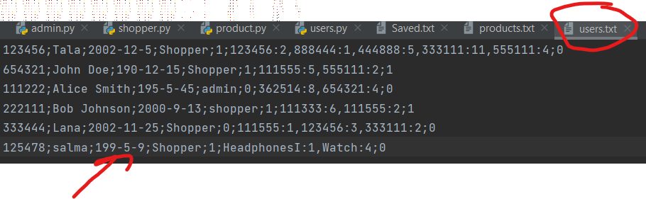

* Display all users:

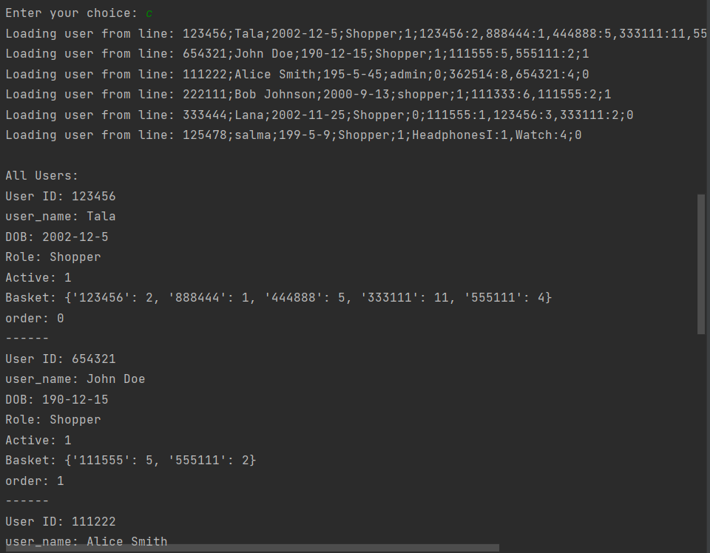

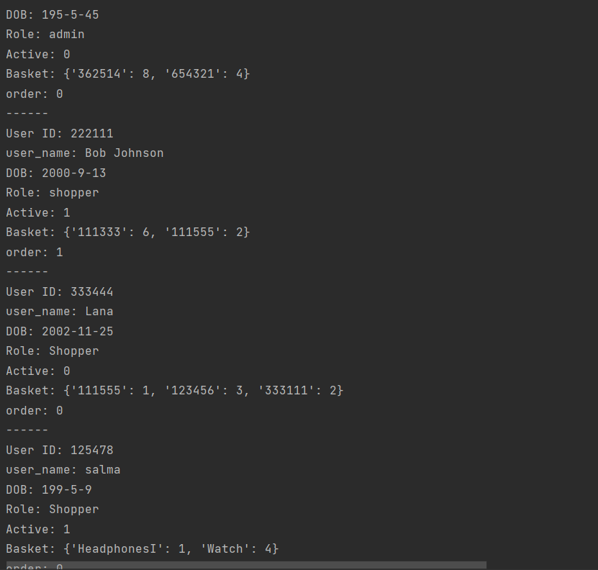

* List of **all** shoppers:

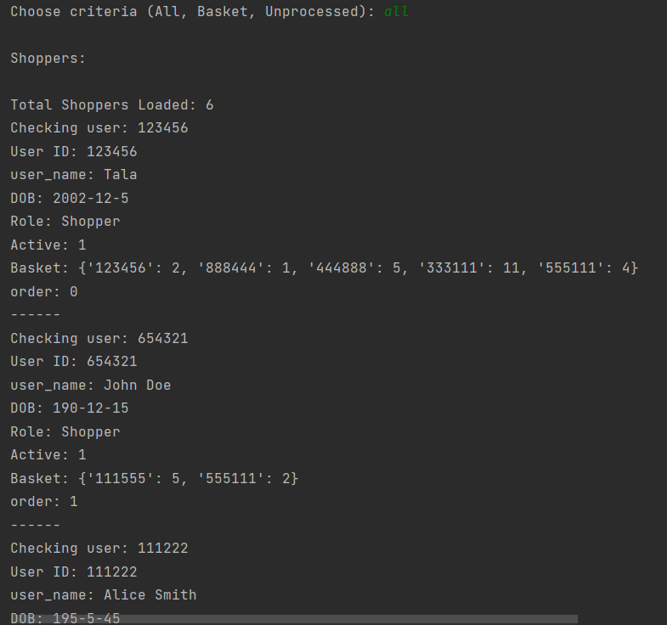

* By **Basket:**

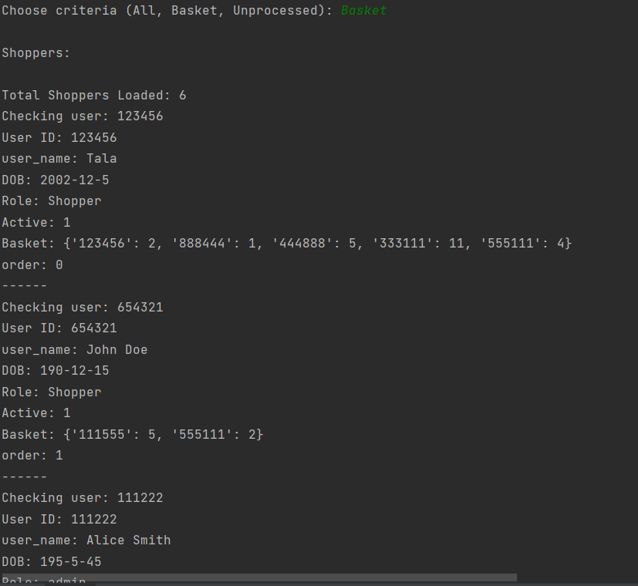

* By **Unprocessed** (not ordering yet):

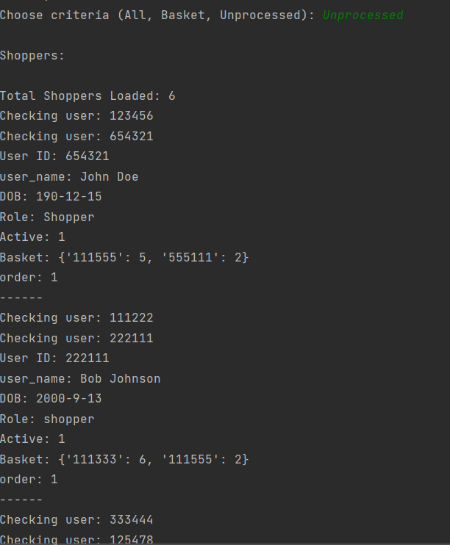

* List of products by the admin:

Display by **Name:**

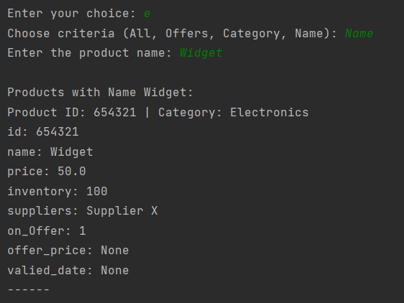

* List by **Category:**

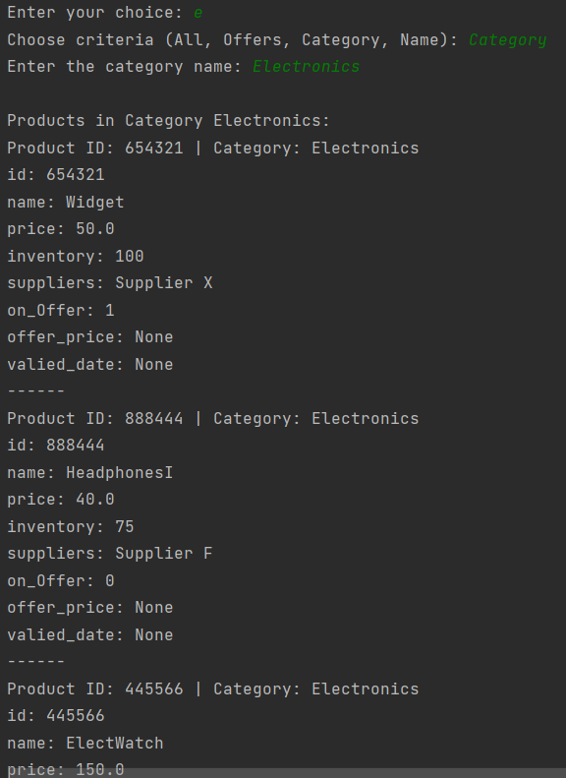

By **Offers:**

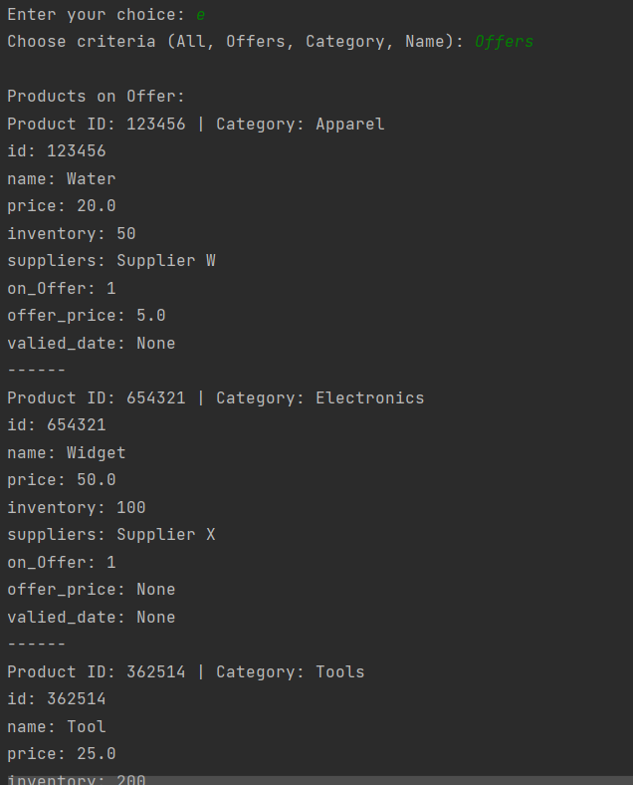

* Place item on sale:

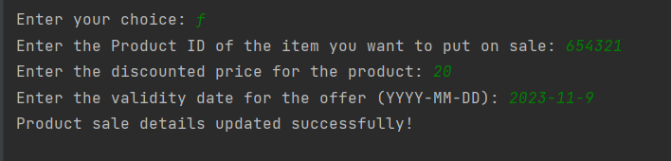

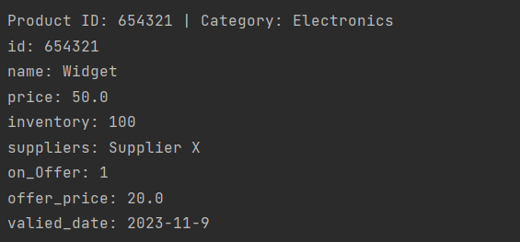

* Update the user information:

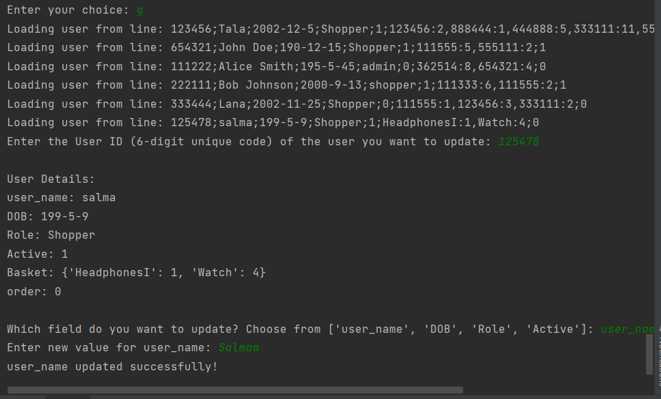

Result in users file:

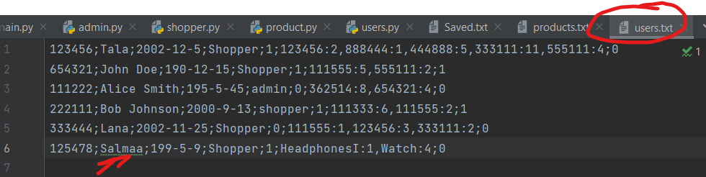

* Execute order:

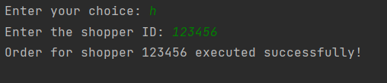

* Change to Shoppers mode:

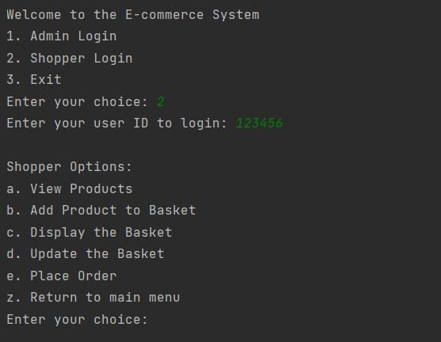

* View all products:

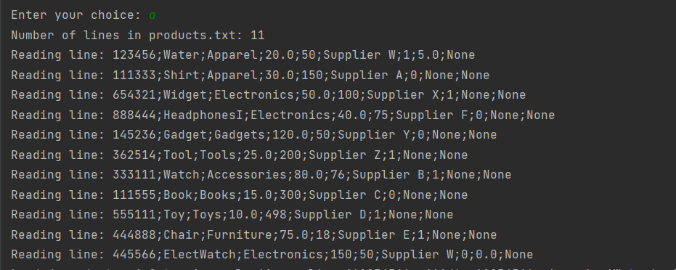

* Display the shoppers basket:

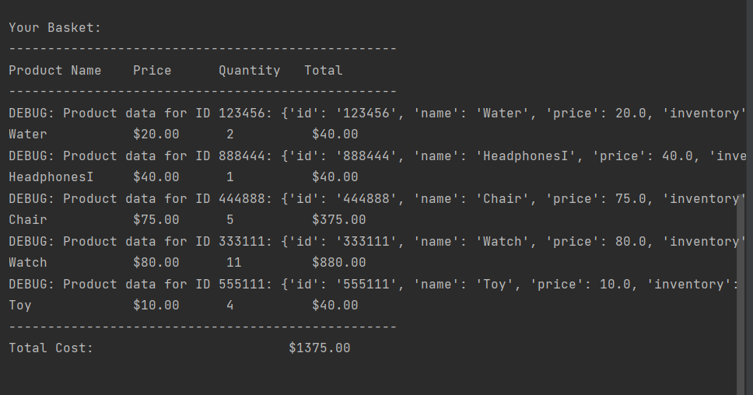

* Place order:



* Back to the main menu (like logout):

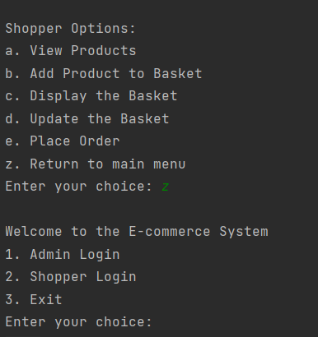

* Exiting:

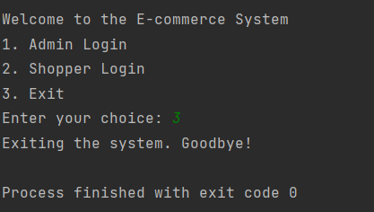

* Save products in the file:



Results in file:

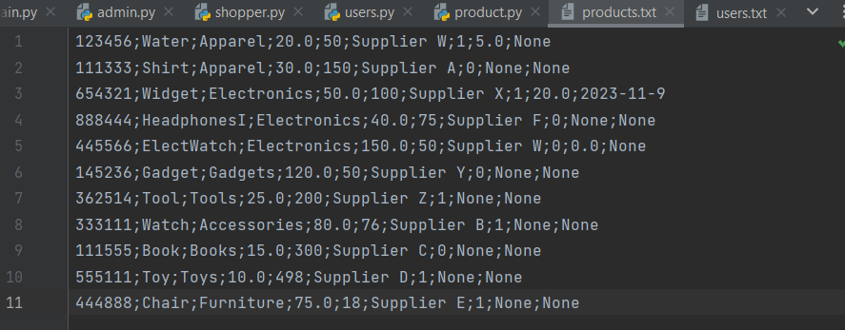

* Save users in file:

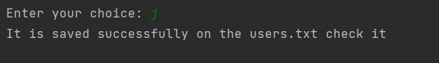

Result in the file:

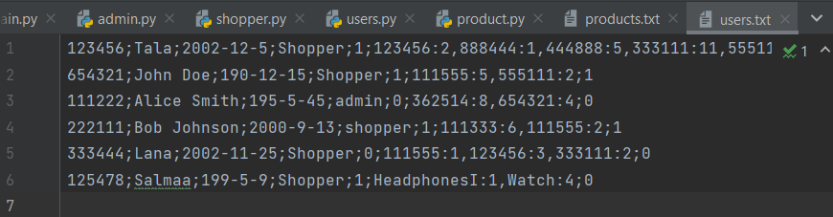

* Shoppers to the basket:

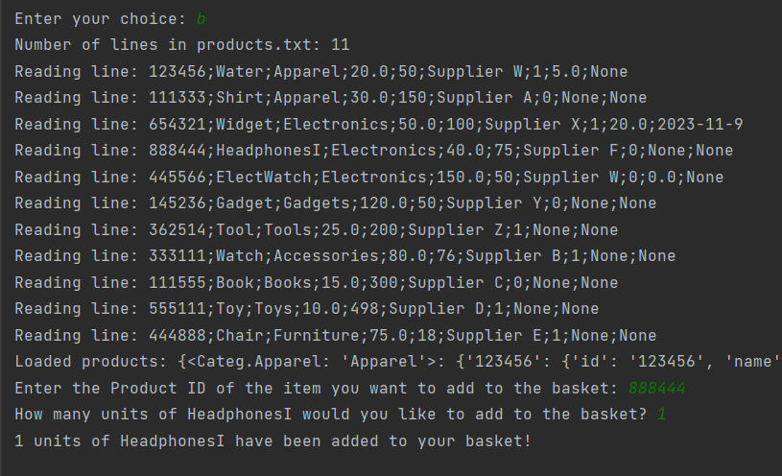

Results in file:

