Components:

16 M/M jumper wire

5 M/Ž jumper wire

Arduino Uno

RTC (Clock) module

8x8 LCD

2x protoboards (2x5x17 pins)

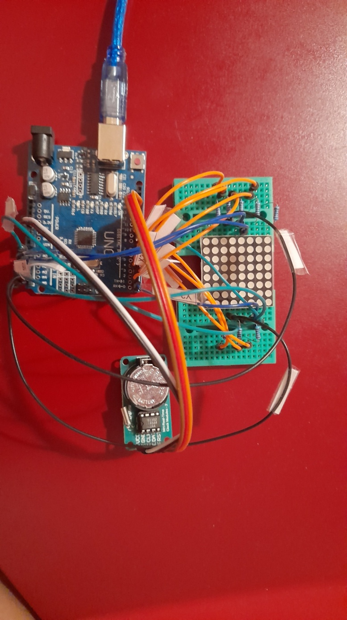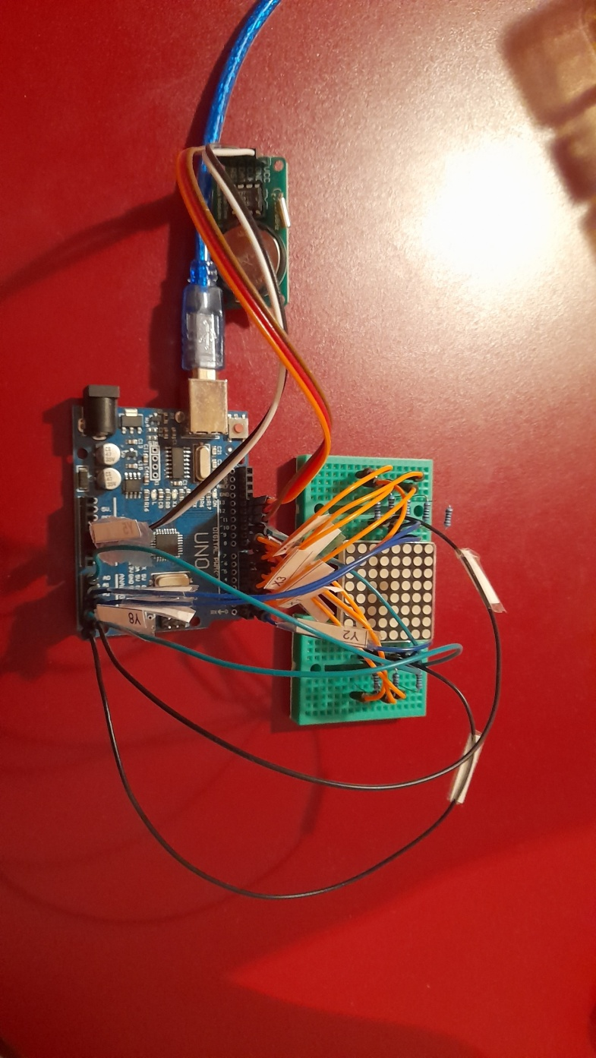8x 220ohm resistors

Wiring:

RTC module:

VCC 》5V

GND 》GND

CLK 》PIN13 (same as p13)

DAT 》p12

RST 》p11

Orientation – how to view:

The lines of the LCD matrix (if we orient the matrix differently, the side without the lines will be visible) are facing the viewer, as showed in the picture:

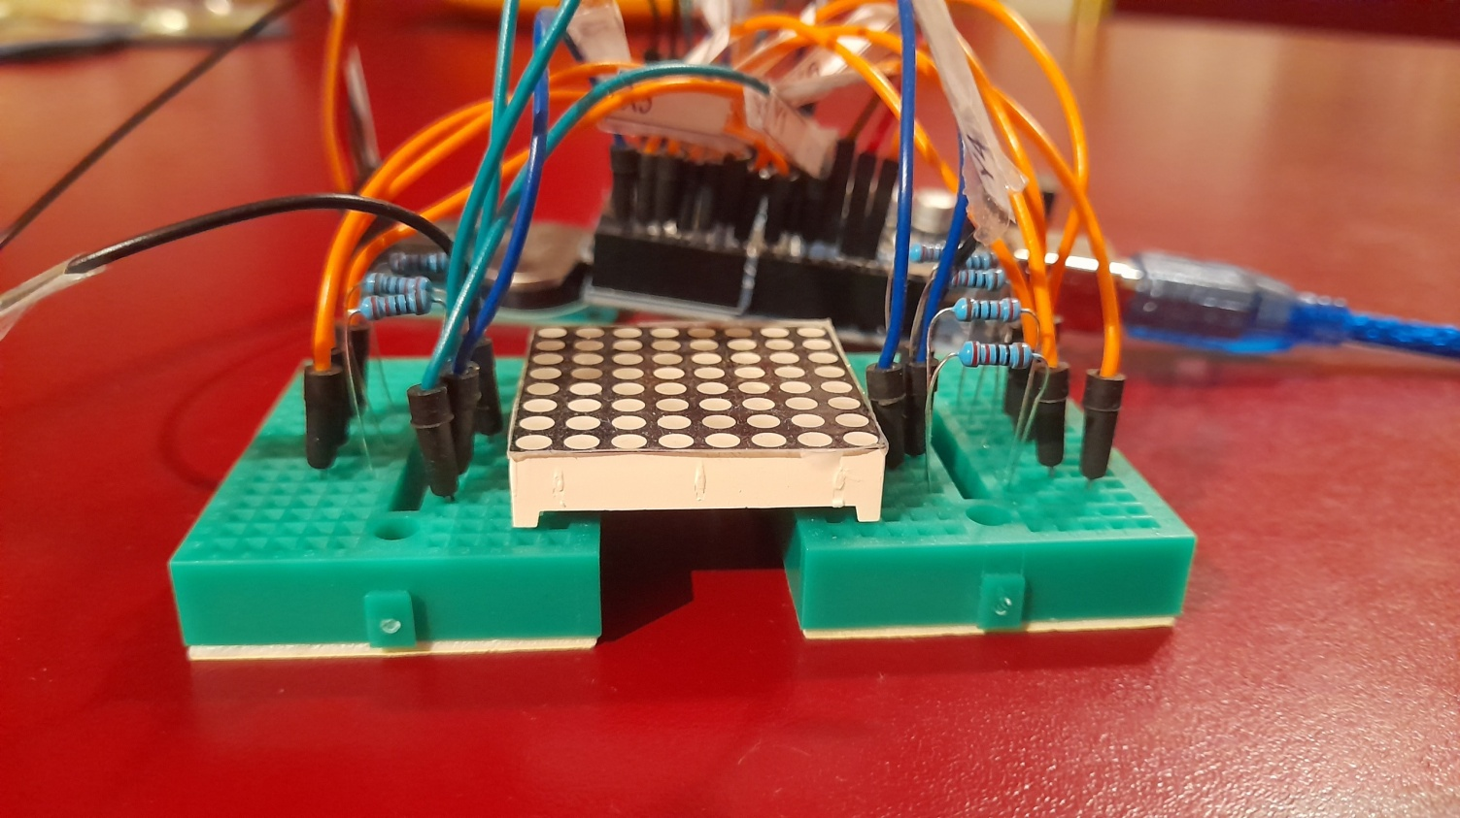(The serial number on the matrix is in this case to our right)

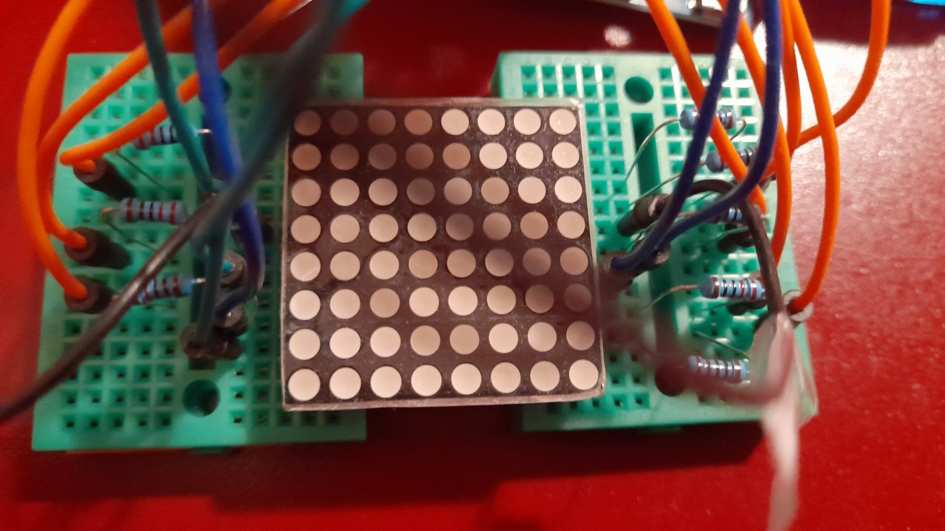

The first pin of the matrix (M1) is located in the lower right corner according to the orientation of the picture, the eighth (M8) is in the upper right, M9 is in the upper left, and M16 is in the lower left corner. The rest of the pins are similarly numbered, following the counterclockwise direction.

M1 》220ohm 》p5

M2 》220ohm 》p3

M3 》A2 (analog pin 2)

M4 》A1

M5 》220ohm 》p2

M6 》A4

M7 》220ohm 》p4

M8 》220ohm 》p7

M9 》220ohm 》p9

M10 》A0

M11 》A5

M12 》220ohm 》p6

M13 》A3

M14 》220ohm 》p8

M15 》p1

M16 》p10

