NAME  Limcuando,Angelo Lance G. |  | DATE 2-4-17 | SCORE
SCHEDULE  Saturday 10:00-12:40 | SCORE |  | SCORE

LABORATORY EXERCISES
RECURSION

OBJECTIVES:
- Understand recursion and its parts
- Use recursion to solve programming problems

PROCEDURE:
- Encode the C++ program below.
- Save as rec1.cpp,and rec2.cpp, respectively.
- Compile and run the program by pressing Ctrl + F9.
- For each syntax or logical error encountered in the given program, do the following:
- Correct the error
- Recompile the program
- Repeat step 4 until no errors are encountered in the program.
- Illustrate the output of the modified program.

Program No. 1

#include <iostream>
using namespace std;

void numberFunction(int i) {
cout << "The number is: " << i << endl;
i++;
if(i<10) {
numberFunction(i);
}
Output:
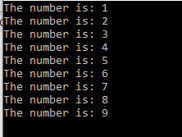

}

int main() {

int i = 1;
numberFunction(i);

return 0;
}

#include <iostream>
using namespace std;

int factorial(int);

int main() {
int n;
Output:

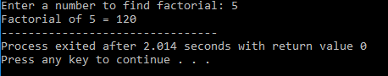

cout<<"Enter a number to find factorial: ";
cin>>n;
cout<<"Factorial of "<<n<<" = "<<factorial(n);
return 0;
}

int factorial(int n) {
if (n>1) {
return n*factorial(n-1);
}
else {
return 1;
}
}

Supplementary Problem

- A recursive function that sums up the 10 integers in an array.

Program:

#include<iostream>
using namespace std;

int sum(int x[], int i){
if(i<0)
return 0;
else
return x[i] + sum(x,--i);
}

int main(){
int x[10];
cout<<"Enter 10 integers to be added: \n";
for(int i=0;i<10;i++){
cout<<": ";
cin>>x[i];
}
cout<<"the total = "<<sum(x,9);
}

Output:
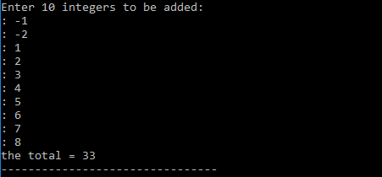

- A recursive function to produce the Fibonacci number for a given index in the series.
Use the function int fibonacci(int n)

Program:

#include<iostream>
using namespace std;

int fibonacci(int n){

if(n<2)
return n;
else
return fibonacci(n-1)+fibonacci(n-2);

}

int main(){

int index;
cout<<"Enter index: ";
cin>>index;
cout<<"Result: "<<fibonacci(index);
}

Output:

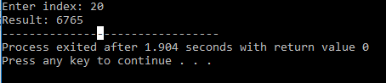

- A recursive function which raises its first parameter to the power of its second parameter.
Use the function int power(int number, int power)

Program:

#include<iostream>
using namespace std;

int power(int number, int coef){

if(coef==0)
return 1;
if(coef==1)
return number;
else
return number * power(number,coef-1);

}

int main(){

int number, coef;
cout<<"Enter Number: ";
cin>>number;
cout<<"Enter Power: ";
cin>>coef;
cout<<"Result: "<<power(number,coef);

}

Output:

