Mini Project #1

Name: Yunchao Liu

##### Name of group mates: [Karthik Subhraveti](https://www.facebook.com/karthik.subhraveti)

section1:

* The simulation will have an array A of 20 values of 1 or 0, meaning 20 computer. And 1 means infected while 0 means uninfected.
* For each infection, generate a random number. If the random number is lesser than 0.1, then set the 0 to 1, meaning an uninfected computer gets infected. The total infect rate will be 1-0.9^X where X is the number of current infected computers
* Create another array B initialized all 0’s. If a computer is infected, then set the corresponding position in the new array to 1, meaning it has been infected.
* For repair, check each value. If the value is 1, set it back to 0. Do it up to 5 times and stop. If there are less than five 1’s, just set them all to 0’s
* Keep doing above steps, each time we do, increase the variable “days” until we have A of all 0’s, meaning the 20 computers are all repaired.
* Do the above experiment 1000 times
* For question 1, average the days we get from each experiment
* For question 2, count the number of a condition where all values in B are 1’s, meaning each computer has been infected at least once. Then divide the number by 1000 to get the probability.
* For the question 3, average the number of infected computers X

section 2:

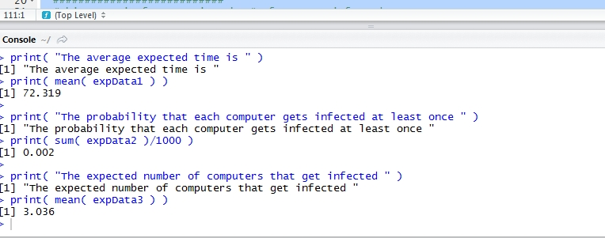

Note: sometimes the data I got vary a lot from 1 to 400 for the first question. However, mostly it will be around 60-130.

sections 3

#########################################################

#This part is for initialization for 1000 experiments

########################################################

rm(list=ls()) # clear working space

expData1 = c() # an array for holding 1000 experiments results for days to get whole system repaired in each experiment

expData2 = rep( 0,times = 1000 ) # an array for holding the case where all computers are infected

expData3 = c() # an array for the number of infected computers in each experiment

expNum = 1 # the index of the number of experiment

while( expNum <= 1000){ # using Monte Carlo Method, do 1000 experiment to estimate

####################################################

#This part is for initialization for each experiment

####################################################

A = rep(0, times = 20) # create an array of 20 values of 0's meaning 20 uninfected computers

A[1] = 1 # set the first value in A meaning a computer is infected

B= rep( 0, times = 20 ) # create an array to record whether a certain computer has been infected

sysVirusRmvd = F # a parameter to determine where the whole system is repaired

days = 0 # the days it takes to get the whole system repaired

while( sysVirusRmvd != T ){ # if the virus still exist in any of the 20 computers, loop

days = days + 1 # increase the days

repaired = 0 # the number of computers that the technician has fixed

X = sum(A) # counting the number of current infected computers

###########################

# This part is for infecting

###########################

for( i in 1:20 ){ # scan every computer

if( A[i] == 0 ){ # if a computer is uninfected

rnd = runif(1, 0, 1)# generate a random number from uniform distribution

if( rnd < 1 - 0.9 ^ X) A[i] = 1# get it infected if the random number is less than 1-0.9^ X, which is the infection rate for the number of current infected computers.

}

}

######################################################################################################

#This part is for checking whether a certain computer has been infected, if yes, set the coresponding position in B to 1

######################################################################################################

for ( j in 1: 20){#scan 20 computers

if ( A[j] == 1 )#if a certain one is infected

B[j] =1 # label it in B by setting the correspoding position to 1

}

X = sum(A)# counting the number of current infected computers

##########################

#This part is for repairing

##########################

k = 1 #loop parameter

while( (repaired < 5) & (k < 20)){# if the repaired computer is less than 5 or we have not scanned 20 computers yet, loop

if( A[k] == 1 ) {# if it is infected

A[k] = 0 # get it repaired by setting it back to 0

repaired = repaired + 1 # increase the number of computer the technician repair for this day

}

k = k + 1 # increase the loop parameter

}

#########################

#This part is for checking whether the whole system is repaired

########################

for(i in 1:20){# scan all 20 computers

if( A[i]== 1 ) # if there is still an infected computer

break # break the loop

}

if( i == 20) # if the i reaches 20, meaning after examing 20 computer we do not find a infected computer

sysVirusRmvd = T # set the sysVirusRmvd, meaning virus has been removed for the system

}

expData1[ expNum ] = days # record the days it taks in the expData1 array

if (sum(B) == 20) # if the sum(B) == 20, it means all computers has been infected at least once

expData2[ expNum ] = 1 # mark this day "1" in the expData2, otherwise the value in expData2 stays 0, which was set when array was created

expData3[ expNum ] = sum( B ) # count the number of infected computer

expNum = expNum + 1 # increase the experiment index

}

###########################

#result printing part

###########################

print( "The average expected time is " )

print( mean( expData1 ) ) # get the mean of expData1 and it is the estimator of expected days it takes to get 20 computers fixed

print( "The probability that each computer gets infected at least once " )

print( sum( expData2 )/1000 ) # we get the probability from the number of experiment in which 20 computer has been infected at least once divided by 1000, the number of experiments

print( "The expected number of computers that get infected " )

print( mean( expData3 ) ) # get the mean of expData2 and it is the estimator os expected computers that get infected