# Congratulations!

Congratulations on purchasing a Maus-Tec™ Electronics Edge-o-Matic 3000™, an automated orgasm denial and edging device, now with network connectivity and advanced features! The Edge-o-Matic 3000 is the next evolution of the popular open source NoGasm project, adding network connectivity, a visual user interface, fine-tuned control of orgasm detection, and expansion for future device control!

This user manual should help you better understand the use, care, and safety considerations of your new Edge-o-Matic 3000. Please read this manual carefully, paying special attention to any warnings and highlighted information.

DO NOT OVER INFLATE YOUR BUTT PLUG. As with any insertable sex toy, please use caution and operate responsibly. If you experience pain or discomfort during use, immediately stop before you hurt yourself.

Be sure to clean the insertable components and sex toys after use, follow proper hygiene with your toys, and never store them wet. That is how you get mold. You can wipe the electronics down with a damp isopropyl alcohol wipe.

The RJ45 expansion port on the right is NOT AN ETHERNET JACK. This is a serial data expansion port designed to allow future toy connectivity. If you hook this up to your LAN you can seriously damage your device, magic smoke and all. Don’t do it.

Only use approved attachments and accessories with the Edge-o-Matic 3000. If you are not certain your device is compatible with the base unit, you can contact Maus-Tec for support. The vibrator output is backwards-compatible with NoGasm accessories.

Do not submerge the Edge-o-Matic in water, drop it, or otherwise abuse the device. If you spill fluids on the device, you can clean it with a damp isopropyl alcohol wipe. Allow the unit to completely dry before use.

This device is open source, and you are free to upload your own software, however, Maus-Tec does not support 3rd party firmware or accessories. If you wish to modify the code officially, please submit a pull request and request your code change to be reviewed by a Maus-Tec developer. If you upload custom firmware, you are doing so at your own risk.

Use lube if this is your first time inserting something in your butt. Take it slow and easy, and do not hurt yourself. With great butt plug comes great responsibility. Maus-Tec is not responsible for you slipping on your own lube spillage or bodily fluids, though if used correctly, the latter may not ever expel.

# Table of Contents

Congratulations! 1

Table of Contents 3

Box Contents 5

Initial Setup 6

First Session Setup 7

Configuring Wireless 8

Hardware Features 9

Main Screen 10

Chart View 12

Manual Operation 13

Automatic Edging Mode 13

Main Menu 14

Edging Settings 15

UI Settings 16

Network Settings 16

Using the SD Card 17

Data Recording 19

Installing Firmware Updates 20

Technical Specifications 21

Software Development 21

Hardware Limitations 22

Serial Port Communication 23

Classic Serial Mode 23

Serial Console Commands 24

WebSocket Communication 26

Server Commands 27

Server Responses 29

Revisions & Errata 32

**Note:** The Edge-o-Matic 3000 continues to receive new firmware updates with feature upgrades and improvements, and so the contents of this manual may not reflect the current state of your device. For the most up-to-date information, please refer to the Maus-Tec Electronics website!

# Box Contents

1

5

4

3

2

Figure 1 - Box Contents

1. AC Power Supply (style varies depending on region)
2. Vibrator Wand
3. Edge-o-Matic 3000
4. Micro SD card w/ Configuration (installed in unit)
5. Air line for butt plug connection.

# Initial Setup

Before setting up your device, double check the Box Contents and make sure you have the Air Line Assembly ready. You will also need a pair of scissors or sharp knife to splice your butt plug’s airline.

1. Cut your butt plug’s airline about 1.5 – 3 inches below the inflation bulb (hand pump). Attach the two ends to the plastic “tee” connector at the end of the Air Line Assembly.
2. Connect the Air Line to the Air Inlet Port on the right side of the Edge-o-Matic 3000. Also connect the vibrator or any accessory you are using.
3. Ensure the SD card is inserted in the unit. You could also check out the default config files and set up your Wi-Fi information (described in the next section) before putting it in. Be careful to align it correctly!
4. Connect the supplied power supply to the unit and plug it into the wall. At this point, the device should boot up!

*Do not insert or remove the SD card while the device is powered on. This will not necessarily harm the device, but will result in data loss, especially if using the session recorder. Furthermore, the settings on the SD card are only read when the device first boots.*

At this point the device should be on the home screen. When you are ready for your session, you can continue to the next setup section.

## First Session Setup

Some calibration may be required for your first session. When you are ready to go, fetch your device, vibrator, butt plug, vibrator attachment and lube. Now is a great time to go re-read the safety precautions on the first page just in case you might have skimmed past those.

1. Insert the butt plug into your butt and inflate it to a comfortable amount. **One pump is sufficient!** If it is inflated too much, it will be less sensitive.
2. On the main screen you should see a butt plug icon with a horizontal meter next to it, one marker is labelled “Pres” and represents the current pressure. Ideally this should be around 60% and is adjusted in settings (Edging Settings > Sensor Sensitivity).
3. Attach the masturbator attachment to your vibrator, secure it to yourself however you please. Press the “Auto” button (blue, far right) to start Automatic mode.
4. While in Automatic mode, the bottom “A” meter (Arousal) will fill as pre-orgasmic contractions are detected. When the meter reaches the checkerboard area, vibration will be stopped. Turning the knob in Automatic mode adjusts the cutoff point.

Read on for more advanced configuration options, including setting automatic ramp-up time, motor max speed, and various detection settings for tuning pressure change detection.

## Configuring Wireless

Wireless network configuration must be done by setting your Wi-Fi credentials in the config.json file. This file is located on the SD card and can be edited in any text editor. See “Using the SD Card” for more information on editing **config.json**.

Your Wi-Fi SSID (network name) and encryption key (password) should be set in the following fields between normal double quotes. Leave the rest of the formatting of this file alone:

{  
 ...  
 "wifi_ssid": "***<Network Name>***",  
 "wifi_key": "***<Network Password>***",  
 ...  
}

Once Wireless is configured, you can view network status and enable/disable Wi-Fi from the “WiFi Settings” menu. To view your device’s IP address, select “WiFi Settings > Connection Status”

# Hardware Features

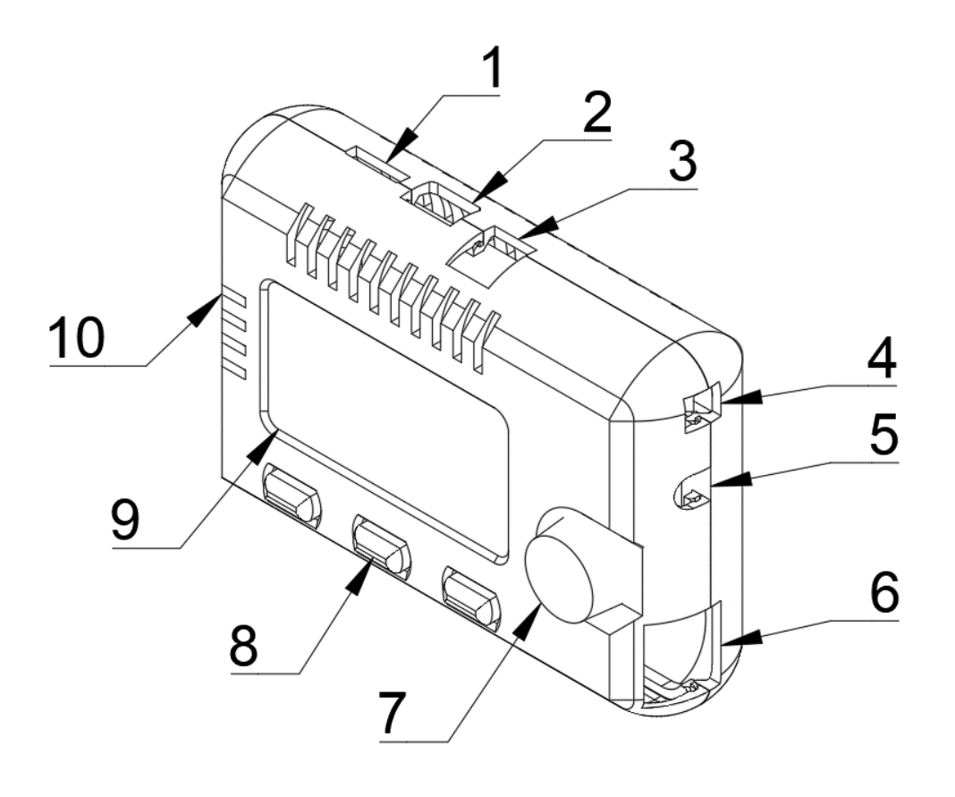

|  |  |
| --- | --- |
| 1 | Micro SD card slot |
| 2 | Micro USB connection |
| 3 | 12V 3A DC power connector |
| 4 | Vibrator power connector |
| 5 | Airline inlet connector |
| 6 | Serial accessory jack* |
| 7 | Scroll knob and select button |
| 8 | Menu buttons |
| 9 | 2.42” OLED display |
| 10 | Air vents |

* This is not an Ethernet jack. Do not connect this to a LAN or other unsupported device, you could damage your device.

# Main Screen

1

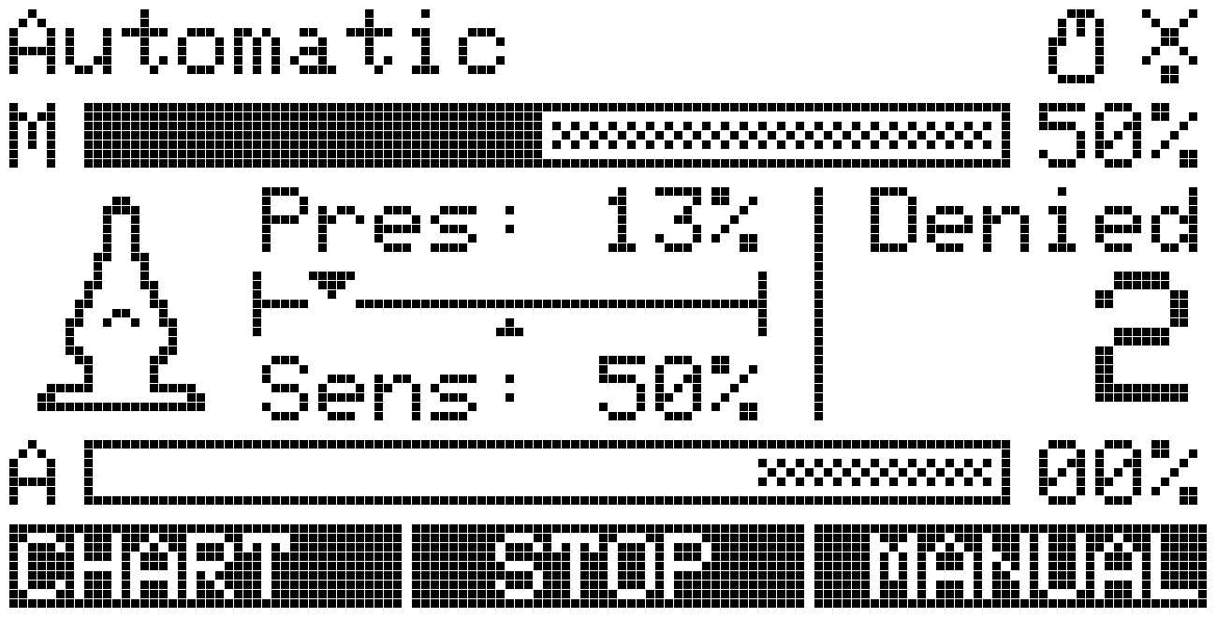

8

4

5

7

6

3

2

Figure 2 – Main Screen

|  |  |
| --- | --- |
| 1 | Current status / mode text |
| 2 | Status icons |
| 3 | Motor speed / max meter |
| 4 | Arousal / peak limit meter |
| 5 | Inflation indicator icon |
| 6 | Pressure and Sensitivity readings |
| 7 | Orgasm denial counter |
| 8 | Menu button actions |

The main screen contains some elements common to the device UI. Those include the current status or mode (1), status icons (2), and labels that correspond to the buttons under the display (8).

The two horizontal meters, “M” and “A” represent the Motor (vibration) speed, and Arousal value. As the device detects orgasm, the Arousal meter will fill. The shaded area represents the maximum value before vibration is stopped. The Motor meter’s shared area represents the maximum value for automatic ramp-up, which can be changed in the Edging Settings menu.

While the device is in Manual mode, you can turn the knob to adjust Motor speed. When the device is in Automatic mode, turning the knob adjusts the Arousal cutoff amount. As the Arousal meter decays, a peak line will stay for a moment. It is recommended that you use this peak line to tune the cutoff limit.

The main screen also includes an inflation level icon (5) which indicates any overpressure events. It is recommended that you keep this icon in a semi-inflated state. The pressure bars to the right (6) will show you the current pressure reading and sensitivity. Pressure sensitivity can be adjusted to boost the pressure reading and compensate for various plugs.

*It is recommended that you inflate the butt plug to a comfortable and safe level without overinflation, then adjust sensitivity until the pressure reading rests somewhere around 60-70%.*

The left button (8) will toggle between Chart and Stats views. The main view is the Stats view. The middle button will immediately stop vibration and enter Manual mode. The right button will toggle between Manual and Automatic mode.

## Chart View

The chart view display operates exactly like the stats view. It shows a running graph of two values: the solid line (3) represents the current arousal percentage, and the dotted line (4) represents the current pressure reading. There are also three statistics on the top of the display (2): “M” represents the motor speed percent, “P” represents the current pressure reading, and “A” represents the current arousal reading.

1

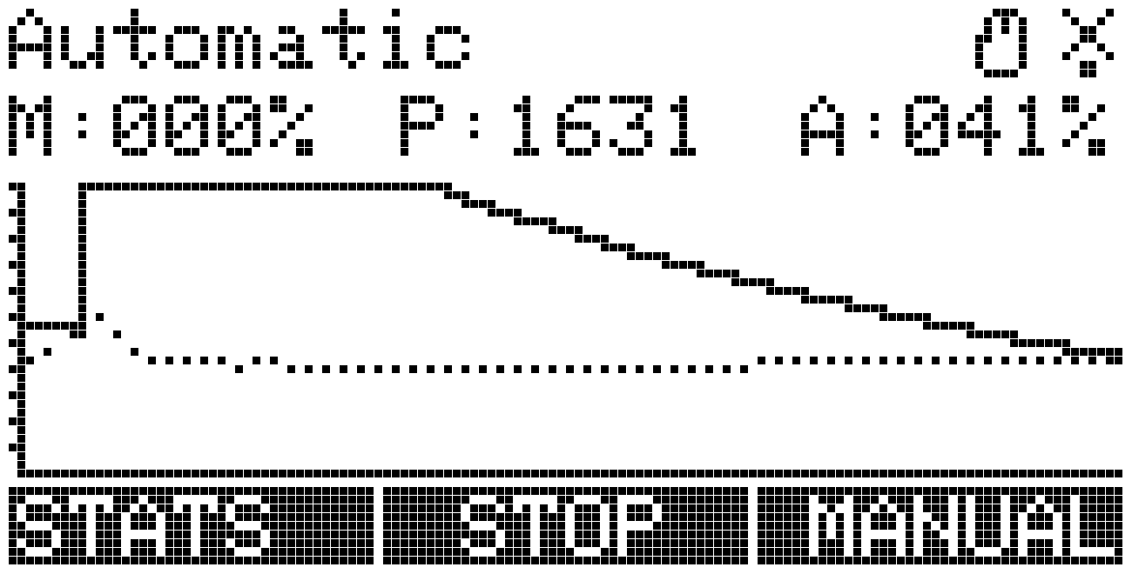

3

4

2

Figure 3 - Chart view, Automatic Mode

In this display, the arousal reading is shown on a scale of 0% to 100%, where 100% is your current arousal limit (the shaded region from the stats display). When the solid arousal line reaches the top of the graph or the arousal percentage reaches 100%, vibration will be stopped. As you adjust the arousal limit using the control knob in automatic mode, the chart will update to show your arousal percentage. It is recommended that you adjust spikes in arousal so that they reach the top of the chart and trigger orgasm detection.

## Manual Operation

Manual mode disables the auto-ramping feature and auto-cutoff, giving you complete control of the vibrator speed. During Manual operation, you can turn the knob to adjust vibrator speed. Pressing the “Stop” button will set the vibrator speed to 0% and enter Manual mode.

*Orgasm detection will NOT stop the vibrator in manual mode, so try not to ruin your session!*

To return to Automatic mode, press the “Auto” button on the home screen. Vibration will resume automatic control.

## Automatic Edging Mode

During Automatic Edging Mode, the vibrator will ramp up to a set maximum speed during a set time period. While in this mode, the device monitors pressure changes and attempts to detect orgasm. When an orgasm is detected, vibration is stopped for a moment to allow the user to cool off, then the ramp-up restarts.

It is important that the butt plug is properly inserted and inflated, and the sensitivity is calibrated to optimal peak detection. Please see “First Session Setup” for details on setup and calibration.

Once pressure sensitivity is adjusted properly, orgasm detection can be adjusted on the fly by using the Arousal cutoff to allow for more arousal before stopping vibrations. This is done by turning the knob in Automatic mode. For convenience, the most recent peak in Arousal is persisted in the “A” Meter as a solid line. This should fall in the shaded region if that peak was pre-orgasm.

# Main Menu

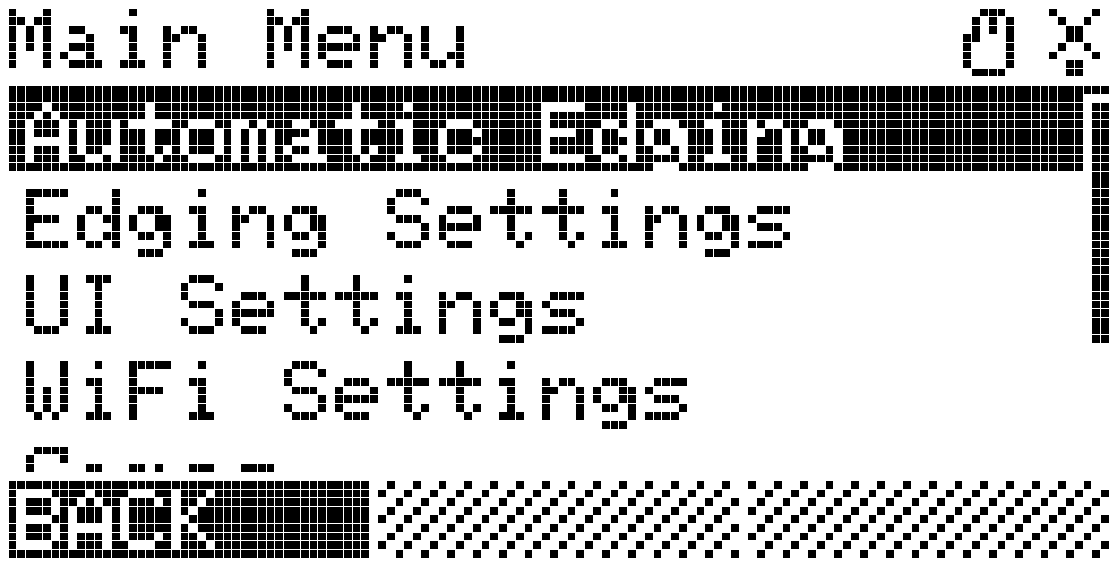

Figure 4 - Main Menu

The Main Menu can be accessed by pressing the scroll wheel down on any screen. While in menus, the scroll wheel is used to navigate between options. To select an option or save a value, press the scroll wheel. Sometimes, other options appear on the bottom of the screen, use the corresponding blue buttons to access these.

While you are in the main menu, the device will continue to operate. If you adjust any settings which temporarily take control of vibration speed, you may need to stop and restart Automatic mode to resume proper operation.

If you enter another mode (Games, for example), the device will exit the normal run mode (Automatic/Manual operation) and that new mode will take control. Playing Snake will stop your session and take control of the vibrator. You should try it.

## Edging Settings

Edging Settings controls the automatic orgasm detection parameters and behavior of the auto-ramping vibration modes. Each of these settings is described below:

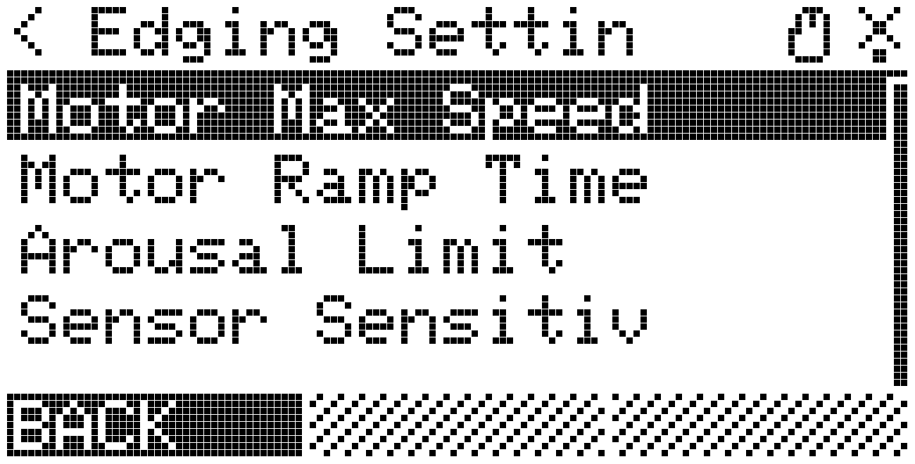

Figure 5 - Edging Settings menu

**Motor Max Speed** – The maximum speed the vibrator motor will ramp up to in Automatic mode.

**Motor Ramp Time** – The time (in seconds) that it takes for the vibrator motor to fully ramp up to in Automatic mode.

**Arousal Limit** – The Arousal threshold before orgasm is detected. This can be changed on the Automatic mode home screen.

**Sensor Sensitiv**ity – This value will amplify the signal coming in from your butt plug. If you find that your pressure is reading low, adjust this value to increase the pressure reading without increasing the butt plug pressure. Ideally, you want to adjust this so that the pressure reading is around 60%.

When you edit a numeric setting, you can use the scroll wheel to adjust the value. To save it, press “Save” or press the scroll wheel. Data is automatically written to the SD card and updated.

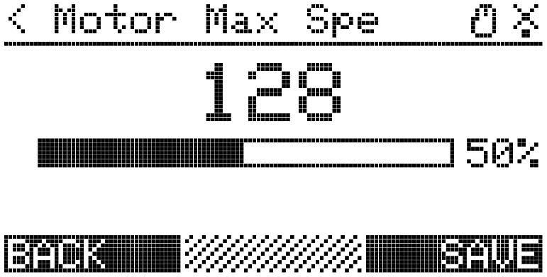

Figure 6 - Example of setting change

Most settings have a value of 0-255, which is converted to a percentage on the bar below the value. For complete documentation on all settings, including those which were not covered in the UI, please refer to the “Using the SD Card” section.

## UI Settings

This section is reserved for future implementation, and will include options for screen timeout and various display configurations.

## Network Settings

This menu allows you to enable/disable Wi-Fi to save power when not used. You can also view your connection status here, which shows you your IP address when connected. This is useful for browser-based connections.

# Using the SD Card

Your Micro SD file should contain a **config.json** file which contains all your device settings. This file is automatically generated by the device when you change settings and is loaded when the device boots. The current options are:

|  |  |
| --- | --- |
| Key | Note |
| wifi_ssid | Your WiFi SSID |
| wifi_key | Your WiFi Password. |
| wifi_on | True to enable WiFi / Websocket server. |
| bt_display_name | AzureFang* device name, you might wanna change this. |
| bt_on | True to enable the AzureFang connection. |
| led_brightness | LED Ring max brightness, only for NoGasm+. |
| websocket_port | Port to listen for incoming Websocket connections. |
| motor_max_speed | Maximum speed for the motor in auto-ramp mode. |
| screen_dim_seconds | Time, in seconds, before the screen dims. 0 to disable. |
| pressure_smoothing | Number of samples to take an average of. Higher results in lag and lower resolution! |
| classic_serial | Output classic NoGasm values over serial for backwards compatibility. |
| sensitivity_threshold | The arousal threshold for orgasm detection. Lower = sooner cutoff. |
| motor_ramp_time_s | The time it takes for the motor to reach motor_max_speed in auto ramp mode. |
| update_frequency_hz | Update frequency for pressure readings and arousal steps. Higher = crash your serial monitor. |
| sensor_sensitivity | Analog pressure prescaling. Adjust this until the pressure is ~60-70% |
| use_average_values | Use average values when calculating arousal. This smooths noisy data. |

Future software updates may introduce new variables. If this is the case, your device should automatically update the file with any new values after your first config change.

If you wish to revert your configuration options to the default values, simply remove that line from the file and restart the device. Any missing values will be added automatically.

This file uses JSON syntax, and it is critical that the options object is properly structured. If you are unsure of what you are doing, use an online JSON linter to help you.

## Data Recording

Data recording can be started by pressing and holding the leftmost (Chart/Stats) button on the main screen. A pop-up will show confirming the filename that you are recording to. If Wi-Fi has been enabled, this filename will be a timestamp, otherwise a pseudorandom number. These files are stored on the root of your SD card.

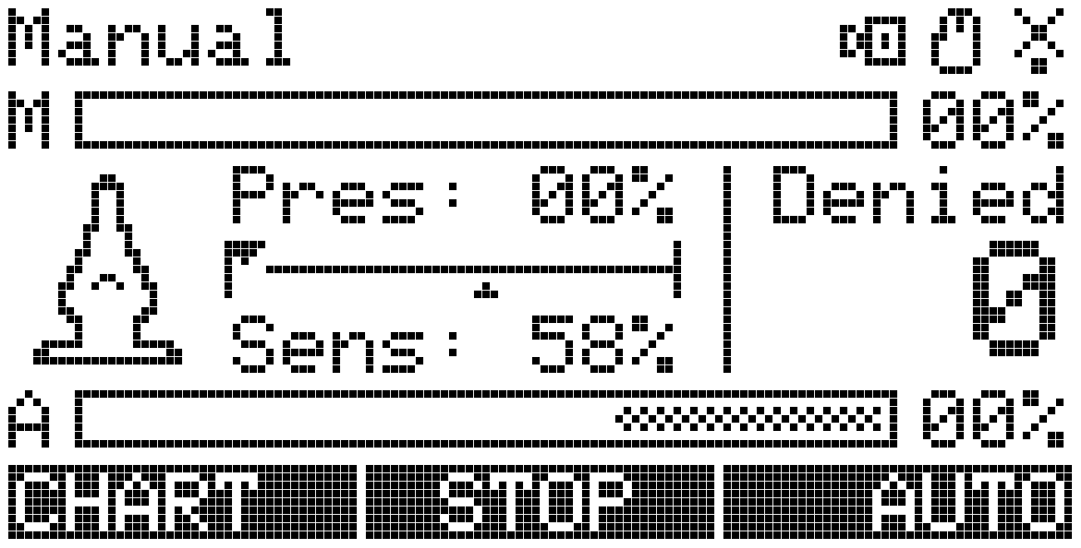

Figure 7 - Screen while recording

While recording, you will notice the camera icon flashing on the top right. Data from this recording is being saved to your SD card as a CSV containing the following values: millisecond timestamp, pressure, average pressure, arousal, motor speed, and arousal threshold.

This is useful for analyzing pressure readings during orgasm and further improving your orgasm detection. Additionally, this file can be supplied to developers to help improve the detection algorithms. It does not contain any personally identifiable information, only sensor readings.

## Installing Firmware Updates

Updates for this file are provided as a **.bin** file, called “**update.bin**”. On a computer, copy this file over to the root of your SD card, insert the card into your device, and power on the device. In the main menu, look for “Update”:

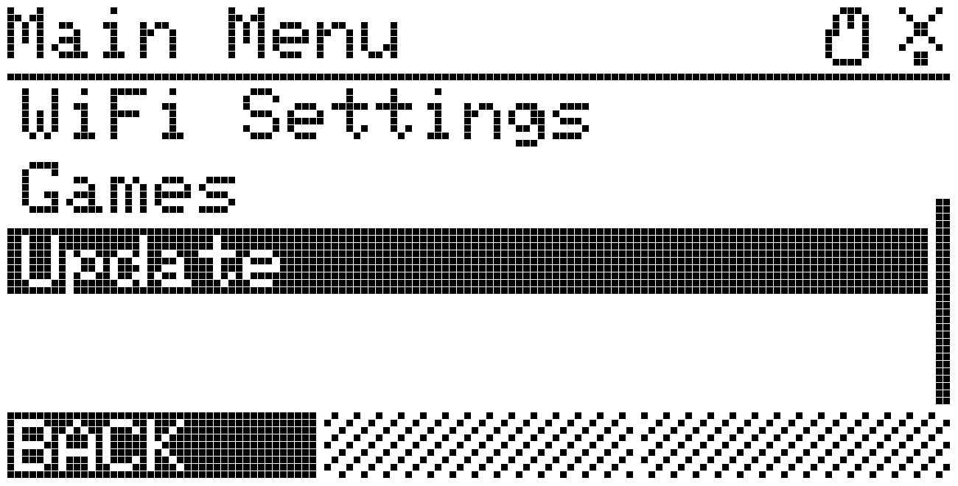

Figure 8 - Menu update option

Select this by pressing the thumbwheel and the update process will begin. If a valid firmware image was found on your SD card, you will see an update progress bar, after which your device reboots automatically into the new software version. If the firmware image was invalid, or an error occurred while installing updates, you will see an appropriate error displayed on screen.

Sometimes this will be an error code. If this happens, contact Maus-Tec for support.

The update process requires certain hardware configurations. If you have manually flashed your firmware over USB, be sure to leave an OTA partition.

# Technical Specifications

This section should provide you a brief overview of your hardware’s technical specifications. It is by no means a complete guide and should be used only as reference but not for implementation. For up-to-date reference, please visit the GitHub repositories linked in the “Software Development” section.

## Software Development

Software for this device is open source and changing frequently. If you would like to customize the software or contribute to it, please visit the GitHub repository at the link below. Any software-related documentation in this manual could possibly be outdated. For the most up-to-date reference on software communication, please reference GitHub.

**Main Code:** github.com/maustec/edge-o-matic-3000  
**React UI:** github.com/maustec/nogasm-ui

Code for this device must be compiled for the ESP32 microcontroller. You are free to flash third party firmware but doing so is not supported by Maus-Tec and Maus-Tec or your retailer cannot be held responsible for damage caused to your device by improper code.

The safest way to develop additional software for this device is to open a Pull Request referencing the original code, and have it reviewed by a Maus-Tec developer. Additionally, you can develop your own software that interfaces over Serial or WebSocket.

## Hardware Limitations

The table below describes the normal and absolute limits for various hardware components on this device. Never exceed the maximum rating shown, as you could most certainly damage the board.

|  |  |  |  |  |
| --- | --- | --- | --- | --- |
|  | Min | Typ. | Max | Unit |
| Input Voltage (Vin) | 5 | 12 | 12.5 | V |
| Vibrator Output Voltage | -- | Vin | -- | V |
| Vibrator Output Current | -- | 1.5 | 3 | A |
| Expansion Output Current | -- | -- | 500 | mA |
| Pressure Input | 0 | -- | 100 | KPa |

Here are some more useful data points for reference:

|  |  |
| --- | --- |
|  | Typical Value |
| Serial Baud Rate | 115200 |
| Pressure Hose Diameter | 2.5mm |
| Wi-Fi Band | 2.4GHz |

# Serial Port Communication

This device offers Serial port communication over the USB connection, like Arduino-style development boards. You will need to install FTDI’s device driver for this to work, after which the device should show up as a native serial port on your computer.

Firmware updates can be flashed using this serial connection, but it is still recommended to update as discussed previously in the “Using your SD Card” section.

**FTDI Driver Download:** www.ftdichip.com/Drivers/VCP.htm

**Baud Rate:** 115200

## Classic Serial Mode

If “classic_serial” is enabled in your config, the output of the serial console will resemble the original NoGasm. This is useful for backwards compatibility with existing monitoring applications designed for the NoGasm V1. To enable/disable Classic Serial mode, execute the following command:

set classic_serial <off|on>

The output stream from Classic Serial mode is the same as the data recorder mentioned in “Using your SD Card”, but without the millisecond timestamp. The comma-separated fields include pressure, average pressure, arousal, motor speed, and arousal threshold.

The setting update_frequency_hz changes the rate of serial output as well as data recorder and sensor updates.

## Serial Console Commands

The serial connection provides several useful commands for interacting with the device and setting configuration options. The available commands are constantly updating in response to demand for third party support, so it is advised that you check the GitHub repository for more up-to-date documentation regarding these commands.

**set <key> [value]**Sets a configuration option <key> to the value [value]. If [value] is omitted, the configuration option will be printed to the serial console. The <key> should be a configuration key listed in “Using the SD card”.

**list**Lists a serialized JSON representation of the current configuration.

**external <enable|disable|slave>**Controls the external communication port. Enabling it will set this device as a master and broadcast useful information to slave devices. Slave mode will accept commands from another master.

**dir**List the contents of the current directory. This operation and the next few listed are used for file manipulation on the SD card.

**pwd**Print your current working directory.

**cd <path>**Change to a new directory.

**cat <filename>**Print the contents of a file to your console.

**help**Displays command help.

# WebSocket Communication

The Edge-o-Matic 3000 serves as a WebSocket host for streaming data over wireless networks. The NoGasm UI project makes use of this, but you are free to develop your own interface.

The WebSocket interface uses JSON serialization for both sending and receiving packets. The structure of a payload sent TO the Edge-o-Matic is a key-value object with each key corresponding to a command, and a value corresponding to the arguments to that command. Responses streamed from the device should be handled similarly.

**An example request sent to the WebSocket channel:**

{  
 "configSet": {  
 "motor_max_speed": 255  
 },  
 "configList": {  
 "nonce": 1234  
 }  
}

**The associated response:**

{  
 "configList": {  
 "nonce": 1234,  
 "config": {…}  
 }  
}

Multiple commands can be sent in either direction, but only one of each command type can be specified. It is recommended that you send only one command per request. To track responses to commands, you can use the “nonce” parameter, which some commands support. This is a numeric identifier that is returned with the associated response and can be used to filter duplicate responses.

## Server Commands

These commands are recognized by the WebSocket server running on the Edge-o-Matic 3000:

**configSet** Sets one or more configuration values. **Arguments:**  
* <any> Config keys / values  
 **Example:**"configSet": {   
 "motor_max_speed": 255   
}

**configList** Requests all config values to be sent.  
**Example:**"configList": {}

**serialCmd** Execute a string as a serial command. **Arguments:**  
cmd String Command to execute  
nonce Numeric Returned in response  
  
**Example:**"serialCmd": {  
 "cmd": "external enable",  
 "nonce": 1234  
}

**getWiFiStatus** Requests the Wi-Fi status to be sent.  
**Example:**"getWiFiStatus": {}

**getSDStatus** Requests SD Card status to be sent.  
**Example:**"getSDStatus": {}

**setMode** Sets the current run mode.  
**Arguments:**  
mode String <automatic|manual>  
  
**Example:**"setMode": "automatic"

**setMotor** Sets vibration speed. Will enter manual mode.  
**Arguments:**  
speed Byte 0-255 motor speed  
  
**Example:**"setMotor": 128

## Server Responses

Your application should be prepared to handle these messages streamed from the server. The actual data may change as this is a printed document and not live documentation. See GitHub for more up-to-date details.

**configList** A listing of the current configuration.  
**Parameters:**  
* <any> Current serialized configuration  
  
**Example:**  
"configList": {  
 "motor_max_speed": 255,  
 "wifi_on": false  
}

**serialCmd** The response from a serial command.  
**Parameters:**text String Output text from command  
nonce Numeric Same as initial request  
  
**Example:**  
"serialCmd": {  
 "nonce": 1234,  
 "text": "Enabled external   
 bus\nOK\n”  
}

**wifiStatus** The current Wi-Fi connection status.  
**Parameters:**ssid String The connected network SSID  
ip String Device IP Address  
rssi Numeric RSSI Value (signal strength)  
  
**Example:**  
"wifiStatus": {  
 "rssi": -56,  
 "ssid": "FBI Spy-Fi",  
 "ip": "10.0.102.192"  
}

**sdStatus** Current SD card status.  
**Parameters:**size Numeric Size of card in MB  
type String Type of card inserted  
  
**Example:**"sdStatus": {  
 "size": 127,  
 "type": "MMC"  
}

**readings** A collection of current readings and device status. This is streamed at the global update frequency, unless disabled, and is used for providing real-time updates to your application.  
**Parameters:**pressure Numeric Current pressure reading  
pavg Numeric Rolling pressure average  
motor Numeric Current vibrator speed  
arousal Numeric Current arousal value  
millis Numeric Millisecond timestamp  
  
**Example:**"readings": {  
 "pressure": 1029,  
 "pavg": 1028,  
 "motor": 255,  
 "arousal": 10,  
 "millis": 198452  
}

**info**

# Revisions & Errata

**Oct. 19, 2020**  
First publication of the operator’s manual.

**Jun. 20, 2021**Removed outdated hardware specifications.

The contents of this guide are as accurate as possible at the time of publication. This project is in active development and the contents herein are subject to change at any time and for any reason. For up-to-date information regarding the Edge-o-Matic 3000 and its associated devices, visit our website at maustec.io and search for Edge-o-Matic.

This is a sex toy intended for adults over the age of 18. The user is responsible for practicing proper hygiene when it comes to the cleaning and use of the equipment and its accessories. Use of this toy is done at your own risk, and it is strongly recommended you educate yourself on the safe use of insertable sex toys.

The ability to detect orgasm via pelvic floor contraction is experimental. While this device has been shown to work in many participants, it cannot be entirely accurate without further research. As improvements are made in the detection algorithm, updates will be provided for your device. The level of accuracy in orgasm detection is not guaranteed for all users. Every effort is being made to develop a universal algorithm.

Maus-Tec and Edge-o-Matic are unregistered trademarks of Maus-Tec LLC, an IL company.