Fedelicio, Lenard Lance D.

IT2C

ITELECT 1

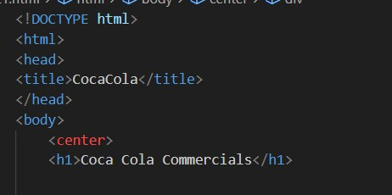

First part of my code, this is where I the use the tags head and title. So that I can name my website, that can be seen in the tab. You can also see that I used the h1 and center, I used h1 to make “Coca Cola Commercials” the title of the website’s page. I also used the center tag inside the body so that every content of the page will be centered

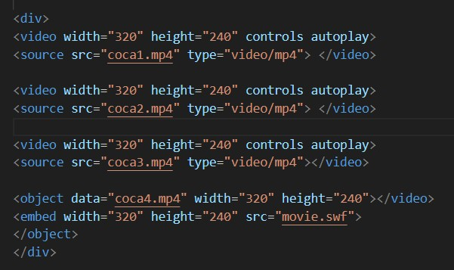

This is the code part of how I inputted 4 Yt coca cola commercials. I used the tag Video so that it will identify that I will call a video of file. I also used width and height to indicate it sized in the page. And I used controls so that user can play, pause, etc. the video. I used autoplay it will play when the website loads. I then use source so that I can input the mp4 file of the videos that I saved in the same folder of the code. I also used div in all parts of the contents to add space between them. I also had to indicate that it’s an mp4

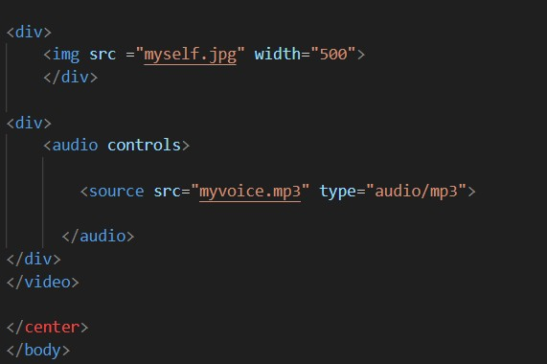

The final part of my code consists my own audio and picture. I used img so that it will expect that I will call an image, I used src so that I’m able to call it to the code and output it to the website. I also use width to adjust the size of the picture in the page. For the audio, it’s pretty much the same as img. I just added controls so that the user can play and pause the audio. And indicate that it’s a mp3 type of audio