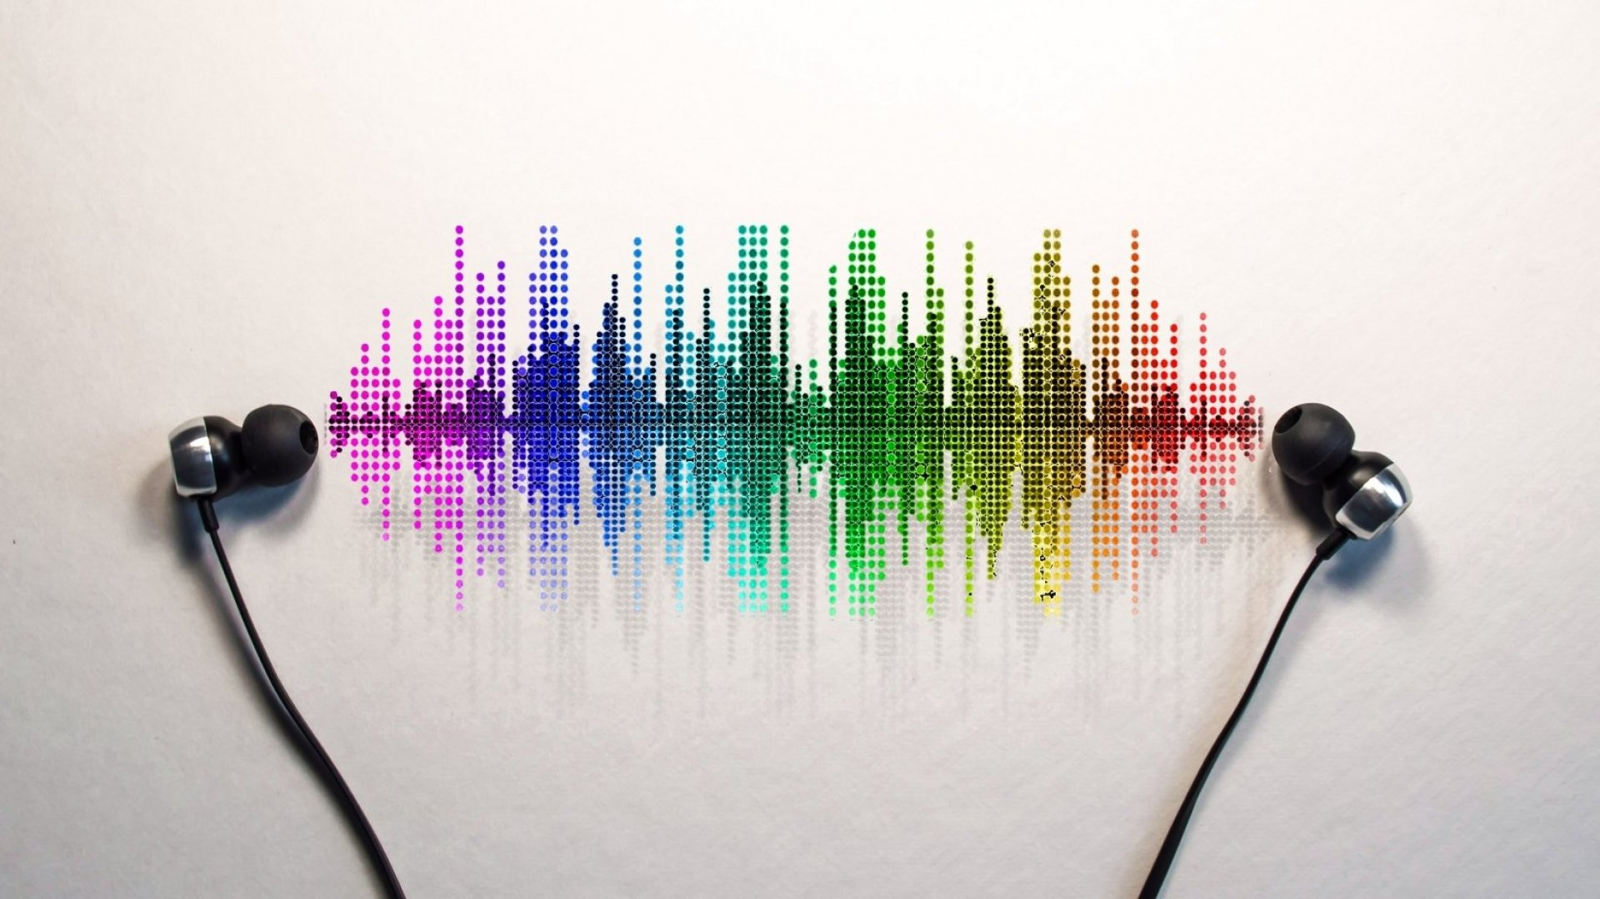

**Popularity and Uniqueness of a Hit Song**

# The Team

|  |  |
| --- | --- |
| Thomas Mansfield | (45381127) |
| Darcey Burch | (45421706) |
| Lance Te | (45581819) |
| Ava Gardiner | (46410961) |

# Introduction

According to ‘The State of the Music Industry’, Universal Music Group (32% market share), Sony Music Entertainment (20%), and Warner Music Group (16%) dominate 68% share of the music recording industry (Stone, 2021). On the other hand, these songs account for less than 1% of all music produced each year. For music enthusiasts, this means there are a lot more songs to uncover. And, in reality, people are beginning to do so as a result of streaming services such as Spotify, Apple Music, and YouTube. Unlike radio, they do not just promote pop, rock, and country music. Consumers can extend their musical horizons by exploring lesser-known genres that are rarely heard on the radio.

As these music streaming services have grown in popularity, vast quantities of digital data have been made available. When paired with user interaction, this data can be utilised to answer a very simple question that all aspiring and accomplished artists ask: What makes a song unique, and what qualities should a song have in order to become a hit?

# Our Goal

Our goal is to determine the key factors that make a hit song. In order to address the core question, we will investigate the following questions:

* What attributes should a song have to be successful?
* Is it possible for a song that sounds sadder or angry to become a hit?
* Does the artist influence the popularity of a song?
* Does the song need to be in a certain genre to be a hit?
* Does a collaboration gain more popularity to a song that has a single artist?

As we conduct our exploratory data analysis, new information might be revealed which requires further exploration. Thus, new questions may arise that supplement our goal.

# Summary of the Dataset

The data we will use will be obtained from Spotify's Web API. To access this web API, we will create a Spotify Developer Account (<https://developer.spotify.com>), and import the Spotipy package into a Jupyter notebook.

We use Spotipy will to gain access to Spotify’s music data to acquire features and traits of individual tracks and artists, some of which we have identified below.

* Tracks: Duration, liveness, loudness
* Artist: Number of followers, genre, popularity

# Techniques

* **Linear regression:** The popularity value of a track is a score between 0-100. With explanatory variables such as energy, danceability, and liveness, we will use linear regression to predict this popularity value.
* **Clustering:** Clustering will allow us to group together songs with similar features, and help us recognise patterns in popular music tracks.
* **Heat Map:** Heat maps will be used to identify which features of a set of popular tracks tend to be high or low.

# Project Plan

|  |  |  |  |  |  |  |  |
| --- | --- | --- | --- | --- | --- | --- | --- |
|  | **Holiday** | **Week 8** | **Week 9** | **Week 10** | **Week 11** | **Week 12** | **Week 13** |
| **Understanding** |  |  |  |  |  |  |  |
| **Proposal** |  |  |  |  |  |  |  |
| **Exploration** |  |  |  |  |  |  |  |
| **Modelling** |  |  |  |  |  |  |  |
| **Presentation** |  |  |  |  |  |  |  |

# References

Stone, J., 2021. The State of the Music Industry in 2020. [Online]  
Available at: <https://www.toptal.com/finance/market-research-analysts/state-of-music-industry>  
[Accessed 3 October 2021].