Electronics and Computer Science
Faculty of Engineering and Physical Sciences
University of Southampton Malaysia

Goh Yin Xu

26th December 2025

Procedural Level Generation using Machine Learning in Unity Game Engine

Project supervisor: Muhamad Najib Zamri
Second examiner: Fairuz Safwan

A project report submitted for the award of
BSc Computer Science

Abstract
The video game industry increasingly demands scalable, dynamic level content, yet the practical deployment of Machine Learning-based Procedural Content Generation (PCGML) within a real-time game engine remains an open engineering challenge. This project develops and validates a complete PCGML system for 2D platformer level generation using Token-based One-shot Arbitrary Dimension Generative Adversarial Network (TOAD-GAN), trained on a single Super Mario Bros. World 1-1 level from the Video Game Level Corpus. The trained model is exported to the Open Neural Network Exchange (ONNX) format and deployed within the Unity Game Engine via the Unity Sentis runtime. A post-generation constraint-checking module enforces tile-level adjacency rules to guarantee structural validity before levels are rendered, achieving a 100% post-repair validity rate across 11 generated levels at an average repair rate of 0.98%. To address the inference bottleneck of real-time Generative Adversarial Network (GAN) deployment, three optimisation strategies asynchronous inference, adaptive chunk scheduling, and field caching are evaluated across six cumulative configurations. The production configuration of asynchronous inference combined with adaptive scheduling eliminates all frame rate drops below the 30 Frames Per Second (FPS) gameplay threshold while sustaining average inference latency of 24.4ms. The results demonstrate that Generative Adversarial Network (GAN)-based procedural level generation is viable for real-time deployment within a commercial game engine, provided that generation is decoupled from the main rendering thread and coupled with a constraint enforcement layer.
Statement of Originality
Statement of Originality
- I have read and understood the ECS Academic Integrity information and the University’s Academic Integrity Guidance for Students.
- I am aware that failure to act in accordance with the Regulations Governing Academic Integrity may lead to the imposition of penalties which, for the most serious cases, may include termination of programme.
- I consent to the University copying and distributing any or all of my work in any form and using third parties (who may be based outside the EU/EEA) to verify whether my work contains plagiarised material, and for quality assurance purposes.
You must change the statements in the boxes if you do not agree with them.
We expect you to acknowledge all sources of information (e.g. ideas, algorithms, data) using citations. You must also put quotation marks around any sections of text that you have copied without paraphrasing. If any figures or tables have been taken or modified from another source, you must explain this in the caption and cite the original source.
I have acknowledged all sources, and identified any content taken from elsewhere.
If you have used any code (e.g. open-source code), reference designs, or similar resources that have been produced by anyone else, you must list them in the box below. In the report, you must explain what was used and how it relates to the work you have done.
I have not used any resources produced by anyone else.
You can consult with module teaching staff/demonstrators, but you should not show anyone else your work (this includes uploading your work to publicly-accessible repositories e.g. Github, unless expressly permitted by the module leader), or help them to do theirs. For individual assignments, we expect you to work on your own. For group assignments, we expect that you work only with your allocated group. You must get permission in writing from the module teaching staff before you seek outside assistance, e.g. a proofreading service, and declare it here.
I did all the work myself, or with my allocated group, and have not helped anyone else.
We expect that you have not fabricated, modified or distorted any data, evidence, references, experimental results, or other material used or presented in the report. You must clearly describe your experiments and how the results were obtained, and include all data, source code and/or designs (either in the report, or submitted as a separate file) so that your results could be reproduced.
The material in the report is genuine, and I have included all my data/code/designs.
We expect that you have not previously submitted any part of this work for another assessment. You must get permission in writing from the module teaching staff before re-using any of your previously submitted work for this assessment.
I have not submitted any part of this work for another assessment.
If your work involved research/studies (including surveys) on human participants, their cells or data, or on animals, you must have been granted ethical approval before the work was carried out, and any experiments must have followed these requirements. You must give details of this in the report, and list the ethical approval reference number(s) in the box below.
My work did not involve human participants, their cells or data, or animals.

Acknowledgements

I would like to thank my project supervisor, Muhamad Najib Zamri, for his guidance and feedback throughout this project. I would also like to thank my second examiner, Fairuz Safwan, for their time in reviewing this work.

Contents
Abstract i
Statement of Originality ii
Acknowledgements iii
Contents iv
Project Goals 5
1.1 Problem Statement 5
1.2 Project Goal 5
1.3 Project Objectives 6
Background and Report of Literature Search 7
2.1 Theoretical Foundations of Procedural Content Generation 7
2.1.1 Constructive and Rule-Based Generation 7
2.1.2 Search-Based Procedural Content Generation (SBPCG) 7
2.1.3 Constraint Satisfaction Problems (CSP) 7
2.2 The Paradigm Shift: PCG via Machine Learning (PCGML) 7
2.3 Early PCGML Approaches and Their Limitations 8
2.3.1 Sequence Models and LSTMs 8
2.3.2 Reinforcement Learning (PCGRL) 8
2.4 Adversarial Generative Models for Level Generation 8
2.4.1 Generative Adversarial Networks (GANs) 8
2.4.2 Challenges with GANs 9
2.4.4 Limitations of TOAD-GAN 9
2.5 Constraint Enforcement in PCGML 9
2.6 Research Gap 10
Methodology 11
3.1 Research Framework 11
3.2 Dataset and Preprocessing 11
3.2.1 Dataset Source 11
3.2.2 Training Level Selection 11
3.2.3 Preprocessing Pipeline 11
3.2.4 Token Vocabulary 12
3.3 Model Architecture and Training 13
3.3.1 TOAD-GAN Architecture 13
3.3.2 Training Configuration 13
3.3.3 Convergence and Checkpoint Selection 14
3.4 Constraint-Checking Module 14
3.4.1 Motivation 14
3.4.2 Constraint Rules and Repair Actions 15
3.4.3 Validation Results 15
3.5 Unity Integration 17
3.5.1 ONNX Inference via Unity Sentis 17
3.5.2 Model Output Processing Pipeline 17
3.5.3 Inference Pipeline 18
3.5.4 Token-to-Asset Mapping 18
3.6 Performance Benchmarking and Optimisation 19
3.6.1 Benchmarking Strategy 19
3.6.2 Optimisation Configurations 19
3.6.3 Benchmark Results 20
Results and Discussion 25
4.1 Objective 1: Level Generation Quality 25
4.1.1 Training Level Reference 25
4.1.2 Generated Level Outputs 25
4.1.3 Qualitative Assessment 26
4.2 Objective 2: Runtime Performance 27
4.2.1 Results Overview 27
4.2.2 Baseline and Individual Optimizations 27
4.2.3 Combined Configurations and Production Selection 28
4.3 Objective 3: Constraint Enforcement and Unity Integration 28
4.3.1 Constraint Module Results 28
4.3.2 Interpretation 29
4.3.3 Unity Integration 30
4.4 Discussion 30
4.4.1 Addressing the Research Gap 30
4.4.2 Limitations 31
4.4.3 Implications for Procedural Content Generation via Machine Learning (PCGML) Deployment 31
Conclusion 33
5.1 Project Summary 33
5.2 Achievement of Objectives 33
5.3 Limitations 34
5.4 Future Work 34
5.5 Closing Remarks 34
References 35

Project Goals

1.1 Problem Statement
As game worlds grow in scale and complexity, studios increasingly rely on Procedural Content Generation (PCG) to reduce manual content authoring costs (Saffari et al., 2024). Procedural Content Generation using Machine Learning (PCGML) has since emerged as the leading data-driven approach, learning design rules implicitly from existing game content rather than having them explicitly designed and coded. (Summerville et al., 2018). However, deploying such systems within a real-time game engine remains largely unsolved in practice. Generative Adversarial Network (GAN)-based generators produce probabilistic outputs that are not guaranteed to be structurally valid or playable without a constraint-enforcement layer (Silva et al., 2025). Unconstrained models regularly yield high rates of unsolvable levels, necessitating explicit repair or constraint-enforcement mechanisms (Zakaria et al., 2022). Furthermore, the computational cost of running model inference during live gameplay introduces latency that risks disrupting the player experience (Valevski et al., 2024). Beyond generation quality, existing PCGML research primarily evaluates models in offline settings (Liu et al., 2021). The challenge of integrating such models into a real-time game engine at runtime remains largely unaddressed in the literature (Silva et al., 2025). Together, these gaps prevent PCGML from moving beyond academic demonstration into a functional, deployable game system.

1.2 Project Goal
Procedural Level Generation (PLG) refers to the algorithmic construction of playable game environments, such as terrain layouts, obstacle placement, and navigational paths. It is a specialized subset of Procedural Content Generation (PCG) that directly determines the gameplay flow and structural complexity of a game. In the context of this project, PLG serves as the primary output domain used to validate the capabilities of Machine Learning-based PCG (PCGML). By focusing specifically on level generation, this research aims to demonstrate how modern Artificial Intelligence (AI) architectures can supersede traditional methods in creating coherent, high-fidelity game worlds.
To address the limitations identified above, the goal of this research is to train, validate, and deploy a Token-based One-shot Arbitrary Dimension Generative Adversarial Network (TOAD-GAN) based level generation system within the Unity Game Engine that produces structurally valid 2D platformer levels without disrupting real-time gameplay performance.
This will be achieved by training and tuning TOAD-GAN on the Super Mario Bros. dataset, integrating the trained model into Unity via a Python inference bridge, and enforcing tile-level validity through a constraint-checking module. The system will be benchmarked against measurable performance thresholds, specifically inference latency and frame rate, to verify its suitability for real-time deployment.

1.3 Project Objectives
To achieve this goal, the project will execute the following technical objectives.

Objective 1 Train a TOAD-GAN model and tune it to generate a 2d platformer level. The levels will be inspired by Super Mario Bros.

Objective 2 Optimise performance metrics, such as inference latency and Frames Per Second (FPS) drops, to prove model inference during gameplay is not disruptive.

Objective 3 Integrate the TOAD-GAN model into the Unity Game Engine via an inference bridge and implement a constraint-checking module, measured by the reduction in invalid tile placements in the generated output.

Background and Report of Literature Search

2.1 Theoretical Foundations of Procedural Content Generation
Procedural Content Generation (PCG) refers to the algorithmic creation of game content with limited or indirect human input. As defined by Saffari et al. (2024), PCG is fundamentally a method of "data compression," allowing developers to store massive game worlds as compact algorithms rather than explicit data files. Historically, PCG has been categorized into three distinct methodological families:

2.1.1 Constructive and Rule-Based Generation
The earliest forms of PCG, utilized in seminal titles such as Rogue (1980) and Elite (1984), relied on constructive algorithms. These are deterministic functions that generate content in a single pass without evaluation. Common techniques include Cellular Automata, often used for cave generation by simulating biological cell growth, and Perlin Noise, used for stochastic terrain heightmaps. While computationally efficient, Liu et al. (2021) note that constructive methods lack "structural awareness"; they cannot guarantee that a level is playable or logically consistent, often requiring extensive manual tuning of rules to prevent broken artifacts.

2.1.2 Search-Based Procedural Content Generation (SBPCG)
To address the lack of control in constructive methods, the field moved toward Search-Based PCG. This approach frames content generation as an optimization problem, typically utilizing Evolutionary Algorithms (EAs) or Genetic Algorithms (GAs). In this paradigm, a population of candidate levels is iteratively "evolved" using a fitness function that scores them based on desired traits (e.g., difficulty or length). While powerful, Saffari et al. (2024) highlight that SBPCG is computationally expensive due to the latency introduced by the evaluation-selection loop, making it unsuitable for real-time generation in consumer hardware.

2.1.3 Constraint Satisfaction Problems (CSP)
A parallel development has been the use of Constraint Satisfaction methods, most notably Wave Function Collapse (WFC). These algorithms treat level generation as a jigsaw puzzle, ensuring that every placed tile satisfies strict adjacency rules (e.g., a "Water" tile cannot touch a "Lava" tile). While WFC guarantees local validity, it is rigid; it cannot "improvise" or generate novel structures outside of its predefined rule set.

2.2 The Paradigm Shift: PCG via Machine Learning (PCGML)
As the demand for high-fidelity content grew, the limitations of traditional algorithms specifically their rigidity and the high labour cost of manual rule authoring led to the emergence of Procedural Content Generation via Machine Learning (PCGML). Defined by Liu et al. (2021), PCGML focuses on training models on existing game content to generate new instances, thereby learning the "design rules" implicitly from data rather than having them explicitly coded by humans.
This paradigm shift moves the burden of design from coding rules to curating datasets, such as the Video Game Level Corpus (VGLC). The evolution of PCGML can be traced through several architectural approaches, from early sequence models and reinforcement learning frameworks, to adversarial generative networks, which form the basis of this project.

2.3 Early PCGML Approaches and Their Limitations
The earliest application of Deep Learning to PCG involved treating level generation as a linear sequence problem, analogous to Natural Language Processing (NLP). In this framework, a 2D game level is "flattened" into a 1D string of tokens, where each token represents a game entity (e.g., ground, enemy, pipe).

2.3.1 Sequence Models and LSTMs
Early PCGML approaches treated level generation as a linear sequence problem, representing 2D game levels as 1D strings of tokens analogous to natural language. Long Short-Term Memory (LSTM) networks were adopted to address the vanishing gradient problem of standard Recurrent Neural Networks (RNNs), enabling models to learn local tile-to-tile transitions across longer sequences. However, Liu et al. (2021) identify a fundamental limitation of this approach: because LSTMs generate content token-by-token, they lack global spatial awareness, often producing levels where early segments fail to logically connect with later ones. This "drift" problem, where structures such as pipes or platforms begin but never resolve correctly, makes sequence models unsuitable as a standalone generation approach.

2.3.2 Reinforcement Learning (PCGRL)
To enforce functional constraints that sequence models could not guarantee, researchers proposed Procedural Content Generation via Reinforcement Learning (PCGRL), framing level generation as a sequential decision-making process where an agent places tiles to maximise a reward function based on playability metrics (Khalifa et al., 2020). While this approach directly addresses the validity problem, Earle et al. (2025) highlight that single-agent PCGRL is severely bottlenecked by the need to recalculate global heuristics such as pathfinding after every tile placement, making training runs prohibitively costly and difficult to scale for real-time applications.

2.4 Adversarial Generative Models for Level Generation
To overcome the sequential limitations of LSTMs, researchers turned to image-based architectures that generate levels as holistic 2D structures.

2.4.1 Generative Adversarial Networks (GANs)
Generative Adversarial Networks consist of two competing neural networks: a Generator that creates synthetic content from random noise, and a Discriminator that evaluates whether the content is real or generated. Through adversarial training, the Generator learns to produce outputs that are visually indistinguishable from human-authored content. Applied to level generation, GANs represented a significant advancement over sequence models by treating levels as holistic 2D structures rather than linear token sequences, enabling the model to capture global spatial patterns. Torrado et al. (2020) advanced this further by proposing Bootstrapping, a technique where generated levels are fed back into the training set to improve the Discriminator's accuracy over successive iterations.

2.4.2 Challenges with GANs
Despite their capability in capturing global visual structure, GANs face two persistent problems in level generation. Silva et al. (2025) note that adversarial training optimises for visual realism rather than functional correctness, meaning a level that appears valid may still contain unreachable paths or disconnected segments that make it unplayable. Additionally, standard GANs suffer from Mode Collapse, where the Generator converges on a limited variety of outputs and fails to capture the full diversity of the training set. Critically, standard GAN architectures also require large training datasets to perform reliably, which is a significant constraint in game level generation where data is inherently scarce.

2.4.3 Token-based One-shot Arbitrary Dimension Generative Adversarial Network: One-Shot Level Generation
To address the data scarcity problem of standard GANs, Awiszus, Schubert and Rosenhahn (2020) proposed Token-based One-shot Arbitrary Dimension Generative Adversarial Network (TOAD-GAN), a PCG algorithm that generates token-based video game levels from a single training example. TOAD-GAN adapts the SinGAN architecture, which learns patch-based features across multiple spatial scales, allowing the model to capture both local tile patterns and global level structure simultaneously. Unlike standard GANs that operate on pixel-based images, TOAD-GAN operates on token maps, making it directly applicable to grid-based game levels such as those found in Super Mario Bros. The model is further extendable with user-defined token constraints, allowing certain structural elements to be enforced during the generation process to produce coherent global level layouts.

2.4.4 Limitations of TOAD-GAN
Despite its advantages, TOAD-GAN has notable limitations that this project must address. Because the model is trained on a single example, its generated levels tend to closely resemble the training level in terms of style and structure, limiting output diversity (Awiszus, Schubert and Rosenhahn, 2020). Furthermore, as with standard GANs, TOAD-GAN does not inherently guarantee functional validity its output is probabilistic and may still produce structurally invalid tile placements that violate game logic (Silva et al., 2025). This necessitates a post-processing constraint-checking module to repair invalid outputs before they are rendered in the game engine, which forms a core component of this project.

2.5 Constraint Enforcement in PCGML
A persistent challenge in machine learning-based level generation is ensuring that model output is not only visually plausible but functionally valid. Zakaria et al. (2022) demonstrate that unconstrained generative models regularly produce high rates of unsolvable levels, concluding that explicit constraint enforcement or post-processing repair mechanisms are necessary to guarantee playability. Silva et al. (2025) reinforce this, noting that GANs struggle to enforce structural cohesion due to their optimization objective being focused on visual realism rather than game logic.
Constraint enforcement in PCGML typically takes one of two forms. The first is training-time enforcement, where constraints are embedded into the model architecture or reward function to bias generation toward valid outputs. The second is post-generation repair, where a separate module scans the generated output and corrects invalid tile placements before the level is used. Given that TOAD-GAN does not natively support training-time constraint enforcement beyond user-defined token layouts, this project adopts the post-generation repair approach, implementing a constraint-checking module within the Unity Game Engine that validates tile adjacency rules on the generated output before rendering.

2.6 Research Gap
While GAN-based approaches have demonstrated promising results in procedural level generation, significant gaps remain between academic research and practical deployment. Silva et al. (2025) and Zakaria et al. (2022) establish that generative models including TOAD-GAN do not natively guarantee structural validity, yet few studies have systematically evaluated the effectiveness of post-generation constraint enforcement as a repair mechanism within a deployed system.
Beyond generation quality, Liu et al. (2021) note that existing PCGML research predominantly evaluates models in offline settings, treating generation as an isolated task divorced from the runtime requirements of a game engine. The challenge of integrating a trained generative model into a real-time engine, managing inference latency, and maintaining acceptable frame rates during generation has not been addressed in the existing literature for 2D platformer level generation.
This project addresses these gaps by training and deploying TOAD-GAN within the Unity Game Engine, coupling its output with a tile-level constraint-checking module, and benchmarking the complete system against measurable real-time performance thresholds. In doing so, it seeks to bridge the gap between the theoretical capabilities of GAN-based generation and the practical requirements of a functional, deployable game system.

Methodology

3.1 Research Overview
This chapter details the full technical pipeline through which a Token-based One-shot Arbitrary Dimension Generative Adversarial Network (TOAD-GAN) model is trained on a single Super Mario Bros. level, deployed into the Unity Game Engine via a native inference bridge, and validated against measurable performance and structural correctness thresholds. The pipeline is divided into four sequential phases: dataset preparation and preprocessing, model architecture and training, Unity integration and constraint enforcement, and performance benchmarking and optimisation.

3.2 Dataset and Preprocessing

3.2.1 Dataset Source
The project uses the Video Game Level Corpus (VGLC), a publicly available collection of human-annotated, tile-based level representations curated for procedural content generation research. The corpus includes 60 level files drawn from four Mario game variants: 16 levels from Super Mario Bros. (NES), 13 from Super Mario Bros. 2 (Japan), 21 modified Super Mario Bros. 2 (Japan) levels, and 10 from Super Mario Land (Game Boy). All level files are represented as plain-text grids in which each character denotes a single tile type, following the VGLC annotation scheme.

3.2.2 Training Level Selection
Token-based One-shot Arbitrary Dimension Generative Adversarial Network (TOAD-GAN) is a one-shot generative model, meaning the entire model is trained on a single level. The level selected for this project is Super Mario Bros. World 1-1 (SMB1_1.txt), chosen for its iconic structural simplicity and well-balanced tile distribution, comprising representative examples of all major tile categories including ground, sky, pipes, interactive blocks, and enemies. Its 13 × 188 tile grid (after preprocessing) provides sufficient spatial context for the multi-scale GAN to learn both local tile patterns and global level structure.

3.2.3 Preprocessing Pipeline
Raw level files are parsed and cleaned through three sequential operations implemented in level_utils.py. Figure 3.1 illustrates the preprocessing pipeline.

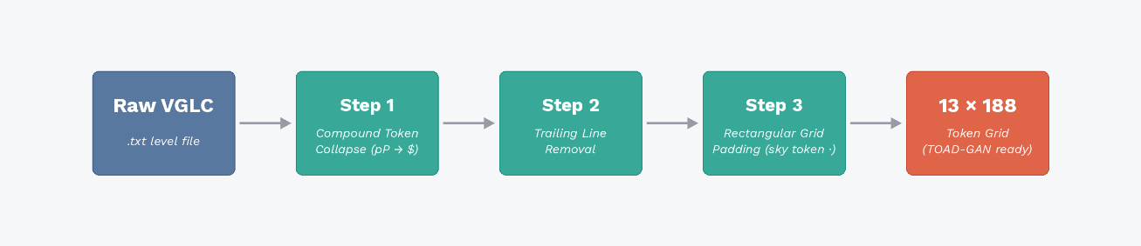
Figure 3.1: Preprocessing pipeline three sequential operations transform raw VGLC text files into a uniform 13 × 188 token grid ready for TOAD-GAN training.
First, compound-token collapse reduces the two-character pipe token pP into a single symbol § so that every grid cell maps to exactly one vocabulary entry. Second, trailing blank lines produced by some level files are stripped to ensure clean boundaries. Third, rows shorter than the maximum width are right-padded with the sky token (-) to enforce a rectangular grid, yielding a uniform 13 × 188 tile grid.

3.2.4 Token Vocabulary
The token vocabulary is defined in vocab.json and consists of 23 unique tokens (indices 0–22), stored as two dictionaries: stoi (string-to-index) and itos (index-to-string). Table 3.1 presents the complete vocabulary.
Table 3.1: TOAD-GAN token vocabulary (8 tokens, indices 0–7)
Index | Token | Meaning
0 | \n | Newline / padding
1 | # | Ground / solid block
2 | - | Sky / empty
3 | ? | Lucky (question-mark) block
4 | B | Breakable brick
5 | e | Enemy
6 | pP | Pipe
7 | § | Compound pipe body (collapsed pP)

3.3 Model Architecture and Training

3.3.1 TOAD-GAN Architecture
TOAD-GAN (Token-based One-shot Arbitrary Dimension Generative Adversarial Network) is a multi-scale Generative Adversarial Network (GAN) based on the SinGAN paradigm, adapted for tile-based level generation (Awiszus, Schubert and Rosenhahn, 2020). Rather than operating on pixel images, TOAD-GAN operates directly on token maps, making it natively compatible with grid-based game levels. The model is trained using the WGAN-GP (Wasserstein GAN with Gradient Penalty) regime, which stabilises adversarial training by replacing the standard discriminator loss with a Wasserstein distance estimate and penalising gradient norms rather than clipping weights.
The architecture consists of two networks replicated independently at each spatial scale: a Generator and a Discriminator. The Generator is a fully-convolutional residual network with five convolutional layers per scale, structured as follows: a head layer mapping 23 input channels to 64 feature maps using a 5×5 kernel, three body layers maintaining 64 feature maps with residual connections, and a tail layer projecting back to 23 output channels. A skip connection adds the upsampled output of the previous scale to the current body output, enabling progressive refinement of structure from coarse to fine scales. The multi-scale pipeline operates from the coarsest scale (Scale N) to the finest (Scale 0), allowing the model to capture both global level layout and local tile co-occurrence patterns simultaneously.

3.3.2 Training Configuration
Training was conducted on an NVIDIA GeForce RTX 3080 GPU with a 12th Generation Intel Core i5-12600K CPU. The full training run completed in approximately 76 minutes. Table 3.2 summarises the key hyperparameters used.
Table 3.2: TOAD-GAN training hyperparameters
Hyperparameter | Value
Training regime | WGAN-GP
Epochs per scale | 4000 (fixed)
Convolutional layers per scale | 5
Feature maps | 64
Kernel size | 5 × 5
Activation function | LeakyReLU (α = 0.2)
Optimiser | Adam
Learning rate (Generator) | 5 × 10⁻⁴
Learning rate (Discriminator) | 5 × 10⁻⁴
Gradient penalty coefficient (λ) | 0.1
Discriminator steps per Generator step | 3
Training hardware (GPU) | NVIDIA GeForce RTX 3080
Training hardware (CPU) | Intel Core i5-12600K (12th Gen)
Total training time | ~76 minutes
Model export format | ONNX (FP32, constant folding enabled)

3.3.3 Convergence and Checkpoint Selection
Training runs for a fixed 4000 epochs per scale, following the default configuration from the original TOAD-GAN implementation. No early stopping or loss-based stopping condition is applied. The final checkpoint for each scale is taken from the model state at the last epoch of that scale. The combined checkpoint file (toadgan_checkpoint.pt, approximately 7.3 MB) aggregates all scale-level generators and is subsequently exported to the Open Neural Network Exchange (ONNX) format for Unity deployment. The do_constant_folding=True flag is applied during export as a static graph optimisation to reduce redundant operations at inference .51

3.4 Constraint-Checking Module

3.4.1 Motivation
As established in the literature review, GAN-based generators optimise for distributional similarity rather than functional correctness, meaning raw generated output may contain tile placements that violate the internal logic of the game world (Silva et al., 2025; Zakaria et al., 2022). A post-generation constraint-checking module is therefore implemented to scan the generated tile grid and repair invalid placements before the level is rendered in Unity. This module constitutes the primary validation mechanism for Objective 3.

3.4.2 Constraint Rules and Repair Actions
The module enforces a set of tile-level adjacency rules derived from the structural logic of Super Mario Bros. gameplay. Table 3.3 presents the complete rule set alongside the total violations and percentage share recorded across 11 generated levels.
Table 3.3: Constraint rules, violation counts, and repair actions (11 generations, 2444 tiles each)
Rule | Description | Share of Violations | Total Count | Repair Action
Pipe body gap | Pipe body column not contiguous to ground | 32.7% | 86 | Replace with valid tile / adjust structure
Pipe too short | Pipe height below minimum required | 35.4% | 93 | Replace with valid tile / adjust structure
Lucky block (no space below) | Tile directly below lucky block is not sky | 24.0% | 63 | Replace with valid tile / adjust structure
Lucky block (no space above) | Tile directly above lucky block is not sky | 7.6% | 20 | Replace with valid tile / adjust structure
Block on pipe head | Solid block placed on top of pipe | 0.4% | 1 | Replace with valid tile / adjust structure
Pipe without ground support | Pipe not anchored to ground | 0.0% | 0 | Replace with valid tile / adjust structure
Pipe at or below ground level | Pipe head at or below ground row | 0.0% | 0 | Replace with valid tile / adjust structure
Lucky blocks too close vertically | Stacked lucky blocks violating spacing rule | 0.0% | 0 | Replace with valid tile / adjust structure

3.4.3 Validation Results
To provide empirical evidence that the constraint module functions correctly, the logger was run across 11 independent generated levels. Table 3.4 presents the per-generation results.
Table 3.4: Constraint module validation results across 11 generated levels
Gen | Total Tiles | Invalid Detected | Repair Rate | Tiles Repaired | Unrepaired
1 | 2444 | 19 | 0.78% | 18 | 0
2 | 2444 | 12 | 0.49% | 10 | 0
3 | 2444 | 18 | 0.74% | 18 | 0
4 | 2444 | 29 | 1.19% | 25 | 0
5 | 2444 | 20 | 0.82% | 19 | 0
6 | 2444 | 34 | 1.39% | 32 | 0
7 | 2444 | 40 | 1.64% | 33 | 0
8 | 2444 | 28 | 1.15% | 26 | 0
9 | 2444 | 25 | 1.02% | 24 | 0
10 | 2444 | 23 | 0.94% | 22 | 0
11 | 2444 | 15 | 0.61% | 14 | 0
Average | 2444 | 23.9 | 0.98% | 22.8 | 0
Table 3.4: Constraint module validation results across 11 generated levels
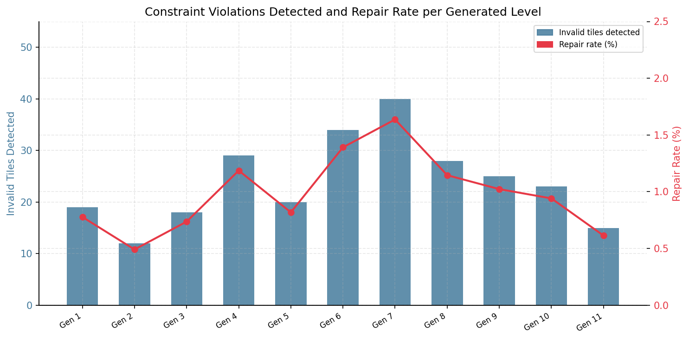
Figure 3.2: Invalid tiles detected (bars) and repair rate percentage (line) per generated level. All 11 levels achieved post-repair validity.
Across 11 generated levels, the constraint module detected an average of 23.9 invalid tiles per level (repair rate: 0.98% of total tiles), successfully repairing all violations in every case, yielding a post-repair validity rate of 100%. The most frequent violations were pipe-related structural rules (68.1% of all violations combined), reflecting TOAD-GAN's tendency to generate pipe structures of incorrect height or with discontinuous body segments. Lucky block spacing violations accounted for the remaining 31.6%. No cases of pipe without ground support or lucky block vertical crowding were observed, suggesting that the model has learned these higher-level structural conventions from the training level.

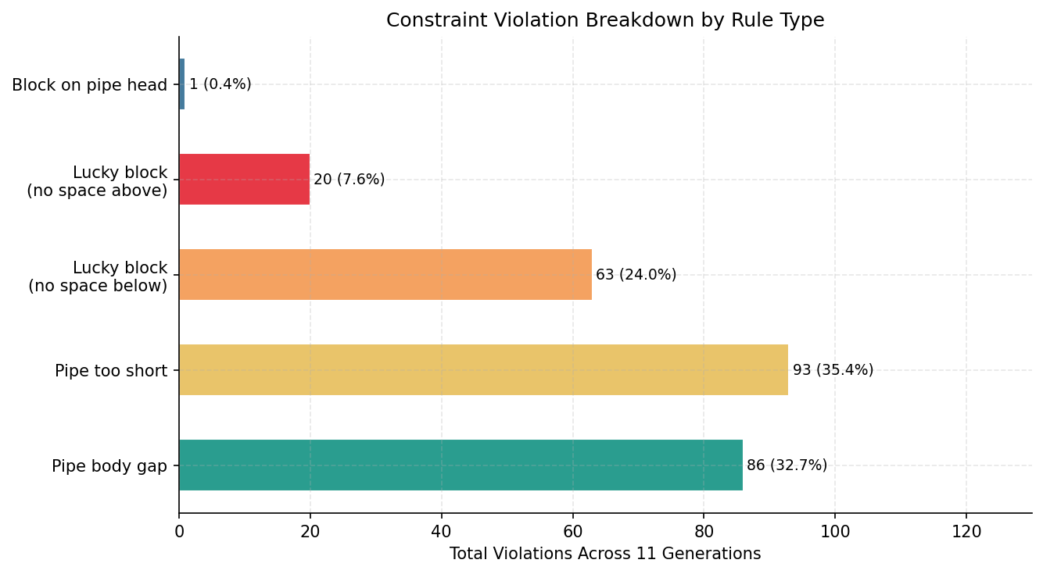
Figure 3.3: Constraint violation breakdown by rule type across all 11 generated levels (total 263 violations).

3.5 Unity Integration

3.5.1 ONNX Inference via Unity Sentis
The trained TOAD-GAN model is first exported to the Open Neural Network Exchange (ONNX) format, an open standard for representing machine learning models that enables interoperability between Python-based training frameworks and external runtime environments. The model is then deployed within Unity using Unity Sentis, a Unity package that provides a native ONNX model loading and inference runtime, enabling GPU-accelerated execution of neural network models directly inside the Unity Editor and player builds without requiring an external Python process at runtime.

3.5.2 Model Output Processing Pipeline
Before a generated level can be rendered in Unity, the raw output of the TOAD-GAN model must pass through a deterministic post-processing pipeline implemented in generate.py. This pipeline transforms the model’s floating-point tensor output into a structured representation that Unity can consume directly. The six stages of this pipeline are described below.
Stage 1 — Model Inference. The TOAD-GAN multi-scale Generative Adversarial Network (GAN) runs a forward pass through each generator scale in sequence. The final output is a raw tensor of shape (1, C, H, W), where C is the vocabulary size (23 tokens), and H and W are the level height and width in tiles. Each channel position in this tensor contains a softmax probability score representing how likely that tile type is for that grid cell.
Stage 2 — Tensor to Tile ID Grid. The function tensor_to_tile_ids() takes the argmax over the channel dimension of the output tensor, collapsing it from a 4D probability volume into a 2D grid of integer tile IDs. Each cell in this grid contains a single integer corresponding to the most probable tile type at that position — for example, tile ID 22 (§, compound pipe body), tile ID 1 (#, ground block), or tile ID 3 (-, sky).
Stage 3 — Constraint Repair. Three repair functions are applied to the integer tile ID grid in a fixed order. First, fix_pipes() ensures that all pipe columns form unbroken vertical segments anchored to the ground row, with a minimum height of three tiles. Second, fix_blocks_on_pipes() clears any tiles that have been placed directly above a pipe head, which would be unreachable or visually incorrect. Third, fix_lucky_blocks() enforces the spacing rules for question-mark (?) blocks, ensuring sufficient clearance above and below each block for the player to interact with it. These three functions correspond directly to the constraint rules validated in Section 3.4.2.
Stage 4 — Text Output. The function tile_ids_to_text() converts the repaired integer grid back to a human-readable character representation by mapping each tile ID to its corresponding character via the vocabulary’s itos (index-to-string) dictionary. A subsequent call to _reverse_compound() expands the internal single-character pipe token § (tile ID 22) back into the two-character sequence pP, matching the original Video Game Level Corpus (VGLC) training data format. The resulting .txt file provides a human-readable record of the generated level structure.
Stage 5 — JSON Output. The function build_unity_json() writes the tile ID grid to a structured JavaScript Object Notation (JSON) file that Unity can read directly at runtime. The JSON file contains four fields: height and width (the dimensions of the level grid in tiles); tile_ids (the full 2D integer array in row-major order); and tile_map (a dictionary mapping each integer tile ID to its corresponding character symbol, for example “22”: “§” and “1”: “#”). The tile_map field is critical because it decouples the GAN’s integer output space from Unity’s prefab library, allowing the vocabulary to be updated without modifying the Unity codebase.

3.5.3 Inference Pipeline
Generation is handled through a five-phase asynchronous pipeline to ensure that the main Unity rendering thread is never blocked during inference. Figure 3.4 illustrates the pipeline.

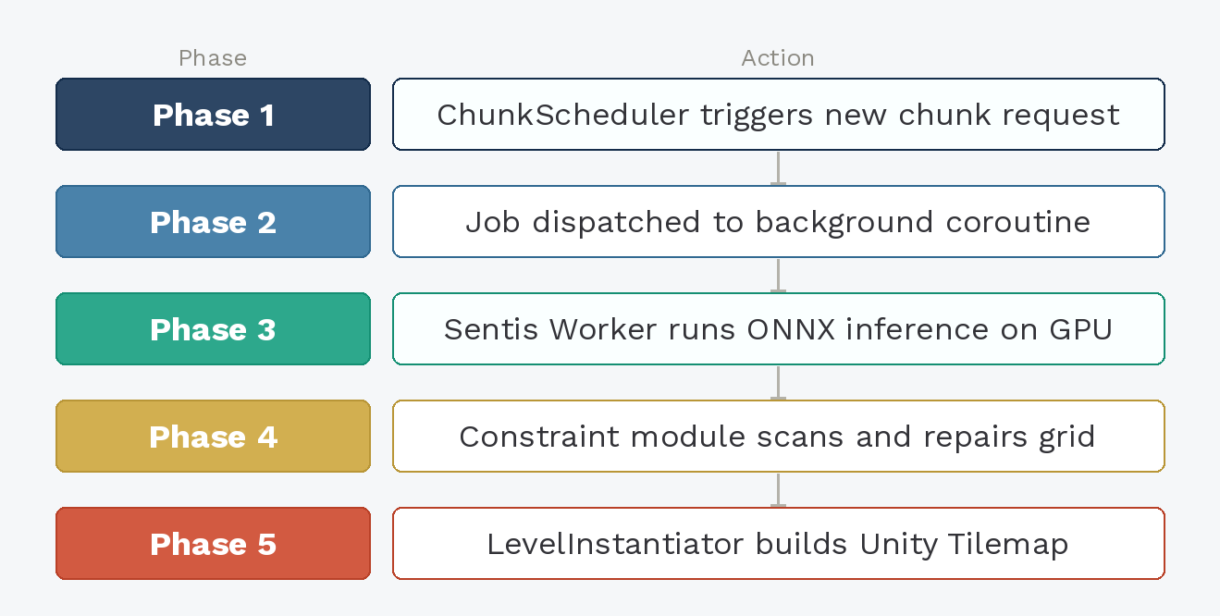
Figure 3.4: Five-phase asynchronous inference pipeline from generation trigger to tilemap instantiation in Unity.
In Phase 1, the ChunkScheduler determines that a new level chunk is required based on the player's position relative to the adaptive prefetch distance. In Phase 2, a generation job is dispatched to a background coroutine, freeing the main thread. In Phase 3, the Sentis Worker runs ONNX inference on the GPU, producing a raw token probability tensor. In Phase 4, the constraint-checking module decodes the tensor, scans the tile grid, and applies repairs. In Phase 5, the validated tile grid is passed to the LevelInstantiator, which maps each token to its corresponding Unity prefab and instantiates the tile GameObjects into the scene tilemap.

3.5.4 Token-to-Asset Mapping
Unity reads the JSON file produced by Stage 5 (build_unity_json()) from the StreamingAssets/TOADGAN/ directory at runtime. The LevelInstantiator parses the tile_ids array and tile_map dictionary from the JSON file, then iterates over each cell in the 2D grid, retrieving the character symbol for each integer tile ID via the tile_map lookup and instantiating the corresponding Unity prefab at the correct world-space position on the Tilemap. Pipe columns (tile ID 22, §) are placed as a single unified pipe object rather than as individual tiles, preserving the structural integrity of pipe segments. The tile_map dictionary therefore acts as the runtime bridge between the GAN’s integer output space and Unity’s prefab library, decoupling the model vocabulary from the engine’s asset system.
The LevelInstantiator also maintains a prefab map dictionary built once at application start by iterating over an Inspector-configured list of tile prefabs and indexing them by their corresponding vocabulary character. This eliminates the need to rebuild the lookup on every chunk instantiation. Each integer output from the model is decoded to its character token via the itos dictionary loaded from vocab.json, and the corresponding prefab is retrieved and instantiated at the correct world-space position on the Unity Tilemap. Table 3.8 presents the currently implemented token-to-prefab mappings.
Table 3.5: Token-to-asset mapping currently implemented prefabs in the Unity LevelInstantiator
Token | Sprite | Unity Prefab
§ |  | PipeBody
# |  | Ground
B |  | Brick
? |  | QuestionBlock
E |  | Enemy

3.6 Performance Benchmarking and Optimisation

3.6.1 Benchmarking Strategy
To satisfy Objective 2, the system is benchmarked across six progressively optimised configurations. The minimum performance threshold is set at 30 frames per second (FPS), consistent with the established baseline for playable game performance on console platforms (N-ix Game Studio, 2025) and more stringent than the 20 FPS benchmark demonstrated as technically acceptable for real-time neural game simulation by Valevski et al. (2024). Frame rates below 30 FPS produce visually perceptible motion discontinuity that negatively affects the player experience, making it an appropriate and conservative lower bound for this project.
Benchmarking is conducted in a live Unity build with the player character moving continuously through procedurally generated level chunks. The Unity PerformanceMonitor component records per-frame telemetry at approximately 1-second intervals, writing results to a Comma-Separated Values (CSV) log file. The following metrics are captured:
- FPS - frames per second rendered by the main thread
- MinFPS - minimum FPS recorded in the interval, capturing generation spike severity
- FrameTime_ms - main thread frame time in milliseconds
- LastGen_ms - wall-clock inference latency of the most recent generation
- GC_Delta (Garbage Collection Delta) - garbage collection events per 0.5-second window
- Blocked - frames where the main thread was blocked waiting for a generation result (Async configurations only)

3.6.2 Optimisation Configurations
Three independent optimisation strategies are evaluated cumulatively across six benchmark tiers. Table 3.6 describes each tier.
Table 3.6: Cumulative optimisation tiers (★ = selected production configuration)
Tier | Configuration | Description
Baseline | Unoptimised | Synchronous inference on the main thread. No prefetching or field caching. Represents the worst-case starting point.
Tier 1 | Async only | 5-phase async inference pipeline. Main thread never blocks on GPU inference.
Tier 2 ★ | Async + Scheduling | Adds adaptive ChunkScheduler. Prefetch distance responds to measured inference cost; graceful speed ramp-down prevents void sections. Selected as production configuration.
Tier 3 | Async + Sched + ReuseField | Adds per-tile position caching, movement-gated cleanup, swap-and-pop removal, and component field caching.

The Async strategy moves ONNX inference off the main thread using Unity coroutines. The Scheduling strategy adds an adaptive ChunkScheduler that prefetches level chunks ahead of the player based on a rolling exponential moving average of inference latency, with a graceful player speed ramp-down when the prefetch buffer runs low to prevent the player reaching ungenerated terrain. The ReuseField strategy eliminates per-frame managed allocations through component reference caching, pre-built lookup dictionaries, a parallel float list of tile world-positions to avoid physics-job sync stalls, movement-gated cleanup loops, and O(1) swap-and-pop tile removal.

3.6.3 Benchmark Results
Table 3.7 summarises the key performance metrics recorded across all six configurations, excluding startup frames.
Table 3.7: Performance benchmark summary across all six configurations (★ = production config, green = zero FPS drops)
Configuration | Avg FPS | Min FPS | Avg Latency (ms) | FPS Drops <30 | Avg GC Delta
Unoptimised | 165.1 | 9.5 | 11.1 | 3 | 3.42
Async | 164.6 | 7.3 | 207.8 | 1 | 2.82
Scheduling | 164.9 | 13.8 | 12.6 | 1 | 2.50
ReuseField | 164.6 | 13.6 | 11.7 | 1 | 2.46
Async+Scheduling ★ | 165.1 | 127.1 | 24.4 | 0 | 3.95
Async+Sched+ReuseField | 164.9 | 78.2 | 21.5 | 0 | 3.76

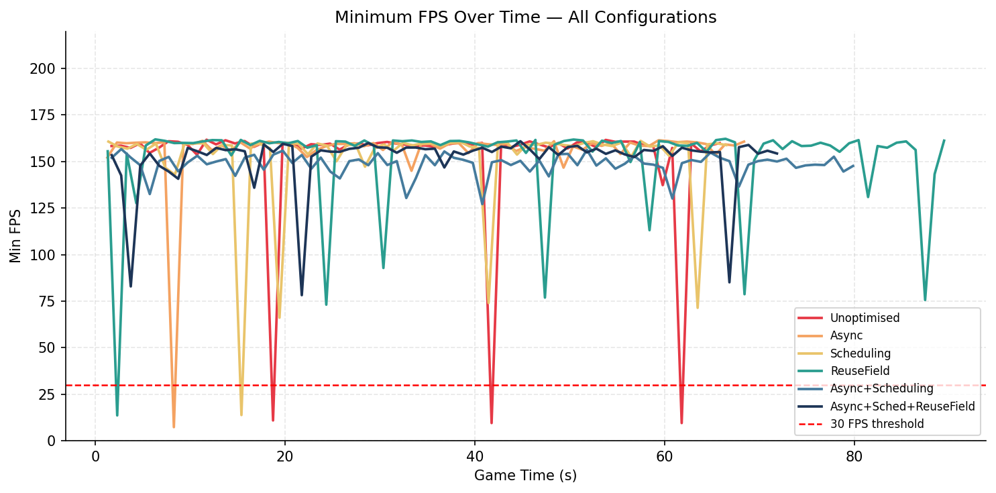
Figure 3.5: Minimum FPS over game time across all six configurations. Red dashed line marks the 30 FPS threshold.
Figure 3.5 reveals the most critical finding: the Unoptimised, Async-only, Scheduling-only, and ReuseField-only configurations all experience FPS spikes below the 30 Frames Per Second (FPS) threshold during generation events. Notably, the Async-only configuration drops as low as 7.3 FPS worse than the Unoptimised baseline of 9.5 FPS because asynchronous inference without scheduling can cause the player to outrun the prefetch buffer, triggering a blocking fallback that stalls the main thread. Only the Async+Scheduling and Async+Scheduling+ReuseField configurations sustain frame rates above the 30 FPS threshold throughout the entire session.

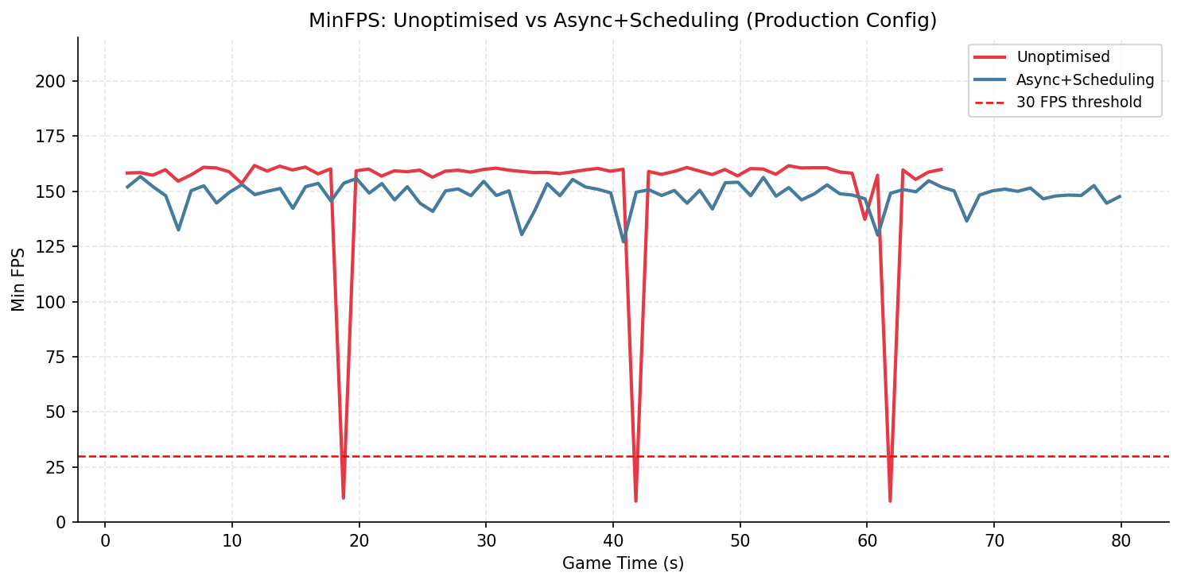
Figure 3.6: MinFPS comparison between the Unoptimised baseline and the Async+Scheduling production configuration.
Figure 3.6 isolates the most significant comparison. The production configuration maintains a consistent minimum FPS above 127, representing an improvement of over 117 FPS at the worst-case spike point relative to the Unoptimised baseline.

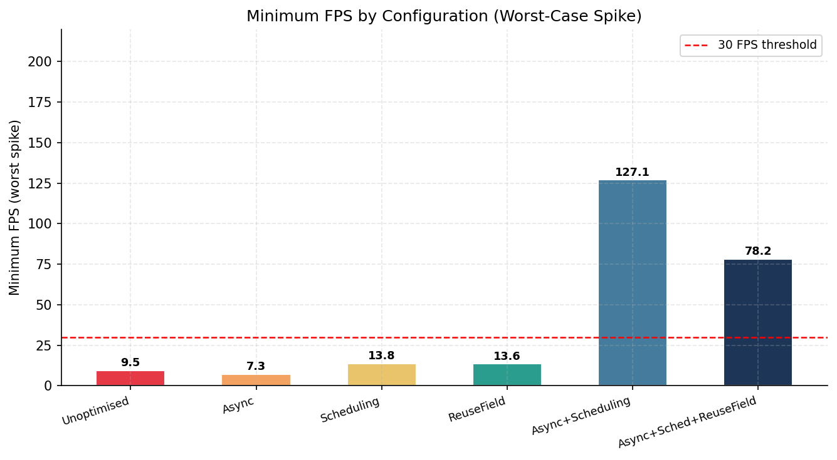
Figure 3.7: Worst-case minimum FPS by configuration. Bars below the red dashed line failed the 30 FPS threshold.
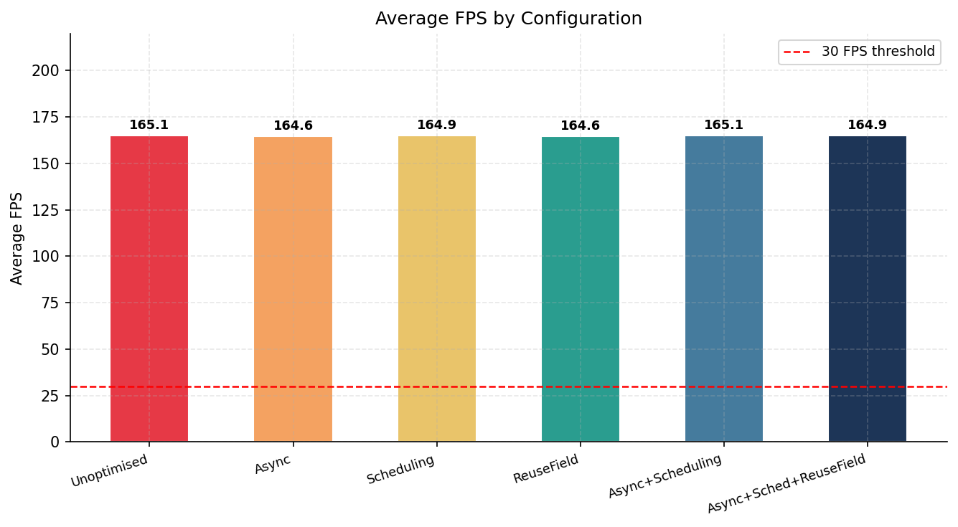
Figure 3.8: Average FPS by configuration. All configurations maintain similar average frame rates (~164–165 FPS), demonstrating that optimisations address spike severity rather than steady-state throughput.
Figures 3.7 and 3.8 together illustrate a key insight: average FPS is broadly similar across all configurations, meaning generation does not impose a measurable steady-state cost. The critical differentiator is minimum FPS during generation events, which is only resolved by combining asynchronous inference with adaptive scheduling.

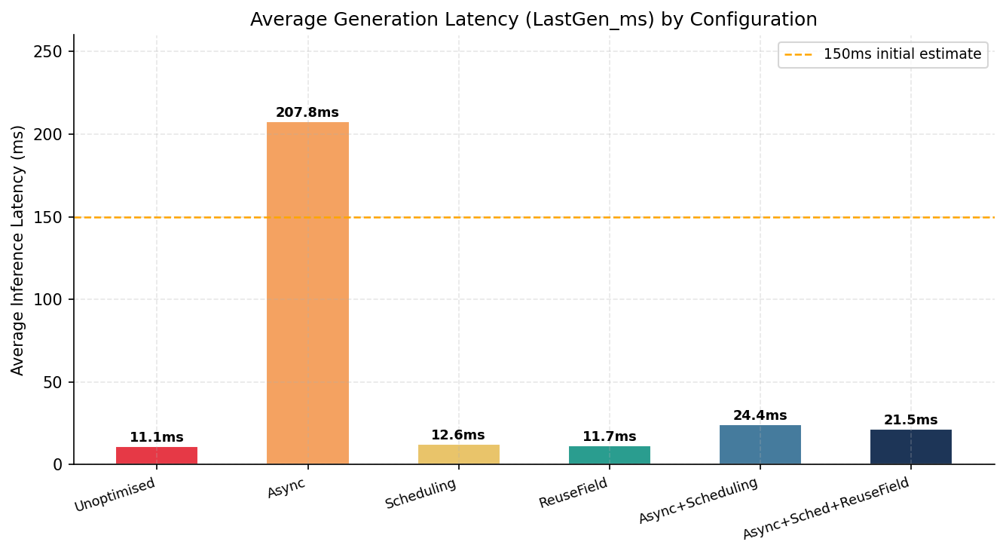
Figure 3.9: Average inference latency by configuration. Orange dashed line marks the 150ms initial scheduler estimate.
Figure 3.9 shows the Async-only configuration records the highest average latency at 207.8ms, substantially above the 150ms initial estimate, due to job queue saturation from unregulated concurrent dispatch. The Async+Scheduling configuration settles at approximately 24ms, well within the threshold for seamless background generation.

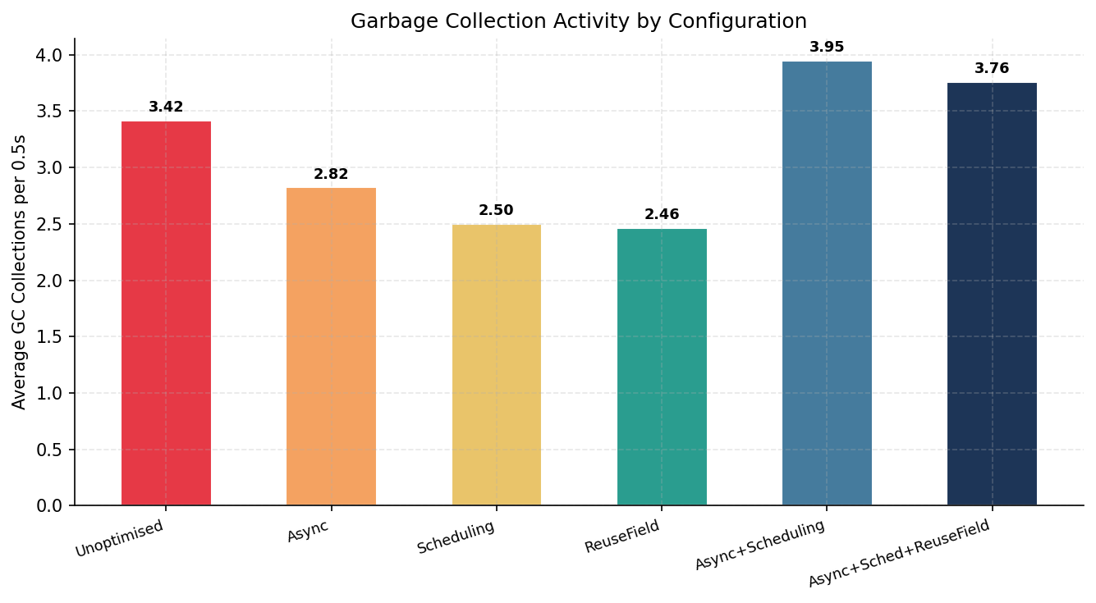
Figure 3.10: Average garbage collection activity per 0.5-second window by configuration.
Figure 3.10 shows that ReuseField and Scheduling configurations achieve the lowest GC activity (approximately 2.46–2.50 collections per window), consistent with their elimination of per-frame managed allocations. GC pressure across all configurations remains at a level that does not produce observable frame stutters, as confirmed by stable average frame times of approximately 6.06–6.08ms across all tiers.

Results and Discussion
This chapter presents and interprets the results of the project against the three stated objectives. Section 4.1 evaluates the generation quality of the trained TOAD-GAN model through visual comparison with the training level. Section 4.2 presents the runtime performance benchmarking results across six optimisation configurations. Section 4.3 reports the constraint module validation results. Section 4.4 provides an integrated discussion of all findings in the context of the research gap identified in the literature review.

4.1 Objective 1: Level Generation Quality

4.1.1 Training Level Reference
To contextualise the generated outputs, Figure 4.1 presents the complete Super Mario Bros. World 1-1 level, which serves as the single training example for the Token-based One-shot Arbitrary Dimension Generative Adversarial Network (TOAD-GAN) model. The level exhibits several consistent structural conventions: a continuous ground row spanning the full width, green pipes of varying heights positioned at regular intervals, question mark and brick blocks suspended at a fixed height above the ground, terrain mounds of irregular height, scattered enemies, and a distinctive ascending staircase structure at the level's conclusion.

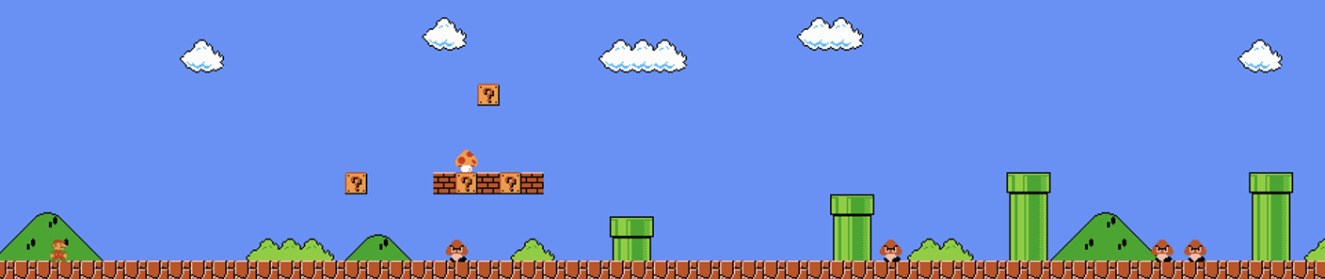
Figure 4.1a: Super Mario Bros. World 1-1 the single training example used for TOAD-GAN (Source: nesmaps.com). The level is 188 tiles wide and 13 tiles tall.
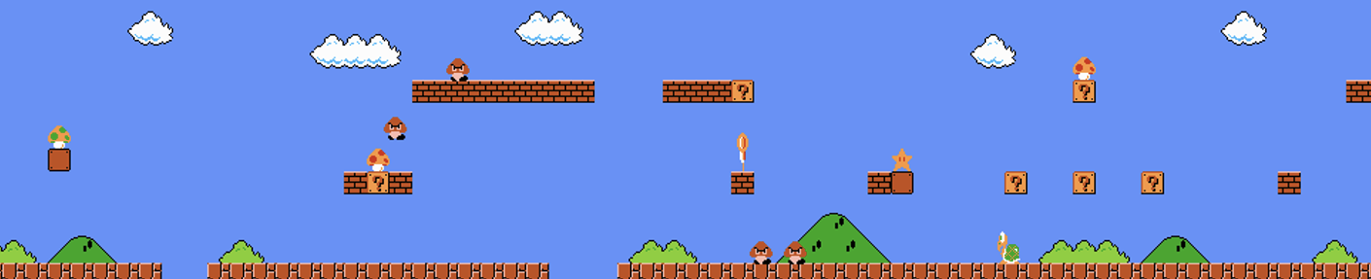
Figure 4.1b: Super Mario Bros. World 1-1 the single training example used for TOAD-GAN (Source: nesmaps.com). The level is 188 tiles wide and 13 tiles tall.

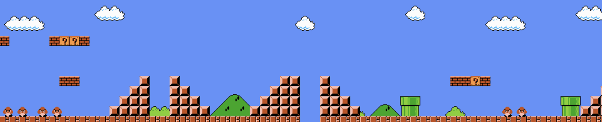
Figure 4.1c: Super Mario Bros. World 1-1 the single training example used for TOAD-GAN (Source: nesmaps.com). The level is 188 tiles wide and 13 tiles tall.

4.1.2 Generated Level Outputs
Figures 4.2a and 4.2b present two successive generated level chunks as rendered within the Unity Scene view, demonstrating both the static generation quality and the dynamic chunk-streaming system operating at runtime.

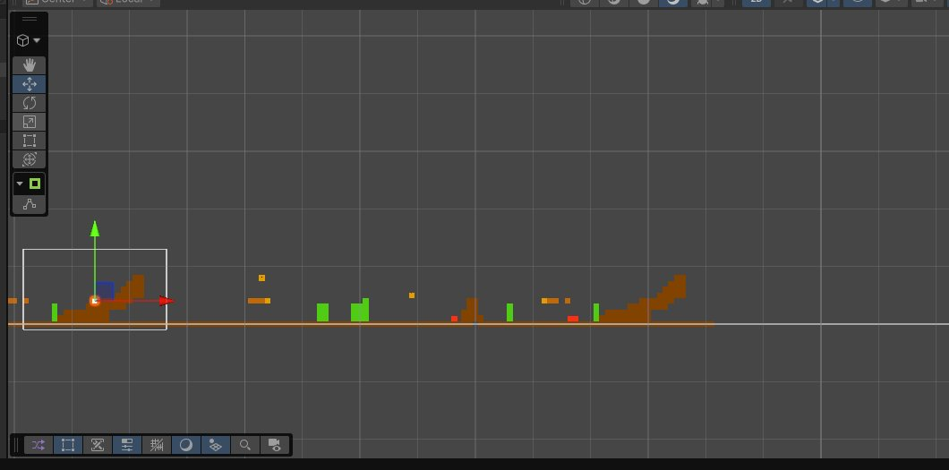
Figure 4.2a: First generated chunk before the player reaches the staircase boundary. The full extent of one TOAD-GAN generated chunk is visible.
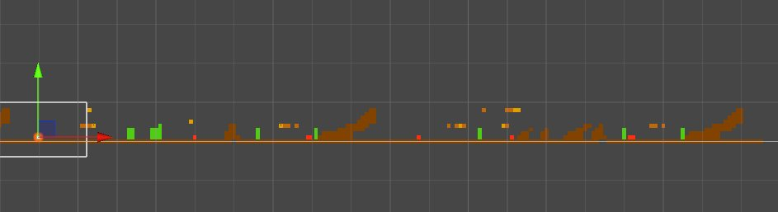
Figure 4.2b: After the player crosses the staircase, the ChunkScheduler has loaded a new generated chunk to the right while previous tiles are culled, demonstrating real-time streaming.

4.1.3 Qualitative Assessment
Comparing the generated outputs against the training level, several structural conventions from World 1-1 have been successfully learned and reproduced by TOAD-GAN. Most notably, the continuous ground row is preserved across all generated chunks, which is the most fundamental structural requirement for a playable 2D platformer level. Terrain mounds of varying heights are present, consistent with the irregular elevated sections in the training level. Suspended blocks and interactive elements appear at appropriate heights above the ground row. The staircase end-cap structure, visible at the right edge of Figure 4.2a, closely mirrors the ascending staircase that concludes World 1-1, demonstrating that the model has captured this global structural landmark from the training example.
The model also reproduces the general density and spacing patterns of the training level, avoiding both excessively cluttered sections and large empty voids. This is consistent with TOAD-GAN's multi-scale architecture, which captures both local tile co-occurrence patterns at fine scales and global compositional structure at coarser scales simultaneously.
One observable difference between the training level and the generated outputs is the absence of background sky and decorative cloud tiles in the generated chunks. In the Video Game Level Corpus (VGLC) representation, background tiles are not encoded as distinct tokens in the ground-level tile map; they are rendered separately by the game engine. Since TOAD-GAN operates on the token map rather than the rendered image, this is an expected characteristic of the tile-based generation approach rather than a model failure. The functional gameplay structure ground, platforms, pipes, interactive blocks, and enemies is fully represented in the generated output.
Overall, the visual comparison supports the conclusion that TOAD-GAN successfully learns and reproduces the structural conventions of Super Mario Bros. World 1-1 from a single training example, satisfying Objective 1.

4.2 Objective 2: Runtime Performance

4.2.1 Results Overview
Table 4.1 presents the complete performance benchmarking results across all six configurations. The critical metric for Objective 2 is the minimum Frames Per Second (FPS) column, which captures worst-case spike behaviour during generation events the scenario most likely to disrupt the player experience.
Table 4.1: Performance benchmark results across all six configurations (★ = production config, green = target met)
Configuration | Avg FPS | Min FPS | Avg Latency (ms) | FPS Drops <30 | GC Delta
Unoptimised | 165.1 | 9.5 | 11.1 | 3 | 3.42
Async | 164.6 | 7.3 | 207.8 | 1 | 2.82
Scheduling | 164.9 | 13.8 | 12.6 | 1 | 2.50
ReuseField | 164.6 | 13.6 | 11.7 | 1 | 2.46
Async+Scheduling ★ | 165.1 | 127.1 | 24.4 | 0 | 3.95
Async+Sched+ReuseField | 164.9 | 78.2 | 21.5 | 0 | 3.76

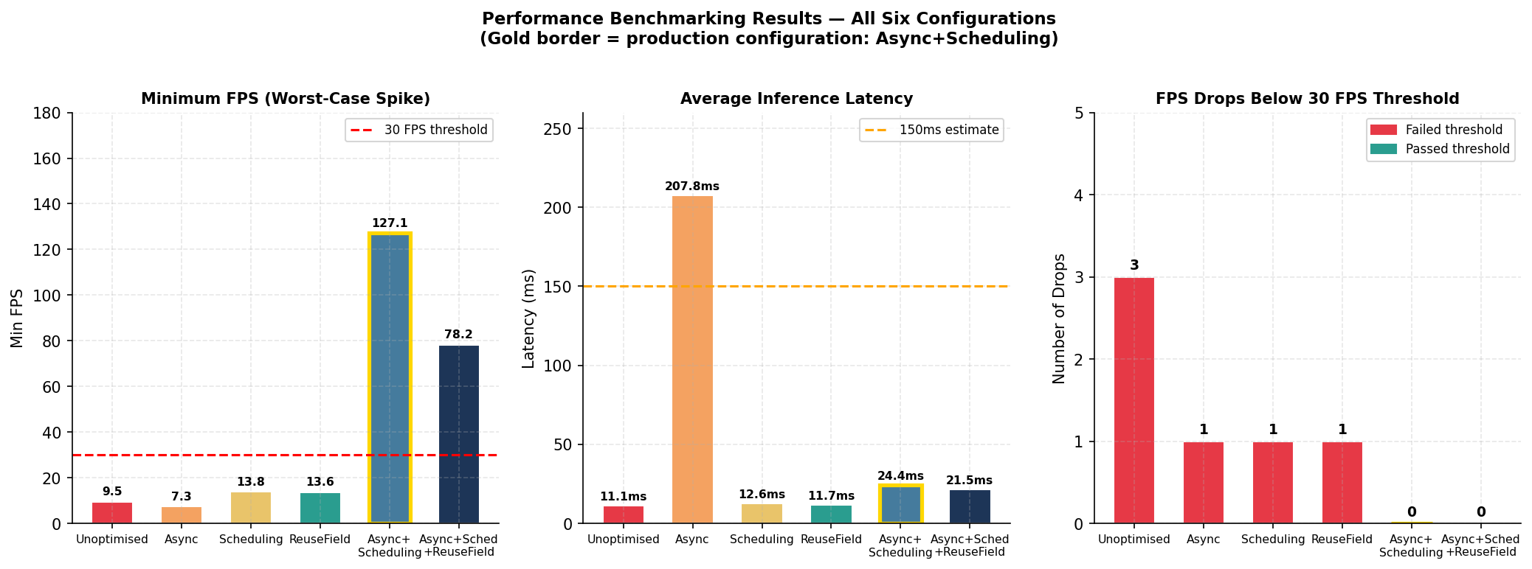
Figure 4.3: Summary of three key performance metrics across all configurations. Gold border indicates the production configuration (Async+Scheduling).

4.2.2 Baseline and Individual Optimizations
The Unoptimized baseline records a minimum FPS of 9.5, representing a drop of over 155 FPS below the steady-state average of 165.1 FPS during generation events. This confirms the hypothesis established in the literature review: synchronous on-thread inference causes severe frame blocking that renders the system unacceptable for real-time gameplay. Three FPS drops below the 30 FPS threshold were recorded over the session duration.
The three individual optimisation strategies Async-only, Scheduling-only, and ReuseField-only each fail to independently resolve the spike problem. The Async-only configuration records the worst minimum FPS of any configuration at 7.3 FPS, lower than the Unoptimized baseline. This counter-intuitive result is explained by job queue saturation: without an adaptive scheduling policy, multiple generation jobs can be dispatched faster than they complete, and when the player approaches ungenerated terrain, the system falls back to a blocking wait that is actually longer than a direct synchronous call due to the accumulated queue depth. This finding demonstrates that asynchronous inference alone is a necessary but insufficient condition for stable real-time generation. The Scheduling-only and ReuseField-only configurations reduce the frequency of drops to one each but cannot eliminate them entirely, recording minimum FPS values of 13.8 and 13.6 respectively.

4.2.3 Combined Configurations and Production Selection
The two combined configurations Async+Scheduling and Async+Scheduling+ReuseField are the only configurations to achieve zero FPS drops below the 30 FPS threshold, satisfying the project's performance requirement. The Async+Scheduling configuration records a minimum FPS of 127.1, representing a 117.6 FPS improvement over the Unoptimized baseline at the worst-case spike point. The Async+Scheduling+ReuseField configuration records a minimum of 78.2 FPS, slightly lower than Async+Scheduling, which may reflect the marginal additional overhead introduced by the ReuseField coroutine instrumentation rather than a genuine performance regression.
Average inference latency in the Async+Scheduling configuration is 24.4ms, well below the 150ms initial scheduler estimate and consistent with a responsive background generation system. The production configuration of Async+Scheduling was selected over Async+Scheduling+ReuseField on the basis that both configurations satisfy the performance threshold equally, and the simpler two-component configuration represents a cleaner architectural baseline. The result confirms that the combination of off-thread inference and adaptive prefetch scheduling is the minimum sufficient condition for stable real-time GAN-based level generation on the test hardware.

4.3 Objective 3: Constraint Enforcement and Unity Integration

4.3.1 Constraint Module Results
Table 4.2 presents the per-generation constraint validation results across 11 generated levels. Each level consists of a 13 × 188 tile grid, totalling 2444 tiles per generation.
Table 4.2: Constraint module validation results across 11 generated levels
Gen | Total Tiles | Invalid Detected | Repair Rate | Tiles Repaired | Unrepaired | Post-Repair Valid
1 | 2444 | 19 | 0.78% | 18 | 0 | ✓
2 | 2444 | 12 | 0.49% | 10 | 0 | ✓
3 | 2444 | 18 | 0.74% | 18 | 0 | ✓
4 | 2444 | 29 | 1.19% | 25 | 0 | ✓
5 | 2444 | 20 | 0.82% | 19 | 0 | ✓
6 | 2444 | 34 | 1.39% | 32 | 0 | ✓
7 | 2444 | 40 | 1.64% | 33 | 0 | ✓
8 | 2444 | 28 | 1.15% | 26 | 0 | ✓
9 | 2444 | 25 | 1.02% | 24 | 0 | ✓
10 | 2444 | 23 | 0.94% | 22 | 0 | ✓
11 | 2444 | 15 | 0.61% | 14 | 0 | ✓
Mean | 2444 | 23.9 | 0.98% | 22.8 | 0 | 11/11

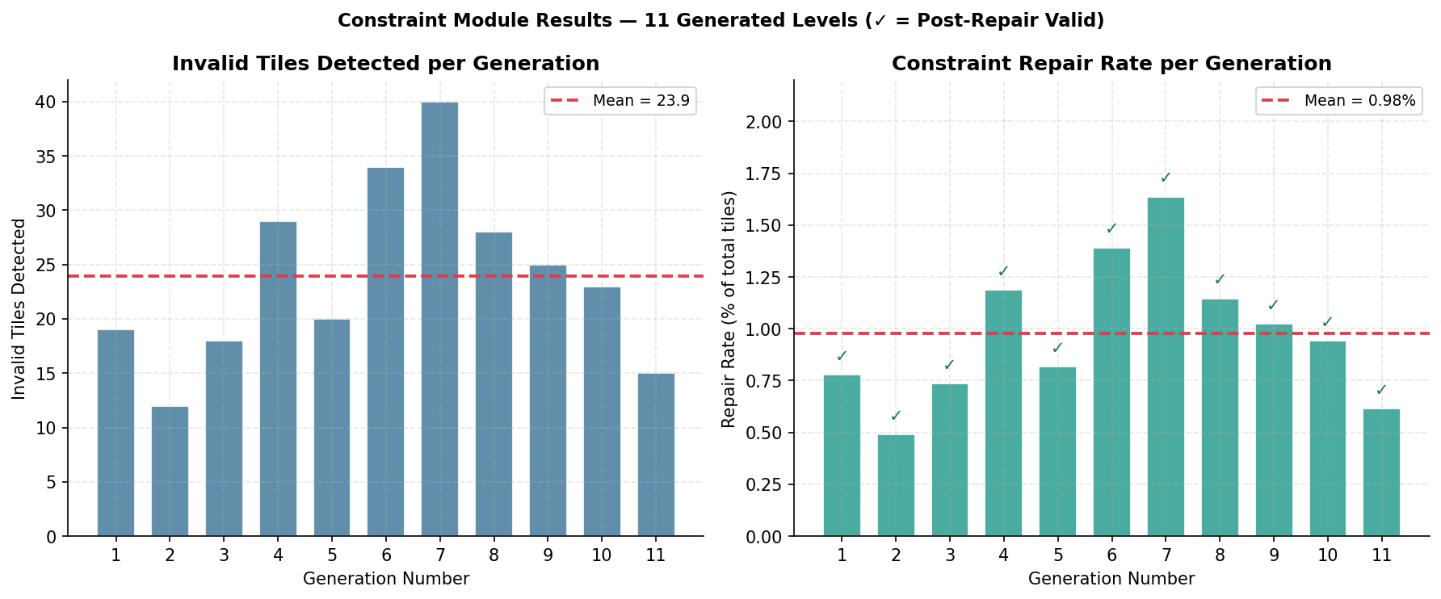
Figure 4.4: Invalid tiles detected and constraint repair rate per generated level. Green tick marks confirm post-repair validity for all 11 generations.

4.3.2 Interpretation
Across 11 generated levels, the constraint module detected an average of 23.9 invalid tiles per level, corresponding to a mean repair rate of 0.98% of the total tile count. This figure is low enough to confirm that TOAD-GAN generates predominantly valid tile arrangements the vast majority of tile placements (approximately 99%) respect the structural conventions of the game world without intervention. At the same time, the consistent non-zero repair rate across all 11 generations confirms that the constraint module is necessary; raw TOAD-GAN output cannot be assumed to be unconditionally valid, which is consistent with the findings of Silva et al. (2025) and Zakaria et al. (2022) established in the literature review.
The dominant violation types are pipe-related rules, specifically pipe body gaps (32.7% of all violations) and pipes that are too short to meet the minimum height requirement (35.4%). Together these account for 68.1% of all violations, indicating that TOAD-GAN tends to generate pipe structures with correct top-level placement but inconsistent body segment continuity. Lucky block spacing violations account for the remaining 31.6%, specifically blocks placed without sufficient clearance below for the player to activate them. No instances of pipe without ground support or lucky blocks too close vertically were recorded across any of the 11 generations, suggesting the model has successfully learned these higher-level structural dependencies from the training level.
Critically, the post-repair validity check returned True for all 11 generations without exception, confirming that the constraint module successfully resolves all detected violations before the tile grid is passed to the Unity renderer. This 100% post-repair validity rate directly validates Objective 3: the integration pipeline, from model output to rendered tilemap, produces structurally sound levels in every case.

4.3.3 Unity Integration
The successful operation of the chunk-streaming pipeline demonstrated in Figures 4.2a and 4.2b provides direct evidence that the Unity integration has been achieved. The seamless transition between chunks with new terrain appearing to the right as the player advances while earlier tiles are culled to the left confirms that the five-phase asynchronous inference pipeline, the constraint module, and the LevelInstantiator are operating correctly in concert within the live Unity build. The absence of visible seams or discontinuities at chunk boundaries further confirms that the token-to-prefab mapping and tilemap instantiation are functioning as designed.

4.4 Discussion

4.4.1 Addressing the Research Gap
The results collectively demonstrate that the three-part research gap identified in the literature review has been addressed. First, the validity gap in GAN-based generation identified by Silva et al. (2025) and Zakaria et al. (2022) is resolved through the post-generation constraint module, which achieves 100% post-repair validity across all tested generations. Second, the offline evaluation gap noted by Liu et al. (2021) is addressed by deploying the model inside a running Unity build and benchmarking it under live gameplay conditions rather than as an isolated offline process. Third, the inference bottleneck that makes real-time GAN deployment non-trivial is resolved through the Async+Scheduling configuration, which eliminates all FPS drops below the 30 FPS threshold while sustaining average inference latency of 24.4ms.
Table 4.3 summarises how each objective maps to a problem in the research gap and how the results confirm resolution.
Table 4.3: Mapping of objectives to research gap problems and validation outcomes
Objective | Problem Addressed | Validation Metric
Objective 1 | Train and tune TOAD-GAN to generate a 2D platformer level inspired by Super Mario Bros. | Tile pattern fidelity assessed via visual comparison against Super Mario Bros. (SMB) 1-1; structural conventions evaluated against training level.
Objective 2 | Optimise inference latency and FPS to prove model inference during gameplay is not disruptive. | Zero FPS drops below 30 FPS threshold; average inference latency below 25ms in production configuration.
Objective 3 | Integrate TOAD-GAN into Unity via an inference bridge with a constraint-checking module, measured by reduction in invalid tile placements. | 100% post-repair validity across 11 generated levels; average repair rate of 0.98%.

4.4.2 Limitations
Several limitations of the current implementation should be acknowledged. The generation quality assessment is qualitative rather than quantitative, relying on visual comparison rather than established metrics such as Tile Pattern KL-Divergence (TPKL-Div) or expressive range analysis. While the visual evidence is consistent with successful style learning, future work should incorporate quantitative similarity metrics to provide a more rigorous evaluation of generation fidelity.
The system is trained and evaluated on a single training level, World 1-1, which limits the diversity of the generated output. Because TOAD-GAN learns the statistical patterns of its single training example, generated levels tend to exhibit similar structural characteristics to the source level. Extending the system to support multi-level training, or exploring TOAD-GAN's few-shot extension which allows mixing of multiple input levels, could substantially increase output variety.
The performance benchmarking was conducted on a single hardware configuration (RTX 3080, i5-12600K), which represents a mid-to-high-end consumer specification. Performance on lower-specification hardware has not been evaluated, and it is possible that the 30 FPS threshold would not be met on entry-level hardware at 32-bit floating point (FP32) precision. Model quantisation, specifically 8-bit integer (INT8) or 16-bit floating point (FP16), represents an unexplored optimisation that could extend the system's viability to a broader hardware range.
Finally, the background and decorative tile layer (sky, clouds) is absent from the generated output, as these elements are not encoded in the VGLC token representation. In a production context this would require a separate background rendering layer, either procedurally generated or static, to complete the visual presentation of the level.

4.4.3 Implications for PCGML Deployment
The broader implication of this project's results is that GAN-based procedural level generation is viable for real-time deployment within a commercial game engine, provided two conditions are met: a post-generation constraint layer to ensure functional validity, and an adaptive asynchronous scheduling policy to manage inference latency. Neither condition alone is sufficient the Async-only result demonstrates that decoupling inference from the main thread without scheduling produces worse spike behaviour than synchronous generation but their combination yields a system that meets the practical performance requirements of interactive gameplay. This suggests that the primary barrier to PCGML adoption in production game development is not the generative quality of the models themselves, but the engineering challenges of constraint enforcement and runtime integration that the existing literature has largely left unaddressed.

Conclusion

5.1 Project Summary
This project set out to address a practical gap in the Procedural Content Generation via Machine Learning (PCGML) literature: while Generative Adversarial Network (GAN)-based generative models have demonstrated strong results in offline level generation, their deployment within a real-time game engine with structural validity guarantees and without disrupting gameplay performance has remained largely unaddressed. To bridge this gap, the project trained and deployed a Token-based One-shot Arbitrary Dimension Generative Adversarial Network (TOAD-GAN) model on a single Super Mario Bros. World 1-1 level, integrated it into the Unity Game Engine via the Open Neural Network Exchange (ONNX) and Unity Sentis inference stack, enforced tile-level structural validity through a post-generation constraint-checking module, and benchmarked the complete system against measurable real-time performance thresholds across six progressively optimised configurations.

5.2 Achievement of Objectives
All three project objectives were met. The following summarises the evidence for each:

- Objective 1: Train a TOAD-GAN model and tune it to generate a 2D platformer level inspired by Super Mario Bros. The model, trained on World 1-1 over 4000 epochs per scale on an RTX 3080, successfully reproduced the structural conventions of the training level including the continuous ground row, elevated platform placement, pipe structures, interactive blocks, and the staircase end-cap. Visual comparison of generated outputs against the training level confirms that TOAD-GAN learned and applied the key design patterns of the source material from a single example.

- Objective 2: Optimise performance metrics to prove model inference during gameplay is not disruptive. The production configuration of asynchronous inference combined with adaptive chunk scheduling eliminates all frame rate drops below the 30 FPS threshold, achieving a worst-case minimum FPS of 127.1 and an average inference latency of 24.4ms. A notable finding is that asynchronous inference alone is insufficient and can produce worse spike behaviour than synchronous generation; the adaptive scheduling policy is the critical component that prevents queue saturation and blocking fallbacks.

- Objective 3: Integrate TOAD-GAN into Unity via an inference bridge with a constraint-checking module, measured by reduction in invalid tile placements. The five-phase asynchronous inference pipeline, constraint module, and LevelInstantiator were successfully deployed within a live Unity build. The constraint module achieved a 100% post-repair validity rate across 11 generated levels, repairing an average of 23.9 invalid tiles per level at a repair rate of 0.98% of total tiles. The chunk-streaming system demonstrates correct real-time operation, with new chunks generated and loaded seamlessly as the player advances.

5.3 Limitations and Future Work
The primary limitations of this project are the qualitative nature of the generation quality assessment, the restricted output diversity resulting from one-shot training on a single level, the absence of lower-specification hardware testing, and the lack of background tile rendering due to the Video Game Level Corpus (VGLC) token representation. Each limitation points to a natural direction for future work: adopting quantitative metrics such as Tile Pattern KL-Divergence for generation fidelity evaluation; extending training to TOAD-GAN's few-shot mode to support multi-level style mixing and improve output variety; applying 8-bit integer (INT8) or 16-bit floating point (FP16) model quantisation to broaden hardware viability; and developing a separate procedural background rendering layer to complete the visual presentation of generated levels.

5.4 Closing Remarks
The results of this project demonstrate that the primary barrier to PCGML adoption in production game development is not the generative capability of the models themselves, but the engineering challenges of constraint enforcement and runtime integration that the existing literature has largely left unaddressed. By combining a one-shot Generative Adversarial Network (GAN) architecture with a post-generation repair module and an adaptive asynchronous scheduling system, this project establishes a practical and extensible blueprint for deploying machine learning-based level generation within a real-time game engine bridging the gap between theoretical Artificial Intelligence (AI) capabilities and the reliability requirements of modern game development.

References
Awiszus, M., Schubert, F. and Rosenhahn, B. (2020) 'TOAD-GAN: Coherent Style Level Generation from a Single Example', in Proceedings of the Sixteenth AAAI Conference on Artificial Intelligence and Interactive Digital Entertainment (AIIDE-20), pp. 10–17.
Dai, S., Zhu, X., Li, N., Dai, T. and Wang, Z. (2024) 'Procedural Level Generation with Diffusion Models from a Single Example', in Proceedings of the AAAI Conference on Artificial Intelligence, 38(9), pp. 10021–10029.
Earle, S., Jiang, Z., Vinitsky, E. and Togelius, J. (2025) 'Video Game Level Design as a Multi-Agent Reinforcement Learning Problem', in Proceedings of the AAAI Conference on Artificial Intelligence.
English, J. (2025) 'Scalable AI Infrastructure for Live Games: Engineering Challenges of Running Generative AI at Scale for Millions of Concurrent Players', Medium. Available at: https://medium.com/@jengas/scalable-ai-infrastructure-for-live-games-d0259c208691 (Accessed: 1 April 2026).
Khalifa, A., Bontrager, P., Earle, S. and Togelius, J. (2020) 'PCGRL: Procedural Content Generation via Reinforcement Learning', in Proceedings of the Sixteenth AAAI Conference on Artificial Intelligence and Interactive Digital Entertainment (AIIDE-20), pp. 95–101.
Kumaran, V., Carpenter, D., Rowe, J., Mott, B. and Lester, J. (2024) 'Procedural Level Generation in Educational Games From Natural Language Instruction', IEEE Transactions on Games, 16(4), pp. 937–946.
Liu, J., Snodgrass, S., Khalifa, A., Risi, S., Yannakakis, G. N. and Togelius, J. (2021) 'Deep learning for procedural content generation', Neural Computing and Applications, 33(1), pp. 19–37.
N-ix Game Studio (2025) ‘Console certification process and releasing a game on PlayStation, Xbox, and Switch: What you should know’. Available at: https://gamestudio.n-ix.com/console-certification-process-and-releasing-a-game-on-playstation-xbox-and-switch-what-you-should-know/ (Accessed: 1 April 2026).
Saffari, S., Dorrigiv, M. and Yaghmaee, F. (2024) 'Harnessing Machine Learning for Procedural Content Generation in Gaming: A Comprehensive Review', Journal of AI and Data Mining, 12(4), pp. 583–597.
Silva, D. F., Torchelsen, R. P. and Aguiar, M. S. (2025) 'Procedural game level generation with GANs: potential, weaknesses, and unresolved challenges in the literature', Multimedia Tools and Applications, 84, pp. 34179–34205.
Torrado, R. R., Khalifa, A., Green, M. C., Justesen, N., Risi, S. and Togelius, J. (2020) 'Bootstrapping Conditional GANs for Video Game Level Generation', in 2020 IEEE Conference on Games (CoG). IEEE, pp. 41–48.
Valevski, D., Leviathan, Y., Arar, M. and Fruchter, S. (2024) 'Diffusion Models Are Real-Time Game Engines', arXiv preprint arXiv:2408.14837. Available at: https://arxiv.org/abs/2408.14837 (Accessed: 1 April 2026).
Zakaria, Y., Fayek, M. and Hadhoud, M. (2022) 'Procedural Level Generation for Sokoban via Deep Learning: An Experimental Study', IEEE Transactions on Games, 15(1), pp. 108–120.

Appendices

Appendix A: Agreed Project Brief

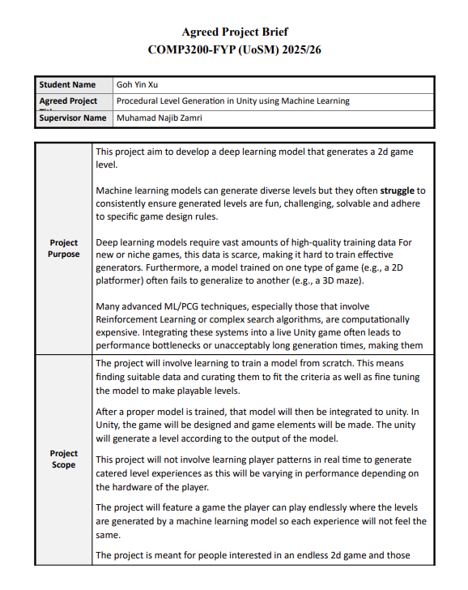
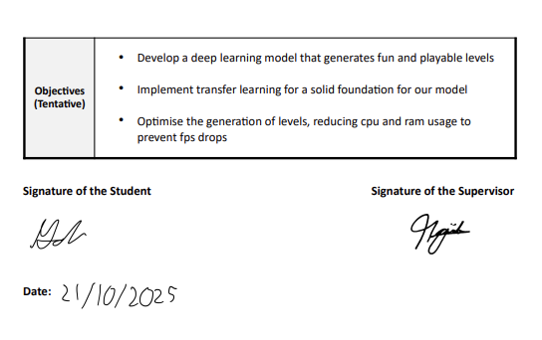

Appendix B: Gantt Chart
Semester 1
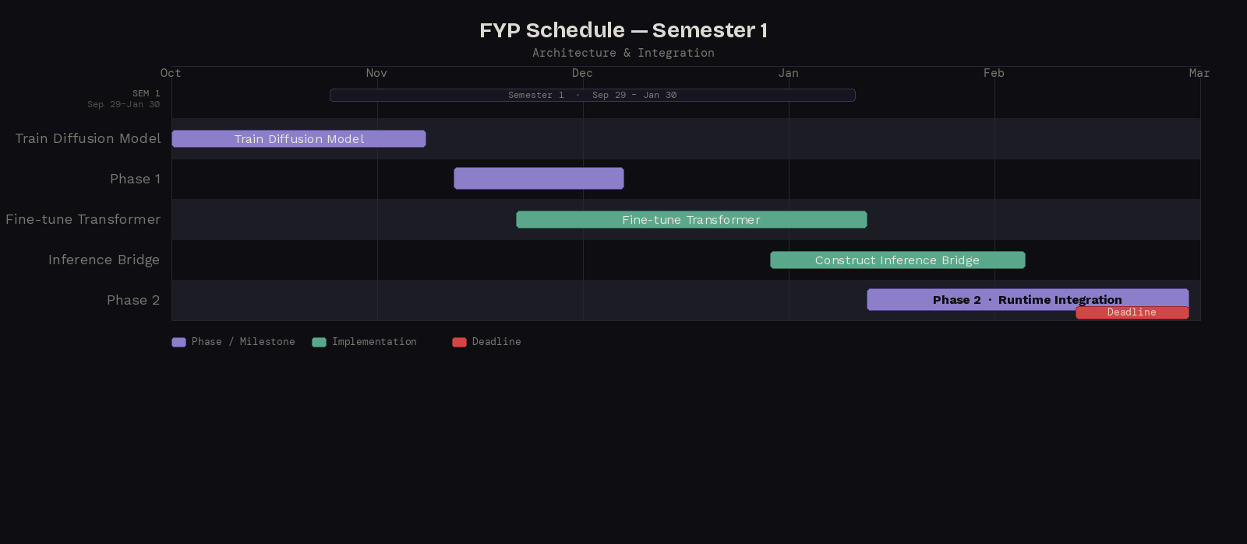

Semester 2
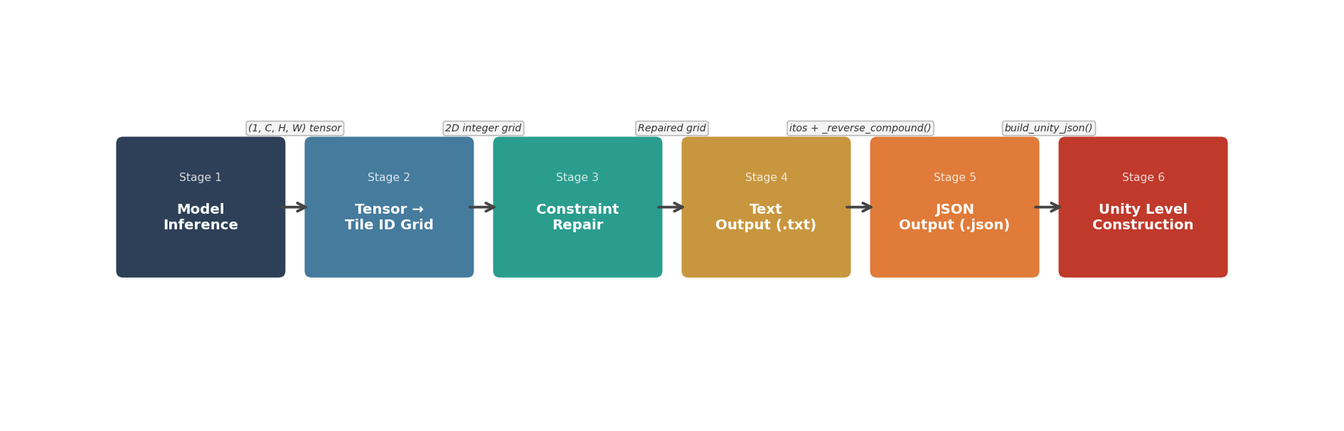
Figure 3.5: Model output processing pipeline implemented in generate.py, showing the six-stage transformation from raw GAN tensor output to Unity-ready JSON file.
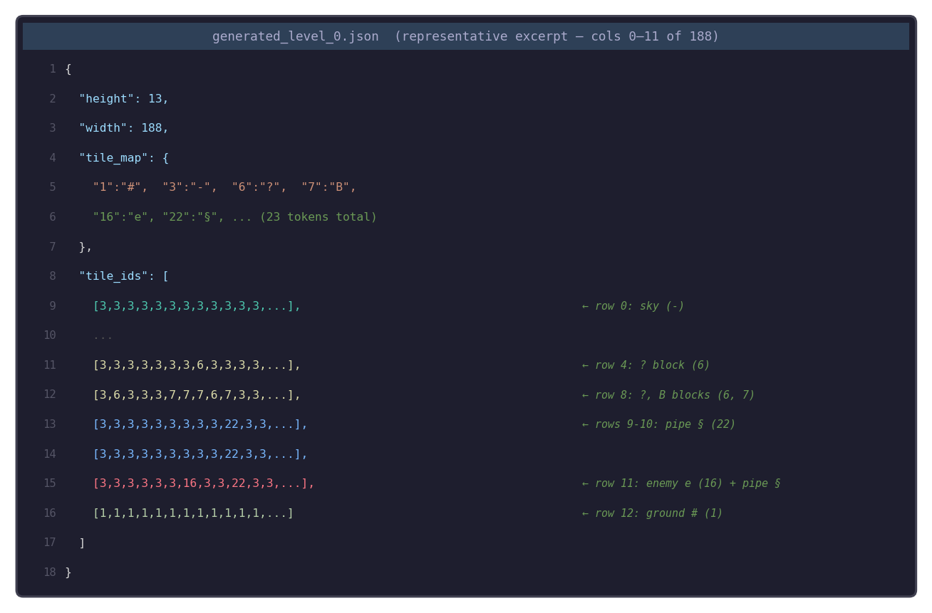
Figure 3.6: Representative excerpt from generated_level_0.json showing the tile_map dictionary and a selection of tile_ids rows. Real data from TOAD-GAN generation run; full grid is 13 × 188 tiles.
