Djiby Sow Rebollo - Ec2125613

Assessment Report: Linear and Binary Search on Random.txt and GPSdata.txt

# Introduction

The purpose of this assessment is to evaluate the efficiency of linear and binary search algorithms   
on two datasets: `Random.txt` containing a list of numbers and `GPSdata.txt` containing state names.  
The search methods used are:  
- Linear Search (unsorted data)  
- Binary Search (sorted data)  
  
This report will explain the output generated by running both search algorithms on these files,   
demonstrating their performance and efficiency by comparing the number of steps required for each search type.

# Results and Explanation

## 1. Linear and Binary Search on Random.txt

The search results for `Random.txt` contain a comparison of linear and binary search algorithms on unsorted and sorted data.   
The linear search was performed on unsorted data, and the binary search was performed on the sorted data.  
  
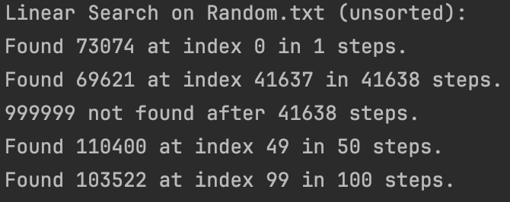  
Data sorted successfully: true

  
  
Binary Search on Random.txt (sorted):  
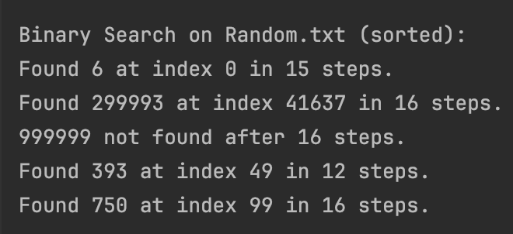  
  
Summary:  
- Binary search performed faster than linear search after sorting.  
- The number of steps decreased significantly when using binary search compared to linear search.

## 2. Linear and Binary Search on GPSdata.txt

The search results for `GPSdata.txt` focus on searching for state names. The states were searched using linear search on unsorted data and binary search on sorted data.  
  
Linear Search on GPSdata.txt (unsorted):  
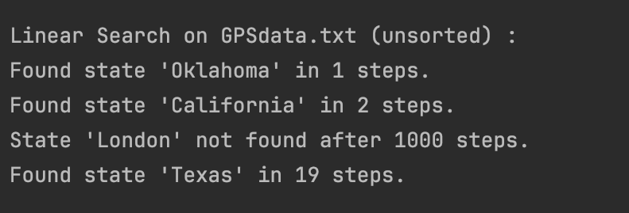  
  
Data sorted successfully: true

  
  
Binary Search on GPSdata.txt (sorted):  
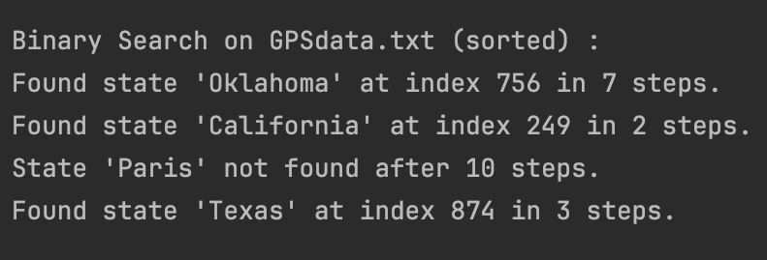  
  
Summary:  
- Binary search was significantly faster compared to linear search, with fewer steps required to find the states in the sorted list.  
- The binary search for `Texas` resulted in fewer steps (3 steps) compared to linear search (19 steps).  
  
Conclusion:  
- The efficiency of binary search is clearly demonstrated, especially when working with large datasets where sorting the data improves search performance. Linear search, while simple, is less efficient as it requires scanning through each element sequentially.