**Hi-Fi Prototype of the SpendGuard**

**Author: Junjie He**

**Student number:225204972**

**1. Solution Overview**

Target users: Students and early career professionals aged 18-30 who frequently make mobile payments and are easily influenced by context.

Core proposition: In a frictionless payment environment, provide lightweight visibility and gentle guardrails 10-30 seconds before and after payment, making the "record first, calm down, double-check" process a habit.

Product of this draft: 16 pages of high-fidelity user interfaces and interaction instructions (Subscriptions excluded, Settings integrated into Account), along with key processes, testing, and compliance baselines.

**Why choose a card-style mobile interface with a white background?**

We chose a card-style mobile interface with a white base and blue as the primary color. This approach minimizes visual noise by accommodating high-frequency actions (recording, transferring, splitting, and repaying), providing users with immediate visibility and gentle safeguards within the 10-30 seconds before and after a payment. A white background emphasizes information hierarchy and readability; blue is used for primary actions and interactive elements, establishing stable behavioral expectations. Yellow and green are used only as embellishments for prompts and positive feedback, ensuring a perceptible yet non-intrusive experience. This format is highly aligned with the usage context of the 18-30 age group, a demographic that frequently uses mobile payments, and supports high-fidelity prototypes that appear to work or are partially functional.

**2. Design Principles**

Low-friction, controllable, and non-disruptive: Complete key tasks in two or three steps; reminders are configurable and can be turned off.

Instant visibility: Each step provides real-time feedback on progress toward this week's available resources, budget, and goals.

Accessibility: Contrast, touch targets, and screen reading order are compliant with WCAG 2.2.

Privacy and local-first: Minimize data collection, enable export/deletion, and revoke authorization with one click.

Consistent component language: Cards with rounded corners, clear hierarchy, light shadows, and a unified linear style for icons.

**Color Scheme and Semantics**

Base (white): Background and cards, ensuring neutrality and white space for information.

Primary (blue): Primary buttons, selected states, key links, and interactive controls (creating an "at-a-glance" actionable flow).

Accent (yellow/green): Yellow is used for gentle reminders of "Attention/Expiring/Approaching Threshold"; green is used for confirmation and encouragement of "Success/Improved/Positive Trend."

Accessibility: Primary buttons and body copy should have a contrast ratio of ≥ 4.5:1; touchable area ≥ 44px; focus rings and reading order should be consistent with visual order.

Fonts and Rhythm: Use medium weight for titles and regular weight for body copy; use (or simulate) fixed width for numerical KPIs to reduce jumps; use a standard spacing of 8/12/16/24 to establish a hierarchical rhythm.

**3. Information Architecture**

16 pages in total (in side navigation order):  
1 Homepage｜2 Features｜3 Shopping Cart｜4 Goals｜5 Log｜6 Transfer｜7 Budget｜8 Report｜9 Split｜10 Calendar｜11 Scan｜12 Financial Manage｜13 Credit card｜14 Finance｜15 Trade｜16 Account.

**4. Hi-Fi Screens & Annotations**

1) Homepage

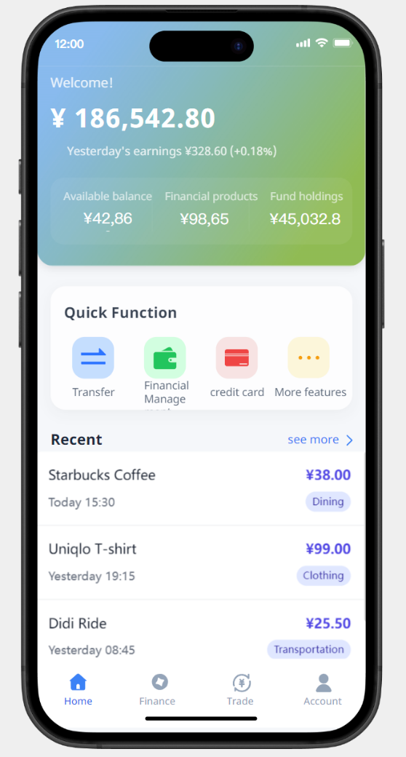The Home screen uses a clean white base with blue as the primary action color and yellow/green as subtle accents. A large gradient **portfolio summary card** sits at the top, highlighting **total assets** and **yesterday’s earnings** (with % change). At the bottom of this card, three compact metrics break down holdings: **Available Balance**, **Financial Products**, and **Fund Holdings**.

Below is a **Quick Function** card with four rounded shortcuts—**Transfer**, **Financial Manage**, **Credit Card**, and **More features**—making high-frequency tasks one tap away. The **Recent** section lists the latest transactions in reverse chronological order, showing merchant + time on the left and **amount** (emphasized) plus a **category tag** (e.g., Dining, Clothing, Transportation) on the right; a **“see more”** link leads to the full history.

A persistent **bottom navigation bar** provides direct access to **Home / Finance / Trade / Account**, with the active tab highlighted in blue. Overall, the page delivers **high-density information with low cognitive load**: glanceable asset status at the top, immediate access to core actions in the middle, and consistent global navigation at the bottom.

2) Features

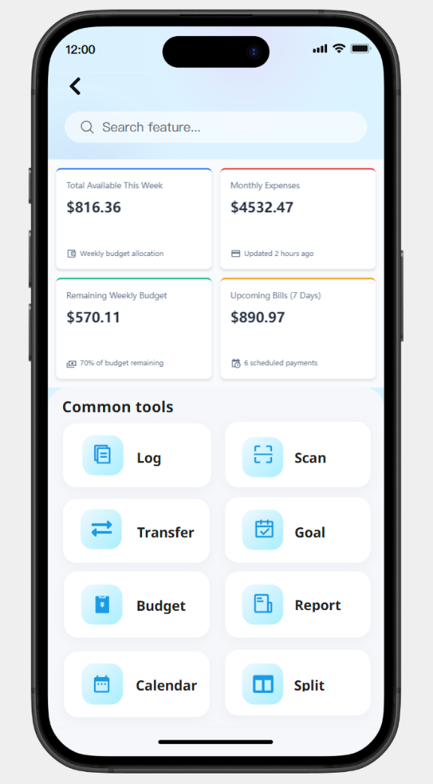

The **Features** page uses a clean white base with blue as the primary action color and soft blue accents for grouping. A centered **search bar** (“Search feature…”) sits beneath the header, narrowing results as you type and surfacing deep links (e.g., bills, budget, split). Below it, a four-tile **KPI overview** provides glanceable stats—**Total Available This Week**, **Monthly Expenses**, **Remaining Weekly Budget**, and **Upcoming Bills (7 Days)**—each tile tappable to its destination (Budget this week, Report: Categories, or Calendar for the next 7 days). Green hints indicate healthy states, while yellow hints flag items that need attention. The **Common tools** grid presents rounded cards with icon + label for **Log**, **Scan**, **Transfer**, **Goal**, **Budget**, **Report**, **Calendar**, and **Split**, giving one-tap access to high-frequency flows. Interactions are light and consistent: large tap targets, subtle shadows, gentle haptics on tap, and pull-to-refresh for KPI timestamps. Overall, the page emphasizes **fast wayfinding**—quick search at the top, status at a glance in the middle, and direct entry points to core tasks below.

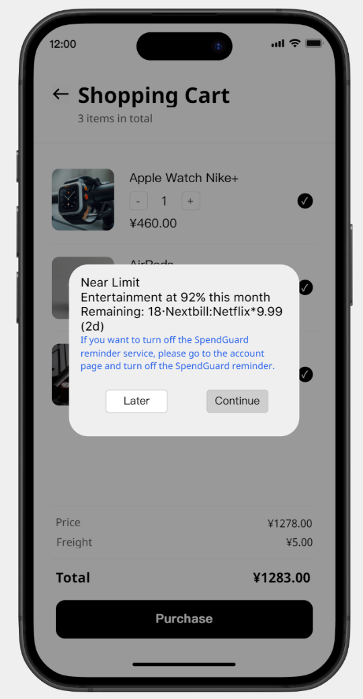3) Shopping Cart

The **Shopping Cart** page presents a clean, scrollable list with a persistent **total bar** anchored at the bottom. Each line item includes a **checkbox** to select it for logging, **quantity stepper** (− / +) for quick adjustments, and a compact field for **coupon code** entry that recalculates the line and cart totals in real time. The bottom bar highlights the updated total and features a primary action—**“Log as planned”**—allowing selected items to be recorded in one tap. A lightweight **guardrail** preserves momentum without blocking: if selecting an item would drive **Weekly Available** below **20%**, a subtle, non-modal reminder slides in near the total bar (e.g., “Weekly Available would drop to $X”), with options to **view budget** or **continue**. Tap targets are large, feedback is immediate (value count-up and gentle haptics), and the overall flow keeps decisions fast while maintaining spending visibility.

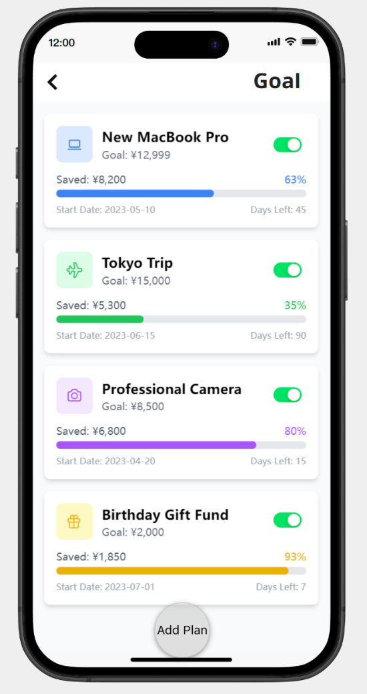4) Goals

The **Goals** page uses a clean white base with blue as the primary action color, presenting a vertical stack of rounded **goal cards**—each showing the goal name, **target amount**, **saved to date**, a colored **progress bar** with the current **percentage**, and a light footer row with **Start Date** and **Days Left (ETA)** for glanceable timelines. A right-aligned **Auto** toggle on every card indicates whether Pay-Yourself-First deposits are active; when enabled, the label and bar feel “alive” (subtle motion/count-up on updates). Color accents (green/yellow/purple/amber) differentiate goals without overwhelming the white canvas, while blue is reserved for interactive states (percent link, card press, and CTAs). Tapping a card opens goal details (transfer in/out, edit plan, history), and the percentage text is actionable—jumping to a progress breakdown. A floating **“Add Plan”** pill centered above the safe area offers single-tap creation of a new goal with templates (e.g., Emergency Fund, Travel). Microcopy stays factual and encouraging (e.g., “Days Left: 15”), with positive completions confirmed in green. Overall, the page emphasizes **progress visibility and low-friction action**—see where you stand, toggle auto-savings, and add or fund a goal in one step.

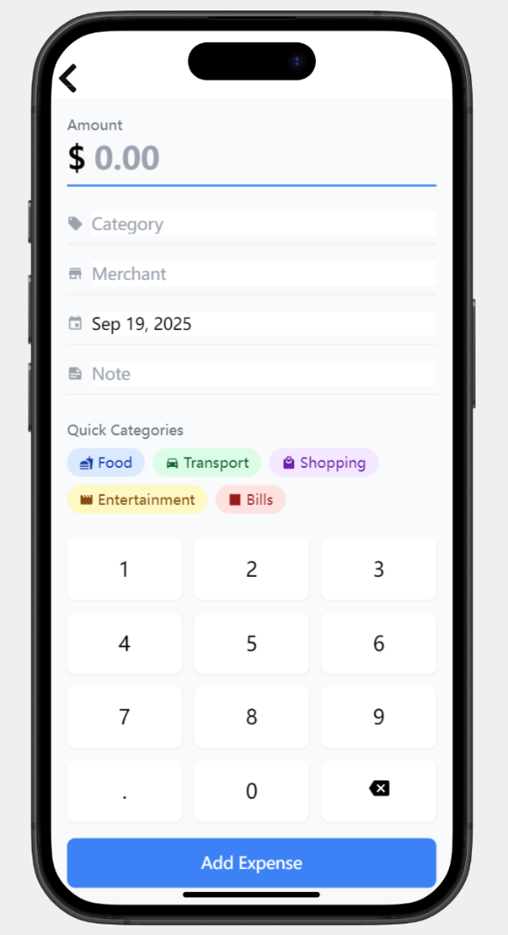5) Log

The **Log** page uses a clean white base with blue as the primary action color, optimizing for **fast single-screen capture**. A large, high-contrast **Amount** field anchors the top, accepting decimals and focusing the numeric keypad below to minimize reach. Beneath it, slim input rows capture **Category**, **Merchant**, **Date**, and **Note**; placeholders keep labels visible for clarity. A **Quick Categories** row exposes color-coded chips (Food, Transport, Shopping, Entertainment, Bills) for one-tap tagging, reducing friction for frequent types. The keypad follows a familiar **3×4 layout** with a dedicated decimal and clear keys; each tap gives light feedback and updates the amount instantly. The bottom-fixed blue **“Add Expense”** button spans the width for confident submission, while the page preserves context—inputs are never obscured, and scroll is minimal. Microcopy stays factual (currency symbol + 2-decimal formatting), and gentle validation catches edge cases (zero amount, missing category) without modal interruptions. Accessibility is built in: ≥44px tap targets, strong text contrast, and screen-reader friendly field names. Overall, the screen prioritizes **speed, accuracy, and low cognitive load**—enter the amount, add just enough detail, and confirm in a single, uninterrupted flow.

6) Transfer

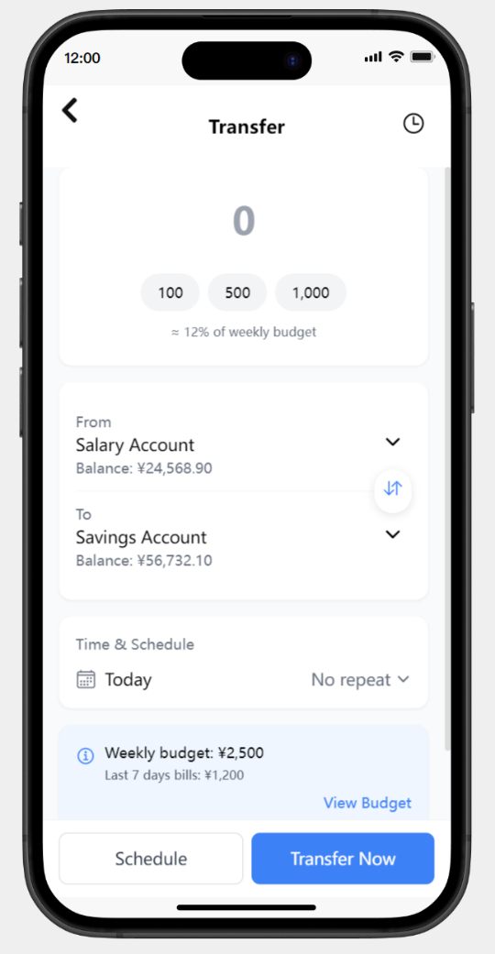The **Transfer** page uses a clean white base with blue as the primary action color, guiding a top-to-bottom flow from **amount** to **confirmation**. A large numeric **Amount** field anchors the top with **quick chips** (100 / 500 / 1,000) and a subtle note showing the **percent of weekly budget** that amount represents. The next card pairs **From** and **To** account selectors—each row shows name + balance with a chevron for pickers—while a small circular **swap** button between them lets users invert direction instantly. A **Time & Schedule** card follows, defaulting to **Today** and **No repeat**, with optional repeat patterns (e.g., Weekly/Monthly/Payday) when tapped. A lightweight **guardrail card** summarizes context—**Weekly budget** and **Last 7 days bills**—and offers a blue **View Budget** link; the reminder is informative, not blocking, preserving momentum. The bottom **fixed action bar** presents a secondary **Schedule** button and a prominent blue **Transfer Now** button. Interactions are consistent: tap targets ≥44px, balances update as the amount changes, and validation stays gentle (From ≠ To, amount ≤ balance). Overall, the screen emphasizes **clarity and choice**—see impact, adjust timing, and complete the transfer in one confident pass.

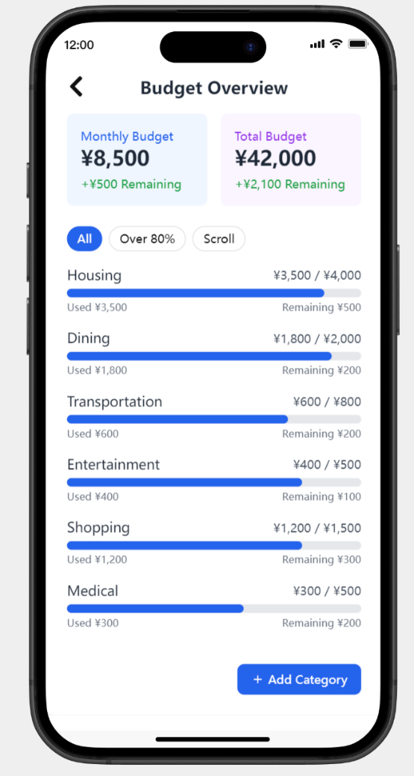7) Budget

The **Budget** page uses a clean white base with blue as the primary action color, presenting a clear **Budget Overview** from top to bottom. At the top, two compact **summary tiles**—**Monthly Budget** and **Total Budget**—show current totals with **Remaining** values called out in green for positive headroom. A pill-style **filter row** follows (**All / Over 80% / Scroll**), letting users focus on risk categories with one tap. The main list stacks **category rows** (Housing, Dining, Transportation, etc.), each with a large **progress bar** and dual captions: **Used ¥X** (left) and **Remaining ¥Y** (right), plus the category cap (e.g., ¥3,500 / ¥4,000) for immediate context. Bars advance in blue, while low headroom can be styled to shift toward yellow to signal attention without shouting; tapping a category opens its detail view with actions such as transfer, reminder, or adjust limit. Values update in place after upstream changes (e.g., logging or transfers), keeping the page live and trustworthy. At the bottom, a full-width blue **“+ Add Category”** button supports quick setup for new envelopes. Interactions emphasize readability and control: large tap targets, consistent typography, and a predictable layout that makes it easy to spot **>80%** categories, understand what’s left, and take the next step.

8) Report

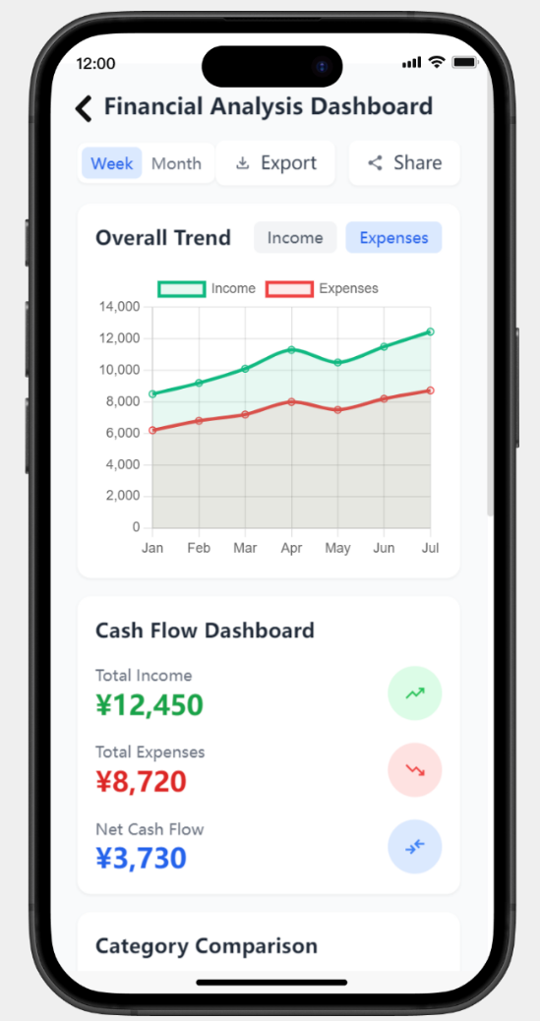The **Report** page uses a clean white base with blue as the primary action color, organizing insights into stacked, glanceable cards. A compact header row provides **period toggles** (Week/Month) plus **Export** and **Share** actions; selections update the view instantly. The **Overall Trend** card shows an inline line chart with tap-chips to focus **Income** or **Expenses**; series colors are semantic—**green** for income, **red** for expenses—while axes and grid remain subtle to reduce noise. Below, a **Cash Flow Dashboard** card summarizes **Total Income**, **Total Expenses**, and **Net Cash Flow**, each paired with a small trend icon; values adopt green/red/blue accents for immediate interpretation. Further down, **Category Comparison** (and subsequent sections) rank top contributors with bars or lists; tapping a category drills into its monthly breakdown and recent transactions. Interactions are consistent and lightweight: large tap targets, pull-to-refresh, and short value animations on period change. Export produces a CSV/PDF with the active filters applied; Share invokes the system sheet. Accessibility and readability remain first-class—strong contrast for key numbers, screen-reader labels for chart series/points, and a predictable scan path from filters to charts to summaries—making it easy to move from **high-level trend** to **actionable detail** in a single flow.

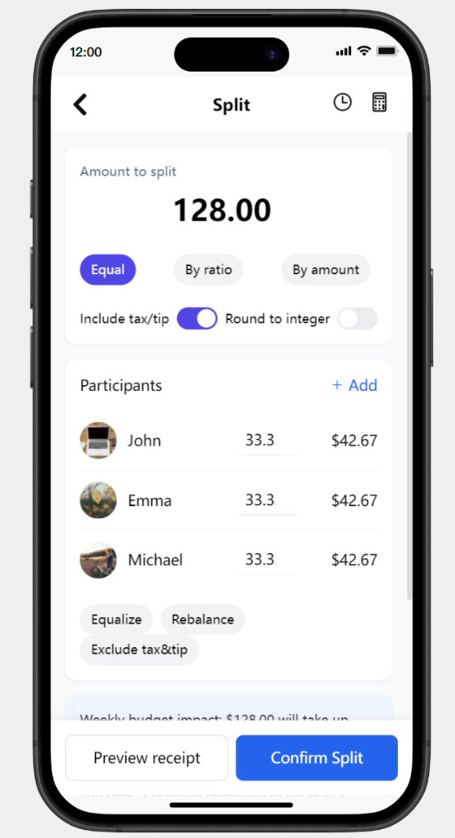9) Split

The **Split** page uses a clean white base with blue as the primary action color, streamlining a top-to-bottom flow from **rule selection** to **confirmation**. A large **“Amount to split”** card anchors the top, with mode chips for **Equal**, **By ratio**, and **By amount**; two compact toggles—**Include tax/tip** and **Round to integer**—refine how the total is distributed. The **Participants** card lists avatars, names, and each person’s **share (%)** and **calculated amount**, updating live as the mode, amount, or toggles change; a right-aligned **+ Add** affordance inserts new participants, while secondary chips (**Equalize**, **Rebalance**, **Exclude tax&tip**) quickly normalize or reapply rules after edits. Subtle helpers keep the page trustworthy and fast: tap targets are ≥44px, value changes animate gently, and errors (e.g., unallocated remainder) surface as a short inline hint rather than a blocking modal. A lightweight guardrail (not shown here) can summarize **weekly budget impact** when a split is about to be logged, offering a non-modal **View budget** link. The bottom **fixed action bar** presents a secondary **Preview receipt** button for itemized review and a prominent blue **Confirm Split** button to finalize. Overall, the screen emphasizes **clarity, flexibility, and momentum**—pick a rule, adjust participants, and confirm in one confident pass.

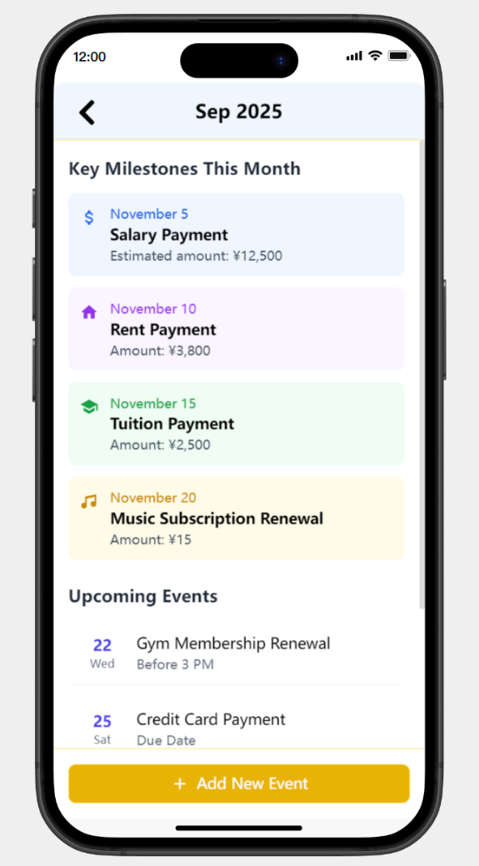10) Calendar

The **Calendar** page uses a clean white base with blue as the primary action color, organizing money-related dates into **milestone cards** and an **upcoming list**. A centered month header (e.g., **Sep 2025**) anchors the view; below it, color-tinted **Key Milestones This Month** cards surface high-impact items—**Salary Payment**, **Rent**, **Tuition**, **Subscription Renewal**—each with date, icon, and amount/estimate for quick scanning. The **Upcoming Events** section lists day-by-day entries in a compact timeline style (weekday + due hint), keeping near-term obligations visible without overload; tapping an item opens details with actions like set reminder, snooze once, or jump to Budget if category-linked. Visual accents (yellow for soon/attention, green for positive inflow) complement, not distract. A full-width yellow **“+ Add New Event”** button at the bottom supports single-tap creation with templates (bill, payday, renewal), while pull-to-refresh updates server-synced entries. Accessibility is built in—clear contrasts, ≥44px targets, and screen-reader labels—so users can **see what’s coming, act early, and stay on track** in one pass.

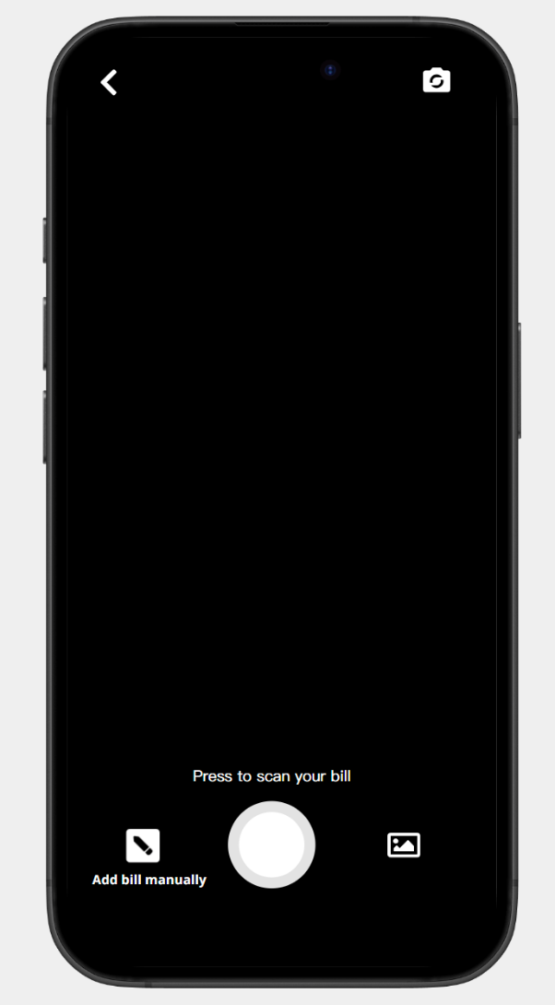11) Scan

The **Scan** page centers a full-screen camera view to capture receipts/bills, with a minimal chrome to keep focus on the document. A back chevron sits top-left, while a top-right control toggles camera options (e.g., switch/flash), keeping actions within thumb reach. A large circular **shutter button** anchors the bottom center; tapping triggers capture with gentle haptics, and an inline hint (“Press to scan your bill”) confirms intent. Two auxiliary actions flank the shutter: **Add bill manually** on the left (opens a lightweight form to type amount, merchant, date) and a **gallery import** on the right for picking an existing photo. On capture, edge detection and perspective correction run automatically; high-confidence OCR extracts **amount**, **merchant**, and **date**, then offers a one-tap handoff to **Log** with fields prefilled (users can edit before saving). If confidence is low, a subtle prompt asks to review rather than blocking the flow. Privacy is respected—processing is local where possible—and accessibility is built in: clear, high-contrast controls, ≥44px tap targets, and descriptive labels (e.g., “Shutter; takes a photo of your bill”). Overall, the screen prioritizes **speed and reliability**: shoot → auto-extract → confirm in Log, with manual and gallery fallbacks always one tap away.

12) Financial Manage

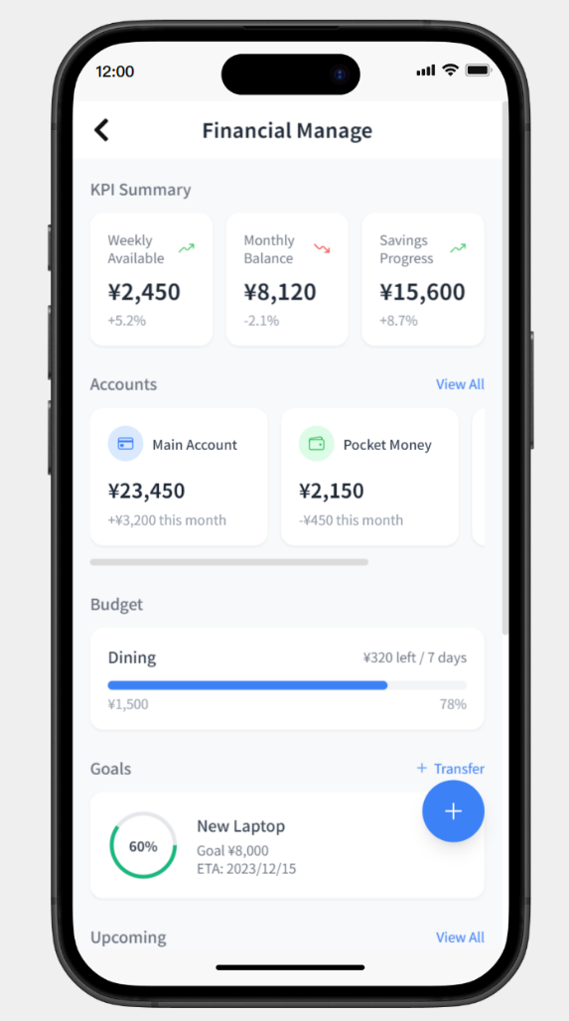The **Financial Manage** page uses a clean white base with blue as the primary action color, stacking glanceable blocks from **overview → control → action**. A compact **KPI Summary** row leads with **Weekly Available**, **Monthly Balance**, and **Savings Progress**, each numeric tile showing a small trend arrow and delta for quick reading. The **Accounts** section follows with rounded cards (e.g., *Main Account*, *Pocket Money*) showing balance and this-month change; the row horizontally scrolls and a **View All** link opens the full list. The **Budget** block highlights the most relevant category (e.g., *Dining*) with a large progress bar, explicit **left amount / days** and **percent used**, encouraging timely adjustments. The **Goals** card surfaces the next priority goal with a progress ring, target/ETA, and a blue **+** FAB for one-tap creation; a **Transfer** link at top-right jumps to funding the selected goal. A forthcoming **Upcoming** section (bills/renewals) sits below to keep near-term obligations in view. Interactions are consistent and calm—pull-to-refresh, gentle value animations, and large tap targets—while green/yellow accents denote positive movement or “attention soon” without overpowering the blue action language. Overall the page provides a **command center** for finances: see the status at a glance, move money where it matters, and act on budgets and goals in one pass.

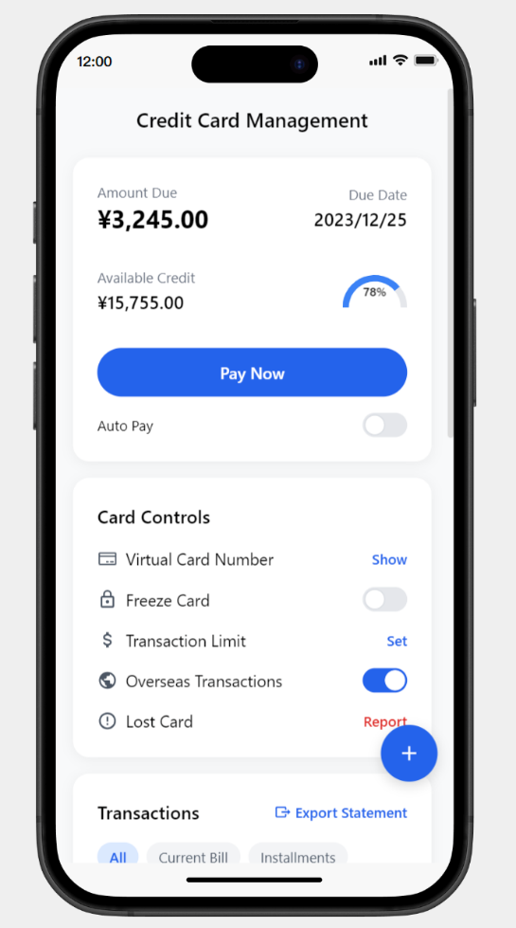13) Credit Card

The **Credit Card** page uses a clean white base with blue as the primary action color, organizing repayment and controls from **top → action → management**. The header card surfaces **Amount Due**, **Due Date**, and **Available Credit** with a utilization gauge; a wide blue **Pay Now** button anchors the primary flow, and an **Auto Pay** toggle lets users enable scheduled payments without leaving the screen. The **Card Controls** card centralizes safety and limits: **Virtual Card Number (Show)** with masked reveal, **Freeze Card** for instant lock, **Transaction Limit (Set)** to define per-txn/day caps, **Overseas Transactions** toggle, and a **Lost Card (Report)** link that opens a guided flow. A blue **+** FAB supports quick add-ons (e.g., add card, set installment). The **Transactions** section below provides filter chips—**All / Current Bill / Installments**—and an **Export Statement** link; list rows show merchant, time, amount, and category for quick reconciliation. Interactions are calm and predictable: large tap targets (≥44 px), gentle haptics on critical switches, masked numbers by default, and clear confirmations for irreversible actions (freeze/report). Optional guardrails can appear near repayment—if paying would push **Weekly Available** too low or utilization ≥80%, a non-modal hint offers **View budget** or **Continue**—keeping momentum while preserving visibility. Overall, the screen brings **repay, secure, and review** into a single, confident pass.

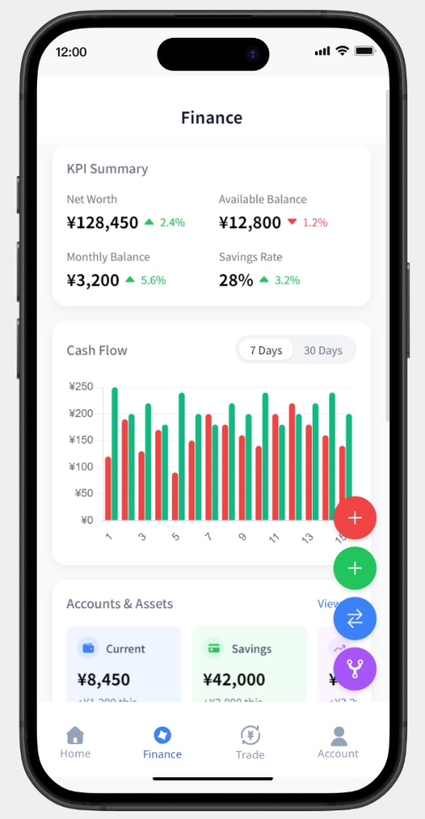14) Finance

The **Finance** page uses a clean white base with blue as the primary action color, stacking **overview → analysis → assets** for fast comprehension. A compact **KPI Summary** card leads with **Net Worth**, **Available Balance**, **Monthly Balance**, and **Savings Rate**, each value paired with a small green/red delta for instant trend reading. The **Cash Flow** card follows with a dense bar chart (green = income, red = expenses) and period chips (**7 Days / 30 Days**) that update the view with a short value animation; axes and grid stay subtle to reduce noise. On the right edge, a floating **speed-dial FAB** exposes quick actions—commonly **Add expense** (red), **Add income** (green), and **Transfer/Rules** (purple)—so money moves are one tap away from the chart context. The **Accounts & Assets** section presents rounded horizontal cards (e.g., *Current*, *Savings*, *Investments*) showing balances and soft category color tints; a **View All** link opens the complete list. Interactions are calm and consistent: large tap targets (≥44px), haptics on FAB actions, and pull-to-refresh across sections. Accessibility remains first-class with strong contrast on key numbers and descriptive labels for chart series. Overall, the screen acts as a **command hub** for finances—see status at a glance, inspect cash-flow patterns, and trigger core actions without leaving the page.

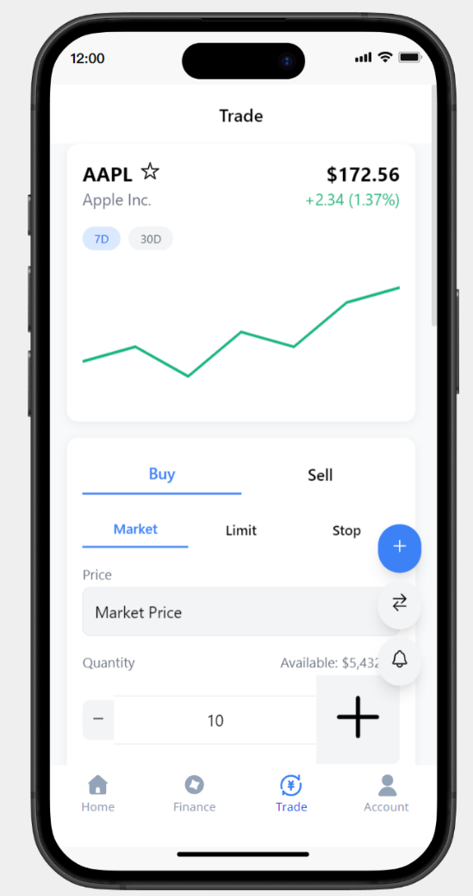15) Trade

The **Trade** page uses a clean white base with blue as the primary action color, arranging **instrument → order → confirm** in a single vertical flow. A compact **instrument header** leads with the ticker (e.g., **AAPL**), company name, **last price**, and **intraday change** in green/red; a mini line chart below offers **7D / 30D** toggles for quick context. The **order panel** splits **Buy / Sell** as tabbed actions and supports **Market / Limit / Stop** types; selecting a type reveals the relevant fields only. **Price** defaults to *Market Price* (read-only until a non-market type is chosen); a small **swap** chip can switch quote/price source if needed. **Quantity** uses a stepper with long-press acceleration, while an inline **Available** balance hint keeps users grounded. A slim **alerts** icon beside quantity opens price/percentage alert presets without leaving the flow. On the right edge, a blue **+ speed-dial FAB** exposes contextual quick actions (e.g., add to watchlist, set alert, paste ticker). Tap targets are ≥44px, value changes animate subtly, and guardrails remain informative—not blocking (e.g., if order size exceeds risk/margin, a short hint suggests “Adjust size” or “View limits”). The persistent bottom nav keeps **Home / Finance / Trade / Account** reachable, making it easy to move from glanceable context to **placing an order in one confident pass**.

16) Account

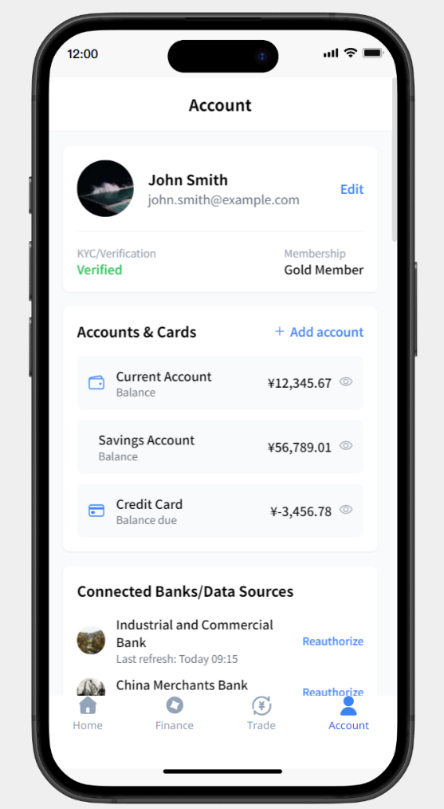The **Account** page uses a clean white base with blue as the primary action color, organizing personal info, accounts, and connections into stacked cards. A **profile card** leads with avatar, name, and email, plus a right-aligned **Edit** link for quick updates; secondary chips show **KYC/Verification** status (e.g., *Verified* in green) and **Membership** tier (e.g., *Gold Member*) for at-a-glance trust and benefits. The **Accounts & Cards** section lists key instruments—**Current Account**, **Savings Account**, **Credit Card**—each row showing a label and balance (or *balance due* for credit) with a subtle chevron affordance to open details; a blue **+ Add account** link supports fast onboarding of new accounts. Below, **Connected Banks/Data Sources** surfaces open-banking links with bank name, favicon, and **last refresh time**, keeping data freshness explicit; a right-aligned **Reauthorize** action appears per connection to renew consent without leaving the page. Interactions remain calm and predictable: large tap targets (≥44 px), masked numbers if “hide balances” is enabled (not shown), and clear confirmations for sensitive actions like reauthorization. The persistent bottom navigation keeps **Home / Finance / Trade / Account** reachable, making this screen the hub for identity, funding sources, and connectivity—**edit your profile, manage accounts, and maintain data links in one confident pass**.

5. Testing Strategy (Improved)

**Objective**  
Verify that core flows are *discoverable, fast, and correctly understood*; quantify whether “light guardrails” inform—not block—decisions.

Participants & Environment

N = 5–7 target users (18–30, mixed iOS/Android; prior mobile banking/budget app use ≈50%).

Real devices + clickable prototype/hi-fi screens; remote or in-person with screen/audio recording.

Pilot with 1 user to smoke-test script and timings; then run the remaining 4–6.

**Protocol**

Consent & warm-up (2–3 min).

Think-aloud during tasks; facilitator only clarifies, not teaches.

Each task hard-stop at 3 minutes; log completion, time, errors.

Post-test UMUX-Lite, 1–2 open questions.

Debrief & thank-you.

**Tasks (final set)**  
T1. Log a coffee and confirm the Weekly Available delta on screen.  
T2. Trigger a guardrail (e.g., action that pushes a budget >80%); choose an option and return.  
T3. Create an Emergency Fund, enable Auto (Payday/Monthly), and read the ETA update.  
T4. In Budget, find a category >80% and take a recommended action (e.g., transfer, set reminder).  
T5. In Calendar, locate the next bill and set a reminder.

Counterbalance task order across participants to reduce learning effects.

**Success Criteria (per task)**

Success: Goal achieved without moderator guidance (clarifying the prompt is OK).

Assisted: Minor hint required (counts as *conditional success*).

Fail: Not completed in 3 min or wrong outcome.

**Metrics & Definitions**

Completion Rate (CR): successes / attempts. Target ≥80% overall; each task ≥70%.

Time on Task (ToT): median duration for successes. Target ≤60s per task.

Error Rate: mis-taps, backtracks, dead-ends. Target ≤2 per task.

UMUX-Lite (0–100): perceived usability. Target ≥70.

Guardrail Comprehension (T2 only): user correctly paraphrases what will happen if they continue or view budget. Target ≥80% correct.

Discoverability: % who locate the correct entry point *without scanning the whole screen*. Target ≥70% on first attempt.

**Pass/Fail Decision Rule (study-level)**  
Participant passes if they meet thresholds on ≥4/5 tasks. Study deemed acceptable if ≥80% of participants pass. Additionally, *no single task* may fall below 60% CR.

**Instrumentation & Artifacts**

Observer sheet (one row per task): start/stop time, path taken, errors, comments.

Screen/audio recordings; auto-timestamp notable events (guardrail shown, reminder set).

Post-test: UMUX-Lite + “What was confusing?” + “What would you change?”

**Analysis Plan**

Compute CR, median ToT, error distributions; chart per task.

Thematic code for confusion points (navigation labels, button placement, guardrail wording).

Severity rubric:

S1 cosmetic; S2 minor friction; S3 prevents task (must fix); S4 blocks majority (hotfix before next run).

**Feedback Loop (Actionable Fixes)**

Label/entry not discovered → raise contrast, add verb-first labels, move to primary zone.

Guardrail skipped/misread → tighten copy to “Fact + Choice” (e.g., “Weekly Available would drop to $X. View budget or continue?”).

Error clusters near adjacent controls → increase hit area ≥48px, spacing ≥12px.

**Schedule**

Day 0: Pilot (revise script).

Days 1–2: 4–6 sessions.

Day 3: Analysis + fix list + *before/after* mockups.

Day 5: Re-test 2 participants on fixed flows (sanity check).

**Reporting (deliverables)**

1-page scorecard (CR/ToT/UMUX-Lite per task).

Clips reel (≤90s) of key insights.

Prioritized fix backlog (S3/S4 first) with owner & ETA.