Node.js + TypeScript + MySQL
Authentication API
Quick Reference & Recreation Guide
Express · Sequelize · MySQL · JWT · Nodemailer · Swagger
What We're Building
A production-ready authentication REST API with user registration, JWT login, role-based access, and account management.

- User registration with email verification
- JWT login (15 min) + HTTP-Only refresh token cookies (7 days)
- Refresh token rotation for extra security
- Admin and User roles (first account = Admin)
- Forgot / reset password via email
- Swagger docs at /api-docs

Project Structure
project-root/
├── _helpers/
│ ├── db.ts ← MySQL + Sequelize connection
│ ├── send-email.ts ← Nodemailer wrapper
│ ├── role.ts ← Role enum (Admin / User)
│ └── swagger.ts ← Swagger UI route
├── _middleware/
│ ├── authorize.ts ← JWT + role guard
│ ├── error-handler.ts ← Global error handler
│ └── validate-request.ts ← Joi body validation
├── accounts/
│ ├── account.model.ts ← Sequelize Account model
│ ├── refresh-token.model.ts ← Sequelize RefreshToken model
│ ├── account.service.ts ← Business logic
│ └── accounts.controller.ts ← Express routes
├── config.json ← DB + JWT + SMTP settings
├── swagger.yaml ← API spec
└── server.ts ← App entry point

Part 1 — Project Setup

1.1 Initialise & Install
npm init -y
# Production
npm install express sequelize mysql2 jsonwebtoken bcryptjs nodemailer
express-jwt joi swagger-ui-express yamljs cookie-parser cors rootpath
# Dev
npm install -D typescript ts-node nodemon @types/node @types/express
@types/jsonwebtoken @types/bcryptjs @types/nodemailer

1.2 tsconfig.json
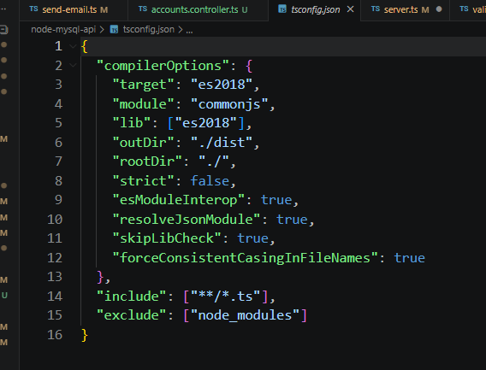

1.3 package.json scripts
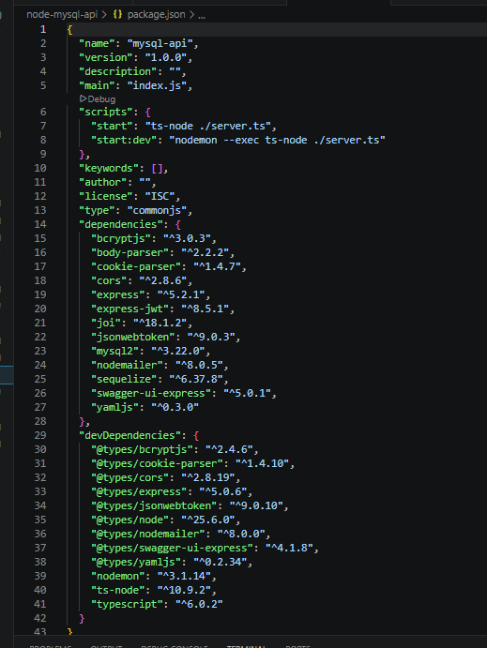
Part 2 — config.json
Create this file in the project root. Get free SMTP credentials at ethereal.email.
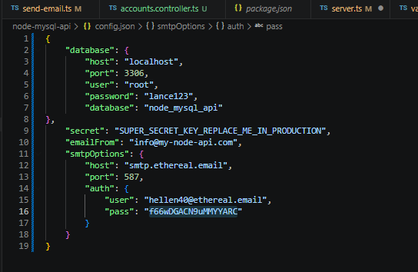
Part 3 — Helper Files

_helpers/db.ts
Connects to MySQL, initialises Sequelize, loads models, syncs tables on startup.

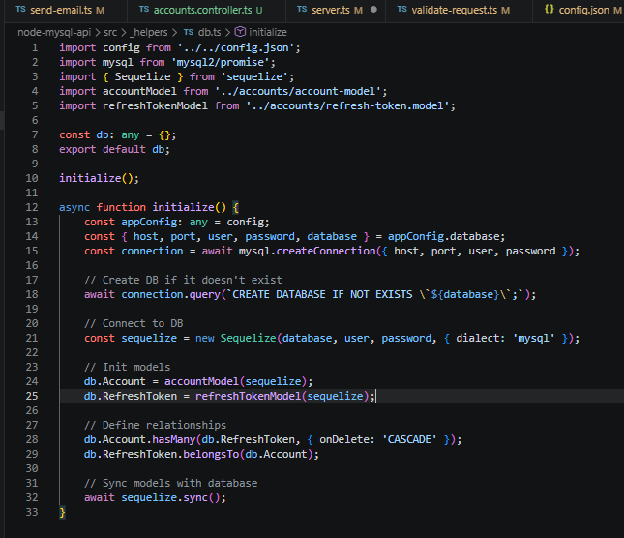
_helpers/send-email.ts
Thin Nodemailer wrapper — reads SMTP from config.json, exports sendEmail().

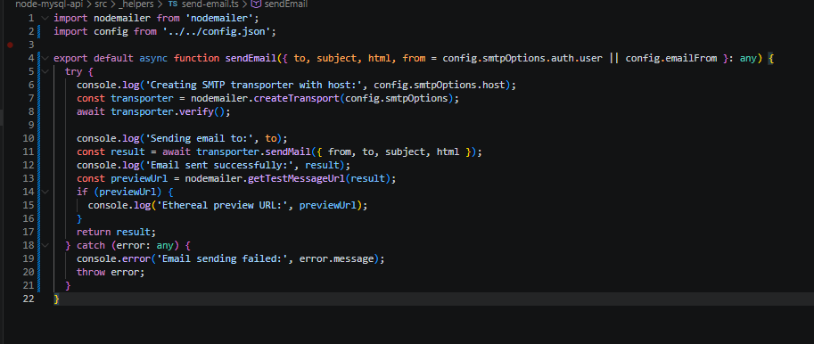
_helpers/role.ts
export const Role = { Admin: 'Admin', User: 'User' };
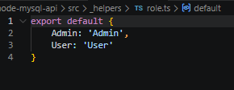

_helpers/swagger.ts
Serves auto-generated Swagger UI from swagger.yaml at the /swagger route.
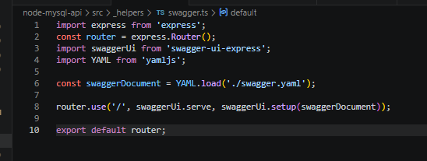

Part 4 — Middleware

_middleware/error-handler.ts
Global error catcher. String errors → 400 (or 404 if ending in 'not found'). No try-catch needed in controllers.

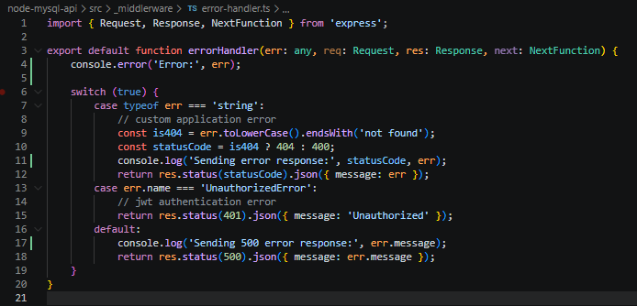
_middleware/validate-request.ts
Validates req.body against a Joi schema. Returns 400 with details if invalid.
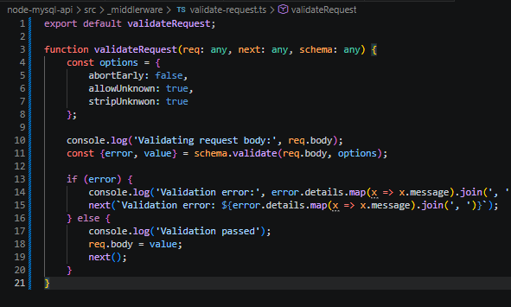

_middleware/authorize.ts
Protects routes. Verifies JWT Bearer token, checks account still exists, enforces role. Returns 401 on failure.
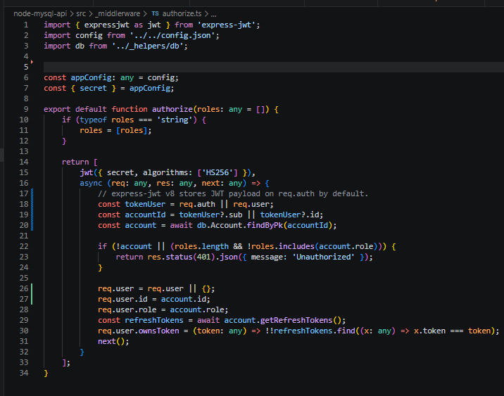

Part 5 — Accounts Module

account.model.ts
Sequelize schema for the accounts table. Virtual fields (isVerified) are computed, not stored. defaultScope hides passwordHash by default.

📸 SCREENSHOT: accounts/account.model.ts — full file

refresh-token.model.ts
Sequelize schema for refreshTokens. Virtual fields isExpired and isActive computed at runtime.

📸 SCREENSHOT: accounts/refresh-token.model.ts — full file

account.service.ts
All business logic. The only layer that touches the database. Key methods:

- authenticate() — verify credentials, return JWT + refresh token
- refreshToken() — rotate token, return new JWT
- register() — hash password, create account, send verification email
- verifyEmail() — mark account as verified
- forgotPassword() / resetPassword() — email-based password reset
- getAll() / getById() / create() / update() / delete() — CRUD

📸 SCREENSHOT: account.service.ts — top section showing exported service object

📸 SCREENSHOT: account.service.ts — authenticate() function

📸 SCREENSHOT: account.service.ts — register() function

accounts.controller.ts
All /accounts routes. Route definitions at the top, handlers below. Uses authorize() for protected routes and Joi schemas for body validation.

📸 SCREENSHOT: accounts.controller.ts — all route definitions (top section)

📸 SCREENSHOT: accounts.controller.ts — authenticate & register handlers

Part 6 — server.ts
import express from 'express';
import { db } from './_helpers/db';
import { accountsController } from './accounts/accounts.controller';
import { errorHandler } from './_middleware/error-handler';
import { swaggerDocs } from './_helpers/swagger';
const app = express();
app.use(express.json());
app.use(cookieParser());
app.use(cors({ origin: true, credentials: true }));
app.use('/accounts', accountsController);
swaggerDocs(app);
app.use(errorHandler); // must be last
db.initialize().then(() =>
app.listen(4000, () => console.log('Server on port 4000'))
);

📸 SCREENSHOT: server.ts — full file in editor

Start the dev server:

npm run dev

📸 SCREENSHOT: Terminal — server running on port 4000 + Sequelize table creation logs

📸 SCREENSHOT: Browser — Swagger UI at http://localhost:4000/api-docs

Part 7 — Testing with Postman

7.1 Register
1 | New tab → POST → http://localhost:4000/accounts/register
2 | Body → raw → JSON → paste the object below
3 | Send → expect 200 OK 'registration successful'

{ "title":"Mr","firstName":"John","lastName":"Doe",
"email":"john@example.com","password":"Pass123!",
"confirmPassword":"Pass123!","acceptTerms":true }

📸 SCREENSHOT: Postman — POST /accounts/register — 200 OK response

7.2 Verify Email
Check Ethereal inbox → copy the token from the email.

📸 SCREENSHOT: Ethereal inbox — verification email with token

1 | POST → http://localhost:4000/accounts/verify-email
2 | Body: { "token": "PASTE_TOKEN" }
3 | Send → 200 OK 'verification successful'

📸 SCREENSHOT: Postman — POST /accounts/verify-email — 200 OK

7.3 Login (Authenticate)
1 | POST → http://localhost:4000/accounts/authenticate
2 | Body: { "email":"john@example.com", "password":"Pass123!" }
3 | Send → copy the jwtToken from the response body
4 | Check the Cookies tab for the refreshToken cookie

📸 SCREENSHOT: Postman — authenticate response body with jwtToken

📸 SCREENSHOT: Postman — Cookies tab showing refreshToken

7.4 Get All Accounts (Admin only)
1 | GET → http://localhost:4000/accounts
2 | Authorization → Bearer Token → paste JWT
3 | Send → 200 OK with array of accounts

📸 SCREENSHOT: Postman — GET /accounts — 401 without token

📸 SCREENSHOT: Postman — GET /accounts — 200 OK with JWT

7.5 Forgot & Reset Password
1 | POST → /accounts/forgot-password Body: { "email":"..." }
2 | Check Ethereal for the reset email → copy the token
3 | POST → /accounts/reset-password Body: { token, password, confirmPassword }

📸 SCREENSHOT: Postman — forgot-password 200 OK + Ethereal reset email

📸 SCREENSHOT: Postman — reset-password 200 OK

7.6 Other Endpoints to Test
- PUT /accounts/:id — update account (Bearer token required)
- POST /accounts/refresh-token — rotates token, returns new JWT
- POST /accounts/revoke-token — revokes a refresh token
- DELETE /accounts/:id — deletes account (Admin or own account)

📸 SCREENSHOT: Postman — PUT /accounts/:id — 200 OK updated account

📸 SCREENSHOT: Postman — DELETE /accounts/:id — 200 OK

7.7 Verify in MySQL
mysql -u root -p
USE node_boilerplate;
SELECT id, email, role, isVerified FROM accounts;
SELECT id, accountId, revoked FROM refreshTokens;

📸 SCREENSHOT: MySQL CLI — accounts and refreshTokens table rows

API Route Reference

Method | Endpoint | Description
POST | /accounts/register | Register new account
POST | /accounts/verify-email | Verify email token
POST | /accounts/authenticate | Login → get JWT
POST | /accounts/refresh-token | Rotate refresh token
POST | /accounts/forgot-password | Send reset email
POST | /accounts/reset-password | Set new password
POST | /accounts/revoke-token | Revoke refresh token [Auth]
GET | /accounts | List all accounts [Admin]
GET | /accounts/:id | Get account by ID [Auth]
POST | /accounts | Admin create account [Admin]
PUT | /accounts/:id | Update account [Auth]
DELETE | /accounts/:id | Delete account [Auth]

Screenshot Checklist

☐ | Terminal — packages installed
☐ | tsconfig.json in editor
☐ | package.json — scripts & dependencies
☐ | config.json in editor
☐ | _helpers/db.ts
☐ | _helpers/send-email.ts
☐ | _helpers/role.ts
☐ | _helpers/swagger.ts + swagger.yaml
☐ | _middleware/error-handler.ts
☐ | _middleware/validate-request.ts
☐ | _middleware/authorize.ts
☐ | accounts/account.model.ts
☐ | accounts/refresh-token.model.ts
☐ | account.service.ts — exported service object
☐ | account.service.ts — authenticate()
☐ | account.service.ts — register()
☐ | accounts.controller.ts — route definitions
☐ | accounts.controller.ts — handlers
☐ | server.ts
☐ | Terminal — server running
☐ | Browser — Swagger UI /api-docs
☐ | Postman — POST /accounts/register 200 OK
☐ | Ethereal — verification email
☐ | Postman — POST /accounts/verify-email 200 OK
☐ | Postman — authenticate response with jwtToken
☐ | Postman — Cookies tab with refreshToken
☐ | Postman — GET /accounts 401 (no token)
☐ | Postman — GET /accounts 200 OK (with JWT)
☐ | Postman — forgot-password + reset email
☐ | Postman — reset-password 200 OK
☐ | Postman — PUT /accounts/:id
☐ | Postman — DELETE /accounts/:id
☐ | MySQL CLI — table rows

Node.js + TypeScript + MySQL Boilerplate API · Recreation Guide

