Full-Stack Web App: Build-From-Scratch Activity Guide
*Implementing a Role-Based SPA Using Only Frontend Tech*

Phase 0: Setup & Planning

Tasks:
1. Create a new folder: `fullstack-prototype-yourlastname`
2. Inside it, create an `index.html`, `style.css`, and `script.js`
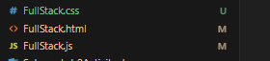
3. In `index.html`, add:
- Basic HTML5 boilerplate
- Viewport meta tag
- Title: “Full-Stack App (Student Build)”
- Link to **Bootstrap 5 CSS** via CDN
- Link your `style.css`
- At the bottom: Bootstrap JS bundle + your `script.js`

Phase 1: Core Structure & Navigation

Build These Components:

1. **Navigation Bar**
- Brand: “Full-Stack App (Your Full Name)”
- Right-aligned links:
- “Login” and “Register” (visible only when **not logged in**)

- Dropdown with username, “Profile”, “My Requests”, “Logout” (visible only when **logged in**)
- Admin-only links: “Employees”, “Accounts”, “Departments” (use `.role-admin` class)

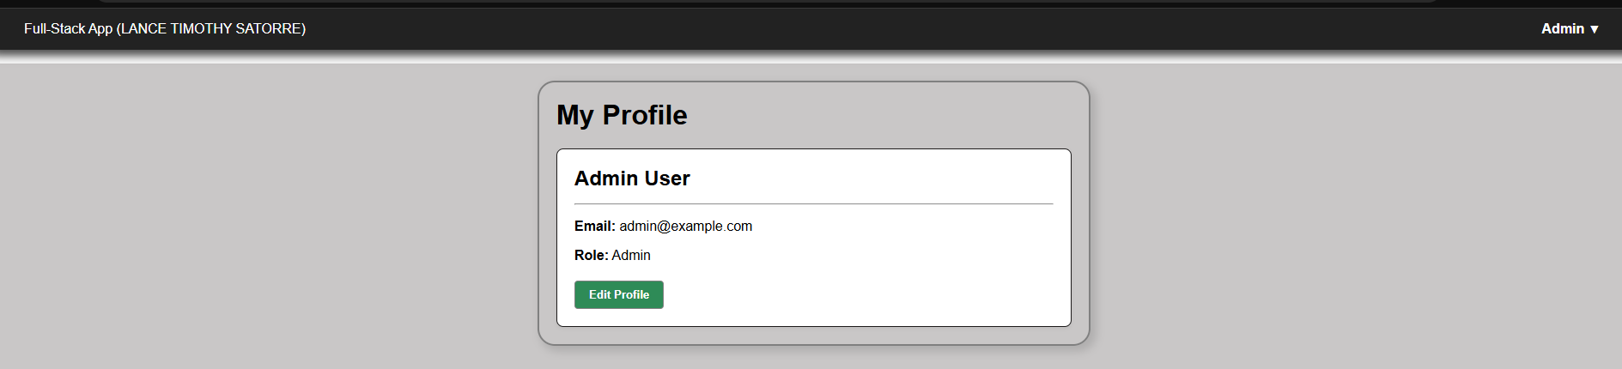

2. **Page Sections** (`<section>` inside `<main>`)
- Home
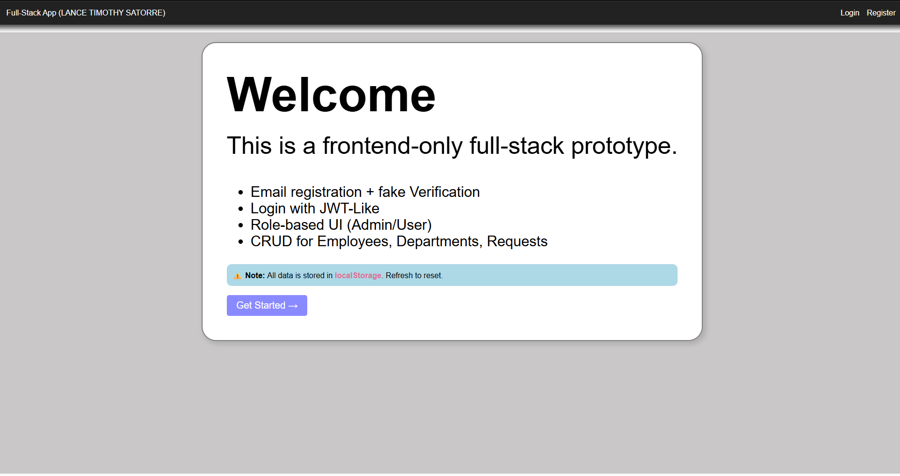
- Register
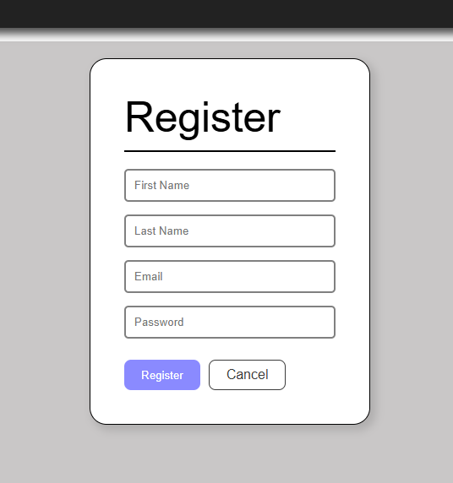
- Verify Email
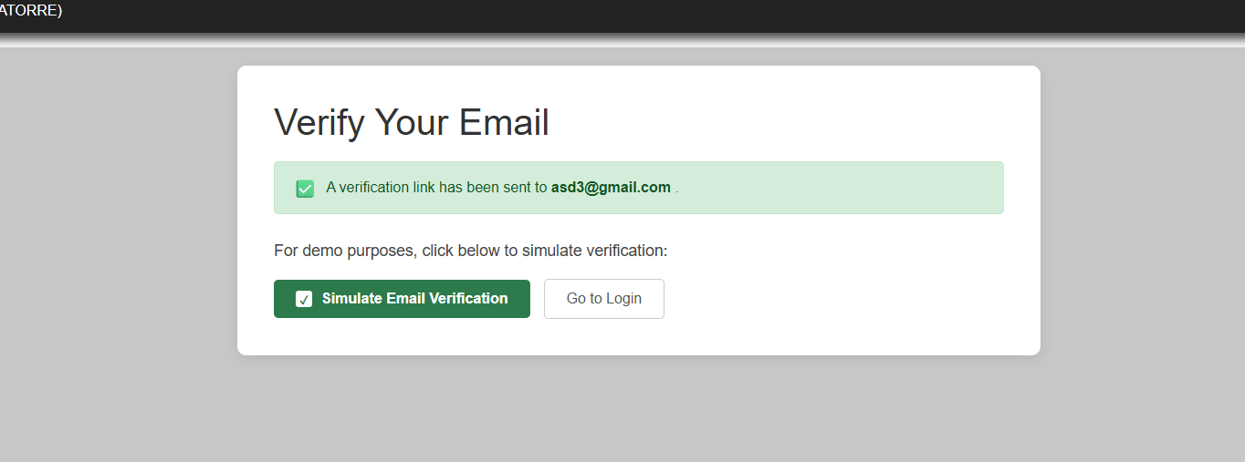

- Login
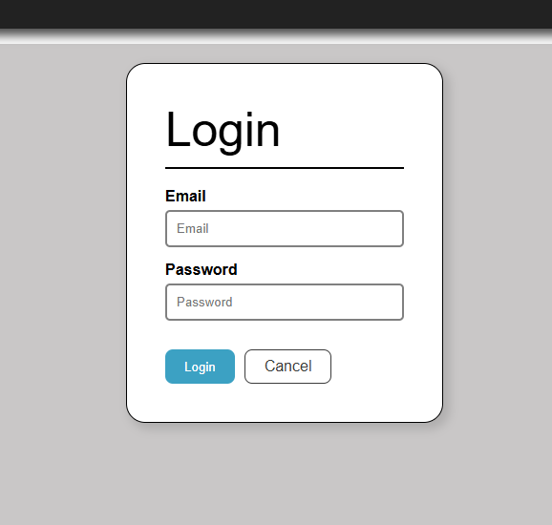
- Profile
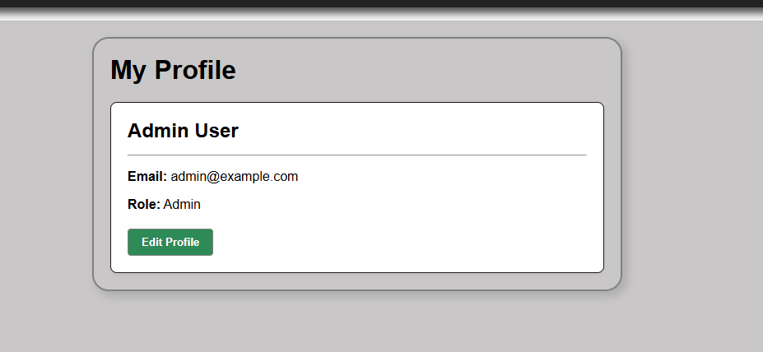
- Employees (admin)
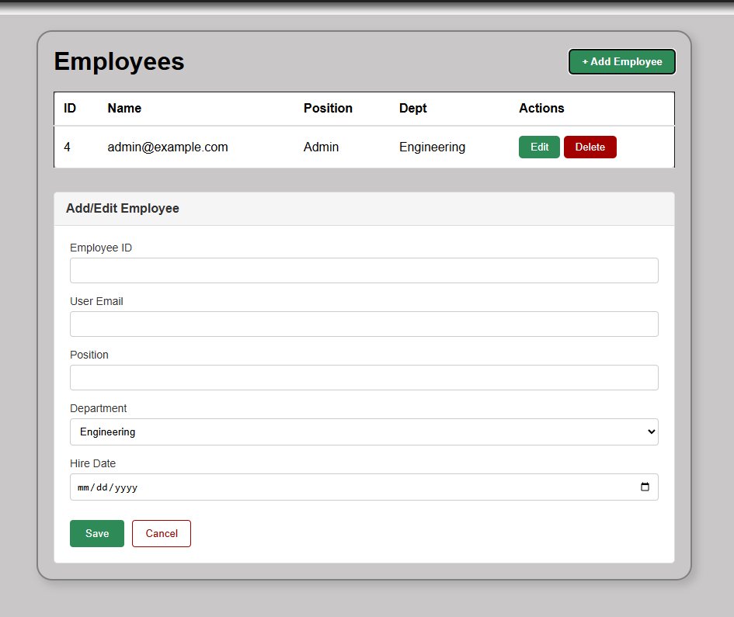
- Departments (admin)
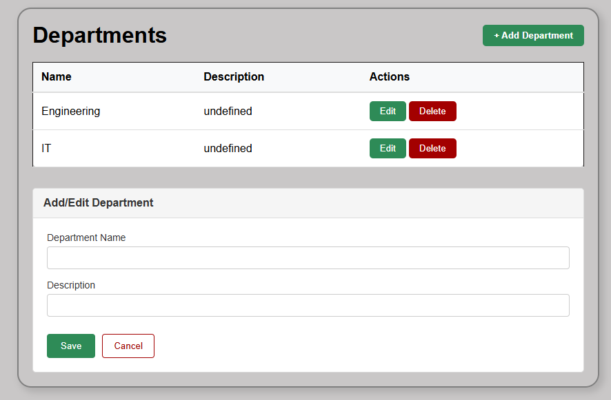
- Accounts (admin)
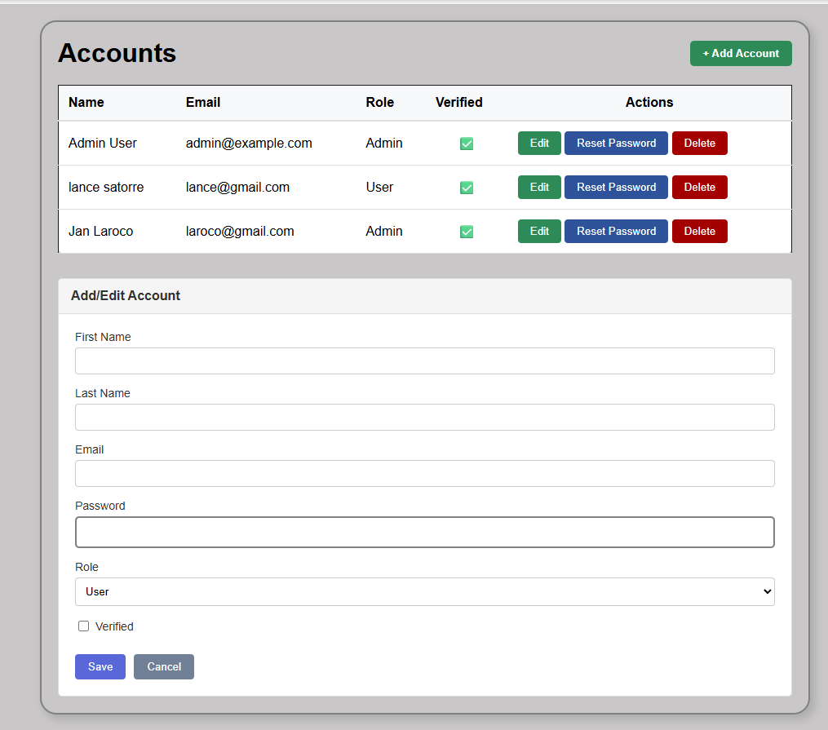
- Requests
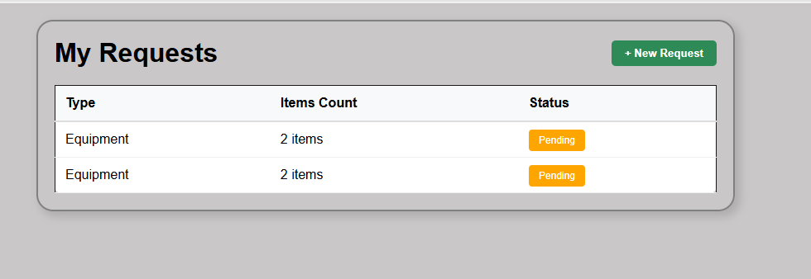
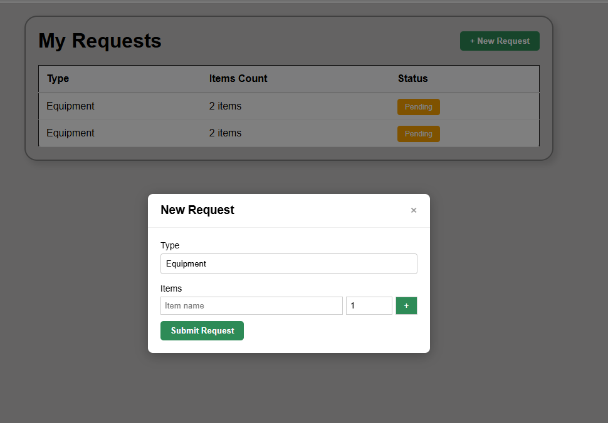

3. **CSS Rules** (in `style.css`):
css
.page { display: none; }
.page.active { display: block; }
body.not-authenticated .role-logged-in { display: none; }
body.authenticated .role-logged-out { display: none; }
.role-admin { display: none; }
body.is-admin .role-admin { display: block; }

4. **Initial Body Class**: `<body class="not-authenticated">`

Phase 2: Client-Side Routing

Implement:

- A global variable: `let currentUser = null;`
- A function `navigateTo(hash)` that updates `window.location.hash`
- A function `handleRouting()` that:
function handleRouting() {
const hash = window.location.hash || '#/';
const pages = ['home-page', 'login-page', 'register-page', 'verify-page', 'profile-page', 'employees-page', 'departments-page', 'accounts-page', 'requests-page'];
pages.forEach(id => { const el = document.getElementById(id); if (el) el.style.display = 'none'; });

if (hash === '#/verify-email') {
const emailDisplay = document.getElementById('verify-email-display');
const email = localStorage.getItem('unverified_email');
if (emailDisplay) emailDisplay.textContent = email || 'your email';
document.getElementById('verify-page').style.display = 'block';
} else if (hash === '#/requests') {
if (!currentUser) { window.location.hash = '#/login'; return; }
renderRequests();
document.getElementById('requests-page').style.display = 'block';
} else if (hash === '#/profile') {
if (!currentUser) { window.location.hash = '#/login'; return; }
renderProfile();
document.getElementById('profile-page').style.display = 'block';
} else if (hash === '#/employees') {
if (!currentUser || currentUser.role !== 'admin') { window.location.hash = '#/'; return; }
populateDepartmentDropdown();
renderEmployeesTable();
document.getElementById('employees-page').style.display = 'block';
} else if (hash === '#/departments') {
if (!currentUser || currentUser.role !== 'admin') { window.location.hash = '#/'; return; }
renderDepartmentsTable();
document.getElementById('departments-page').style.display = 'block';
} else if (hash === '#/accounts') {
if (!currentUser || currentUser.role !== 'admin') { window.location.hash = '#/'; return; }
renderAccountsTable();
document.getElementById('accounts-page').style.display = 'block';
} else if (hash === '#/login') {
document.getElementById('login-page').style.display = 'block';
} else if (hash === '#/register') {
document.getElementById('register-page').style.display = 'block';
} else {
document.getElementById('home-page').style.display = 'block';
}
}

- Reads current hash (e.g., `#/login`)
- Hides all `.page` elements
- Shows the matching page (e.g., `login-page`)
- Redirects unauthenticated users away from protected routes (`#/profile`, etc.)
- Blocks non-admins from admin routes
- Add `hashchange` event listener to call `handleRouting()`
- On page load, set hash to `#/` if empty

> 💡 Test: Type `#/register` in URL → Register form appears.

Phase 3: Authentication System

Build Step-by-Step:

A. **Registration**
- Form with: First Name, Last Name, Email, Password (min 6 chars)
- On submit:
- Check if email already exists
- If not, save new account to `window.db.accounts` with `{ verified: false }`
- Store email in `localStorage.unverified_email`
- Navigate to `#/verify-email`

B. **Email Verification (Simulated)**
- Show message: “Verification sent to [email]”
- Button: “✅ Simulate Email Verification”
- Finds account by `unverified_email`
- Sets `verified: true`
- Saves to storage
- Navigates to login

C. **Login**
- Form: Email + Password
- On submit:
- Find account with matching email, password, and `verified: true`
- If found:
- Save `auth_token = email` in `localStorage`
- Call `setAuthState(true, user)`
- Navigate to profile
- Else: show error

D. **Auth State Management**
- Function `setAuthState(isAuth, user)`:
- Updates `currentUser`
- Toggles `body.authenticated` / `not-authenticated`
- If admin, adds `body.is-admin`

E. **Logout**
- Clear `auth_token` from `localStorage`
- Call `setAuthState(false)`
- Navigate to home

Phase 4: Data Persistence with localStorage

Implement:
- `STORAGE_KEY = 'ipt_demo_v1'`
- `loadFromStorage()`:
- Parses `localStorage[STORAGE_KEY]`
- If missing/corrupt, seeds with:
- One admin account (`admin@example.com`, `Password123!`, `verified: true`)
- Two departments: Engineering, HR
- `saveToStorage()`: stringifies `window.db` and saves
- Call `loadFromStorage()` on init
- After any data change (create/update/delete), call `saveToStorage()`

Phase 5: Profile Page

Build:
- `renderProfile()` function:
- Displays user’s name, email, role
- Shows “Edit Profile” button (can just show alert for now)
- Call this function when navigating to `#/profile`

Phase 6: Admin Features (CRUD)

For Each Admin Section:

A. **Accounts**
- Table: Name, Email, Role, Verified (/—), Actions (Edit, Reset PW, Delete)
- “+ Add Account” opens form (First, Last, Email, Password, Role dropdown, Verified checkbox)
- Edit: pre-fill form
- Reset Password: prompt for new password (min 6 chars)
- Delete: confirm + prevent self-deletion

B. **Departments**
- Table: Name, Description, Actions
- “+ Add Department” → alert (“Not implemented” is OK for now)
- Render list from `window.db.departments`

C. **Employees**
- Table: ID, User (email), Position, Dept (name), Actions
- “+ Add Employee” form:
- Employee ID (text)
- User Email (must match existing account)
- Position
- Department (dropdown populated from departments)
- Hire Date
- On save: link to user ID and dept ID

> Use helper functions like `renderAccountsList()`, `renderEmployeesTable()`

Phase 7: User Requests

Implement:
- “My Requests” page shows only requests where `employeeEmail === currentUser.email`
- “+ New Request” opens modal with:
- Type dropdown (Equipment, Leave, Resources)
- Dynamic item fields (name + qty), with “+” to add more, “×” to remove
- On submit:
- Validate at least one item
- Save request with: `type`, `items[]`, `status: "Pending"`, `date`, `employeeEmail`
- Display requests in a table with status badges (Pending=warning, Approved=success, Rejected=danger)

Phase 8: Testing & Polish

Test Scenarios:
1. Register → verify → login → view profile
2. Log in as admin → create new user → log out → log in as new user
3. Submit a request → see it in “My Requests”
4. Refresh browser → data persists
5. Try accessing `#/employees` as regular user → blocked

Add UX Improvements:
- Toast notifications (`showToast(message, type)`)

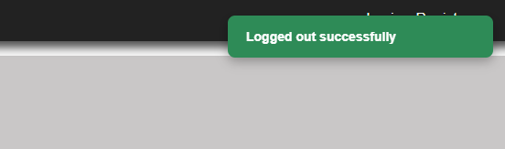
- Form validation feedback
- Loading states (optional)
- Responsive layout (Bootstrap helps!)
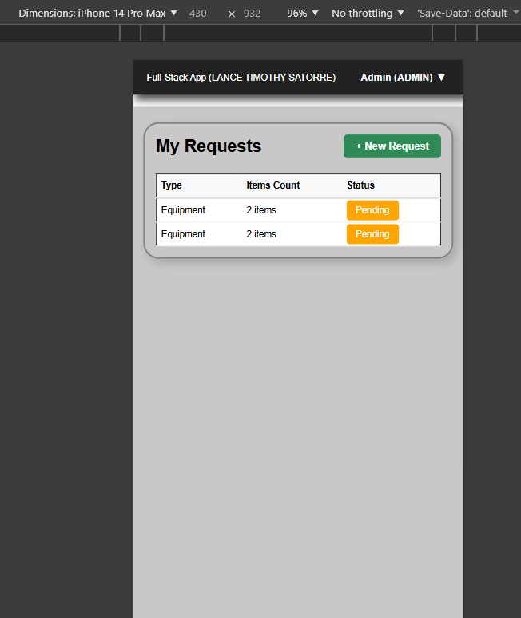

Final Challenge (Optional)

> **Refactor for Maintainability**
> - Move all DOM rendering into separate functions
> - Replace inline event handlers with `addEventListener`
> - Create a simple “router” object to map routes to renderers

Deliverable

By the end, you should have a **fully working single-file app** (`index.html`) that matches the behavior of the prototype—but written entirely by you.

> **Success Criteria**: All features work without errors, data persists across refreshes, and UI respects roles.

Happy coding!
This hands-on build will deeply prepare you for connecting this frontend to a real backend (Node.js + Express + MySQL) next.

