Nightingale
Technical Brief
STATUS  Prototype - verified with limits | BASELINE  HEAD 51a1ce4 + F Final working tree | LAST UPDATED  03 Sep 2026
SCOPE | Synthetic-data prototype for a shared longitudinal care record; not production medical software.

1. Abstract
Nightingale is a shared longitudinal care record that turns fragmented dated notes into one verifiable patient story. Real-world Events remain the Timeline unit; parallel Artifacts preserve raw, AI-scribed, clinician, staff, and patient-facing representations without overwriting one another. Glance surfaces current priorities while every derived statement resolves to an exact source Span.

2. Design principles
- Timeline = what happened. Glance = what matters now. Patient View = what the patient needs to know or do.
- Server-side role, clinic, and patient scope is authoritative; the frontend is never the security boundary.
- AI assists language only. Provider output cannot create authority, bypass safety, or become its own source.

3. Proposed architecture
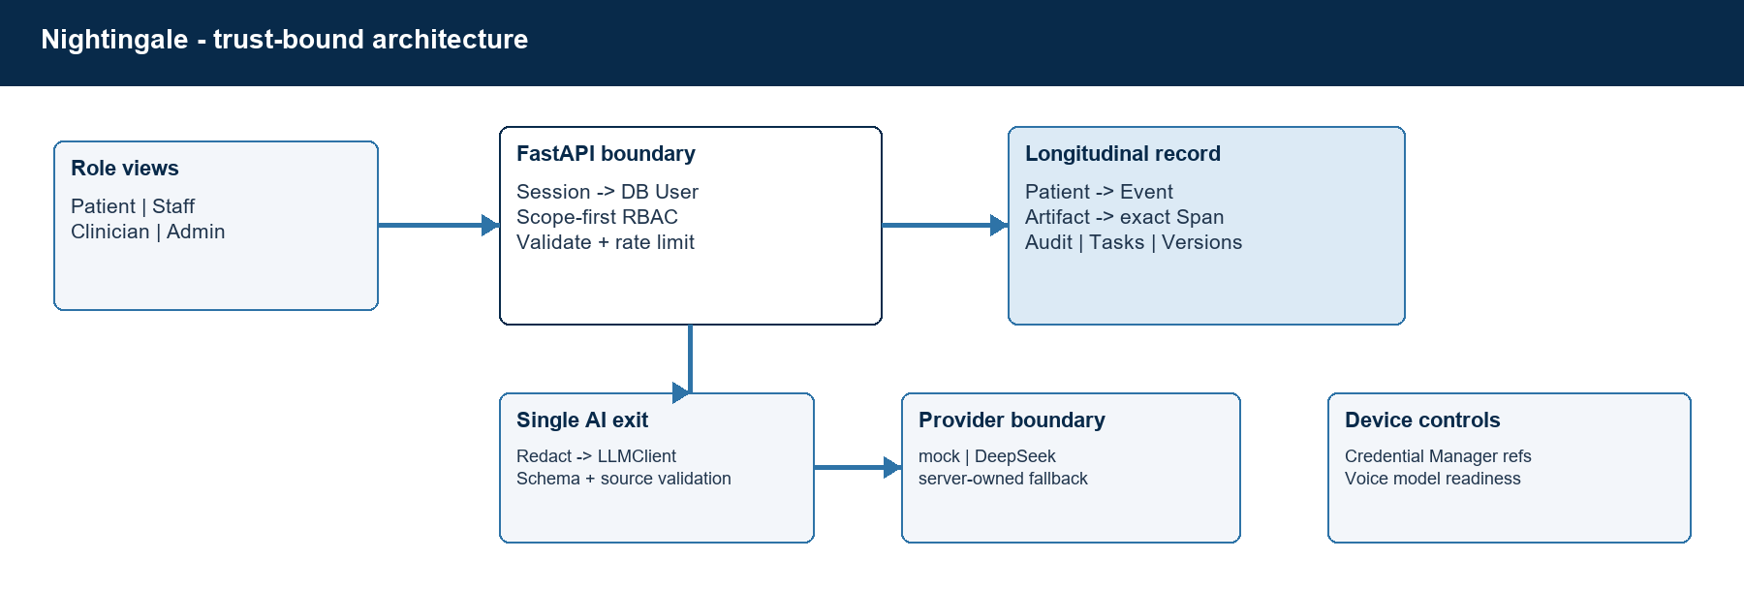
Figure 1. Trust boundaries, durable record, and the single AI egress path.
Authority boundary | The server owns RBAC, safety, state, Task authority, provenance, and limits. AI/patient-derived content never overwrites clinician or staff Artifacts.

4. Data model and provenance
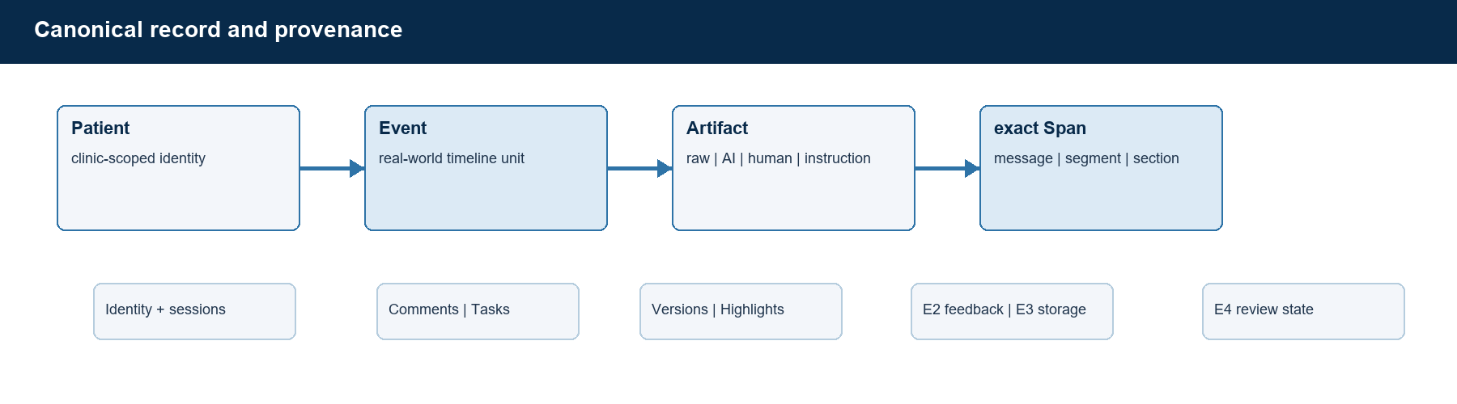
Figure 2. Candidate Brief Entry maps to Event + parallel Artifacts; exact Span is the trust anchor.

5. Role journeys
Role | Primary safe journey
Clinician | Read Glance in under 10 seconds -> inspect exact source -> review Event lifecycle and collaboration.
Staff | Add same-clinic Staff Notes, Nurse Consults, comments, and Tasks without assuming clinician authority.
Patient | Read instructions and Tasks -> complete a bounded raw-first Check-in -> return/correct/confirm safely.

6. RBAC and authority
Role | Can | Cannot
Patient | Own safe view, visible Tasks, own Check-in | Internal notes/comments; other patient; clinical authoring
Staff | Same-clinic staff notes, Nurse Consult, Tasks | Clinician authorship; other clinic
Clinician | Same-clinic review, notes, Copilot | Staff authorship; other clinic
Admin | Identity/session/invite and device settings | Clinical Note, Copilot, Task, or plan authoring

7. Patient Multi-turn Check-in
active | awaiting confirmation | submitted | safety escalated | abandoned
Every patient message is committed first with a stable message_id. At most four clarification questions are allowed. Deterministic safety and medical-request rules run after raw persistence; confirmation creates the formal AI Summary, and every candidate quote must resolve to one patient message or be dropped.

8. Verification status
Capability | Status | Evidence boundary
E1 Role workspaces | IMPLEMENTED_AND_VERIFIED | Role-specific UI, RBAC, scope, and state isolation.
E2 + SL1-SL3 ranking | IMPLEMENTED_WITH_LIMITS | Formal Glance is deterministic base-only; frozen synthetic Shadow models and the observed-feedback bridge do not serve a model.
E3 Data-decay shadow | IMPLEMENTED_AND_VERIFIED | Protection-first shadow payload; not total DB savings.
E4 Voice + consult review | IMPLEMENTED_WITH_LIMITS | Default-off local lifecycle; Doctor confirmation requires three source-review attestations. Real ASR inputs and multilingual clinical validity remain NOT_RUN.
Patient Multi-turn Check-in | IMPLEMENTED_AND_VERIFIED | Raw-first, bounded safety, concurrency, RBAC, exact provenance.
E5 Submission package | REPOSITORY PACKAGE COMPLETE | Repository artifacts exist; external video playback, link access and email delivery remain owner-controlled evidence.

9. Measured evidence
Signal | Observed | Boundary
Backend | 710 passed / 2 skipped | 712 collected; skips require ignored local ASR model/audio inputs. F Final 9/9 passed.
Frontend | Build passed / 112 modules | TypeScript no-emit and Vite production build passed.
Focused regression | 75 safety + 62 learning | Provenance/RBAC/publication/concurrency and SL1/SL2/SL3 Shadow isolation passed.
Glance | Layer B P95 5.115 ms | 100 local samples after 10 warm-ups; target <= 300 ms.

10. Provider, ASR, learning, and security boundary
- Check-in mock and deterministic fallback journeys are verified; DeepSeek live turn succeeded, but the strict final Summary failed validation and fell back.
- D3 live Provider layer is NOT_RUN by design; D4 frozen Copilot evaluation passed with provider=mock.
- E4 is default-off local faster-whisper with no diarization or invented confidence. Doctor Consult confirmation now requires three source-review attestations. A synthetic Malay-English-Hokkien statement passed exact transport and provenance tests; translation, physical microphone, clinical multilingual understanding, and noisy accuracy are NOT_RUN.
- Formal Glance remains deterministic base-only. SL1 records all candidate decisions, SL2 uses frozen synthetic role models in Shadow, and SL3 has no eligible real-feedback model. Names, IC/ID patterns, and phones are redacted before LLM egress; SQLCipher, TLS, metadata-only audit, and Credential Manager references protect the local prototype.

11. Trade-offs
Decision | Why
Deterministic ranking before LLM ranking | Transparent, fast, reproducible, and auditable under a 72-hour prototype constraint.
Shadow learning behind deterministic controls | Complete candidate snapshots, fixed bands, protection, provenance, caps, freeze/replay and rollback permit evaluation without automatic unsafe demotion or a serving claim.

Use footnotes for definitions, assumptions, or terms that need precision without interrupting the main narrative.

