PBrownProject2
  - Data Tidying and Analysis
Precious Brown
IS 362 Data Acquisition and Management
Professor Larry Cohen
October 11, 2026

Purpose and main findings
This project transforms three wide discussion datasets into structures suitable for analysis. The work focuses on reshaping columns into observations, separating combined values, maintaining appropriate measurement units, and checking that the original values are preserved.
The supplied examples identify chicken as the largest meat-sales category, adults as the largest absolute library-service group, teens as the highest relative computer-use group, and Detroit as the basketball team with the largest first-to-last improvement. These conclusions describe the provided examples rather than verified real-world populations.
Dataset | Discussion contributor | Final observation structure
Meat sales | Precious Brown | 15 meat and month rows
Library usage | Joseph Damiano | 12 branch and age rows
Basketball records | Shehou Fisiru | 18 team and season rows

Dataset acknowledgment
I credit Joseph Damiano for the fictional library-usage table and its resource-usage questions, posted October 4, 2026, and Shehou Fisiru for the basketball win/loss table and explanation of its untidy structure, posted October 10, 2026. Both appeared in Discussion 5/6: Untidy Data. Their values are reproduced without substitution. My grocery-store meat example was prepared for the October 4 discussion with ChatGPT assistance.

Files and reproducibility
PBrownProject2.ipynb contains the complete Python workflow and executed outputs for all three datasets. The data folder contains the original wide CSVs; output contains derived CSVs; figures contains the light-purple charts. This Word report summarizes methods, selected transformation code, results, and limitations. All 14 code cells executed successfully, including the validation checks.
No instructor sample data are used. No missing values or duplicate source keys were found. The project does not invent missing years, months, population counts, or analysis questions attributed to classmates.

1 Meat sales preparation
Source: Precious Brown, October 4, 2026 discussion example, drafted with ChatGPT assistance. These are constructed sample values, not audited store records. Question: Which meats sell the most by weight, how does volume change by month, and what cautious inventory observations follow?

Original wide dataset
Meat | January pounds | February pounds | March pounds
Chicken | 850 | 920 | 980
Beef | 640 | 610 | 720
Pork | 420 | 390 | 450
Turkey | 280 | 240 | 260
Lamb | 150 | 170 | 210

Cleanup and transformation
The source has five rows, one for each meat. Months appear as column headings. I rename the identifier, trim text, melt the three month columns into rows, remove the repeated unit phrase from month labels, and store pounds_sold as a nonnegative integer. Month is an ordered category so January, February, and March remain chronological. No year was supplied.
meat = meat_raw.rename(columns={'Type of Meat': 'meat'}).copy()
meat['meat'] = meat['meat'].str.strip()
meat = meat.melt(id_vars='meat', value_vars=month_columns,
var_name='month', value_name='pounds_sold')
meat['month'] = meat['month'].str.replace(' Pounds Sold', '', regex=False)
meat['month'] = pd.Categorical(meat['month'], categories=month_order,
ordered=True)
meat['pounds_sold'] = integer_counts(meat['pounds_sold'])

Tidy structure and validation
Meat | Month | Pounds sold
Beef | January | 640
Beef | February | 610
Beef | March | 720
Chicken | January | 850
Chicken | February | 920
Chicken | March | 980

The final table contains 15 unique meat-month observations. Checks confirm no missing values, no duplicate keys, nonnegative integer counts, and the same total weight before and after reshaping. A pivot back to the original structure checks every one of the 15 values. No rows are dropped and no values are imputed.

1 Meat sales results
Meat | Total pounds | Share percent | Jan to Mar pounds | Jan to Mar percent
Chicken | 2750 | 37.72 | 130 | 15.29
Beef | 1970 | 27.02 | 80 | 12.5
Pork | 1260 | 17.28 | 30 | 7.14
Turkey | 780 | 10.7 | -20 | -7.14
Lamb | 530 | 7.27 | 60 | 40.0

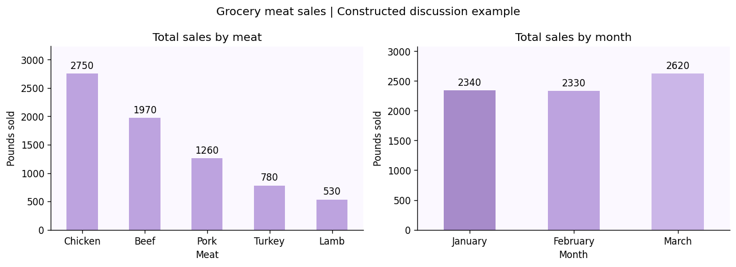
Figure 1. Constructed meat-sales example from Precious Brown.
Chicken totals 2,750 pounds, or 37.72% of all 7,290 pounds sold. Beef is second at 1,970 pounds. Monthly totals are 2,340 in January, 2,330 in February, and 2,620 in March. March is 12.45% above February and 11.97% above January.
Lamb has the largest percentage increase from January to March, 40%, while chicken has the largest absolute increase, 130 pounds. Turkey declines by 20 pounds, or 7.14%. The first monthly change remains missing because there is no preceding month in the dataset.

Inventory interpretation and limits
The sample supports reviewing chicken and beef replenishment first and investigating higher March volume. It does not measure actual waste, profit, unmet demand, seasonality, or future sales. Purchase quantities, stockouts, spoilage, prices, and additional months would be needed to support stocking or waste-reduction decisions.

2 Library usage preparation
Source: Joseph Damiano, Discussion 5/6: Untidy Data, October 4, 2026. Joseph explicitly created fictional monthly values. The observation month and year are unspecified. His proposed analysis compares services across demographics and branches, including relative computer usage and youth or senior usage.

Original wide dataset
Branch | Service | Kids 0 to 12 | Teens 13 to 18 | Adults 19 to 64 | Seniors 65 plus
Downtown | Books Borrowed | 520 | 180 | 940 | 610
Downtown | Computer Sessions | 110 | 320 | 580 | 210
Northside | Books Borrowed | 340 | 115 | 620 | 450
Northside | Computer Sessions | 85 | 210 | 390 | 140
West End | Books Borrowed | 210 | 90 | 430 | 380
West End | Computer Sessions | 45 | 160 | 290 | 95

Reshaping both dimensions
I standardize column names and trim branch and service labels. Melting the four age-group columns creates 24 branch-service-age observations. Pivoting service type then creates two measure columns, books_borrowed and computer_sessions, with 12 branch-age rows. Keeping the service units separate avoids treating books and sessions as interchangeable.
library_long = library_long.melt(
id_vars=['branch', 'service_type'], value_vars=age_columns,
var_name='age_group', value_name='usage_count'
)
library_long['usage_count'] = integer_counts(library_long['usage_count'])
library = library_long.pivot(
index=['branch', 'age_group'], columns='service_type', values='usage_count'
).rename(columns={'Books Borrowed': 'books_borrowed',
'Computer Sessions': 'computer_sessions'}).reset_index()

Tidy structure and validation
Branch | Age group | Books borrowed | Computer sessions
Downtown | Kids (0-12) | 520 | 110
Downtown | Teens (13-18) | 180 | 320
Downtown | Adults (19-64) | 940 | 580
Downtown | Seniors (65+) | 610 | 210

Checks confirm six unique source branch-service rows, 24 unique long observations, and 12 unique final branch-age rows. A round-trip pivot checks every original count. Counts are complete, nonnegative integers; the two expected service types are present. Nothing is deleted or imputed.

2 Library usage results
Age group | Books borrowed | Computer sessions | Sessions per book
Kids (0-12) | 1070 | 240 | 0.224
Teens (13-18) | 385 | 690 | 1.792
Adults (19-64) | 1990 | 1260 | 0.633
Seniors (65+) | 1440 | 445 | 0.309

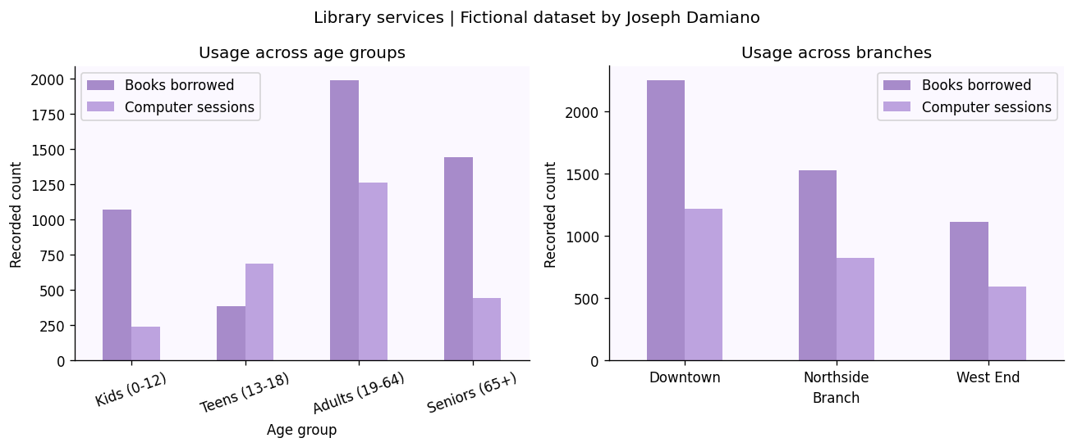
Figure 2. Fictional library-usage dataset credited to Joseph Damiano.
Adults have the largest absolute totals: 1,990 books and 1,260 computer sessions. Teens have the highest ratio, 690 sessions divided by 385 books, or 1.792 sessions per book. This is a transaction ratio, not the proportion of patrons who prefer or depend on computers.
Downtown leads overall with 2,250 books and 1,220 sessions. It also leads youth usage, defined as kids and teens combined, with 700 books and 430 sessions, and senior usage with 610 books and 210 sessions. Northside has 455 youth books and 295 youth sessions; West End has 300 and 205. Senior counts are 450 books and 140 sessions at Northside, and 380 and 95 at West End.

Resource interpretation and limits
The fictional pattern supports examining teen computer access and Downtown service capacity. It cannot identify the largest youth or senior population: repeat use may generate several records per person. Funding decisions also require unique patron counts, branch capacity, hours, costs, wait times, and community needs.

3 Basketball records preparation
Source: Shehou Fisiru, Discussion 5/6: Untidy Data, October 10, 2026. Records are reproduced exactly as posted and are not independently verified NBA statistics. Because the supplied post has no explicit analysis question, this project selects questions about seasonal leaders, changes in wins, and the selected conference groups.

Original wide dataset
Team | Conference | 2023-24 | 2024-25 | 2025-26
New York Knicks | East | 50-32 | 51-31 | 53-29
Boston Celtics | East | 64-18 | 61-21 | 56-26
Detroit Pistons | East | 14-68 | 44-38 | 60-22
Oklahoma City Thunder | West | 57-25 | 68-14 | 64-18
San Antonio Spurs | West | 22-60 | 34-48 | 62-20
Denver Nuggets | West | 57-25 | 50-32 | 54-28

Separate seasons and combined values
Each source row represents a team, while each season cell contains two values. I melt the seasons into one column, validate the wins-losses pattern, split the string, convert wins and losses to integers, and derive games, win percentage, and season start year. Conference remains attached to each team.
basketball = basketball.melt(
id_vars=['team', 'conference'], value_vars=seasons,
var_name='season', value_name='record'
)
assert basketball['record'].str.fullmatch(r'\d+-\d+').all()
parts = basketball['record'].str.split('-', expand=True)
basketball['wins'] = integer_counts(parts[0])
basketball['losses'] = integer_counts(parts[1])
basketball['games'] = basketball['wins'] + basketball['losses']
basketball['win_percent'] = basketball['wins'] / basketball['games'] * 100

Tidy structure and validation
Team | Season | Wins | Losses | Games | Win percent
Boston Celtics | 2023-24 | 64 | 18 | 82 | 78.05
Boston Celtics | 2024-25 | 61 | 21 | 82 | 74.39
Boston Celtics | 2025-26 | 56 | 26 | 82 | 68.29

The final table has 18 unique team-season rows. Every supplied record totals 82 games. Checks cover missing values, conference labels, integer counts, and reconstruction of every original win-loss string. These checks demonstrate internal consistency, not real-world accuracy. The combined record field is removed only after validation.

3 Basketball results
Season | Leading team in sample | Wins | Losses | Win percent
2023-24 | Boston Celtics | 64 | 18 | 78.05
2024-25 | Oklahoma City Thunder | 68 | 14 | 82.93
2025-26 | Oklahoma City Thunder | 64 | 18 | 78.05

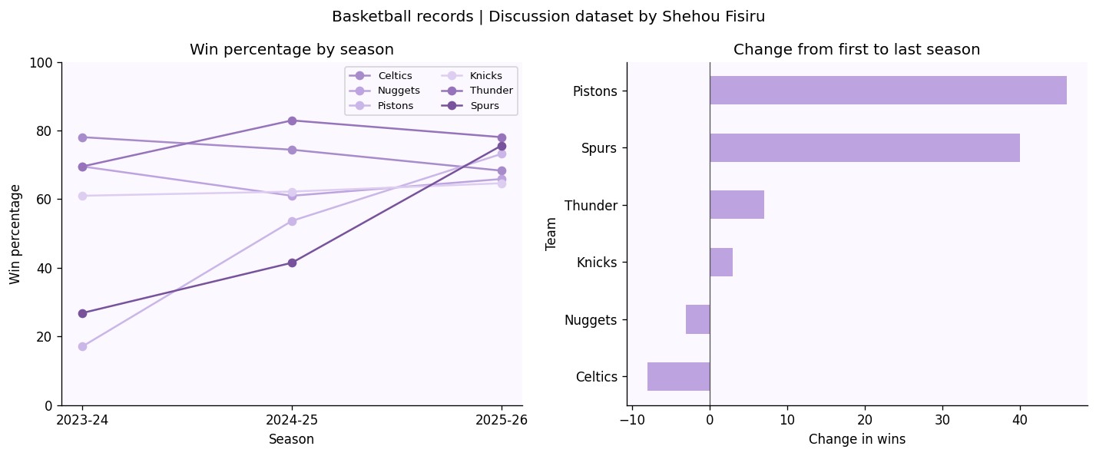
Figure 3. Classmate-provided basketball records credited to Shehou Fisiru.
Boston leads the first season at 78.05%. Oklahoma City leads the second at 82.93% and the third at 78.05%. Detroit has the largest first-to-last improvement, from 14 to 60 wins: 46 additional wins and 56.10 percentage points. San Antonio gains 40 wins, Oklahoma City 7, and New York 3. Boston loses 8 wins and Denver 3.
Season | Selected East win percent | Selected West win percent
2023-24 | 52.03 | 55.28
2024-25 | 63.41 | 61.79
2025-26 | 68.7 | 73.17

These conference comparisons cover only three selected teams per conference. They are not complete conference standings. Percentage-point changes differ from relative percentage growth. The supplied table supports descriptive comparisons but cannot establish why performance changed or verify the records as official results.

Conclusion and source acknowledgment
All three workflows preserve the source values while producing consistent observation structures. Meat sales required melting month columns; library usage required melting age groups and separating service measures; basketball required both melting seasons and splitting composite records. Each workflow checks original values after transformation, rather than relying only on a matching grand total.
The notebook exports 13 derivative tables and three figures without overwriting the original CSVs. Display rounding does not change the underlying calculations. The examples illustrate how reliable structure and explicit assumptions support downstream analysis, while limitations prevent conclusions about waste, populations, or official sports results that the data cannot establish.

Code assistance and contributions
ChatGPT assisted with drafting the original meat example, transcribing the discussion tables, and drafting the Python code, validation checks, explanations, charts, and report. Precious Brown selected the meat-sales topic and the classmates’ datasets, supplied the discussion materials, and requested the light-purple presentation and explicit credits. Joseph Damiano and Shehou Fisiru supplied their respective datasets. This statement does not claim that Precious independently wrote the generated code. Any additional student-written changes should be identified by cell or section before submission, in accordance with the syllabus.
I also created the GitHub repository, uploaded the project materials, and organized the source datasets, figures, and analysis outputs into their designated folders. This established the repository structure expected by the notebook’s relative file paths. These contributions involved project organization and submission preparation; I did not modify the supplied analysis code.

References
Brown, P. (2026, October 4). Grocery-store meat sales example [Course discussion post]. Discussion 5/6: Untidy Data, IS 362, CUNY School of Professional Studies. Constructed example drafted with ChatGPT assistance.
Damiano, J. (2026, October 4). Discussion 5/6: Untidy Data [Course discussion post]. IS 362, CUNY School of Professional Studies. Fictional library-usage dataset and resource-usage questions, supplied as a screenshot.
Fisiru, S. (2026, October 10). Discussion 5/6: Untidy Data [Course discussion post]. IS 362, CUNY School of Professional Studies. Basketball win/loss dataset and explanation of its structure, supplied as screenshot and text.
Cohen, L. (2026). IS 362 Project 2 assignment instructions and course syllabus [Course materials]. CUNY School of Professional Studies. Supplied by the student.
OpenAI. (2026, October 11). ChatGPT assistance with transcription, code, analysis, validation, visualization, and report preparation. See the contribution statement above.
The private course discussion is identified by contributor, date, and title. No public discussion URLs are invented. Submit this Word report and PBrownProject2.ipynb, together with the actual GitHub notebook URL after uploading the project.

