This is a title

Josie Hughes1,✉, Sarah Endicott1, Anna M Calvert1, and Cheryl A Johnson1

16 October, 2024

Abstract

This is an abstract. This is an abstract. This is an abstract.This is an abstract. This is an abstract. This is an abstract.This is an abstract. This is an abstract. This is an abstract.This is an abstract. This is an abstract. This is an abstract.This is an abstract. This is an abstract. This is an abstract.This is an abstract. This is an abstract. This is an abstract.This is an abstract. This is an abstract. This is an abstract.This is an abstract. This is an abstract. This is an abstract.This is an abstract. This is an abstract. This is an abstract.

1 Landscape Science and Technology Division, National Wildlife Research Center, Environment and Climate Change Canada, 1125 Colonel By Dr, Ottawa, ON, K1S 5B6, Canada

✉ Correspondence: [Josie Hughes <[josie.hughes@ec.gc.ca](mailto:josie.hughes@ec.gc.ca)>](mailto:josie.hughes@ec.gc.ca)

Keywords: keyword 1; keyword 2; keyword 3

Highlights: These are the highlights.

# Introduction

*The following shows an example paragraph with citations* The number of species threatened with extinction is high and getting higher (IPBES, 2019). Reliable information on the status of populations and likely impacts of management are needed to inform conservation action, but effective monitoring is challenging and costly (Dunham et al., 2023; Legg and Nagy, 2006; Lindenmayer and Likens, 2018; Wintle et al., 2010).

# Methods

## Caribou population monitoring data and composition survey errors

*This shows some examples of equations in text and in separate blocks*

Given these assumptions and definitions, the sex and bias-corrected recruitment rate $X$ can be written as a function of the observed calf:cow ratio $R$, the cow multiplier $w$, the ratio of young bulls to adult females $q$, and the misidentification probabilities $u$ and $z$ (see Supplement B for details). For simplicity, we combine the probabilities into a bias term $c$ that is integrated into the Bayesian population model and simulations (below):

$$c=\frac{w\left(1+qu−u\right)}{\left(w+qu−u\right)\left(1−z\right)};X=cR/2. \left(1\right)$$

## Anthropogenic disturbance and monitoring scenarios

*This includes and example of how to reference a table and a figure*

In simulated monitoring scenarios, we assume collars are deployed in January, and continue to function for up to 6 years. The target number of collared females $n$ varies among scenarios, as does the total duration of the monitoring program $d$ and the ratio of uncollared to collared adults in the recruitment survey $w$ (Table 1). Collars lost to mortality may be replaced each year ($o=1$), or there may be a 3 year gap between deployments ($o=4$).

Table 1: An example table

|  | mpg | cyl | disp | hp | drat | wt | qsec | vs | am | gear | carb |
| --- | --- | --- | --- | --- | --- | --- | --- | --- | --- | --- | --- |
| Mazda RX4 | 21.0 | 6 | 160 | 110 | 3.90 | 2.620 | 16.46 | 0 | 1 | 4 | 4 |
| Mazda RX4 Wag | 21.0 | 6 | 160 | 110 | 3.90 | 2.875 | 17.02 | 0 | 1 | 4 | 4 |
| Datsun 710 | 22.8 | 4 | 108 | 93 | 3.85 | 2.320 | 18.61 | 1 | 1 | 4 | 1 |
| Hornet 4 Drive | 21.4 | 6 | 258 | 110 | 3.08 | 3.215 | 19.44 | 1 | 0 | 3 | 1 |
| Hornet Sportabout | 18.7 | 8 | 360 | 175 | 3.15 | 3.440 | 17.02 | 0 | 0 | 3 | 2 |
| Valiant | 18.1 | 6 | 225 | 105 | 2.76 | 3.460 | 20.22 | 1 | 0 | 3 | 1 |

We focus on exploring a set of scenarios in which buffered anthropogenic disturbance, measured as the percentage of area within 500 m of some type of anthropogenic disturbance (ECCC, 2011; Johnson et al., 2020), increases by 1% per year (Figure 1).

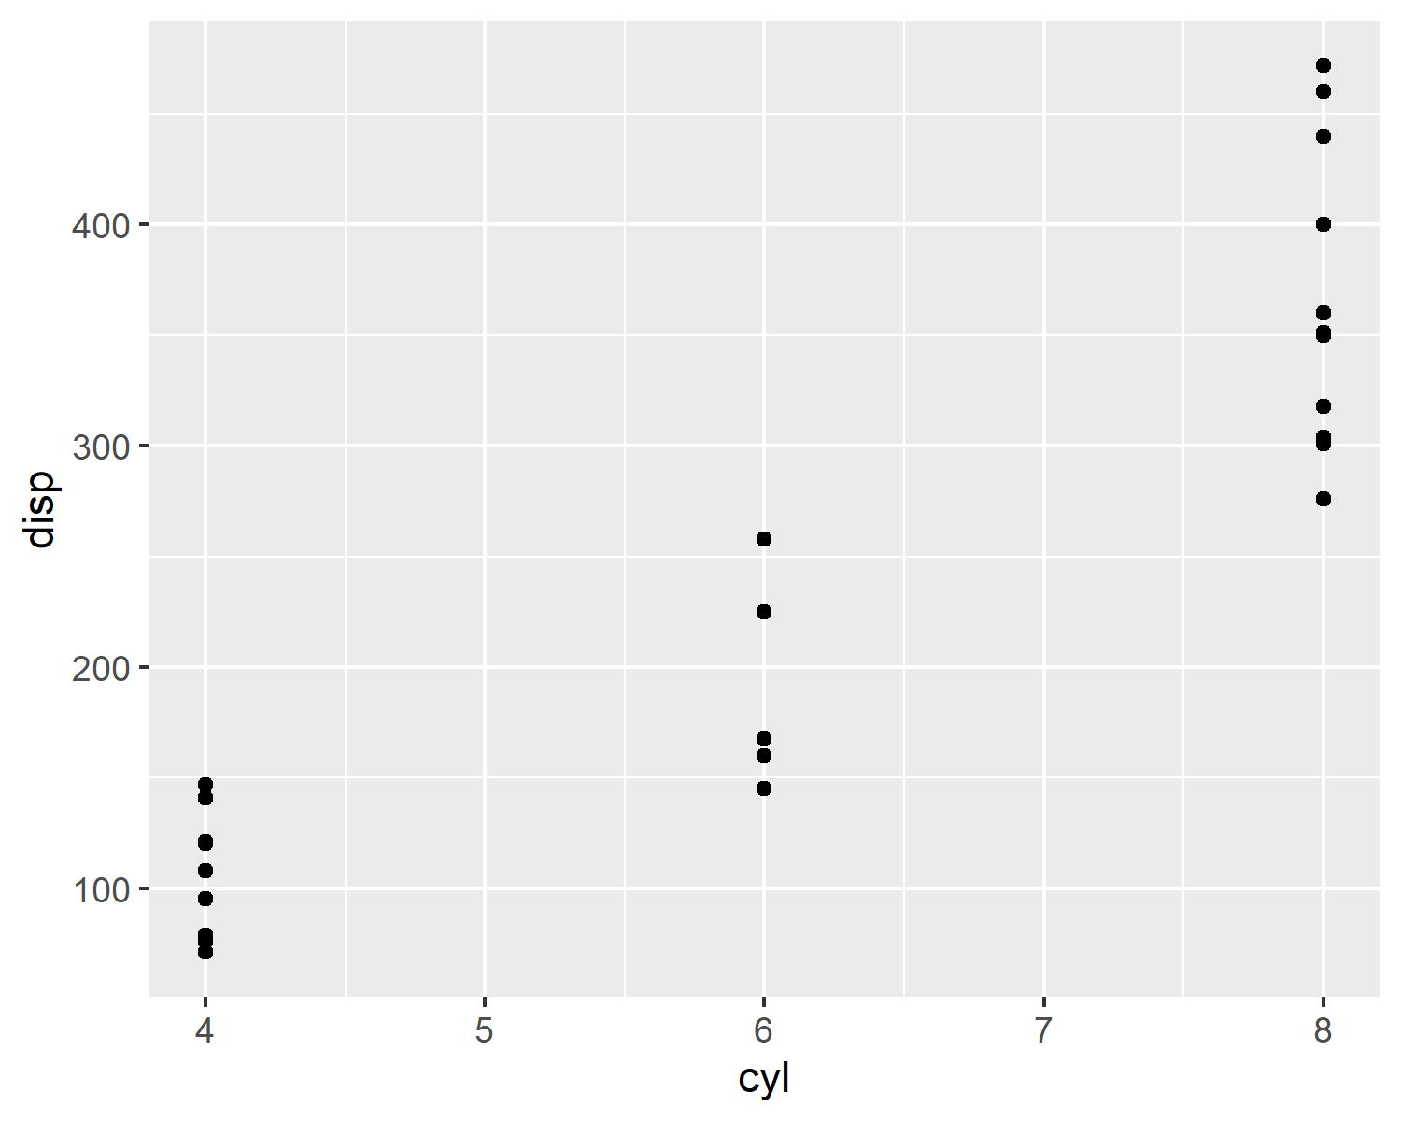

Figure 1: An example figure

# References

Dunham, K.D., Devers, P.K., Lawson, A.J., Lyons, J.E., McGowan, C.P., Royle, J.A., 2023. Strategic monitoring to minimize misclassification errors from conservation status assessments. Biological Conservation 286, 110260. <https://doi.org/10.1016/j.biocon.2023.110260>

ECCC, 2011. [Scientific assessment to inform the identification of critical habitat for woodland caribou (*Rangifer tarandus caribou*), boreal population, in Canada.](http://epe.lac-bac.gc.ca/100/200/301/environment_can/2011/scientific_assessment_inform-ef/CW66-296-2011-eng.pdf) Envrionment and Climate Change Canada, Ottawa.

IPBES, 2019. Global assessment report on biodiversity and ecosystem services of the Intergovernmental Science-Policy Platform on Biodiversity and Ecosystem Services, in: Brondízio, E.S., Settele, J., Díaz, S., Ngo, H.T. (Eds.), Global Assessment Report on Biodiversity and Ecosystem Services of the Intergovernmental Science-Policy Platform on Biodiversity and Ecosystem Services. IPBES secretariat, Bonn, Germany. <https://doi.org/10.5281/zenodo.6417333>

Johnson, C.A., Sutherland, G.D., Neave, E., Leblond, M., Kirby, P., Superbie, C., McLoughlin, P.D., 2020. Science to inform policy: Linking population dynamics to habitat for a threatened species in Canada. Journal of Applied Ecology 57, 1314–1327. <https://doi.org/10.1111/1365-2664.13637>

Legg, C.J., Nagy, L., 2006. Why most conservation monitoring is, but need not be, a waste of time. Journal of Environmental Management 78, 194–199. <https://doi.org/10.1016/j.jenvman.2005.04.016>

Lindenmayer, D., Likens, G., 2018. Effective Ecological Monitoring. Csiro Publishing.

Wintle, B.A., Runge, M.C., Bekessy, S.A., 2010. Allocating monitoring effort in the face of unknown unknowns. Ecology Letters 13, 1325–1337. <https://doi.org/10.1111/j.1461-0248.2010.01514.x>

### Colophon

This report was generated on 2024-10-16 14:57:07.874545 using the following computational environment and dependencies:

The current Git commit details are: