Group 5
STAR SCHEMA RE-DESIGN DOCUMENTATION
1. Issues we had with previous version of star schema:
- Had both “ShipDate” and “ShipDateKey”
- Why store the same information twice?
- “TimeKey” for minute-level time tracking
- Orders don't need this granularity (hours/minutes irrelevant)
- Breaks traceability
- Origin/Destination requires warehouse assignments
- Your MongoDB may not have this data
- Missing calculated metrics
- Complex location dimension
- Unnecessary TimeKey
- Inventory snapshots don't need minute-level tracking
- Daily snapshots are sufficient
- When was this inventory counted?
- Need to track historical inventory levels
- Just storing values, not calculating anything useful
- Need reorder alerts, stock status
- No "on-time delivery" flag
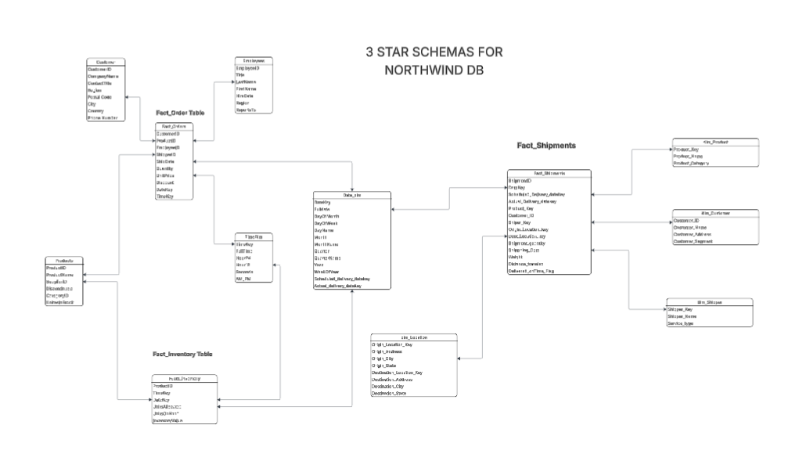
Figure 1: Previous version
Before Fact tables and dimensions: dim_customer, dim_date, dim_employee, dim_location, dim_shipper, dim_time, dim_product, fact_orders, fact_shipment, and fact_inventory.
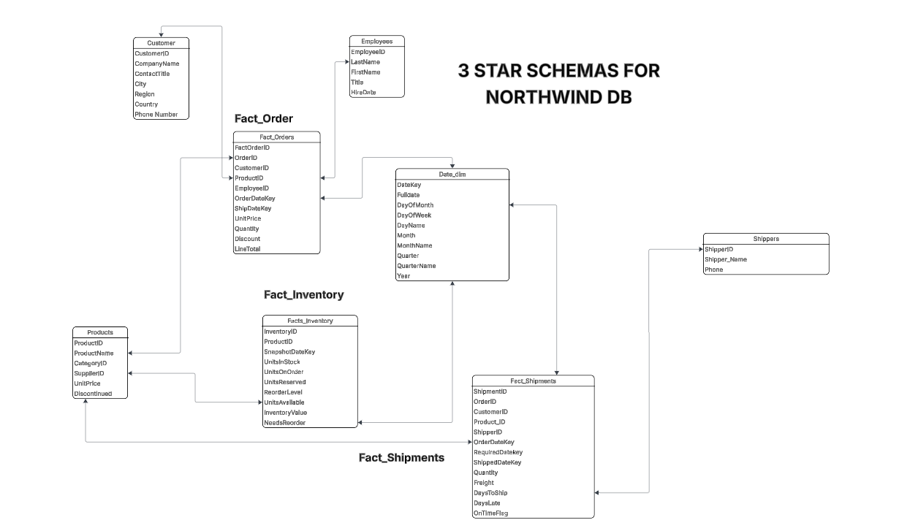
Figure 2: Redesigns
After Re-design: Fact_orders, fact_shipments, fact_inventory, customer, date_dim, employees, products and shippers’ dimensions.
2. New Star schema Design
1. Removed complex location dimension
2. Added shipping performance metrics
3. Added on-time delivery tracking
4. Shipper performance analysis
5. On-time delivery rates
6. Shipping cost analysis
7. Customer delivery experience
8. Identify problematic routes/shippers

The questions we answered:
- Which shipper is fastest?
- Which shipper has best on-time %?
- Which customers get late deliveries?
- How much does express shipping cost vs standard?
- Stock level monitoring
- Reorder point alerts
- Stockout analysis
- Overstock identification
- Which products need reordering?
- What's our total inventory value?
- Which products are out of stock?
- Historical inventory trends
- Slow-moving vs fast-moving products

Merging DB

Business Questions Answered:
- Which employees drive most revenue? (Performance + Sales)
- Are we paying competitively? (Compensation vs Performance)
- Does training improve performance? (Training ROI)
- Who should be promoted? (Performance + Tenure)
- Salary cost as % of revenue? (Compensation vs Sales)

New HR Fact Tables:
Fact_EmployeePerformance (~108 records)
- Monthly metrics per employee
- Sales, orders, customer satisfaction
- Links to NorthwindDW.Fact_Orders via EmployeeID
Fact_EmployeeCompensation (~27 records)
- Salary history
- Raises, bonuses, commissions
- Total compensation tracking
Fact_EmployeeTraining (~36 records)
- Training programs completed
- Cost and duration
- Performance improvement (before/after)

