**Documentation/Instruction**

**HOW TO RUN/PLAY**

Compile

Server - javac -d bin -cp src src/dod/Program.java

GUI - javac -d bin -cp src src/playerGUI.java

RUN

Server - java -cp bin dod.Program [map filename] (map name optional) (port is 55679)

GUI - java -cp bin playerGUI

**RULES**

Icons

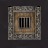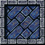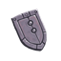

Empty Tile Wall Gold Tile Exit Tile

YOU Potion Scroll of Sight Shield Sword Other Player

Use the N,E,S,W Buttons to move in said direction

Use the Pickup Button to pick up the Item on the Current Tile

Use the End Turn Button to End your Turn before you AP = 0 .

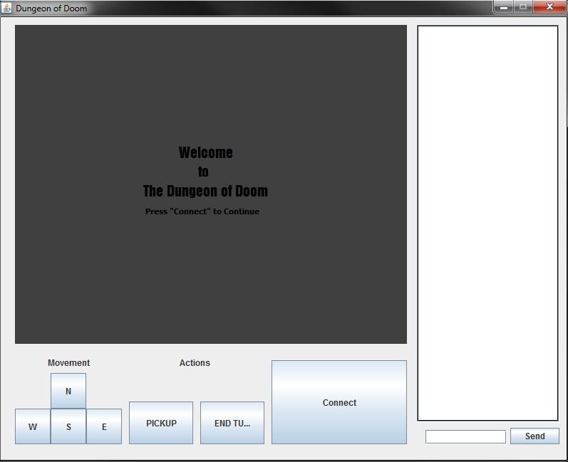**Final GUI Design**

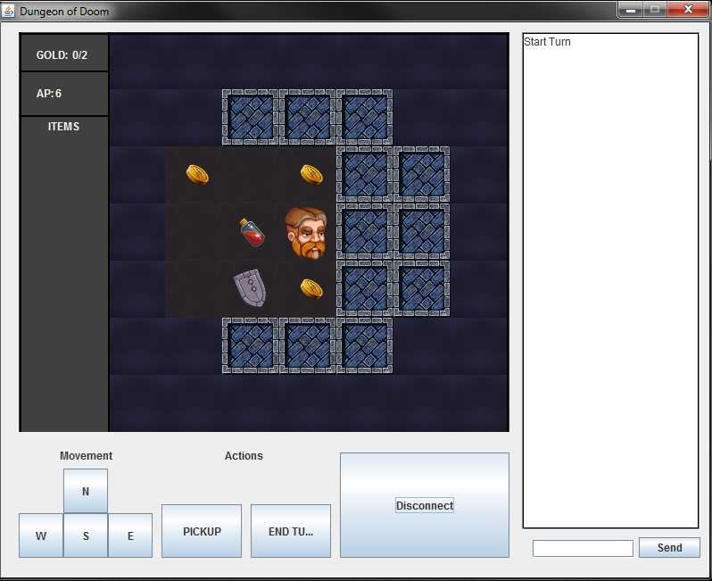

Map

Player Information

Player GUI when you have connected to a Server

PlayerGUI when you first Launch it

Graphics Pane

Chat Box

Buttons