Environment Setup
How to Install The Tools 1
Install with Docker (Recommended method) 1
Videos 1
Steps 1
Installing Without Docker on Ubuntu 22.04 (Advanced Users) 3
Use the Installation Script to Install all Tools 3
Checking your install 4
Next: Getting started with GLayout 4

How to Install The Tools
The below steps will install many tools you can use to get started with open-source design including:
- Yosys
- GF180 PDK
- SKY130 PDK
- Magic
- Netgen
- Openroad
- Klayout
- Ngspice
- OpenFASOC

Install with Docker (Recommended method)
The easiest way to install the tools is using Docker.

Videos
The following videos will guide you through the process of installing and using Docker on various platforms.
- Mac: Mac: Install Open Source Design Tools
- Ubuntu Linux (you will need the docker install steps for your distro, see links below): Linux: Install Open Source Design Tools

Steps
Docker is cross-platform and installable anywhere. The installation process for Docker varies based on the platform you are using. Please follow the specific instructions for your platform:
  - Install Docker on Mac
  - Install Docker on Linux (select your OS below)
    - CentOS
    - Ubuntu
    - Fedora
    - Debian
    - Red-Hat
- Install git so that you can get the docker image
  - Installation is platform dependent, you can see the steps here
- Once docker and git are installed, clone the OpenFASOC repository
git clone https://github.com/idea-fasoc/OpenFASOC.git
- Navigate to the docker folder
cd OpenFASOC/docker/conda
- Mac only, edit “~/.docker/config.json” to remove the line “credsStore” : “desktop”
- Build and run the Docker container
Linux/WSL
sudo docker build -t openfasoc:glayout .
cd ../../
sudo docker run -v $(pwd):$(pwd) -w $(pwd) --name glayoutcontainer -it openfasoc:glayout
pip install -r requirements.txt
pip install gdstk prettyprint
Mac
sudo docker build -t openfasoc:glayout . --platform=”linux/amd64”
cd ../../
sudo docker run -v $(pwd):$(pwd) -w $(pwd) --name glayoutcontainer -it openfasoc:glayout
pip install -r requirements.txt
pip install gdstk prettyprint

Optional: for running graphical applications (such as klayout) in the docker container
- Port graphical applications in docker (so you can run klayout inside the docker container)
  - Mac
    - Visit https://www.xquartz.org/ and download the “Quick Download” file
    - Once the package is installed, run the installer
    - Reboot your computer after xquartz is installed
    - Launch the xquartz application
      - Type in “xhost 127.0.0.1”
    - Go to xquartz preferences > Security and check these options
​​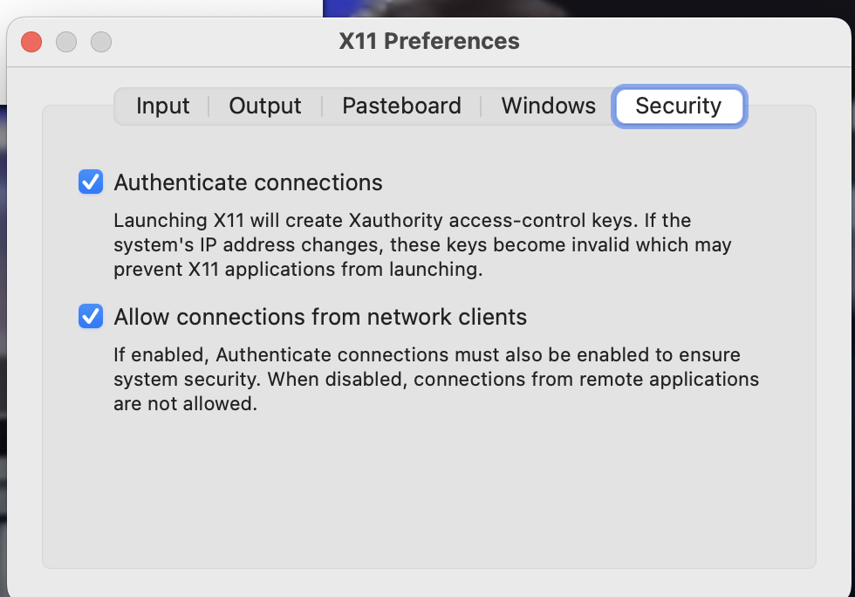
    - Open the docker application and start the container, copy the container id
  - Linux/WSL
    - Open a terminal and run “xhost +Local:*”
- Open the Docker Container (the following commands create a new container from the image)
Linux
sudo docker run -v $(pwd):$(pwd) -w $(pwd) -e DISPLAY -v /temp/.X11-unix:/tmp/.X11-unix --net=host -it --name glayoutcontainer openfasoc:glayout
WSL
docker run -it -v /tmp/.X11-unix:/tmp/.X11-unix -v /mnt/wslg:/mnt/wslg -v $(pwd):$(pwd) -w $(pwd) -e DISPLAY -e WAYLAND_DISPLAY -e XDG_RUNTIME_DIR -e PULSE_SERVER --name glayoutcontainer openfasoc:glayout
Mac
open -a xquartz
sudo docker run --env=DISPLAY=host.docker.internal:0 -v $(pwd):$(pwd) -w $(pwd) -it --name glayoutcontainer openfasoc:glayout

Miscellaneous Docker Commands -
- To remove the container, run the command: docker container rm glayoutcontainer
- To restart the container, run the command docker container restart glayoutcontainer
- To execute a running container, first check its status by running
  - docker container ls -a
  - docker exec -it glayoutcontainer bash (if glayoutcontainer is running) (-it runs the container in interactive mode)
Note: ‘exit’ in a running docker container halts all running processes and stops. A graceful shutdown can be achieved by using docker stop glayoutcontainer

Installing Without Docker on Ubuntu 22.04 (Advanced Users)
Note, We recommend using Docker as this method has not been tested on different platforms.

Use the Installation Script to Install all Tools
Note: Only tested on Ubuntu 22 and Centos 7
Run the following commands to clone and run the dependencies script.

express install
sudo apt-get install git
git clone https://github.com/idea-fasoc/OpenFASOC.git
cd OpenFASOC
chmod +x dependencies.sh
sudo ./dependencies.sh
# install glayout to system python
python3 -m pip install glayout
The express install installs the PDKs in /home/{username}/miniconda3/share/pdk

Checking your install
Once the install is complete, you can check your install by running the following command
Check Install
# assuming you are in the OpenFASOC directory
cd openfasoc/generators/glayout
python3 test_glayout.py
This script will test if:
- The python version meets requirements (3.10 or newer)
- The conda packages have been installed
- The PDKs sky130 or gf180 have been installed and are in their expected locations
- Python packages have been properly installed
- glayout is working as required. The script:
  - places an nmos component
  - runs a Layout-vs-Schematic check on it

Installing KLive
- Run your container using a previously described run command (Step 8 of Install with Docker)
- Run KLayout by just typing “klayout” in the docker container
- Install KLive
  - Go to Tools -> Manage Packages -> Install New Packages -> Search
  - Search for KLive
  - Install the package that looks like this:
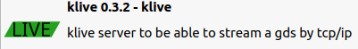
- Once it's installed, on your host system. Type in “docker ps -a”. This will list all of your running containers. Copy the container ID of the most recently started one or the one you installed klive
- Enter the command “docker commit <container id> openfasoc:glayout

Common Issues
- “Conflict. The container name ‘/glayoutcontainer’. is already in use by container…”?
Remove the container with docker rm <container id> or start the container again with docker start <container id>. It is up to you to decide whether to reuse or remove and run a container. Going with the latter will give you the option to mount folders in your host system.

- WSL:
Error cannot connect to Docker daemon at unix:///var/run/docker.sock …

  - Select one after running this command:
sudo update-alternatives –config iptables
  - Start the docker daemon
sudo service docker start
  - Check the status of the docker daemon
sudo service docker status

- Info: Could not load the Qt platform plugin "xcb" in "" even though it was found.
Fatal: This application failed to start because no Qt platform plugin could be initialized. Reinstalling the application may fix this problem.

MacOS: Make sure you follow all of the steps within Step 7 and 8 in this document. When you run the container make sure it has the argument --env=DISPLAY=host.docker.internal:0

All other systems: Make sure you run the corresponding run command provided in step 8 of this document with the relevant command line arguments.

- Getting a bunch of E: Unable to locate package errors within your container?

  - First reboot your computer.
  - Reinstall the Docker engine on Linux or Mac
  - Run these commands:
docker stop $(sudo docker ps -aq)
docker container prune
docker image prune
sudo docker builder prune --all
  - Restart the building process

Next: Coding with GLayout
Now that the tools are installed, please go through the doc to start coding with GLayout and contributing:
Contributing and Coding Documentation

