FDD and Use Case: panel review sheet
Version 2 of the Functional Decomposition Diagram (FDD) for the panel to check against how TaraBasa AI really works. Written 20 October 2026. The picture below is the review version: green is new, amber is updated, blue is unchanged from version 29. The manuscript version of each figure is one colour.
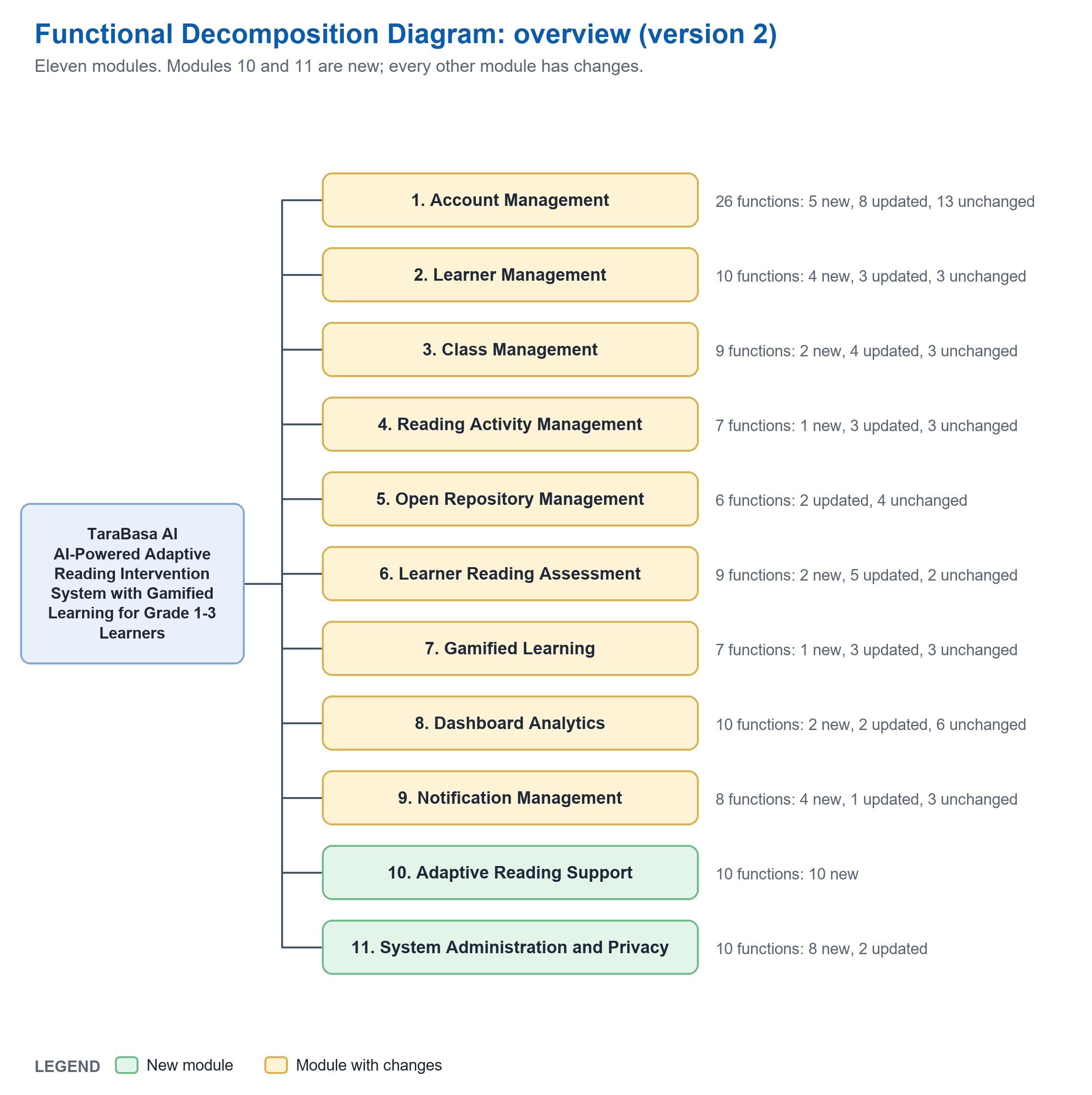
Version 29 has 9 modules and 80 functions. Version 2 has 11 modules and 112 functions: 39 new, 33 updated, 40 unchanged. Seven functions of version 29 were merged into others (listed below). The use case diagrams are drawn from the same list, so each use case is a function of the FDD.

Questions for the panel
Each line is something the system does today that differs from the original plan or from the actor prompts. Please mark each one.
No. | Statement about the flow | Shown in | Agree | Change | Comment
1 | 'AI' in TaraBasa means a speech recognition service plus written rules and a formula service. No model was trained. Is that acceptable for the title 'AI-powered adaptive reading intervention'? | Chapter 1 scope; Figure 9; Table 7
2 | One class holds one grade only, even for a teacher who handles several grades (a DepEd multigrade class is not modelled). | Figure 4.2; Module 3
3 | A reading step moves only after 3 strong readings (90 percent or more) of at least 2 activities, or after 2 weak readings (under 70) in a row, and only one step. | Figure 3.3; Table 7
4 | A Parent cannot start a child's reading. A child reads only after signing in with the PIN. | Figure 5.2; Module 6
5 | A teacher who is not yet approved can sign in with limited access (view only, 2 free AI drafts) after confirming the email. | Figure 4.1; Module 1
6 | Only Parents browse the Open Repository; Teachers only share. The payment is simulated; no real money is handled. | Figure 4.3, 5.2; Module 5
7 | The Admin works on the website only and has Overview, Approvals, Accounts, System health and Activity log. There is no AI configuration screen, no announcements and no admin reports. | Figure 6.1; Module 11
8 | There is no SMS. Parents and teachers see updates in the app and the website. The digital equity goal (parents without smartphones) becomes future work. | Chapter 3 network; Module 9
9 | The first reading check starts where the Parent's profile says the child is, not at the grade, and has at most 3 items. | Figure 3.2; Table 7
10 | Practice Games are free play: they never change points, streak or reading step. | Figure 3.4; Module 7
11 | Linking an existing child needs the child's PIN as well as the code (the original actor prompt asked for the code only). | Figure 5.1; Module 2
12 | A parent or teacher can delete their own account, and a parent can delete a child, without anyone's approval (Data Privacy Act). | Figure 5.1; Module 1, 2, 11

Order of the modules. In version 29 the FDD figure lists Reading Assessment fifth, Gamified Learning sixth and Open Repository seventh, but the List of Modules numbers Open Repository 5, Reading Assessment 6 and Gamified Learning 7. Version 2 uses the List of Modules numbers in both.

From version 29 to version 2
Version 29 | Version 2 | What changed
Module 1 Account Management (27 functions) | Module 1 (26 functions) | Email must be confirmed; card or code and PIN for learners; Google sign in; grade change request; self deletion. The Admin's 6 account functions moved to Module 11.
Module 2 Learner Management (6) | Module 2 (10) | Check-digit Learner Code, QR card, PIN reset, removing a child, profile details.
Module 3 Class Management (7) | Module 3 (9) | One grade per class, QR add with a check, reading groups, learner profile, moving a learner.
Module 4 Reading Activity (6) | Module 4 (7) | Levels per request, background writing, writing for a class, placing in levels, fit check.
Module 5 Open Repository (6) | Module 5 (6) | Best match first; payment simulated.
Module 6 Learner Reading Assessment (10) | Module 6 (9) | Placement and diagnostic became one first reading check; warm-up and practice added; result and feedback merged.
Module 7 Gamified Learning (6) | Module 7 (7) | 100 badges, day streak, four games, text size.
Module 8 Dashboard Analytics (8) | Module 8 (10) | 'Did it work?', class report, plain-language progress.
Module 9 Notification Management (4) | Module 9 (8) | Alerts from readings, one-tap suggested activity, handled, emails (no SMS).
(none) | Module 10 Adaptive Reading Support (10, all new) | The rules and services the system applies to each reading.
(Admin part of Module 1) | Module 11 System Administration and Privacy (10) | Approvals, grade requests, accounts, deletion, system health, activity log.

Functions of version 29 that were merged or renamed:
In version 29 | In version 2
Manage user accounts; Deactivate account | Deactivate or reactivate account (Module 11)
View pending teacher accounts; Verify employee ID; Activate teacher account; Reject teacher account | Approve or reject teacher (with reason) (Module 11)
Take placement assessment; Take diagnostic assessment | Take first reading check (Module 6)
Start adaptive recommended activity; Start reading activity | Start recommended or other activity (Module 6)
View reading feedback; View assessment result | View result and word review (Module 6)
View adaptive learning progress | View reading path and progress (Module 6)
Verify email | Confirm email by link (Module 1)

Module by module (every function, with its status)

Module 1: Account Management (UPDATED)
Email must be confirmed before sign in; learners sign in by card or code; people can delete their own account. Admin work moved to Module 11.
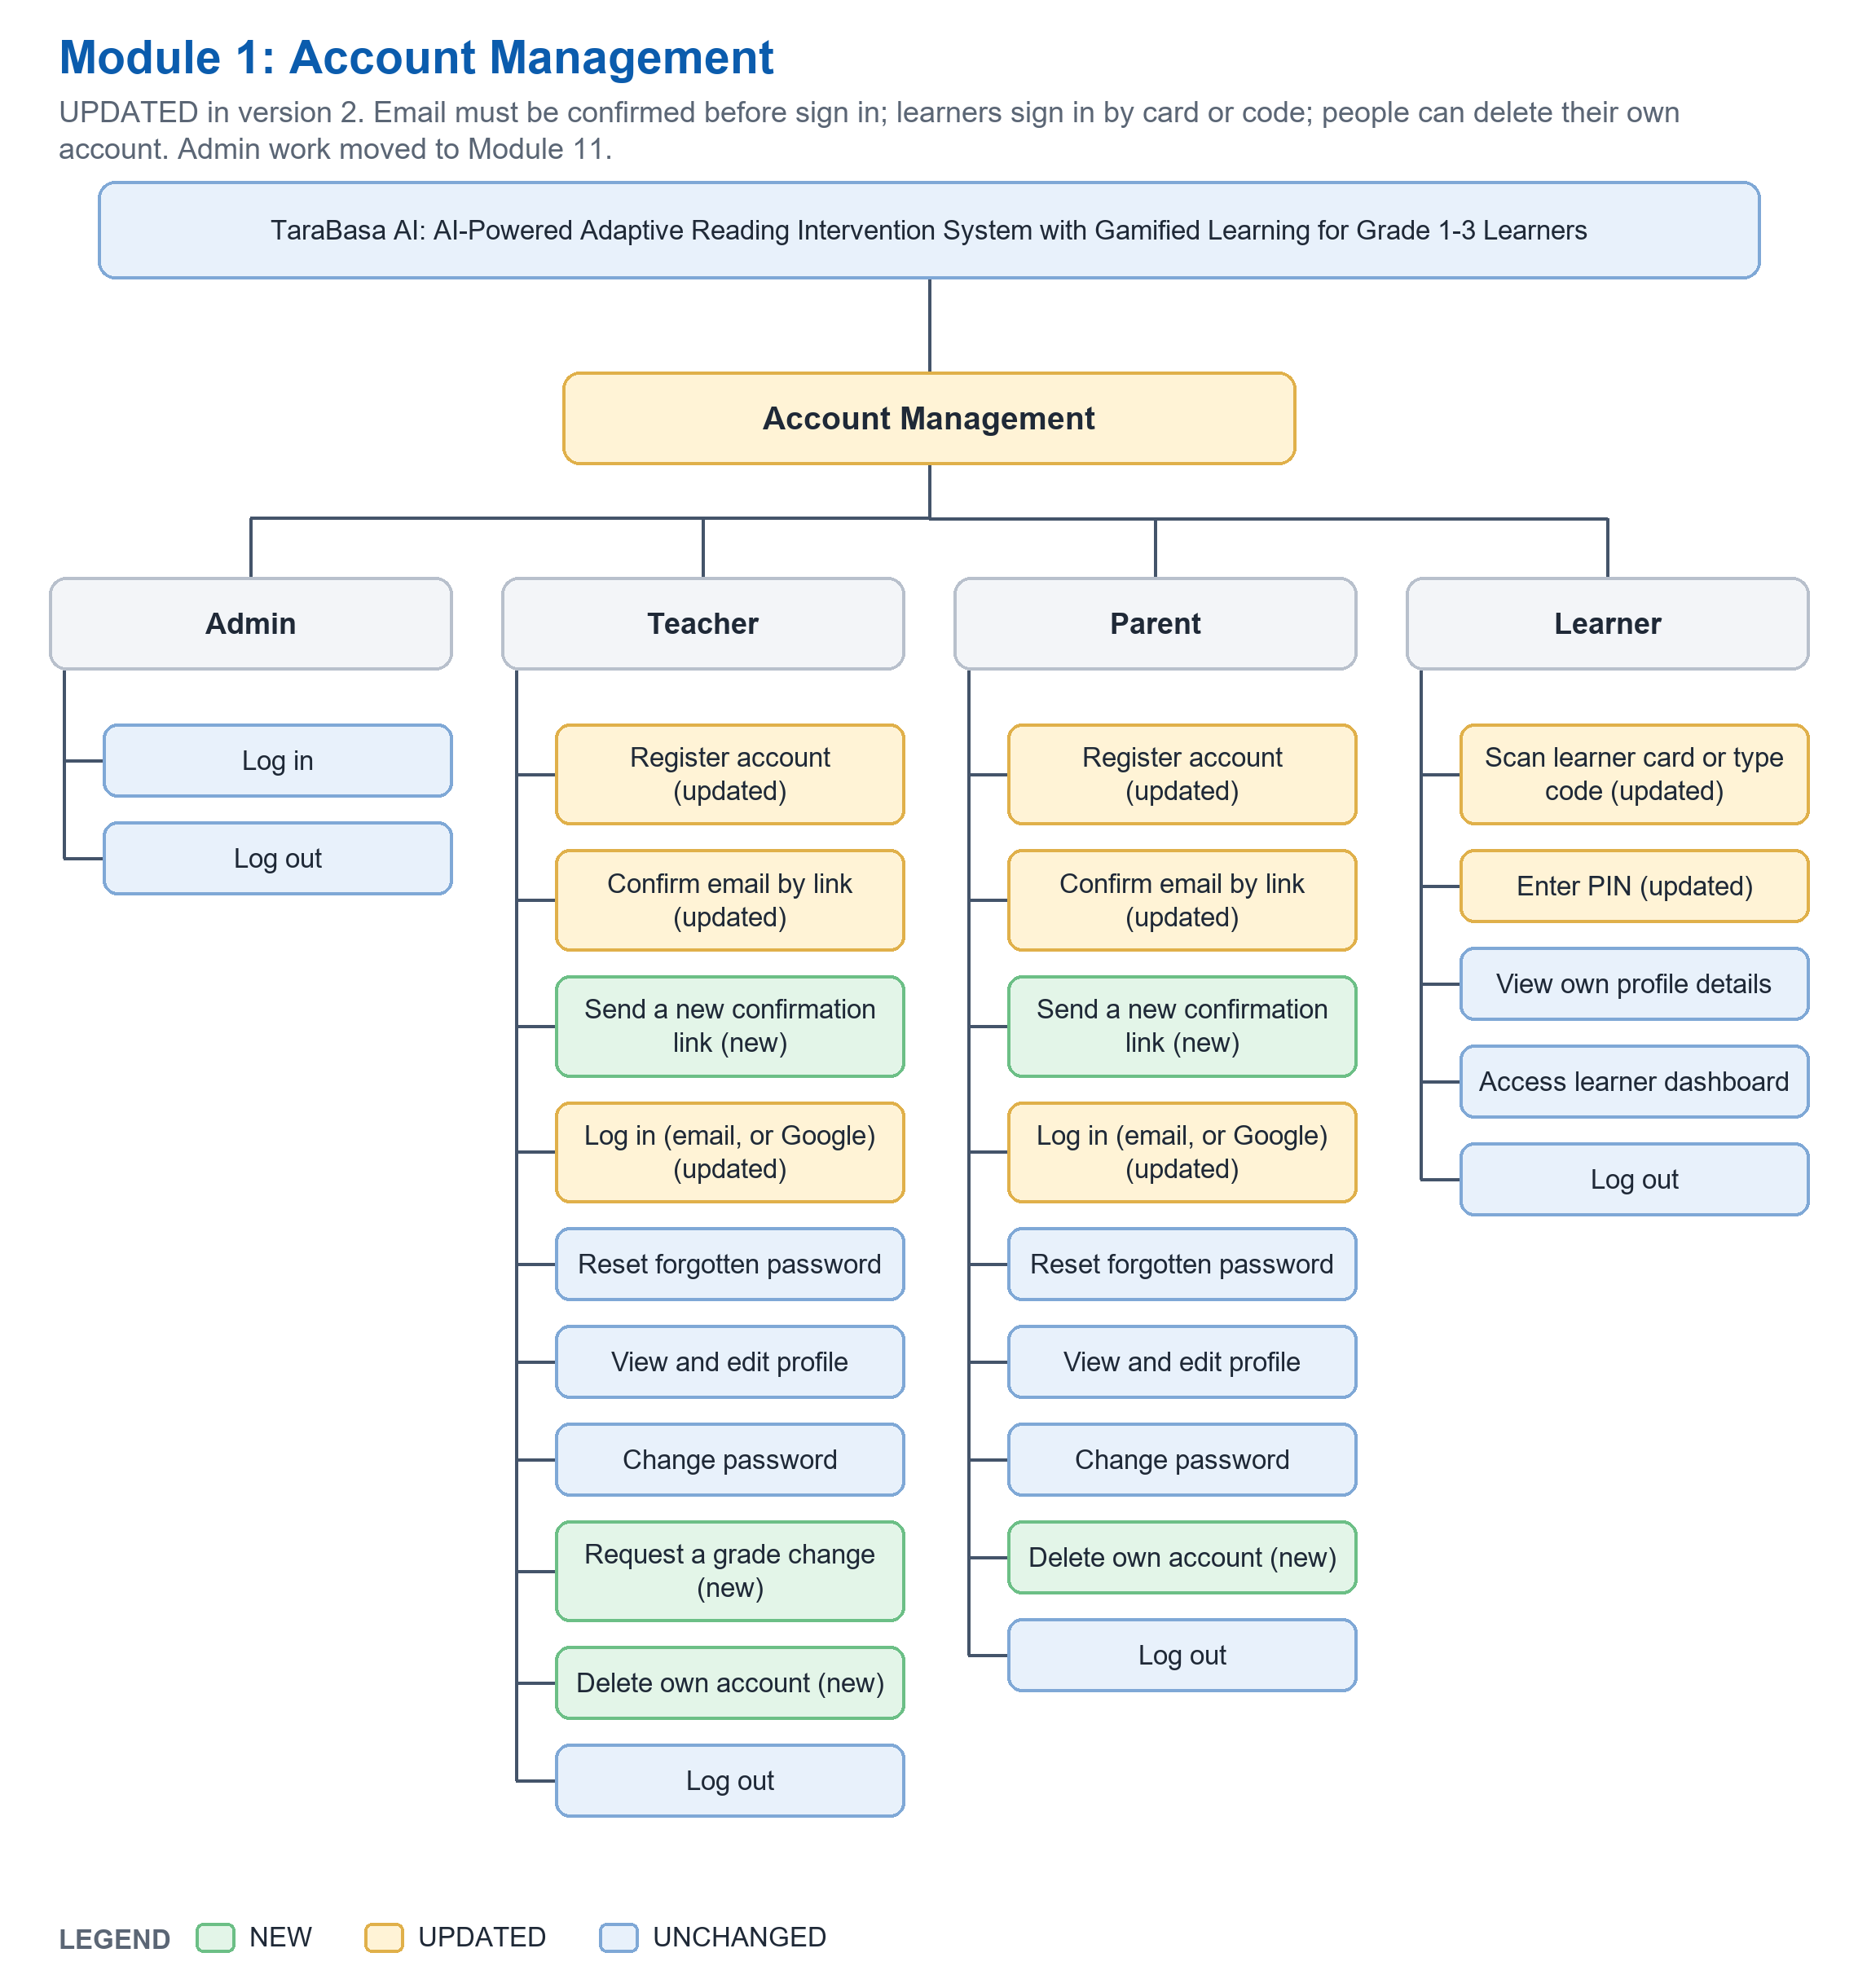
Actor | Function | Status | What is different from version 29
Admin | Log in | UNCHANGED
Admin | Log out | UNCHANGED
Teacher | Register account | UPDATED | Name is First, Middle initial, Last; the email domain is checked and a typo hint is shown; the account starts unconfirmed.
Teacher | Confirm email by link | UPDATED | v29 said 'Verify email'. Now sign in is refused until the link is opened (it lasts 60 minutes; a wrong or old link offers a new one).
Teacher | Send a new confirmation link | NEW | One send a minute for each account; the answer is the same for every address.
Teacher | Log in (email, or Google) | UPDATED | Role checks; five wrong tries then a pause; rejected or deactivated accounts get a message; Google sign in on the website.
Teacher | Reset forgotten password | UNCHANGED
Teacher | View and edit profile | UNCHANGED
Teacher | Change password | UNCHANGED
Teacher | Request a grade change | NEW | Adding a grade waits for the Admin (the teacher names who at school can confirm it); taking one away is immediate.
Teacher | Delete own account | NEW | Needs the password; removes the children that only this parent guards.
Teacher | Log out | UNCHANGED
Parent | Register account | UPDATED | Name is First, Middle initial, Last; the email domain is checked and a typo hint is shown; the account starts unconfirmed.
Parent | Confirm email by link | UPDATED | v29 said 'Verify email'. Now sign in is refused until the link is opened (it lasts 60 minutes; a wrong or old link offers a new one).
Parent | Send a new confirmation link | NEW | One send a minute for each account; the answer is the same for every address.
Parent | Log in (email, or Google) | UPDATED | Role checks; five wrong tries then a pause; rejected or deactivated accounts get a message; Google sign in on the website.
Parent | Reset forgotten password | UNCHANGED
Parent | View and edit profile | UNCHANGED
Parent | Change password | UNCHANGED
Parent | Delete own account | NEW | Needs the password; removes the children that only this parent guards.
Parent | Log out | UNCHANGED
Learner | Scan learner card or type code | UPDATED | v29: enter the code. Now the QR on the printed card can be scanned; the QR holds only the code.
Learner | Enter PIN | UPDATED | 4 digits; 5 wrong tries lock for 15 minutes and the parent is told.
Learner | View own profile details | UNCHANGED
Learner | Access learner dashboard | UNCHANGED
Learner | Log out | UNCHANGED

Module 2: Learner Management (UPDATED)
Learner Code has a check digit and a printed QR card; a Parent can reset a forgotten PIN and remove a child; more profile details are kept.
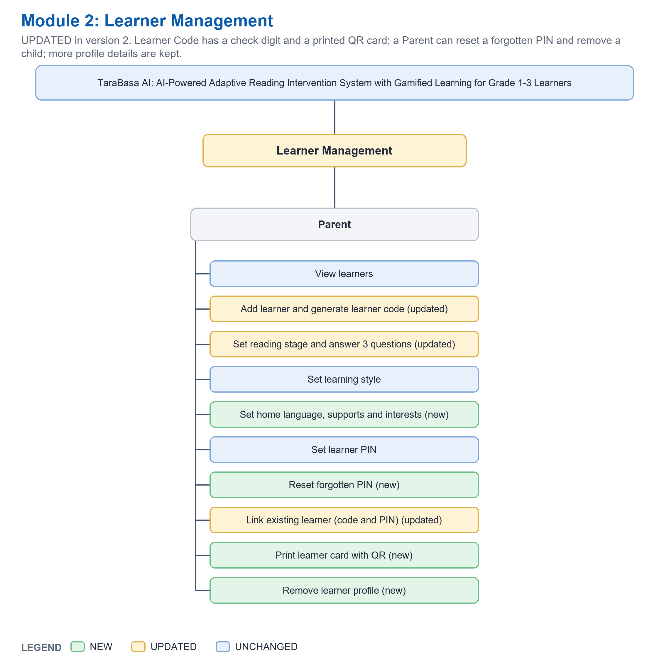
Actor | Function | Status | What is different from version 29
Parent | View learners | UNCHANGED
Parent | Add learner and generate learner code | UPDATED | The code has a check digit (for example TB26-48293); a printable card with a QR code is made.
Parent | Set reading stage and answer 3 questions | UPDATED | These answers decide where the first reading check starts, instead of the grade.
Parent | Set learning style | UNCHANGED
Parent | Set home language, supports and interests | NEW | Shown to the teacher; interests help choose topics.
Parent | Set learner PIN | UNCHANGED
Parent | Reset forgotten PIN | NEW | Needs the parent's password; at most 3 changes a day; the other guardians are told.
Parent | Link existing learner (code and PIN) | UPDATED | v29: the code only. Now the child's PIN is also needed (a change from the actor prompt; tell the team).
Parent | Print learner card with QR | NEW | A card with the name, the code and the QR; never the PIN.
Parent | Remove learner profile | NEW | Deletes the child if the parent is the only guardian; otherwise only unlinks this parent.

Module 3: Class Management (UPDATED)
One grade per class; adding by the last 5 characters or a QR scan with a check before Add; reading groups; moving a learner; learner profile for the teacher.
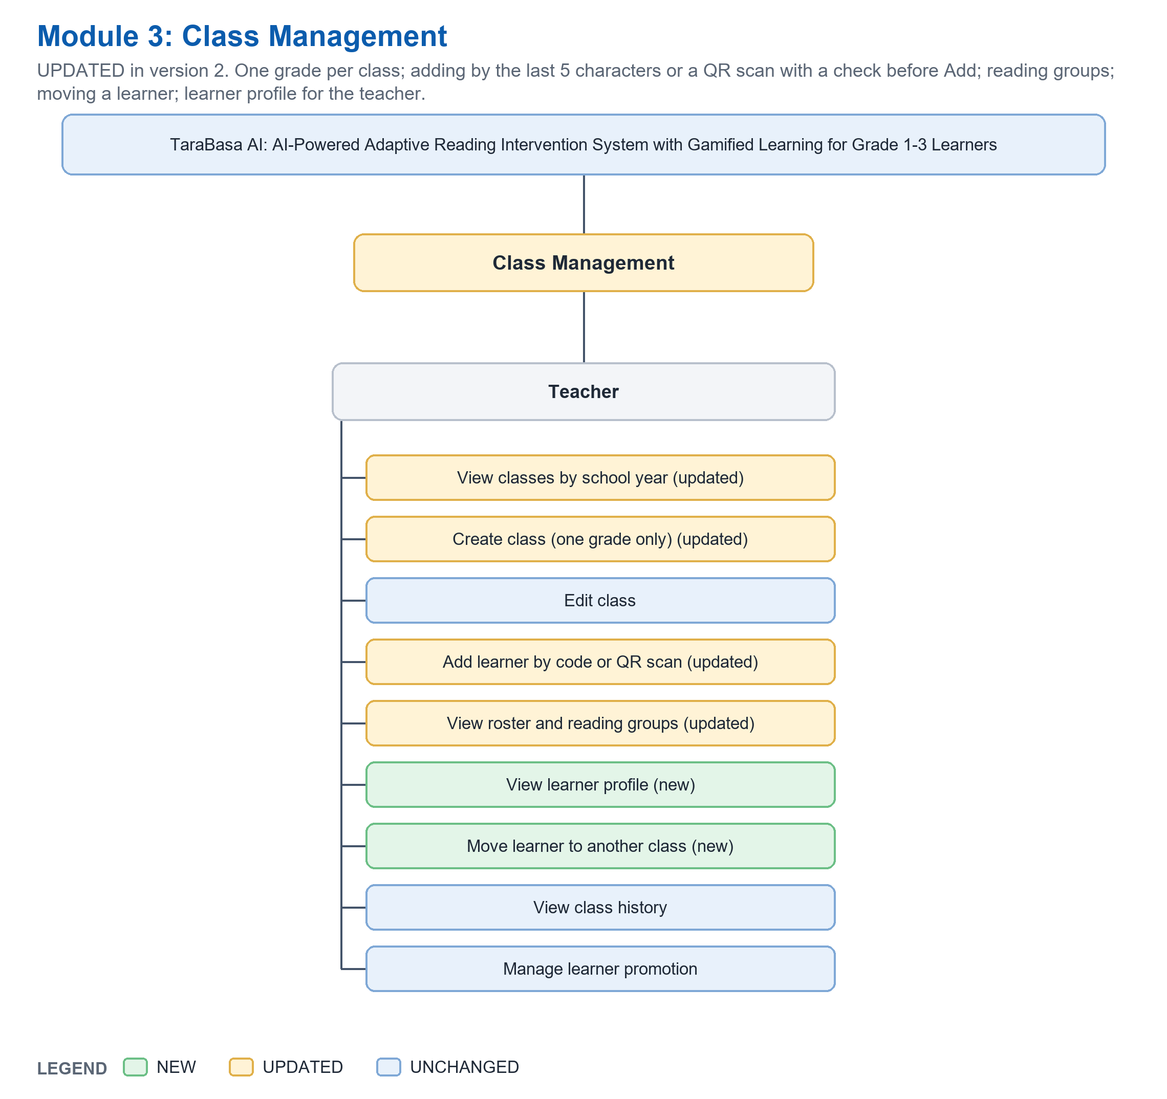
Actor | Function | Status | What is different from version 29
Teacher | View classes by school year | UPDATED | Past school years are read only.
Teacher | Create class (one grade only) | UPDATED | Only a grade the teacher handles; one class holds one grade, even for a multi-grade teacher.
Teacher | Edit class | UNCHANGED
Teacher | Add learner by code or QR scan | UPDATED | Last 5 characters or a QR scan; the code is checked while typed and the Add button stays off when the grade or level does not fit.
Teacher | View roster and reading groups | UPDATED | The class is split into three reading groups from the children's levels.
Teacher | View learner profile | NEW | What the parent shared, where the child reads now, what suits the child, the main mistake pattern.
Teacher | Move learner to another class | NEW | Same grade only; the same rules as adding.
Teacher | View class history | UNCHANGED
Teacher | Manage learner promotion | UNCHANGED

Module 4: Reading Activity Management (UPDATED)
The Teacher chooses how many drafts per level, can write for a class, places each draft in a level, and assigning checks that the children can read it.
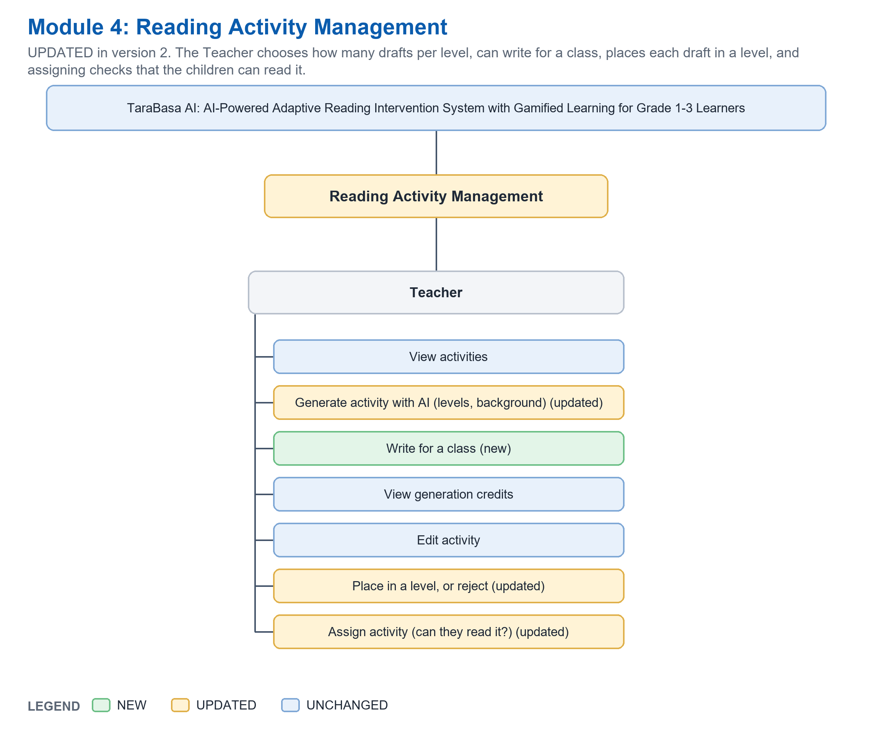
Actor | Function | Status | What is different from version 29
Teacher | View activities | UNCHANGED
Teacher | Generate activity with AI (levels, background) | UPDATED | v29: pick a topic. Now: grade, skill, kind and how many at each level; written in the background; one credit when saved.
Teacher | Write for a class | NEW | Uses the class's real readings to write a short basis for the AI writer.
Teacher | View generation credits | UNCHANGED
Teacher | Edit activity | UNCHANGED
Teacher | Place in a level, or reject | UPDATED | v29: approve or reject. Now the Teacher places a draft in Easy, Medium or Hard; the AI's level is only a suggestion.
Teacher | Assign activity (can they read it?) | UPDATED | To a learner, class, reading group or focus group; refused when the grade or the length does not fit.

Module 5: Open Repository Management (UPDATED)
Browse shows best matches first; paying is simulated (no real money); only the Parent browses, the Teacher only shares.
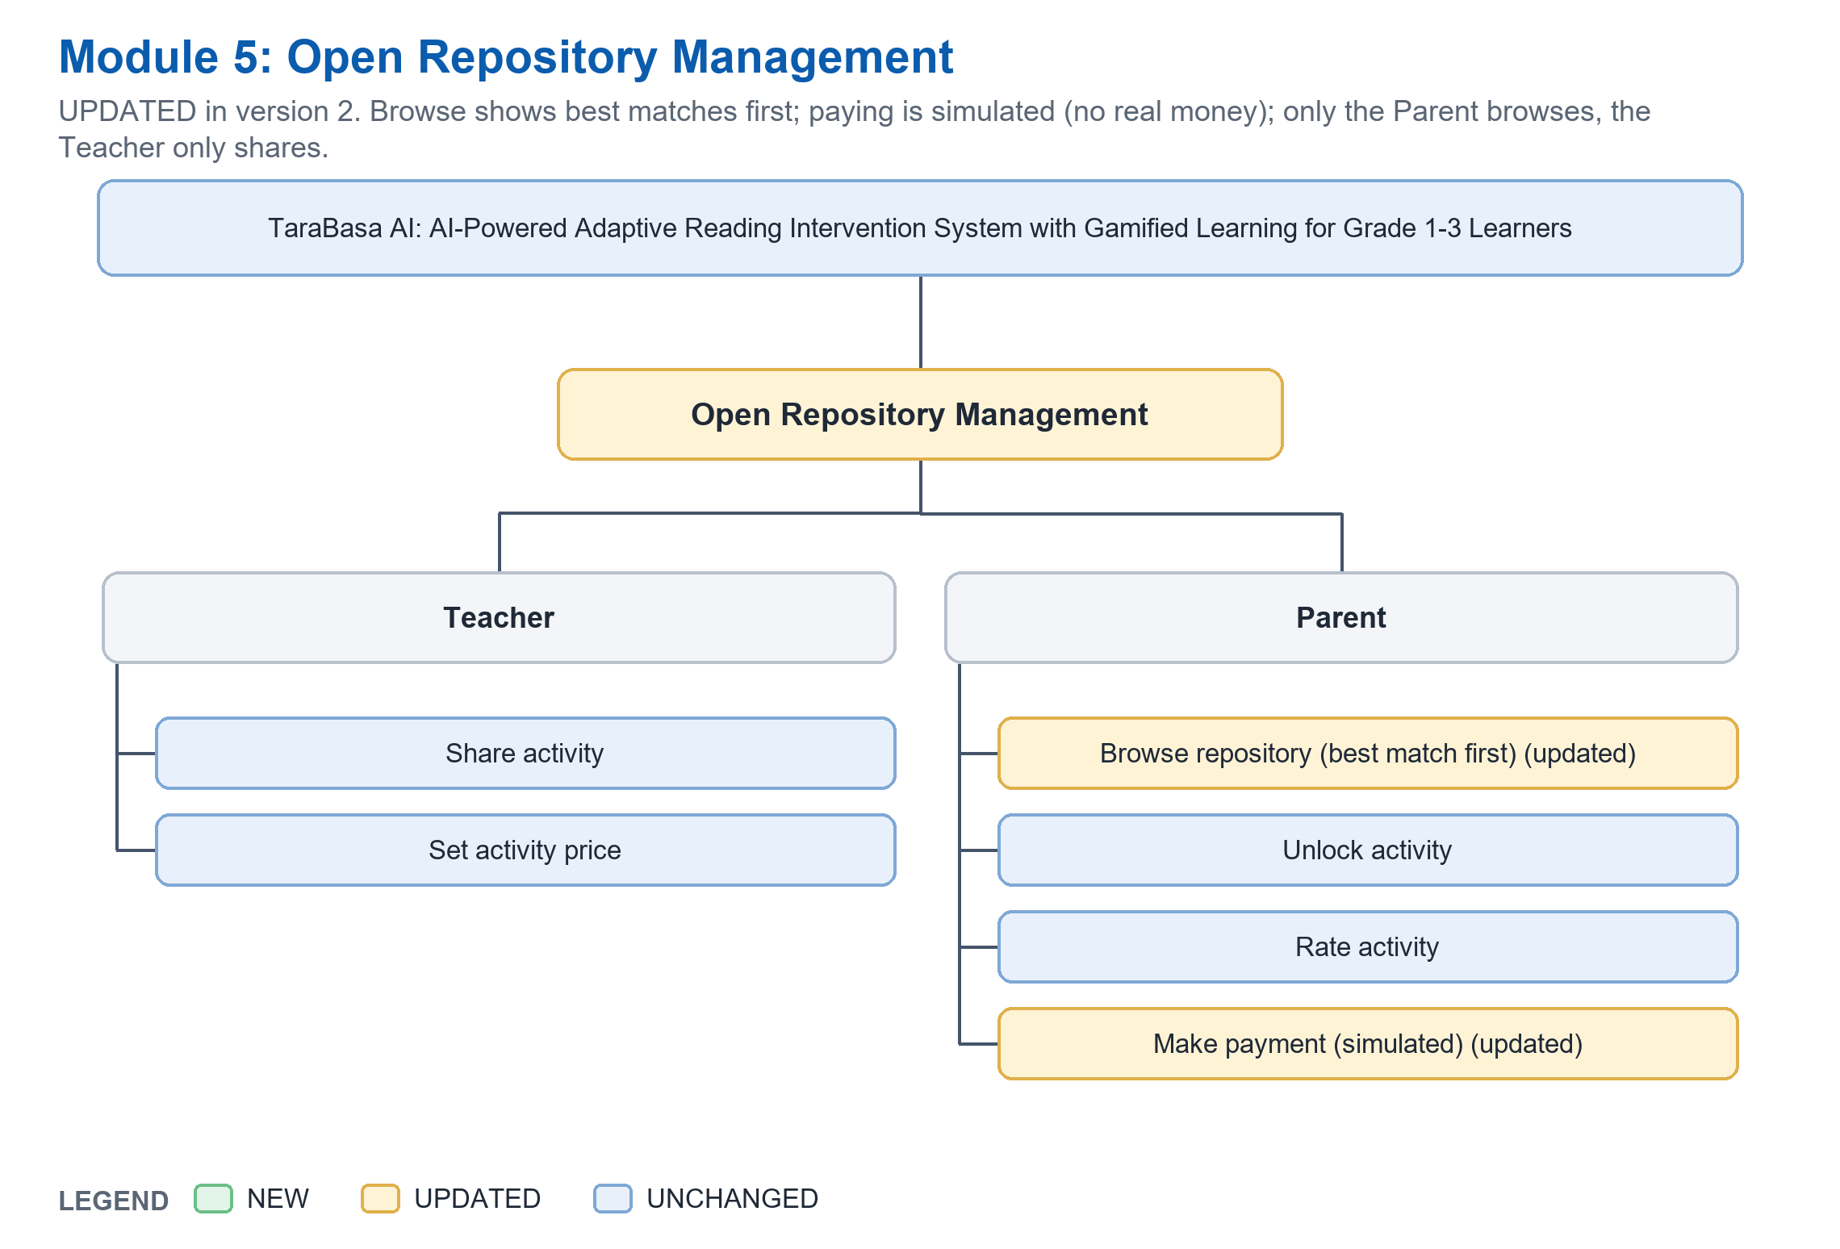
Actor | Function | Status | What is different from version 29
Teacher | Share activity | UNCHANGED
Teacher | Set activity price | UNCHANGED
Parent | Browse repository (best match first) | UPDATED | The best match for the child (level and mistakes) comes first; only Parents browse.
Parent | Unlock activity | UNCHANGED
Parent | Rate activity | UNCHANGED
Parent | Make payment (simulated) | UPDATED | No real payment is made in the prototype.

Module 6: Learner Reading Assessment (UPDATED)
Placement and diagnostic are one first reading check; practice with free tries and a microphone warm-up were added.
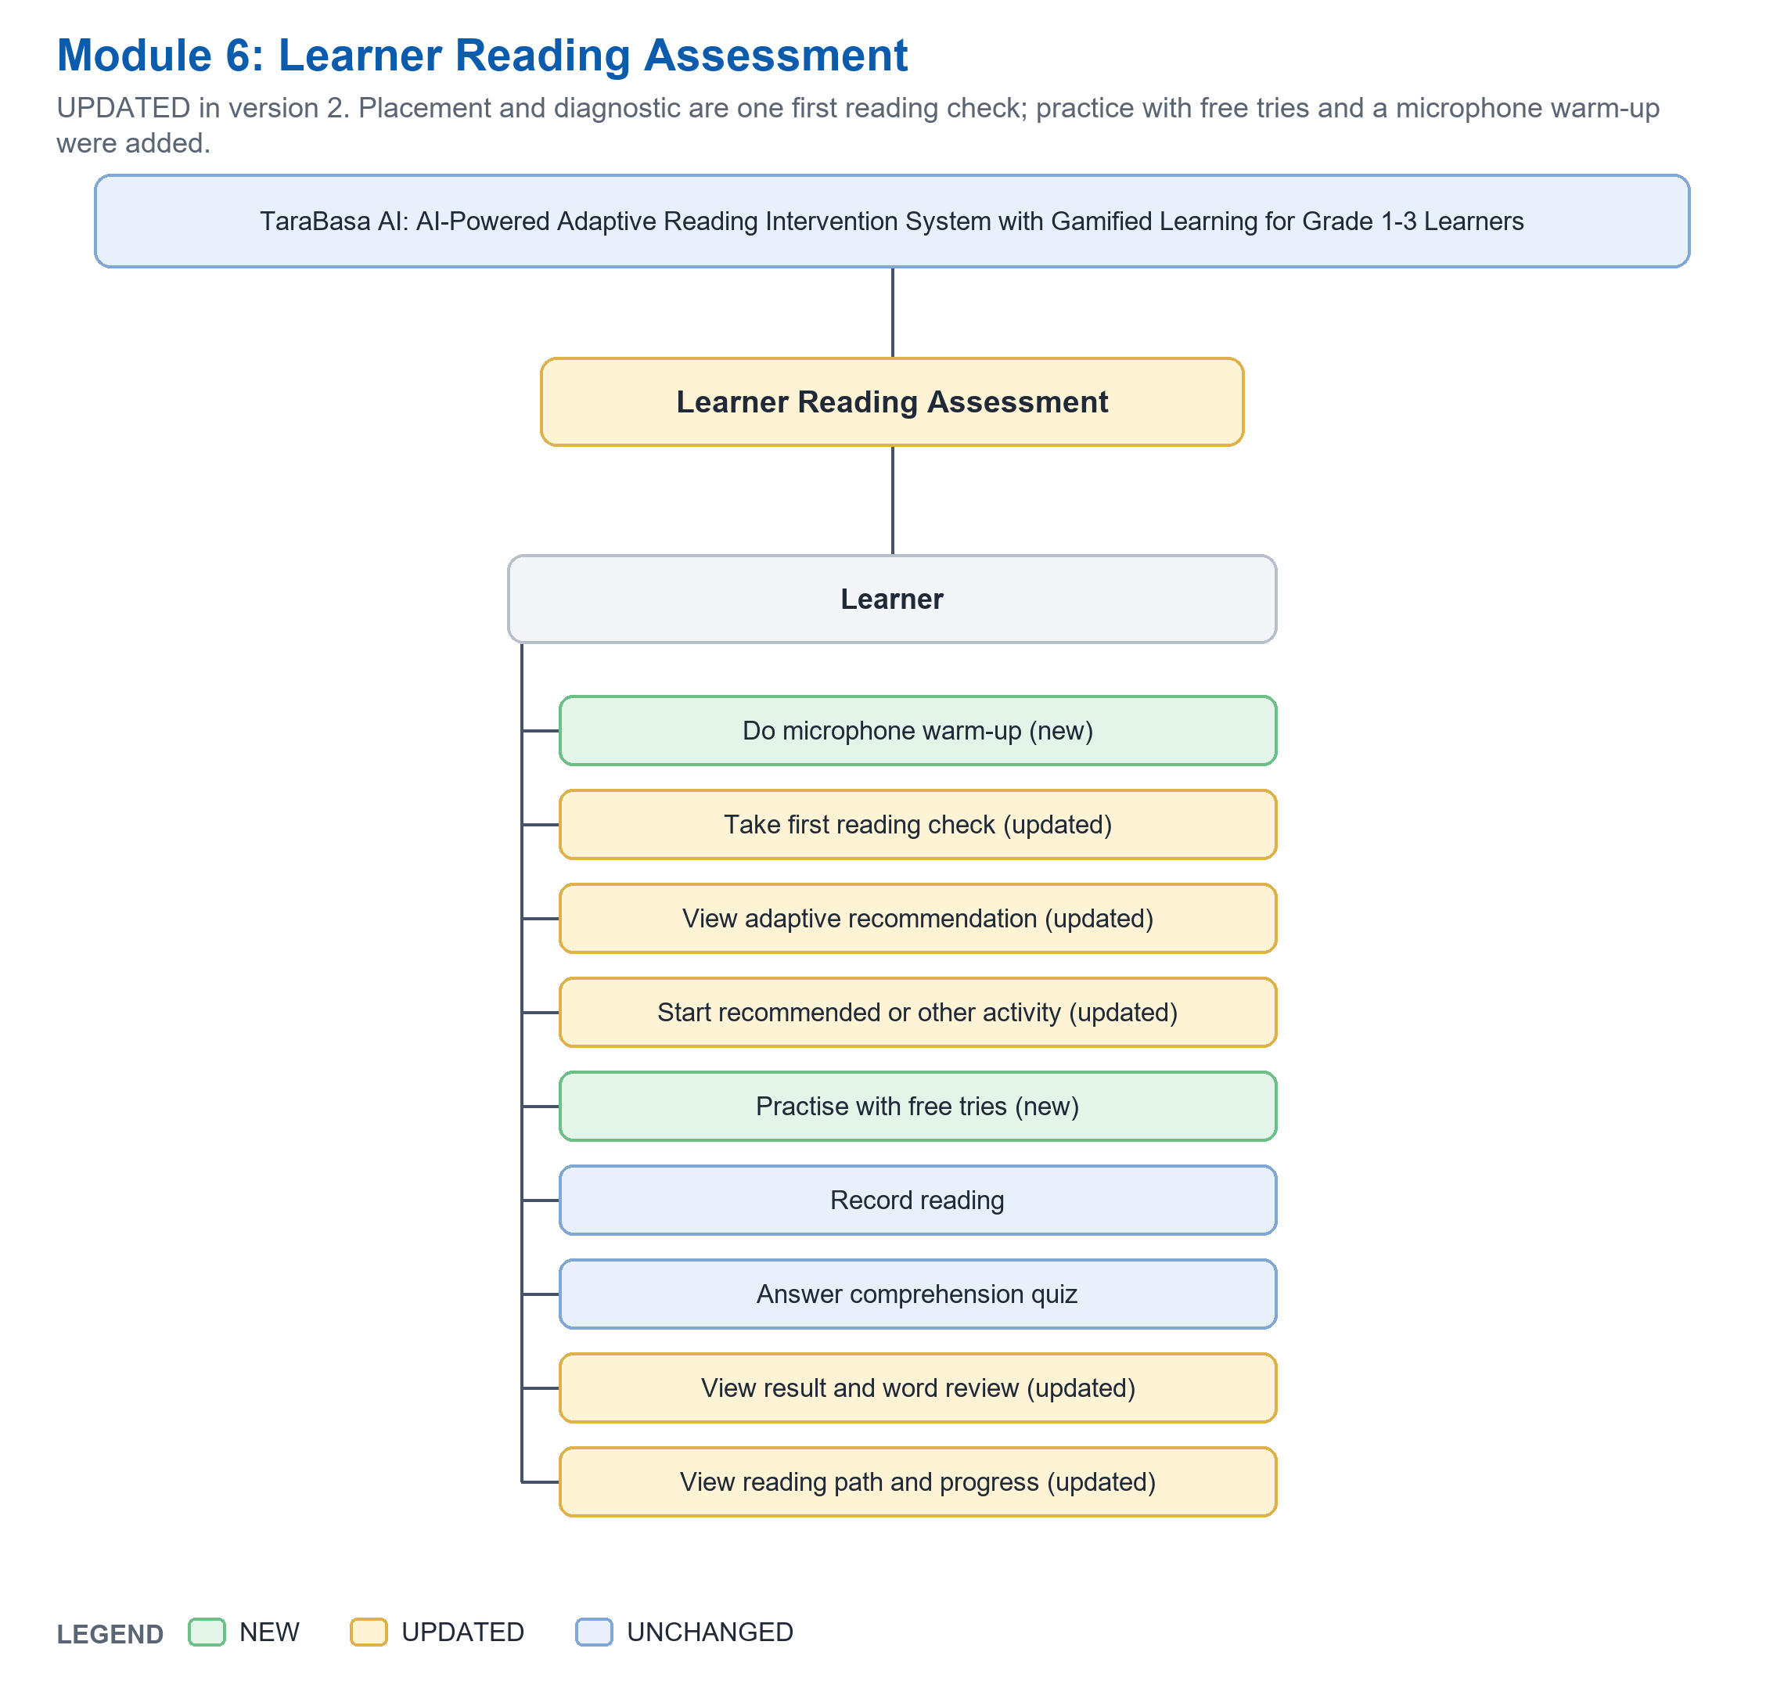
Actor | Function | Status | What is different from version 29
Learner | Do microphone warm-up | NEW | One word; it only listens, sends nothing and keeps nothing.
Learner | Take first reading check | UPDATED | Replaces 'placement' and 'diagnostic': one check of at most 3 items that starts where the parent's profile says.
Learner | View adaptive recommendation | UPDATED | 'Picked just for you' from the recommendation service.
Learner | Start recommended or other activity | UPDATED | Merged: the learner picks from one list (assigned, unlocked, recommended).
Learner | Practise with free tries | NEW | Listen to Tara, then two free tries; nothing is saved.
Learner | Record reading | UNCHANGED
Learner | Answer comprehension quiz | UNCHANGED
Learner | View result and word review | UPDATED | Result and feedback are one screen; a word by word review; no score after the first check.
Learner | View reading path and progress | UPDATED | Four steps (Letter Explorer to Story Reader) with the child's step marked.

Module 7: Gamified Learning (UPDATED)
Four read-aloud practice games; 100 badges; day streak and weekly goal; text size.
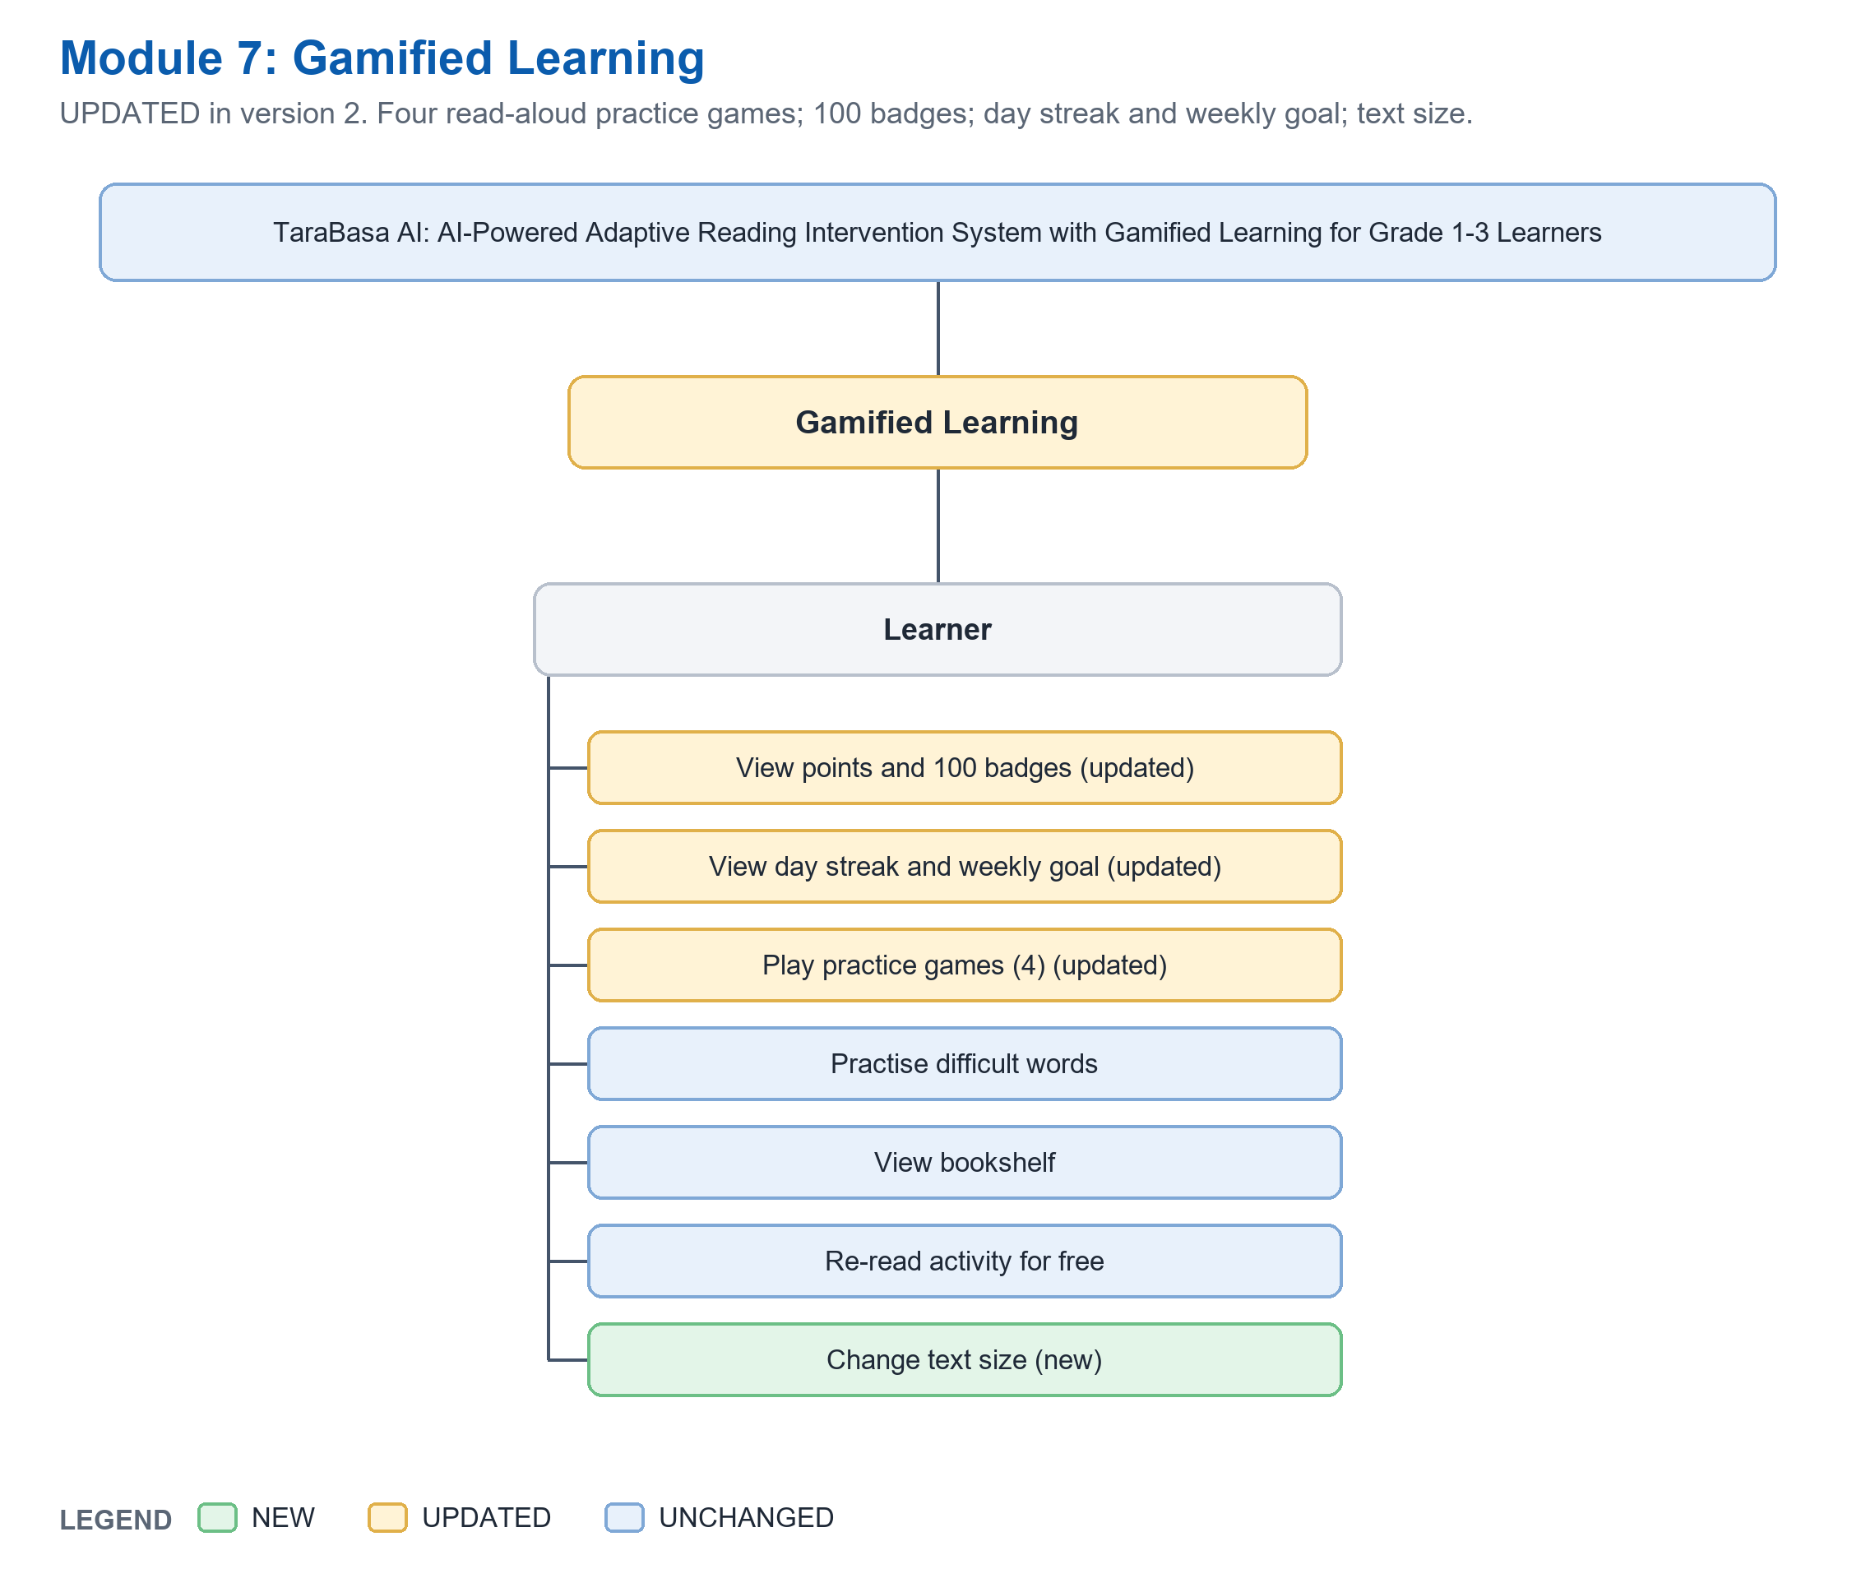
Actor | Function | Status | What is different from version 29
Learner | View points and 100 badges | UPDATED | One hundred badges, each worked out from real readings and game plays.
Learner | View day streak and weekly goal | UPDATED | Days in a row worked out from real readings; the goal is 5 readings a week.
Learner | Play practice games (4) | UPDATED | Balloon Pop, Word Train, Sentence Stars, Syllable Steps; all are read aloud and free play.
Learner | Practise difficult words | UNCHANGED
Learner | View bookshelf | UNCHANGED
Learner | Re-read activity for free | UNCHANGED
Learner | Change text size | NEW | Five sizes, remembered for the child.

Module 8: Dashboard Analytics (UPDATED)
Teacher overview, 'Did it work?' and a class report; Parent sees the level in plain words and tips to practise at home.
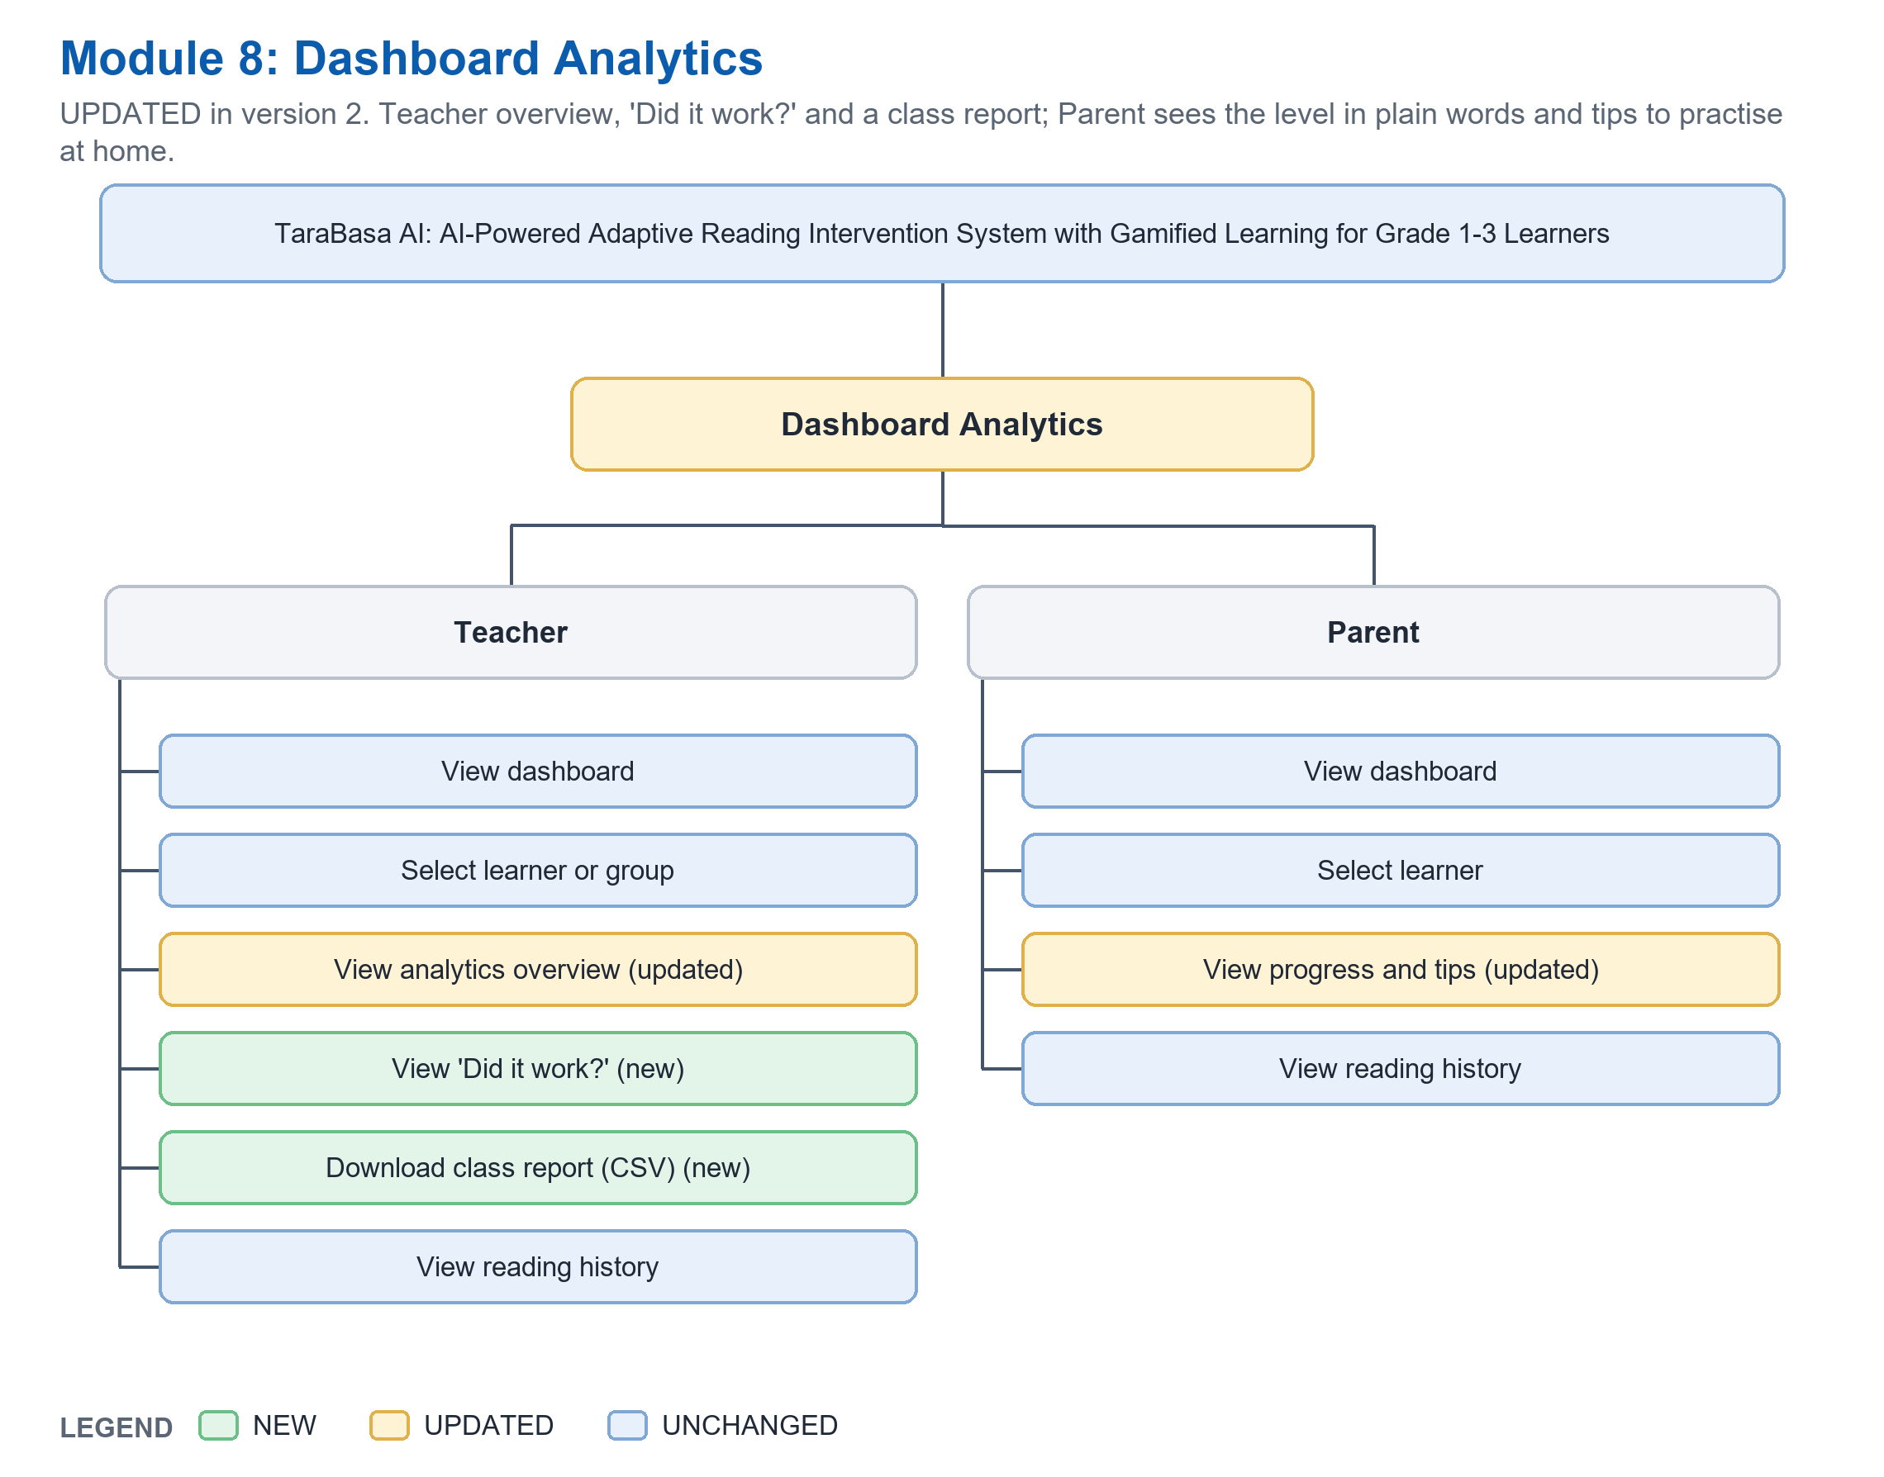
Actor | Function | Status | What is different from version 29
Teacher | View dashboard | UNCHANGED
Teacher | Select learner or group | UNCHANGED
Teacher | View analytics overview | UPDATED | Class numbers, levels in Phil-IRI names, words missed most, assigned activities.
Teacher | View 'Did it work?' | NEW | Compares readings of activities written for the class with general ones; says 'too early' until there is enough.
Teacher | Download class report (CSV) | NEW | A class report as a spreadsheet file.
Teacher | View reading history | UNCHANGED
Parent | View dashboard | UNCHANGED
Parent | Select learner | UNCHANGED
Parent | View progress and tips | UPDATED | The level in plain words, 'Practise at home' tips, weekly goal, badges.
Parent | View reading history | UNCHANGED

Module 9: Notification Management (UPDATED)
Teacher alerts are worked out from readings and can be acted on; emails are sent for confirmation and reset only (no SMS).
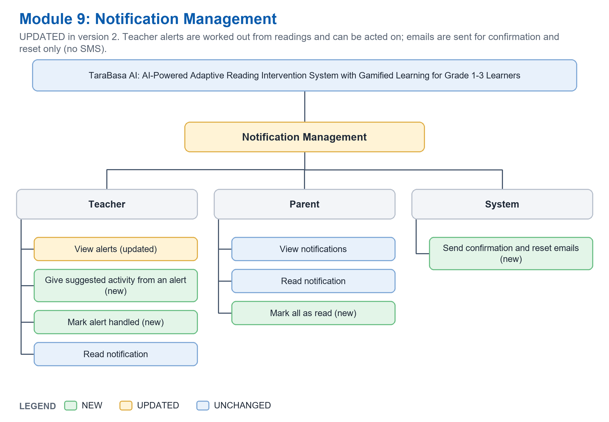
Actor | Function | Status | What is different from version 29
Teacher | View alerts | UPDATED | Five kinds worked out from real readings: needs support, ready to move up, starting to read, gone quiet, moved up.
Teacher | Give suggested activity from an alert | NEW | One tap gives the suggested activity from the teacher's own approved ones.
Teacher | Mark alert handled | NEW | Hides the alert until the child reads again.
Teacher | Read notification | UNCHANGED
Parent | View notifications | UNCHANGED
Parent | Read notification | UNCHANGED
Parent | Mark all as read | NEW | Marks every notification as read.
System | Send confirmation and reset emails | NEW | Through the Gmail API; there are no text messages.

Module 10: Adaptive Reading Support (NEW)
The rule-based 'AI expert' was missing from the FDD: scoring clean-up, gradual reading steps, recommender, mistake patterns, word bank and 'can they read it' checks.
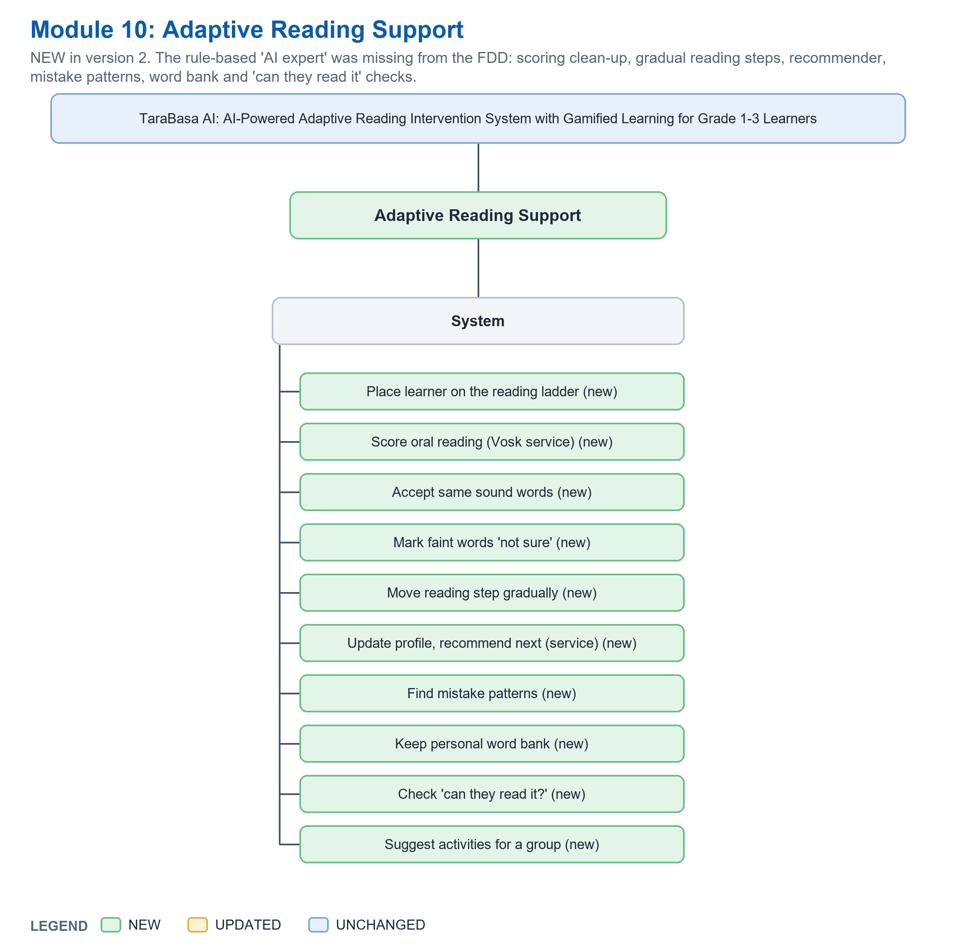
Actor | Function | Status | What is different from version 29
System | Place learner on the reading ladder | NEW | Seven rungs; starts from the parent's profile; at most 3 items.
System | Score oral reading (Vosk service) | NEW | Words, timing and confidence, accuracy, speed and a voice score, from the speech service.
System | Accept same sound words | NEW | For example sun and son, mangoes and mangos; near misses stay mistakes.
System | Mark faint words 'not sure' | NEW | Heard below 0.50 confidence and not matching: left out of the score; at most 25 percent of the words.
System | Move reading step gradually | NEW | Up after 3 strong readings of 2 activities; down after 2 weak readings in a row; one step at a time.
System | Update profile, recommend next (service) | NEW | The recommendation service updates the profile with fixed formulas and suggests the next kind and level.
System | Find mistake patterns | NEW | Ten kinds, found from the last 8 readings.
System | Keep personal word bank | NEW | Struggling, then improving, then mastered after 3 correct readings.
System | Check 'can they read it?' | NEW | Grade and length against what the children's steps can read.
System | Suggest activities for a group | NEW | From the teacher's own approved activities; the teacher decides.

Module 11: System Administration and Privacy (NEW)
The Admin screens (approvals, accounts, system health, activity log, grade requests, deletion) are a module of their own.
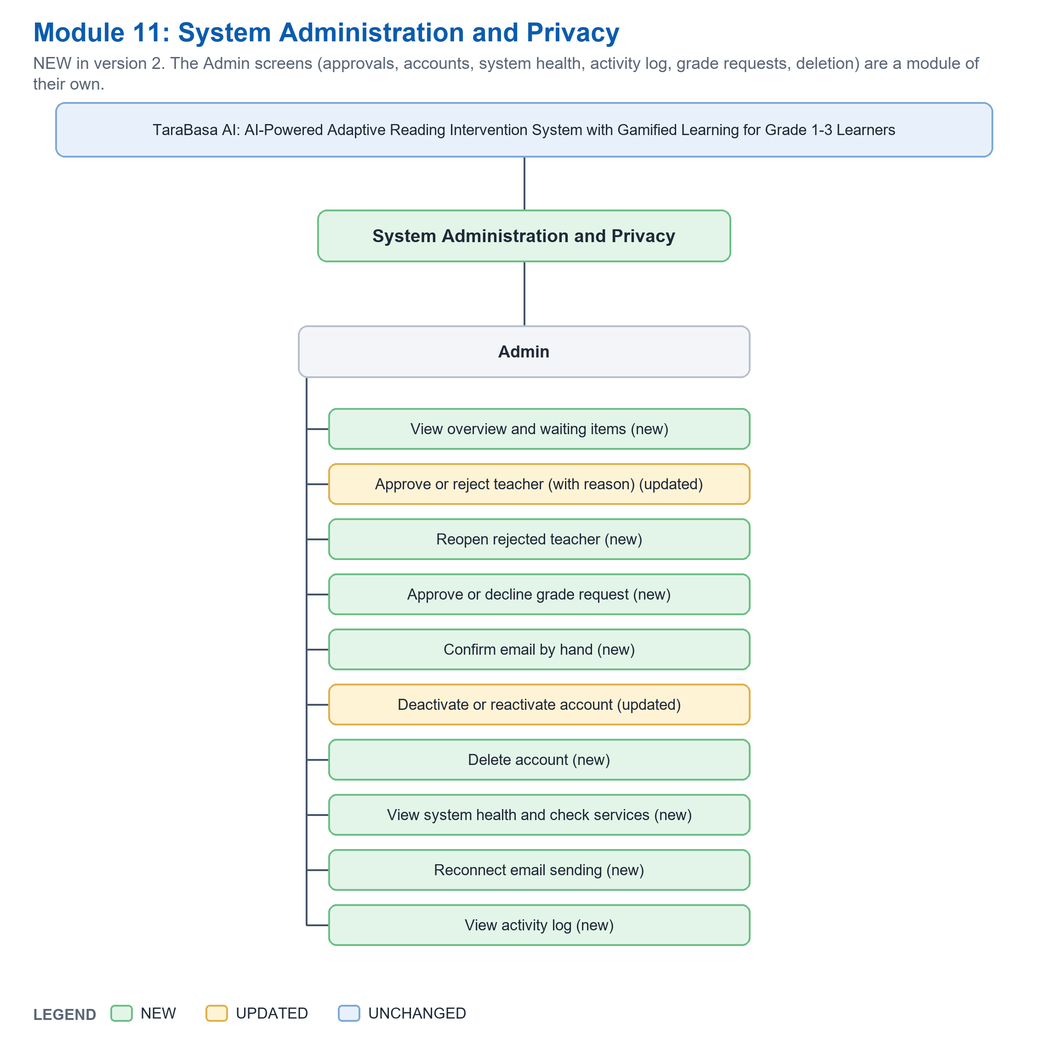
Actor | Function | Status | What is different from version 29
Admin | View overview and waiting items | NEW | Teachers waiting, email problems, real service problems.
Admin | Approve or reject teacher (with reason) | UPDATED | v29: activate or reject. Now needs a confirmed email; a rejection has a reason that the teacher sees.
Admin | Reopen rejected teacher | NEW | A rejected teacher can be looked at again.
Admin | Approve or decline grade request | NEW | A teacher's request to add a grade is decided here.
Admin | Confirm email by hand | NEW | With a reason, written in the activity log.
Admin | Deactivate or reactivate account | UPDATED | v29: deactivate. Now also reactivate, with a note.
Admin | Delete account | NEW | With a reason; a deleted person's name is removed from the log.
Admin | View system health and check services | NEW | Tests the reading service, the activity writer, the recommender and email; says Working, Asleep or Needs you.
Admin | Reconnect email sending | NEW | Gives a new email permission when the old one expired.
Admin | View activity log | NEW | Who did what, and why.

Workflow figures of version 29 that were wrong
Version 29's workflow figures were read as pictures against the system's routes. The new figures are in 05_Figures and in block C4 of the insert text.
Old figure | What was wrong | New figures
3.1 and 3.2 Learner | Login by PIN only. One reading moves the level up, keeps it, or moves it down with a flag. 'Warm-Up Game'. No comprehension quiz, word bank, badges detail, or first-check ladder. 'AI Score (Speech-to-Text)'. | 3.2 to 3.4 (plus the overview 3.1): card or code with PIN; first reading check ladder; practice stage; unclear audio retry; comprehension quiz; slow step rule; word bank; recommender; badges; alerts; games; bookshelf; rewards.
4.1 and 4.2 Teacher | A not yet approved teacher is stopped with a pending notice. The Teacher can browse the Open Repository. No alerts, no analytics detail, no promotion flow, no reading groups, no fit check. | 4.1 to 4.4: confirm email; Pending can view; grade requests; one grade per class; add by code or QR with a check; roster, move, promotion; generate in the background; place in levels; assign with a fit check; share; analytics; alerts; profile.
5.1 and 5.2 Parents | A 'Practice Reading' branch opens the learner interface. No email confirmation, no PIN reset, no QR card, no removing a child, no alerts detail. | 5.1 and 5.2: confirm email; add a child with the 3 questions; learner card; link with PIN; reset PIN; remove a child; progress with tips; activities; alerts; delete account.
6.1 Administrator | Edit Profile and Save Changes branches (no such page). Only approve or reject teachers and activate or deactivate accounts. | 6.1: Approvals (waiting, rejected, grade requests); Accounts (search, deactivate, confirm email, delete); System health; Activity log.

Use case diagrams
The six use case diagrams are drawn from the same list as the FDD. Colour in the review versions is the same as above. Version 29 had four diagrams with 8 + 8 + 21 + 15 use cases; version 2 has six diagrams. The same function used by two actors (for example Register account) is one use case with two lines.

