TaraBasa AI: insert-ready manuscript text
For the writer of the manuscript. Everything below is the text to paste, in the manuscript's own formatting. Written 20 October 2026 from the system as it is today, checked against version 29 (the PDF).
How to use this file
- Each block starts with a small grey box. The box is for you, not for the manuscript. It says what the block is (NEW, UPDATED, FIX, DECISION), where it goes, what it replaces, and why. Never paste the box.
- Paste only what is between the box and the line 'end of ...'. The text, tables and pictures there already use the manuscript's formatting: Times New Roman 11 pt, justified, 1.5 line spacing, first-line indent 0.5 inch, headings in the manuscript's styles.
- When you paste into the manuscript, choose 'Use Destination Styles' (Keep Text Only also works for text). Then nothing changes font, size or spacing.
- Bracketed text [like this] is for you to complete (school name, results of the user test, the phone you tested on). Do not leave a bracket in the final file.
- Words in italic under a table or in a grey 'Note' are instructions. They are not part of the manuscript.
- Figure and table numbers follow the numbering map in 01_Review_and_Change_Register.docx (Annex 1). Change them at the end with Find and Replace.
- The pictures are 300 dpi PNG files, 6.0 inches wide at most (the text width). The editable versions (.drawio) and vector versions (.svg) are in 05_Figures.
Tags
NEW  does not exist in v29 | UPDATED  exists, replace | FIX  error to correct | DECISION  team decides first | CHECK  confirm a fact | DELETE  remove

PART A. FRONT MATTER AND CHAPTER 1
A1  FIX | Place at: Cover page, line 'A Capstone Proposal' and the date line.  Replaces: 'A Capstone Proposal' and 'July 2026'.  Note: The document is the final manuscript, so it is a Capstone Project, not a proposal. Put the real month and year of submission.

A Capstone Project
----- end of A1: copy only the text above this line -----
A2  UPDATED | Place at: Chapter 1, 'Scope and Limitations of the Study'. Replace the second paragraph (starts 'The TaraBasa AI platform integrates ...', pages 5 to 6) and the last two paragraphs before 'Despite these limitations' (starts 'The study is limited ...' and 'The application requires a stable internet connection ...'). Keep the first paragraph, after deciding the school name (see C5).  Replaces: The three paragraphs named above.  Basis: Real system as of 20 October 2026: the phone app serves Learner, Teacher and Parent; the website serves all four; the Admin uses the website only; no SMS; rule-based support.  Note: The study's school is written two ways in version 29 (Cebu City here, Suba Elementary School in Liloan, Cebu in the Validation Board). Choose one and use it everywhere.

Scope and Limitations of the Study
The TaraBasa AI platform integrates AI-assisted speech recognition for oral reading assessment, rule-based adaptive support that personalizes reading activities according to learners’ reading performance, gamified learning to enhance learner engagement and motivation, and analytics to assist teachers and parents in monitoring learners’ reading development. The system consists of an Android mobile application for learners, teachers, and parents, and a website that serves all four types of users: learners, teachers, parents, and system administrators. The administrator uses the website only. The mobile application and the website use the same accounts and the same database, so a reading completed on one is visible on the other. Learners read aloud, play read-aloud practice games, and see their reading path and badges. Teachers create classes, generate and review reading activities, assign them to learners, classes, or reading groups, and monitor learners through analytics and alerts. Parents create and manage their children’s profiles, view progress and tips for practicing at home, and unlock additional activities from the Open Repository. Administrators approve teacher accounts, manage accounts, and monitor the health of the system.
The study is limited to the development and evaluation of TaraBasa AI within its current implementation in Cebu and does not examine its long-term effects on learners’ English reading proficiency, academic achievement, reading motivation, or overall literacy development. Likewise, the study does not evaluate large-scale or nationwide institutional adoption, integration with existing Department of Education information systems and reading programs, or external factors such as digital literacy, device availability, internet connectivity, and home learning environments. While these factors may influence the effectiveness and future scalability of the system, they are beyond the scope of the present study.
The application requires an internet connection to score a reading, to write activities, and to send account emails. The speech recognition component supports English oral reading assessment and may produce inaccurate results because of variations in learners’ pronunciation, speech clarity, background noise, microphone quality, internet connectivity, or limitations of the speech recognition model, which is built for adult speech. To reduce unfair marking, the system accepts words that sound the same, leaves words it heard only faintly out of the score, and allows a recording that could not be heard to be repeated. Assessment results are intended to assist teachers and should not replace professional judgment in evaluating learners’ reading performance.
The adaptive support in TaraBasa AI is rule-based. The reading step, the recommended activity, the mistake patterns, and the alerts are produced by written rules and fixed formulas, and the researchers did not train a machine learning model. The numerical settings of these rules were chosen by the researchers from the literature and from testing with synthesized voices; they have not yet been validated with recordings of Filipino children. The services for scoring, activity writing, and recommendation run on free hosting plans that sleep when they are idle, so the first request after a quiet period can take about a minute. Adaptive reading activities are limited to the content available in the system: the texts of the first reading check, which were written by the researchers, and the activities that an AI service drafted and a teacher approved. The system does not send text messages (SMS); teachers and parents receive updates inside the application and the website.
----- end of A2: copy only the text above this line -----
A3  FIX | Place at: Chapter 1, 'Flow of the Study', the sentence under the heading (page 7) and the paragraph beginning 'The next phase focuses on determining the algorithms ...' (page 9). Figure 1 stays.  Replaces: Page 7: 'The procedure involves identifying hand gestures and interpreting their meanings by matching them to the corresponding universal words, and vice versa ...' (left over from another study). Page 9: second paragraph.  Note: The hand gesture sentence describes a different project and must be removed.

Flow of the Study
This diagram shows the study’s inputs, processes, and outputs. The inputs are the data gathered on the English reading difficulties and intervention practices of Grade 1 to Grade 3 learners, the review of related literature, and the curriculum references (the MATATAG Curriculum and the Philippine Informal Reading Inventory). The process follows the Agile methodology to design, develop, test, and review the speech recognition-based assessment, the rule-based adaptive support, the gamified activities, and the monitoring tools. The output is TaraBasa AI, an adaptive reading intervention system available as a mobile application and a website.
The next phase focuses on determining the mechanisms that were integrated into the system. A speech recognition service was identified to assess learners’ English oral reading by measuring word accuracy, reading speed, and a voice score. An adaptive support mechanism was likewise determined: a recommendation service that uses fixed formulas, combined with written rules that move a learner’s reading step slowly, find repeated mistakes, and suggest activities. These ensure that learners receive reading activities that match their assessed performance.
----- end of A3: copy only the text above this line -----
A4  NEW | Place at: Chapter 1, 'Definition of Terms' (pages 9 to 10). Add these terms in alphabetical order with the existing ones. Use the same pattern: the term in bold, then 'It refers to ...'.  Replaces: Nothing; these terms are new.  Basis: Terms the manuscript uses but never defines (Phil-IRI, MATATAG, Open Repository, Learner Code and others).

Definition of Terms (additions)
Adaptive Recommender. It refers to the outside service used by TaraBasa AI that keeps a numerical profile of each learner’s reading skill and, by fixed formulas, suggests the next kind of reading activity and its level.
Alerts. It refers to the messages that TaraBasa AI shows to teachers and parents when a learner’s recent readings show a need for support, readiness to move up, a need to start with letters, a long quiet period, or a move to a higher level.
First Reading Check. It refers to the short oral reading check, of at most three items, that a learner completes the first time the learner signs in. It starts at the step suggested by the Parent’s profile of the child and ends with a reading step.
Learner Code. It refers to the unique code, such as TB26-48293, that TaraBasa AI makes for each learner. With the learner’s 4-digit PIN it is used to sign in. The last character is a check digit that lets the system notice a mistyped code.
MATATAG Curriculum. It refers to the Department of Education’s curriculum for basic education. TaraBasa AI uses its learning competency codes to describe what each reading activity practices.
Mistake Pattern. It refers to a kind of reading mistake, such as missing word endings or letter blends, that a learner repeats across several readings and that the system finds by rules from the words the learner missed.
Open Repository. It refers to the shared library in which teachers list approved activities, free or paid, and from which parents unlock activities for their children.
Personal Word Bank. It refers to the list of words a learner missed. A word is ‘struggling’ when it is first missed, ‘improving’ after it is read correctly, and ‘mastered’ after it is read correctly three times.
Philippine Informal Reading Inventory (Phil-IRI). It refers to the Department of Education’s tool for finding learners’ reading levels. Its levels (Independent, Instructional, and Frustration) are based on oral reading accuracy.
Reading Group. It refers to one of the three groups into which TaraBasa AI divides a class by reading level, so that a teacher can assign an activity to the group that can read it.
Reading Step. It refers to a learner’s place on a four-step reading path: Letter Explorer, Word Builder, Sentence Reader, and Story Reader. The step moves slowly, as explained in the Adaptive Reading Support Design.
Rule-Based Support. It refers to decisions made by written rules and fixed formulas, for example moving a reading step, as opposed to decisions made by a trained machine learning model.
----- end of A4: copy only the text above this line -----
A4b  UPDATED | Place at: Chapter 1, 'Definition of Terms'. Replace these four existing definitions.  Replaces: 'Gamified Learning', 'Parent Notification System', 'System Administrator' and 'Learners'.  Basis: 'Parent Notification System' said TaraBasa informs parents automatically; it now means in-app alerts. The Administrator no longer manages reading materials or reports.

Gamified Learning. It refers to the integration of game elements such as points, badges, levels, a weekly goal, and read-aloud practice games within TaraBasa AI to encourage learner engagement and sustained participation in reading activities.
Learners. It refers to the elementary pupils who use TaraBasa AI as the primary beneficiaries of the adaptive reading intervention system. A learner does not register alone: a parent creates the learner’s profile, and the learner signs in with a Learner Code and a 4-digit PIN.
Alerts and Notifications System. It refers to the feature of TaraBasa AI that shows parents and teachers, inside the mobile application and the website, a learner’s reading results, assigned activities, and alerts about the learner’s progress.
System Administrator. It refers to the authorized user who approves teacher accounts and the grades teachers handle, manages accounts, monitors the health of the system’s services, and reads the activity log of administrative actions within TaraBasa AI.
----- end of A4b: copy only the text above this line -----

PART B. CHAPTER 2: REVIEW OF RELATED LITERATURE AND STUDIES
B1  UPDATED | Place at: Chapter 2, 'Comparative Matrix', the two paragraphs after Table 1.3 (pages 25 to 26). Replace only the second paragraph ('Despite these similarities ...'). The first paragraph stays.  Replaces: The paragraph that says TaraBasa AI is 'the only system among those reviewed that provides parent monitoring with SMS notifications' and that it has 'AI intervention recommendations'.  Basis: SMS is not built; the 'AI recommendations' are produced by rules and a formula service, which the text should say.

Despite these similarities, TaraBasa AI offers several features that distinguish it from the reviewed systems. Unlike the existing applications, TaraBasa AI combines a recommendation service with written rules to suggest reading activities and to alert teachers when a learner needs support, is ready to move up, or needs to start with letters. The suggestions come from the learner’s recent readings and are explained to the teacher, who decides what to assign. It also includes a Personal Word Bank that records the words a learner missed and follows each word until it is read correctly several times, so that the practice games can return to the learner’s own difficult words. Furthermore, among the five systems reviewed, TaraBasa AI is the only one that gives parents their own view of the child’s progress, with the reading level in plain words, tips for practicing at home, and in-app alerts, and that lets parents unlock additional activities made by teachers. By combining AI-assisted reading assessment, speech recognition, adaptive learning, rule-based recommendations, gamified learning, teacher and parent monitoring, learner analytics, and a personal word bank within a single platform, TaraBasa AI delivers a more comprehensive and practical reading intervention system for Philippine public elementary schools than the existing applications.
----- end of B1: copy only the text above this line -----
B2  UPDATED | Place at: Chapter 2, Tables 1.1 to 1.3, Table 2, and the paragraph after Table 2 (pages 23 to 28).  Replaces: Words that name features TaraBasa does not have: SMS, 'AI pronunciation coaching', 'AI Reading Intervention Planner', 'AI Intervention Identification'.  Basis: Table 2 compares features: every claim about TaraBasa must be something the system does.  Note: The related systems' own cells (Google Read Along, Lexia, Raz-Kids, Ello, Amira) stay as they are.

Find and replace in the tables (working note, not manuscript text):
Where | Replace this | With this
Tables 1.1 to 1.3, 'Limitations' column of each system | No parent monitoring or SMS notifications. | No parent monitoring or in-app alerts.
Table 2, row label | Parent monitoring / SMS notification | Parent monitoring and in-app alerts
Table 2, row label | AI Intervention recommendations | Rule-based intervention suggestions
Table 2, row label | Personal Word Bank | Personal Word Bank (missed words followed to mastery)
Table 2, row label | AI-powered reading assessment | AI-assisted reading assessment

In contrast, TaraBasa AI uniquely integrates AI-assisted oral reading assessment with speech recognition, word-by-word feedback, adaptive reading steps and recommendations, rule-based intervention suggestions for teachers, a Personal Word Bank, gamified read-aloud activities, teacher and parent dashboards with in-app alerts, learner progress analytics, and alignment with the MATATAG Curriculum and the Phil-IRI within a unified platform. By combining these features into one system, TaraBasa AI provides a more comprehensive, localized, and practical solution for supporting reading intervention among Grade 1 to Grade 3 learners in Philippine public elementary schools.
(This paragraph replaces the last two sentences of the paragraph after Table 2, from ‘In contrast, TaraBasa AI uniquely integrates ...’ to the end.)
----- end of B2: copy only the text above this line -----
B3  NEW | Place at: Chapter 2, 'Related Literature', after the paragraph that ends 'a meaningful advantage over the manual tracking Phil-IRI currently requires' (page 19) and before 'Several AI-supported reading platforms currently demonstrate ...'. No new heading.  Replaces: Nothing; these five paragraphs are new.  Basis: Gives the literature basis for choices the system already makes: the speech engine, the speed score, the AI writer, tap-only controls, the syllable method.  Note: Each citation is in 04_New_References_and_Basis.docx with a verification status. The sources marked 'found by search' must be opened and read by the writer before the paragraph is kept.

The speech recognition used by TaraBasa AI is Vosk, an offline recognition toolkit that is built on Kaldi, an open-source speech recognition toolkit introduced by Povey et al. (2011). The researchers used a small English model to turn a learner’s recording into words with timing and confidence values, and the system compares these words with the activity text to compute accuracy and words correct per minute. Recognition systems are usually built and tested on adult speech, and Potamianos and Narayanan (2003) reported that children’s speech is harder to recognize because it differs acoustically from adult speech and varies with the child’s age. For this reason TaraBasa AI does not treat the recognizer’s output as final: it accepts words that sound the same, leaves faintly heard words out of the score, allows a recording that could not be heard to be repeated, and presents the result as support for the teacher’s judgment.
Reading speed is reported as words correct per minute. Hasbrouck and Tindal (2017) published oral reading fluency norms for Grades 1 to 6 in the United States. The speed score that TaraBasa AI receives from its reading service is computed from one target range of words per minute and not from these norms, so it is not adjusted for each grade or for learners who read English as a second language. For this reason the reading step moves on word accuracy alone, while the speed and voice scores contribute only to the weighted profile score that the recommendation service keeps, and the limit is stated openly in this study.
The reading activities are drafted by a generative language model, Gemini (Gemini Team, 2023), which is reached through a separate service. The model writes drafts at the grade, skill, and level a teacher asks for, and nothing reaches a learner until the teacher edits it, places it in a level, or rejects it. The teacher, not the model, decides the level of each activity, and the system adds a length check so that an activity is not assigned to children who could not read it.
Interface choices for Grade 1 to Grade 3 learners follow research on young children’s use of touchscreens. In a study of 90 children aged 2 to 8 years, Yadav et al. (2020) found that most children aged 7 to 8 could tap, but fewer could swipe and fewer still could drag and drop. TaraBasa AI therefore uses taps for every learner action, including the syllable game, in which the parts of a word are joined by tapping them in order. Hirsh-Pasek et al. (2015) argued that learning applications support learning when children are mentally active, engaged, and given meaningful experiences, and that tapping alone does not make an application educational. For this reason, in each practice game the child has to read aloud, the game answers what the child reads, and the games never change the child’s points or reading step.
The syllable game and the practice of longer words follow the syllable method taught in Philippine classrooms, in which learners first split a word into syllables, then blend the parts, and only then read the word in a sentence. The MATATAG guide for Grade 1 Reading and Literacy lists competencies for segmenting a word of two or three syllables and for sounding out words accurately (Department of Education, 2024a), and it asks for explicit instruction that gradually hands responsibility to the learner. Earlier studies found that syllables are easier for young children to separate than single sounds (Liberman et al., 1974) and that repeated oral reading improves fluency (Therrien, 2004).
----- end of B3: copy only the text above this line -----

PART C. CHAPTER 3: RESEARCH METHODOLOGY
C1  UPDATED | Place at: Chapter 3, 'Software Engineering Methodology' (page 30): the sentence listing the system's components in the first paragraph of that page, and the 'Development Phase' paragraph.  Replaces: Two phrases that name SMS: 'and SMS notifications' and 'and SMS notification functionality'.  Note: Also change 'will be' to the past tense where the work is already done (the sprint plan and the Gantt chart keep their future wording only for work not yet finished).

Replace the sentence (page 30, first paragraph):
This methodology is appropriate for TaraBasa AI because the system integrates multiple components, including AI-powered reading assessment, speech recognition, adaptive learning activities, gamified reading exercises, learner progress monitoring, teacher and parent dashboards, and in-app alerts and email notifications.
Replace the sentence (Development Phase):
This includes implementing the AI-assisted reading assessment, adaptive learning activities, gamified reading exercises, learner monitoring features, teacher and parent dashboards, and the alert and notification functions.
----- end of C1: copy only the text above this line -----
C2  UPDATED | Place at: Chapter 3, Agile Sprint Plan, Tables 3.5 to 3.8 (pages 35 to 38), the column of the 9th Sprint.  Replaces: 'Progress Alerts and SMS Communication' and every cell of that column that says SMS.  Basis: SMS was dropped; the sprint delivered in-app alerts and emails.

SDLC phase | 9th Sprint: Progress Alerts and In-App Notifications (Time frame: 2 weeks)
Plan | Define notification triggers, recipients, message types, learner progress alerts, and the alert rules for needing support, readiness to move up, starting to read, and long quiet periods.
Design | Design the notification center, alert presentation, read and unread status, the suggested next step, and the notification management interfaces.
Develop | Implement system notifications, notification records, read and unread status, learner progress alerts, suggested activities, and confirmation and reset emails.
Test | Test notification generation, recipient accuracy, notification status, progress alerts, suggested activities, and email delivery and reliability.
Deploy | Deploy notification management and email functions to the staging environment.
Review | Review notification relevance, alert reliability, email delivery, and communication effectiveness.

----- end of C2: copy only the text above this line -----
C3  UPDATED | Place at: Chapter 3, 'Business Model Canvas', Table 4 and Table 4.1 (pages 40 to 41) and the paragraph after them (page 42).  Replaces: Cells that name Google Cloud Speech-to-Text, Semaphore SMS, SMS updates, Android Studio, React.js, Firebase and Advertisement; and the whole paragraph on page 42.  Basis: Real stack and features. Advertisement is removed because TaraBasa AI is used by children and its privacy page states that no advertising is shown. If the panel wants a revenue stream, keep Subscription and the sale of shared activities.  Note: 'No Read, No Move' has no citation in version 29. Cite the DepEd issuance or remove the phrase (see 04_New_References_and_Basis).

Block by block (replace the old bullet with the new text):
Block | Replace this | With this
Key Partners | (Teachers, Parents) | Teachers; parents; the partner school; the Department of Education curriculum references; service providers (Render hosting, TiDB Cloud database, Google for the Gmail API and the Gemini model).
Key Activities | Develop AI models for reading assessment and intervention. | Connect a speech recognition service for reading assessment and write the rules for adaptive intervention.
Value Proposition | Phil-IRI-aligned AI reading assessment and diagnostic placement | AI-assisted oral reading assessment with a first reading check, reported in Phil-IRI level names for adults.
Value Proposition | AI-powered reading intervention planning and learner intervention identification | Rule-based alerts and suggested activities for teachers, explained by the evidence.
Value Proposition | SMS parent notifications that require no smartphone or internet access | In-app alerts and progress pages for parents on the phone app or the website.
Customer Relationships | Automated SMS updates | Automatic in-app alerts to teachers and parents after each reading.
Customer Relationships | Weekly progress summaries maintain ongoing parent involvement. | A weekly reading goal and a progress page keep parents involved.
Key Resources | Google Cloud Speech-to-Text API | Vosk speech recognition service (Reading-api).
Key Resources | Cloud hosting platform | Render web hosting and TiDB Cloud database.
Key Resources | Semaphore SMS Gateway API | Gmail API for account emails.
Key Resources | English reading content database (Phil-IRI levels) | First reading check texts and AI-drafted, teacher-approved activities, coded to the MATATAG Curriculum.
Key Resources | Android development environment (Android Studio, Expo) | React Native with Expo; Visual Studio Code.
Key Resources | Web development (VS Code, React.js) | Laravel 13 (PHP 8.4) with Blade pages; Visual Studio Code.
Channels | Mobile app; web application; school deployment | Android application for learners, teachers and parents; website for all four roles; school deployment.
Cost Structure | Google Cloud Speech-to-Text API usage fees (per request) | Hosting and database plans (free plans were used in development; paid plans are needed for steady classroom use).
Cost Structure | SMS Gateway API charges (per message sent) | Remove.
Cost Structure | Cloud hosting and storage fees (Firebase/Google Cloud, monthly) | Render and TiDB Cloud plans; AI service usage (Gemini) per request.
Revenue Streams | Subscription; Advertisement | Subscription (school license); sale of shared activities in the Open Repository (the prototype simulates the payment).

Replace the paragraph after the canvas (page 42):
Table 4 visualizes the Business Model Canvas for TaraBasa AI, which serves three main customer segments: learners, teachers, and parents. For learners, it offers AI-assisted reading assessment with a first reading check, adaptive reading activities, read-aloud practice games, and a Personal Word Bank. Teachers benefit from rule-based alerts and suggested activities, learner progress monitoring, and class reports that support reading instruction and the Department of Education’s reading assessment practices. Parents receive progress pages, tips for practicing at home, and in-app alerts about their child’s reading. The system is delivered as an Android application and a website, and is supported by partnerships with teachers, parents, and the partner school, and by service providers for hosting, the database, speech recognition, and email. Revenue is expected from school subscriptions and from the sale of shared activities. Key resources include the speech recognition service, the rules for adaptive support, cloud hosting, and curriculum-coded reading content, with core activities in data gathering, interface design, the writing of adaptive rules, and system integration. These are sustained by a cost structure of hosting, database, and AI service plans and content development for an adaptive reading intervention platform for Philippine public elementary schools.
----- end of C3: copy only the text above this line -----
C4  UPDATED | Place at: Chapter 3, 'Program Workflow' (pages 42 to 53). Replace Figures 3.1 to 6.1 and the four explanation paragraphs under them. The introduction paragraph on page 42 stays. The new Figure 3.1 (System Flow Chart) comes first; the Learner figures become 3.2 to 3.4.  Replaces: Figure 3.1 and 3.2 (Learner), 4.1 and 4.2 (Teacher), 5.1 and 5.2 (Parents), 6.1 (Administrator).  Basis: The old figures show a Parent starting a practice reading, a Teacher browsing the Open Repository, an Admin editing a profile, a Pending teacher blocked from signing in, and a learner moved up or down by one reading. None of these is how the system works.  Note: Figure files are in 05_Figures (PNG for Word, .drawio to edit). Each picture is 6.0 inches wide so it fits the text width.

Program Workflow
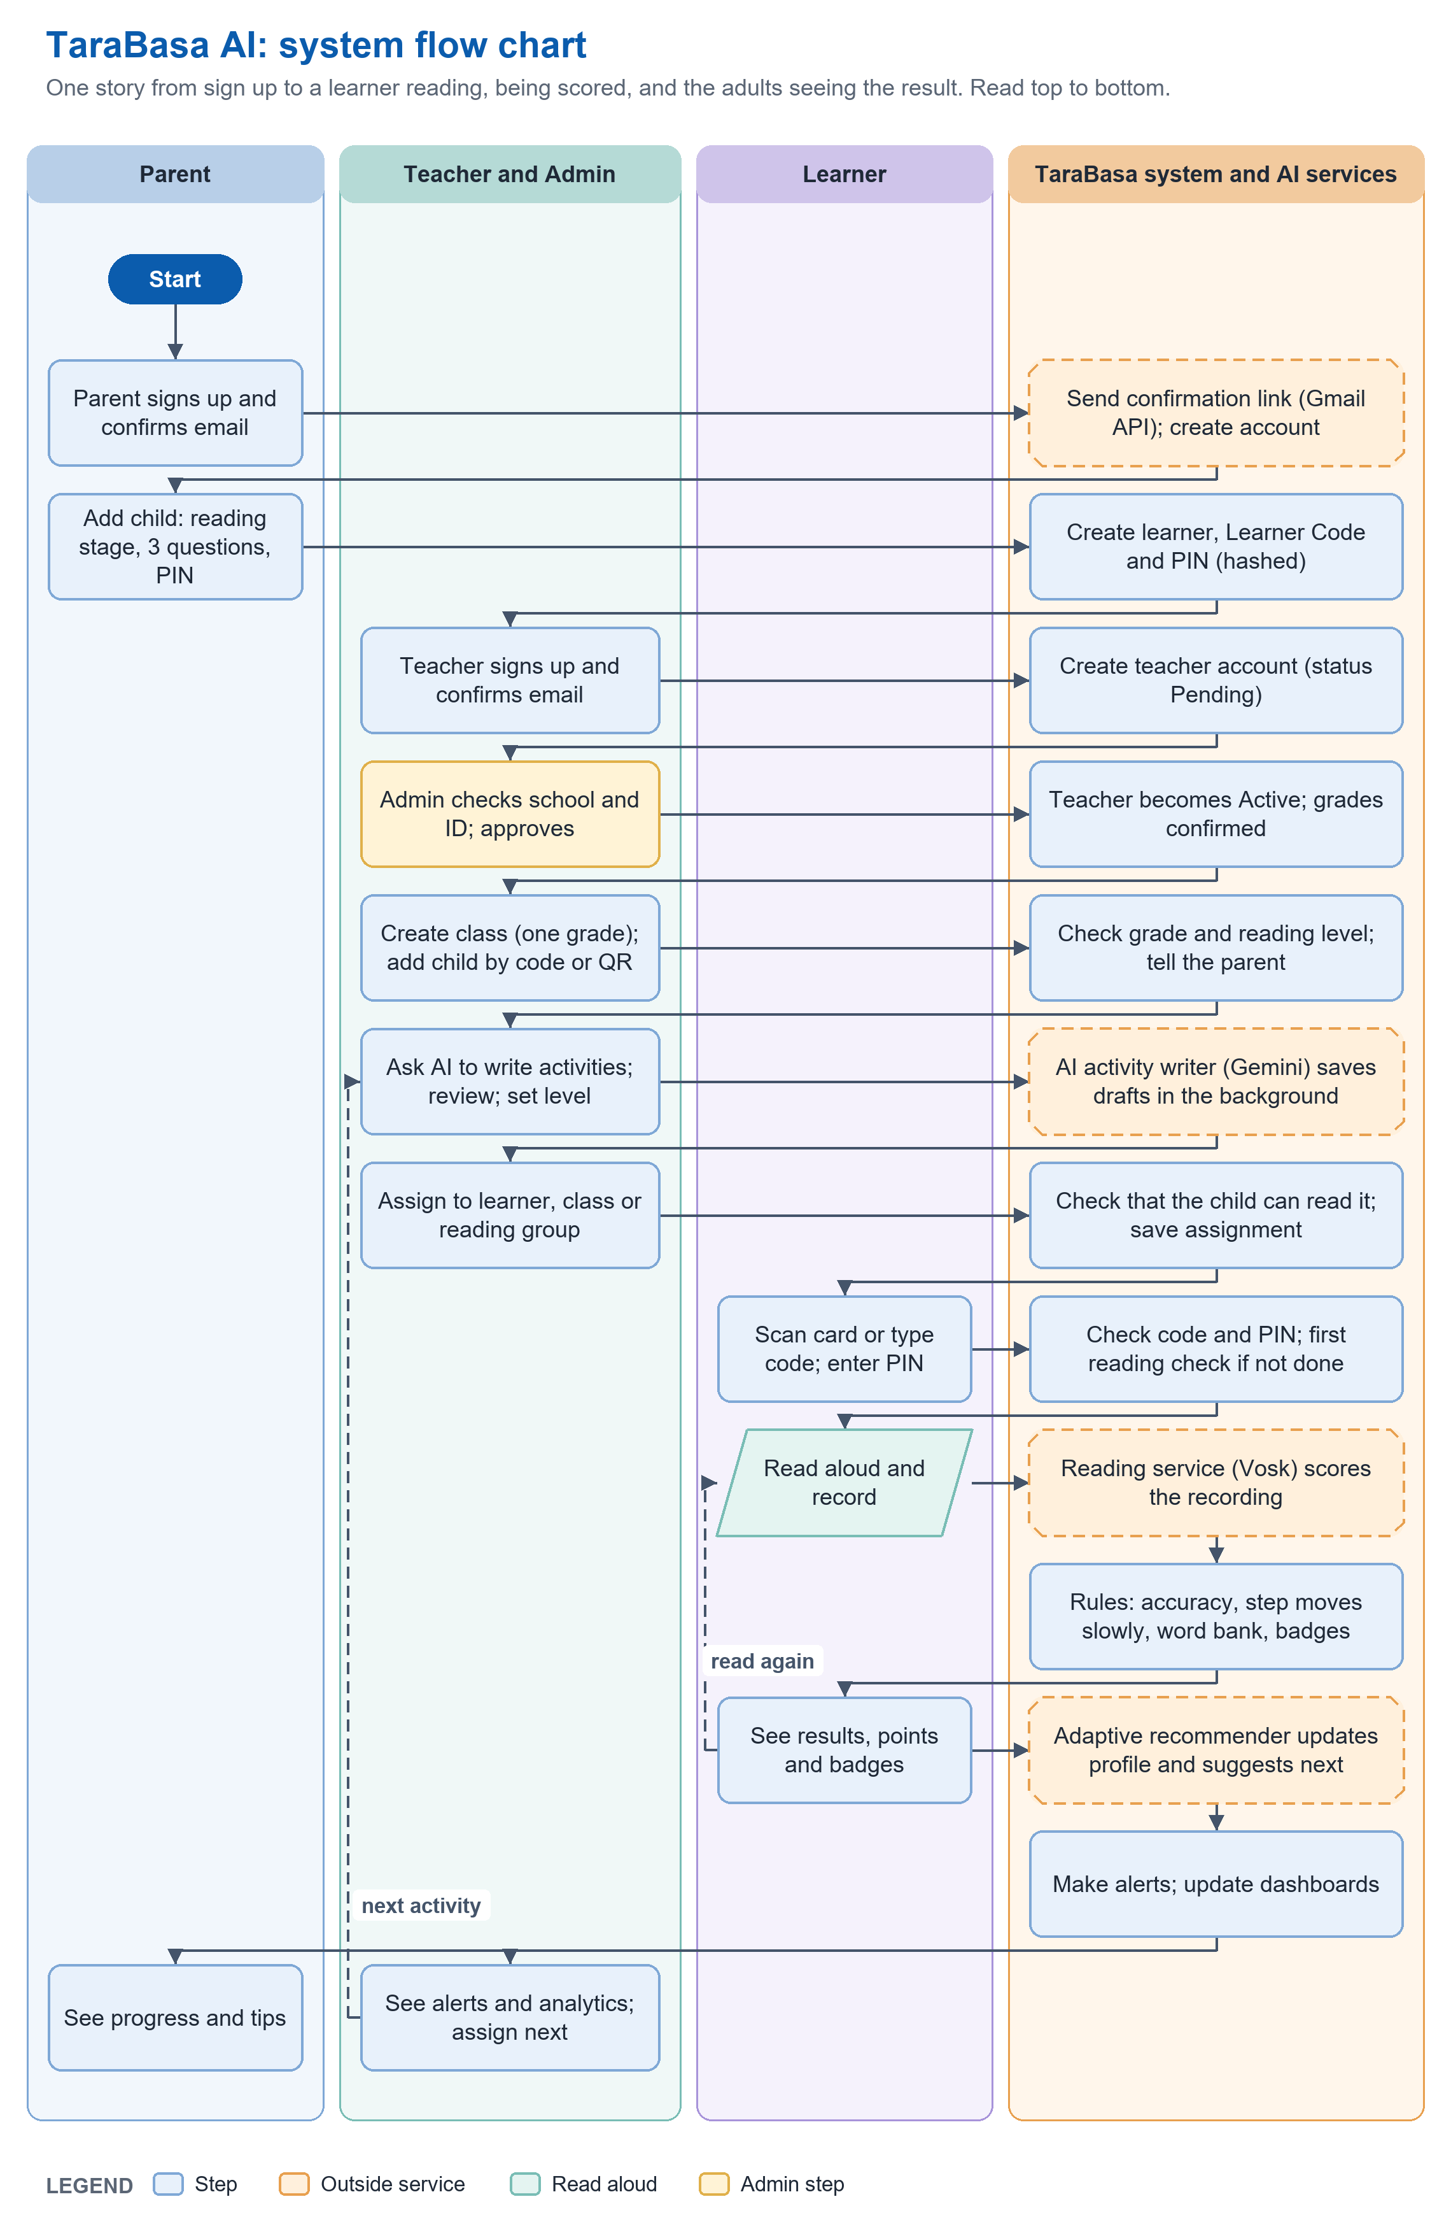
Figure 3.1: System Flow Chart
Figure 3.1 gives the flow of the whole system as one story. A parent signs up, confirms the email address, and adds a child, and the system creates the learner and the Learner Code. A teacher signs up, confirms the email address, and is approved by the Administrator, then creates a class, adds the child by code or QR, asks the AI service to write activities, reviews them, and assigns them. The learner signs in, completes the first reading check, and reads; the reading service scores each recording, written rules move the reading step slowly and keep the word bank and badges, and the adaptive recommender updates the learner’s profile and suggests what is next. The system then makes alerts and updates the dashboards that teachers and parents see, and the cycle repeats. The figures that follow show each actor’s workflow in detail.
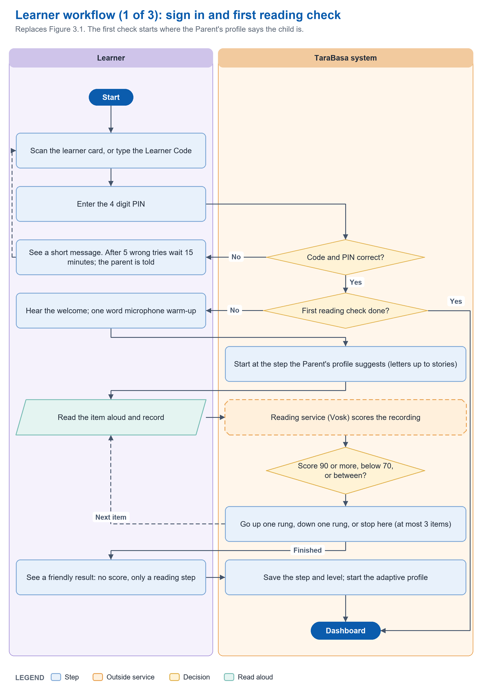
Figure 3.2: Program Workflow (Learners)
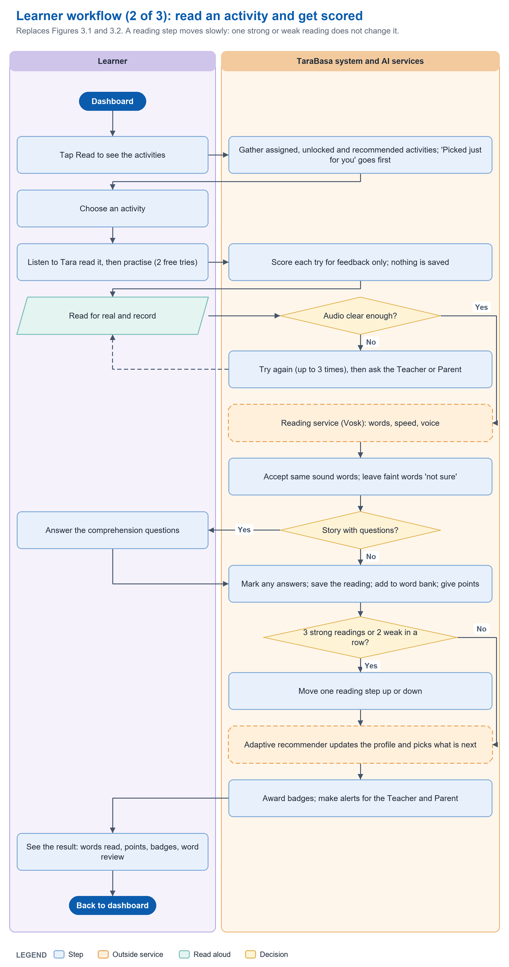
Figure 3.3: Program Workflow (Learners) cont'd
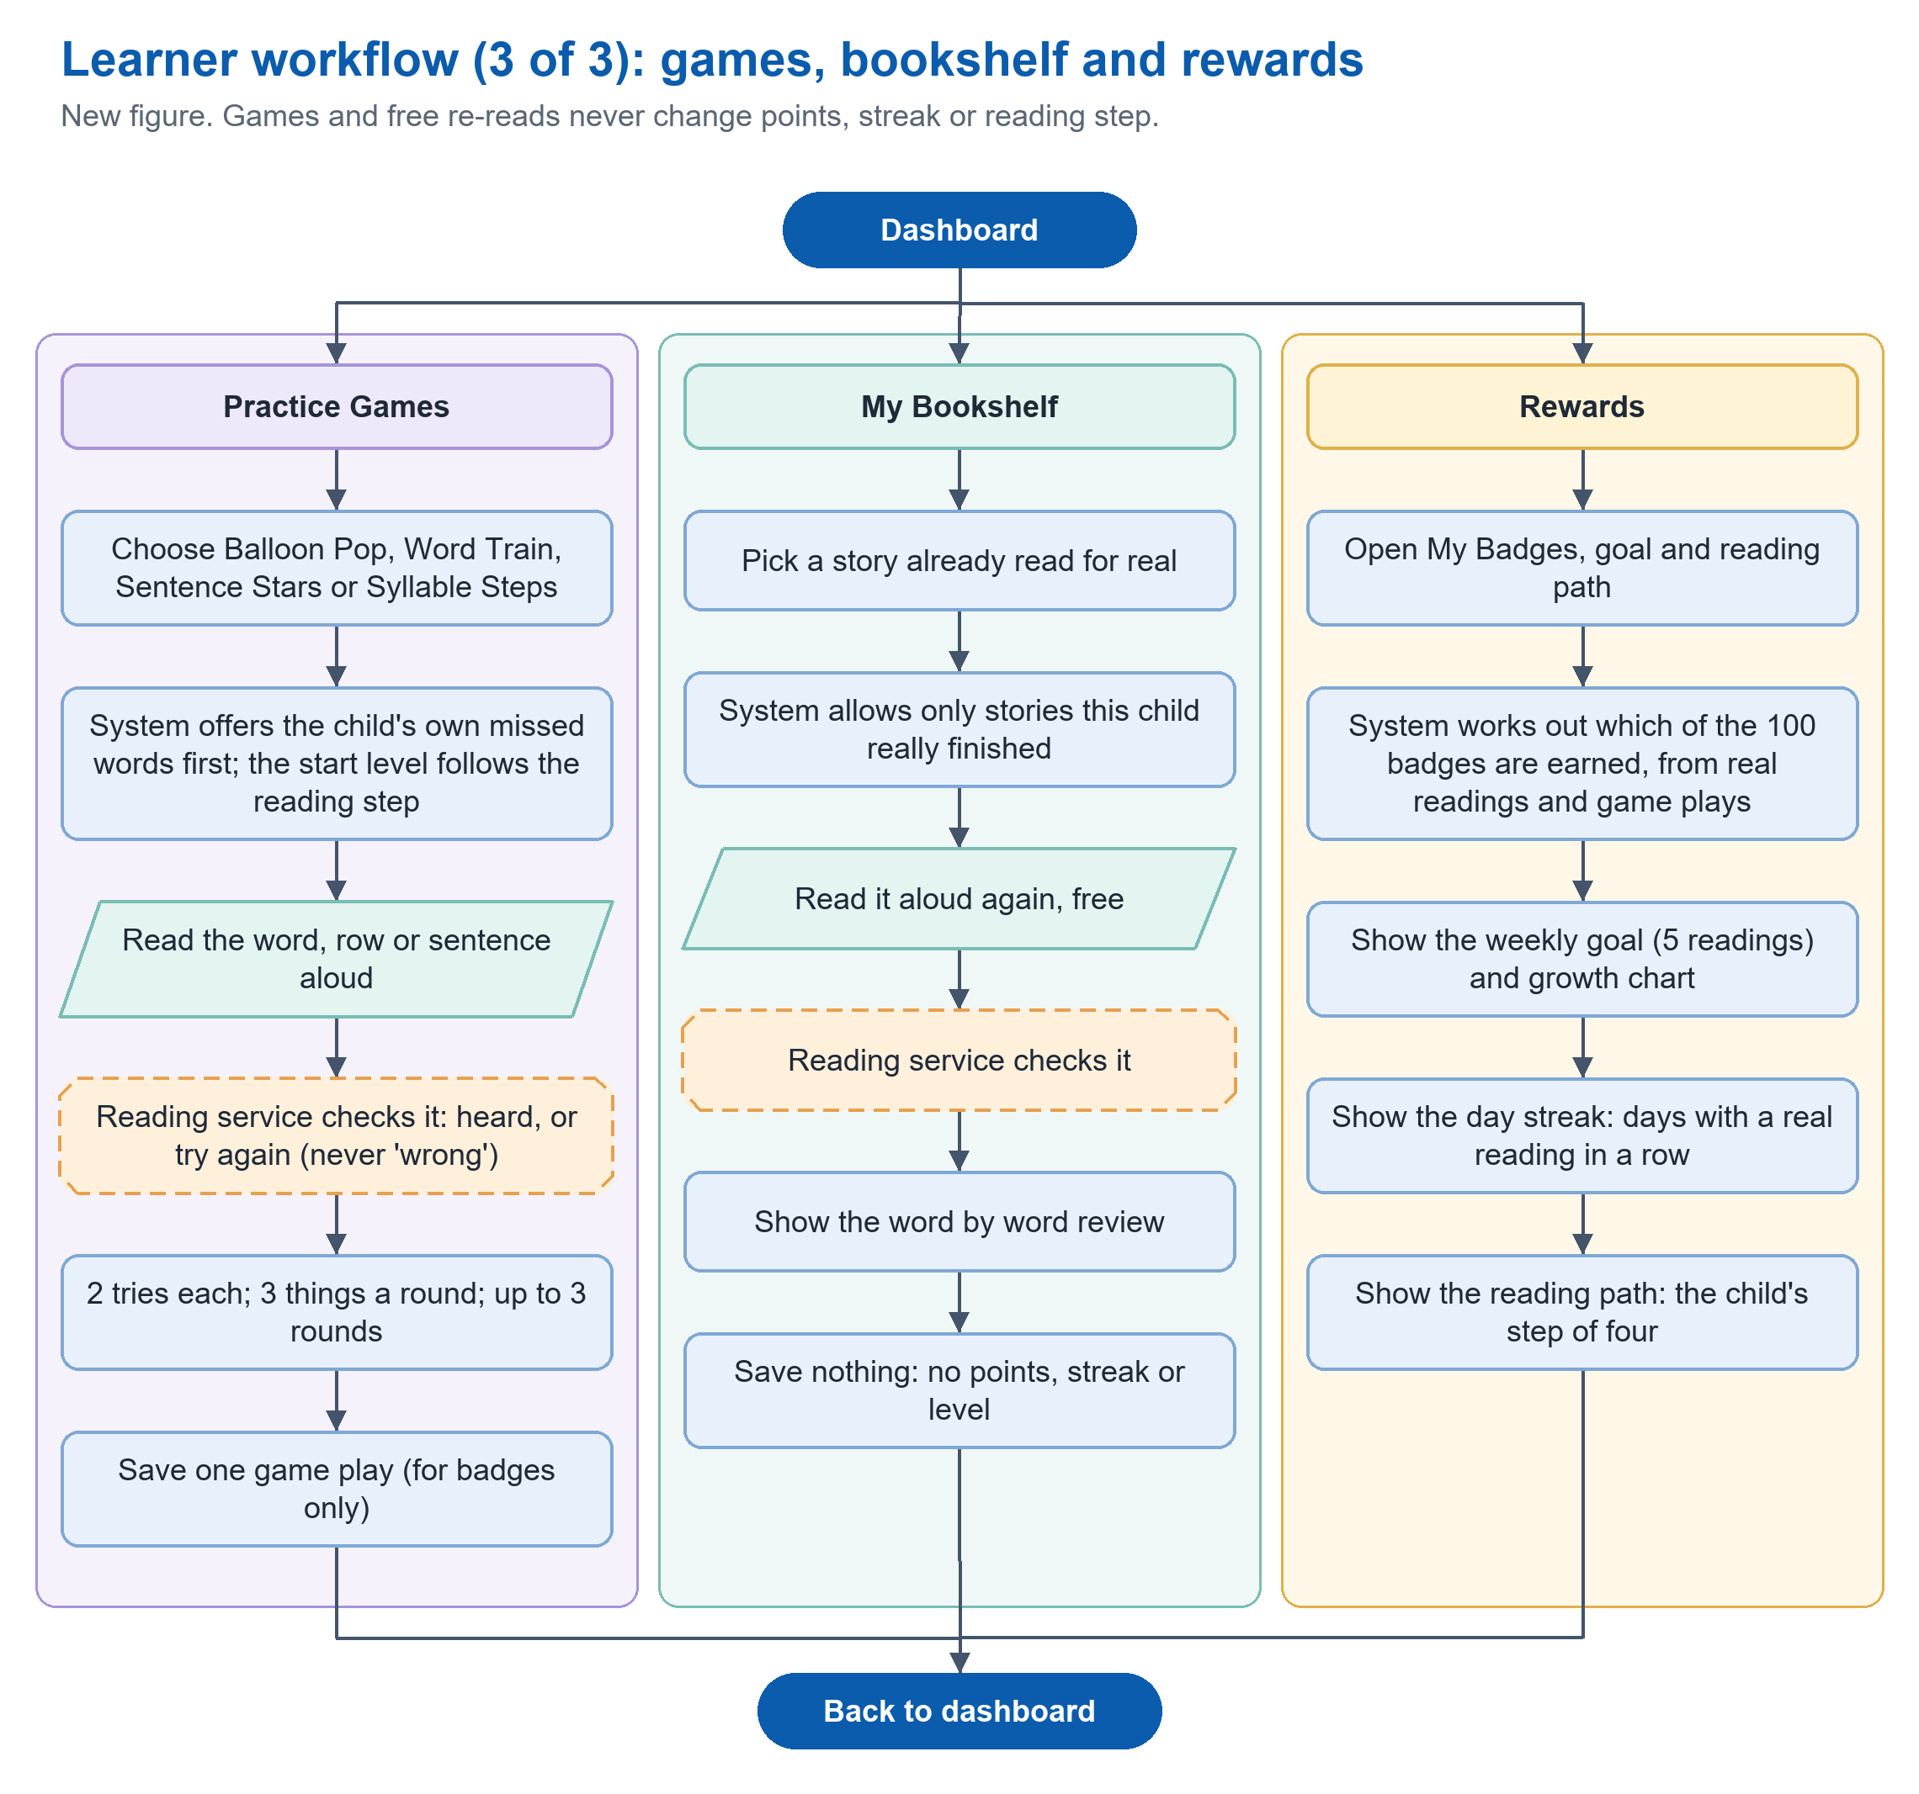
Figure 3.4: Program Workflow (Learners) cont'd
Figures 3.2 to 3.4 illustrate the workflow of the Learner actor. In Figure 3.2, the Learner signs in by scanning the learner card or typing the Learner Code and then entering a 4-digit PIN. The system checks the code and the PIN; after five wrong tries the Learner must wait 15 minutes and the Parent is told. A Learner who has not yet completed the first reading check hears a welcome, does a one-word microphone warm-up, and reads up to three items, starting at the step that the Parent’s profile suggests. The recording is scored by the reading service, and the system moves one rung up, one rung down, or stops, according to the score. The Learner sees a friendly result without a score, and the system saves the reading step and starts the learner’s adaptive profile. In Figure 3.3, a Learner who has finished the first check chooses an activity from those assigned by the Teacher, unlocked by the Parent, or recommended by the system, listens to Tara read the text, and may practice twice without any effect on the record. The final reading is recorded; a recording that cannot be heard may be repeated up to three times before the Learner is asked to see a Teacher or Parent. A valid recording is scored, words that sound the same are accepted, and faintly heard words are marked as not sure. A story with questions is followed by a short comprehension quiz. The system saves the reading, adds missed words to the Personal Word Bank, and gives points. The reading step moves only after three strong readings of at least two activities, or after two weak readings in a row, and then by one step only. The adaptive recommender updates the learner’s profile and suggests what to read next, badges are awarded, and alerts are made for the Teacher and the Parent. Figure 3.4 shows the Learner’s other options: read-aloud Practice Games, which never change points, streak, or reading step; My Bookshelf, which allows a finished story to be read again for free; and the Rewards area, which shows badges, the weekly goal, the day streak, and the reading path.
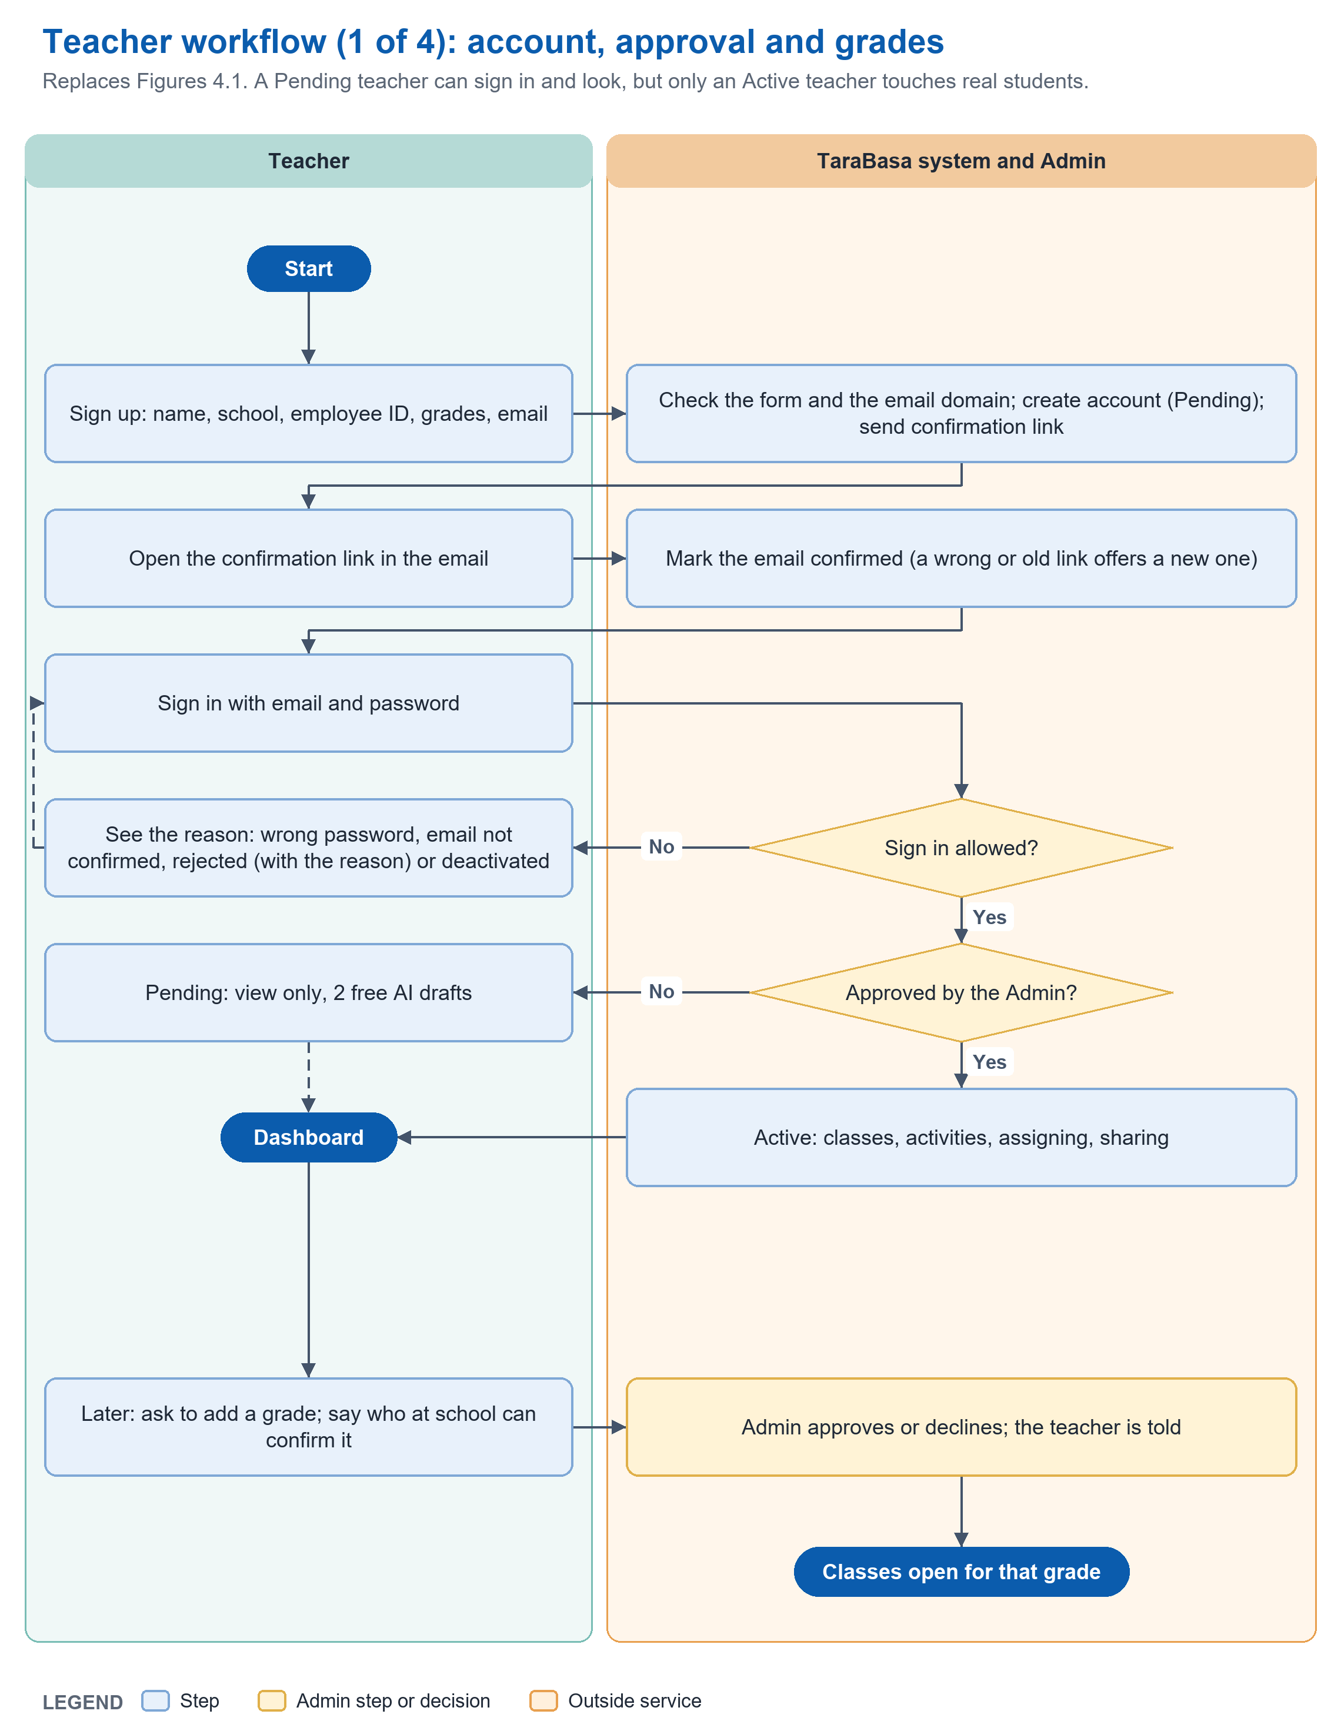
Figure 4.1: Program Workflow (Teacher)
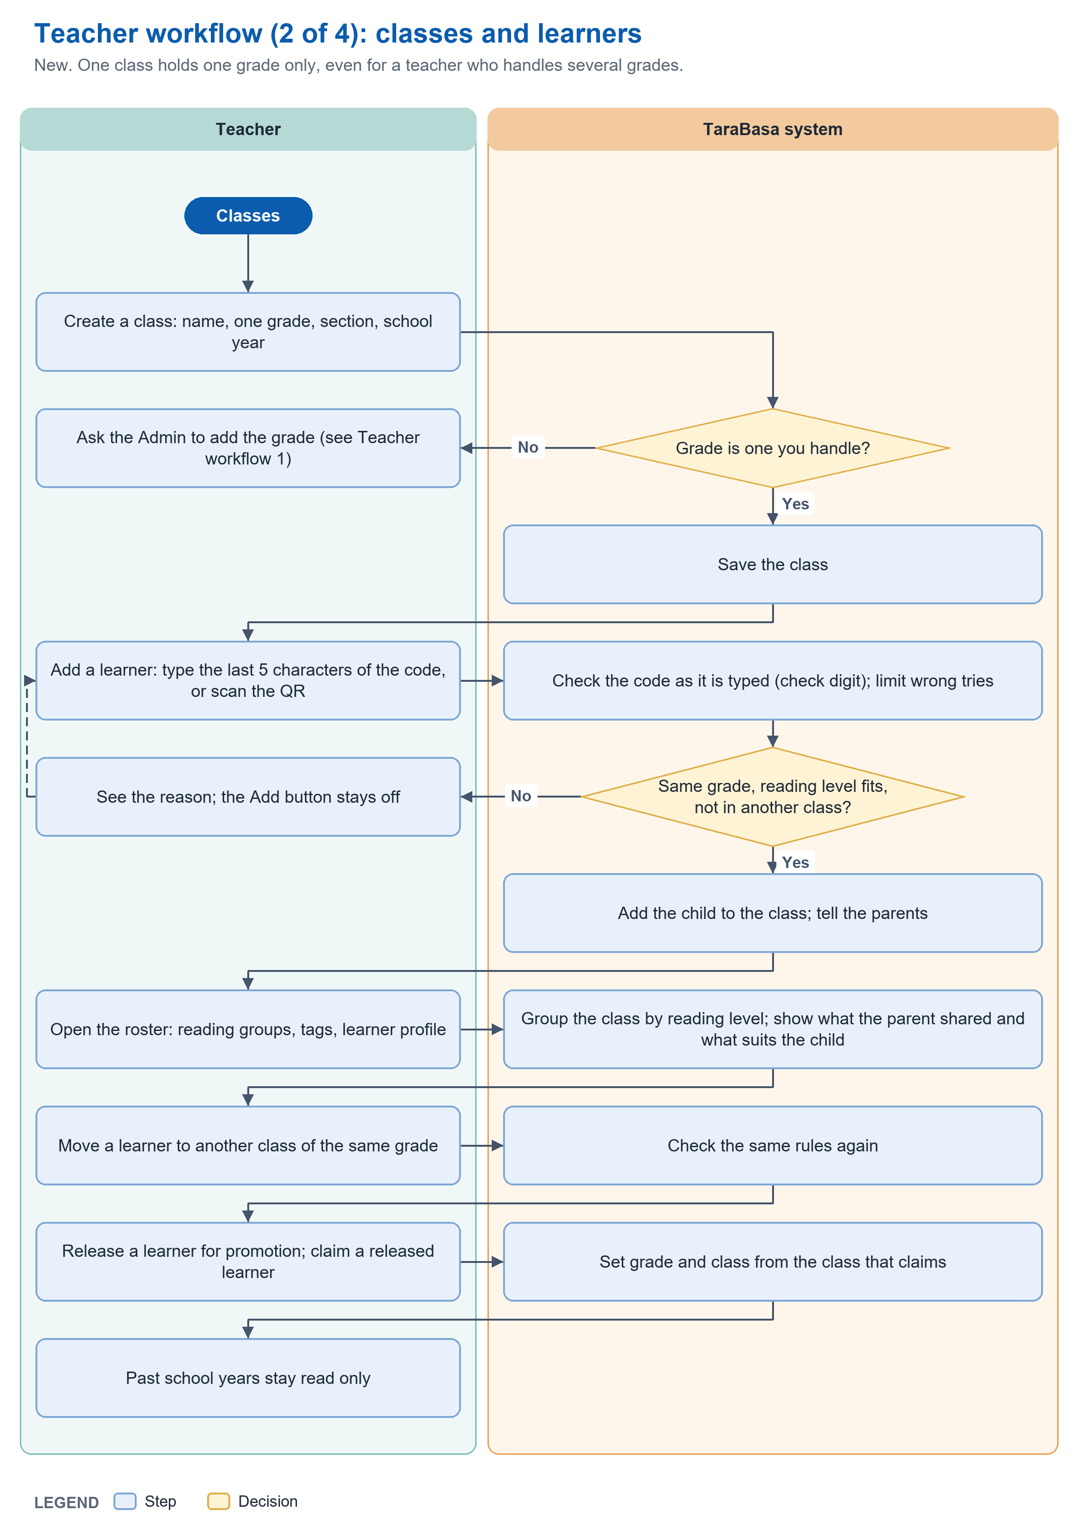
Figure 4.2: Program Workflow (Teacher) cont'd
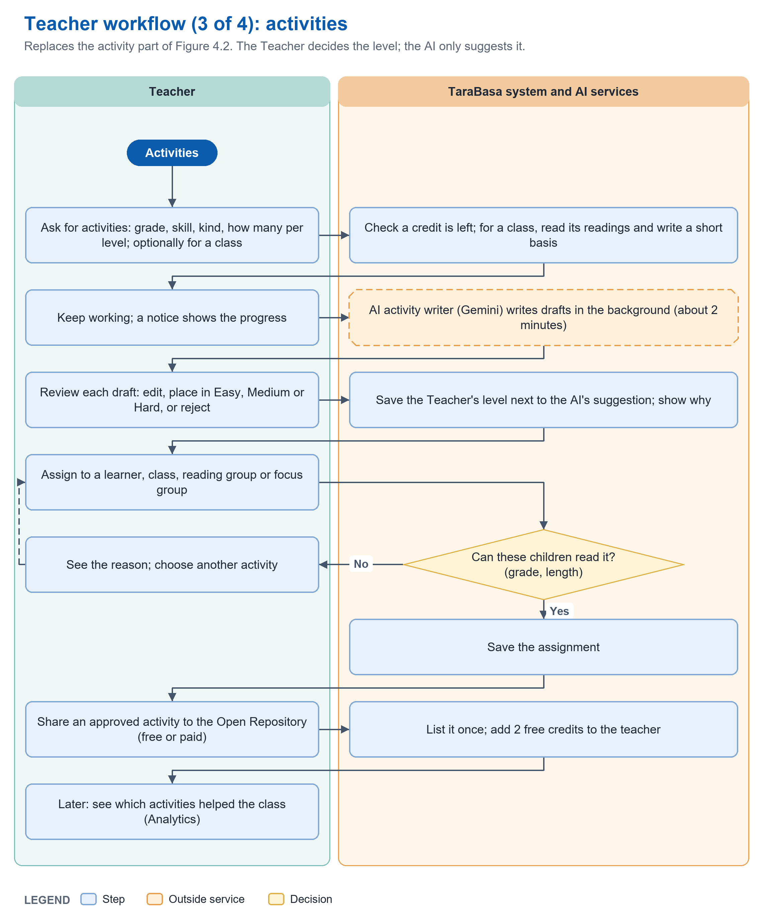
Figure 4.3: Program Workflow (Teacher) cont'd
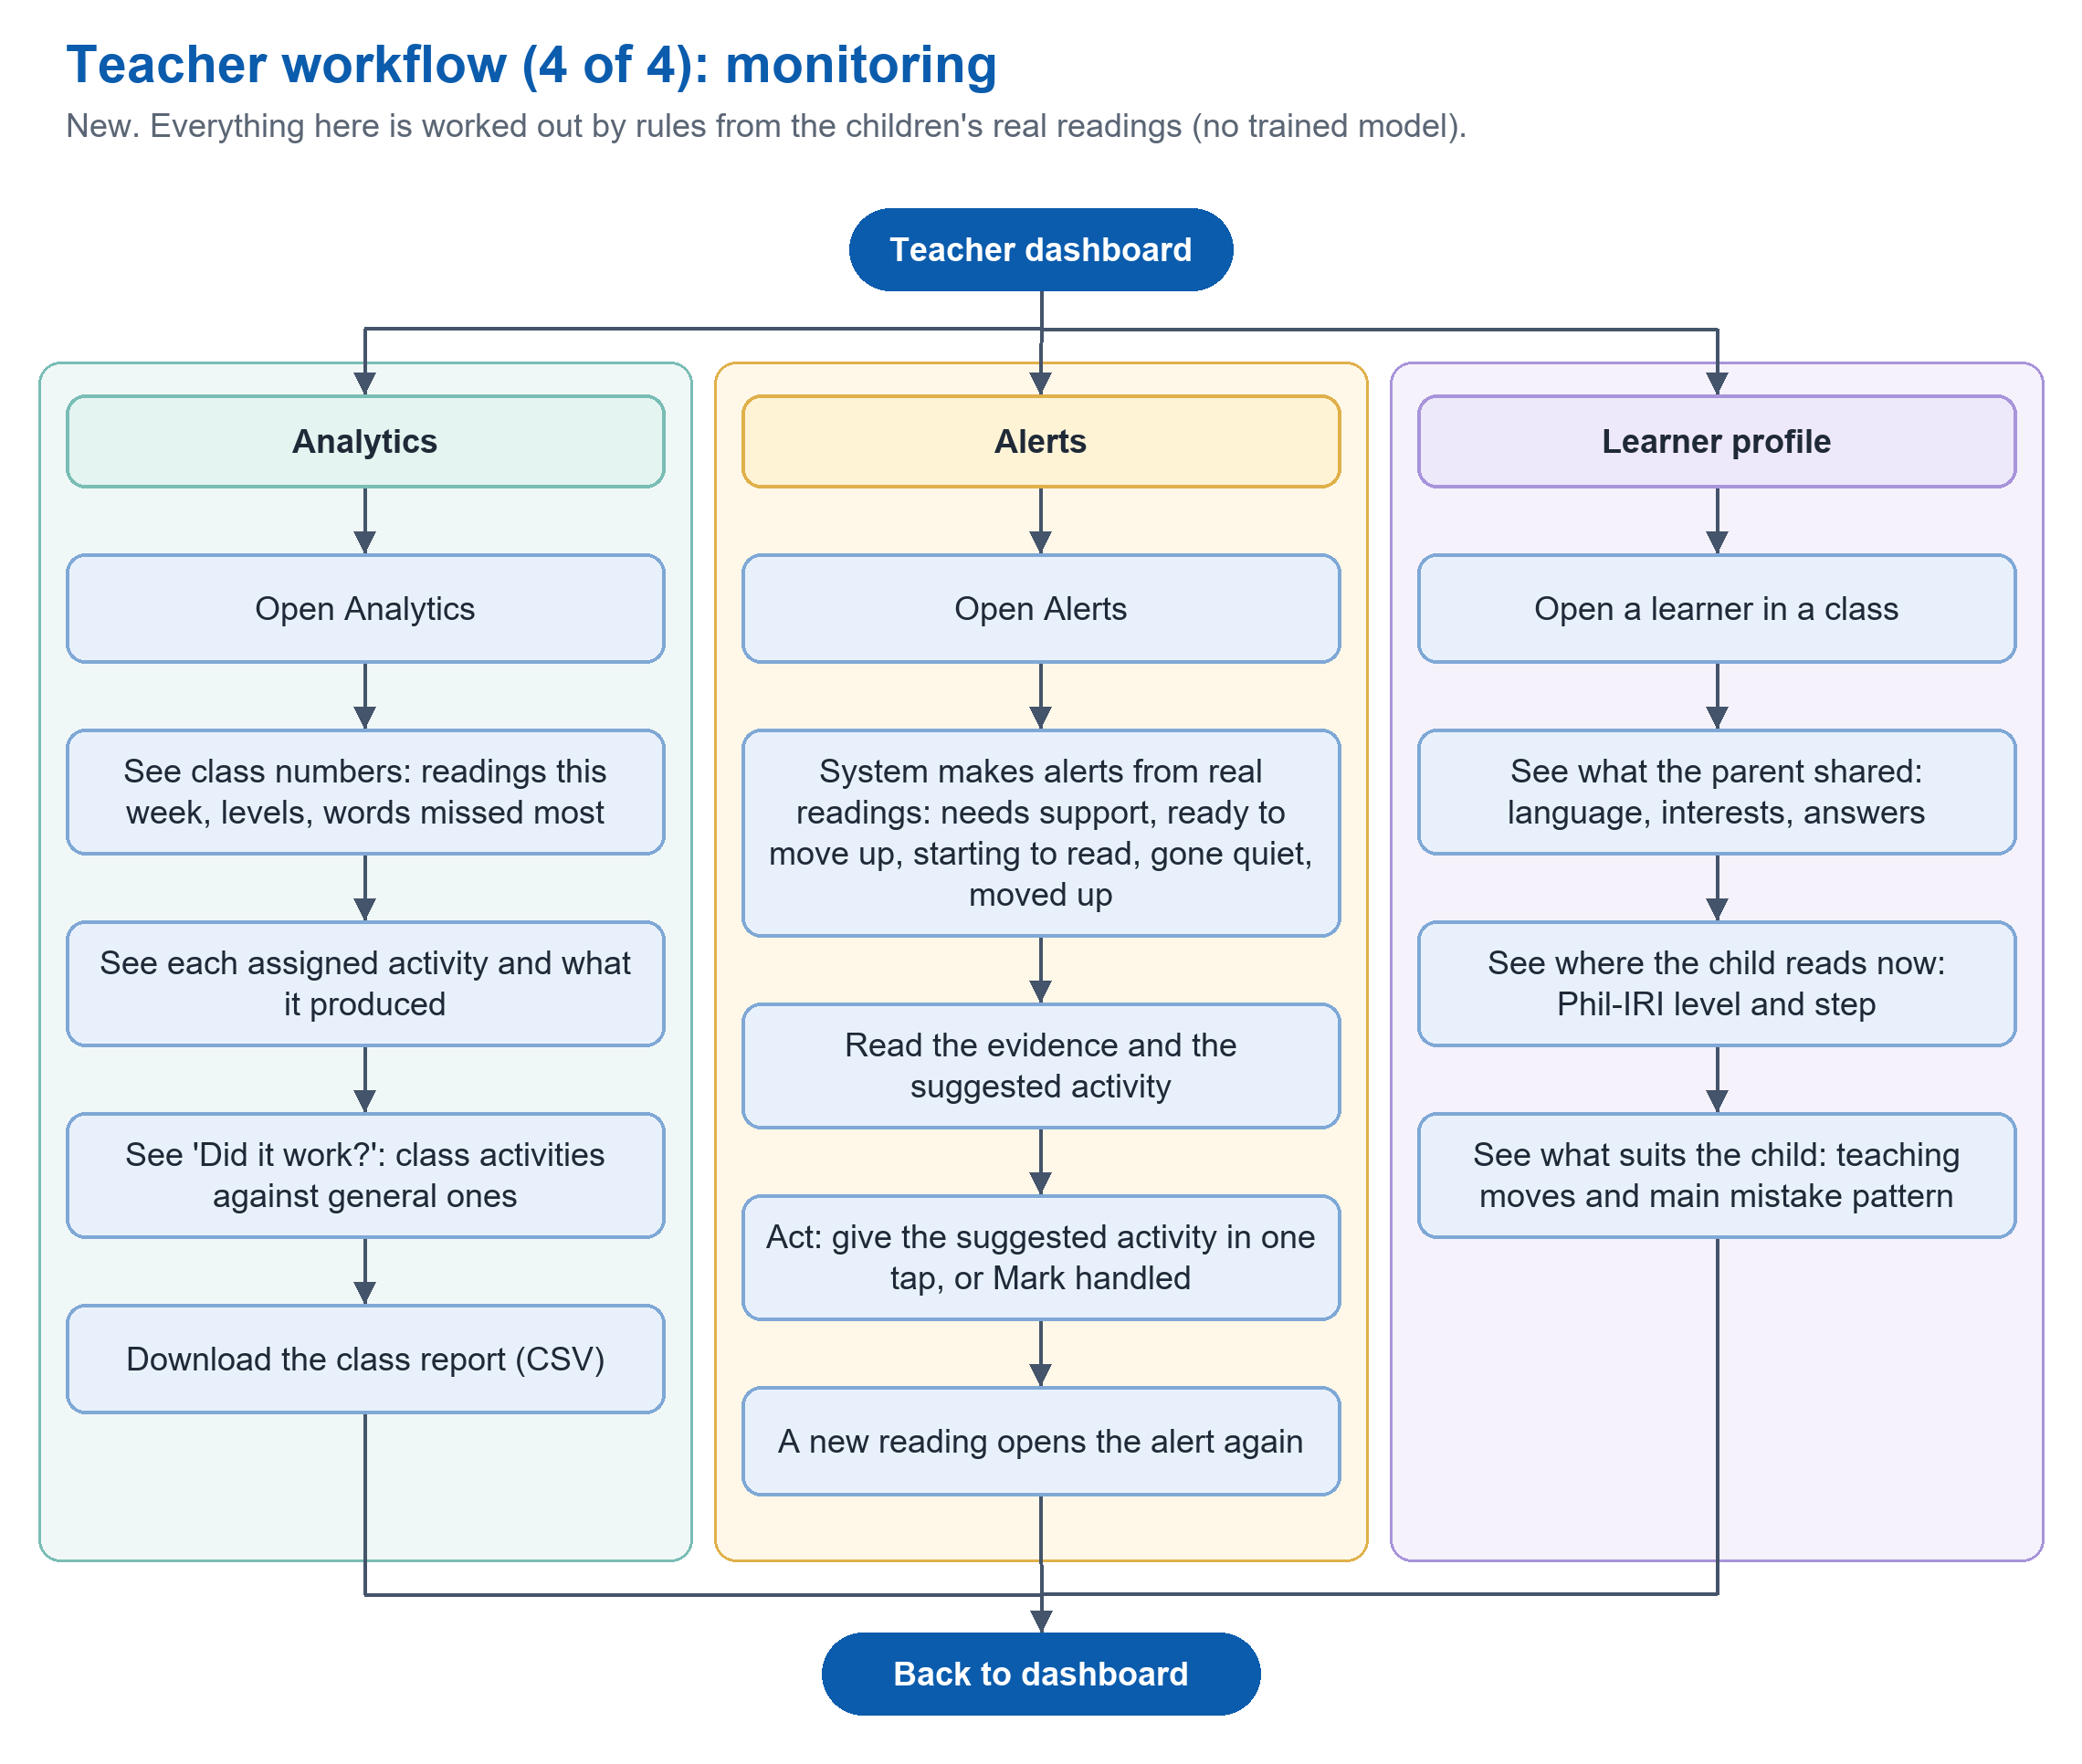
Figure 4.4: Program Workflow (Teacher) cont'd
Figures 4.1 to 4.4 present the workflow of the Teacher actor. In Figure 4.1, the Teacher signs up with a name, school, employee identification number, the grades handled, and an email address. The system checks the form and the email domain, creates the account as Pending, and sends a confirmation link. After the Teacher opens the link and signs in, a Pending account can view the dashboard and use the free AI drafts, while an account approved by the Administrator has full access to classes, activities, assigning, and sharing. A Teacher who later handles another grade asks the Administrator to add it and names a person at the school who can confirm it; the grade is added only when the Administrator approves. Figure 4.2 shows classes and learners. A class belongs to one grade only, even for a Teacher who handles several grades. A Teacher adds a learner by typing the last five characters of the Learner Code or by scanning the learner card. The system checks the code while it is typed and allows the Add button only when the learner is of the class’s grade, does not read far above the level of the class, and is not already in another class. The Teacher can then view the roster divided into reading groups, open a learner’s profile, move a learner to another class of the same grade, and release or claim a learner for promotion. Figure 4.3 shows activities. The Teacher asks for activities by grade, skill, kind, and the number wanted at each level, optionally for one class, and the activity writer prepares the drafts in the background. The Teacher edits each draft, places it in the Easy, Medium, or Hard level, or rejects it, and assigns approved activities to a learner, class, reading group, or focus group. The system refuses an assignment that the children could not read because of its grade or length, and an approved activity may be shared to the Open Repository, which adds free generation credits. Figure 4.4 shows monitoring: analytics, alerts that suggest a next step, and the learner profile. The Teacher does not browse the Open Repository; only Parents do.
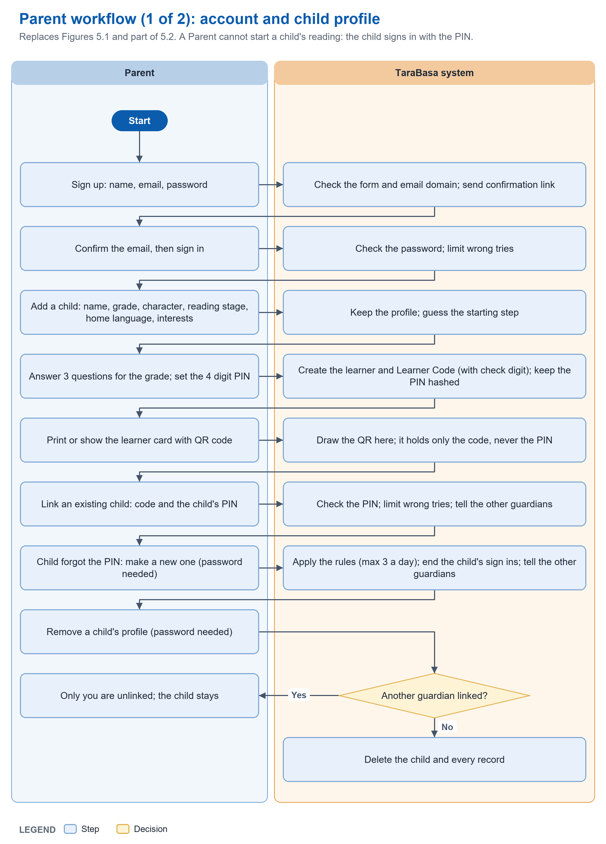
Figure 5.1: Program Workflow (Parents)
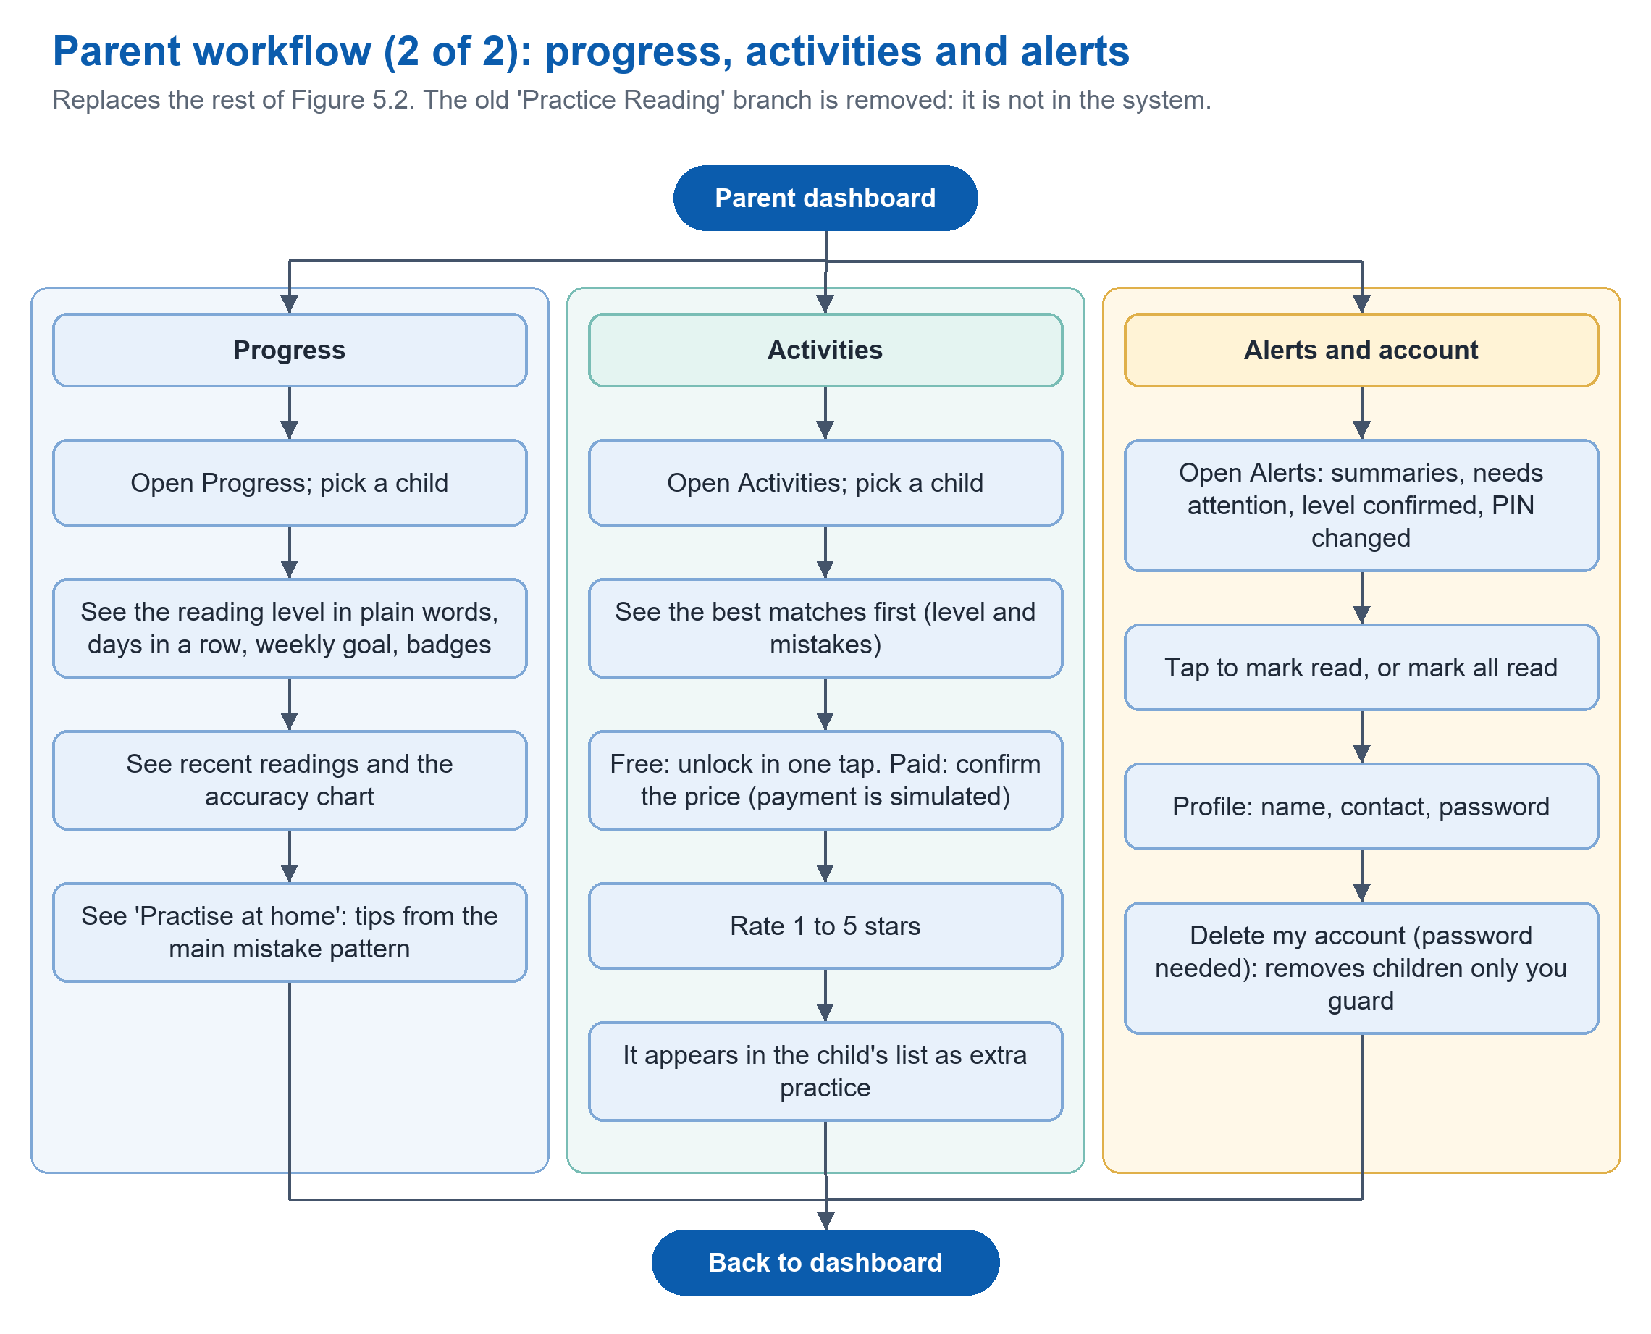
Figure 5.2: Program Workflow (Parents) cont'd
Figures 5.1 and 5.2 detail the workflow of the Parent actor. The Parent signs up, confirms the email address, and signs in. To add a child, the Parent enters the name, grade, character, reading stage, and optionally the home language, supports, and interests, answers three questions about the child’s reading, and sets a 4-digit PIN. The system creates the learner and the Learner Code and shows a printable learner card with a QR code that holds only the code. A Parent can link an existing child with the code and the child’s PIN, make a new PIN for a child who forgot it (the Parent’s password is needed and the number of changes is limited), and remove a child’s profile; if another guardian is linked, only the Parent who asked is unlinked, and otherwise the child’s records are deleted. In Figure 5.2, the Parent opens Progress to see the child’s reading level in plain words, days in a row, weekly goal, badges, recent readings, and tips for practicing at home; opens Activities to see the Open Repository with the best matches for the child first, unlock a free or paid activity (the payment is simulated), and rate it; and opens Alerts and the profile. A Parent cannot start a reading for a child. A child reads only after signing in with the PIN, so that the Parent’s own sign in is not a way around the child’s account.
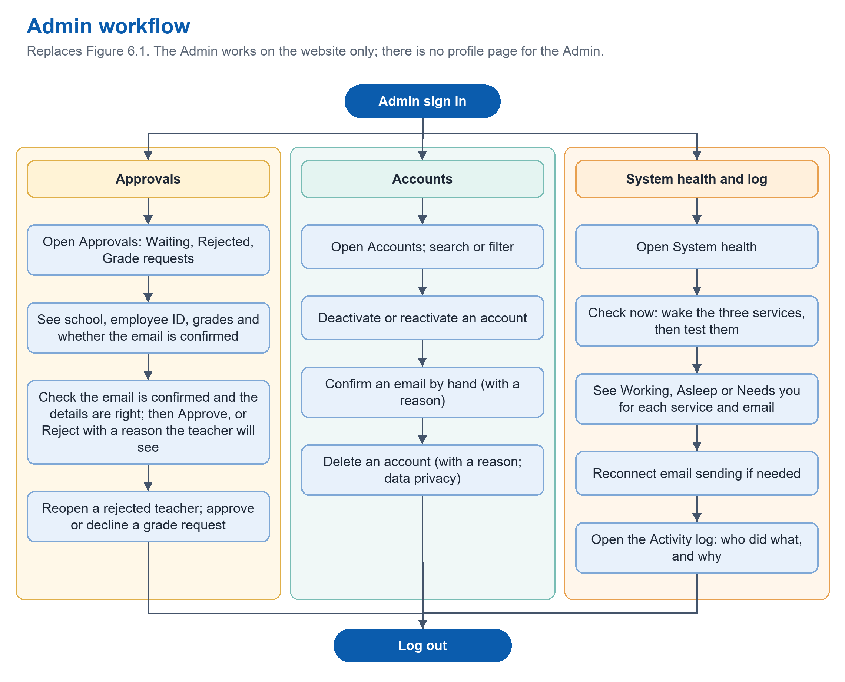
Figure 6.1: Program Workflow (Administrator)
Figure 6.1 presents the workflow of the Administrator actor, who works on the website only. After signing in, the Administrator opens Approvals to see the teachers who are waiting, with their school, employee identification number, grades, and whether the email address is confirmed. The Administrator approves a teacher whose details are correct, or rejects the account with a reason that the teacher will see, and may reopen a rejected account or approve or decline a request to add a grade. In Accounts the Administrator searches and filters accounts, deactivates or reactivates an account, confirms an email address by hand with a reason, and deletes an account with a reason. In System health the Administrator tests the reading service, the activity writer, the adaptive recommender, and email sending, and reconnects email sending when needed. The Activity log records who did what and why. There is one Administrator account, created by the system’s owners, and there is no self-registration.
----- end of C4: copy only the text above this line -----
C5  DECISION | Place at: Chapter 3, 'Validation Board' (pages 53 to 57), and Chapter 1, 'Scope and Limitations'.  Replaces: The pilot school and the survey numbers.  Basis: Two things the writer must settle with the team before editing; this block has no text to paste.

1. Which school? Chapter 1 says 'a selected public elementary school in Cebu City'. The Validation Board says 'Suba Elementary School in Liloan, Cebu' (twice). Liloan is a municipality, not Cebu City. Use one wording everywhere (Chapter 1, Chapter 3 Validation Board and Development Phase, the transmittal letter in Appendix A).
2. How many respondents? The Validation Board gives percentages (90.9 percent and 84.7 percent agreed; 36.4 percent and 63.6 percent for phonics) but no number of respondents. Write 'n =' for each group. The teacher percentages fit 11 respondents exactly (10 of 11 is 90.9 percent, 4 of 11 is 36.4 percent, 7 of 11 is 63.6 percent). Please confirm this against Appendix D. The parent percentage 84.7 does not fit a small number; take n from Appendix E.
Suggested sentence pattern: 'Based on the survey of [n] teachers (Appendix D), [x] percent agreed that ...'.
----- end of C5: copy only the text above this line -----
C6  UPDATED | Place at: Chapter 3, 'Gantt Chart/PERT Chart', Tables 6.1 to 6.4 (pages 58 to 61).  Replaces: Task names that say SMS or pronunciation feedback, and the coloured bars.  Basis: SMS was dropped; the colours (green complete, yellow ongoing, red incomplete) must show the real status on the date of submission.  Note: Dates are the team's own plan; only the task names are changed here.

Task ID | Replace this task name | With this
4.1.6 | SMS Notification Integration for Parents | Alerts and Notification Management for Teachers and Parents
4.2.3 | Speech Recognition and Pronunciation Feedback System | Speech Recognition and Word Feedback System
4.3.6 | Validate SMS Notification triggers | Validate alert and notification triggers
4.4.3 | Deploy Parent Web Dashboard and SMS integration | Deploy Parent Web Dashboard and email sending
4.4.4 | Deploy local version of Learner Mobile App | Deploy the Android application (Learner, Teacher and Parent) as a test build
4.5.6 | Verify sms notificatiom, delivery speed, message accuracy and web-based notification feedback behavior | Verify alert accuracy, email delivery, and notification behavior
4.2 (new rows) | (none) | Add: Teacher and Parent screens in the mobile application; Practice Games; Admin system health and activity log

----- end of C6: copy only the text above this line -----
C7  UPDATED | Place at: Chapter 3, 'Functional Decomposition Diagram' (pages 61 to 66). Replace Figures 7.1 to 7.6 and their paragraphs with Figures 7.1 to 7.12 below.  Replaces: The nine-module FDD. Page 61 also repeats the words 'Figure 7.1 Figure 7.1 presents' (delete one).  Basis: Nine modules in version 29 leave out the system's adaptive rules and the Administrator's screens, and the modules appear in a different order in the figure (Reading Assessment fifth) than in the List of Modules (Open Repository fifth). Version 2 keeps the List of Modules numbering for both.  Note: The panel review sheet (03_FDD_and_Use_Case_Panel_Review.docx) lists every function as new, updated, or unchanged and shows the old to new mapping.

Functional Decomposition Diagram
This section presents the functional decomposition diagram, which breaks the proposed system into eleven modules and shows, for each module, the functions that each type of user can perform. It provides a clear overview of the system’s processes and improves the understanding of how the application operates.
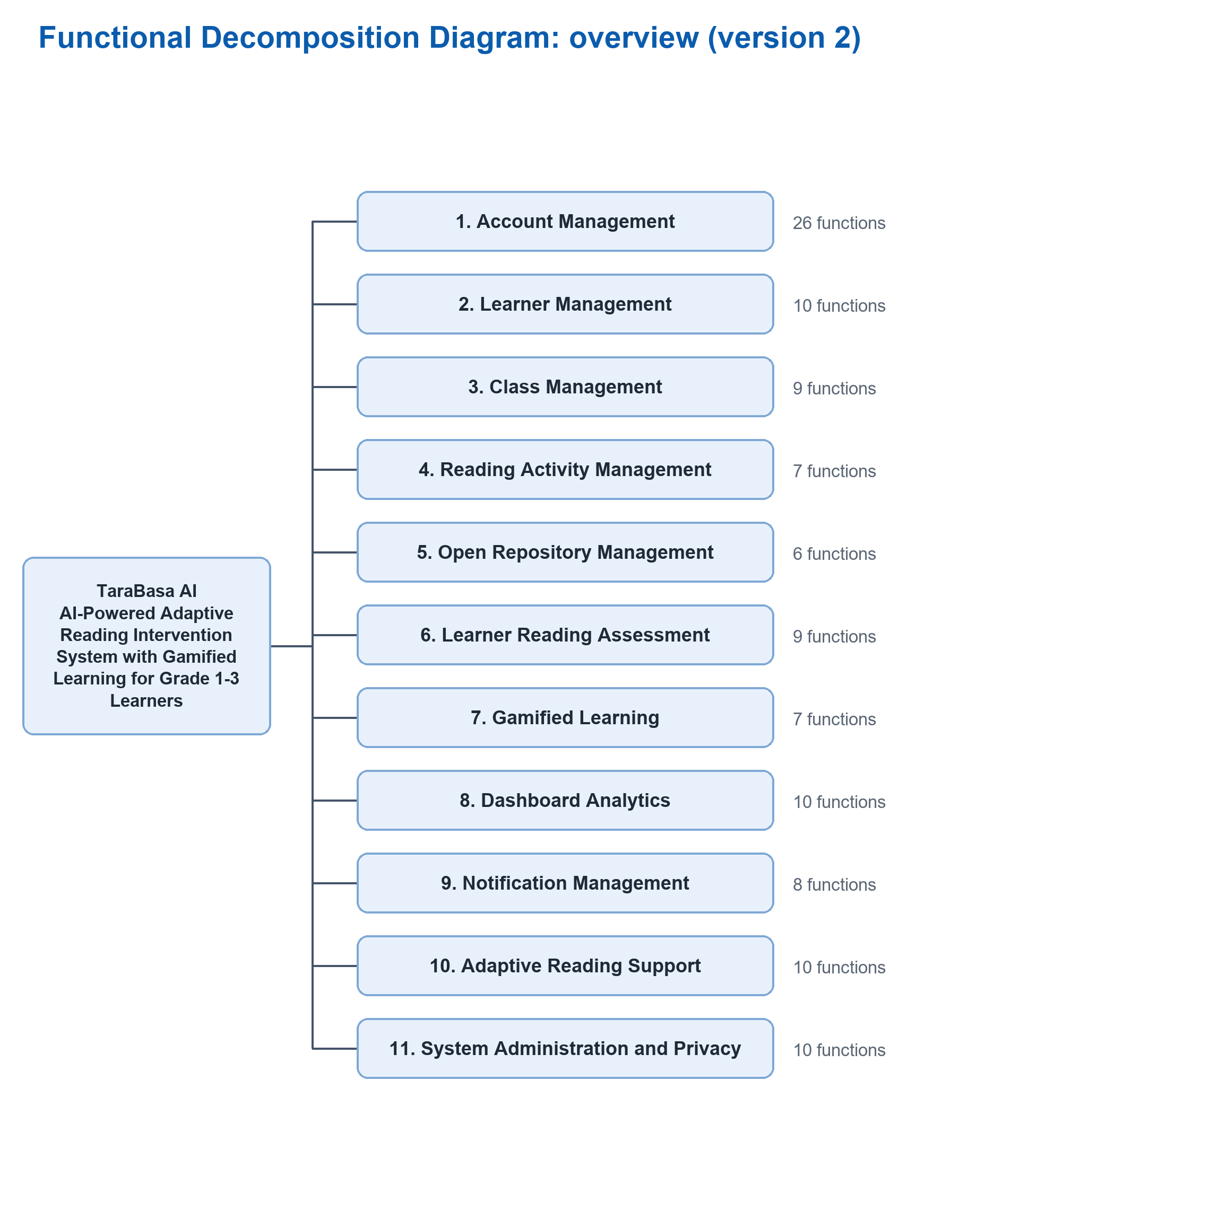
Figure 7.1: Functional Decomposition Diagram
Figure 7.1 presents the overall structure of TaraBasa AI, decomposed into eleven modules: Account Management, Learner Management, Class Management, Reading Activity Management, Open Repository Management, Learner Reading Assessment, Gamified Learning, Dashboard Analytics, Notification Management, Adaptive Reading Support, and System Administration and Privacy. Account Management, Learner Management, and Class Management handle who uses the system, who belongs to it, and how learners are grouped. Reading Activity Management and Open Repository Management cover the creation, approval, assignment, and sharing of reading activities. Learner Reading Assessment and Gamified Learning cover the learner’s reading experience, while Dashboard Analytics and Notification Management keep teachers and parents informed of progress. Adaptive Reading Support holds the rules and services that the system applies to each reading, and System Administration and Privacy holds the administrator’s functions, including the deletion of accounts.
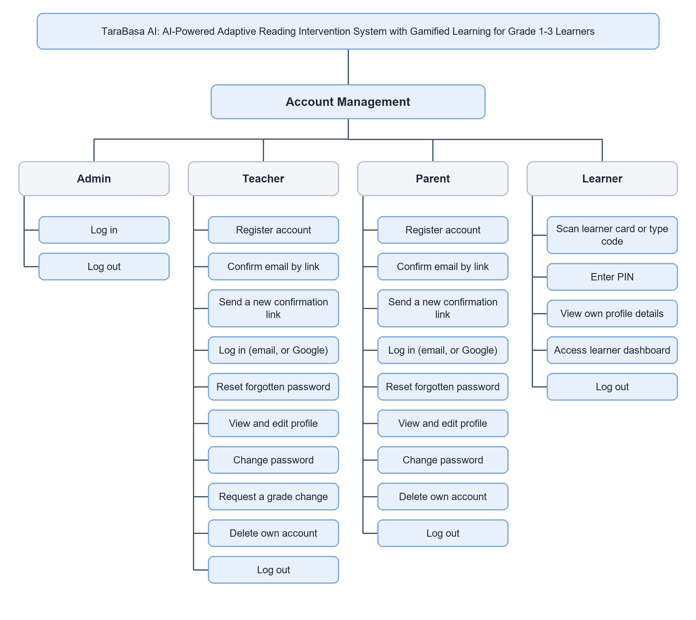
Figure 7.2: Functional Decomposition Diagram cont'd
Figure 7.2 presents the Account Management module. The Administrator signs in and signs out. A Teacher and a Parent each register, confirm the email address by a link (and may ask for a new link), sign in with an email and password or with a Google account on the website, reset a forgotten password, view and edit the profile, change the password, and sign out. A Teacher may also ask to handle another grade, and both may delete their own account. A Learner scans the learner card or types the Learner Code, enters the PIN, views the learner’s own profile details, uses the learner dashboard, and signs out. A Learner never registers alone, which reflects the system’s design principle that a parent creates the learner’s account.
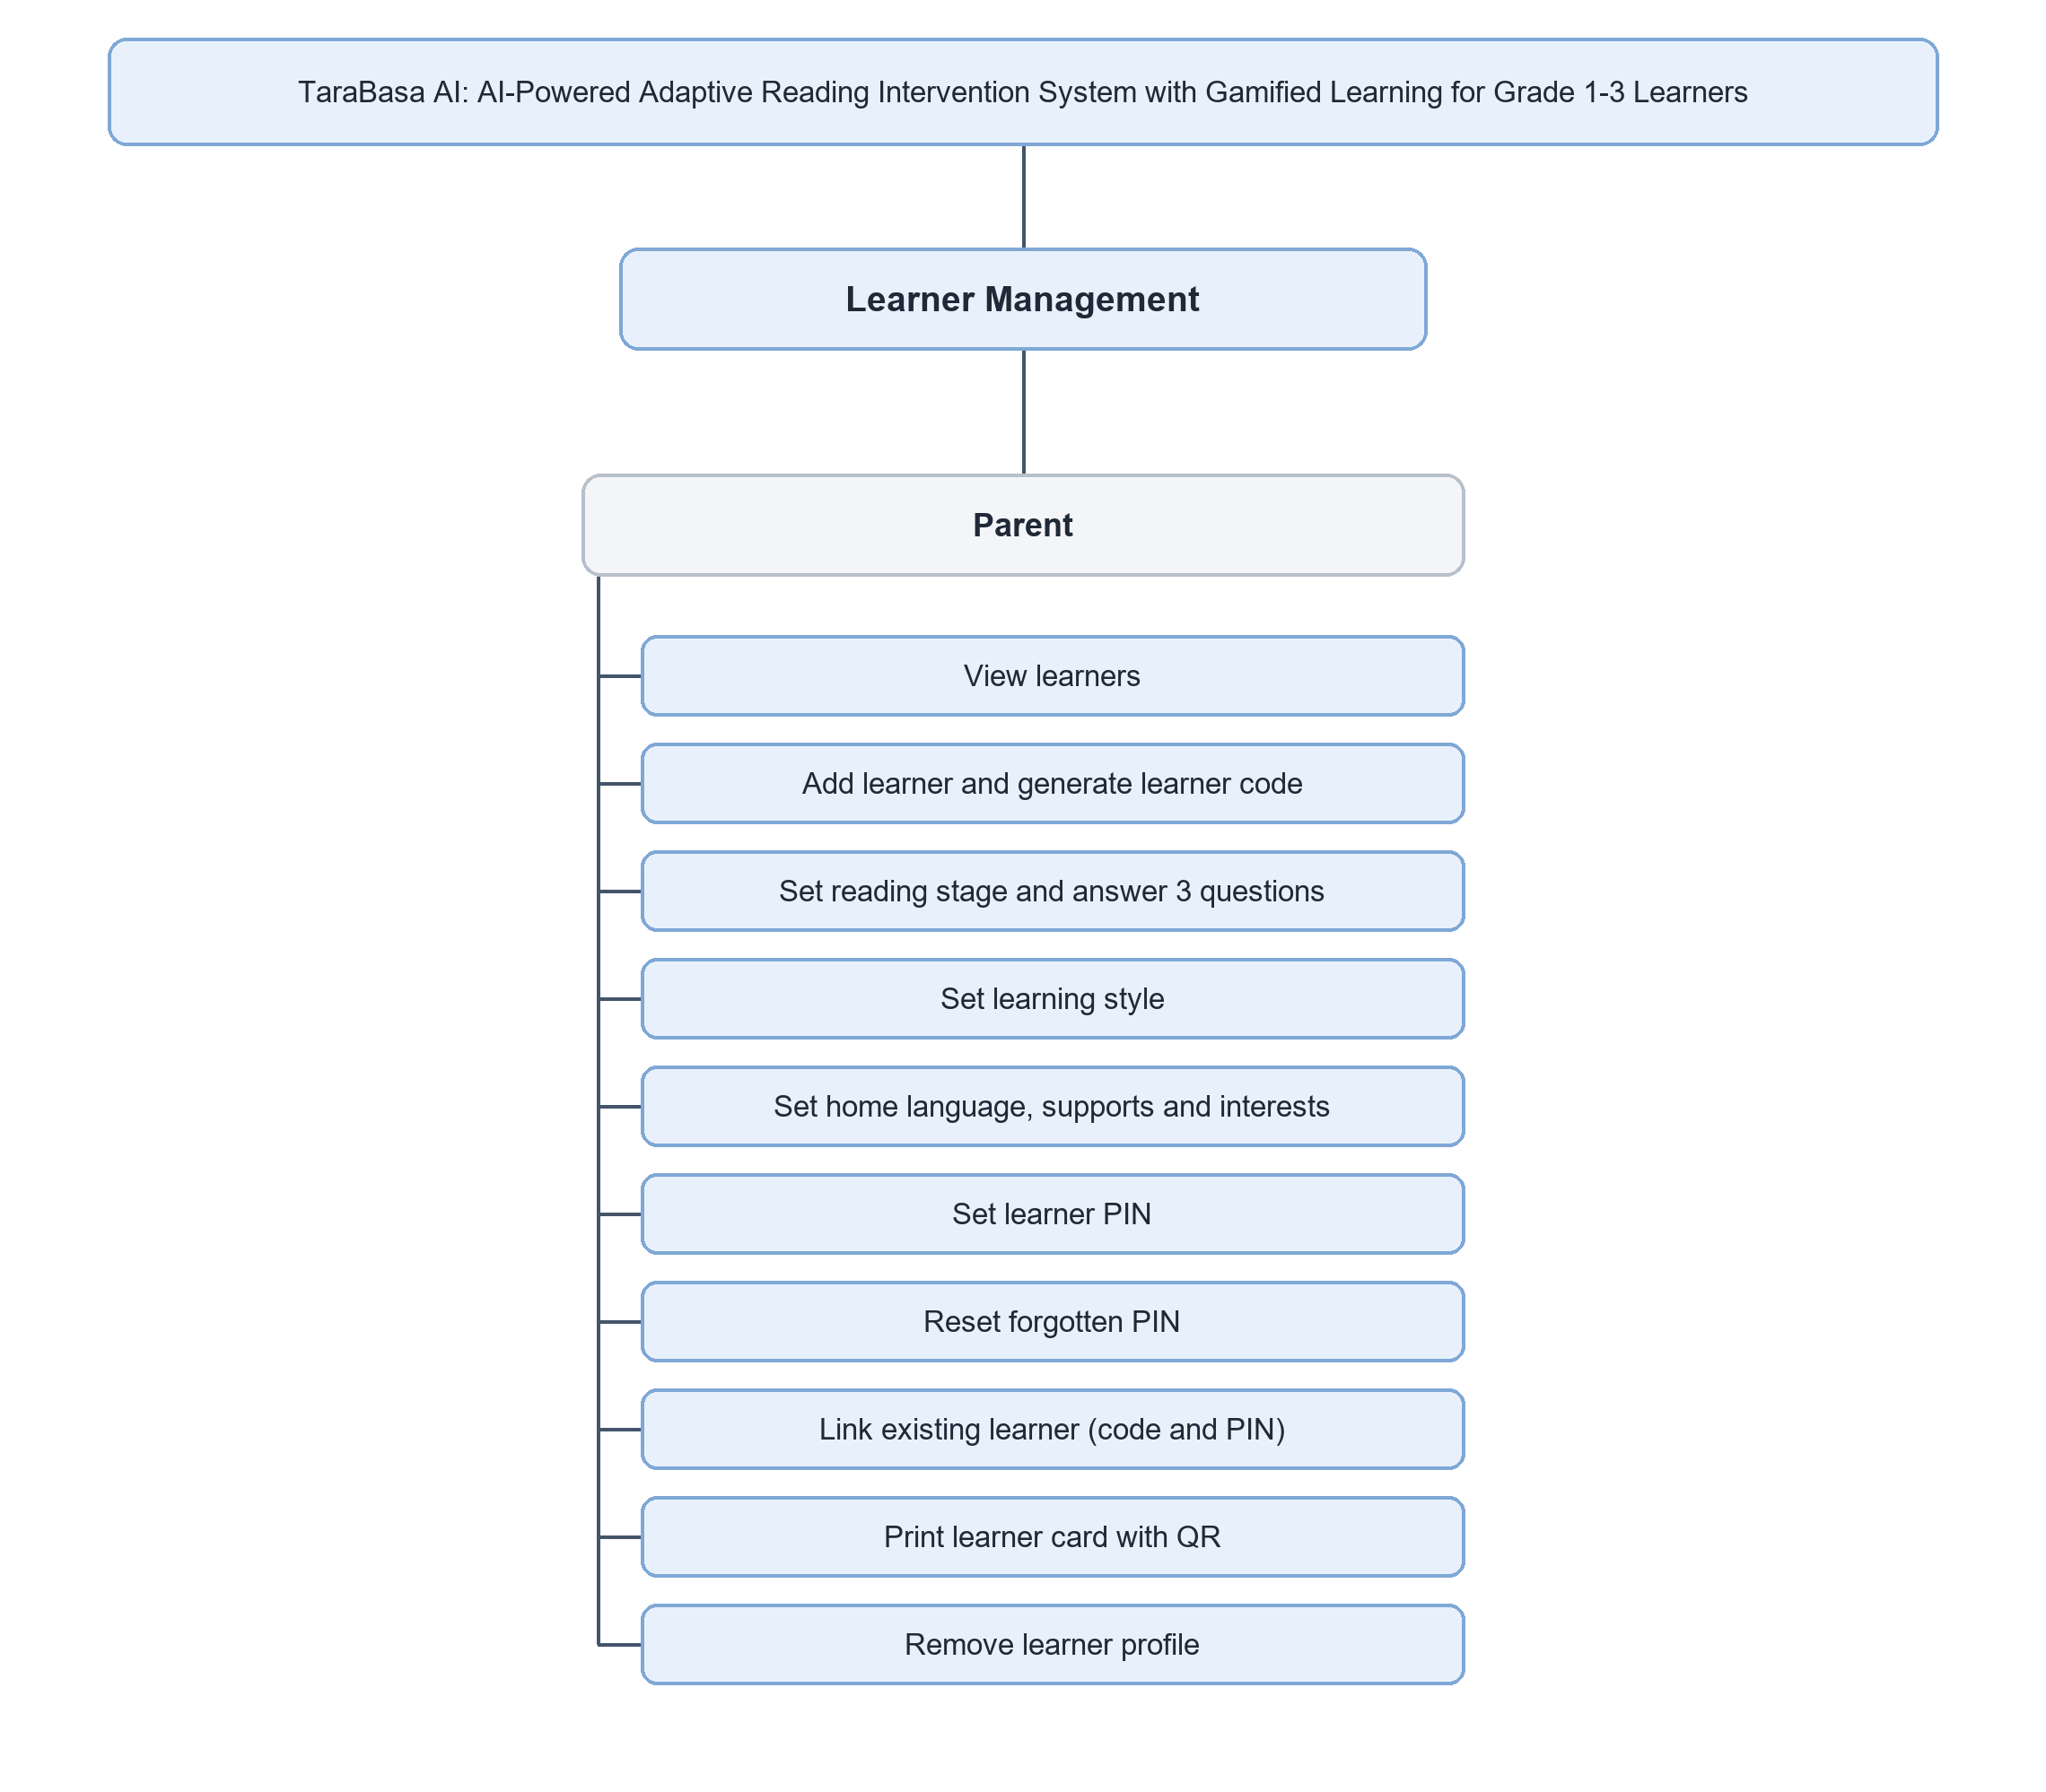
Figure 7.3: Functional Decomposition Diagram cont'd
Figure 7.3 presents the Learner Management module, which belongs to the Parent. The Parent views the linked learners and adds a learner, which generates the Learner Code. The Parent sets the reading stage and answers three questions about the child’s reading, sets the learning style, the home language, the supports, and the interests, and sets the PIN. The Parent can reset a forgotten PIN, link an existing learner with the code and the PIN, print the learner card with its QR code, and remove the learner profile.
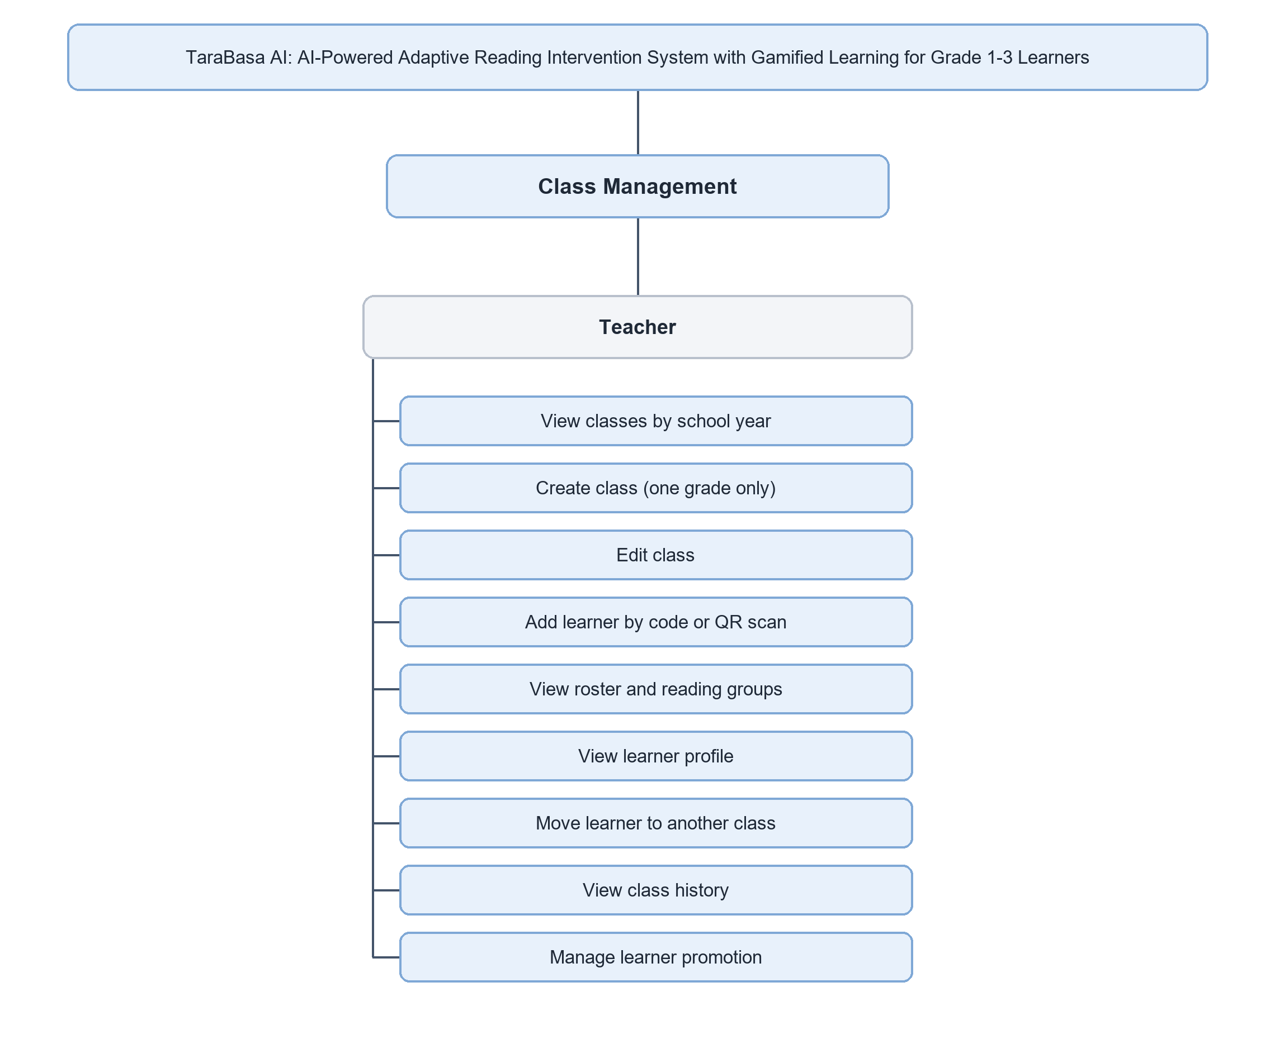
Figure 7.4: Functional Decomposition Diagram cont'd
Figure 7.4 presents the Class Management module, which belongs to the Teacher. The Teacher views the classes of a school year, creates a class for one grade only, and edits the class. The Teacher adds a learner by typing the last characters of the Learner Code or scanning the QR code, views the roster divided into reading groups, views a learner’s profile, moves a learner to another class, views the class history, and manages learner promotion by releasing a learner or claiming a released learner.
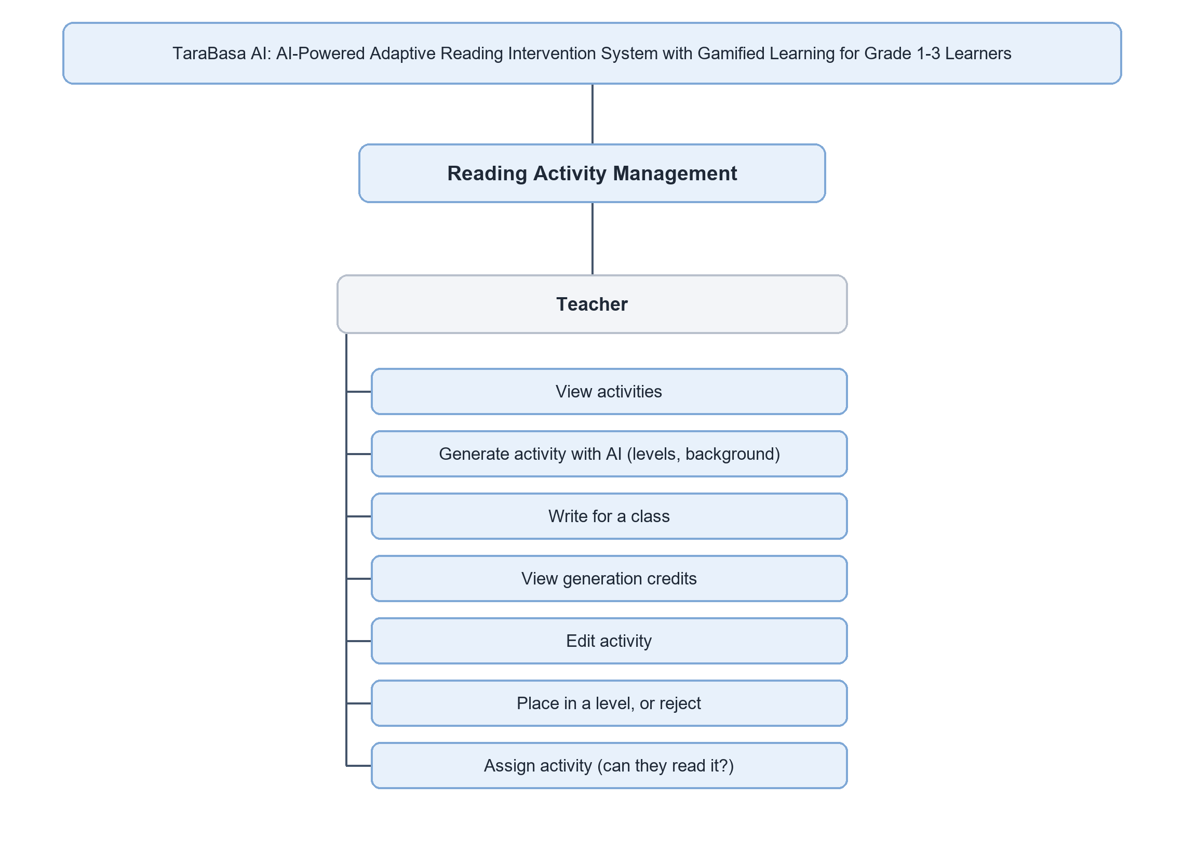
Figure 7.5: Functional Decomposition Diagram cont'd
Figure 7.5 presents the Reading Activity Management module, which belongs to the Teacher. The Teacher views the activities, asks the AI engine to generate drafts, choosing how many are wanted at each level and letting the work run in the background, and may write for a class. The Teacher views the generation credits, edits a draft, places it in the Easy, Medium, or Hard level or rejects it, and assigns an activity after the system checks that the children can read it.
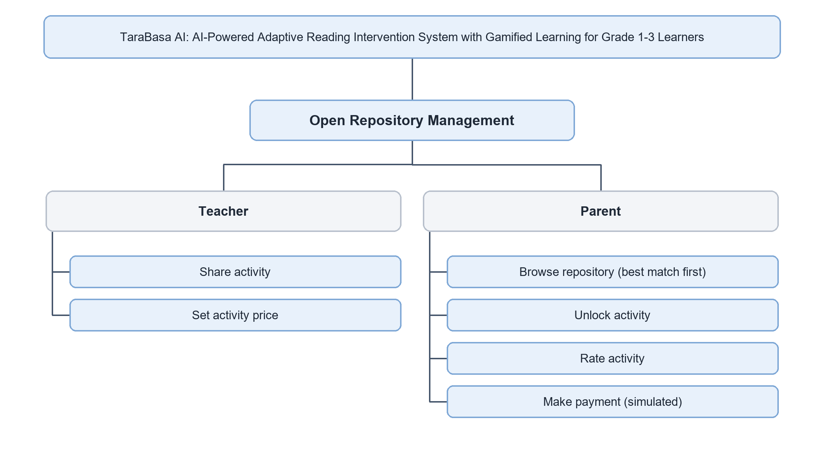
Figure 7.6: Functional Decomposition Diagram cont'd
Figure 7.6 presents the Open Repository Management module. The Teacher shares an approved activity to the repository and sets its price, which may be free. The Parent browses the repository, where the best matches for the child come first, unlocks an activity, rates it, and makes the payment for a paid activity. The payment is simulated; no real money is handled.
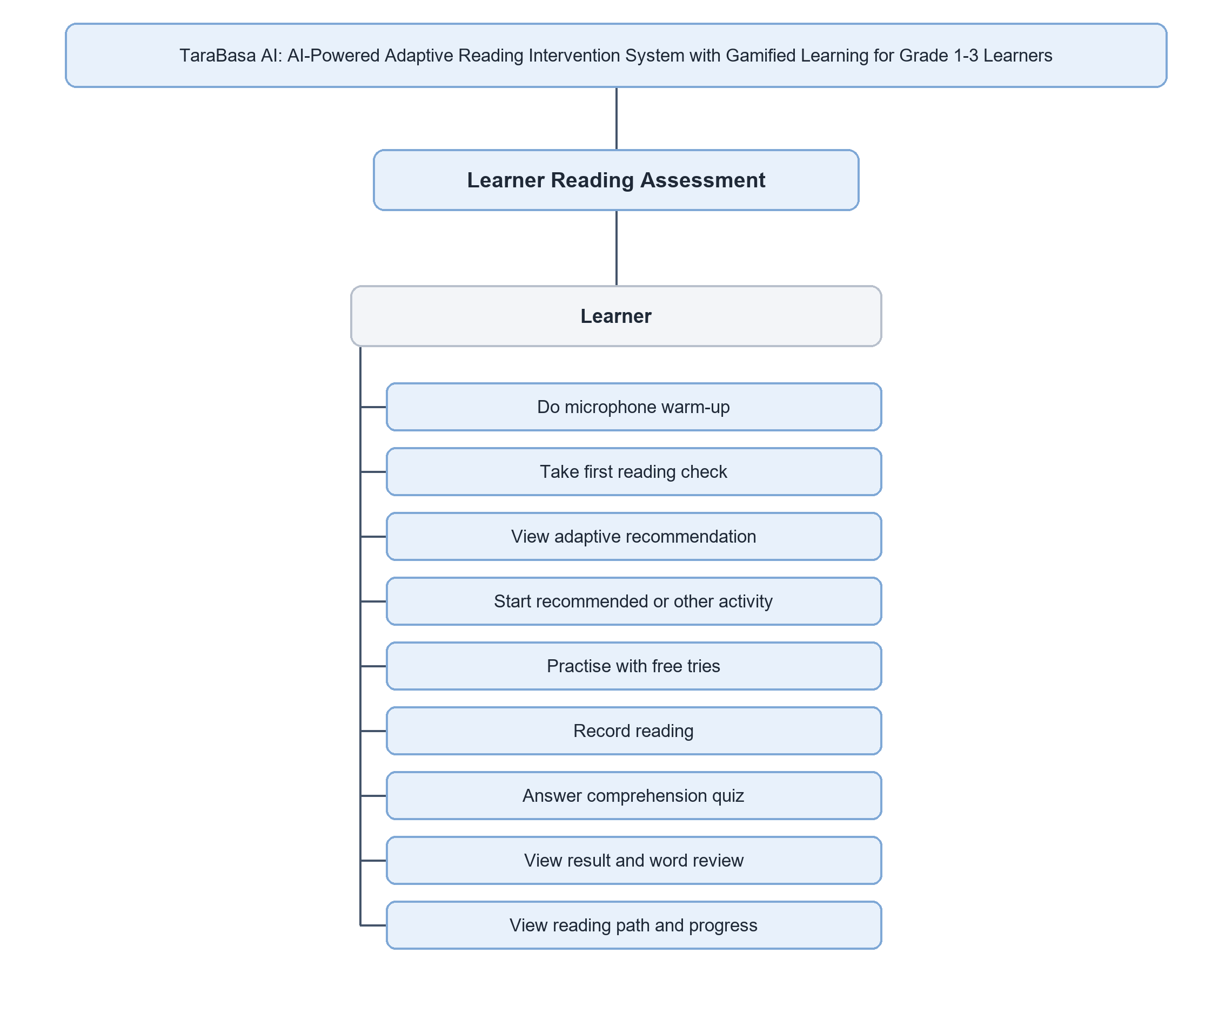
Figure 7.7: Functional Decomposition Diagram cont'd
Figure 7.7 presents the Learner Reading Assessment module, which belongs to the Learner. The Learner does a microphone warm-up, takes the first reading check, and views the adaptive recommendation. The Learner starts the recommended activity or another one, practices with free tries, records the reading, answers the comprehension quiz when the story has one, views the result with a word-by-word review, and views the reading path and progress.
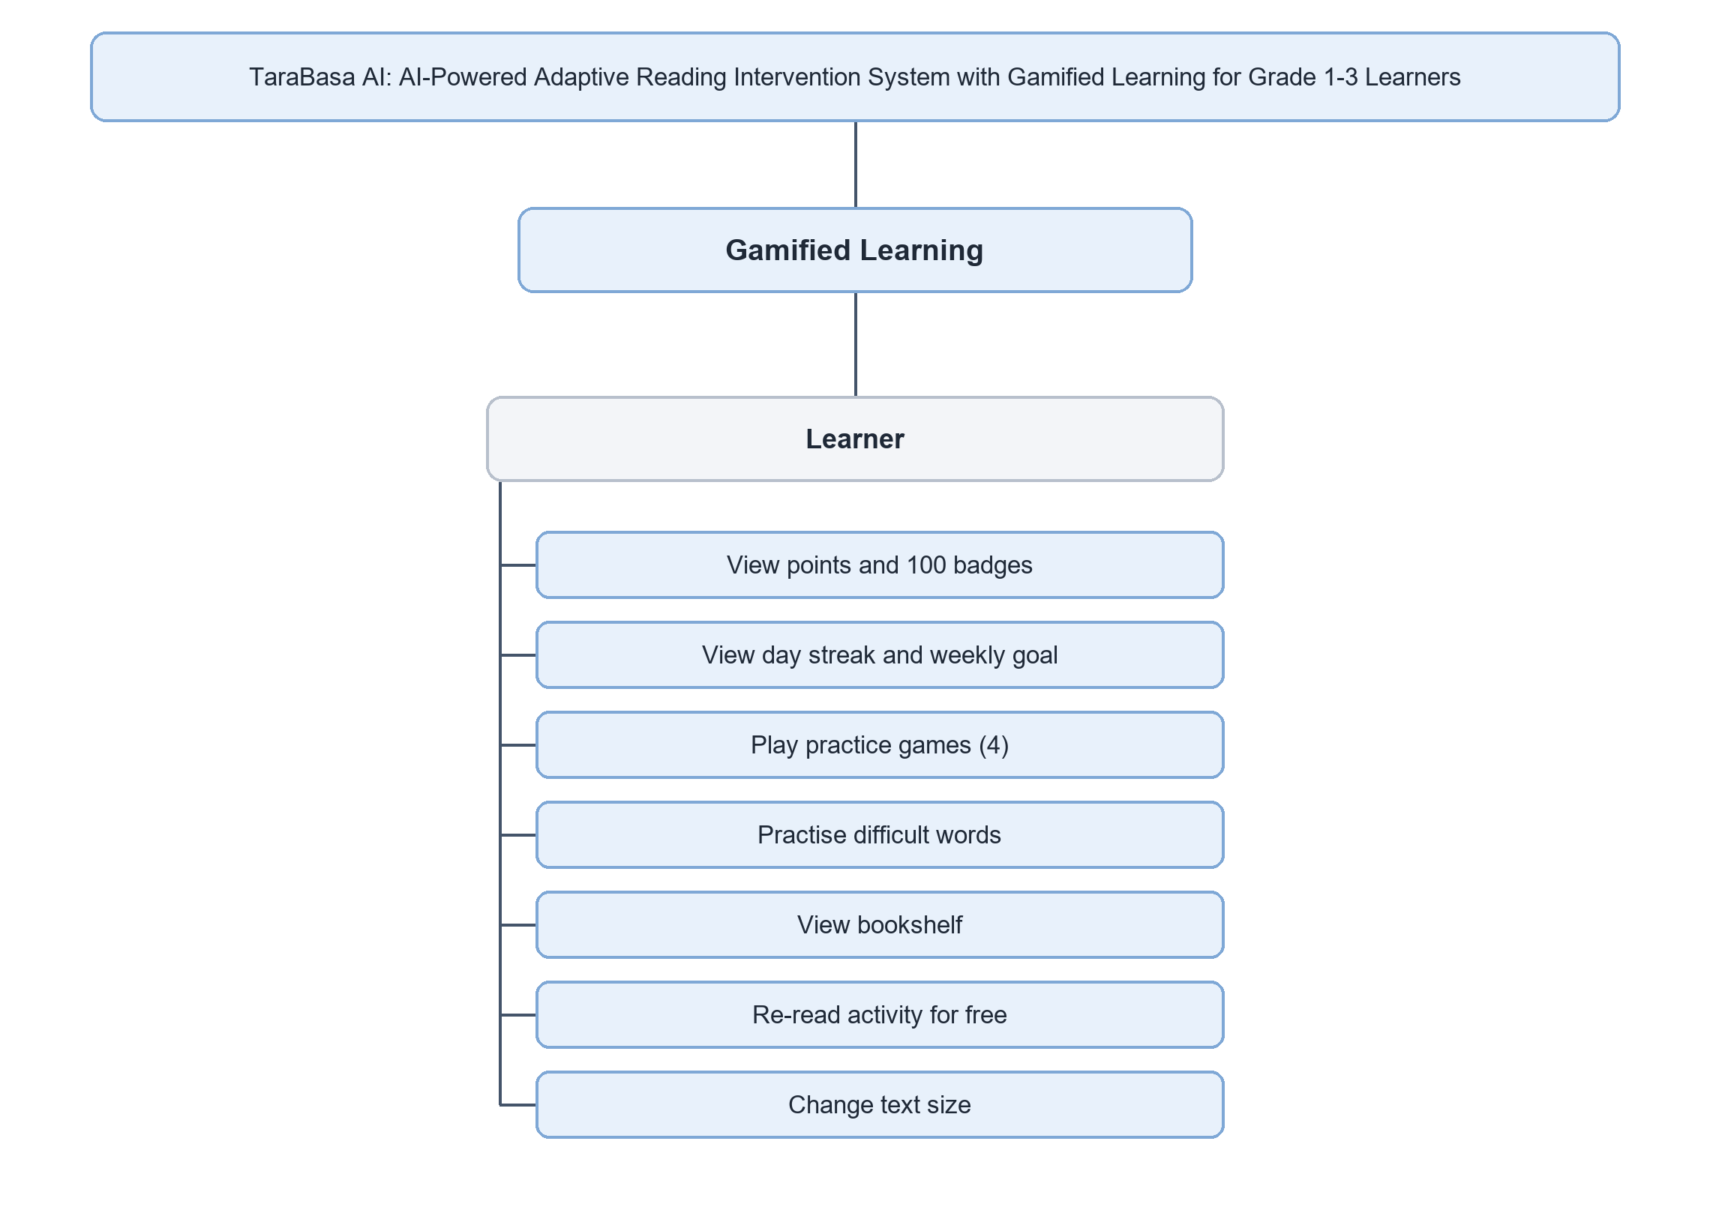
Figure 7.8: Functional Decomposition Diagram cont'd
Figure 7.8 presents the Gamified Learning module, which belongs to the Learner. The Learner views points and the 100 badges, the day streak and the weekly goal, plays the four read-aloud practice games, practices difficult words, views the bookshelf, re-reads a finished activity for free, and changes the text size.
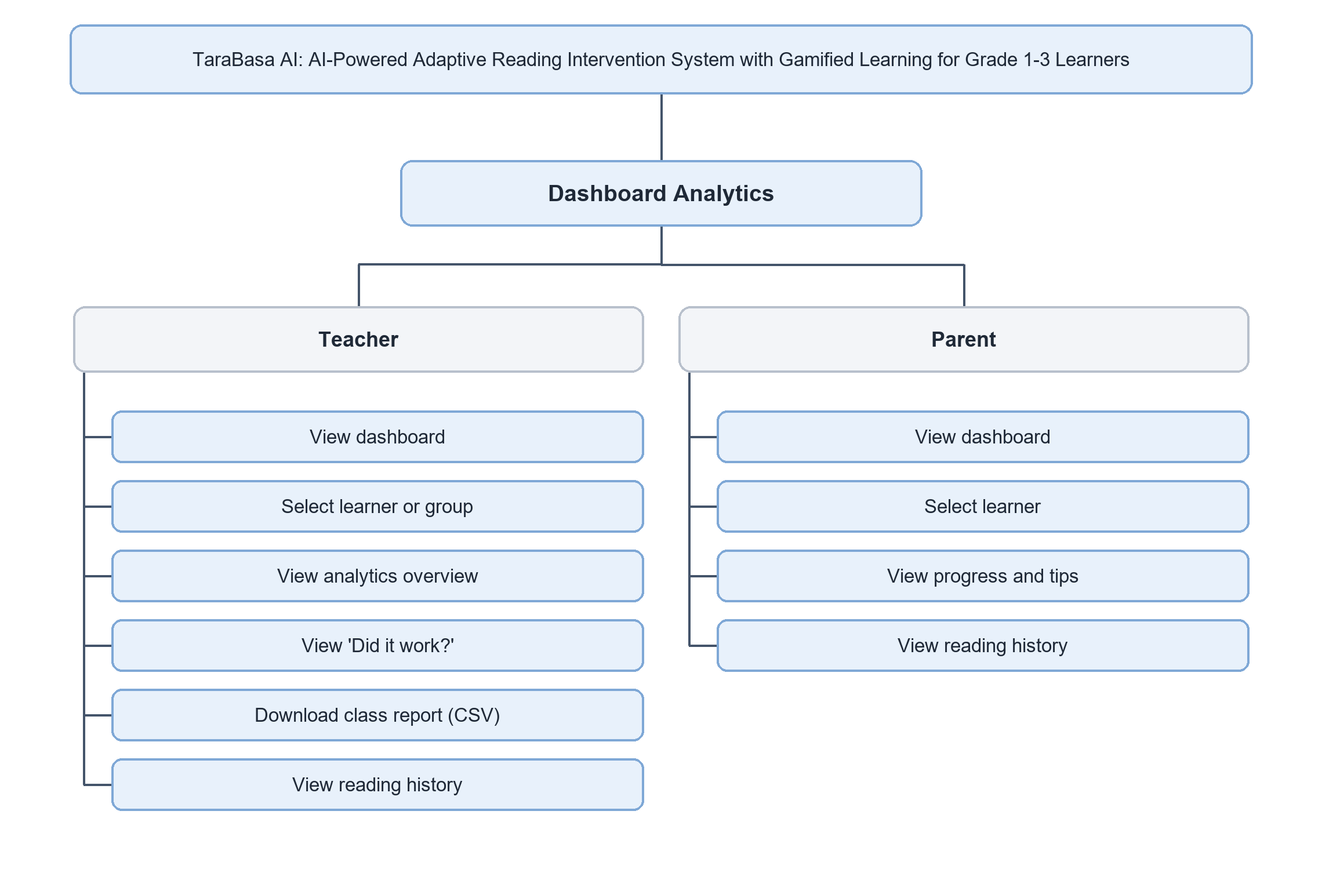
Figure 7.9: Functional Decomposition Diagram cont'd
Figure 7.9 presents the Dashboard Analytics module. The Teacher views the dashboard, selects a learner or group, views the analytics overview and the ‘Did it work?‘ comparison, downloads the class report as a CSV file, and views the reading history. The Parent views the dashboard, selects one of the linked learners, and views that learner’s progress, with the reading level in plain words and tips for practicing at home, and the reading history.
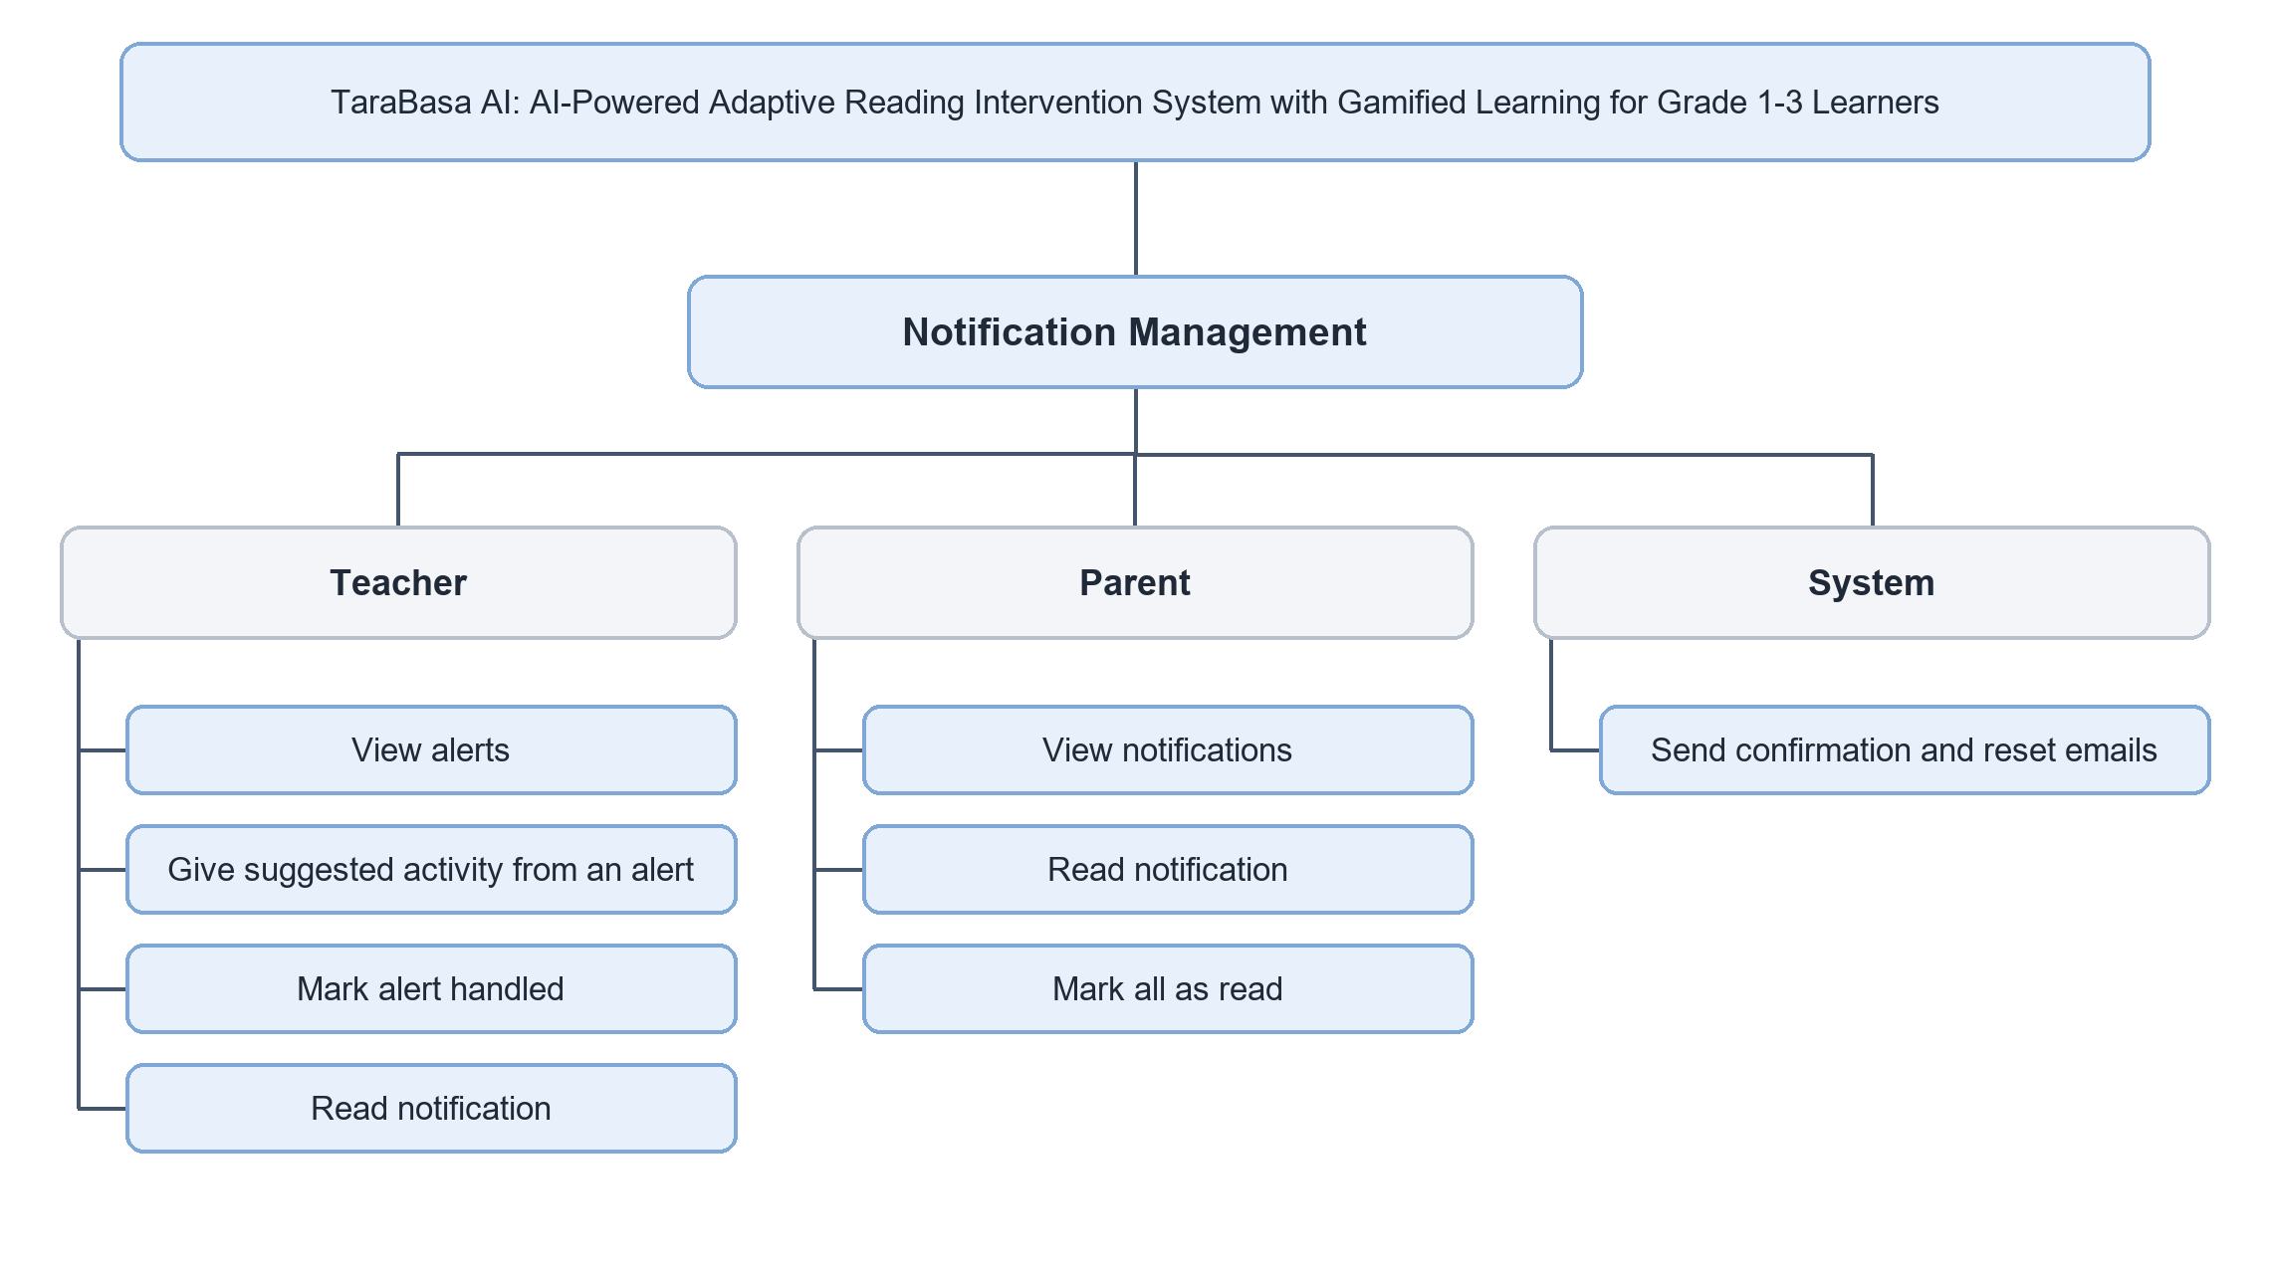
Figure 7.10: Functional Decomposition Diagram cont'd
Figure 7.10 presents the Notification Management module. The Teacher views the alerts, which the system works out from the learners’ readings, gives the suggested activity in one tap, marks an alert handled, and reads notifications. The Parent views and reads notifications and marks them all as read. The system sends the confirmation and reset emails. There are no text messages.
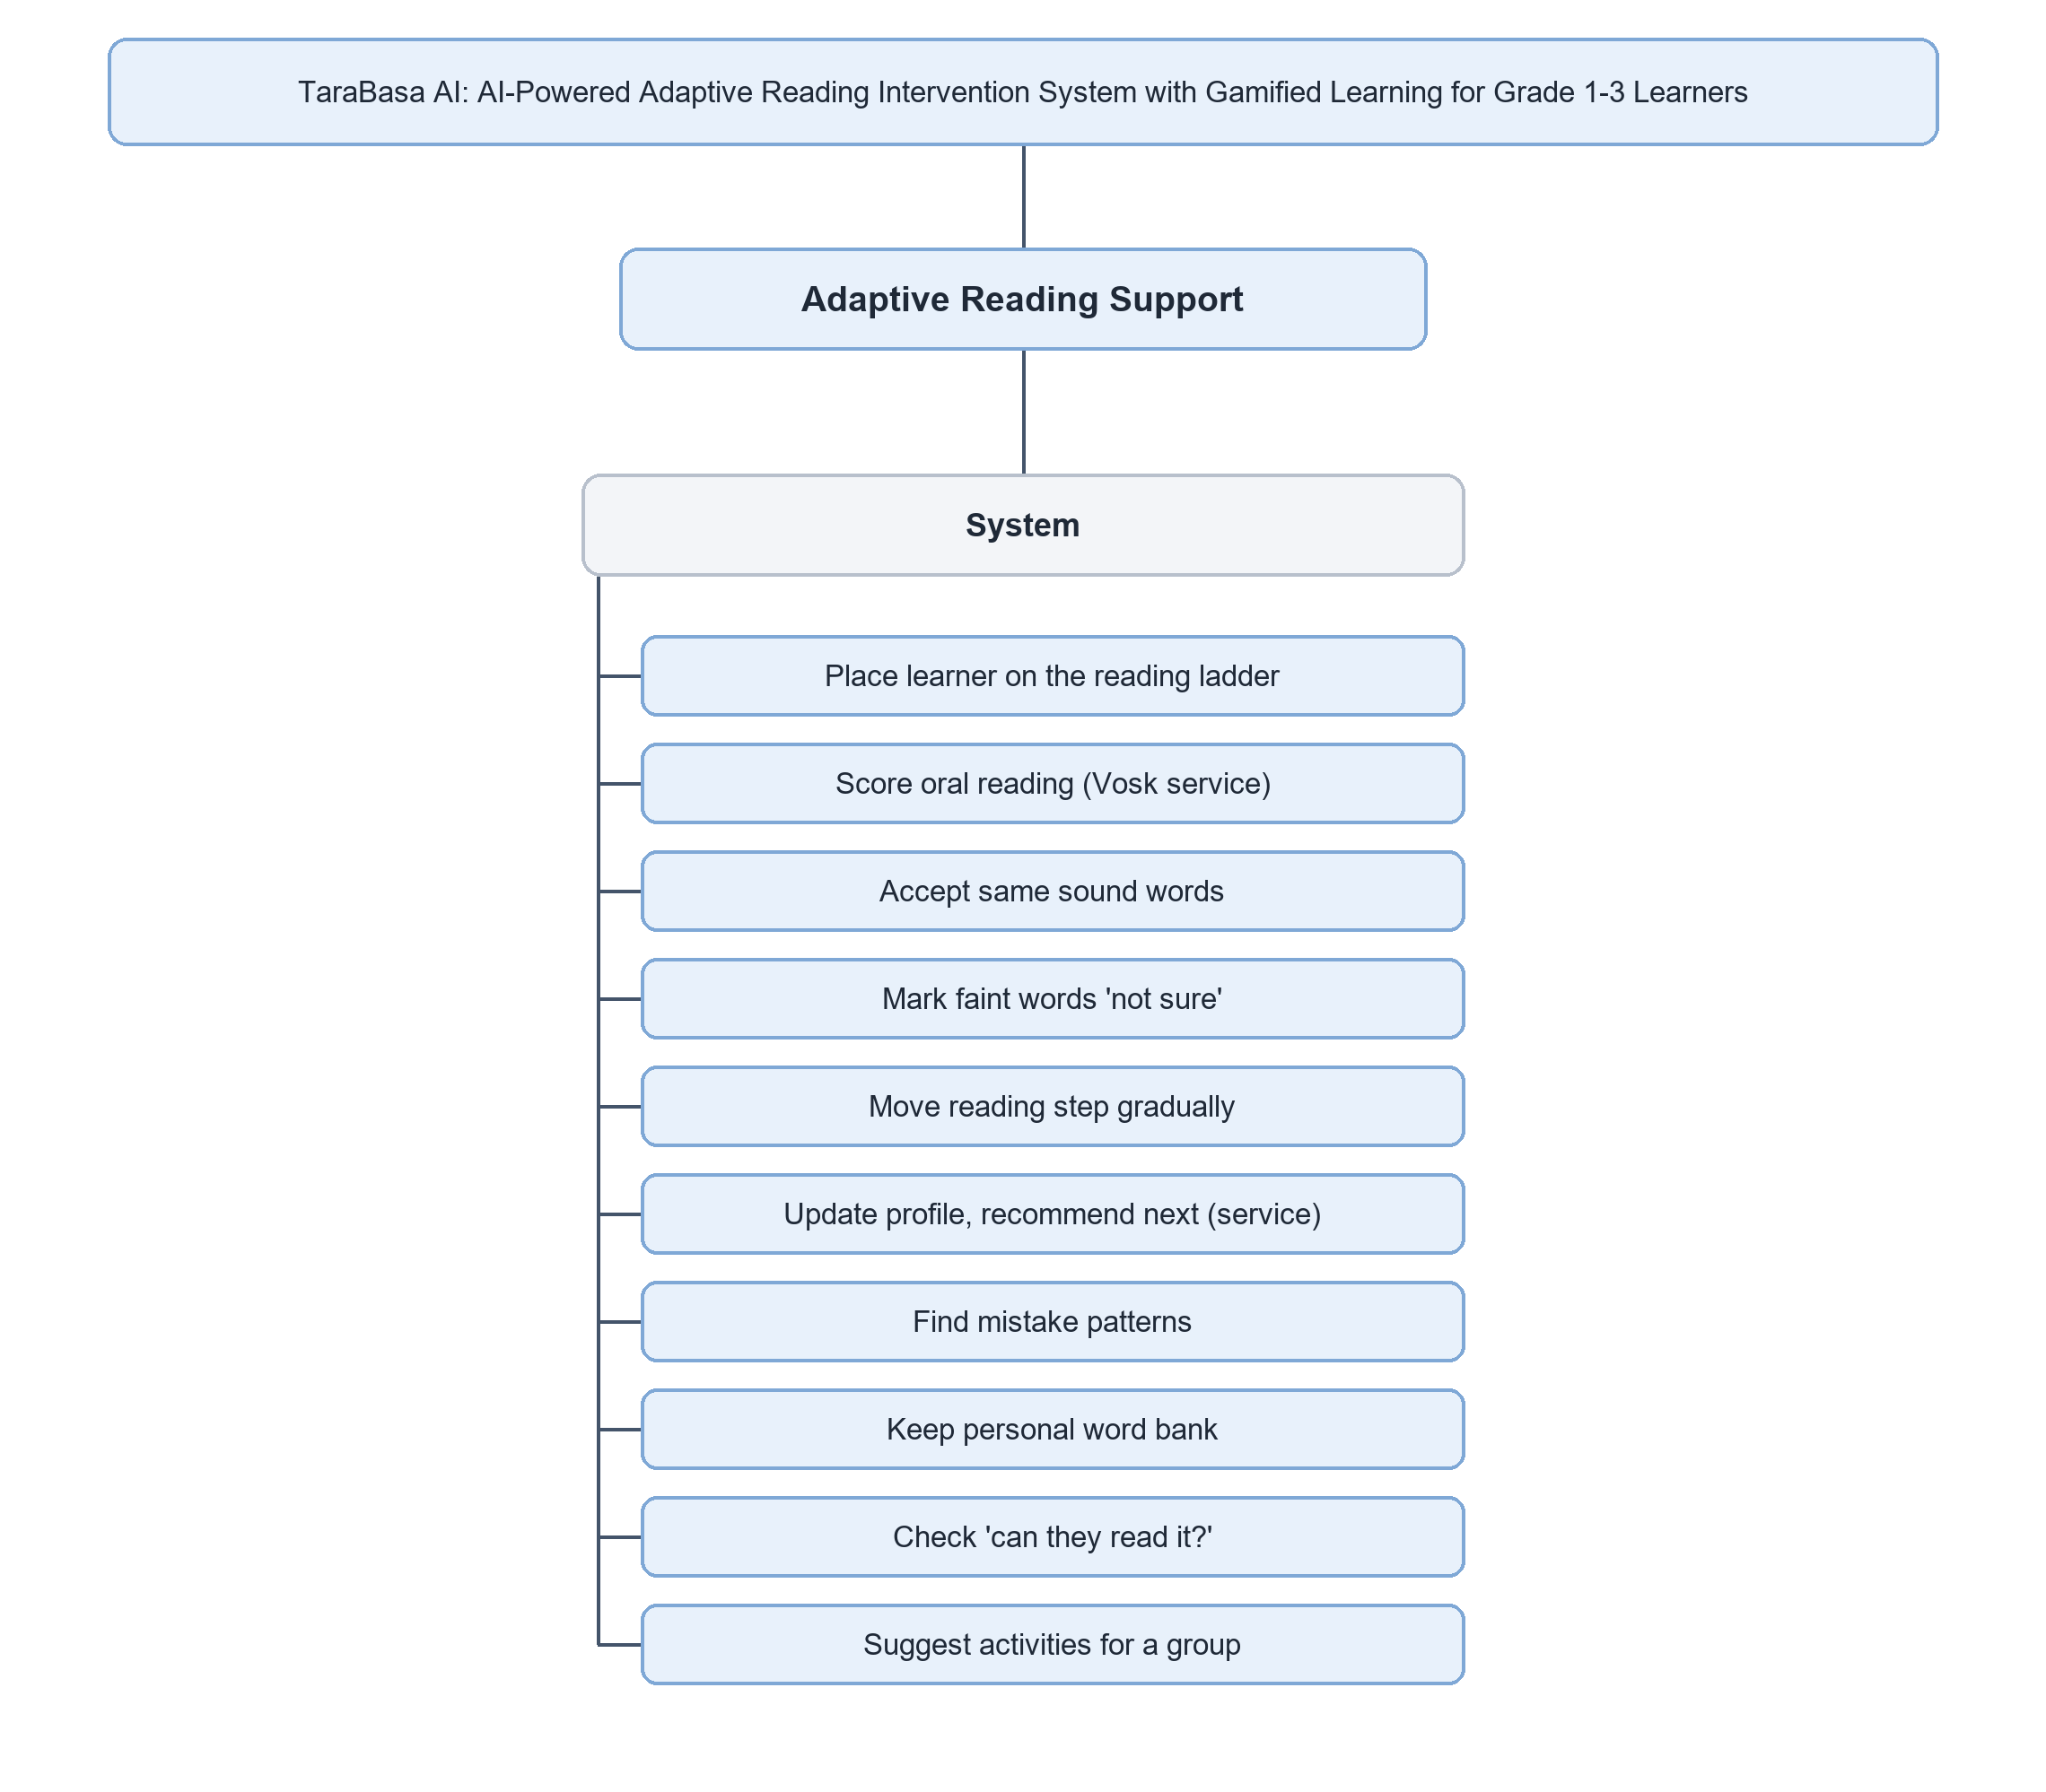
Figure 7.11: Functional Decomposition Diagram cont'd
Figure 7.11 presents the Adaptive Reading Support module, which is carried out by the system itself and not by a user. The system places the learner on the reading ladder, scores the oral reading through the speech service, accepts words that sound the same, marks faintly heard words as not sure, moves the reading step gradually, updates the learner’s profile and recommends the next activity through the recommendation service, finds mistake patterns, keeps the personal word bank, checks whether the children can read an activity, and suggests activities for a group.
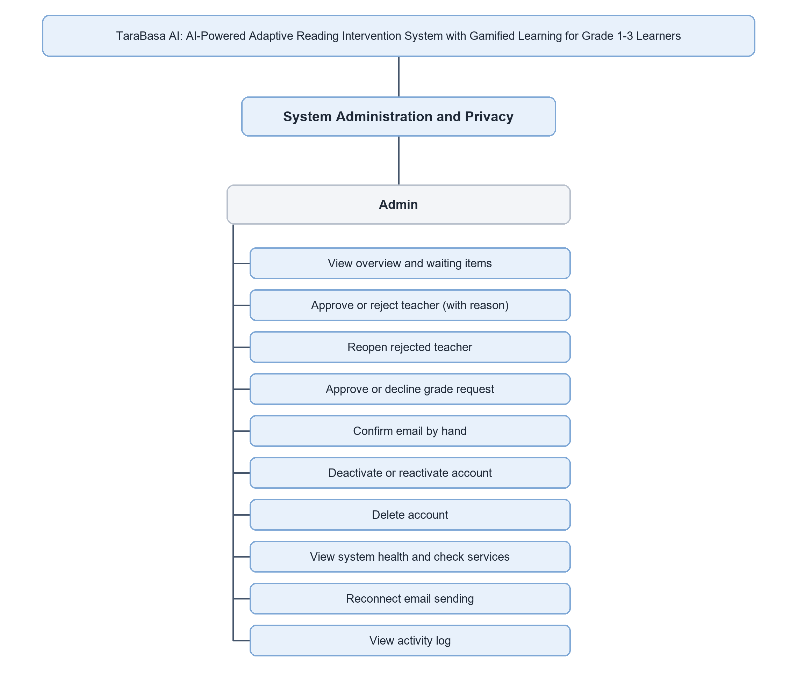
Figure 7.12: Functional Decomposition Diagram cont'd
Figure 7.12 presents the System Administration and Privacy module, which belongs to the Administrator. The Administrator views the overview and the waiting items, approves a teacher or rejects the account with a reason, reopens a rejected teacher, and approves or declines a request to add a grade. The Administrator confirms an email address by hand, deactivates or reactivates an account, deletes an account, views the system health and checks the services, reconnects email sending, and views the activity log.
----- end of C7: copy only the text above this line -----
C8  UPDATED | Place at: Chapter 3, 'Use Case Diagram/DFD' (pages 67 to 70). Replace Figures 8.1 to 8.4 with Figures 8.1 to 8.6 and their paragraphs. The introduction paragraph stays.  Replaces: The four use case diagrams of version 29.  Basis: Generated from the same list of functions as the FDD, so the two cannot disagree. The colours of the review version (new, updated, unchanged) are removed here: these pictures are the manuscript versions in one colour family; the colour review versions are in 05_Figures/usecase.

Use Case Diagram/DFD
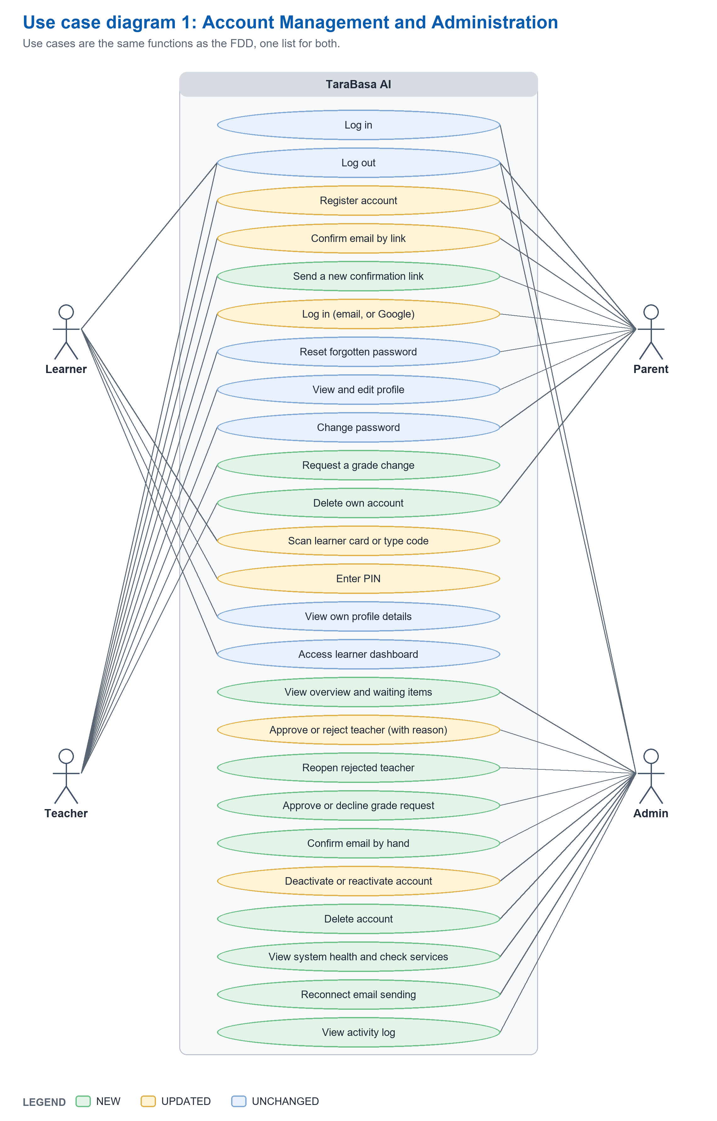
Figure 8.1: Use Case Diagram - Account Management and Administration
Figure 8.1 presents the Account Management and System Administration modules. Teachers, Parents, and Learners share the core access functions of registering (for Teachers and Parents), confirming the email address, signing in, and signing out. Teachers and Parents can also reset a forgotten password, change their password, view and edit their profile, and delete their own account, and Teachers can ask to handle another grade. Learners sign in with the Learner Code and the PIN. The Administrator signs in, views the waiting items, approves or rejects teachers, reopens rejected teachers, decides on grade requests, confirms an email address by hand, deactivates or reactivates accounts, deletes an account, views the system health, reconnects email sending, and views the activity log.
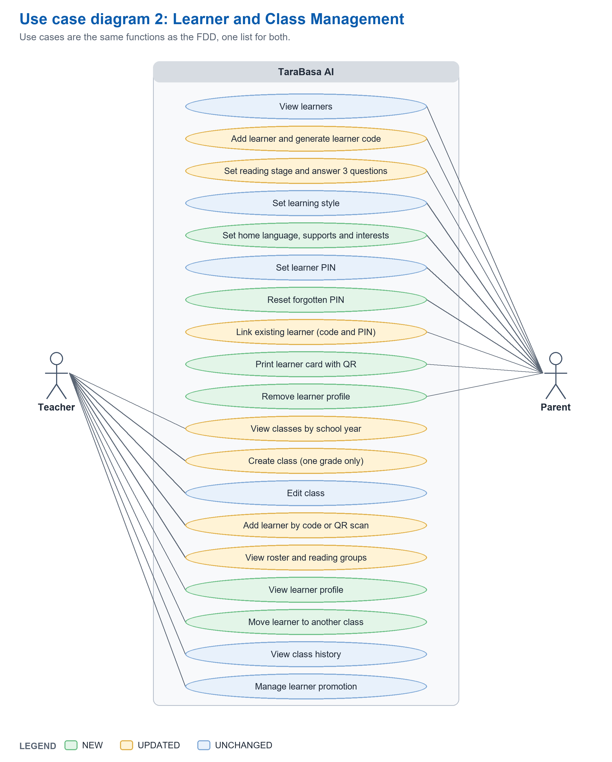
Figure 8.2: Use Case Diagram cont'd - Learner and Class Management
Figure 8.2 presents the Learner Management and Class Management modules. Parents view their learners, add a learner and generate the Learner Code, set the reading stage and the answers to three questions, set the learning style, the home language, the supports, and the interests, and set or reset the PIN. They can also link an existing learner, print the learner card with its QR code, and remove a learner profile. Teachers view their classes by school year, create or edit a class for one grade, and add a learner by code or QR scan. They view the roster and the reading groups, view a learner’s profile, move a learner to another class, view the class history, and manage learner promotion.
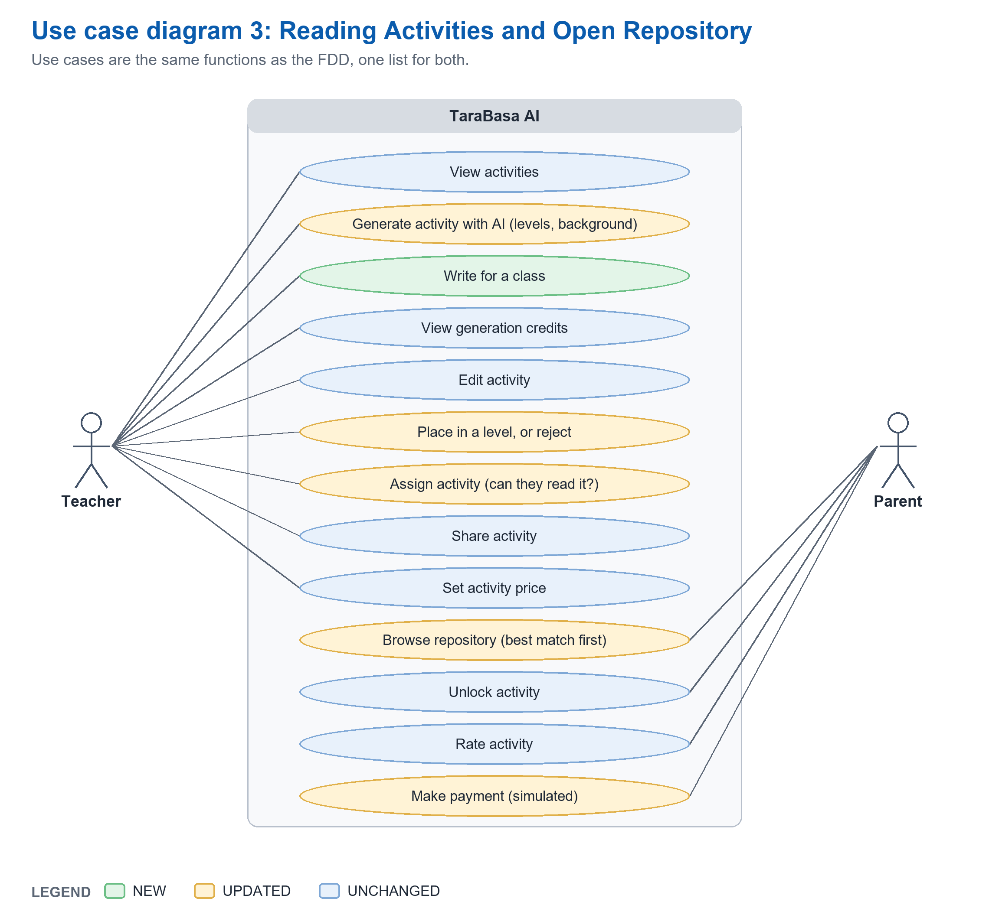
Figure 8.3: Use Case Diagram cont'd - Reading Activities and Open Repository
Figure 8.3 presents the Reading Activity Management and Open Repository Management modules. Teachers view activities, generate drafts with the AI engine, write for a class, and view their generation credits. They edit a draft, place it in a level or reject it, and assign the activity after the system checks that the children can read it. Teachers also share an activity to the repository and set its price. Parents browse the repository, where the best matches come first, unlock an activity, rate it, and make the payment, which is simulated.
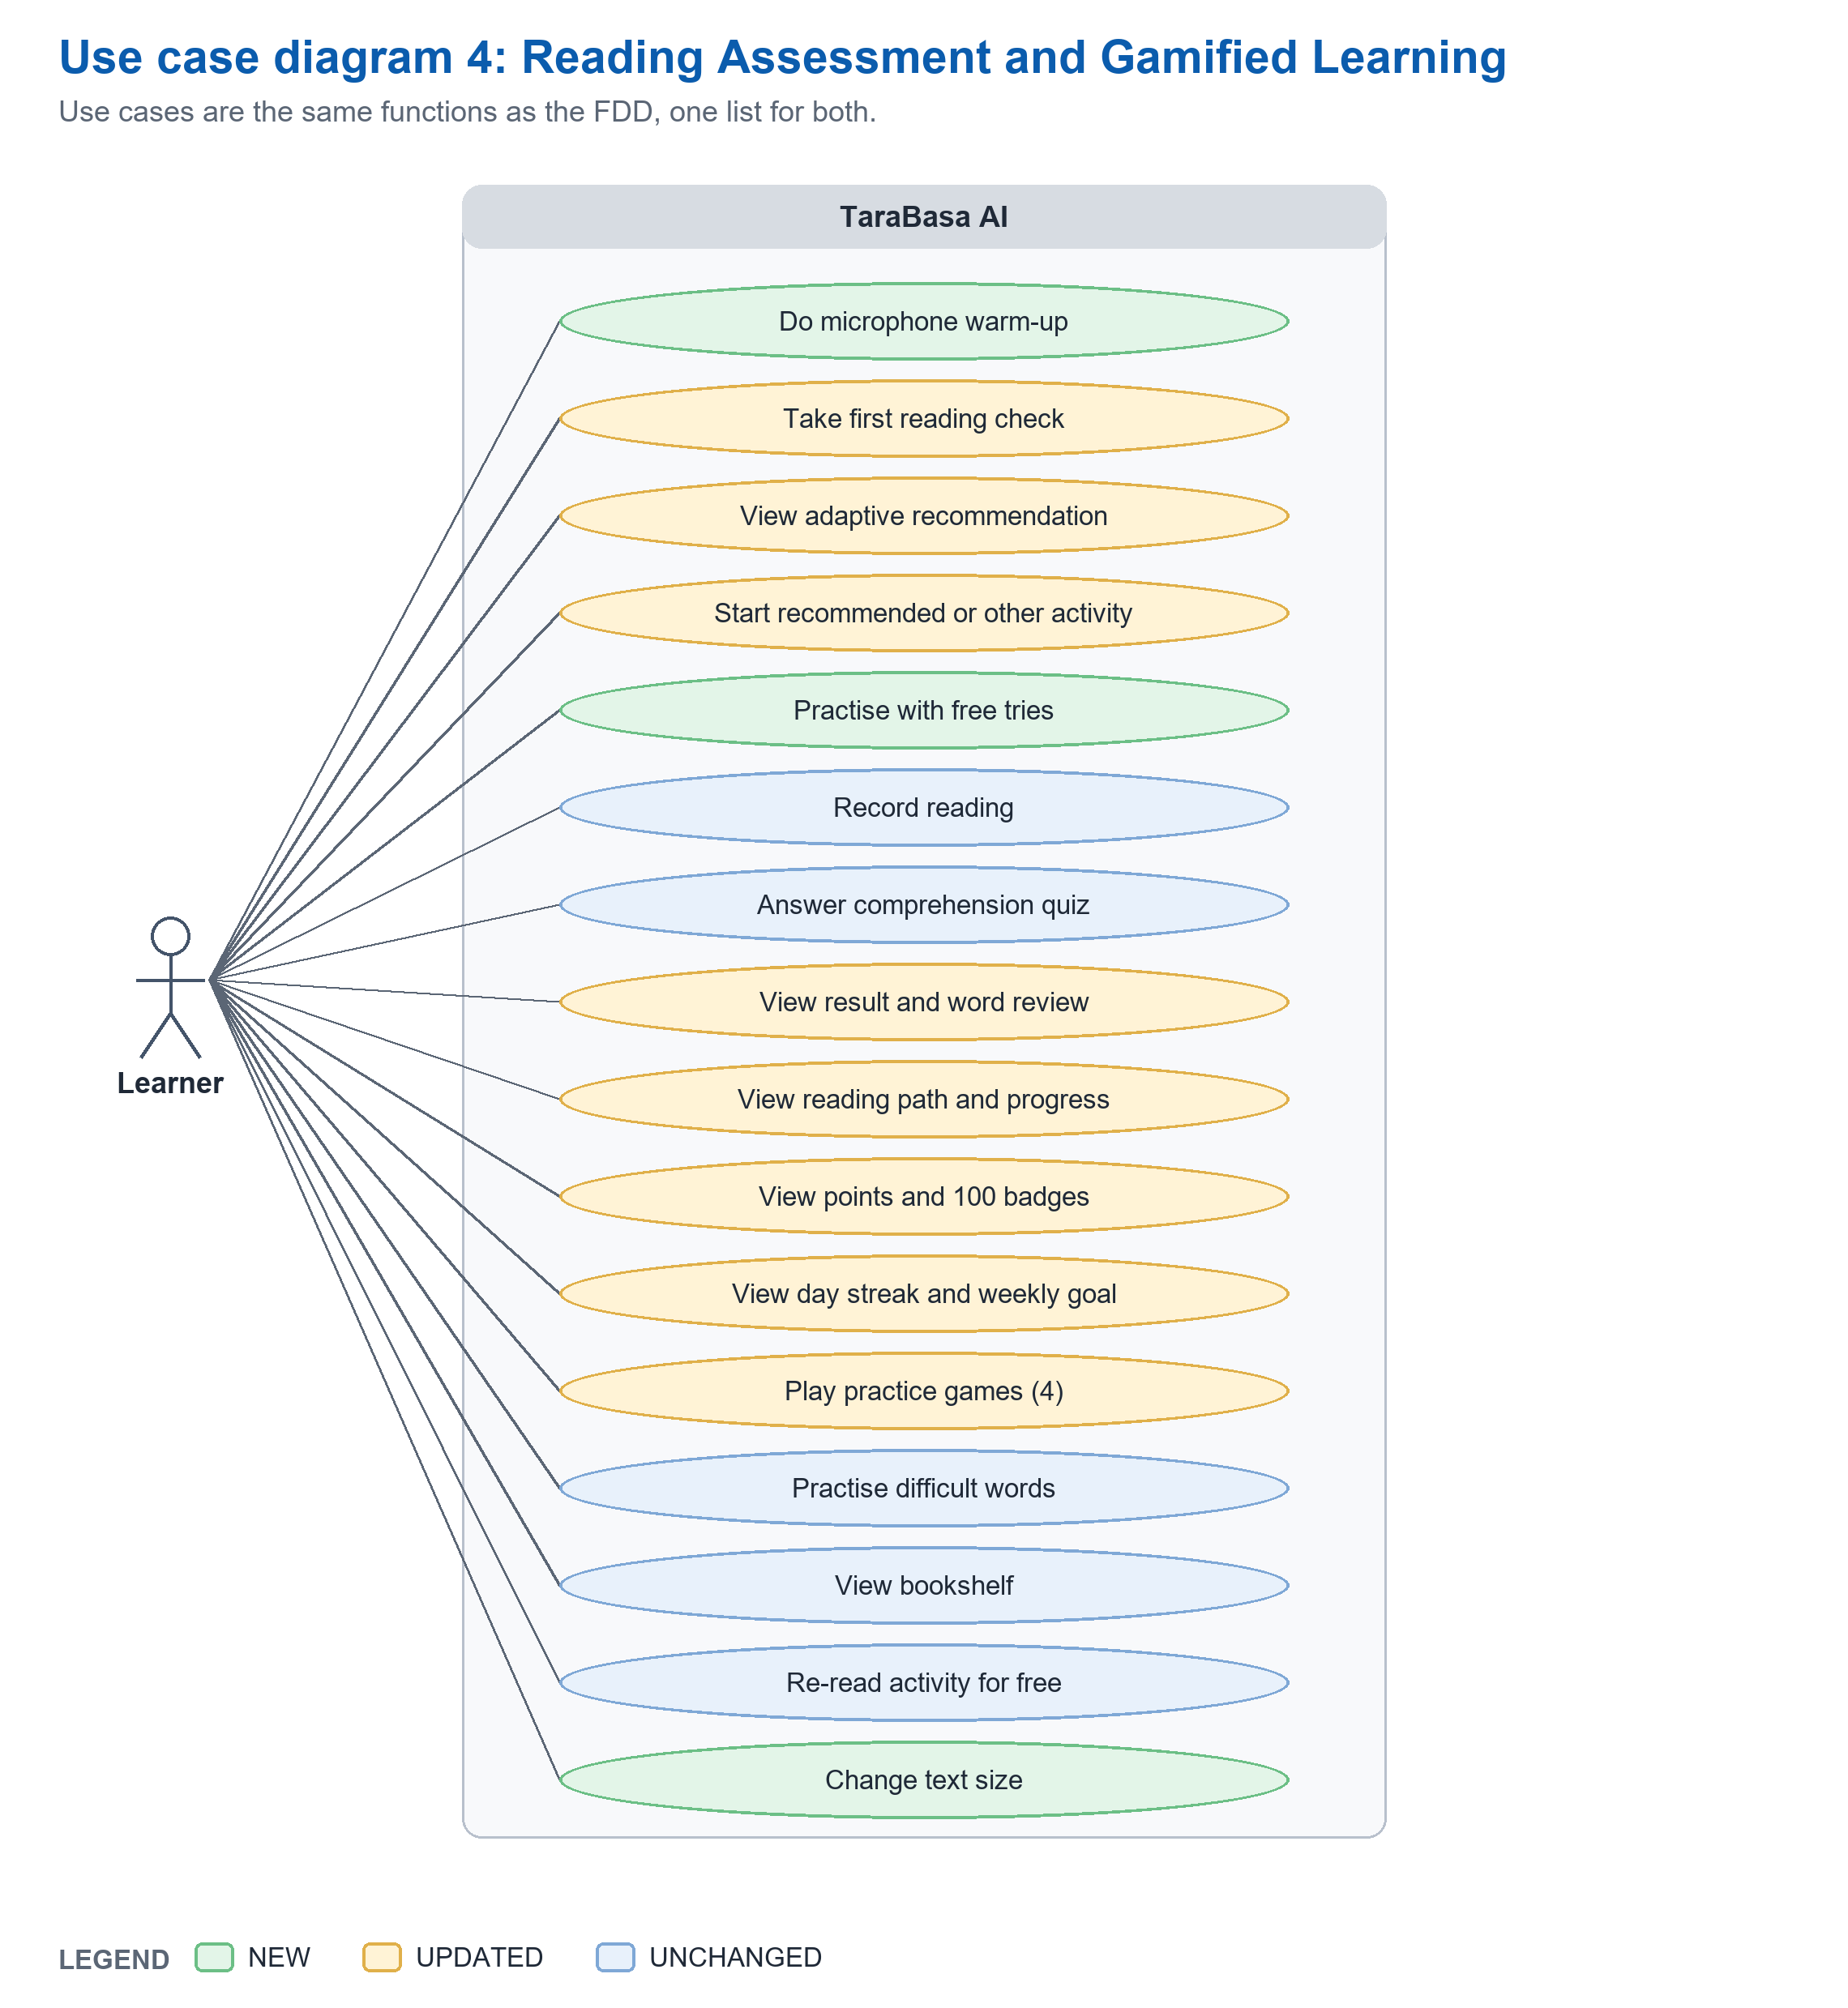
Figure 8.4: Use Case Diagram cont'd - Reading Assessment and Gamified Learning
Figure 8.4 presents the Learner Reading Assessment and Gamified Learning modules, which are used by Learners. Learners do a microphone warm-up, take the first reading check, and view the adaptive recommendation. They start the recommended activity or another one, practice with free tries, record the reading, answer the comprehension quiz, and view the result with a word review. Learners also view the reading path, their points and badges, the day streak and weekly goal, play the practice games, practice difficult words, view the bookshelf, re-read an activity for free, and change the text size.
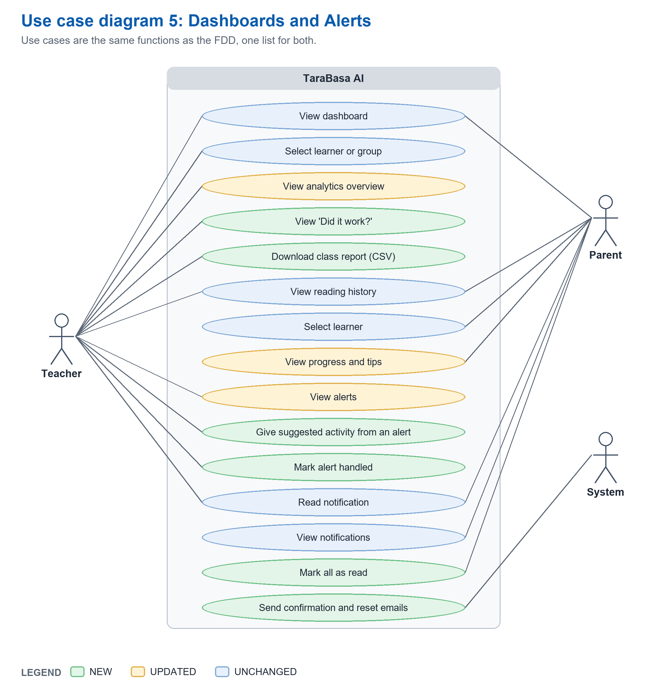
Figure 8.5: Use Case Diagram cont'd - Dashboards and Alerts
Figure 8.5 presents the Dashboard Analytics and Notification Management modules. Teachers and Parents both view the dashboard, select a learner, and view the reading history. Teachers also view the analytics overview, the ‘Did it work?‘ comparison, and the class report, and Parents view the progress with tips for practicing at home. Teachers view the alerts, give the suggested activity from an alert, and mark an alert handled. Parents view notifications and mark them as read. The system sends the confirmation and reset emails.
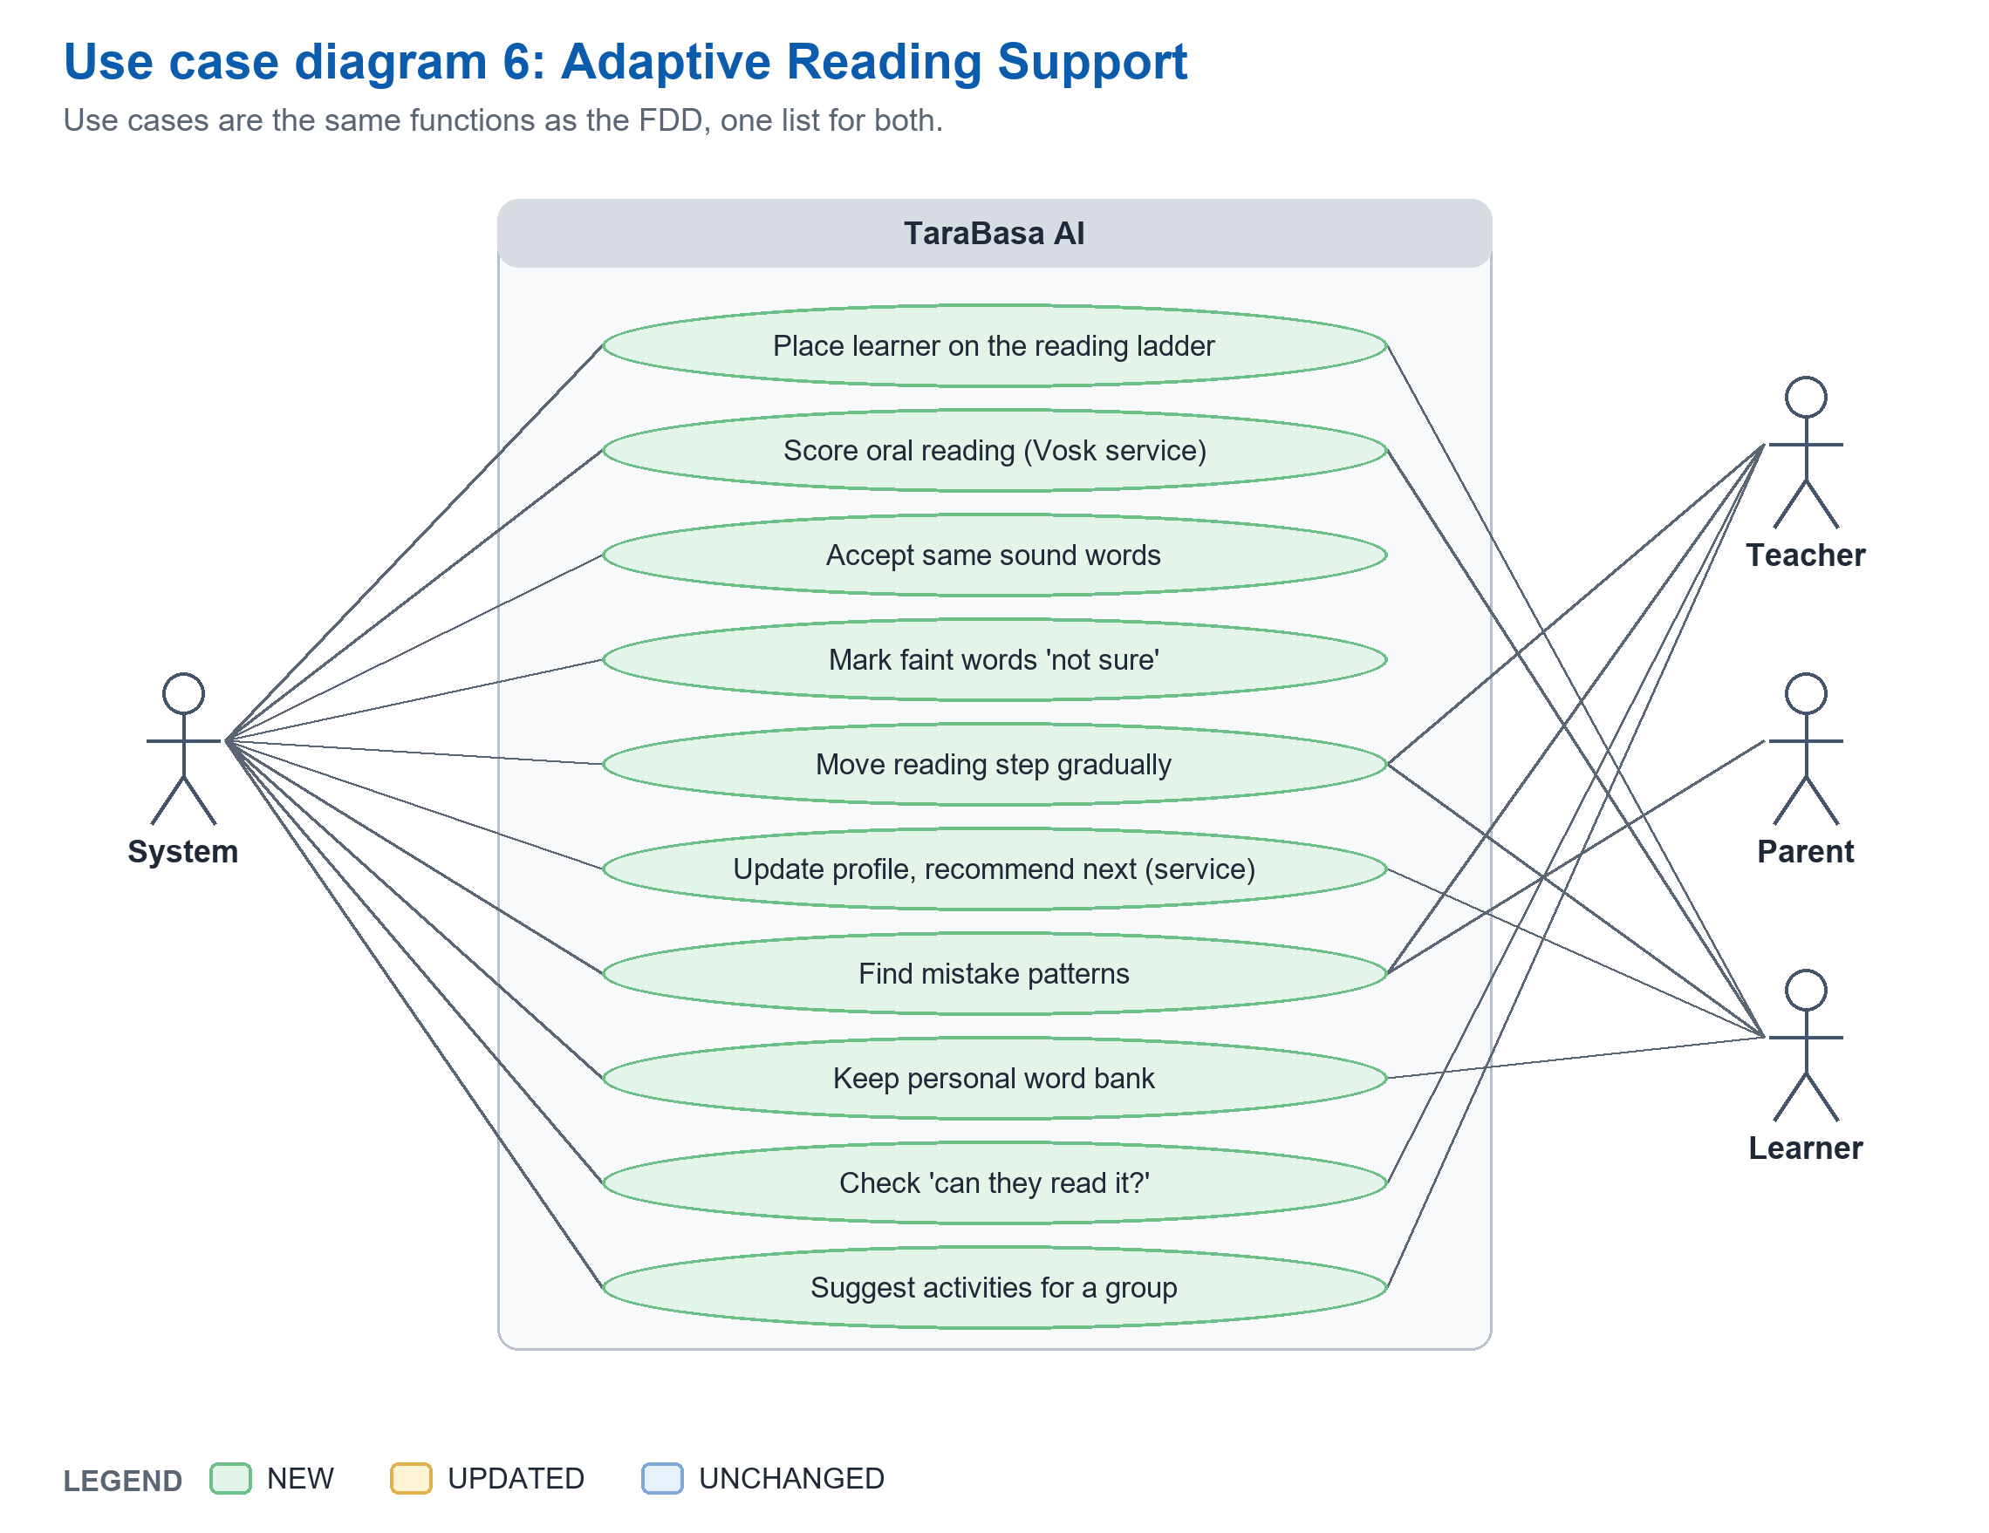
Figure 8.6: Use Case Diagram cont'd - Adaptive Reading Support
Figure 8.6 presents the Adaptive Reading Support module. The system itself carries out these functions after a Learner reads: placing the learner on the reading ladder, scoring the oral reading, accepting words that sound the same, marking faintly heard words as not sure, moving the reading step gradually, updating the profile and recommending the next activity, finding mistake patterns, keeping the personal word bank, checking whether the children can read an activity, and suggesting activities for a group. Learners, Teachers, and Parents use the results of these functions through their own screens.
----- end of C8: copy only the text above this line -----
C9  NEW | Place at: Chapter 3, 'Analysis Design Phase', after 'Use Case Diagram/DFD' (page 70) and before 'User Interface Design' (page 71). This adds one H3 section, Figure 9, and Table 7.  Replaces: Nothing; the rule-based adaptive support is not described anywhere in version 29.  Basis: Phil-IRI levels (DepEd Order No. 14, s. 2018); MATATAG Curriculum; National Reading Panel (2000); Ehri et al. (2001); Therrien (2004); the practice-game research in B3.  Note: This section is where the panel will test the claim 'adaptive'. It says plainly what is a rule, what is an outside service, and that no model was trained. Do not change that wording.

Adaptive Reading Support Design
TaraBasa AI supports each learner with a chain of written rules and fixed formulas, shown in Figure 9, that turns one recording into a decision about the next step. The researchers did not train a machine learning model. Two outside services take part: a reading service that turns a recording into words, timing, and scores, and a recommendation service that keeps a numerical profile of the learner by fixed formulas. All other decisions are rules written in the application, with the settings listed in Table 7.
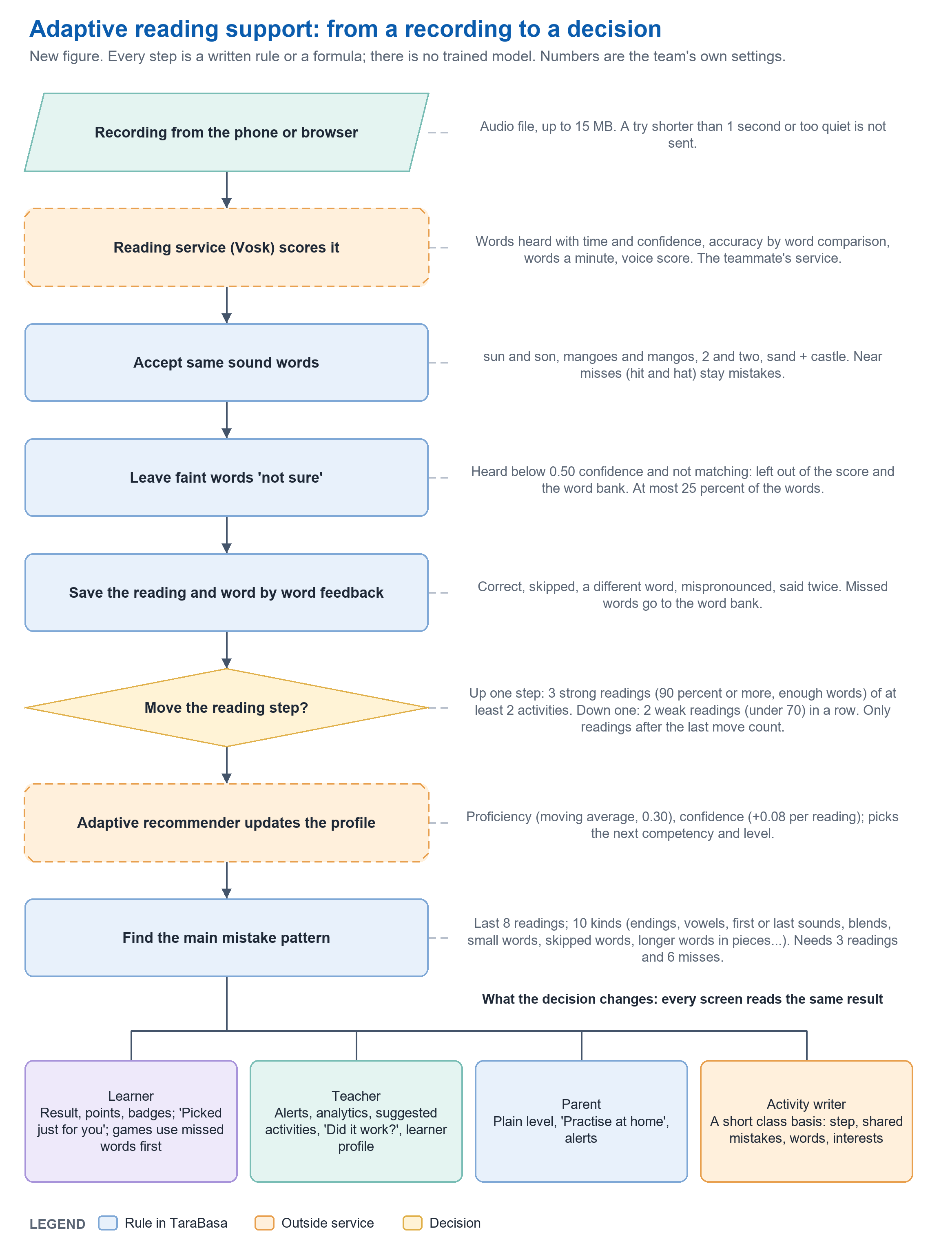
Figure 9: Adaptive Reading Support Rule Chain
The first reading check places a learner on a ladder of seven rungs, from saying letter names, through reading short words, short sentences, and longer sentences, to reading stories of about 30, 60, and 100 words. The check starts at the rung that the Parent’s description of the child and the child’s answers suggest, not at the learner’s grade, so that a Grade 3 child who cannot yet read starts with letters and a Grade 2 child who reads well starts with a story. A reading of 90 percent or more moves the check up one rung, a reading below 70 percent moves it down one rung, and a reading in between ends the check, which lasts at most three items. The rung where the check ends becomes the learner’s reading step, and the step is shown to the child as one of four: Letter Explorer, Word Builder, Sentence Reader, and Story Reader. Adults see the same step as a Phil-IRI level name (Non-reader, Frustration, Instructional, or Independent), and the Department of Education bases the Phil-IRI levels on oral reading accuracy (Department of Education, 2018).
After each reading the system cleans the score before it is used. Words that sound the same, such as sun and son, and spelling variants are accepted. A word that the reading service marked wrong but heard only faintly is marked as not sure and left out of the score, the word bank, and the alerts, up to a quarter of the words, so that a poor recording is not counted as the child’s mistake. The reading step then moves slowly: it moves up one step only after three strong readings, of at least two different activities, since the last move, and it moves down one step only after two weak readings in a row. A single reading never moves a learner, so that reading six words perfectly once does not make a child a sentence reader. The step is the learner’s place on the path and the level that adults see.
The recommendation service is sent the scores of each reading together with the learner’s current profile, and it returns the updated profile, which the application stores, and a suggestion for the next kind of activity and its level. The system puts a matching activity first in the learner’s list as ‘Picked just for you’. The system also looks at the words a learner missed in the last eight readings and sorts the misses into kinds, such as small words skipped, word endings, vowel sounds, first sounds, last sounds, letter blends, and longer words read in pieces. When one kind accounts for a quarter or more of the misses over at least three readings, the system names it as the learner’s main mistake pattern. The pattern is used to order the activities offered to the learner, to choose the words in the practice games, to give the Parent a tip for practicing at home, and to add a short note to the request that a Teacher sends to the activity writer when the Teacher asks for activities for a class. A word the learner misses goes to the Personal Word Bank as a struggling word, and it becomes mastered after three correct readings.
The teacher’s side of the support is an alert and a suggestion. The system marks a learner who needs support (the latest reading under 70 percent, or three under 70 in a row), a learner who is ready to move up (three readings of 90 percent or more), a learner who is just starting to read (on the letters step), a learner who has gone quiet (no reading for seven days), and a learner who has moved up. Each alert shows the evidence and, when a suitable activity exists in the Teacher’s own approved activities, suggests one that the Teacher can give in one tap. Before any assignment the system checks that the children can read the activity: the activity must be of the children’s grade, and its length must not be far above what a child at that step can read. The Teacher can still choose, because the system advises and the Teacher decides.
The four practice games (Balloon Pop, Word Train, Sentence Stars, and Syllable Steps) ask the learner to read aloud. The Syllable Steps game follows a syllable method of four steps: hear and echo the parts of a word, split it, join it by tapping the parts in order, and read it in a sentence. Only the last step is scored, because the recognizer cannot reliably hear single syllables. The games are free play and never change the learner’s points, streak, or reading step.

Table 7

RULES AND SETTINGS OF THE ADAPTIVE READING SUPPORT
Rule | Setting | Where the number comes from
First reading check, length | At most 3 items | Team's choice (keeps the check short for Grade 1 to 3)
First reading check, moving | 90 percent or more: up one rung. Below 70: down one rung. 70 to 89: stop. | Team's choice; 90 matches the lower edge of the Phil-IRI Instructional level
First reading check, ladder | Seven rungs: letters, short words, short sentences, longer sentences, stories of about 30, 60 and 100 words | Team's choice; items coded to MATATAG competencies
Level after the check | Rungs 0 to 2 Beginning; 3 and 4 Developing; 5 and 6 Proficient | Team's choice; follows the recommender's easy, medium, hard bands
A strong reading | 90 percent or more with at least 4, 6, 10, 17, 27 or 45 words (steps 0 to 5) | Team's choice; the word minimum stops a very short text from counting
Moving a step up | 3 strong readings of at least 2 different activities among the last 5 after the last move: up one step | Team's choice
Moving a step down | 2 weak readings (under 70 percent) in a row, on texts that were not too long for the child: down one step | Team's choice; a weak reading is set well below the Phil-IRI Frustration line (90) so one hard text does not move a child
Words that sound the same | Lists of same sound words, spelling variants, numbers and split words | Written lists in the settings; near misses stay mistakes
Not sure words | A missed word heard below 0.50 confidence is left out; at most 25 percent of the words; never a skipped word | Team's first guess from synthesized voices; to be tuned with children's recordings
Mistake pattern | Last 8 readings; at least 3 readings and 6 misses; the pattern must be 25 percent or more of the misses; called early until 5 readings | Team's choice
Personal word bank | Struggling, then Improving after one correct reading, then Mastered after 3 correct readings; at most 4 new words per reading | Team's design; no study checked for these numbers
Can the children read it? | A comfortable and a stretch number of words for each step: 6 and 10, 10 and 14, 16 and 24, 28 and 40, 45 and 60, 75 and 100, 130 and 170; a class is refused when 20 percent or more of its known learners could not read it | Team's choice, anchored on the first check's own texts
Alert: needs support | The latest reading was under 70 percent within 14 days, or the last 3 readings were under 70 | Team's choice
Alert: ready to move up | The last 3 readings were all 90 percent or more (and the app has not moved the learner yet) | Team's choice
Alert: starting to read / gone quiet | A learner on the letters step; no reading for 7 days or more | Team's choice
Practice games | 3 things per round; 2 first-try reads make a clean round and the next level; 2 tries each; up to 3 rounds; a row or sentence counts as read when two thirds of its words are heard | Team's choice; set with synthesized voices
Weekly goal | 5 readings a week, counted by Philippine time | Team's choice
Adaptive recommender | Moving average of the profile (0.30); confidence up 0.08 per reading; easy, medium, hard bands from the service's own settings | The teammate's service (fixed formulas)
Basis for a class | Something is said about a class only when at least 2 children show it; the note to the AI writer is at most 560 characters | Team's choice
Table 7 lists every setting that the rules use. The settings are kept in one file for each rule so that they can be changed without changing the program. They are the researchers’ own choices, set from the literature and from tests with synthesized voices, and they have not been checked against recordings of Filipino children. The intended check is described in the testing section: the readings collected in the pilot will be used to see whether the reading step moves when teachers expect it to move.
----- end of C9: copy only the text above this line -----
C10  DECISION | Place at: Chapter 3, 'User Interface Design' (pages 71 to 98).  Replaces: The introduction paragraph, and Figures 9 to 36.  Basis: The figures are the first design (prototype). Several no longer match the system, three Admin screens were never built, and two captions repeat the wrong text. Decide with the team: (a) keep them and say they are the initial design, then add real screenshots in a new 'Implemented Screens' section; or (b) replace each with a real screenshot. Option (a) is quicker.

Replace the introduction paragraph with:
The following figures present the initial User Interface Design of TaraBasa AI, showing how the application was first designed to look and function. The layout, color scheme, and experience were made to suit Grade 1 to Grade 3 learners, their teachers, and their parents. During development some screens changed; the screens that were implemented are shown in the section Implemented Screens, which follows the storyboards.
Screen map (working table, not for the manuscript). 'Figure' is the number in version 29; add 1 to every number from 9 on because a new Figure 9 is inserted.
Figure | Screen | What the real system has | Action
9 | Splash Screen | Exists in the phone app. | KEEP
10 | Welcome Screen | Caption text repeats the Splash Screen description (page 72). | FIX the text
11 | Parent Registration | Real form has First name, Middle initial, Last name, email, password; the email must be confirmed before sign in. The text says 'full name'. | UPDATE text; replace picture with the real screen
12 | Login Screen | Teachers and Parents sign in with email; Learners scan a card or type a code and a PIN. 'Password recovery' exists. | UPDATE text
13 | Create Child Profile | Real wizard has 5 steps: name and grade, character, reading stage and 3 questions, PIN. No 'age' or 'school name'. | REPLACE with the real wizard
14 | Parent Dashboard | Real Home shows child chips, a flag, days in a row, weekly goal, badges, source of readings. | REPLACE with the real screen
15 | Learner Home | Real Home shows reading path, stats, goal and growth; navigation is Home, Read, Games, Badges, Shelf. | REPLACE with the real screen
16 to 21 | Assessment intro, reading, quiz, results, lesson result, rewards | Real screens exist but look different (Tara the owl, star results, reading scene, badges page). | REPLACE with the real screens
22 to 29 | Teacher screens (dashboard, class list, learner profile, assign, intervention flag, reports, notifications, profile) | Real Teacher menu: Home, Classes, Activities, Alerts, Analytics, Promotions, Profile. 'Intervention Flag' is now Alerts. Assigning is a window. | REPLACE with the real screens; rename 'Intervention Flag' to Alerts
30 | Admin Login (Web) | Exists. | KEEP
31 | Admin Dashboard (Web) | Real Admin Overview shows waiting items and tiles, not 'total schools' and charts. | REPLACE
32 | AI Configuration (Web) | NOT BUILT. There is no screen that sets thresholds, badge conditions or rewards. | REMOVE (or label as future work)
33 | Reports and Analytics (Web admin) | NOT BUILT for the Admin. Reports and the CSV exist for Teachers only. | REMOVE (or label as future work)
34 | All Users (Web) | Real screen is Accounts: search, filter, deactivate, confirm email, delete. No edit, password reset, export. | UPDATE
35 | System Logs (Web) | Real screen is Activity log: who, what, why. No IP address column. | UPDATE
36 | User Detail (Web) | NOT BUILT. The caption text repeats Figure 17 (Reading Assessment). | REMOVE

Real screens to photograph for the section 'Implemented Screens' (take them from the live site or the Android app, 1080 px wide, no real names): Parent: Home, My children, Progress, Activities, Alerts. Teacher: Home, Classes (open a class), Activities (the level board), Alerts, Analytics. Learner: Home, Read, Games, Badges, a reading screen, a result screen. Admin: Overview, Approvals, Accounts, System health.
----- end of C10: copy only the text above this line -----
C11  UPDATED | Place at: Chapter 3, 'Storyboard' (pages 99 to 106).  Replaces: Sentences about features that are not in the system.  Basis: Teacher to Parent messaging, push notifications, weekly summaries, Admin AI configuration, announcements and report export are not built.

Where | Problem in version 29 | Replace with
Figure 37 (Admin storyboard), page 99 | Says the Admin sets thresholds and rewards in 'AI Configuration', composes announcements, edits a user and resets passwords, and exports reports as PDF or CSV. | Replace by: 'The Administrator signs in to the Overview, which shows the teachers waiting and the state of the services. From Approvals the Administrator approves or rejects teachers; from Accounts the Administrator searches, deactivates, confirms an email or deletes an account; System health tests the services; the Activity log records every action with its reason.'
Figure 38 (Learner storyboard), page 101 | Says 'new learners are prompted to register'; mentions 'My Lessons'. | Replace by: 'A learner does not register alone. The parent creates the profile; the learner signs in by scanning the card or typing the Learner Code and the PIN.' Replace 'My Lessons' with 'Read'.
Figure 39 (Teacher storyboard), pages 103 to 104 | Says the sidebar toggles 'automated email alerts, push notifications, or weekly reporting summaries' and that an 'Intervention Flags' screen has a 'Message Parent' option. | Replace by: 'Alerts shows who needs support, who is ready to move up, and who is just starting, with the evidence and a suggested activity that can be given in one tap.' Delete the sentences about push notifications, weekly summaries, and messaging the parent: they are not in the system.
Figure 40 (Parent storyboard), pages 105 to 106 | Says 'as detailed in parent.png' (file name left in the text); describes a 'Teacher Messaging' portal; says the child profile has age and school name. | Delete 'as detailed in parent.png'. Delete the messaging sentences. Replace the profile description with the real wizard (name, grade, character, reading stage and questions, PIN).

----- end of C11: copy only the text above this line -----
C12  UPDATED | Place at: Chapter 3, 'Database Design' (pages 128 to 131): Figure 41 (ERD) and the three pages of narrative after it; and 'Data Dictionary' (pages 107 to 124). ALSO MOVE the whole 'Database Design' section so that it comes before 'Data Dictionary': the Table of Contents lists it first, but in version 29 it sits after the Technology Stack.  Replaces: Figure 41 and the narrative that mentions 'Curriculum Guide', 'Badge', 'Notification ... SMS notifications', 'Teachers may upload curriculum guides'.  Basis: The real database (the migrations) has 23 tables made by the application: 14 of the 16 tables of version 29, and 9 new ones. 'Curriculum Guide' and 'Badge' are not tables.  Note: Figure 42 below is the new ERD (version 29's Figure 41). Table numbers in this block follow the numbering map in 01: the data dictionary becomes Tables 8 to 30.

Database Design
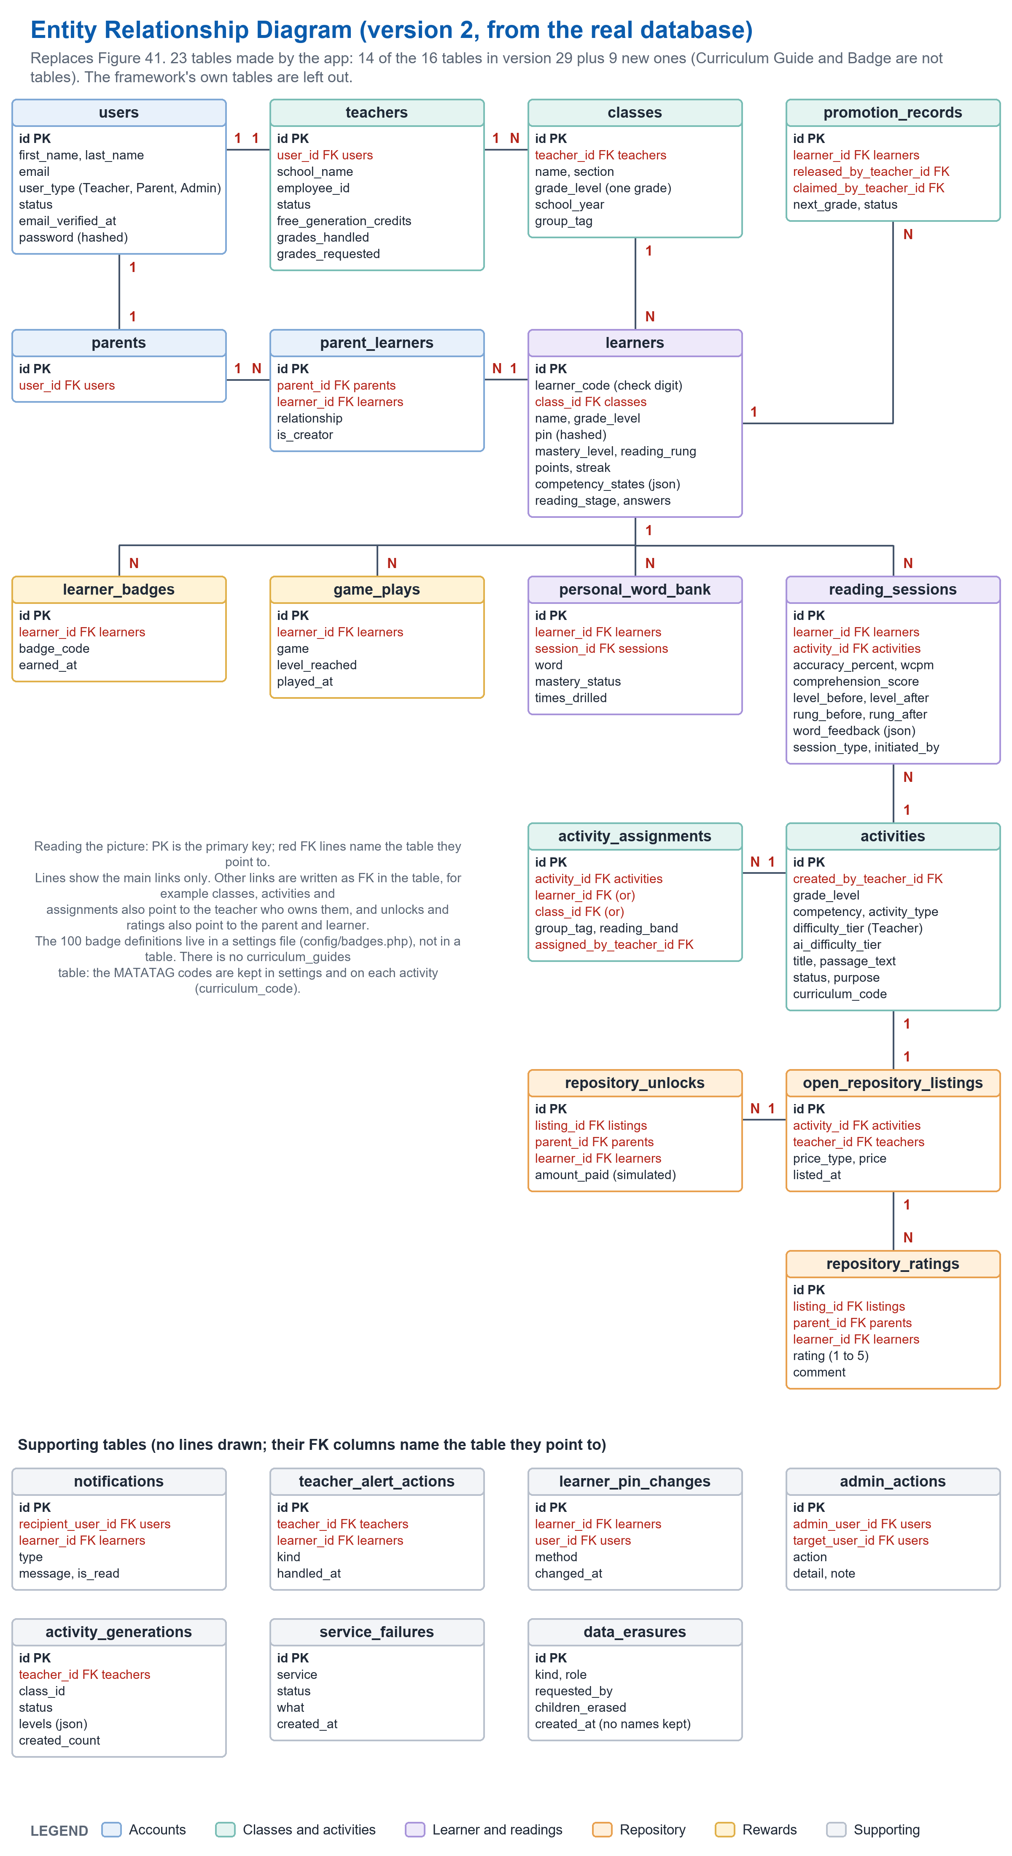
Figure 42: Entity Relationship Diagram
Figure 42 presents the Entity Relationship Diagram (ERD) of the TaraBasa AI platform, showing the 23 tables that the application keeps and how they relate. The tables support AI-assisted reading assessment, adaptive gamified learning, teacher monitoring, parent monitoring, and repository-based reading intervention for Grade 1 to Grade 3 learners in Philippine public elementary schools. The tables that the framework itself needs, such as sessions and queued jobs, are left out.
At the center of the system is the User entity, which stores the account information of every registered adult: name, email address, a hashed password, user type (Teacher, Parent, or Admin), status, and the date the email address was confirmed. The Teacher entity extends the User entity through a one-to-one relationship and stores the school, the employee identification number, the status (Pending, Active, or Rejected), the grades the teacher handles, any request to add a grade, and the number of free generation credits. The Parent entity extends the User entity in the same way.
Teachers own one or more Class records, and each class holds learners of one grade only. A Learner record stores the Learner Code, the grade, a hashed PIN, the reading rung and level, points and streak, and the learner’s adaptive profile. A learner may belong to no class until a teacher adds the learner. Parents and learners are linked through the Parent Learner entity, which resolves the many-to-many relationship so that a learner may have more than one guardian. The Promotion Record entity keeps the history of a learner who is released by one teacher and claimed by another when the learner moves to the next grade.
The Activity entity holds the reading activities, whether drafted by the AI writer for a teacher or written for the first reading check. Each activity stores its grade, competency, kind, passage, instructions, comprehension questions, curriculum code, the level suggested by the AI and the level chosen by the teacher. A teacher gives an activity to learners through the Activity Assignment entity, whose target is a learner, a class, a reading group, or a focus group. The Activity Generation entity records a teacher’s request for drafts while the AI writer works in the background.
Every reading is recorded in the Reading Session entity: accuracy, words correct per minute, the comprehension score, the level and reading rung before and after, the word-by-word feedback, and whether the reading was flagged. Missed words are kept in the Personal Word Bank entity, one row for each learner and word. The Learner Badge entity records which of the 100 badges a learner earned and when; the badge definitions themselves are kept in a settings file. The Game Play entity records each finished practice game, which is used only for the game badges.
A teacher may share an approved activity through the Open Repository Listing entity, free or at a price. A parent unlocks a listing for a child through the Repository Unlock entity and may rate it once through the Repository Rating entity. The payment is simulated. Notifications to teachers and parents are kept in the Notification entity, the handling of an alert by a teacher in the Teacher Alert Action entity, and the changes of a child’s PIN in the Learner Pin Change entity. The Admin Action entity is the activity log, the Service Failure entity is a short diary of problems with outside services, and the Data Erasure entity records only that a deletion took place, without any name or identifier.
Overall, the ERD shows how reading performance data flow from the speech assessment into the reading step, the word bank, the alerts, and the dashboards that teachers and parents use, while the records that identify a person can be deleted on request.
Data Dictionary: what changes in each table (working table; use the numbers of the new numbering map).
Table | Add these columns | Change | Remove
User (Table 8) | User_MiddleInitial VARCHAR 5 YES. User_EmailVerifiedAt TIMESTAMP YES (sign in is blocked for a Teacher or Parent until it is filled). | User_Status values: Active, Inactive. User_Type: Teacher, Parent, Admin. | -
Teacher (Table 9) | Tchr_RejectionReason VARCHAR 255 YES. Tchr_GradesHandled JSON YES. Tchr_GradesRequested JSON YES, Tchr_GradesRequestedAt TIMESTAMP YES, Tchr_GradesRequestNote VARCHAR 255 YES. | Tchr_Status NOT NULL with the values Pending, Active, Rejected (version 29 says 'YES' for null). | -
Learner (Table 11) | Lrnr_AvatarPhotoPath, Lrnr_LearningStyle, Lrnr_ReadingStage, Lrnr_PlacementAnswers (JSON), Lrnr_ReadingRung TINYINT (0 to 6), Lrnr_RungChangedAt, Lrnr_CompetencyStates (JSON), Lrnr_NextRecommendedCompetency, Lrnr_NextRecommendedDifficulty, Lrnr_SubdomainStates (JSON), Lrnr_NextRecommendedSubdomain, Lrnr_ReadingFontStep, Lrnr_ThemeColor, Lrnr_HomeLanguage, Lrnr_Supports (JSON), Lrnr_Interests (JSON). All YES (null). | Lrnr_ClassID: Null is YES (empty until a teacher adds the learner). Lrnr_PIN: VARCHAR 255, stored hashed (version 29 says VARCHAR 10). Lrnr_LearnerCode: format such as TB26-48293 with a check digit. Lrnr_MasteryLevel: Null is YES. Lrnr_Streak: counts scored readings, not days in a row (the day streak is worked out). | -
Parent_Learner (Table 12) | - | Add: one row for each parent and learner pair. | -
Class (Table 13) | - | Cls_GradeLevel holds one grade only; Cls_SchoolYear marks the school year; past years are read only. | -
Promotion_Record (Table 14) | Promt_ReleasedFromClassID, Promt_ClaimedIntoClassID INT YES. | - | -
Activity (Table 15) | Act_GenerationID, Act_BundleTitle, Act_VariantLabel, Act_CompetencyLabel, Act_ActivityType, Act_TeacherNotes TEXT, Act_Title, Act_Instructions TEXT, Act_PassageText TEXT, Act_ReferenceText TEXT, Act_WordCount, Act_TargetSkills JSON, Act_ReadingFeatures JSON, Act_FollowUpQuestions JSON, Act_AiDifficultyTier, Act_Purpose, Act_CurriculumCode, Act_CheckRung, Act_GenerationBasis JSON. | Act_TeacherID: Null is YES (the first reading check texts have no teacher). Act_Topic: Null is YES. Act_SkillFocus becomes Act_Competency. Act_DifficultyTier is the level the teacher chose. | Act_GameType (the system has no game type on an activity).
Open_Repository_Listing (Table 16) | - | Orl_ActivityID is unique: an activity is listed once. | -
Repository_Unlock (Table 17) | - | A learner can unlock a listing once. The amount is simulated. | -
Reading_Session (Table 18) | Sess_SessionType (Practice or Diagnostic), Sess_SpeedScore, Sess_ProsodyScore, Sess_AdaptiveAttemptScore, Sess_ComprehensionScore FLOAT YES; Sess_SkippedWordCount, Sess_SubstitutionCount, Sess_InsertionCount INT YES; Sess_RungBefore, Sess_RungAfter TINYINT YES; Sess_WordFeedback JSON YES; Sess_AdaptiveSubdomain VARCHAR YES. | Sess_LevelBefore and Sess_LevelAfter are the Beginning, Developing or Proficient level. Pronunciation and fluency scores and the mispronunciation and repetition counts are left empty (null): the reading service does not measure them. | -
Personal_Word_Bank (Table 19) | Unique pair (learner, word). | Rename the table 'Personal Word Bank' (version 29 says 'World'). | -
Learner_Badge (Table 20) | - | Lbdg_BadgeID becomes Lbdg_BadgeCode VARCHAR 255: the 100 badge definitions are in a settings file, not a table. | Table 'Badge' (Bdge_*): there is no such table.
Notification (Table 21) | - | Notf_RecipientUserID refers to a user (Teacher or Parent). Notf_Type is a short text such as session summary, needs attention, level confirmed, PIN changed, guardian removed. No SMS. | -
Curriculum_Guide (Table 14 in v29) | - | - | There is no such table. The MATATAG codes and wording are kept in settings and on each activity (Act_CurriculumCode). Delete the table and its paragraph, and the 'Curriculum Guide' entity from the ERD narrative.

New data dictionary tables (insert after the Notification table, in the same format as the existing ones):

Table 22

ACTIVITY_ASSIGNMENT
Column Name | Data Type | Field Size | Null | Description
Asg_ID (PK) | INT | -- | NOT NULL | Unique identifier for the assignment
Asg_ActivityID (FK) | INT | -- | NOT NULL | Refers to the activity that was assigned
Asg_LearnerID (FK) | INT | -- | YES | Set when the activity is assigned to one learner
Asg_ClassID (FK) | INT | -- | YES | Set when the activity is assigned to a whole class
Asg_GroupTag | VARCHAR | 255 | YES | Set when the activity is assigned to a focus group, which is a tag used by the teacher's classes
Asg_ReadingBand | VARCHAR | 255 | YES | Set when the activity is assigned to one reading group of a class (needs support, instructional, or independent)
Asg_AssignedByTeacherID (FK) | INT | -- | NOT NULL | Refers to the teacher who made the assignment
Asg_AssignedAt | TIMESTAMP | -- | NOT NULL | Date and time the assignment was made
Table 22 describes the Activity_Assignment table, which records who an activity was given to. Exactly one target is set for each row: a learner, a class, a reading group of a class, or a focus group. The same table is read to decide which activities appear in a learner’s list.

Table 23

ACTIVITY_GENERATION
Column Name | Data Type | Field Size | Null | Description
Gen_ID (PK) | INT | -- | NOT NULL | Unique identifier for the request for activities
Gen_TeacherID (FK) | INT | -- | NOT NULL | Refers to the teacher who asked for the activities
Gen_Status | VARCHAR | 255 | NOT NULL | Queued, Running, Done, or Failed
Gen_GradeLevel | VARCHAR | 255 | NOT NULL | Grade level asked for
Gen_Competency | VARCHAR | 255 | NOT NULL | Reading skill asked for
Gen_ActivityType | VARCHAR | 255 | NOT NULL | Kind of reading activity asked for
Gen_Topic | VARCHAR | 255 | YES | Optional topic typed by the teacher
Gen_TeacherNotes | TEXT | -- | YES | Optional notes typed by the teacher
Gen_Levels | JSON | -- | NOT NULL | How many drafts were asked for at each level
Gen_ClassID | BIGINT | -- | YES | Class the activities were written for, if any
Gen_Basis | JSON | -- | YES | The short class summary sent to the AI writer
Gen_CreatedCount | SMALLINT | -- | NOT NULL | Number of drafts saved
Gen_Message | TEXT | -- | YES | Plain message shown to the teacher when the request fails or ends
Gen_StartedAt / Gen_FinishedAt / Gen_AcknowledgedAt | TIMESTAMP | -- | YES | When the work started, when it ended, and when the teacher dismissed the notice
Table 23 describes the Activity_Generation table. An AI request can take about two minutes, so it is saved here and written in the background; the teacher can leave the page and return. One free credit is used only when the drafts are saved.

Table 24

REPOSITORY_RATING
Column Name | Data Type | Field Size | Null | Description
Rr_ID (PK) | INT | -- | NOT NULL | Unique identifier for the rating
Rr_ListingID (FK) | INT | -- | NOT NULL | Refers to the repository listing that was rated
Rr_ParentID (FK) | INT | -- | NOT NULL | Refers to the parent who gave the rating
Rr_LearnerID (FK) | INT | -- | NOT NULL | Refers to the learner who used the activity
Rr_Rating | TINYINT | -- | NOT NULL | Rating from 1 to 5 stars
Rr_Comment | TEXT | -- | YES | Optional comment from the parent
Rr_RatedAt | TIMESTAMP | -- | NOT NULL | Date and time of the rating
Table 24 describes the Repository_Rating table. A parent may rate a listing once; the average rating is shown to the teacher who shared it.

Table 25

GAME_PLAY
Column Name | Data Type | Field Size | Null | Description
Gp_ID (PK) | INT | -- | NOT NULL | Unique identifier for the finished game
Gp_LearnerID (FK) | INT | -- | NOT NULL | Refers to the learner who played
Gp_Game | VARCHAR | 255 | NOT NULL | Balloon Pop, Word Train, Sentence Stars, or Syllable Steps
Gp_LevelReached | TINYINT | -- | NOT NULL | Level the learner ended on
Gp_TopLevelCleared | BOOLEAN | -- | NOT NULL | True when a whole round was finished at the top level
Gp_HadPerfectRound | BOOLEAN | -- | NOT NULL | True when a round was read right the first time
Gp_Rounds | TINYINT | -- | NOT NULL | Number of rounds played
Gp_PlayedAt | TIMESTAMP | -- | NOT NULL | Date and time the game finished
Table 25 describes the Game_Play table. The practice games are free play, so a finished game saves only this one row, which is used to award the game badges. It never changes points, streak, or reading step.

Table 26

TEACHER_ALERT_ACTION
Column Name | Data Type | Field Size | Null | Description
Tac_ID (PK) | INT | -- | NOT NULL | Unique identifier
Tac_TeacherID (FK) | INT | -- | NOT NULL | Refers to the teacher who handled the alert
Tac_LearnerID (FK) | INT | -- | NOT NULL | Refers to the learner the alert was about
Tac_Kind | VARCHAR | 255 | NOT NULL | Kind of alert: support, ready, start, quiet, or moved
Tac_HandledAt | TIMESTAMP | -- | NOT NULL | When the teacher marked the alert handled
Table 26 describes the Teacher_Alert_Action table. Alerts themselves are worked out from the readings; this table keeps only the fact that a teacher handled one. A new reading opens the alert again.

Table 27

LEARNER_PIN_CHANGE
Column Name | Data Type | Field Size | Null | Description
Pin_ID (PK) | INT | -- | NOT NULL | Unique identifier
Pin_LearnerID (FK) | INT | -- | NOT NULL | Refers to the learner whose PIN was changed
Pin_UserID (FK) | INT | -- | YES | Refers to the parent who made the change
Pin_Method | VARCHAR | 255 | NOT NULL | Generated by the system, or chosen by the parent
Pin_ChangedAt | TIMESTAMP | -- | NOT NULL | Date and time of the change
Table 27 describes the Learner_Pin_Change table, which limits a PIN to three changes a day. The PIN itself is never stored here.

Table 28

ADMIN_ACTION
Column Name | Data Type | Field Size | Null | Description
Adm_ID (PK) | INT | -- | NOT NULL | Unique identifier
Adm_AdminUserID (FK) | INT | -- | YES | Refers to the administrator who acted
Adm_AdminName | VARCHAR | 255 | NOT NULL | The administrator's name at the time
Adm_Action | VARCHAR | 255 | NOT NULL | What was done, such as approved, rejected, or deleted an account
Adm_TargetUserID (FK) | INT | -- | YES | Refers to the account acted on
Adm_TargetName | VARCHAR | 255 | NOT NULL | The account holder's name, or a general word when the account was deleted
Adm_TargetRole | VARCHAR | 255 | NOT NULL | Role of the account acted on
Adm_Detail / Adm_Note | VARCHAR | 255 | YES | The reason and any note
Adm_CreatedAt | TIMESTAMP | -- | NOT NULL | Date and time of the action
Table 28 describes the Admin_Action table, the activity log that the administrator reads. Names are copied into the row so the log still reads after an account is deleted, and a deleted person’s name is removed.

Table 29

SERVICE_FAILURE
Column Name | Data Type | Field Size | Null | Description
Svf_ID (PK) | INT | -- | NOT NULL | Unique identifier
Svf_Service | VARCHAR | 255 | NOT NULL | Which service: reading, activity writer, recommender, or email
Svf_Status | SMALLINT | -- | YES | Answer code of the service
Svf_Trail / Svf_ContentType / Svf_What | VARCHAR | 255 | YES | What was tried and what came back
Svf_Body / Svf_Details | TEXT | -- | YES | The service's answer and the check details
Svf_CreatedAt | TIMESTAMP | -- | NOT NULL | Date and time
Table 29 describes the Service_Failure table, a short diary of problems with the outside services. It is shown on the administrator’s System health screen and kept for 14 days.

Table 30

DATA_ERASURE
Column Name | Data Type | Field Size | Null | Description
Era_ID (PK) | INT | -- | NOT NULL | Unique identifier
Era_Kind | VARCHAR | 255 | NOT NULL | child, account, or unlinked
Era_Role | VARCHAR | 255 | NOT NULL | Role of the person whose data was removed
Era_RequestedBy | VARCHAR | 255 | NOT NULL | self, or admin
Era_ChildrenErased | SMALLINT | -- | NOT NULL | Number of children whose records were deleted
Era_CreatedAt | TIMESTAMP | -- | NOT NULL | Date and time
Table 30 describes the Data_Erasure table. It records only that a deletion happened. It keeps no name, email, code, or identifier, so that deleting data does not leave new personal data behind.
----- end of C12: copy only the text above this line -----
C13  UPDATED | Place at: Chapter 3, 'Network Design' (pages 124 to 127): Figures 42 and 43 and their paragraphs. The introduction stays.  Replaces: The network model (Google Cloud Speech-to-Text and SMS Gateway API) and the topology (a school local area network with Android tablets, the SMS path to non-smartphone parents).  Basis: No SMS and no Google Speech-to-Text. Free hosting that sleeps. The Admin on the website only.  Note: The old topology said parents without a smartphone are reached by SMS. That path does not exist now, so the digital equity claim ('no parent is excluded') must also be removed or reworded.

Network Model
A network model is a conceptual framework that describes the architecture, components, and interactions within a computer network. It outlines how different devices and services communicate with each other to achieve seamless connectivity and efficient data transfer.
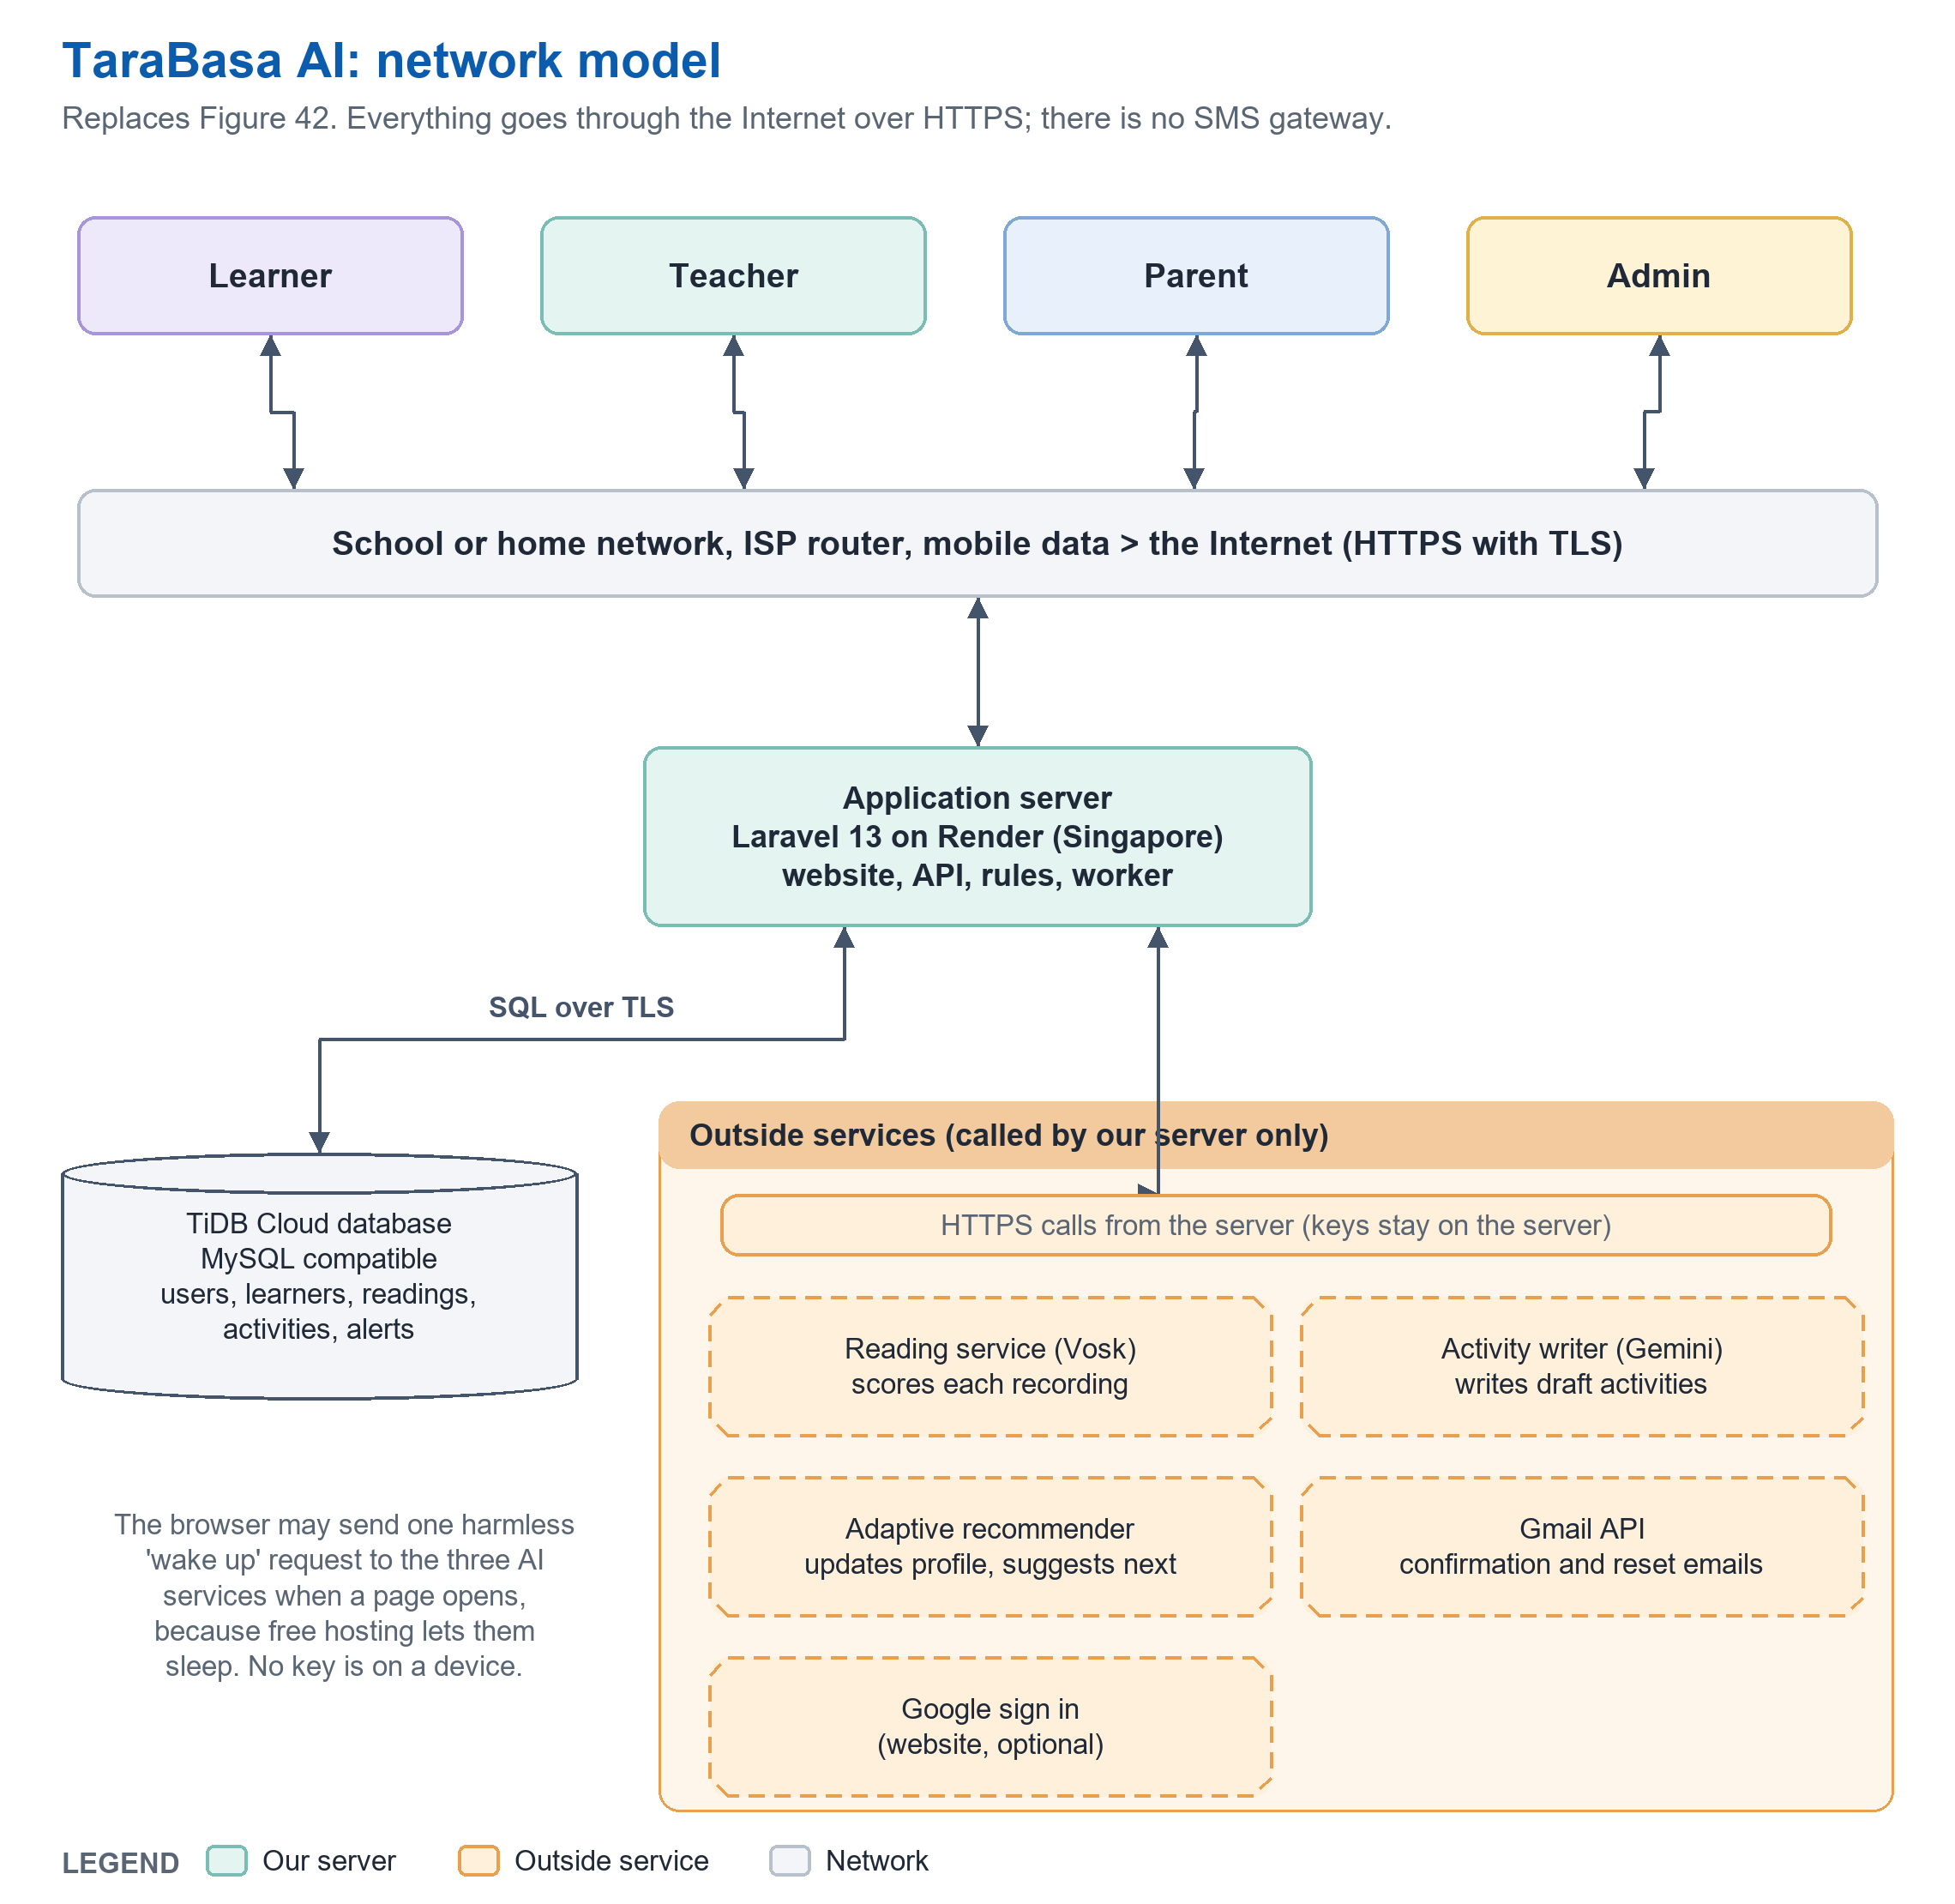
Figure 43: TaraBasa AI Network Model
Learners, teachers, parents, and the administrator reach TaraBasa AI through a school or home network or mobile data, and the Internet, over an encrypted HTTPS connection. The application server runs on Render, in Singapore, and serves both the website and the mobile application. The server reads and writes the TiDB Cloud database through an encrypted SQL connection. It calls four outside services over HTTPS and never lets a phone or a browser call them directly, so that the keys stay on the server: the reading service (Vosk), which scores each recording; the activity writer (Gemini), which drafts activities; the adaptive recommender, which updates each learner’s profile; and the Gmail API, which sends account emails. Google sign in is an optional way for adults to sign in on the website. The system has no SMS gateway: teachers and parents see updates inside the application and the website. Because the hosting plans are free, the server and the three AI services sleep when they are not used. A page may send one harmless request from the browser to wake them, and the server waits for them before it scores a reading.

Network Topology
This section presents a visual illustration of the network topology, which represents how devices and components are integrated into a computer network. The topology diagram shows the links between network nodes and helps in understanding the data flow and the protocols used for data transfer.
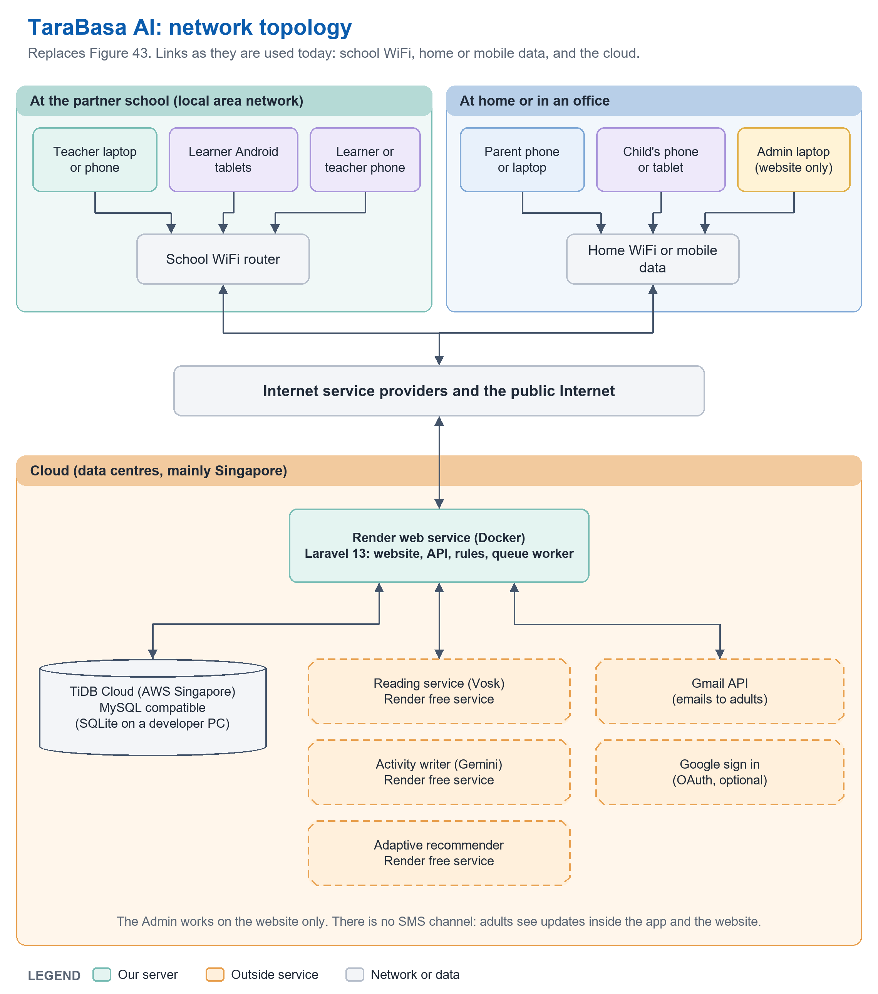
Figure 44: TaraBasa AI Network Topology
The network topology of TaraBasa AI centers on a cloud application server, which hosts the website, the application programming interface, the rules, and a background worker, and which is reached through the Internet. From this server the TiDB Cloud database and the outside services are called over the Internet. On the access side, teachers and learners at the partner school connect through the school’s WiFi router, with teacher laptops or phones and learner Android tablets, to the school’s Internet connection. Parents and children at home connect through home WiFi or mobile data, and the administrator connects through an office or home Internet connection to the website. All traffic is carried over HTTPS. Because the system needs an Internet connection for scoring and for writing activities, a school with a weak connection may find the first reading of a session slow, and the limits of the study state this.
----- end of C13: copy only the text above this line -----
C14  UPDATED | Place at: Chapter 3, 'Development/Construction/Build Phase', the paragraph on page 127.  Replaces: The whole paragraph (XAMPP, Android Studio, Google Cloud Speech-to-Text, Philippine SMS gateway).  Basis: The partner school name must match the decision made in C5.

Development/Construction/Build Phase
During the development phase, everything required to implement the project was organized following the Agile Methodology adopted in Chapter 1. The research team coordinated with the partner school [name of school, to match Chapter 1] to confirm classroom access, learner participation, and device availability for pilot testing. Development environments were set up using Visual Studio Code for the website and the mobile application, PHP 8.4 with Laravel 13 for the server, Node.js with Expo for the mobile application, and SQLite for local development. The production system was hosted on Render with a TiDB Cloud database. Access to the outside services was arranged early in this phase: the reading service (Vosk), the activity writer (Gemini), the adaptive recommender, and the Gmail API, since each required an account and, in some cases, verification time before development could proceed. A working timeline was established for each Agile sprint, covering account management, the reading assessment, gamification, the teacher and parent screens, and the administrative tools, with testing and revisions at the end of each sprint.
----- end of C14: copy only the text above this line -----
C15  UPDATED | Place at: Chapter 3, 'Technology Stack Diagram' (pages 127 to 128): Table 23 and its paragraphs. Add Figure 45 (architecture picture) under the first paragraph.  Replaces: Kotlin, Android Studio, XAMPP, Apache, Bootstrap, RESTful API, Cloud SQL, SMS Gateway API, Google Cloud Speech-to-Text.  Basis: Real stack, confirmed from the repository (composer.json, mobile/package.json, Dockerfile) on 20 October 2026; Expo SDK 57 needs Android 7 or newer (Expo documentation); Render free services sleep after 15 minutes without traffic (Render documentation); TiDB Cloud Starter free quota is 5 GiB of row storage and 50 million request units a month for each cluster (TiDB Cloud documentation).  Note: Table number becomes 31 in the new numbering.

Technology Stack Diagram
The table below is the technology stack diagram, which presents the technologies of the proposed system, categorized into five sections: mobile application, website, server and database, AI services, and future development.

Table 31

TECHNOLOGY STACK
Mobile Application | Website | Server and Database | AI Services | Future Development
• React Native 0.86 with Expo SDK 57  • React 19 and TypeScript  • Expo Audio (recording)  • Expo Camera (QR scanning)  • Expo Speech (read aloud)  • Secure Store (sign in token)  • Lottie animations  • Android 7.0 or newer | • Laravel Blade pages  • HTML, JavaScript  • Hand-written CSS (no CSS framework)  • Lottie web player  • Cropper.js (photo crop)  • jsQR (QR scanning)  • Chrome, Edge, Firefox | • PHP 8.4 and Laravel 13  • Laravel Sanctum (phone sign in)  • Database queue and worker  • Docker image on Render (Singapore)  • TiDB Cloud Starter (MySQL compatible)  • SQLite (development only)  • Gmail API (OAuth) for email | • Vosk small English model (Kaldi based) through Reading-api (FastAPI)  • Gemini through a FastAPI activity writer  • Adaptive recommender (FastAPI, fixed formulas)  • Rules written in the application  • All three on Render | • iOS application  • Filipino and Bisaya voice recognition  • Offline mode  • Paid hosting and a persistent file store  • Tuning the rules with recordings of children  • Teacher and parent messaging
TaraBasa AI is an AI-assisted mobile and web platform for adaptive reading assessment and intervention. The mobile application is built with React Native and Expo, which produce an Android application from one TypeScript program, and uses the device’s microphone to record a learner’s reading, the camera to scan the QR code on a learner card, and the device’s own voice to read words aloud. The website is built with Laravel Blade pages, hand-written style sheets, and plain JavaScript, and serves all four types of users, with the administrator using the website only.
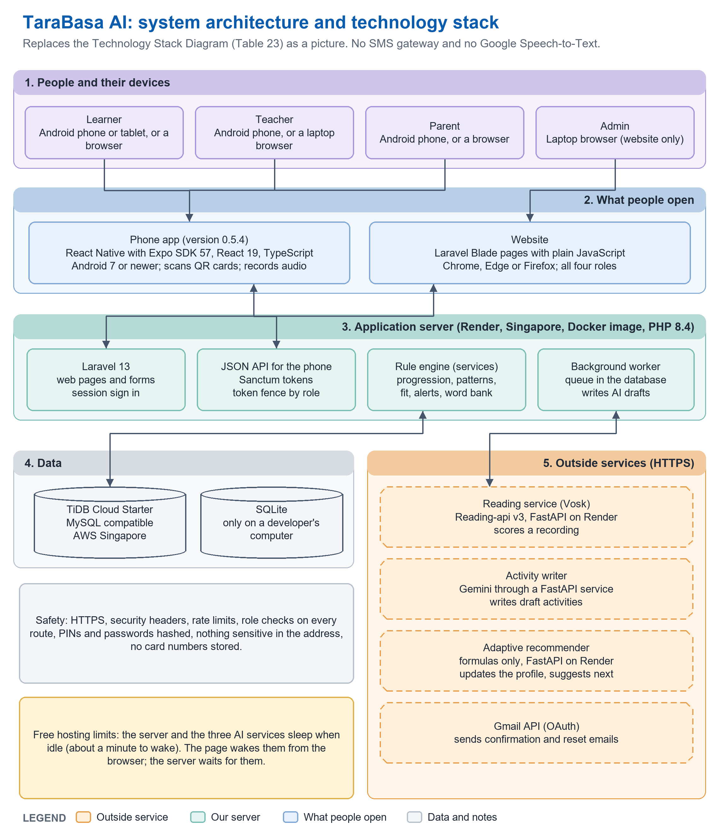
Figure 45: System Architecture and Technology Stack
The server runs PHP 8.4 and Laravel 13 in a Docker image on the Render hosting service in Singapore. Laravel serves the web pages and a JSON interface for the mobile application, which signs in with Sanctum tokens. A background worker, using a queue kept in the database, writes AI activity drafts without making a teacher wait. The data are kept in TiDB Cloud, a database compatible with MySQL, and in SQLite on a developer’s computer. The speech recognition is done by Vosk, an offline toolkit built on Kaldi, through a separate Python service that compares the recognized words with the activity text; the researchers did not train a speech model. Activities are drafted by the Gemini model through a second service, and a third service keeps each learner’s adaptive profile with fixed formulas. Account emails are sent through the Gmail interface. Looking ahead, future development includes an iOS application, Filipino and Bisaya voice recognition, an offline mode, paid hosting and a persistent store for photographs, and tuning the rules with recordings of children.
----- end of C15: copy only the text above this line -----
C16  UPDATED | Place at: Chapter 3, 'Software Specification' (page 132): Table 24 and its paragraph.  Replaces: Kotlin, Android Studio, Cloud SQL, Bootstrap, XAMPP, Google Cloud Speech-to-Text, Semaphore SMS API, 'Android OS Version 8.0 and above'.  Basis: Real stack (see C15). Android 7.0 is the Expo SDK 57 minimum.  Note: Table number becomes 32.

Software Specification
This section presents the software that was used, including the operating system, programming languages for both the front end and the back end of the application, platforms, and the database needed to develop the entire TaraBasa AI system. It functions as a blueprint that the researchers followed to develop the program correctly.

Table 32

SOFTWARE SPECIFICATIONS
Component | Specification
Operating System | Windows 10/11 (development); Android 7.0 or newer (mobile application); any current browser (website)
Text Editor/IDE | Visual Studio Code; Git and GitHub for version control
Programming Language | PHP 8.4, TypeScript, JavaScript, Python (the AI services)
Web Browser | Google Chrome, Microsoft Edge, Mozilla Firefox
Mobile Framework | React Native 0.86 with Expo SDK 57
Web Framework | Laravel 13 with Blade pages and hand-written CSS (no CSS framework)
Database | TiDB Cloud (MySQL compatible) for the live system; SQLite for development
Speech Recognition Service | Vosk (Kaldi based) through Reading-api
Activity Writing Service | Google Gemini through a FastAPI service
Adaptive Recommendation Service | FastAPI service with fixed formulas
Email | Gmail API (OAuth)
Hosting | Render (Docker), Singapore
Automated Testing | PHPUnit (656 tests on 20 October 2026; replace with the number on the day of submission)
Table 32 outlines the software specification for developing the TaraBasa AI platform. The researchers chose Windows for development machines and Android 7.0 or newer for the mobile application, which is the lowest version that Expo SDK 57 supports and reflects the older Android devices that are common in Philippine public elementary schools. Visual Studio Code is the main editor, with PHP 8.4, TypeScript, and JavaScript for the website, the server, and the mobile application, and Python for the AI services. Supported browsers are Google Chrome, Microsoft Edge, and Mozilla Firefox. TiDB Cloud serves as the live database and SQLite is used for development. The Vosk speech recognition service, the Gemini activity writing service, the adaptive recommendation service, and the Gmail interface complete the specification, supporting the platform’s AI assessment and its account emails. The system has no SMS gateway.
----- end of C16: copy only the text above this line -----
C17  UPDATED | Place at: Chapter 3, 'Hardware Specification' (pages 133 to 134): Table 25 and its paragraph.  Replaces: 'Camera 12MP or higher', 'Octa Core ... 2.0 GHz', '4 GB RAM', '6 GB available space' for the Android device.  Basis: A camera is only needed to scan a card and its quality does not matter; a microphone is required. The Android numbers were not tested; fill in the real test phone in the bracket.  Note: Table number becomes 33. The server row is new: it matters because the free plan sleeps and limits speed.

Hardware Specification
This section provides a description of the hardware requirements needed for the system. It outlines the specifications, requirements, and limitations of each hardware component necessary to support the development, deployment, and operation of the proposed system.

Table 33

HARDWARE SPECIFICATIONS
Device | Component | Specification
PC (development) | CPU | 64-bit, 2.5 GHz or faster; Intel Core i5 10th Generation or AMD Ryzen 5 3000 series or higher
 | Memory | At least 8 GB RAM
 | Storage | At least 10 GB available
 | GPU | Integrated or dedicated graphics
Android device (learner, teacher, parent) | System | Android 7.0 or newer (the minimum of Expo SDK 57)
 | Memory | At least 2 GB RAM [test phone model and RAM: team to fill in]
 | Storage | At least 100 MB free for the application (the test build is about 44 MB)
 | Microphone | Required: the learner's reading is recorded with it
 | Camera | Optional: only to scan the QR code on a learner card; a code can be typed instead
 | Network | WiFi or mobile data: an Internet connection is needed to score a reading
Server (cloud) | Hosting | Render web service (Docker) in Singapore; the free plan sleeps after 15 minutes without traffic, and about a minute is needed to wake it
 | Database | TiDB Cloud Starter (the free quota is 5 GiB of row storage and 50 million request units a month for each cluster)
Table 33 outlines the hardware specifications for TaraBasa AI. For development, a personal computer with a 64-bit processor of 2.5 GHz or faster, at least 8 GB of memory, 10 GB of free storage, and graphics is used. For learners, teachers, and parents, an Android device with Android 7.0 or newer and at least 2 GB of memory is needed, with a microphone to record the learner’s reading. A camera is optional and is used only to scan the QR code on a learner card. Because scoring and activity writing happen on the server, the device does not need a strong processor, but it needs WiFi or mobile data. The server runs on a free hosting plan that sleeps when idle, so the first request after a quiet period takes about a minute, and the live database is limited by the free quota of its plan. A steady classroom use would need paid plans.
----- end of C17: copy only the text above this line -----
C18  UPDATED | Place at: Chapter 3, 'List of Modules' (pages 134 to 139): Tables 26.1 to 26.5 become Tables 34.1 and following.  Replaces: The nine-module list and its totals ('Total Number of Modules 15').  Basis: Same format as version 29, rebuilt from the same list of functions as the FDD. A System column is added because modules 9 and 10 contain functions the system performs itself.  Note: Programmer names: modules 1 to 9 keep the owners in version 29; modules 10 and 11 are for the team to assign.

List of Modules
The modules and features required to run the TaraBasa AI application efficiently are outlined in this section. Different programmers are given the modules to build the different features.

Table 34.1

LIST OF MODULES
Programmer | Module / Functionality | Learner | Teacher | Parent | Admin | System
Acuyan | MODULE 1: Account Management
 | 1.1.1 Log in |  |  |  | *
 | 1.1.2 Log out |  |  |  | *
 | 1.2.1 Register account |  | *
 | 1.2.2 Confirm email by link |  | *
 | 1.2.3 Send a new confirmation link |  | *
 | 1.2.4 Log in (email, or Google) |  | *
 | 1.2.5 Reset forgotten password |  | *
 | 1.2.6 View and edit profile |  | *
 | 1.2.7 Change password |  | *
 | 1.2.8 Request a grade change |  | *
 | 1.2.9 Delete own account |  | *
 | 1.2.10 Log out |  | *
 | 1.3.1 Register account |  |  | *
 | 1.3.2 Confirm email by link |  |  | *
 | 1.3.3 Send a new confirmation link |  |  | *
 | 1.3.4 Log in (email, or Google) |  |  | *
 | 1.3.5 Reset forgotten password |  |  | *
 | 1.3.6 View and edit profile |  |  | *
 | 1.3.7 Change password |  |  | *
 | 1.3.8 Delete own account |  |  | *
 | 1.3.9 Log out |  |  | *
 | 1.4.1 Scan learner card or type code | *
 | 1.4.2 Enter PIN | *
 | 1.4.3 View own profile details | *
 | 1.4.4 Access learner dashboard | *
 | 1.4.5 Log out | *
 | No. of Points (1 point per module per user) | 1 | 1 | 1 | 1
Acuyan | MODULE 2: Learner Management
 | 2.1.1 View learners |  |  | *
 | 2.1.2 Add learner and generate learner code |  |  | *
 | 2.1.3 Set reading stage and answer 3 questions |  |  | *
 | 2.1.4 Set learning style |  |  | *
 | 2.1.5 Set home language, supports and interests |  |  | *
 | 2.1.6 Set learner PIN |  |  | *
 | 2.1.7 Reset forgotten PIN |  |  | *
 | 2.1.8 Link existing learner (code and PIN) |  |  | *
 | 2.1.9 Print learner card with QR |  |  | *
 | 2.1.10 Remove learner profile |  |  | *
 | No. of Points (1 point per module per user) |  |  | 1
Acuyan | MODULE 3: Class Management
 | 3.1.1 View classes by school year |  | *
 | 3.1.2 Create class (one grade only) |  | *
 | 3.1.3 Edit class |  | *
 | 3.1.4 Add learner by code or QR scan |  | *
 | 3.1.5 View roster and reading groups |  | *
 | 3.1.6 View learner profile |  | *
 | 3.1.7 Move learner to another class |  | *
 | 3.1.8 View class history |  | *
 | 3.1.9 Manage learner promotion |  | *
 | No. of Points (1 point per module per user) |  | 1
Morbos | MODULE 4: Reading Activity Management
 | 4.1.1 View activities |  | *
 | 4.1.2 Generate activity with AI (levels, background) |  | *
 | 4.1.3 Write for a class |  | *
 | 4.1.4 View generation credits |  | *
 | 4.1.5 Edit activity |  | *
 | 4.1.6 Place in a level, or reject |  | *
 | 4.1.7 Assign activity (can they read it?) |  | *
 | No. of Points (1 point per module per user) |  | 1
Rojas | MODULE 5: Open Repository Management
 | 5.1.1 Share activity |  | *
 | 5.1.2 Set activity price |  | *
 | 5.2.1 Browse repository (best match first) |  |  | *
 | 5.2.2 Unlock activity |  |  | *
 | 5.2.3 Rate activity |  |  | *
 | 5.2.4 Make payment (simulated) |  |  | *
 | No. of Points (1 point per module per user) |  | 1 | 1
Morbos | MODULE 6: Learner Reading Assessment
 | 6.1.1 Do microphone warm-up | *
 | 6.1.2 Take first reading check | *
 | 6.1.3 View adaptive recommendation | *
 | 6.1.4 Start recommended or other activity | *
 | 6.1.5 Practise with free tries | *
 | 6.1.6 Record reading | *
 | 6.1.7 Answer comprehension quiz | *
 | 6.1.8 View result and word review | *
 | 6.1.9 View reading path and progress | *
 | No. of Points (1 point per module per user) | 1
Morbos | MODULE 7: Gamified Learning
 | 7.1.1 View points and 100 badges | *
 | 7.1.2 View day streak and weekly goal | *
 | 7.1.3 Play practice games (4) | *
 | 7.1.4 Practise difficult words | *
 | 7.1.5 View bookshelf | *
 | 7.1.6 Re-read activity for free | *
 | 7.1.7 Change text size | *
 | No. of Points (1 point per module per user) | 1
Acuyan | MODULE 8: Dashboard Analytics
 | 8.1.1 View dashboard |  | *
 | 8.1.2 Select learner or group |  | *
 | 8.1.3 View analytics overview |  | *
 | 8.1.4 View 'Did it work?' |  | *
 | 8.1.5 Download class report (CSV) |  | *
 | 8.1.6 View reading history |  | *
 | 8.2.1 View dashboard |  |  | *
 | 8.2.2 Select learner |  |  | *
 | 8.2.3 View progress and tips |  |  | *
 | 8.2.4 View reading history |  |  | *
 | No. of Points (1 point per module per user) |  | 1 | 1
Pulga | MODULE 9: Notification Management
 | 9.1.1 View alerts |  | *
 | 9.1.2 Give suggested activity from an alert |  | *
 | 9.1.3 Mark alert handled |  | *
 | 9.1.4 Read notification |  | *
 | 9.2.1 View notifications |  |  | *
 | 9.2.2 Read notification |  |  | *
 | 9.2.3 Mark all as read |  |  | *
 | 9.3.1 Send confirmation and reset emails |  |  |  |  | *
 | No. of Points (1 point per module per user) |  | 1 | 1 |  | 1
[assign] | MODULE 10: Adaptive Reading Support
 | 10.1.1 Place learner on the reading ladder |  |  |  |  | *
 | 10.1.2 Score oral reading (Vosk service) |  |  |  |  | *
 | 10.1.3 Accept same sound words |  |  |  |  | *
 | 10.1.4 Mark faint words 'not sure' |  |  |  |  | *
 | 10.1.5 Move reading step gradually |  |  |  |  | *
 | 10.1.6 Update profile, recommend next (service) |  |  |  |  | *
 | 10.1.7 Find mistake patterns |  |  |  |  | *
 | 10.1.8 Keep personal word bank |  |  |  |  | *
 | 10.1.9 Check 'can they read it?' |  |  |  |  | *
 | 10.1.10 Suggest activities for a group |  |  |  |  | *
 | No. of Points (1 point per module per user) |  |  |  |  | 1
[assign] | MODULE 11: System Administration and Privacy
 | 11.1.1 View overview and waiting items |  |  |  | *
 | 11.1.2 Approve or reject teacher (with reason) |  |  |  | *
 | 11.1.3 Reopen rejected teacher |  |  |  | *
 | 11.1.4 Approve or decline grade request |  |  |  | *
 | 11.1.5 Confirm email by hand |  |  |  | *
 | 11.1.6 Deactivate or reactivate account |  |  |  | *
 | 11.1.7 Delete account |  |  |  | *
 | 11.1.8 View system health and check services |  |  |  | *
 | 11.1.9 Reconnect email sending |  |  |  | *
 | 11.1.10 View activity log |  |  |  | *
 | No. of Points (1 point per module per user) |  |  |  | 1
 | Total number of modules per user | 3 | 6 | 5 | 2 | 2
 | Total Number of Modules | 18
----- end of C18: copy only the text above this line -----
C19  NEW | Place at: Chapter 3, after 'Program Specification' and 'List of Modules' (page 139), as a new H3 section before the References.  Replaces: Nothing. Version 29 has no testing or evaluation evidence.  Basis: The repository's automated tests (PHPUnit) and the live-service checks recorded in the project notes.  Note: Numbers must be refreshed on the day of submission: run 'php artisan test' and replace 656. Replace the bracketed lines with the results of the user acceptance test and the real phone test (planned for 21 October 2026).

System Testing
TaraBasa AI was tested by automated tests, by walking through each role in a browser, and by sending real recordings to the live scoring service. On 20 October 2026 the automated test suite, which uses PHPUnit, contained 656 tests that passed. They check sign up and sign in for each role, the rules for confirming an email address, the one-grade rule for classes and the check before a learner is added, the first reading check and its staircase, the rule that moves a reading step slowly, the cleaning of speech scores, the alerts, the practice games, the Open Repository, the deletion of a child or an account, the Administrator’s screens, the security headers and rate limits, and the interface that the mobile application uses. Every role’s pages were also opened in a browser at phone, tablet, and laptop widths, and checked for sideways scrolling, text that was cut off, and buttons that were too small to tap.
The reading rules were checked with real recordings: synthesized English voices read the first reading check texts, the games’ words and sentences, and the syllable method words to the live reading service, and the texts were reworded when the recognizer mixed words up. This shows that the pipeline works from a recording to a result, and it does not show how well the system works for children. The recognizer is built for adult speech, a synthesized voice is not a child, and a row of single short words is the hardest case for it. For this reason the numerical settings in Table 7 are provisional.
[Insert here the method and results of the user acceptance test with teachers and parents at the partner school: number of participants, tasks, and the percentage who completed each task. Insert also the result of testing the Android application on a real phone, naming the phone model and the Android version.]
The following were not tested and are limits of the study: a real child reading into a real microphone, a whole class recording at the same time, and the effect of the system on learners’ reading proficiency over time.
----- end of C19: copy only the text above this line -----
C20  NEW | Place at: Chapter 3, after 'System Testing', as a new H3 section 'Data Privacy and Ethical Considerations'; also one sentence in Chapter 1 'Scope and Limitations' is not needed.  Replaces: Nothing. Version 29 has no section on data privacy, although the system holds the data of children.  Basis: Republic Act No. 10173 (Data Privacy Act of 2012), Section 16(e) on the right to remove or destroy personal data; the live site's Privacy Policy, Terms of Use, Cookie Policy, Refund Policy and Parent and Guardian Consent notice, dated 21 October 2026.  Note: The statements below describe what the system does today. If the system changes, change this text and the Privacy page together. The Act's exact wording was found by search and must be read in the original before it is quoted.

Data Privacy and Ethical Considerations
TaraBasa AI holds personal data of adults and of children, so it was designed to keep as little as possible. A parent, not the child, creates the child’s profile and chooses what to enter; the photograph is optional. The system keeps the child’s first and last name, grade, a character or photograph, and a 4-digit PIN that is stored scrambled (hashed), together with the reading results: scores, the words missed, points, badges, and the reading level. A child’s recording is sent to the scoring service only to be scored and is not saved; only the result is kept. Passwords and PINs are stored hashed, the connections use HTTPS, and the system shows no advertising and uses no analytics.
The Data Privacy Act of 2012 (Republic Act No. 10173) gives a person the right to have personal data removed or destroyed. TaraBasa AI lets a parent remove a child’s profile and lets a parent or a teacher delete their own account, without anyone’s approval, on the website and in the mobile application. When a parent is the only guardian of a child, the child’s profile and every reading record, badge, word, and alert are deleted; when another guardian is linked, only the parent who asked is removed. A teacher’s account takes with it the teacher’s classes and shared listings, while the learners stay with their parents. The administrator can delete an account for a person who cannot sign in, with a reason that is written in the activity log, and the log keeps the reason but not the person’s name. The system keeps one line that a deletion happened, with no name or identifier.
Because a child cannot give consent alone, and the Act treats a person’s age and information about education as sensitive personal information, a child’s profile is created only after the parent or legal guardian ticks a consent box that links to a Parent and Guardian Consent notice. The photograph has its own separate, optional box, and a second guardian who links to a child confirms that they are the child’s parent or guardian. Adults tick a box to accept the Terms of Use and to confirm they have read the Privacy Policy when they register. Each tick is recorded with the version of the documents and the date, and the record is deleted together with the child or the account. The website publishes a Privacy Policy, Terms of Use, Cookie Policy, Refund Policy, and the consent notice. It sets only two cookies that are needed to keep a person signed in, loads no analytics, advertising, or font service from other companies, and takes no payments, because the prices shown on shared activities are only simulated. These documents were written by the project team, not by a lawyer, and a list of the points still open (registration with the National Privacy Commission, a named data protection contact, and written agreements with the service providers) is kept with the project files.
Teachers see the name, reading level, and progress of the learners in their classes, and parents see their own children. The administrator manages accounts but does not read a child’s readings. Outside services receive only what they need: the scoring service receives the recording and the words of the activity; the recommendation service receives scores and numbers, not the child’s name; and the activity writer receives what the teacher typed and, for a class, a short summary without any name or learner code. [Writer: add one sentence about the surveys and interviews of this study, confirming that respondents took part voluntarily and that answers are reported without names, and cite the consent statement in the transmittal letter, Appendix A. The team must confirm this; it is not recorded in the project files.]
----- end of C20: copy only the text above this line -----

PART D. BACK MATTER
D1  FIX | Place at: References, Table of Contents, List of Tables, List of Figures, Appendices list.  Replaces: See 04_New_References_and_Basis.docx for the references and Annexes 1 and 2 of 01 for the numbers.  Note: Do this last. The contents, the list of tables and the list of figures are typed tables in version 29, so their page numbers do not follow the text.

1. References: use 04. 2. Renumber figures and tables with the map. 3. Rebuild the contents (best from the heading styles). 4. Fix the page numbers in the two lists. 5. Read the whole file once for the words SMS, Kotlin, Bootstrap, XAMPP, Cloud SQL, Google Cloud, Semaphore, Android Studio: none should remain except where they say the system does not use them.
----- end of D1: copy only the text above this line -----

