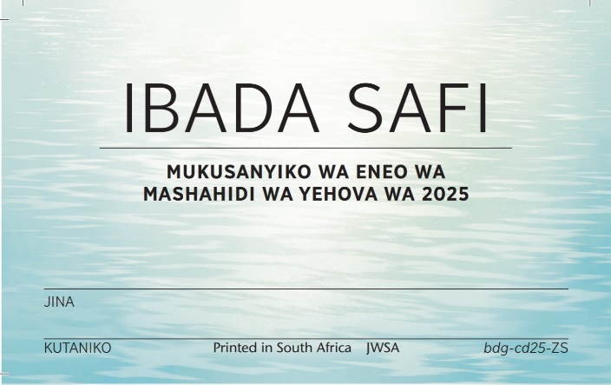



**GOMA MUTONGO SW**

**GOMA MUTONGO SW**

**GOMA MUTONGO SW**

**GOMA MUTONGO SW**

**GOMA MUTONGO SW**

**GOMA MUTONGO SW**

**GOMA MUTONGO SW**

**GOMA MUTONGO SW**

**GOMA MUTONGO SW**

**GOMA MUTONGO SW**

**GOMA MUTONGO SW**