Lane Dorscher
Week 2.2 Networking 06/18/2026
Groups And Communities:
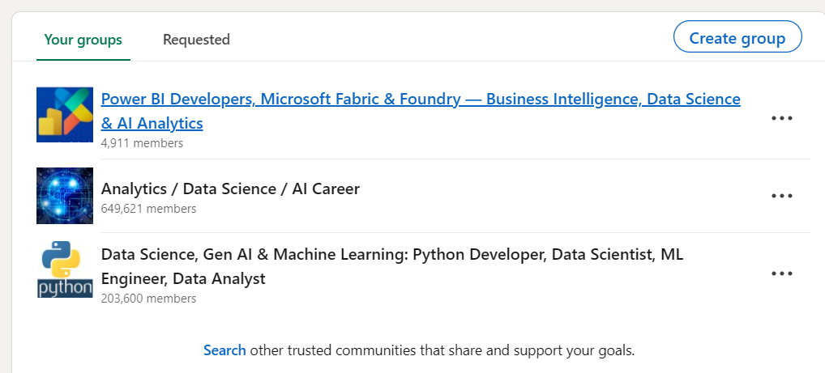
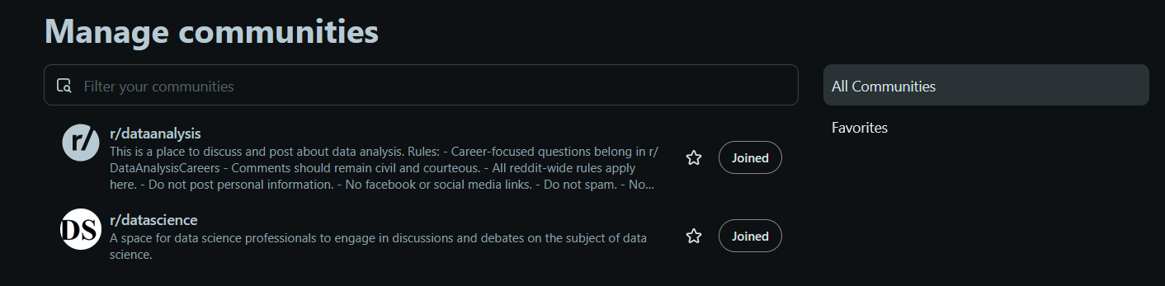

Comments:
https://www.reddit.com/r/dataanalysis/comments/1u82tg9/comment/osdvowe/?utm_source=share&utm_medium=web3x&utm_name=web3xcss&utm_term=1&utm_content=share_button
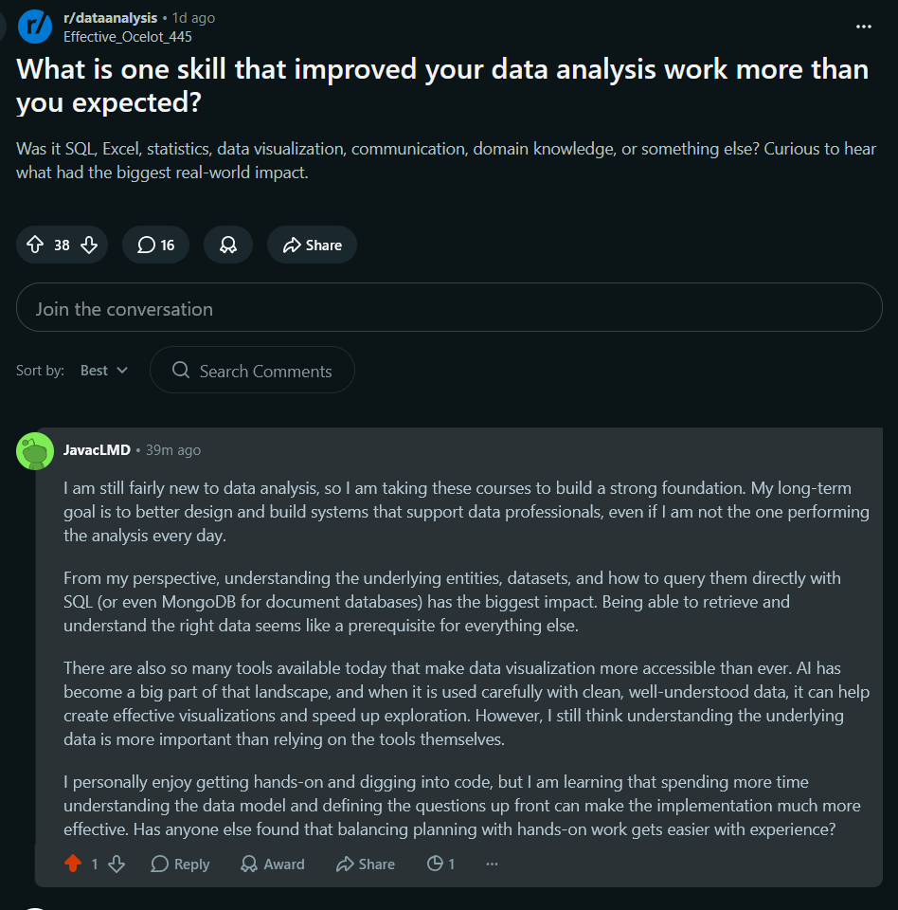

https://www.reddit.com/r/dataanalysis/comments/1u8q9o8/comment/ose1g3j/?utm_source=share&utm_medium=web3x&utm_name=web3xcss&utm_term=1&utm_content=share_button
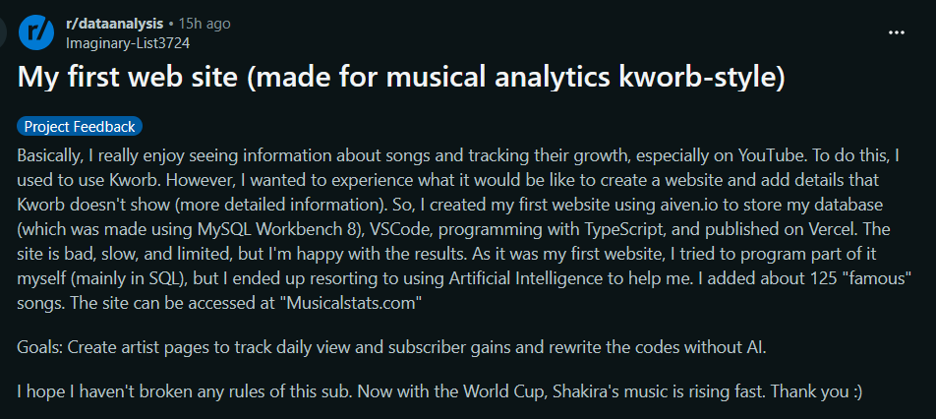
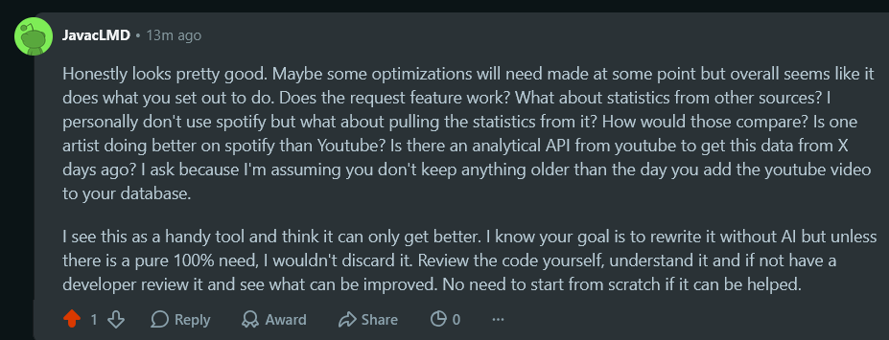

https://www.linkedin.com/feed/update/urn:li:groupPost:10309698-7472237874927632384/?dashCommentUrn=urn%3Ali%3Afsd_comment%3A%287473065582758739969%2Curn%3Ali%3AgroupPost%3A10309698-7472237874927632384%29
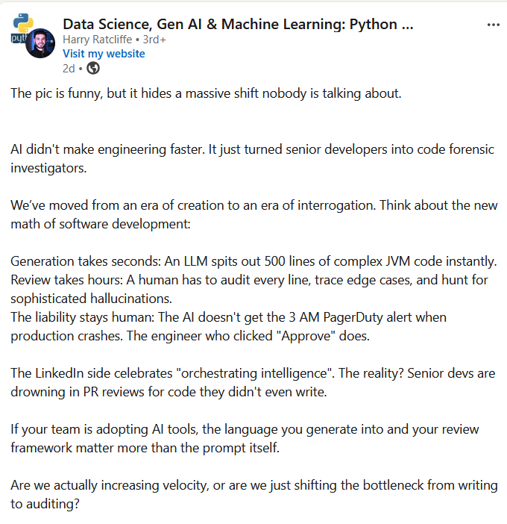
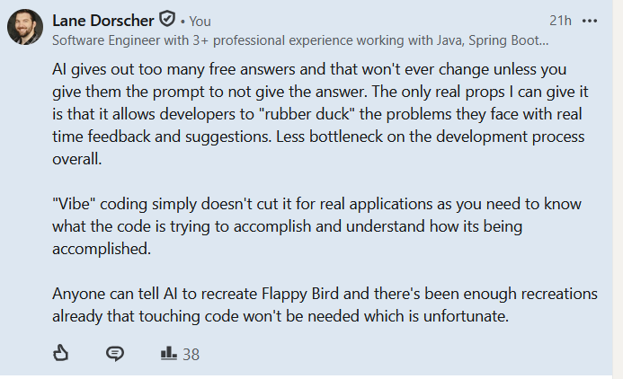
Professional Outreach:
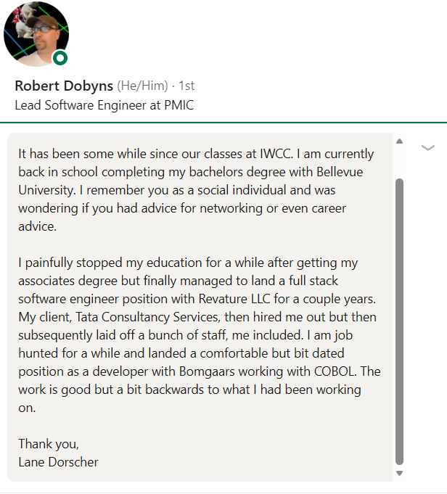

Reflection
I was scouring LinkedIn for a long time and felt like I was getting nowhere. There were plenty of groups, both public and private, but most of what I found was engagement bait or bots pretending to start discussions. Engagement itself is not a bad thing, but when it is obvious that the posts are automated or made just to farm reactions, it makes it hard to want to participate. Even a lot of the replies did not feel authentic. The experts I hoped to learn from often came across as snide or dismissive toward people who were new to the field. That has honestly been my impression of LinkedIn ever since I started using it more regularly.
Maybe it is generational, but I found the communities on Reddit much more enjoyable, especially the ones centered around learning. I feel like I can share what I know, ask questions, and get feedback from everyday people who actually work in the profession. They are willing to talk about the mistakes they have made and what they learned from them instead of pretending they have all the answers. Those kinds of conversations are much more valuable to me than perfectly polished posts.
A lot of the discussions revolved around AI and whether it is going to replace developers or data scientists. I do not really share that opinion. To me, AI is just another tool in the toolbox. It is incredibly useful and can speed up a lot of work, but it should not be treated as the single source of truth. AI is just as impressionable as a student. Coach it enough in the wrong direction and it will confidently hand out incorrect answers. That is why understanding the material is still more important than simply knowing how to use AI.
One thing this assignment reminded me of is that I have never been much of a social person. Networking has always made me a little anxious. I forget people's names unless I interact with them regularly, and whenever I get a message my first thought is usually, "What do they want from me?" Sending the first message feels even more awkward because I do not want to bother people. Usually, if I reach out to someone, it is because I genuinely need something. Even so, this assignment showed me that networking does not have to mean forcing conversations. Sometimes it is enough to participate in discussions, learn from others, and contribute when there is something meaningful to say.

