Module 3.3 Networking Lane Dorscher
DSC300 6/28/2026

https://www.reddit.com/r/dataanalysis/comments/1uf1lfb/comment/ouesz65/?utm_source=share&utm_medium=web3x&utm_name=web3xcss&utm_term=1&utm_content=share_button
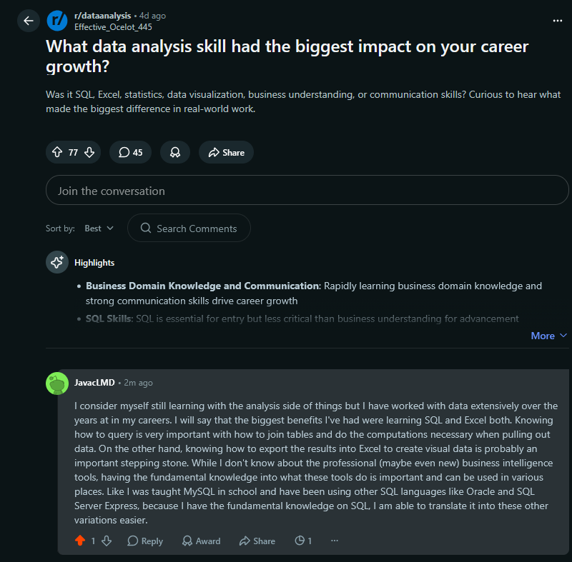

https://www.reddit.com/r/dataanalysis/comments/1uf1lfb/comment/ouetss3/?utm_source=share&utm_medium=web3x&utm_name=web3xcss&utm_term=1&utm_content=share_button
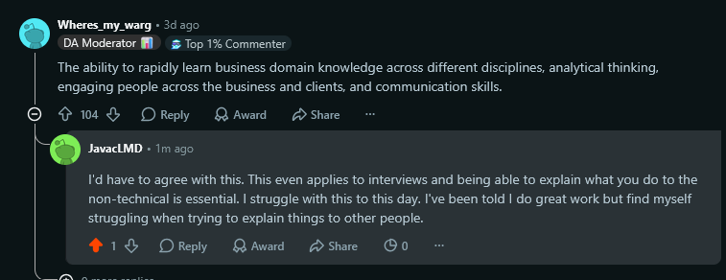
https://www.reddit.com/r/dataanalysis/comments/1u81zi9/comment/ouev69h/?utm_source=share&utm_medium=web3x&utm_name=web3xcss&utm_term=1&utm_content=share_button
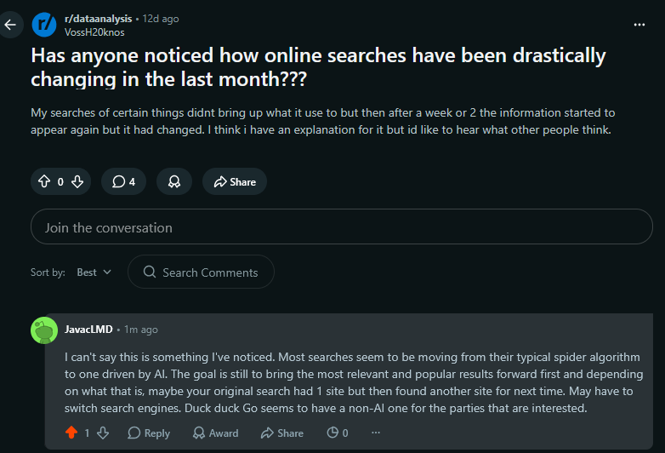

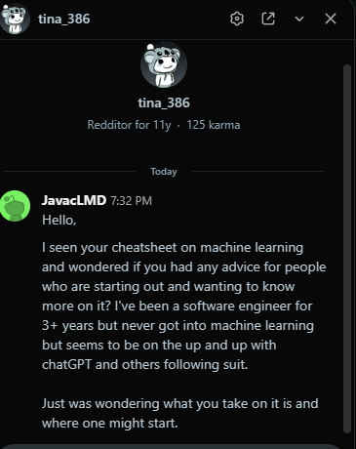
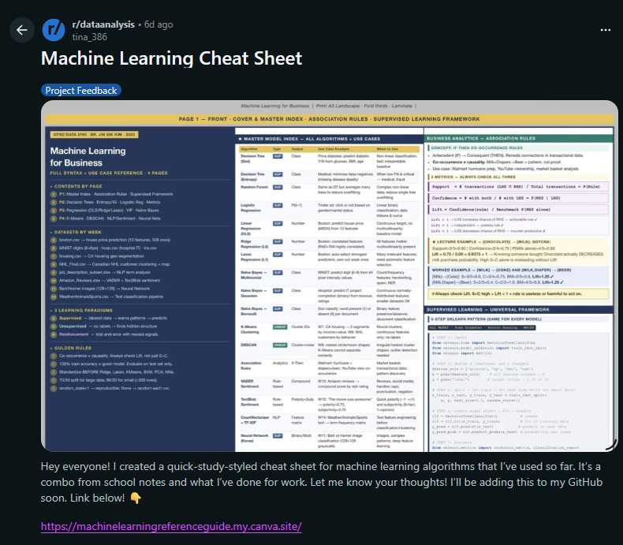
Reflections:
This week I continued networking through Reddit. Once again, I found the conversations to be much more natural and engaging than my experience on LinkedIn. People seem genuinely interested in discussing problems, sharing what they have learned, and helping others work through challenges. I enjoy being part of those conversations because even if I do not have all the answers, I can often share my own experiences while learning from people who have been working in the field much longer than I have.
One thing I have realized throughout this course is that I am still building my knowledge of business intelligence. I understand the value it provides to organizations, but my interests naturally lean more toward designing databases and building the applications that use them. I enjoy thinking about how data should be structured, how relationships between tables should be designed, and how those decisions impact performance and maintainability. Learning more about the business intelligence side has helped me appreciate how important good data design is before analytics can provide meaningful insights.
Unfortunately, my experience with LinkedIn has continued to reinforce my previous impressions. Shortly after becoming more active, I received several connection requests and messages that initially appeared genuine. However, many quickly turned into advertisements for paid resume builders, career coaching services, or companies wanting me to pay to promote myself to employers. While I know LinkedIn can still be valuable for professional networking, these experiences have made it difficult to find authentic conversations. For now, Reddit continues to be the platform where I have the most meaningful interactions and where I feel I can both contribute and continue learning.

