Module 4.2 Networking Lane Dorscher
DSC300 7/5/2026
https://www.reddit.com/r/dataanalysis/comments/1ujgih3/comment/ov1ddvk/?utm_source=share&utm_medium=web3x&utm_name=web3xcss&utm_term=1&utm_content=share_button
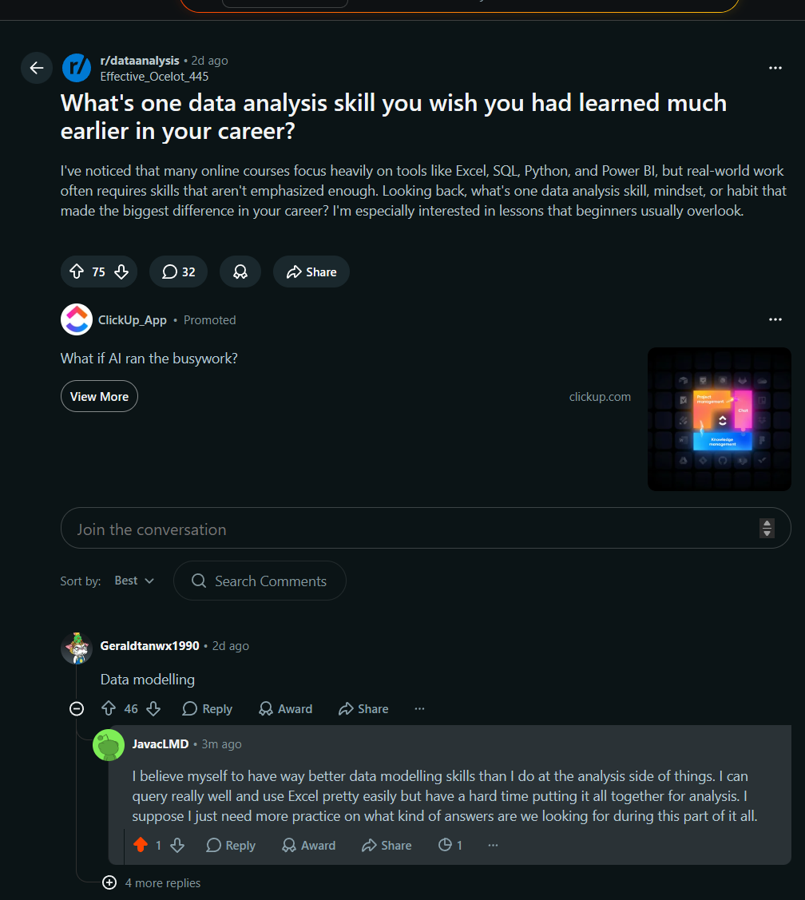

https://www.linkedin.com/feed/update/urn:li:activity:7476782674355929089?commentUrn=urn%3Ali%3Acomment%3A%28activity%3A7476782674355929089%2C7479175316884701184%29&dashCommentUrn=urn%3Ali%3Afsd_comment%3A%287479175316884701184%2Curn%3Ali%3Aactivity%3A7476782674355929089%29
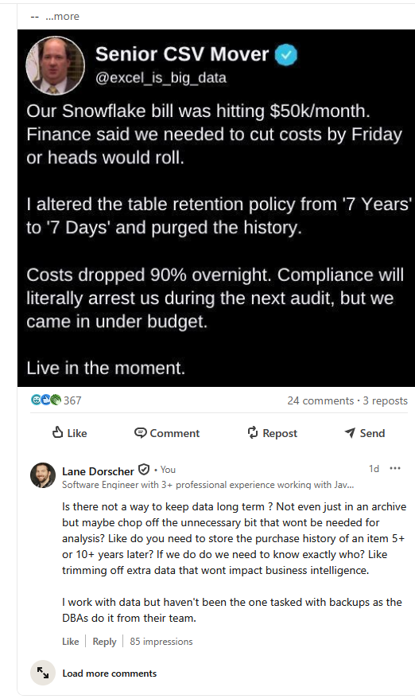

https://www.reddit.com/r/dataanalysis/comments/1ulr5zw/comment/ovq8c5b/?utm_source=share&utm_medium=web3x&utm_name=web3xcss&utm_term=1&utm_content=share_button
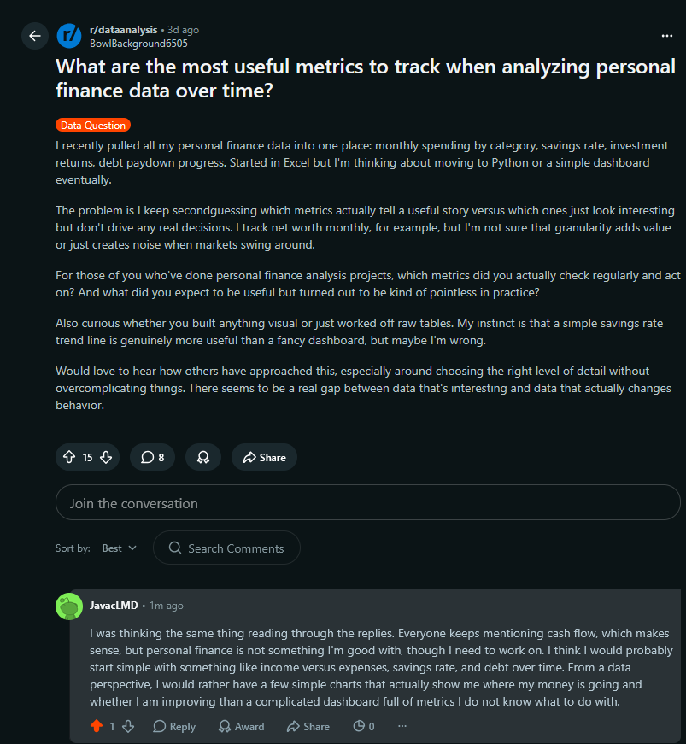
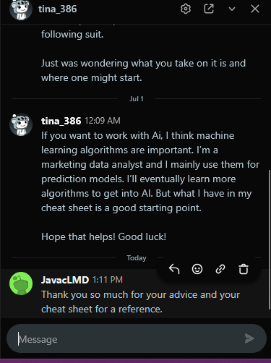
Reflections:
I made an inquiry on LinkedIn earlier this week but have yet to receive a response. However, I did come across some interesting projects while browsing Reddit. There are so many great developers out there creating projects in their free time to solve problems or simply make their own lives easier. I would love to dive into some projects of my own, especially involving data analysis, if I had more time to commit to them. Between my job, schoolwork, and home life, there is not much free time left over for another project right now.
I also received a response from last week's networking attempt on Reddit, and they gave me some good insight into where I could start. There is still a lot about data analysis and machine learning that I do not know, but seeing what other developers are building makes me interested in learning more. I look forward to learning about machine learning algorithms in the future and eventually gaining enough experience to experiment with some ideas of my own.

