Module 8.2 Networking Lane Dorscher
DSC-300 8/2/2026

https://www.reddit.com/r/datascience/comments/1v5z7ue/comment/p1dnda0/?utm_source=share&utm_medium=web3x&utm_name=web3xcss&utm_term=1&utm_content=share_button

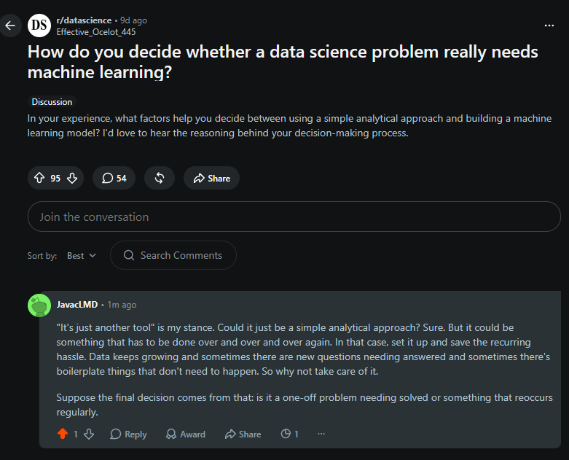
https://www.reddit.com/r/datascience/comments/1uxgk64/comment/p1dlm59/?utm_source=share&utm_medium=web3x&utm_name=web3xcss&utm_term=1&utm_content=share_button

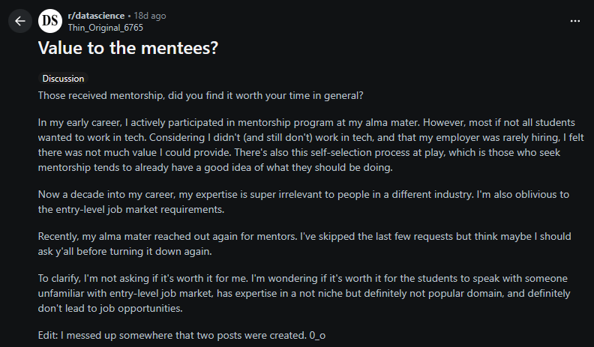
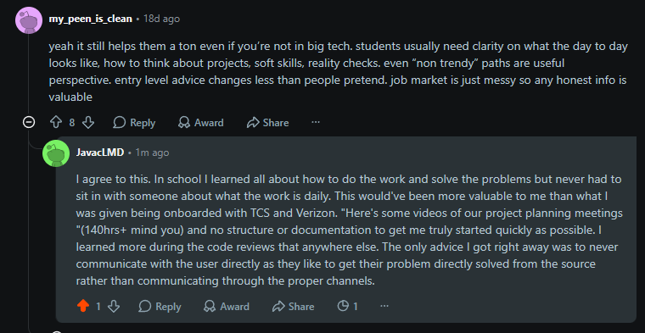

How do you handle messy date formats when merging datasets from different sources? : r/dataanalysis
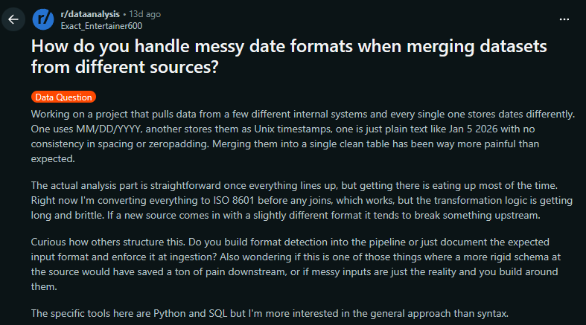
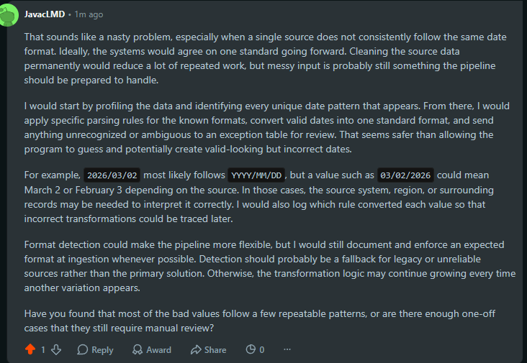
Reflection
Reading through everyone's posts and perspectives is fascinating and sometimes enlightening. I enjoy engaging with the people asking for help when I feel like I have some insight that could solve their problem. The discussion about date formats was especially interesting. One comment brought up the possibility of a 2026/02/03 format, which stopped me in my tracks. After thinking about it, I realized trying to guess whether it meant yyyy/mm/dd or yyyy/dd/mm is a bad idea because it could easily be misinterpreted and skew the final analysis. It could represent February 3rd or March 2nd, so the safest approach would be to separate ambiguous dates for manual review instead of making assumptions.
My background is in technology and software development, so these kinds of engineering problems are what I enjoy the most. I like figuring out how to collect, validate, and transform data into something reliable. What I don't enjoy as much is the actual analysis. I think back to someone's project about music video views and popularity from a few weeks ago. It's a project I could get behind from the software side, but the numbers themselves don't mean much to me the way they would to a music producer. This course has helped me appreciate that both sides are important, even if I naturally gravitate toward building the systems that make the analysis possible.

