Module 4.2 Assignment Lane Dorscher
CSD-310 07/02/2026
I did not want to clutter up my computer with extra background applications so instead I favored using Docker CLI and Desktop to create a virtual container to run it. I can easily manage them from one source and even set up different databases easily this way with only needing the clients. Docker is still something I struggle with but it has made installations of databases much easier and hopefully will streamline development as I get comfortable with it.
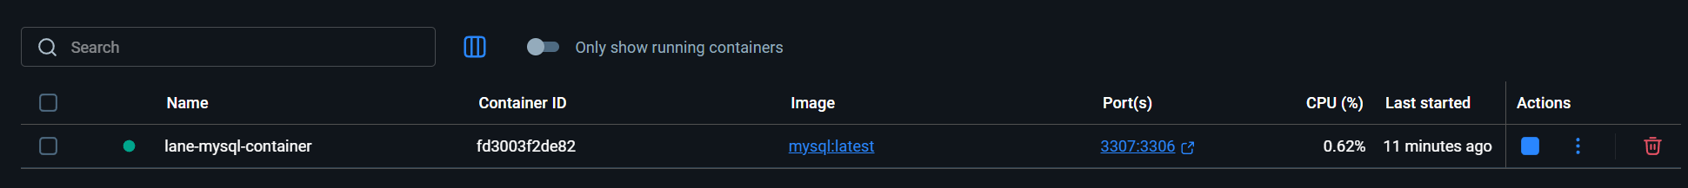
Created a new database called “movies”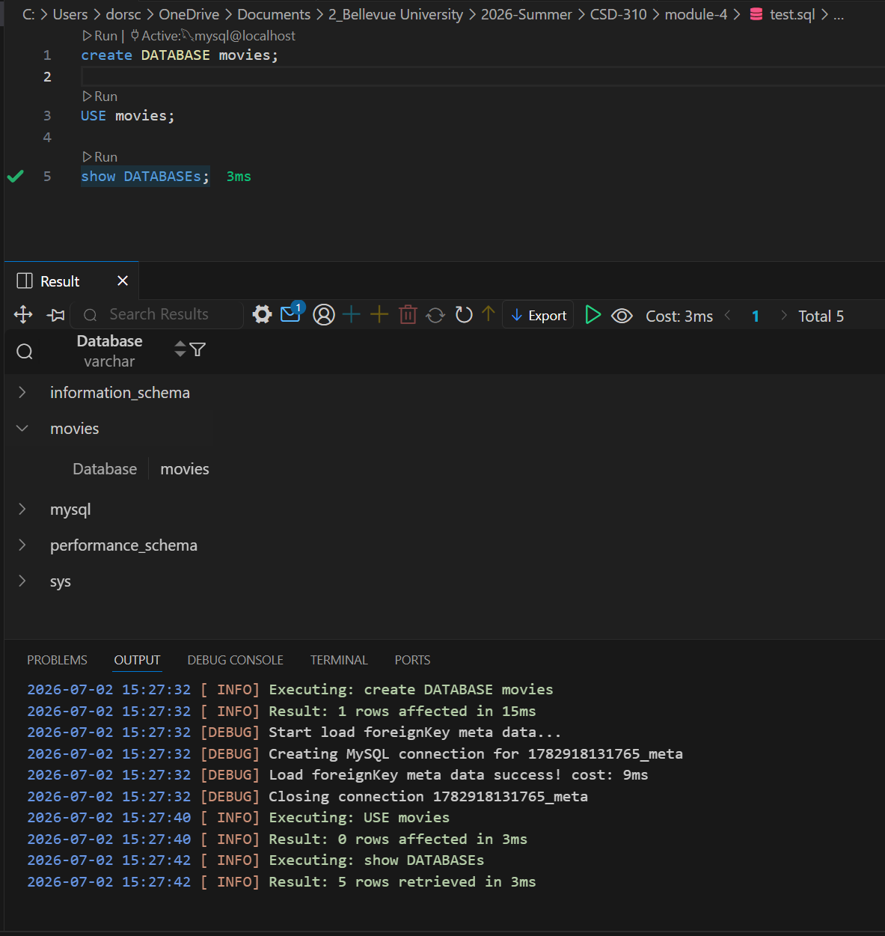

To play around with the language, I created a small movie database with 3 tables: movies, actors, and a junction table, movie_actors. To keep it simple, movies table has a primary key, title, director, release year and the genre. Actors only has a primary key, name, and birth_year fields. The junction table has a foreign keys that uses the primary key of both the previous tables. This is on the idea that a movie can have many actors and an actor can be in many movies.
Creating some tables
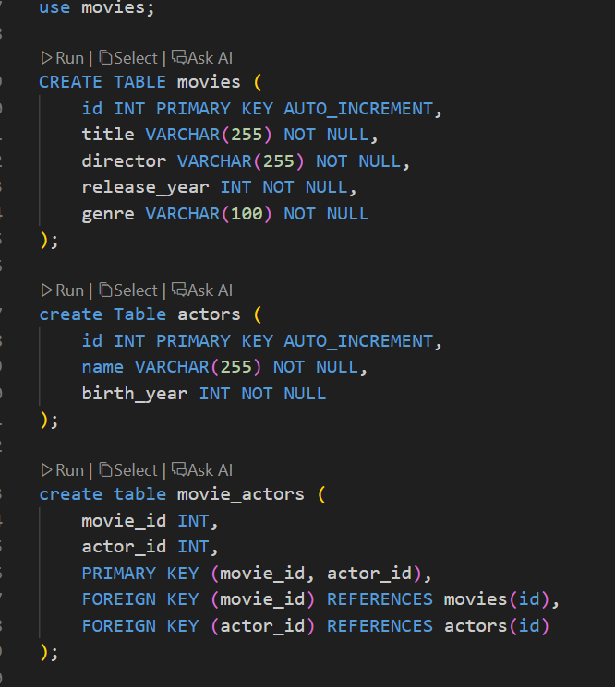

Tables are nothing without the data they represent, so I prepopulated some data from some popular movies though my favorite is Heath Ledgers “A Knight’s tale” which in order to get the apostrophe in the string, had to use double quotes for the rest of it and reverted back to single quotes for the other strings.
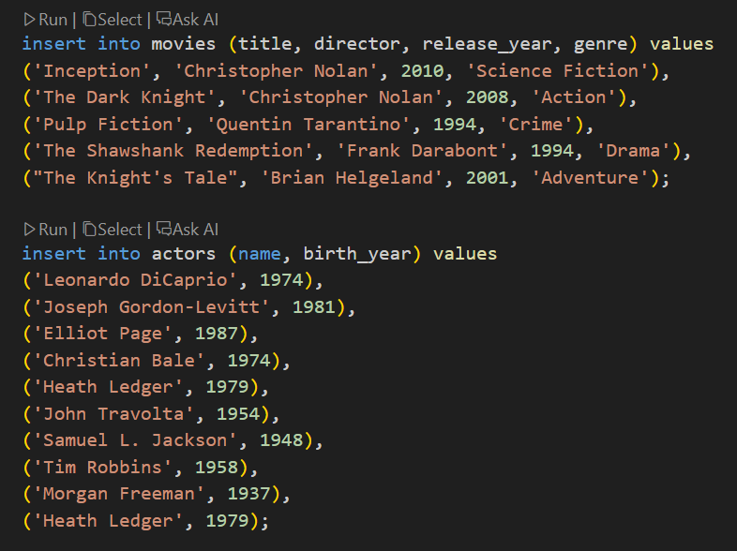
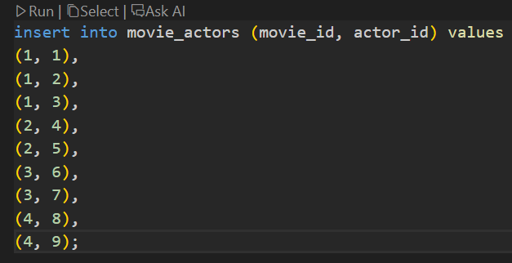
TO actually query the tables, I used the SELECT statement and gave them an alias which is not always required but is helpful for presenting the column headers making it easier to read. The other advantage is if a field shares a name, we can easily distinguish the two in the output.
