Module 5.2 Assignment Lane Dorscher
CSD-310 07/07/2026
Ran the source successfully
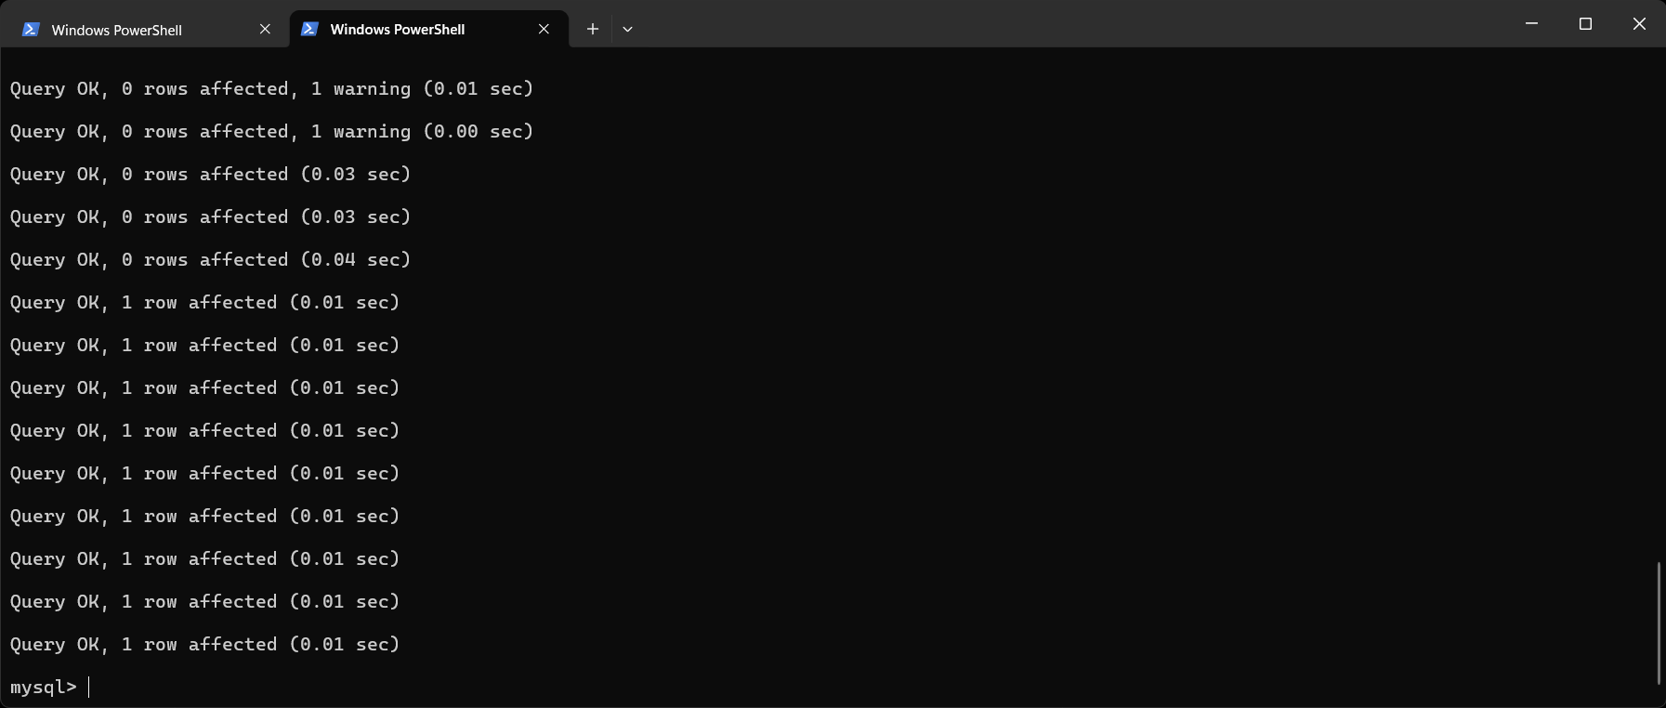
Show the tables successfully
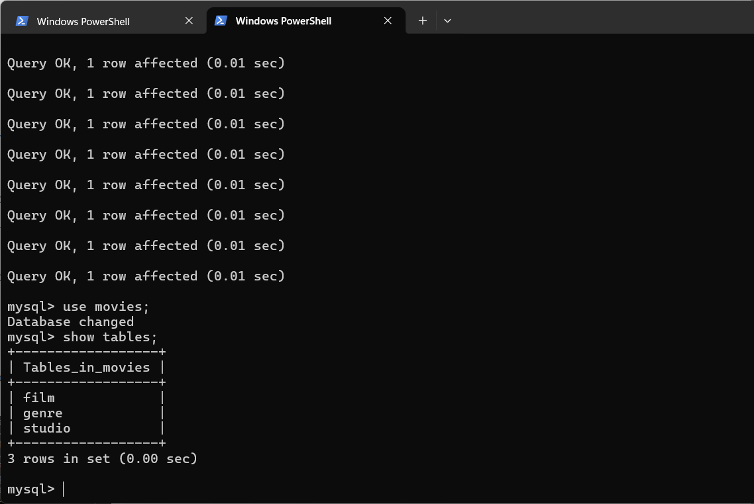

Python Program ran successfully
