Lane Dorscher
Module 2.3 Assignment 6/17/2026
ERD:
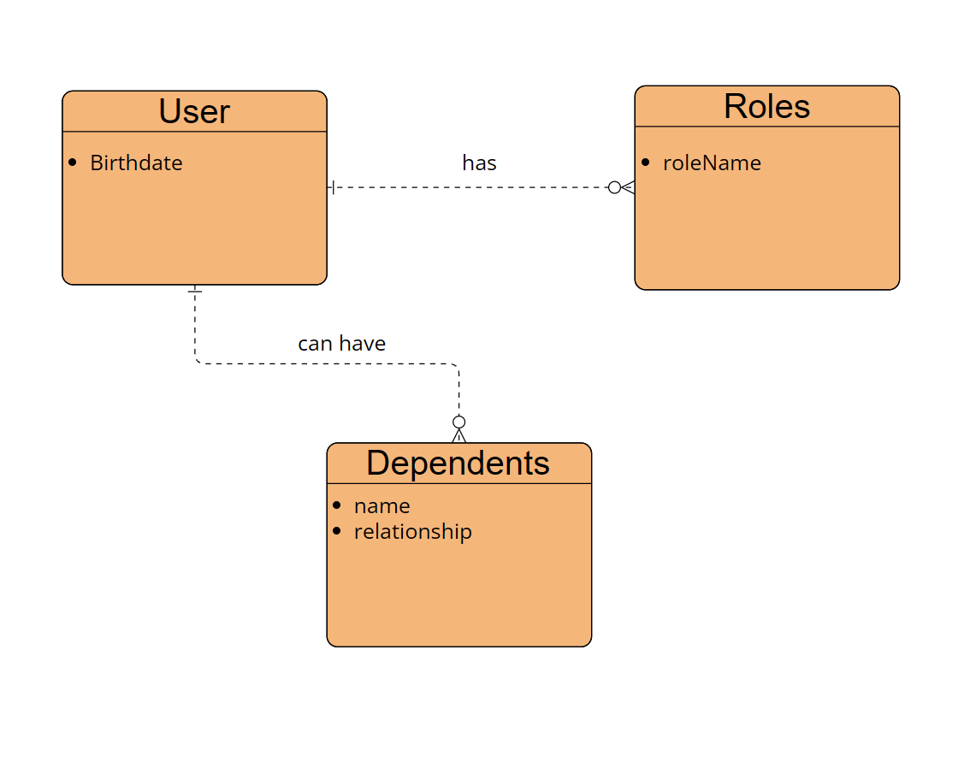
NoSQL:
