Lane Dorscher
Module 2.2 Assignment 6/19/2026
The debugger stopped at a breakpoint before calling get_float_input().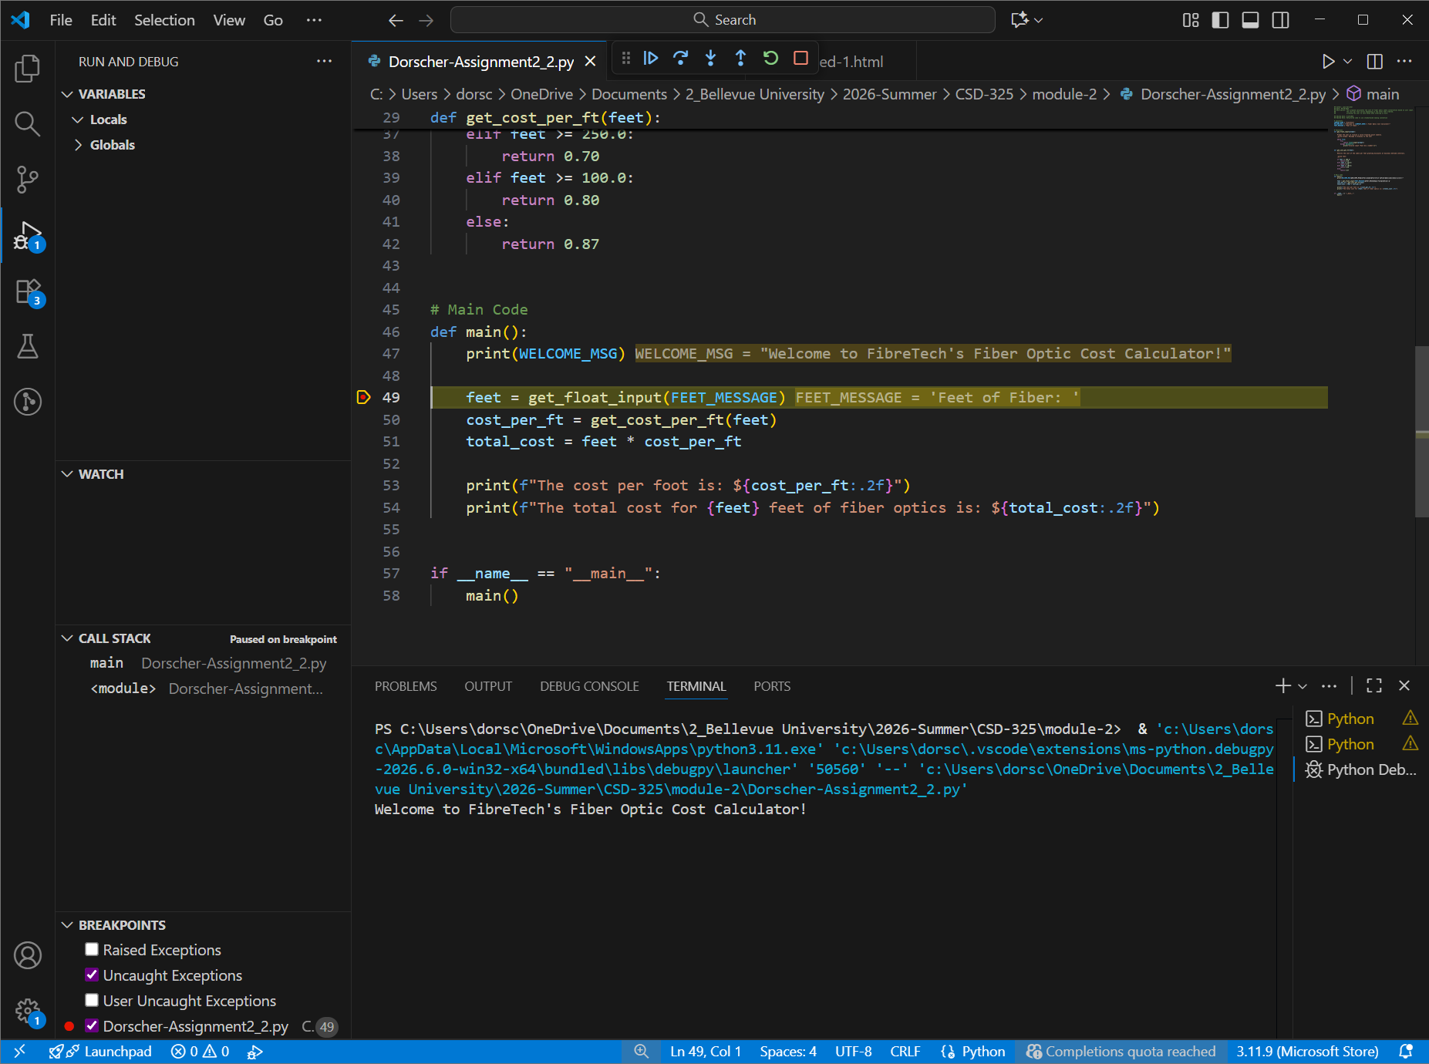

The debugger stepped into the get_float_input function.
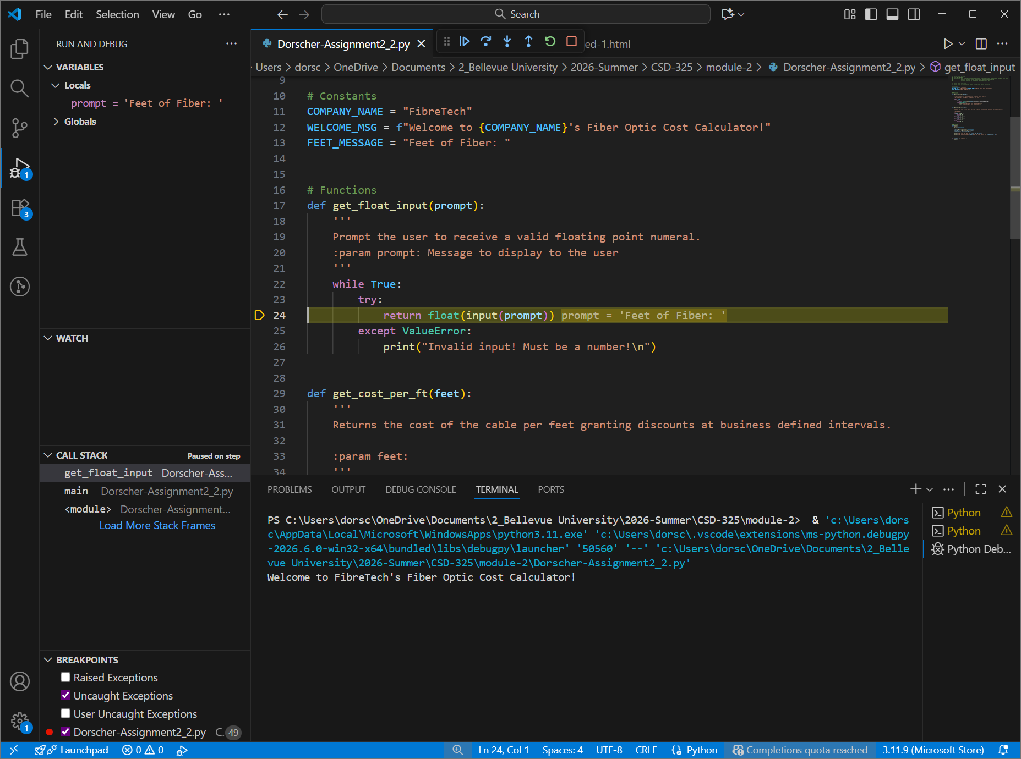

The debugger stepped through get_cost_per_ft function and selected the $0.70 rate because the input value “feet” is 375 and satisfies the second condition.
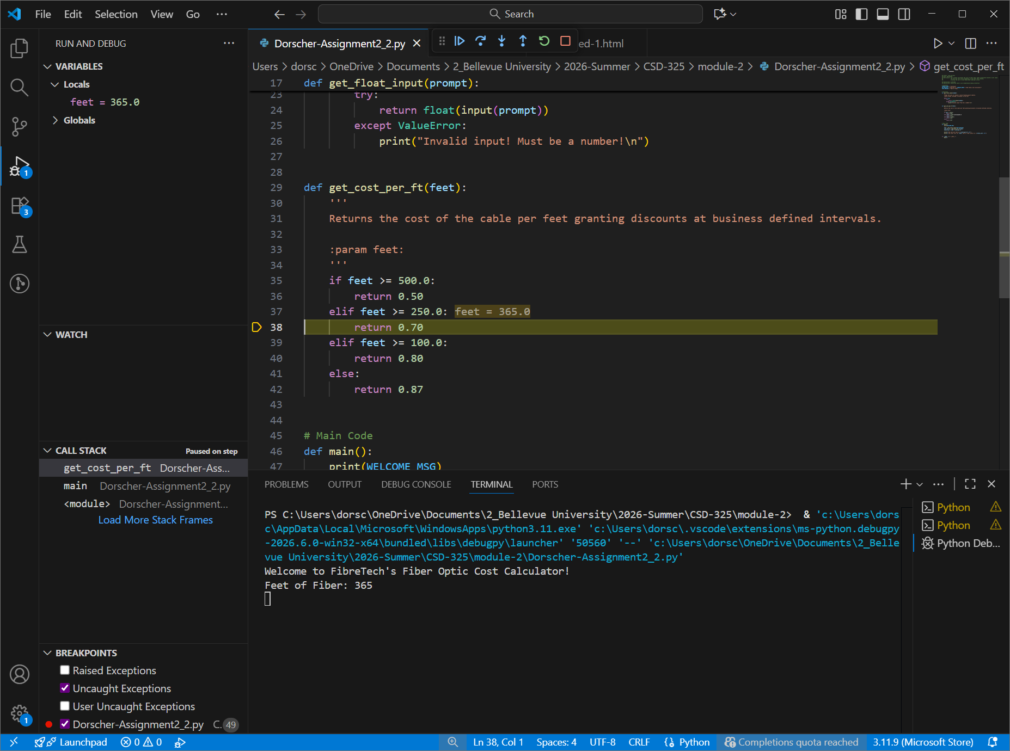

Ran it again and typed invalid input into the get_float_input function. Program caught the exception to print the error.
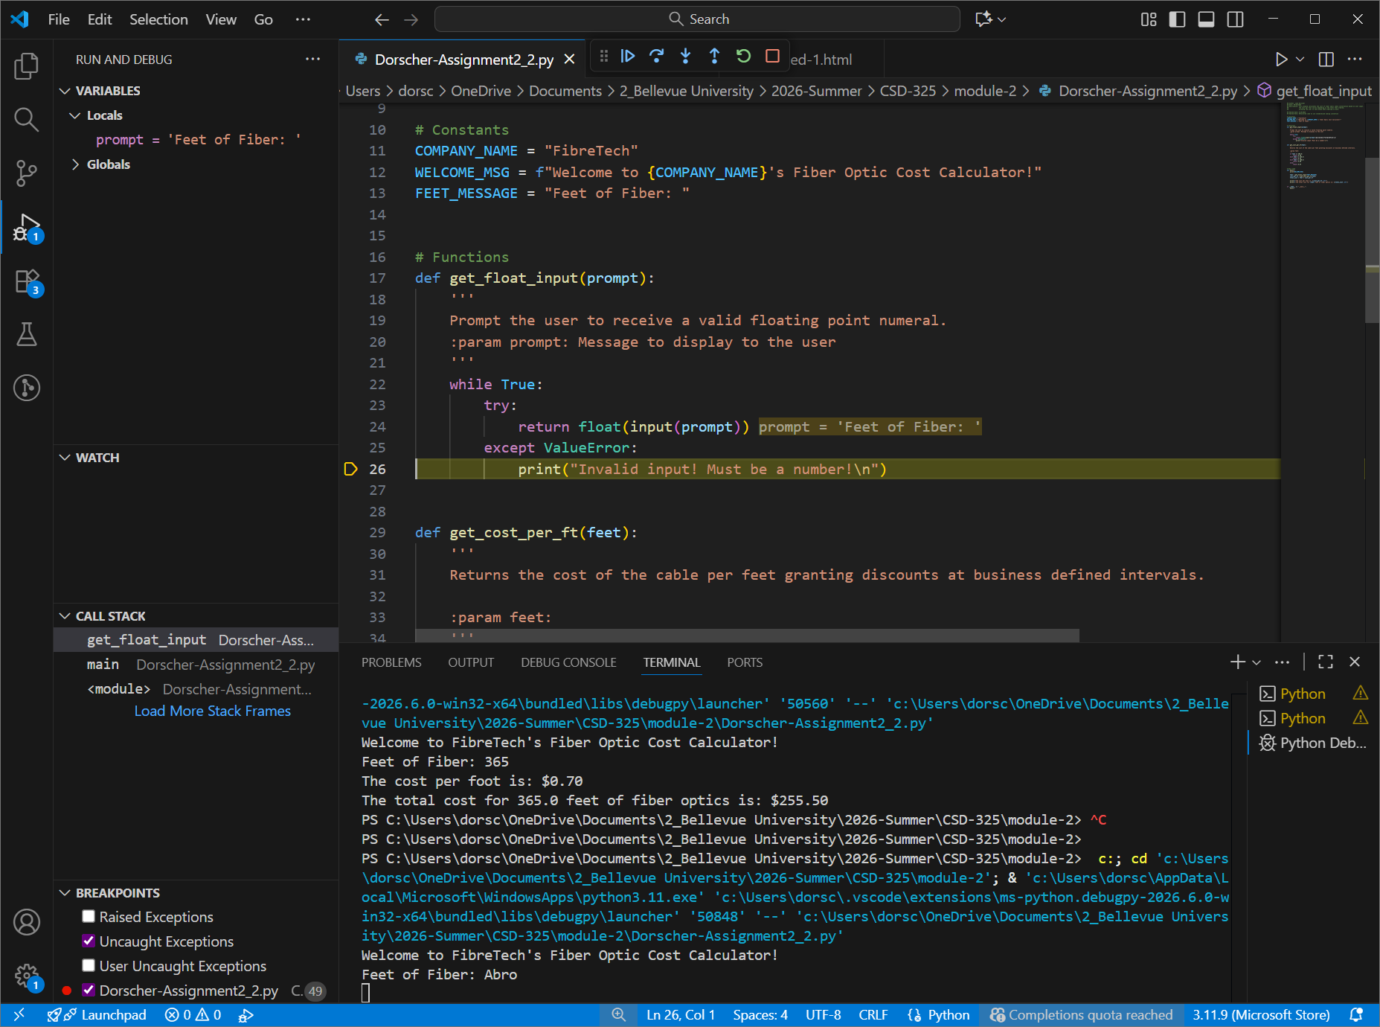

Debugger shows it going back to the start of the while loop.
