Module 11.2 Assignment Lane Dorscher
CSD-325 08/23/2026
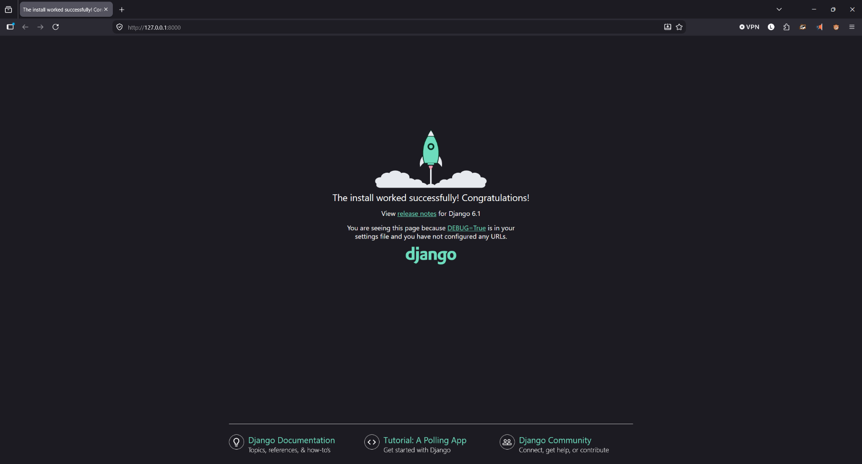
Step 4b

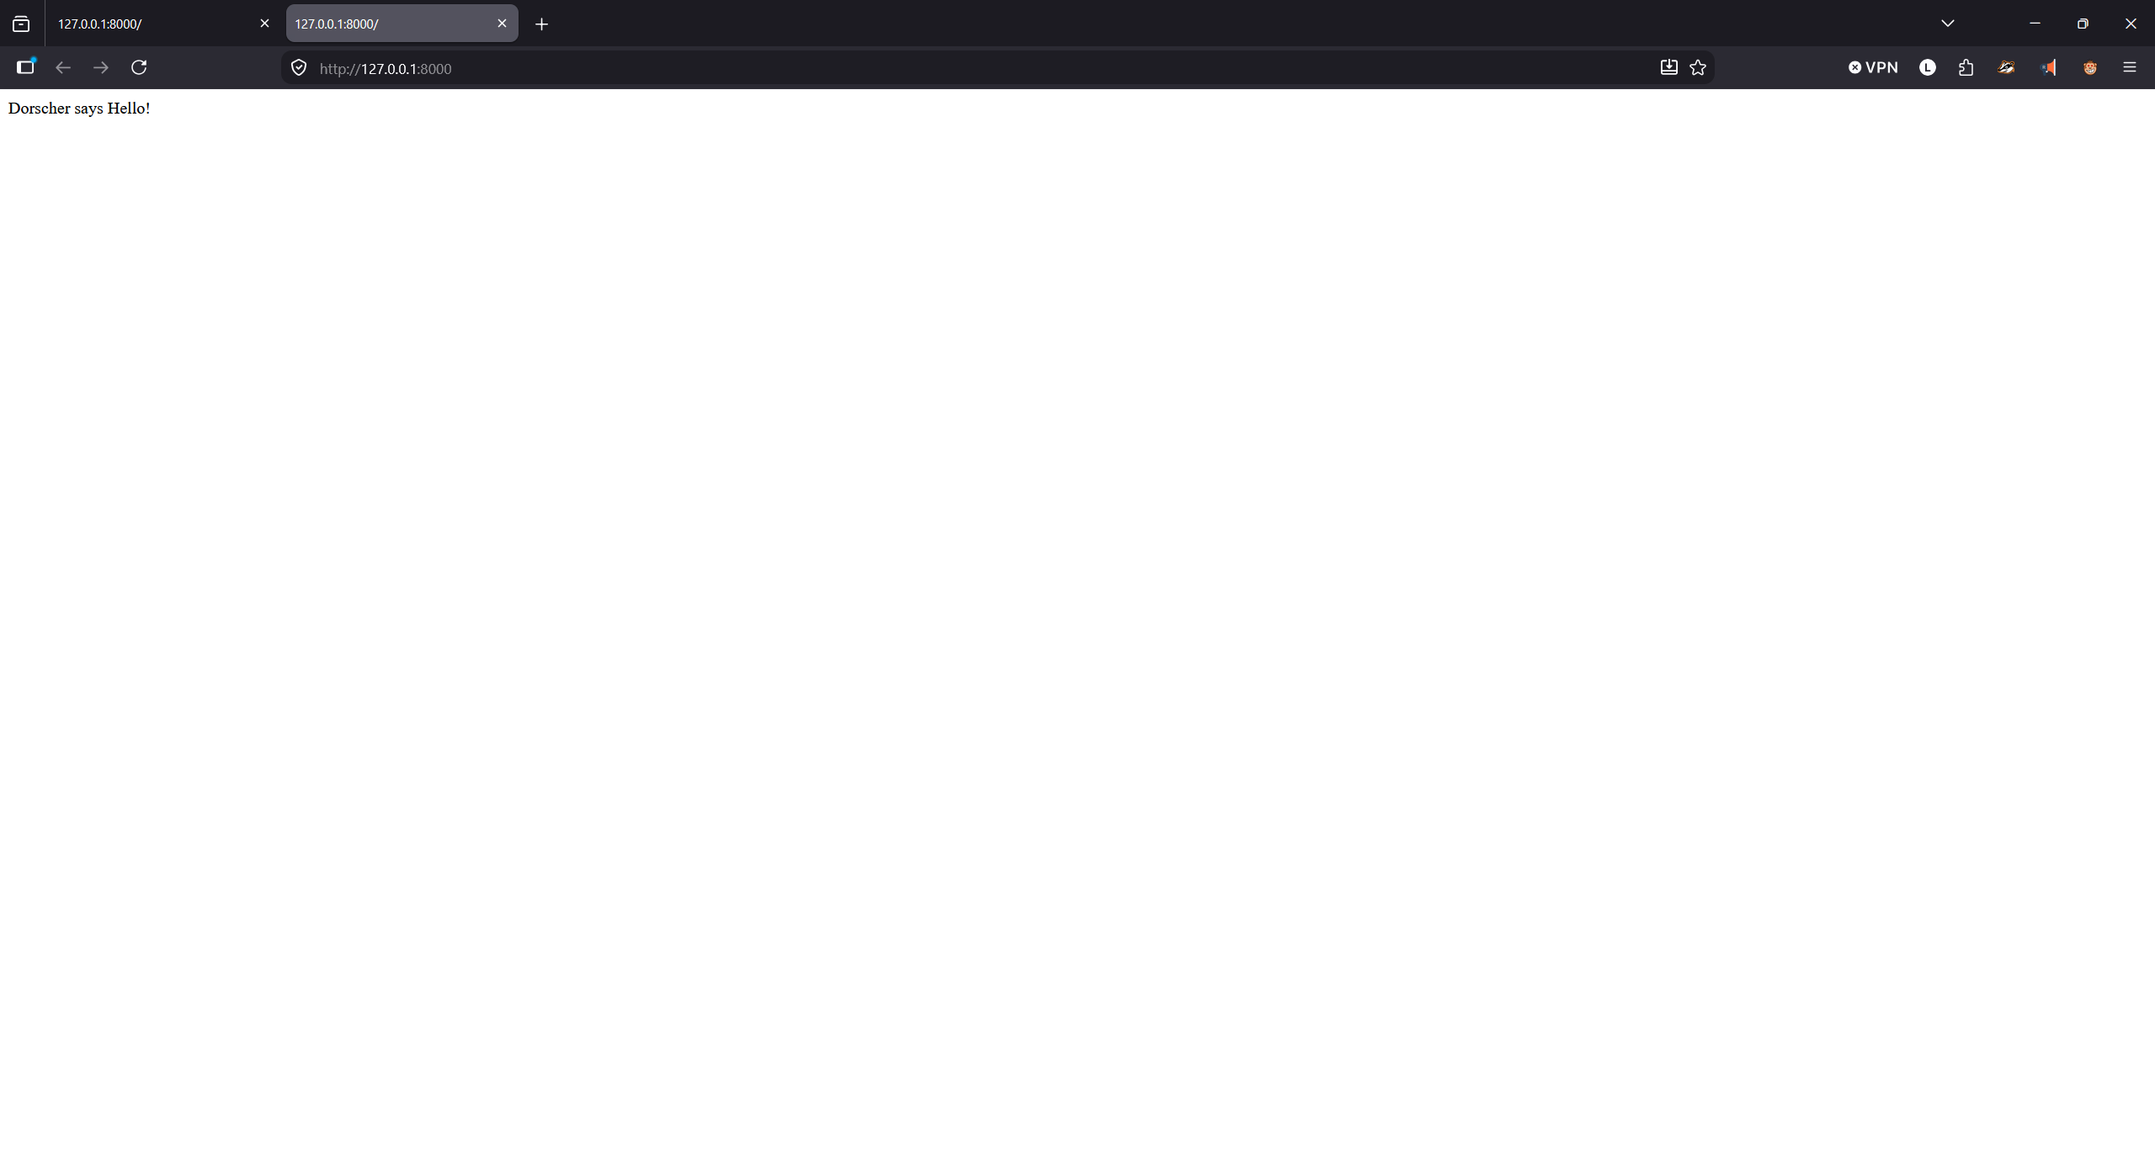
Step 4f

