Module 8.2 Assignment Lane Dorscher
CSD-325 8/4/2026
API: http://api.open-notify.org/astros.json
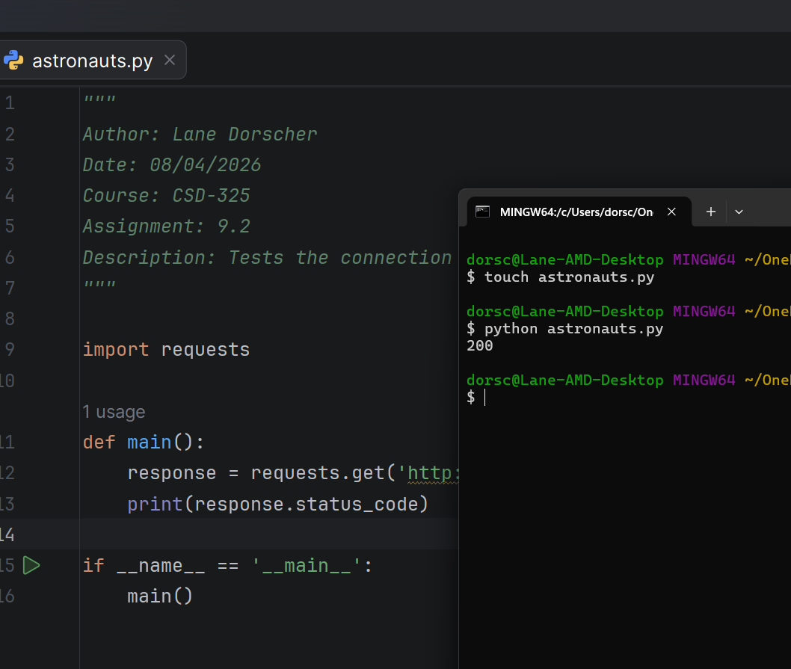

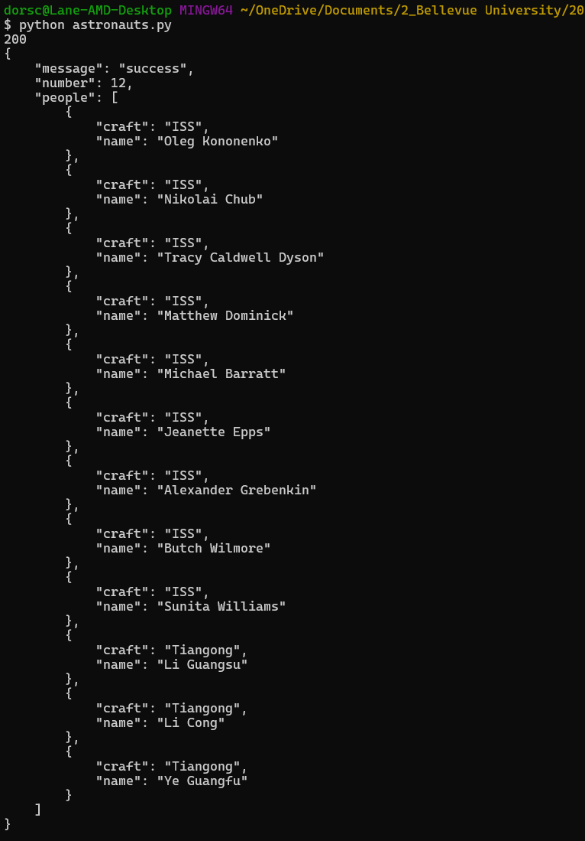

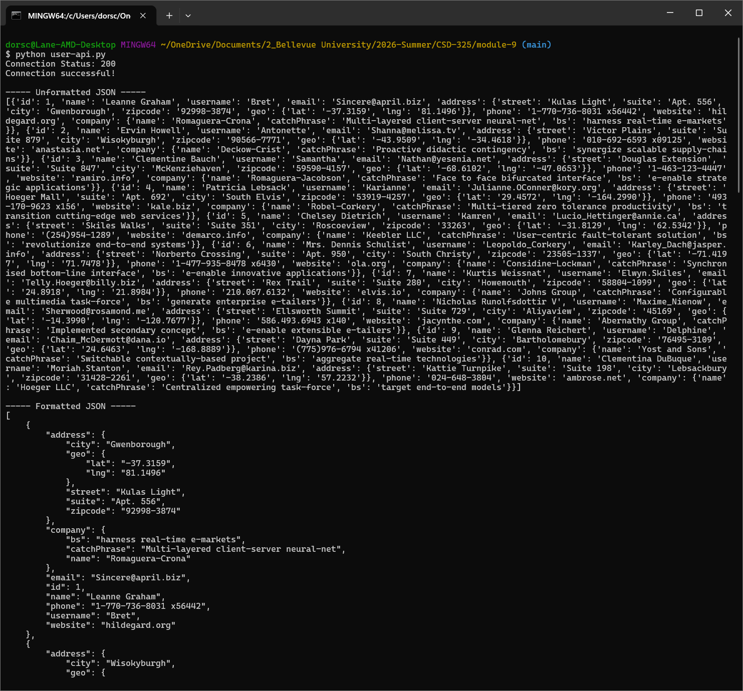
API: https://jsonplaceholder.typicode.com/users

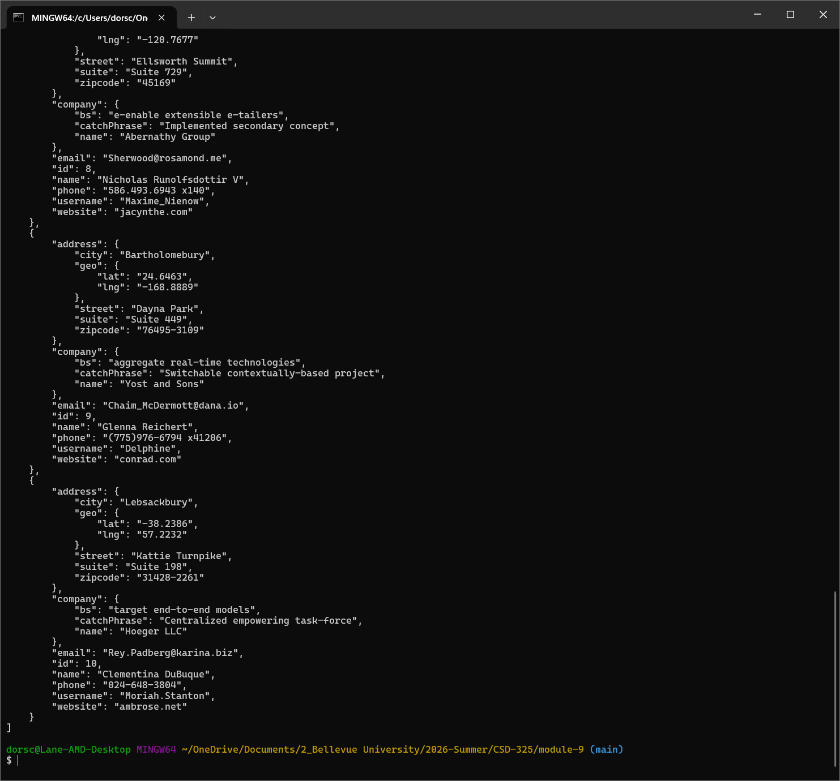
And continues…

