Module 4.2 Assignment Lane Dorscher
CSD-325 6/30/2026
Original Flowchart
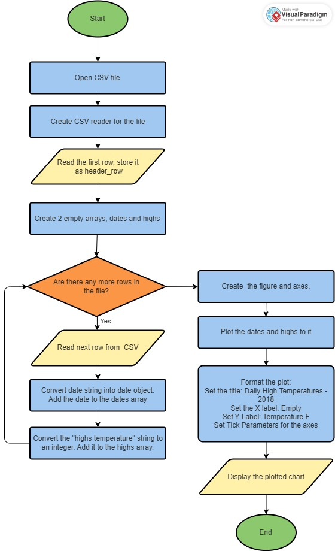
Updated Flowchart
