Module 7.2 Assignment Lane Dorscher
CSD-325 7/22/2026
A) Write a function that accepts two parameters: a city name and a country name. The function should return a single string of the form City, Country

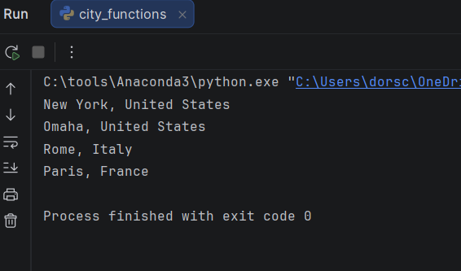

B) Create a file called test_cities.py that tests the function you just wrote (remember that you need to import unittest and the function you want to test). Write a method called test_city_country() to verify that calling your function with values such as Santiago and Chile results in the correct string
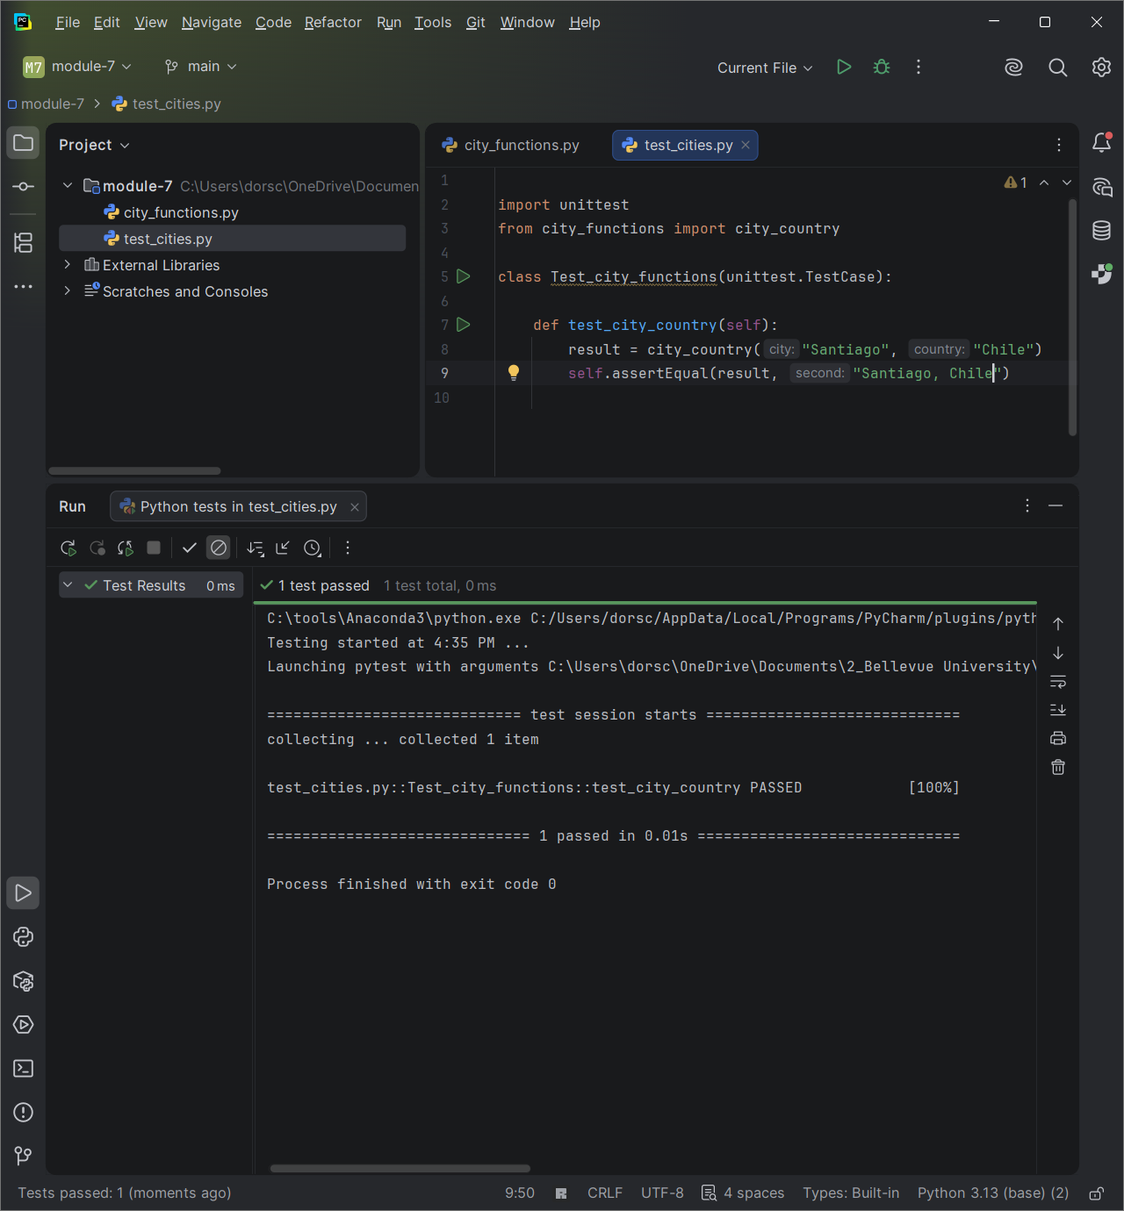

C & D) Modify your city_country function in city_functions.py so it requires a third parameter, population. It should now return a single string of the form City, Country - population xxx
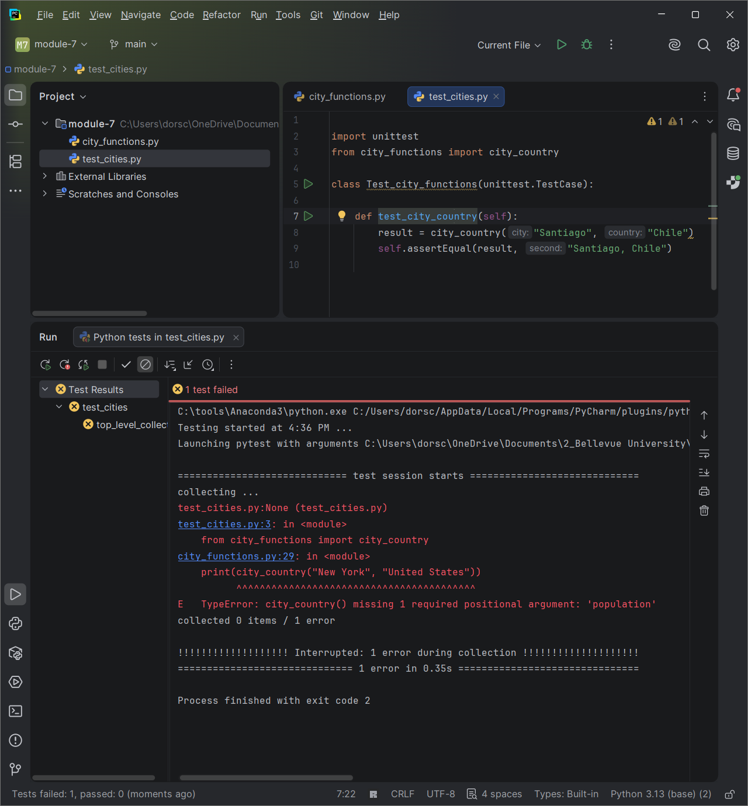

E & F) Now modify your city_country function in city_functions.py so that the population parameter is optional.
Run test_cities.py again. It should pass. Take a screenshot of the result and paste into your Word document.
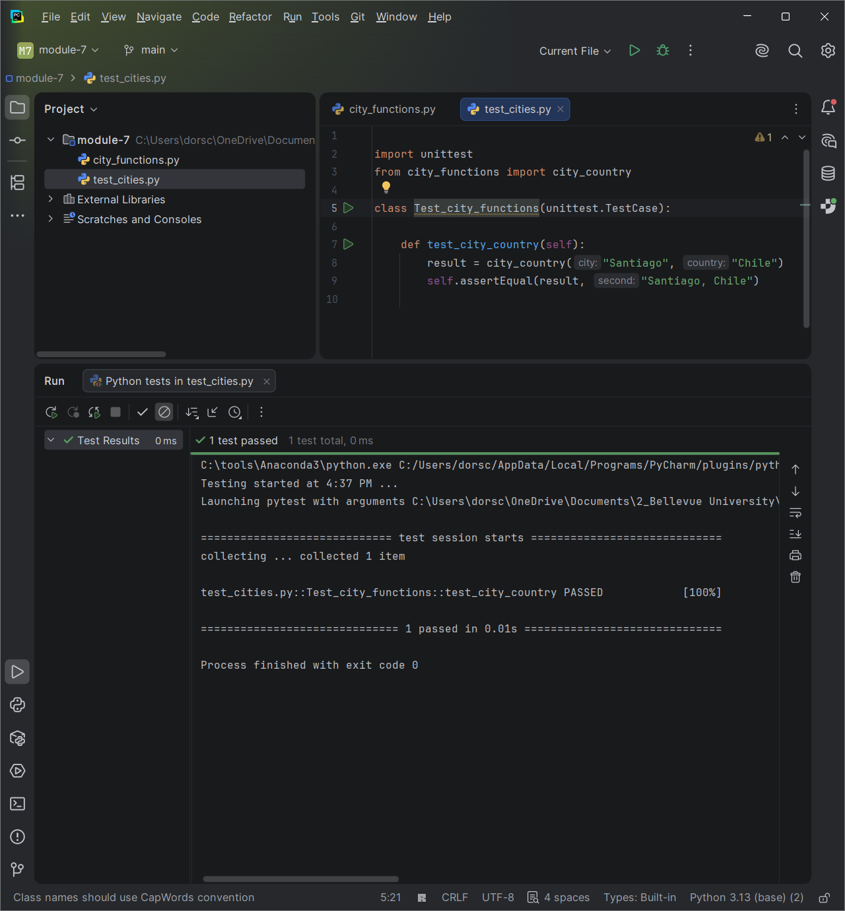

G & H) Modify your city_country function in city_functions.py so it requires a fourth parameter, language. It should now return a single string of the form City, Country - population xxx, Language, such as Santiago, Chile - population 5000000, Spanish.
Run test_cities.py again. It should fail. Take a screenshot of the result and paste into your Word document.
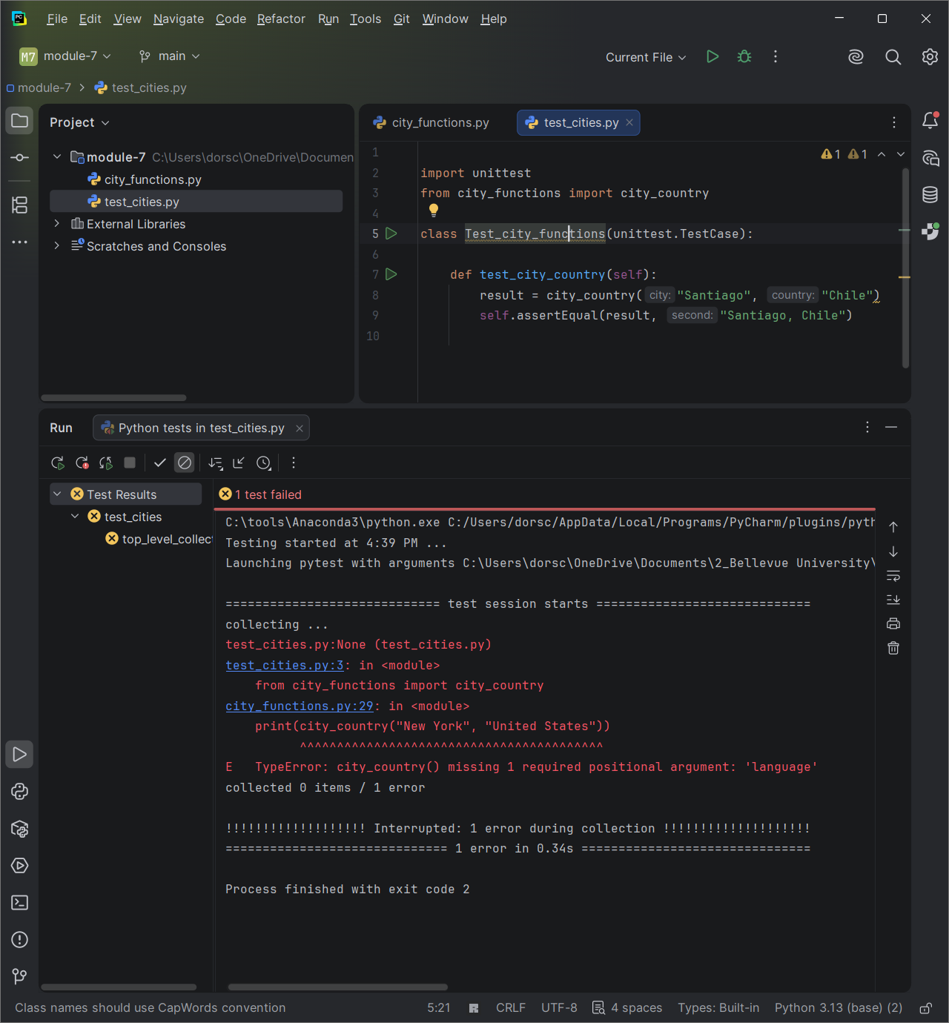

I & J) Now modify your city_country function in city_functions.py so that the language argument is optional.
Run test_cities.py again. It should pass. Take a screenshot of the result and paste into your Word document
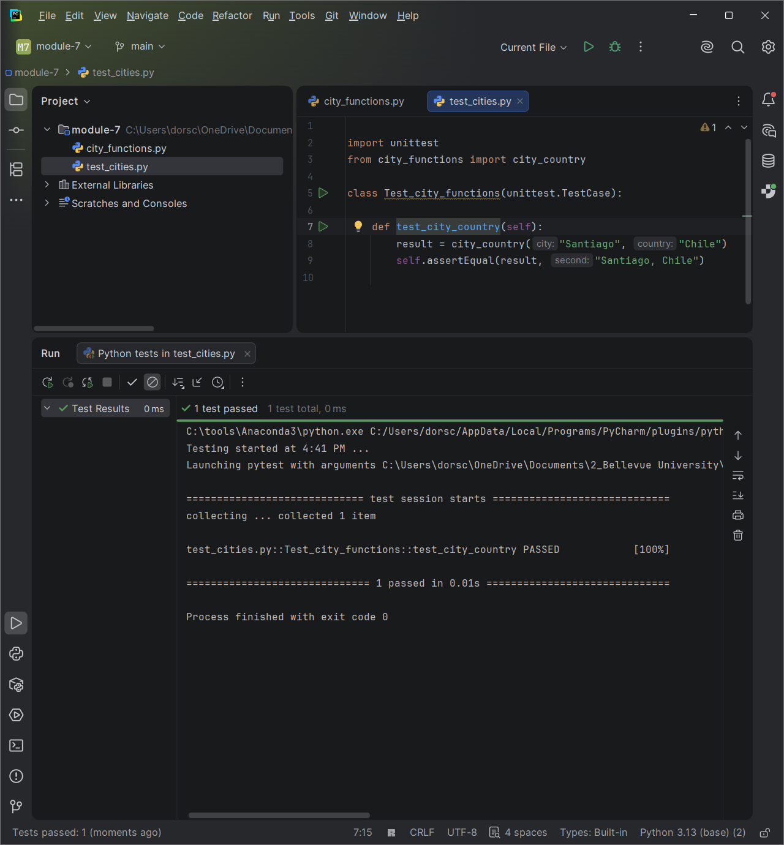

K) Run city_functions.py. Call the function at least three times using a City, Country for one, City, Country, Population for the next and City, Country, Population, Language for the last.
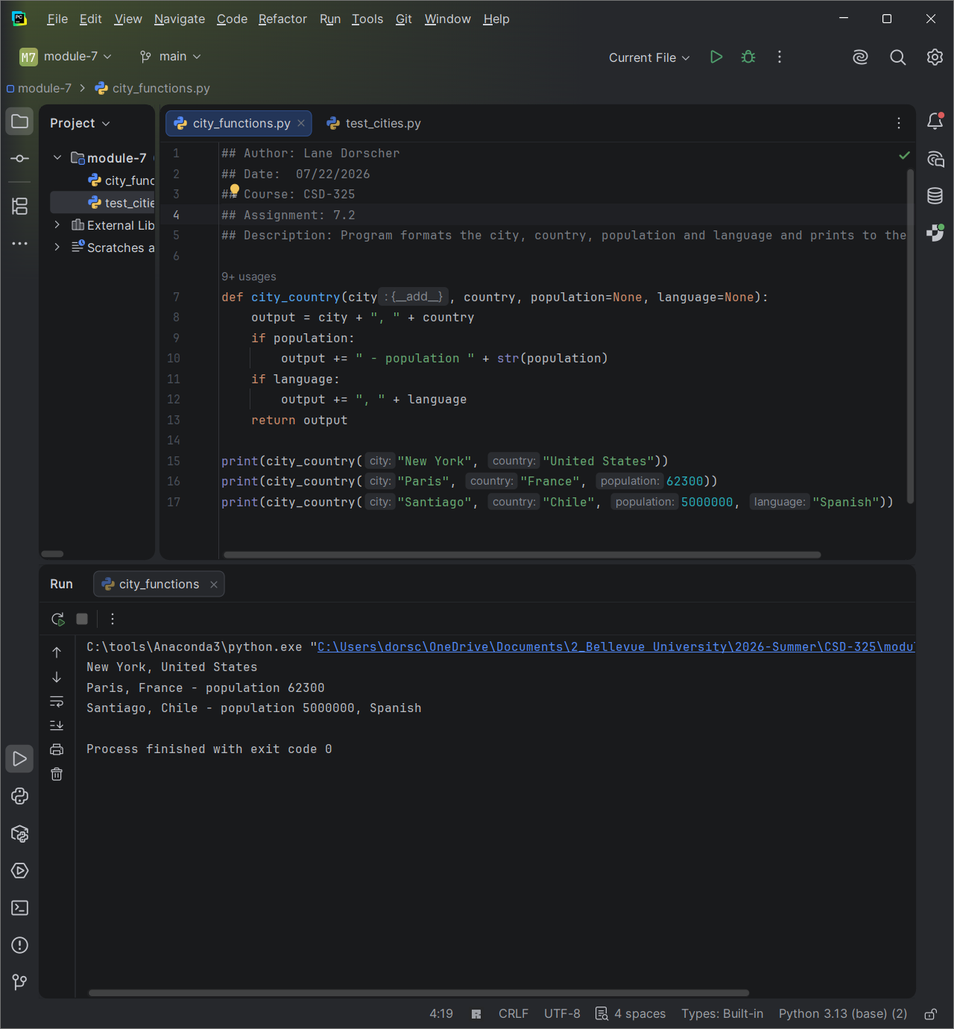

Extra) Added additional test cases for all combinations and included a one that assertsNotEqual
