Module 1 Assignment 2 Lane Dorscher - 06/09/2026
New directory
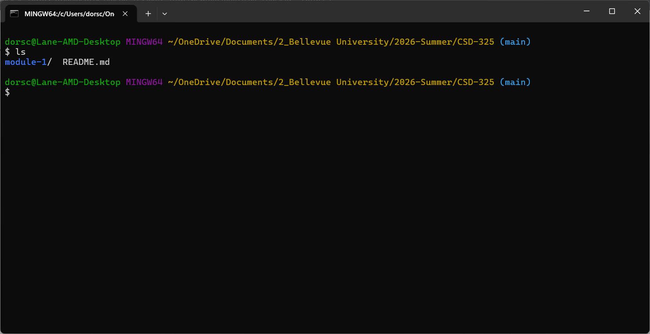
New file
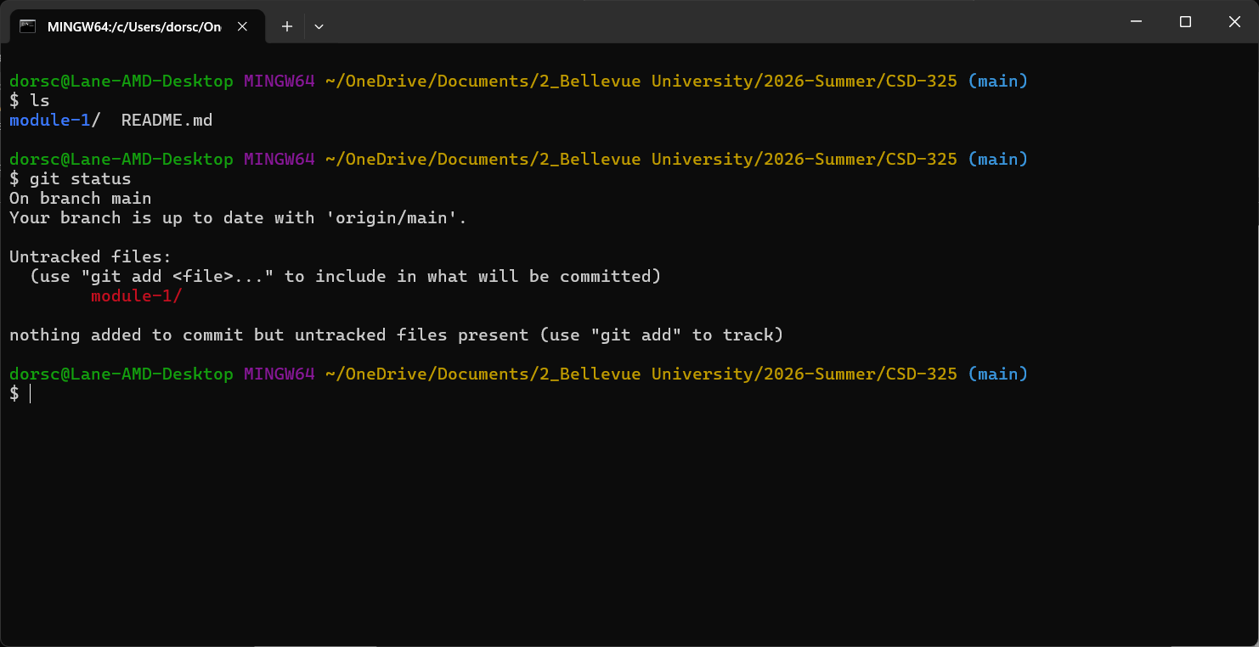

Staged File

