Value Stream Mapping My Weekly Routine

Lane Dorscher
CS 380 DevOps
Bellevue University Computer Science
10/10/2026
Chandra Bobba

Introduction
For this assignment, I chose to analyze my weekly routine of balancing work, college, family responsibilities, and personal time. Stiling (2020) explains how Value Stream Mapping, or VSM, can identify inefficiencies in everyday activities, not just software development.

Analysis
My workweek consists of three remote days and two office days. Each morning starts at 6 AM, getting my children ready for daycare. On office days, I commute approximately 90 minutes each way, which I use to listen to prepared lectures and coursework. My workday runs approximately nine hours, followed by family responsibilities, homework, and personal time before bed around 11 PM. Figure 1 below shows how I spend my weekdays on a Value Stream Map. 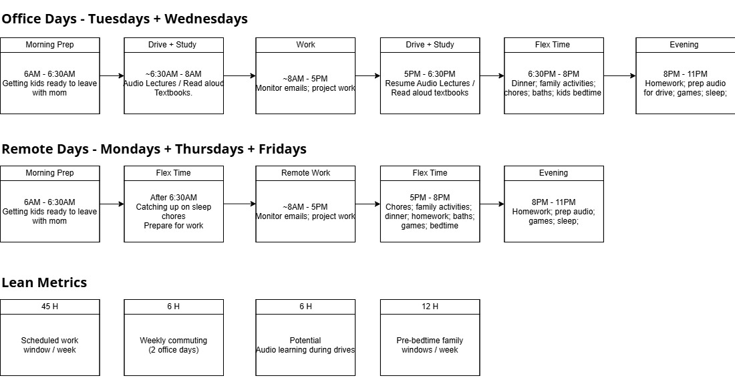
Figure 1: Weekly Routine Value Stream Map
Analyzing my schedule, I spend approximately 45 hours working and six hours commuting weekly. However, I don't consider commuting entirely wasted time since I use it for coursework. Remote days provide greater flexibility, allowing approximately three hours with my family before bedtime compared to 90 minutes on office days.
One area where I could reduce unnecessary processing time is preparing coursework materials. If I currently spend approximately 15 minutes preparing materials each evening, that amounts to 75 minutes weekly. By organizing materials in two 20-minute sessions instead, I could potentially reduce that time to 40 minutes, saving approximately 35 minutes each week. This would allow me to dedicate more time to completing assignments or relaxing without sacrificing family time. Although these are estimated savings, tracking the process over several weeks would help determine whether the changes would actually improve my routine.

Conclusion
Ultimately, optimizing my schedule isn't about eliminating family time, recreation, or sleep. Instead, it's about reducing unnecessary steps and making better use of the time available while maintaining a healthy balance between responsibilities.

References
Stiling, T. (2020, October 29). 3 easy steps for using VSM in everyday life. CSD380.

