Project: Todo Application
Course: CSD 380
Description: Functional test plan for the Todo web application covering all ten requirements in the Todo Business Requirements document.
Date: 2026/10/01
To complete the test case plan, fill out the information for Project, Course, Description and Date in the header below.
.
TABLE OF CONTENTS
Test 1. Access the Todo Application and Handle Invalid URLs 2
Test 2. Create a Task and Prevent an Empty Task Form 3
Test 3. Edit a Task and Prevent an Empty Edit Form 4
Test 4. Delete a Task 5
Test 5. Display Mobile and Tablet Views 6

For each test, the developer should: provide a test description, a test objective, the developer name and date tested. For each step, fill out the actions to be taken and describe the expected results, and indicate yes or no for each step depending upon the result. The peer tester should provide their name, date tested, indicate yes or no for each step depending upon the result, and a screenshot (thumbnail) of the result.

Test 1 | Access the Todo Application and Handle Invalid URLs
 | Test Objective: Covers Requirements 10, 1 and 5. Verifies users can reach the Todo application through its standard URL, view the list of todo task items, and see a custom 404 page for an invalid URL. | Developer: Tanner Elston  Date tested: 2026/10/01 | Peer tester: Lane Dorscher  Date tested: 2026/10/04
Step | Action | Expected results: | Developer pass/fail | Tester pass/fail  + Screenshot
1 | Open a new browser tab, type https://buwebdev.github.io/todo/ into the address bar, and press Enter. | The Todo application opens with the heading “Welcome to the Todo App!” | yes | Yes  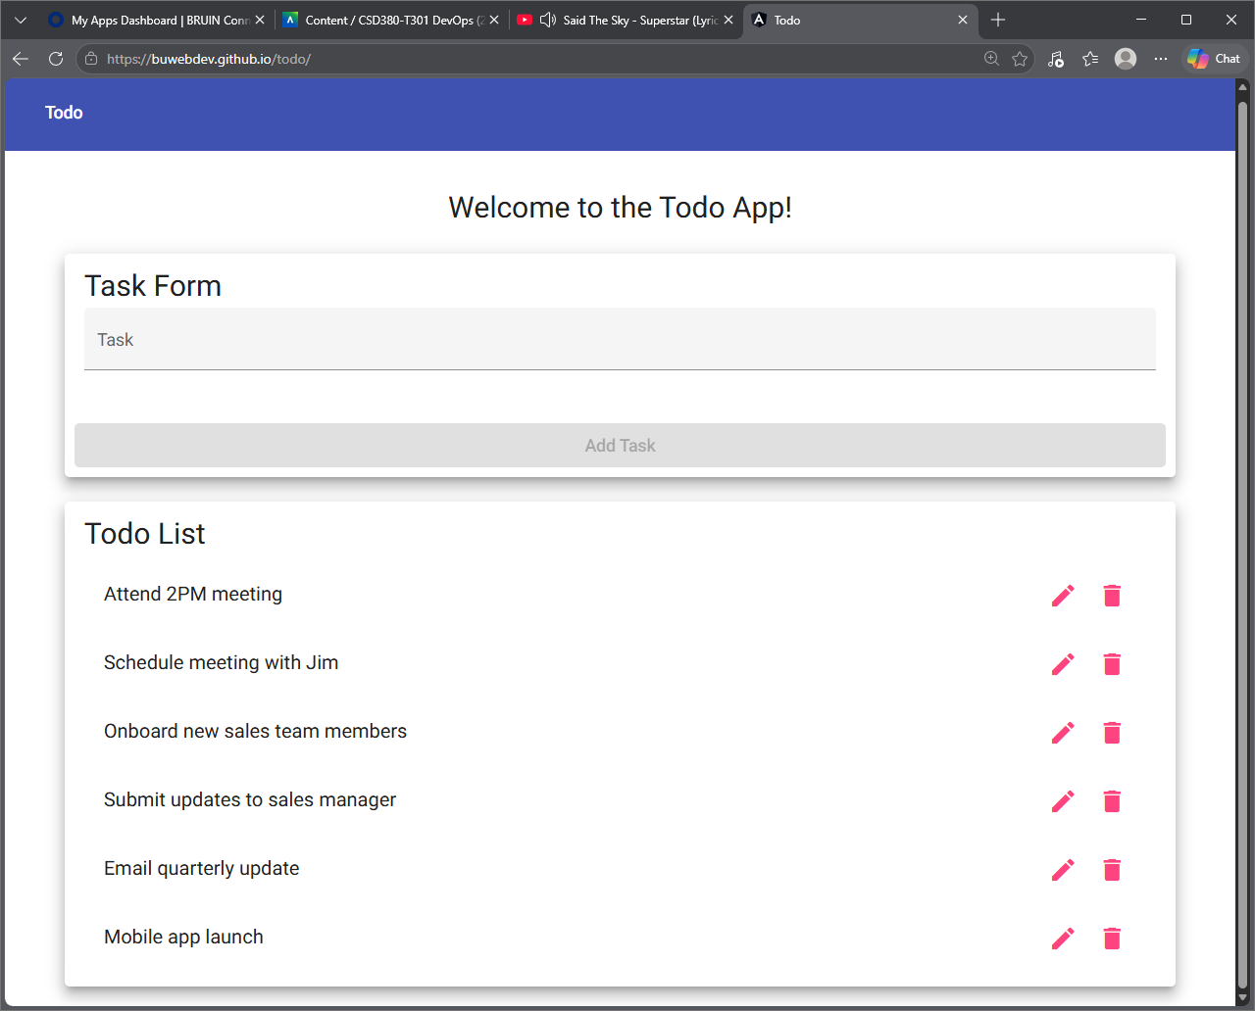
2 | Review the Todo List section. | The Todo List shows six task items, starting with “Attend 2PM meeting”, each with a pencil icon and a trash icon. | yes | Yes
3 | Compare the page to the landing page prototype in the requirements document. | The Task Form, Add Task button, and Todo List match the layout of the prototype. | yes | Yes  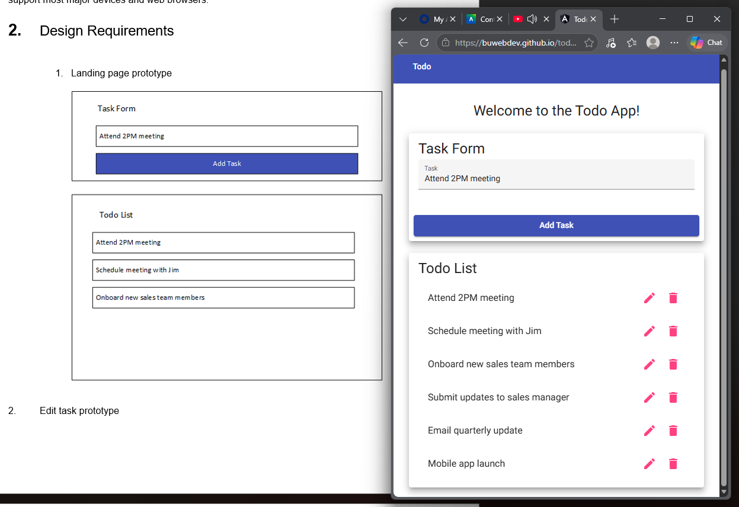
4 | Go to https://buwebdev.github.io/todo/invalid-page. | A custom 404 page clearly tells the user that the page could not be found. | no | Yes  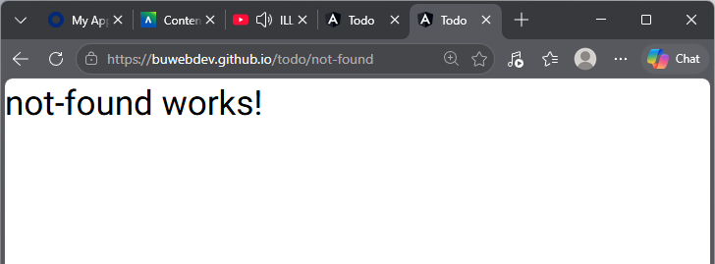
5 | Look for a way back to the home page. | The 404 page provides a link or button that returns the user to the Todo List. | no | No
Comments | Step 3 is a difficult step to ask the user of in the event they don’t have access to the same documents the developer does as its fairly common a developer has more robust permissions than the typical user. A tester MIGHT but I’ve seen where they don’t.  Step 4 is a technicality, The link provided redirects to https://buwebdev.github.io/todo/not-found in which it is a custom message saying “not-found works!” but there is no functionality that would return you to the original Todo List other than the browsers own back button or browser history (step 5)

Test 2 | Create a Task and Prevent an Empty Task Form
 | Test Objective: Covers Requirements 2 and 6. Verifies a user can create a new todo task item and cannot submit the Task Form without entering one. Start from a freshly loaded page. | Developer: Tanner Elston  Date tested: 2026/10/01 | Peer tester: Lane  Date tested: 2026/10/04
Step | Action | Expected results: | Developer pass/fail | Tester pass/fail
1 | Leave the Task field empty. | The Add Task button is disabled. | yes | Yes  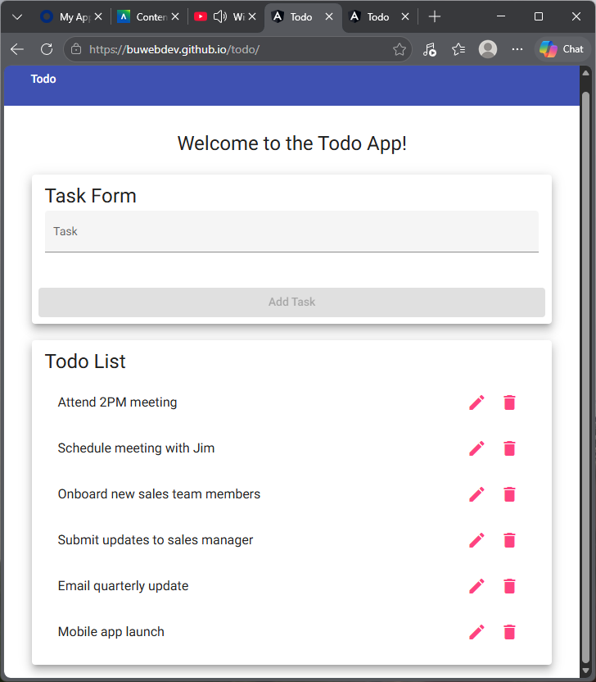
2 | Type “Buy groceries” into the Task field. | The Add Task button becomes enabled. | yes | Yes  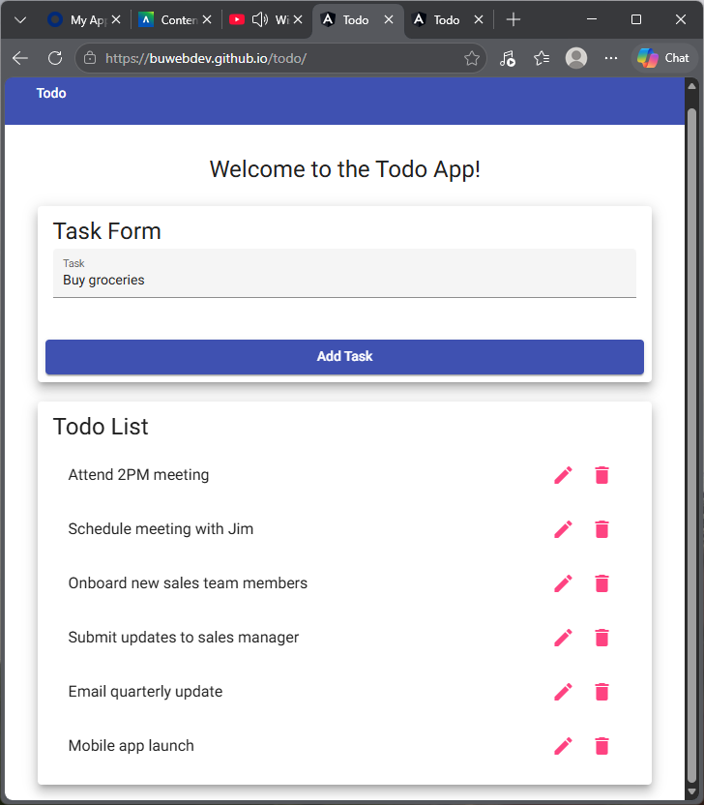
3 | Click the Add Task button. | “Buy groceries” appears at the bottom of the Todo List and the Task field is cleared. | yes | Yes 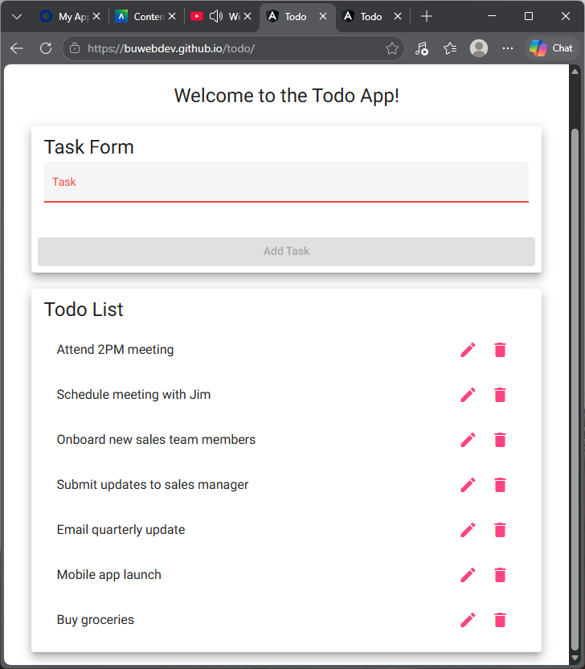
4 | Enter four spaces in the Task field. | The Add Task button stays disabled because spaces alone are not a todo item. | no | No, highlighted text input to show field is populated with 4 spaces.  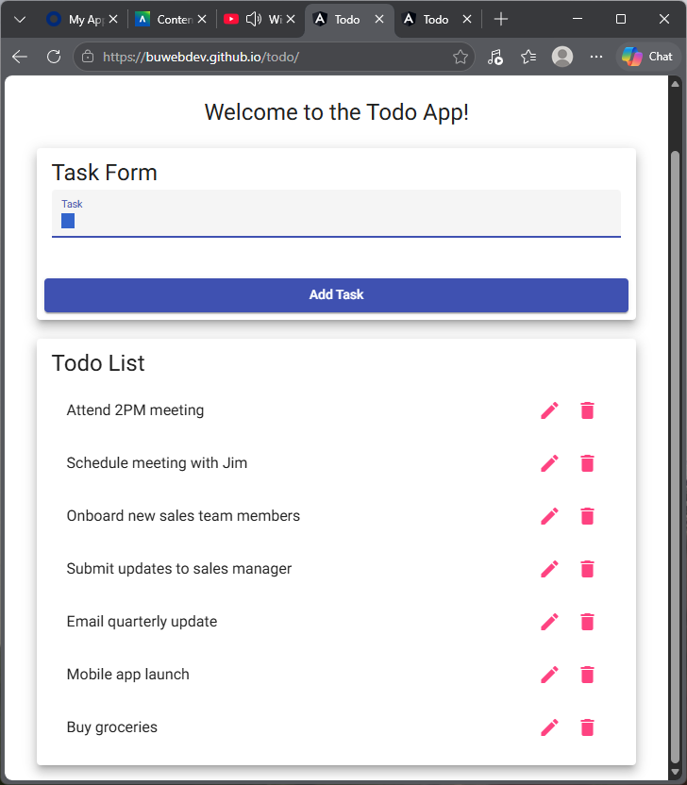
5 | With only spaces entered, click Add Task. | No blank task is added to the Todo List. | no | No  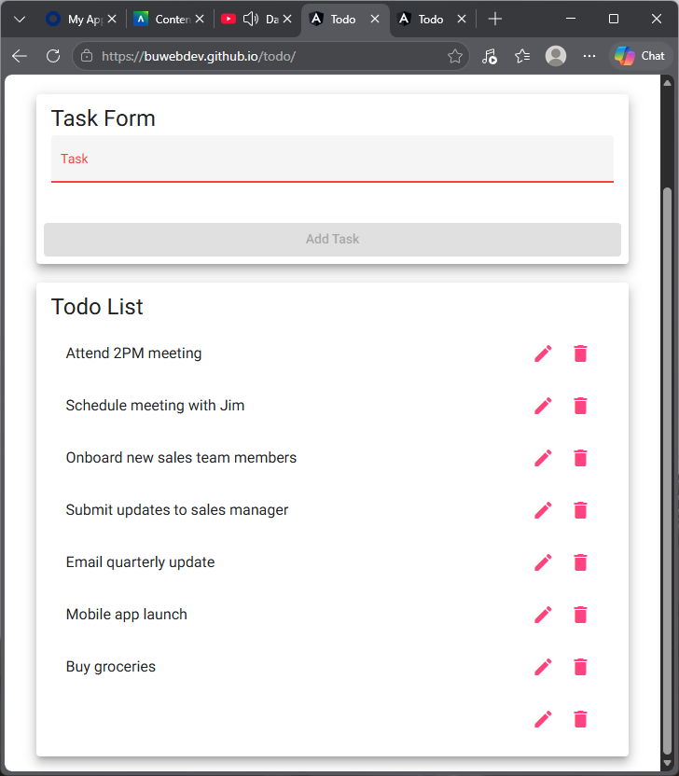
Comments

Test 3 | Edit a Task and Prevent an Empty Edit Form
 | Test Objective: Covers Requirements 3 and 7. Verifies a user can edit a todo task item and cannot submit the Edit Form without entering one. Start from a freshly loaded page. | Developer: Tanner Elston  Date tested: 2026/10/01 | Peer tester: Lane Dorscher  Date tested: 2026/10/04
Step | Action | Expected results: | Developer pass/fail | Tester pass/fail
1 | Click the pencil icon next to “Schedule meeting with Jim”. | The Edit Form opens and shows the current task text. | yes | Yes  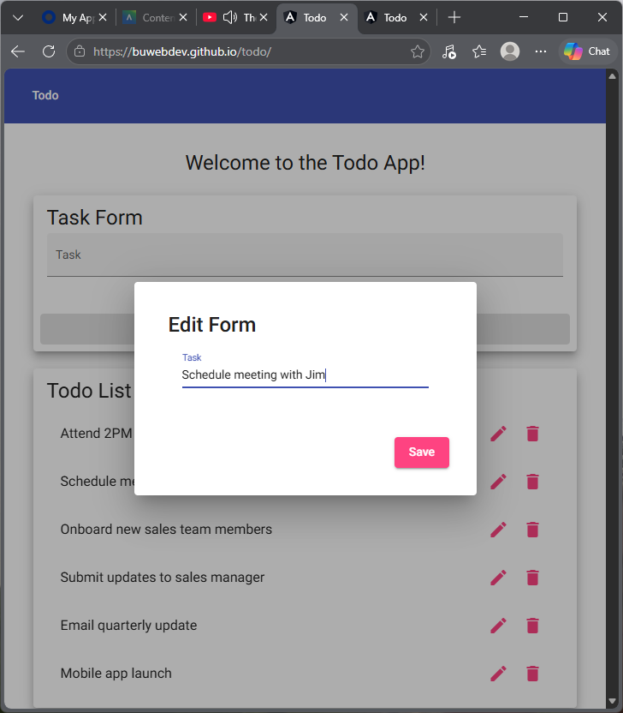
2 | Change the text to “Schedule meeting with Sarah” and click Save. | The Edit Form closes and the Todo List shows “Schedule meeting with Sarah” in the same position. | yes | Yes  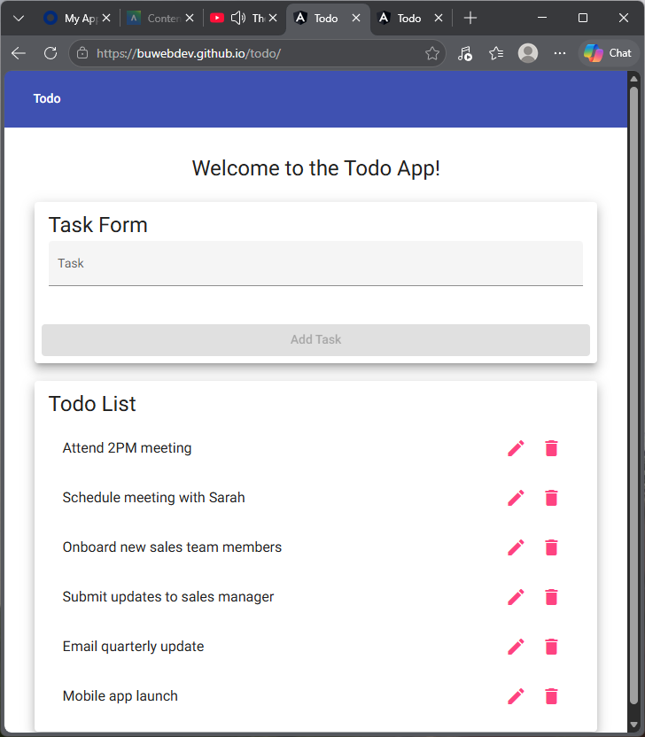
3 | Click the pencil icon next to “Onboard new sales team members” and delete all of the text. | The Save button becomes disabled or an error message appears. | no | No  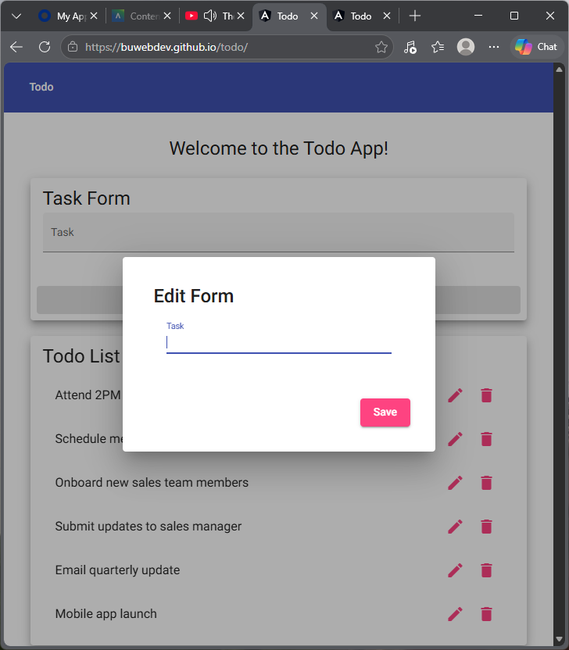
4 | Click Save. | The form is not submitted and the Edit Form stays open. | no | No  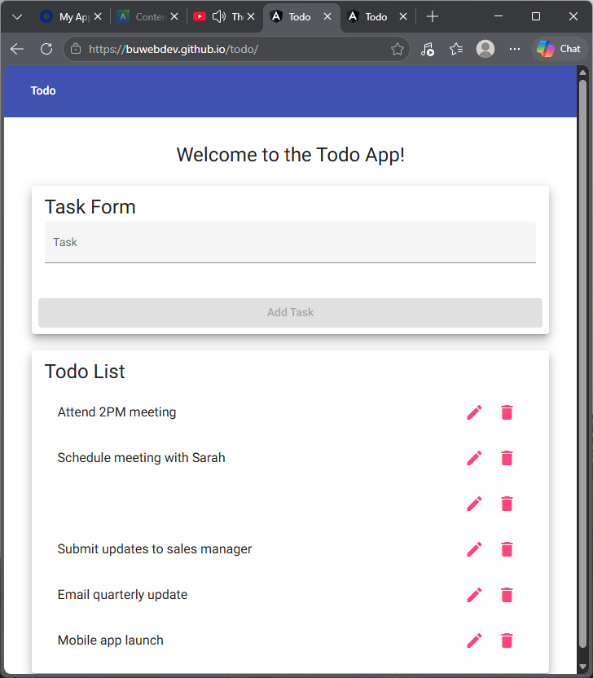
5 | Review the Todo List. | The task text still reads “Onboard new sales team members” and no blank row appears in the list. | no | No
Comments | This is a great test case to go with the requirement regarding the Add Task. It does a great job at reflecting how users can bypass critical business steps that would not be considered normally. Since this test does not pass, it can be fixed by developer and considering the “developer” in this scenario saw that it failed, they could correct it before the tester even sees it. A tester would also consider writing up these detailed test cases based off business requirements.

Test 4 | Delete a Task
 | Test Objective: Covers Requirement 4. Verifies a user can delete a todo task item and that only the selected task is removed. Start from a freshly loaded page. | Developer: Tanner Elston  Date tested: 2026/10/01 | Peer tester: Lane Dorscher  Date tested: 2026/10/04
Step | Action | Expected results: | Developer pass/fail | Tester pass/fail
1 | Locate “Email quarterly update” in the Todo List. | The task is visible with a pencil icon and a trash icon. | yes | Yes
2 | Click the trash icon next to “Email quarterly update”. | “Email quarterly update” is removed from the Todo List. | yes | Yes  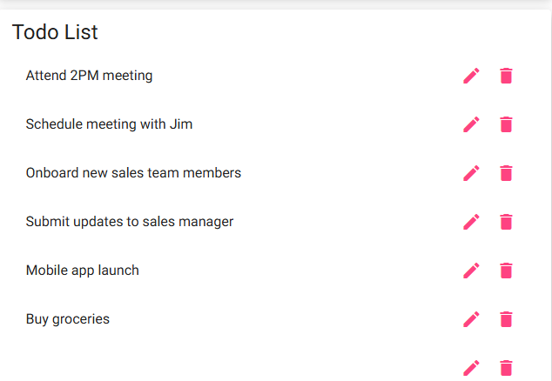
3 | Review the rest of the Todo List. | The other five tasks remain in their original order. | yes | Yes  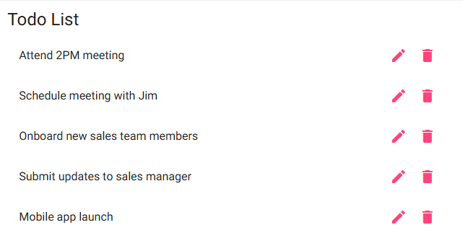
4 | Add a task named “Test task”, then click its trash icon. | “Test task” is added to the list and then removed. | yes | Yes  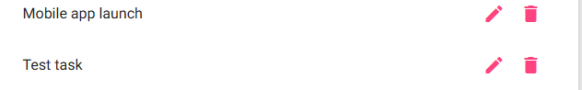  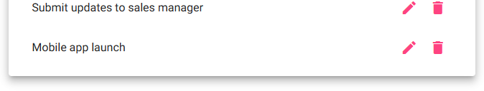
5 | Click the trash icon next to “Mobile app launch”. | “Mobile app launch” is removed and the Todo List shows four tasks. | yes | Yes  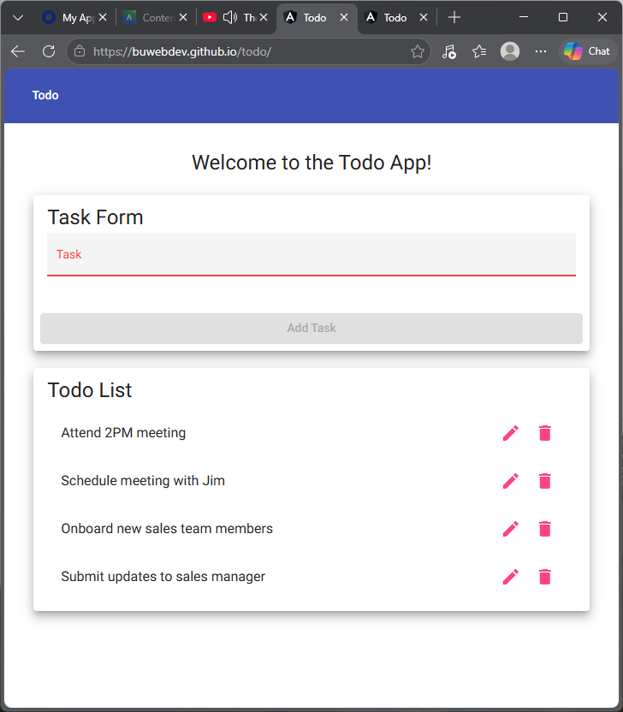
Comments | Step 4 has 2 notable actions and expected behaviors listed for both. The actions and respective results should be split up so there is clear separation of expected results to prevent confusion between them. In a cucumber environment, or similar, where we test this behavior, we would be able to track which step failed specifically.

Test 5 | Display Mobile and Tablet Views
 | Test Objective: Covers Requirements 8 and 9. Verifies the Todo application provides usable views on mobile and tablet devices. | Developer: Tanner Elston  Date tested: 2026/10/01 | Peer tester: Lane Dorscher  Date tested: 2026/10/04
Step | Action | Expected results: | Developer pass/fail | Tester pass/fail
1 | Open https://buwebdev.github.io/todo/ in Chrome, open DevTools (F12), turn on the device toolbar, and select iPhone SE (375 x 667). | The page fits the mobile screen with no horizontal scrolling. | yes | Yes  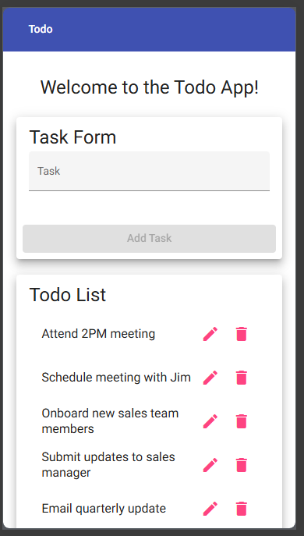
2 | Review the Task Form and Todo List in the mobile view. | Both sections stack in a single column and every task name and icon is visible. | yes | Yes
3 | Type “Mobile test” and tap Add Task. | “Mobile test” appears at the bottom of the Todo List. | yes | Yes  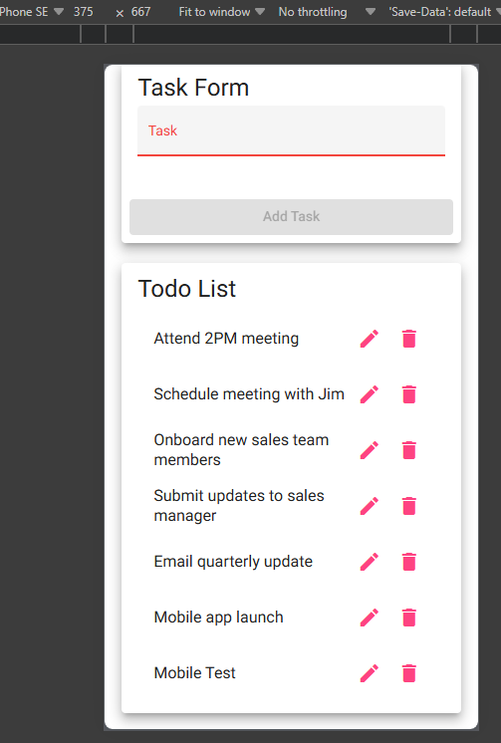
4 | Tap the pencil icon next to “Attend 2PM meeting”. | The Edit Form opens and fits within the mobile screen. | yes | Yes  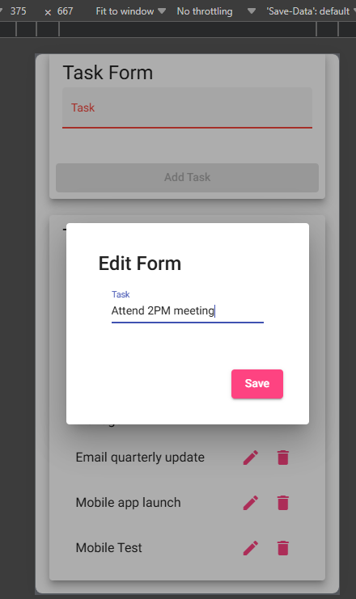
5 | Switch the device to iPad Mini (768 x 1024) and reload the page. | The page fits the tablet screen with no horizontal scrolling and all elements are visible. | yes | Yes  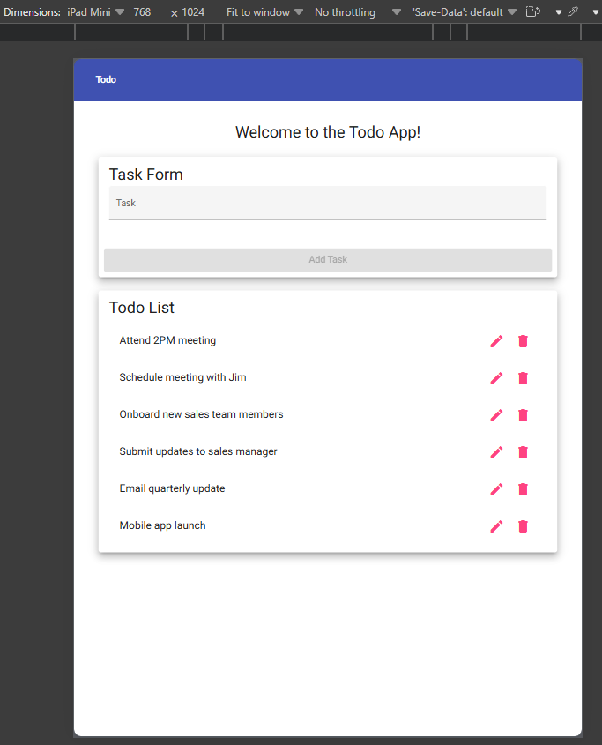
Comments | Good use of the available developer tools browsers provide for testing dynamic web pages. Step 2 seemingly could also work as an expected result within step 1 as the page loads right into the single column layout with Task Form and Todo List readily available. Arguably step 5 could/should just copy this whole test case for Iphone SE and replace with the iPad Mini, same test steps different dimensions but same goals.

