Student Name: Rakesh Shrestha
Assignment: Module 4.2 Assignment: Test Plan
Project: | Todo Application (https://buwebdev.github.io/todo/)
Course: | CSD380-T301 DevOps (2271-1)
Description: | Functional test plan for the Todo application covering all ten requirements in the Todo Business Requirements document. Test environment: Google Chrome (latest) on Windows 11.
Date: | 2026/10/02

TABLE OF CONTENTS
Test Plan Purpose and Requirements Coverage 2
Test 1: Open the Todo App and View the Task List 3
Test 2: Create a Task and Block an Empty Task 4
Test 3: Edit a Task and Block an Empty Edit 5
Test 4: Delete a Task 6
Test 5: Invalid URL Shows a Custom 404 Page 7
Test 6: Mobile and Tablet Views 8
Execution Notes and Reference 9

Test Plan Purpose
The assignment requires at least five functional tests. This plan includes six, which together cover all ten requirements in the Todo Business Requirements document: viewing, creating, editing, and deleting tasks; blocking empty entries on both the task form and the edit form; showing a custom 404 page for invalid URLs; supporting mobile and tablet screens; and reaching the site through https://buwebdev.github.io/todo/.
I wrote each step around the actual buttons and labels in the app and in the prototypes from the requirements document, such as the "Add Task" button, the "Edit Form" window, and the pencil and trash can icons, so anyone can repeat the tests and get the same results. The Developer pass/fail, Tester pass/fail, and Comments fields are left blank for now. They will be filled in when the tests are run in Module 4.3. The tests are planned for Google Chrome on Windows 11.
Requirements Coverage Matrix
Requirement # | Business Requirement | Test Case
1 | View a list of todo task items | Test 1
2 | Create a new todo task item | Test 2
3 | Edit a todo task item | Test 3
4 | Delete a todo task item | Test 4
5 | For invalid URLs, provide users with a custom 404 error page | Test 5
6 | Prevent users from submitting a task form without entering a todo item | Test 2
7 | Prevent users from submitting the edit form without entering a todo item | Test 3
8 | Provide users with a view for mobile devices | Test 6
9 | Provide users with a view for tablet devices | Test 6
10 | Allow users to visit the website through https://buwebdev.github.io/todo/ | Test 1

Test 1  TC-01 | Open the Todo App and View the Task List
 | Test Objective: Verifies requirements 1 and 10. Verify the app loads at the required URL and shows the Todo task list.  Precondition: A current web browser and an internet connection.  Test Data: URL: https://buwebdev.github.io/todo/ | Developer: Rakesh Shrestha  Date tested: | Peer tester: Lane Dorscher  Date tested: 2026/10/04
Step | Action | Expected results: | Developer pass/fail | Tester pass/fail  + Screenshot
1 | Open the browser and go to https://buwebdev.github.io/todo/. | The page loads with no error. The browser tab reads "Todo". |  | Yes  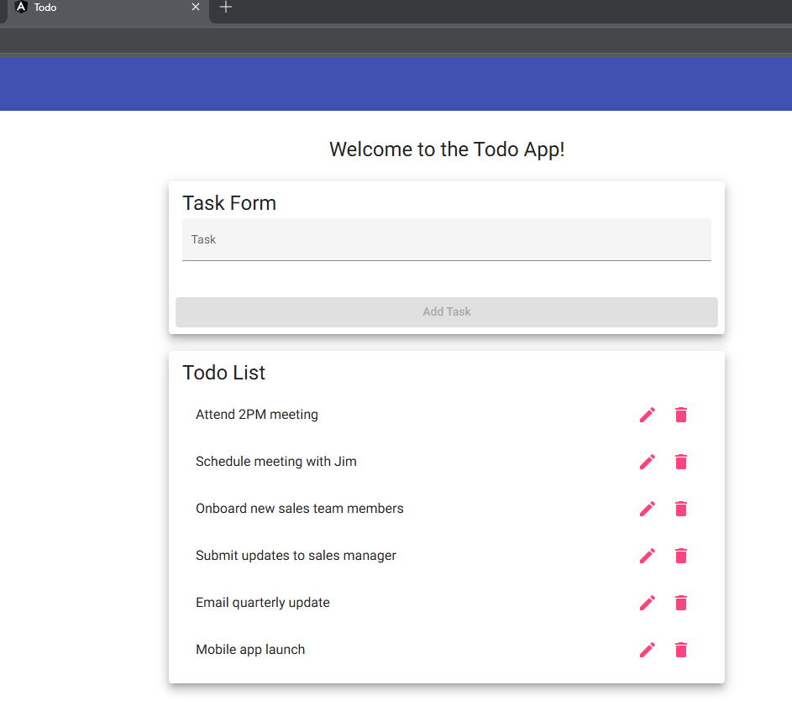
2 | Look at the top of the page. | A blue toolbar with a "Todo" button appears, along with the heading "Welcome to the Todo App!" |  | Yes
3 | Look at the "Todo List" card. | Six default tasks are listed, starting with "Attend 2PM meeting" and ending with "Mobile app launch." |  | Yes  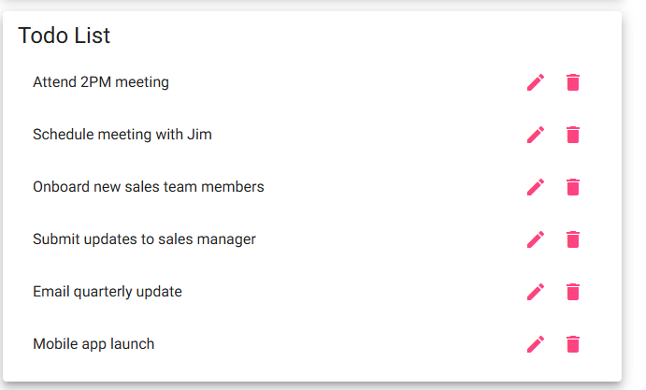
4 | Look at the right side of each task. | Each task has an edit (pencil) icon and a delete (trash can) icon. |  | Yes
5 | Refresh the browser window. | The page reloads correctly and the same six tasks are shown. |  | Yes  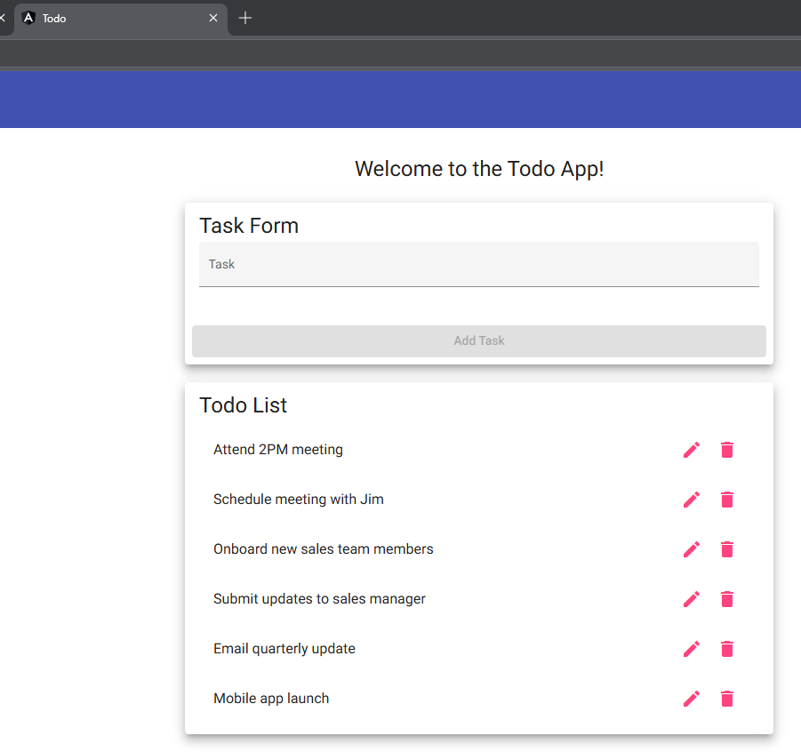
Comments | Very clean and structured test case steps. Does a good job at articulating that this test case is to validate the page and content loads accordingly.

Test 2  Test 2 | Create a Task and Block an Empty Task
 | Test Objective: Verifies requirements 2 and 6. Verify a user can add a new task, and that the Task Form cannot be submitted when the Task field is empty.  Precondition: The Todo app is open and showing the six default tasks.  Test Data: Valid task: "Module 4.2 Test Task". Invalid input: an empty Task field. | Developer: Rakesh Shrestha  Date tested: | Peer tester: Lane Dorscher  Date tested: 2026/10/04
Step | Action | Expected results: | Developer pass/fail | Tester pass/fail  + Screenshot
1 | With the Task field empty, look at the "Add Task" button in the Task Form. | The "Add Task" button is grayed out and cannot be clicked. |  | Yes  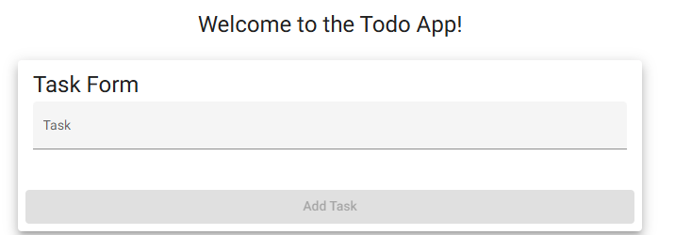
2 | Click inside the Task field, then click somewhere else on the page without typing. | The button stays disabled and nothing is added to the list. |  | Yes  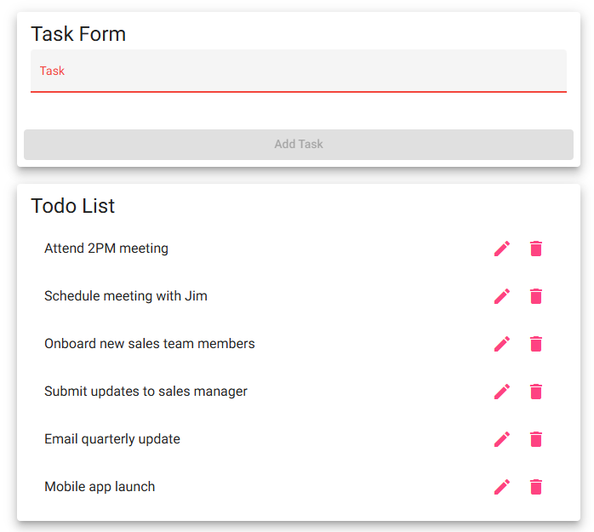
3 | Type "Module 4.2 Test Task" in the Task field. | The text shows in the field and the "Add Task" button becomes clickable. |  | Yes  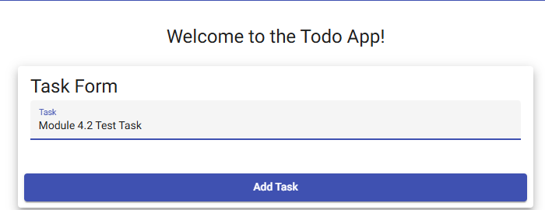
4 | Click "Add Task". | "Module 4.2 Test Task" appears at the bottom of the Todo List. |  | Yes  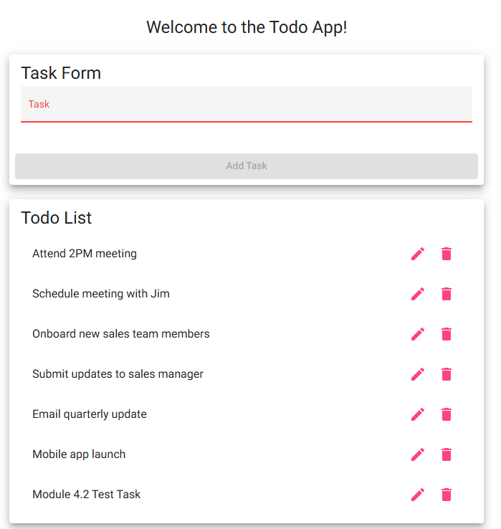
5 | Look at the Task field and count the tasks in the list. | The Task field is cleared, and the list now has seven tasks with no blank entries. |  | Yes
Comments | Very detailed steps and result expectations. Might get away with combining step 5 with step 4 as both require verifying the task list and task entry field.

Test 3  Test 3 | Edit a Task and Block an Empty Edit
 | Test Objective: Verifies requirements 3 and 7. Verify a user can change a task through the Edit Form, and that the Edit Form cannot be saved with an empty task.  Precondition: Test 2 was just run in the same browser session, so "Module 4.2 Test Task" is in the list.  Test Data: Updated text: "Module 4.2 Updated Test Task". Invalid input: an empty Task field. | Developer: Rakesh Shrestha  Date tested: | Peer tester: Lane Dorscher  Date tested: 2026/10/04
Step | Action | Expected results: | Developer pass/fail | Tester pass/fail  + Screenshot
1 | Click the pencil icon next to "Module 4.2 Test Task". | An "Edit Form" window opens with "Module 4.2 Test Task" already in the Task field. |  | Yes  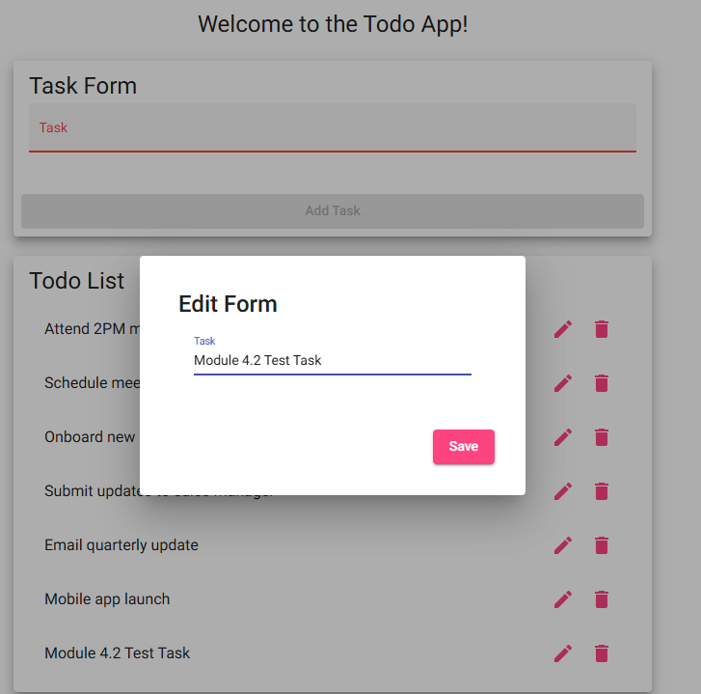
2 | Change the text to "Module 4.2 Updated Test Task" and click "Save". | The window closes and the task now reads "Module 4.2 Updated Test Task" in the same spot in the list. |  | Yes  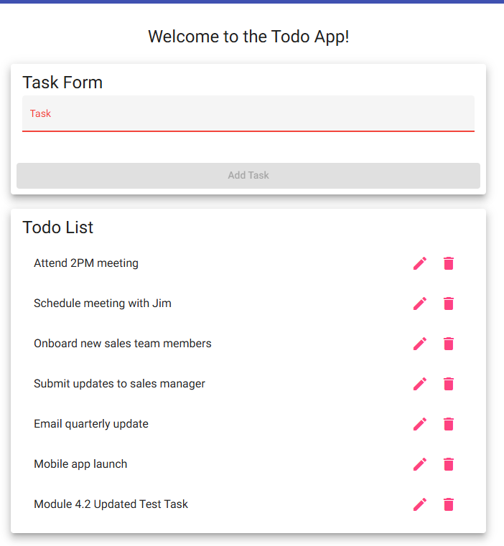
3 | Click the pencil icon next to the same task again. | The Edit Form opens with "Module 4.2 Updated Test Task" in the Task field. |  | Yes  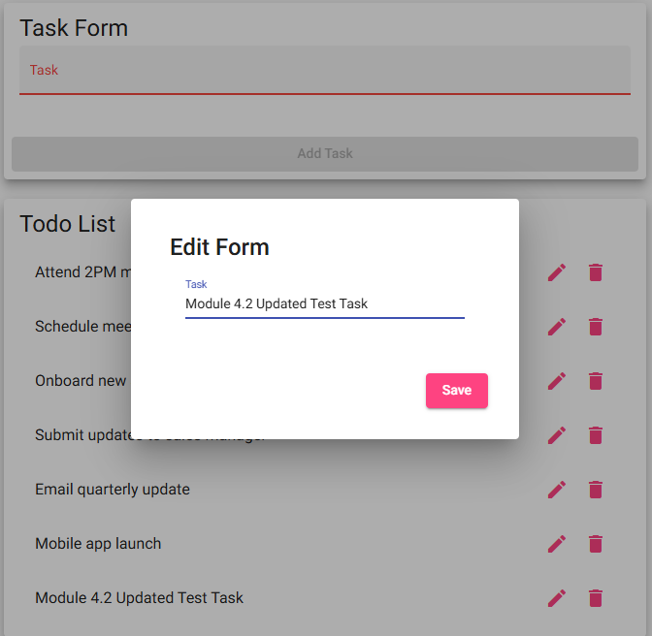
4 | Delete all of the text so the Task field is empty. | The Task field is empty. |  | Yes  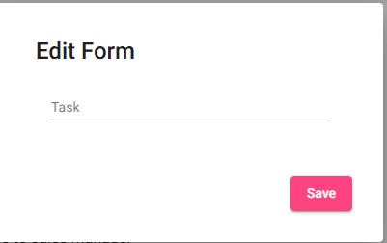
5 | Try to click "Save". | The Edit Form does not save the task when the Task field is empty, and no blank task is added to the list. |  | No  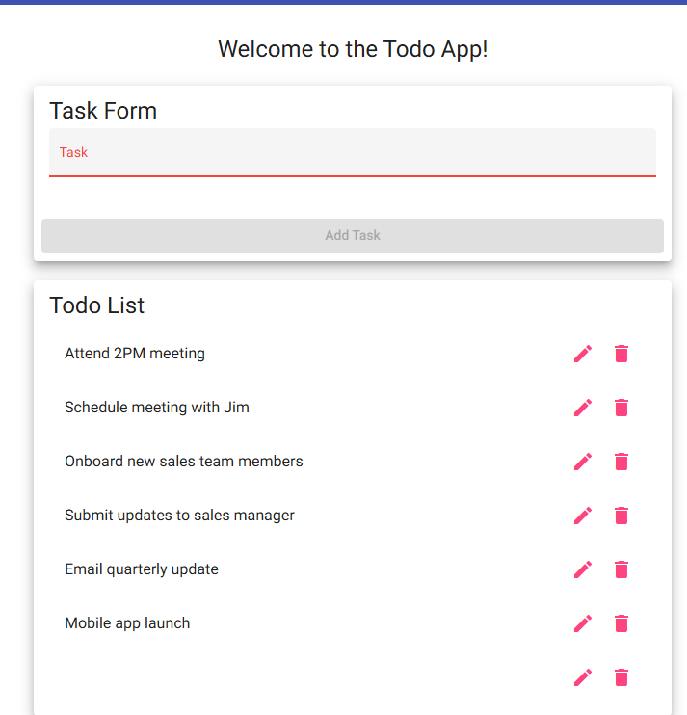
6 | Close the form if possible and check the task in the list. | The task still reads "Module 4.2 Updated Test Task." No blank task appears in the list. |  | No  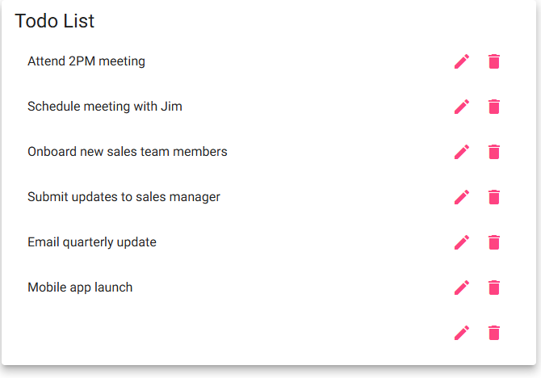
Comments | Good testing of requirements. All steps and expected results were clear and well documented.
Test 4  TC-04 | Delete a Task
 | Test Objective: Verifies requirement 4. Verify a user can remove a task from the Todo List without affecting the other tasks.  Precondition: Test 3 was just run in the same session, so "Module 4.2 Updated Test Task" is in the list.  Test Data: Task to delete: "Module 4.2 Updated Test Task" | Developer: Rakesh Shrestha  Date tested: | Peer tester: Lane Dorscher  Date tested: 2026/10/04
Step | Action | Expected results: | Developer pass/fail | Tester pass/fail  + Screenshot
1 | Count the tasks in the Todo List. | Seven tasks are listed. |  | Yes  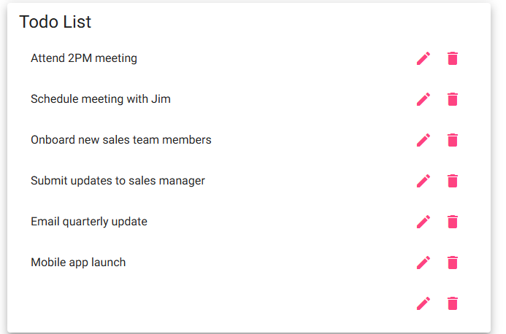
2 | Click the trash can icon next to "Module 4.2 Updated Test Task". | The task is removed from the list right away. |  | Yes  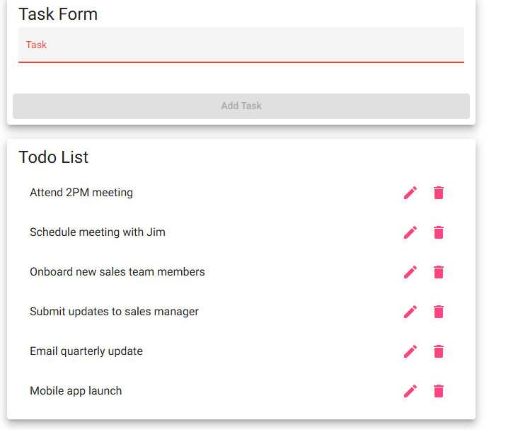
3 | Review the remaining tasks. | Six tasks remain, and they match the original default tasks. |  | Yes
Comments | Only caveat I faced following the steps was my task for “Module 4.2 Updated Test Task” did not exist because of failed expected behavior when modifying a task, was able to delete the blank task that I did create from previous steps. If expected results worked as expected this wouldn’t have happened so no need to change anything.

Test 5  TC-05 | Invalid URL Shows a Custom 404 Page
 | Test Objective: Verifies requirement 5. Verify that an invalid URL takes the user to the app's own 404 page instead of a blank page or a generic browser or server error.  Precondition: A current web browser and an internet connection.  Test Data: Invalid URLs: https://buwebdev.github.io/todo/not-a-real-page and https://buwebdev.github.io/todo/#/not-a-real-page | Developer: Rakesh Shrestha  Date tested: | Peer tester: Lane Dorscher  Date tested: 2026/10/04
Step | Action | Expected results: | Developer pass/fail | Tester pass/fail  + Screenshot
1 | Open a new tab and go to https://buwebdev.github.io/todo/not-a-real-page. | A custom 404 page from the Todo app is shown, not a generic GitHub or browser error page. |  | Yes  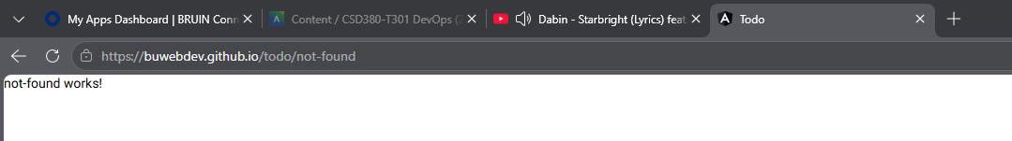
2 | Read the page that appears. | The page clearly tells the user the page was not found. |  | Yes  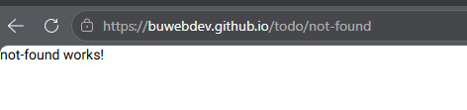
3 | Go to https://buwebdev.github.io/todo/#/not-a-real-page. | The same custom 404 page is shown. |  | No  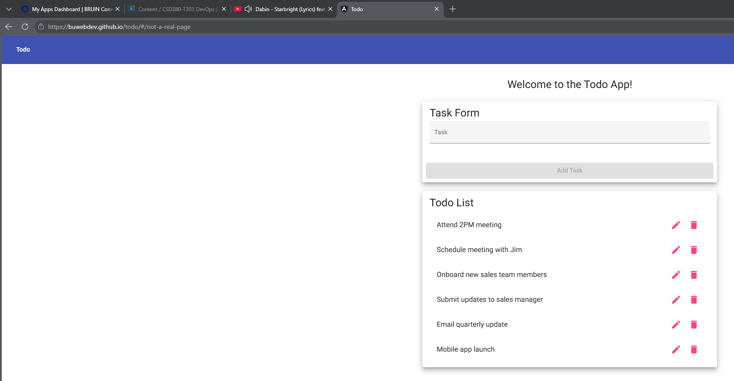
4 | Use the browser's Back button or go to the main URL again. | The Todo app loads normally with the six default tasks. |  | Yes  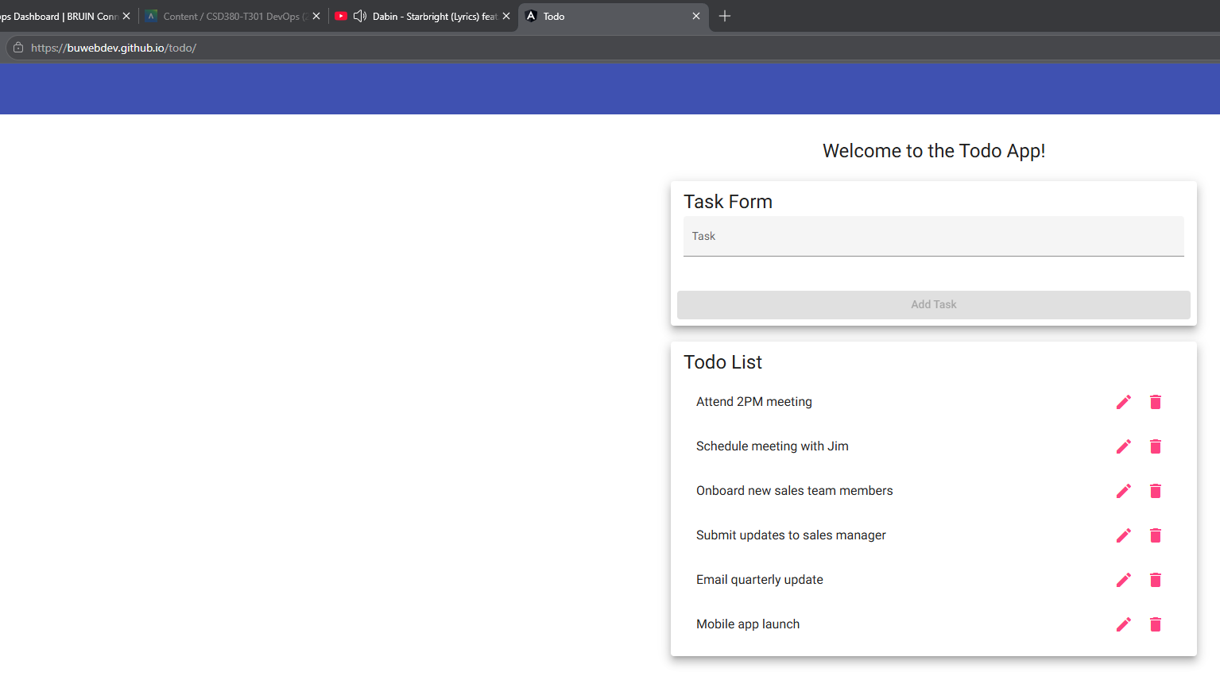
Comments | I think technically my test passed in step 1 as it redirected me to the not-found page though it did not have customized features or what resource was attempted to be accessed.

Test 6  TC-06 | Mobile and Tablet Views
 | Test Objective: Verifies requirements 8 and 9. Verify the app adjusts to mobile and tablet screen sizes and stays usable.  Precondition: The Todo app is open in Google Chrome on a desktop or laptop.  Test Data: Mobile: iPhone 12 Pro (390 x 844). Tablet: iPad Mini (768 x 1024). | Developer: Rakesh Shrestha  Date tested: | Peer tester: Lane Dorscher  Date tested: 2026/10/04
Step | Action | Expected results: | Developer pass/fail | Tester pass/fail  + Screenshot
1 | Press F12 to open Chrome DevTools, then click the device toolbar icon (or press Ctrl+Shift+M). | The page switches to a resizable device preview. |  | Yes  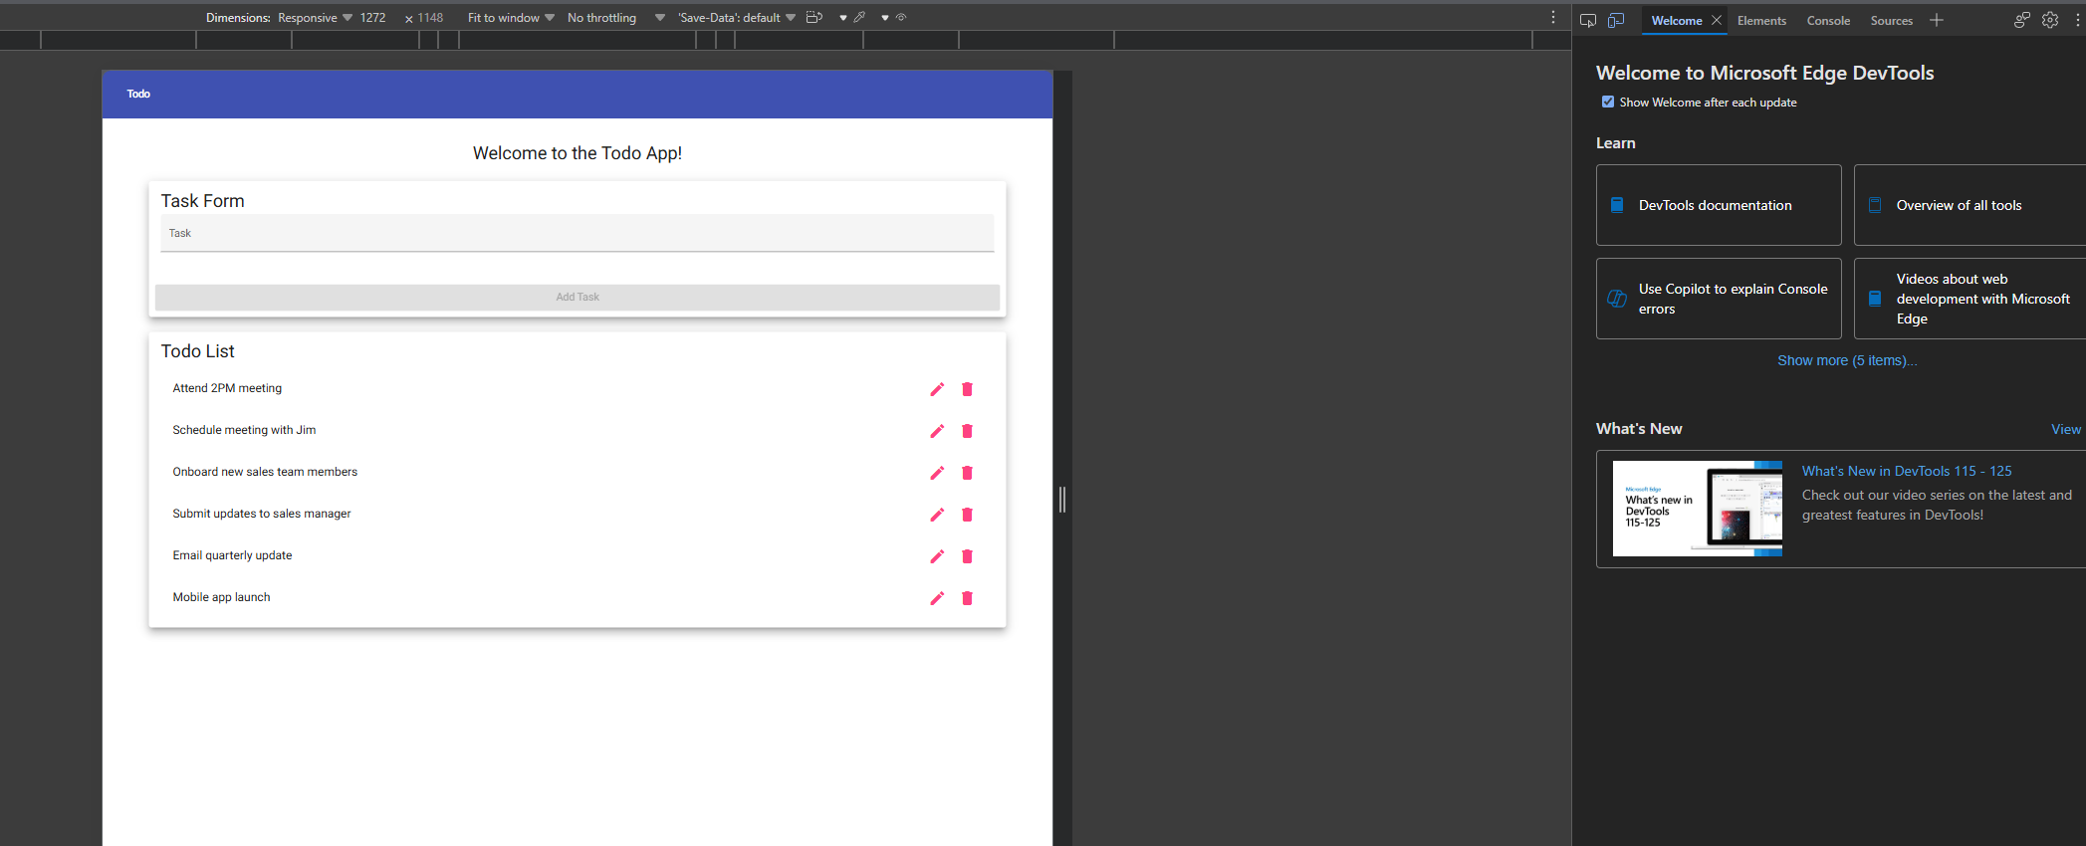
2 | Select "iPhone 12 Pro" from the device list. | The app fits the narrow screen with no sideways scrolling. |  | Yes 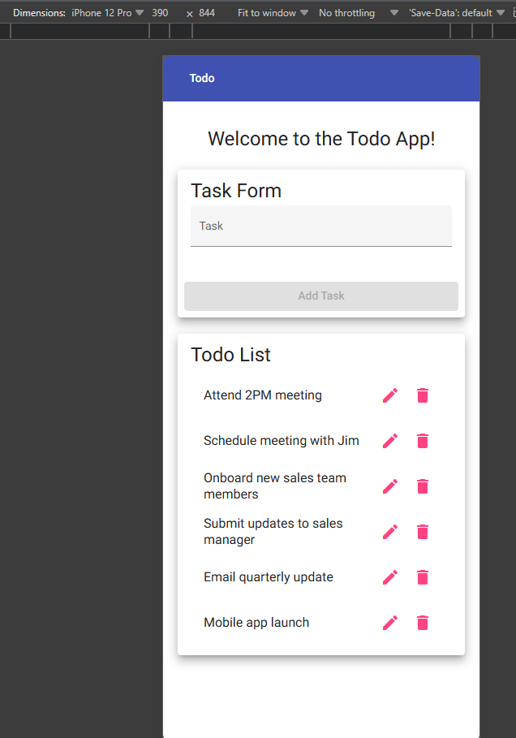
3 | Add a task called "Mobile test" and then delete it. | The Task field, the "Add Task" button, and the edit and delete icons are all readable and work. |  | Yes  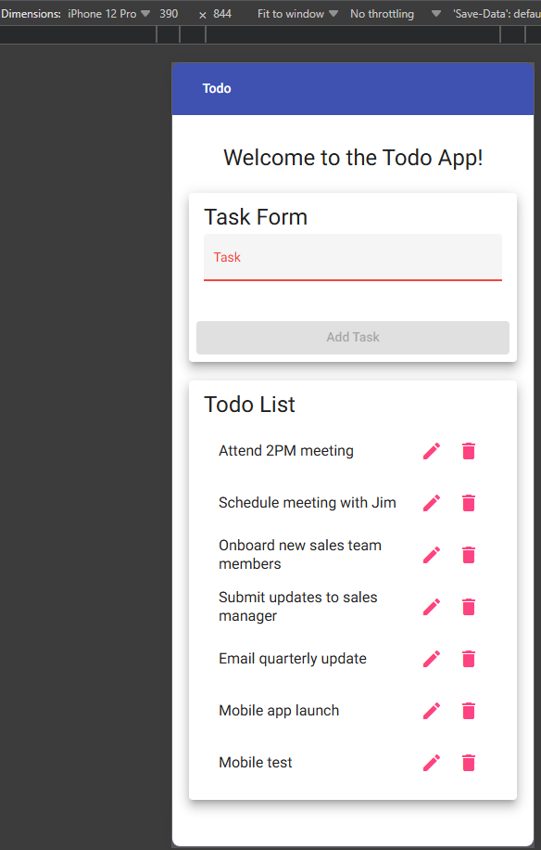 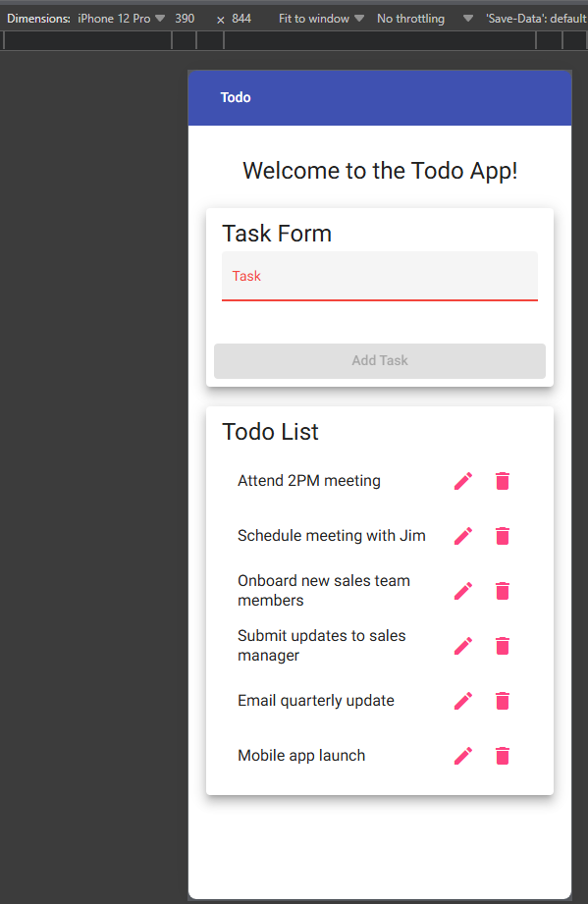
4 | Select "iPad Mini" from the device list. | The app fits the tablet screen with no sideways scrolling. |  | Yes  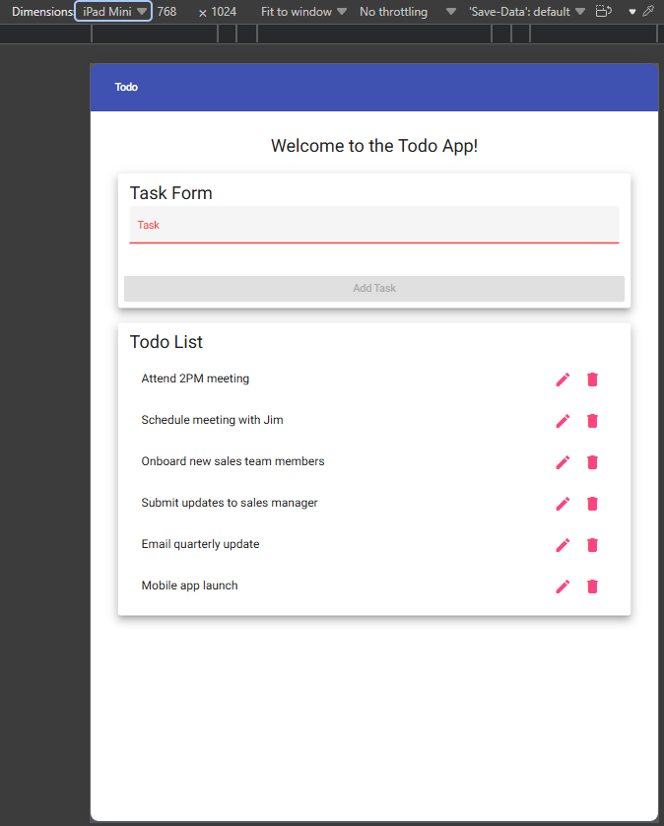
5 | Click the pencil icon on any task, then click "Save". | The Edit Form fits on the screen and the "Save" button can be reached and clicked. |  | Yes  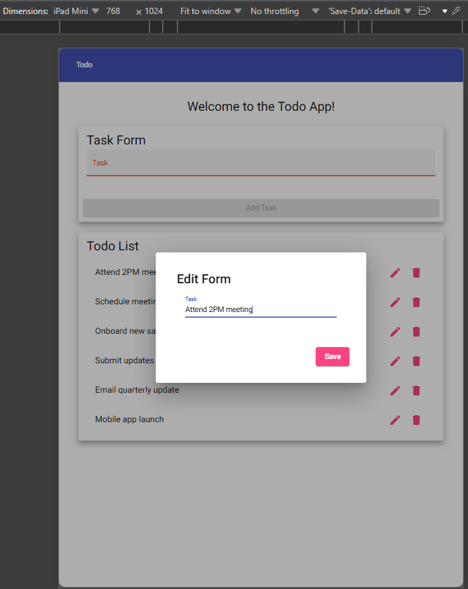
Comments | Only comments of noting is these mobile devices could be extensive as the normal webpage version is WITH the exception of ensuring the dimensions of the screen match the targeted device. Web versions might be different than the mobile version HOWEVER this is becoming far less common with responsive and dynamic web design becoming increasingly popular.

Execution Notes
1. Run Test 2, Test 3, and Test 4 in order without refreshing the page. The app does not save tasks, so a refresh resets the list to the six default tasks and the test data from Test 2 would be lost.
2. Mark a step "yes" only when what happens matches the expected result exactly. If a step fails, write down the step number, what actually happened, and any error message, and attach a screenshot as the template asks.
3. A failed test is still a useful result. Chapter 10 of The DevOps Handbook explains that building automated tests into daily work creates a fast feedback loop that helps developers find problems early and fix them quickly (Kim et al., 2021). Writing these manual tests clearly is the first step toward automating them later.
Reference
Kim, G., Humble, J., Debois, P., Willis, J., & Forsgren, N. (2021). The DevOps handbook: How to create world-class agility, reliability, & security in technology organizations (2nd ed.). IT Revolution Press.

